Precision Cardiovascular Medicine: Artificial Intelligence and Epigenetics for the Pathogenesis and Prediction of Coarctation in Neonates

SUPPLEMENTAL MATERIAL
Supplemental Table S1: Clinical demographics of CoA cases versus controls

Demographics | Mean (SD) |  | p-value
 | Controls | CoA
Number | 16 | 24 | -
Mother Age (years) | 27.062 (4.697) | 29.333 (5.998) | 0.2103  (T)
Gender
Male | 9 | 16 | 0.521 (W)
Female | 7 | 8
Ethnicity
White | 11 | 16 | 0.9062 (W)
African American | 3 | 8
Other | 2 | 0
Gestational Age (Weeks) | 38.875  (1.147) | 37.792  (3.120) | 0.599 (W)
T- Student t-test
W- Wilcoxon Mann Whitney test

Supplemental Table S2: Coarctation prediction using Artificial Intelligence (stringent p-values*)
 | SVM | GLM | PAM | RF | LDA | DL
AUC  95% CI | 0.92  (0.73-1) | 0.93  (0.73-1) | 0.96  (0.73-1) | 0.93  (0.72-1) | 0.91  (0.72-1) | 0.97  (0.80-1)
Sensitivity | 0.90 | 0.90 | 0.90 | 0.85 | 0.83 | 0.95
Specificity | 0.85 | 0.90 | 0.87 | 0.85 | 0.90 | 0.98

*Individual CpG locus p< 5x10⁻⁸ for defining methylation change
Most important CpG biomarkers listed in decreasing order of contribution - per AI platform used:
SVM: cg17259183, cg12071328, cg15578311, cg05867499, cg04708753
GLM: cg17259183, cg05867499, cg04708753, cg02484732, cg14825413
PAM: cg17259183, cg12071328, cg15578311, cg05867499, cg02484732
RF: cg12071328, cg17259183, cg05867499, cg15578311, cg14825413
LDA: cg17259183, cg12071328, cg15578311, cg02484732, cg04043455
DL: cg23490161, cg15578311, cg17259183, cg04043455, cg02484732

Supplemental Table S3: Coarctation prediction using Artificial Intelligence*

 | SVM | GLM | PAM | RF | LDA | DL
AUC  95% CI | 0.89  (0.72-1) | 0.91  (0.72-1) | 0.91  (0.73-1) | 0.88  (0.71-1) | 0.76  (0.56-0.96) | 0.94  (0.82-1)
Sensitivity | 0.82 | 0.85 | 0.87 | 0.75 | 0.70 | 0.95
Specificity | 0.75 | 0.85 | 0.75 | 0.75 | 0.75 | 0.93

*Individual CpG locus significant methylation difference (CoA vs controls) defined as FDR p-value <0.05

Most important CpG biomarkers listed in decreasing order of contribution - per AI platform used:

SVM: cg17259183, cg14150199, cg27047371, cg12071328, cg20739510
GLM: cg09428571, cg05867499, cg05042705, cg12193484, cg04708753
PAM: cg17259183, cg12071328, cg27047371, cg20739510, cg25910466
RF: cg22753548, cg25910466, cg27149073, cg12071328, cg26394619
LDA: cg17259183, cg20739510, cg27047371, cg12071328, cg14150199
DL: cg17259183, cg09428571, cg15578311, cg02484732, cg18017761

Supplemental Table S4: Prediction of Coarctation- Logistic Regression Analysis

Group | AUC (95% CI) | Specificity | Specificity
Training/Discovery | 0.969 (0.952 ~ 0.986) | 0.926 (0.891 ~ 0.961) | 0.882 (0.829 ~ 0.935)
10-fold Cross-Validation | 0.883 (0.766 ~ 1.000) | 0.917 (0.917 ~ 1.000) | 0.875 (0.713 ~ 1.000)

Regression equation: logit (P) = log(P / (1 - P)) = -12.62 + 33.584 cg17259183
+ 95.598 cg12071328 + 15.737 cg05867499

Supplemental Table S5: Epigenetically Modified Genes in Coarctation: Role in Heart Development and Function
Gene Symbol | Gene Name | Role and effect of mutations in Heart/ CVS | References
TGFβ1 | Transforming growth factor, beta 1 | Cardiac fibrosis, ventricular remodeling,  valvular pathogenesis | (1)
SMAD1 | Small Mother against decapentaplegic homolog-1 | Endothelial proliferation, angiogenesis, left ventricle remodeling and cardiac hypertrophy | (2)
FOSL2 | Fos-Like antigen | Epithelial mesenchymal transformation (EMT), gives rise to all heart cell types, Mutation leads to CHD | (3)
THBS1 | Thrombospondin 1 | Affects tissues modeling: heart disease, heart failure | (4)
MYO5A | Myosin 5A | Regulates potassium ion channels:  myocyte repolarization, cardiac rhythm | (5)
TNNI3 | Troponin I | Familial disease Left ventricular dysfunction and abnormal morphology of cardiovascular system | (6)

Supplemental Table S6: Epigenetically Dysregulated Molecular Pathways in isolated CoA

Molecular  Pathways | Function | Role in Heart/ CVS | Reference
Integrin  Signaling | Vasculogenesis, angiogenesis (e.g. VEGFR) | Heart and vessel remodeling and development, cardiac growth | (7)
TGFβ  signaling | Family of growth and differentiation factors | Critical for CVS development  and heart modeling | (8)
RAR (retinoid acid receptor) | RA binds to RAR controls mammalia developmental processes | Multifaceted role in heart-regulate damage and repair in remodeling | (9)
Glucocorticoid receptor  signaling | Glucocorticoid actions mediated by GR | GR signaling in myocardiocytes: cardiac development and function | (10)

Supplemental Table S7: Gene enrichment statistics under disease pathways associated with CoA.
Disease pathway | Significance
Abnormal morphology of cardiovascular system | 0.0037
Left ventricular dysfunction | 0.0013
Heart conduction disorder | 0.0024
Thrombus | 0.0083
Coronary artery disease | 0.0041

Supplemental Figure S1: Three dimensional PLS-DA overfitting model of CoA cases vs normal controls followed by VIP scores of the significant CpG markers. The data are color coded according to their grouping analysis (Red nodes represent cases and green nodes represent controls).
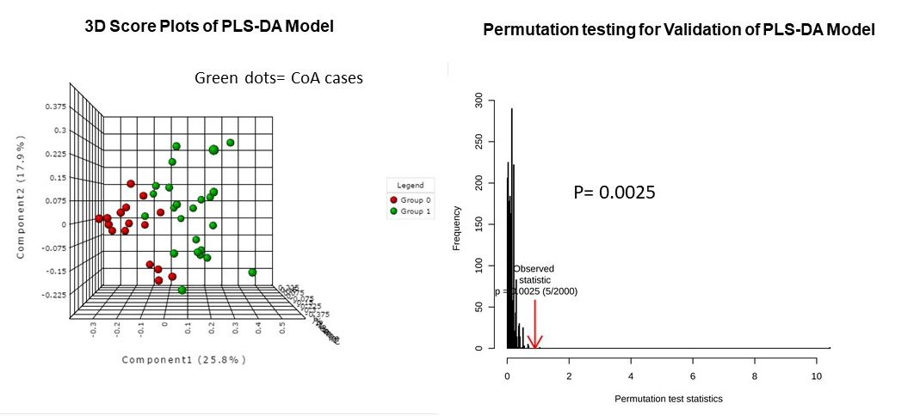
References

1. Miyasato SK, Loeffler J, Shohet R, Zhang J, Lindsey M, Le Saux CJ. Caveolin-1 modulates TGF-beta1 signaling in cardiac remodeling. Matrix Biol. 2011;30(5-6):318-29. Epub 2011/06/07.
2. Duan Y, Zhu W, Liu M, Ashraf M, Xu M. The expression of Smad signaling pathway in myocardium and potential therapeutic effects. Histol Histopathol. 2017;32(7):651-9. Epub 2016/11/16.
3. Thomson S, Petti F, Sujka-Kwok I, Mercado P, Bean J, Monaghan M, Seymour SL, Argast GM, Epstein DM, Haley JD. A systems view of epithelial-mesenchymal transition signaling states. Clin Exp Metastasis. 2011;28(2):137-55.
4. Lynch JM, Maillet M, Vanhoutte D, Schloemer A, Sargent MA, Blair NS, Lynch KA, Okada T, Aronow BJ, Osinska H, Prywes R, Lorenz JN, Mori K, Lawler J, Robbins J, Molkentin JD. A thrombospondin-dependent pathway for a protective ER stress response. Cell. 2012;149(6):1257-68.
5. Schumacher-Bass SM, Vesely ED, Zhang L, Ryland KE, McEwen DP, Chan PJ, Frasier CR, McIntyre JC, Shaw RM, Martens JR. Role for myosin-V motor proteins in the selective delivery of Kv channel isoforms to the membrane surface of cardiac myocytes. Circ Res. 2014;114(6):982-92. Epub 2014/02/11.
6. Parvatiyar MS, Pinto JR, Dweck D, Potter JD. Cardiac troponin mutations and restrictive cardiomyopathy. J Biomed Biotechnol. 2010;2010:350706.
7. Malinin NL, Pluskota E, Byzova TV. Integrin signaling in vascular function. Curr Opin Hematol. 2012;19(3):206-11.
8. Kitisin K, Saha T, Blake T, Golestaneh N, Deng M, Kim C, Tang Y, Shetty K, Mishra B, Mishra L. Tgf-Beta signaling in development. Sci STKE. 2007;2007(399):cm1.
9. Xavier-Neto J, Sousa Costa AM, Figueira AC, Caiaffa CD, Amaral FN, Peres LM, da Silva BS, Santos LN, Moise AR, Castillo HA. Signaling through retinoic acid receptors in cardiac development: Doing the right things at the right times. Biochim Biophys Acta. 2015;1849(2):94-111.
10. Oakley RH, Cidlowski JA. Glucocorticoid signaling in the heart: A cardiomyocyte perspective. J Steroid Biochem Mol Biol. 2015;153:27-34.

