Supplemental Figures
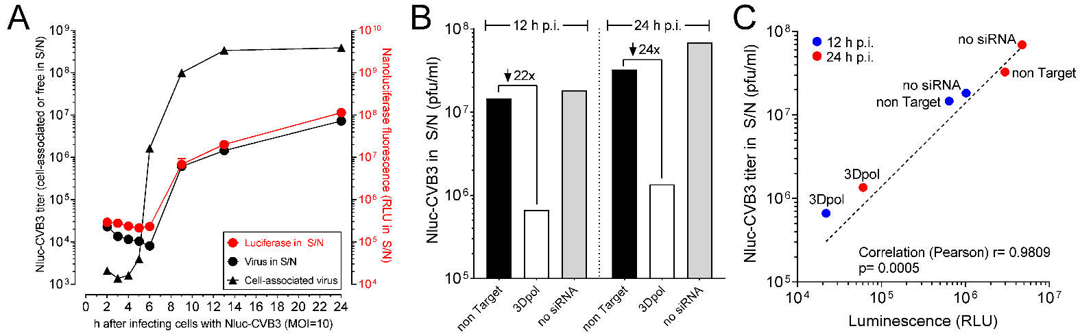

Figure S1. Development and characterization of a luciferase-based assay to identify the impact of host genes on CVB3 replication. We developed a novel assay based on a recombinant CVB3 that encodes nano-luciferase (Nluc), a protein from deep-sea shrimp that is >2 logs more sensitive than either the renilla or firefly luciferases. The nano-luciferase open reading frame (ORF) was preceded by an in-frame short ORF representing the signal sequence of IL-6; the whole ORF was cloned into the wtCVB3 backbone to generate Nluc-CVB3. We have previously shown that CVB3 profoundly inhibits cellular protein transport, so we reasoned that, despite its carrying a signal sequence, the virus-encoded Nluc might remain cytosolic until cell lysis took place, allowing the release of luciferase activity in the supernate to act as a surrogate marker for the release of infectious virus particles. (A) Cells were infected at an MOI of 10, and at the indicated times points the cells and the supernatant (S/N) were separately harvested. The cells were subjected to three cycles of freeze/thawing, then were titrated for infectious virus, while the supernatant was directly tested for the presence of (i) infectious virus and (ii) nano-luciferase. The great majority of infectious material remained associated with cells (or with cellular debris), and only relatively small amounts of virus were released into the supernatant. More importantly (for this experiment), over the 24-h time period, the levels of luciferase activity in the supernatant very closely followed the amounts of infectious virus, and were very different from the titers of cell-associated virus. For example, at 6 h p.i., there was a dramatic (>2 log) increase in intracellular virus, but the supernatant showed no detectable increase in luciferase activity; this is consistent with the powerful anti-secretory effects of several CVB3 proteins to prevent the secretion of Nluc. At the 6 h time point, too, there was no rise in titer of infectious virus in the supernatant, indicating that cell lysis was minimal. However, analyses of the supernatant at 9 h p.i. showed parallel increases in luciferase activity and the titer of free virus, suggesting that luciferase had been released not by secretion, but instead by virus-induced cell lysis. A similar correlation was observed at the last two time points (13 & 24 h p.i.). Next, we determined if the Nluc assay could be used to evaluate the ability of an siRNA to inhibit the release of infectious CVB3. To do so, we employed an siRNA that is targeted to the virus 3D region and has been shown, by others, to be highly effective in suppressing CVB replication. Three groups of cells were prepared (transfected with a non-target siRNA; transfected with the 3Dpol siRNA; or non-transfected) and were infected with Nluc-CVB3 at an MOI of 10, as described in Materials and Methods. Supernatant was harvested 12 and 24 h later, and was tested for the presence of both infectious virus and Nluc activity. As shown in (B), when compared to non-target siRNA, the 3Dpol siRNA caused a ~95% reduction in infectious virus titer, and (C) at both time points there was a strong correlation between infectious virus titer and Nluc activity. Related to Figure 1C.

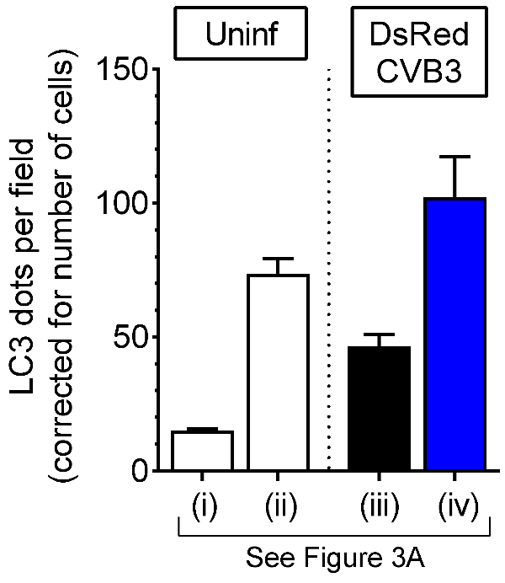

Figure S2. FR activates autophagy in the pancreas. For the four panels in Figure 3A that are labeled with Roman numerals, the Spot function of Imaris software was used to count green puncta (GFP-LC3) and blue nuclei (as an indicator of the number of cells in the field). For each panel, the number of green puncta, corrected for cell number, is displayed above. In uninfected mice [clear bars, (i) vs (ii)], FR led to an ~6-fold increase in GFP-LC3 puncta. DsRedCVB3 infection of normal-fed animals [sample (iii), black bar] up-regulates pancreatic autophagy, as we have previously published. DsRedCVB3 infection of FR mice [regimen 3, sample (iv), blue bar] leads to even greater autophagy activation. Related to Figure 3A.

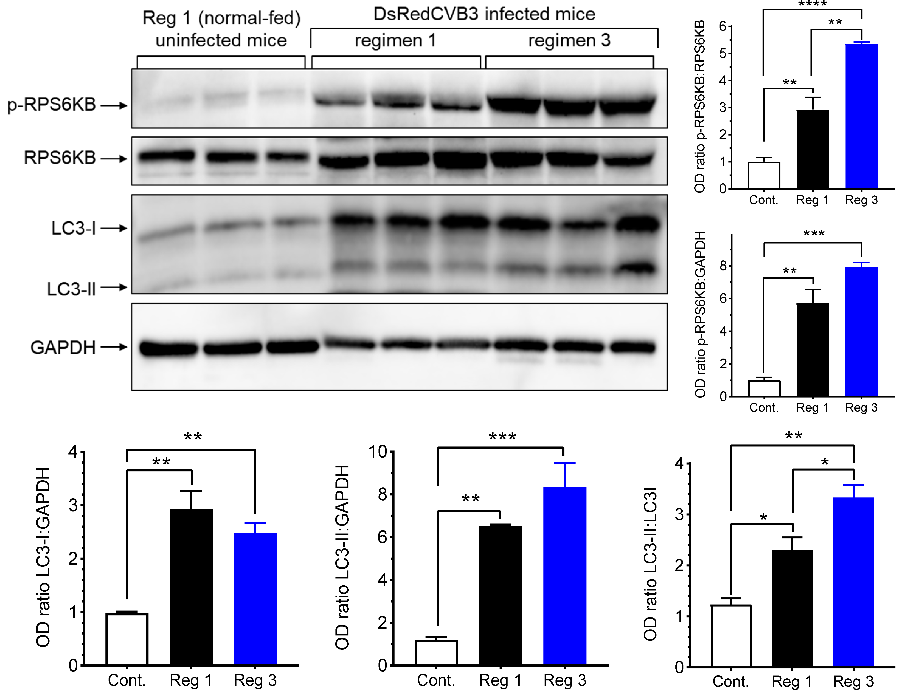

Figure S3. FR and rCVB3 infection independently and synergistically activate autophagy in vivo. Mice were fed and infected with DsRedCVB3 (10⁷ pfu i.p.), under feeding regimen 1 (normal fed) or regiment 3. At 48 h p.i., the mice were sacrificed and pancreatic lysates were prepared and analyzed by western blot. The ratios of various proteins were determined by densitometry (ImageJ) and were expressed in bar graphs normalized to uninfected normal-fed mice. Two markers of autophagy activity were evaluated: RPS6KB (top two rows, and two graphs at the right side of blots) and LC3 (third row and three graphs below the blots). RPS6KB/p70S6K is a substrate of MTOR complex 1. This protein is activated by phosphorylation (Thr389), and the abundance of p-RPS6KB reflects MTORC1 activity during short-term starvation; it is also tightly correlated with autophagy activity during long-term starvation (1-4). When compared to normal-fed uninfected mice, CVB3 infection alone led to a ~3-fold rise in the ratio of p-RPS6KB:RPS6KB, and an additional 1.8-fold rise when the infected mice had been subjected to food restriction (top-right graph). The LC3-II:LC3-I ratios in the pancreata (bottom right graph) confirm the activation of autophagy by CVB3 infection (black bar vs. open bar) and the higher activation when the infected mice were additionally under food restriction (blue bar vs. black bar).

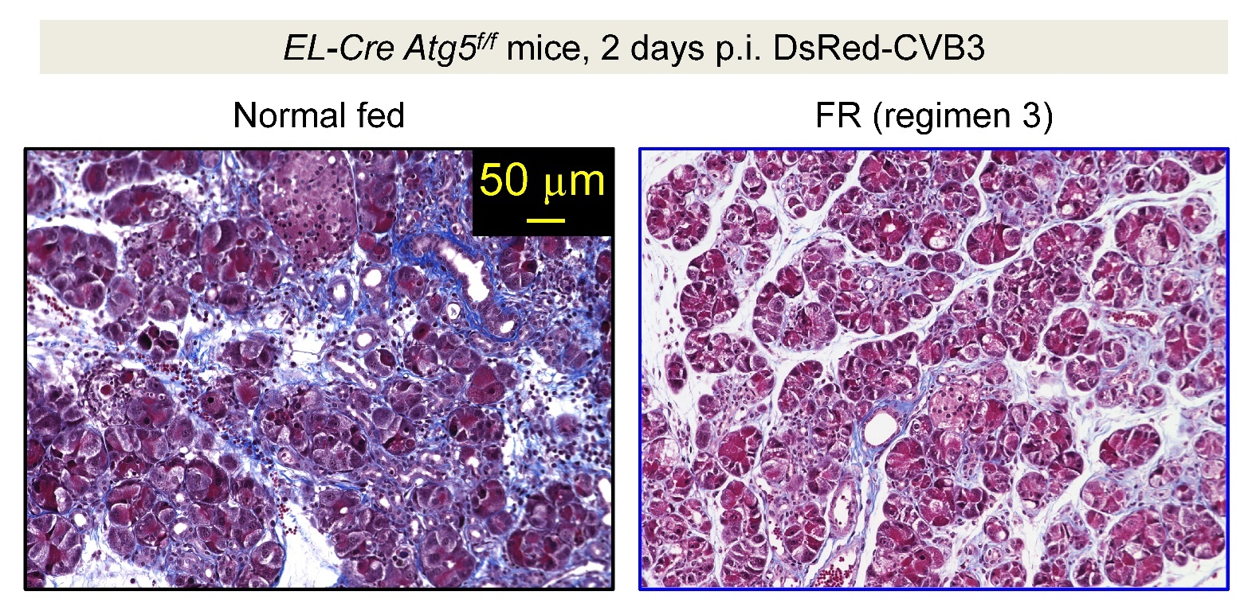

Figure S4. Disruption of acinar cell autophagy reduces the pro-viral effect of FR. Histological sections of DsRedCVB3 infected pancreata from representative normal-fed, and FR EL-Cre Atg5^{f/f} mice are shown (Masson’s trichrome stain). Related to Figure 3D.

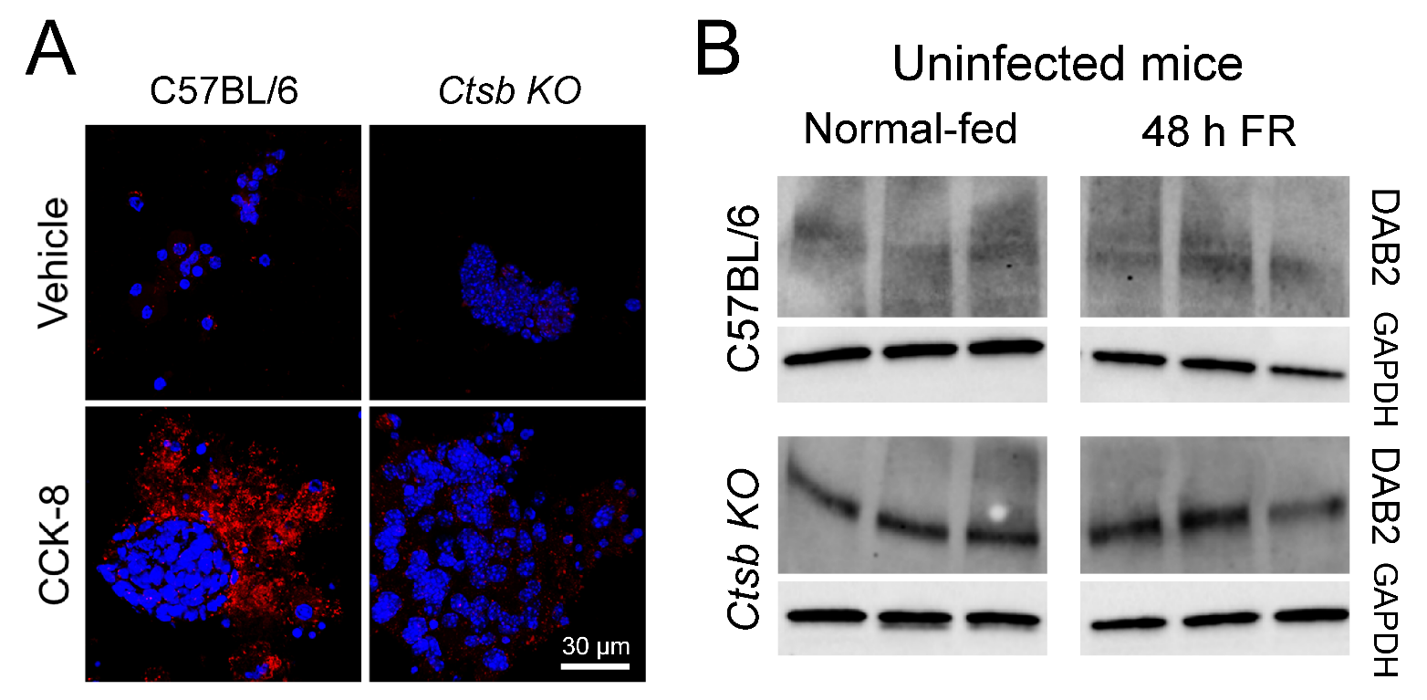

Figure S5. Evaluation of CTSB activity in isolated pancreatic acinar cells, and DAB2 expression in Ctsb KO mice. Ctsb KO mice are phenotypically indistinguishable from their wild-type counterparts as judged by numerous criteria including growth, lifespan, behavior, reproductive capacity, cytometric analysis of immune cells in the spleen, and histological examination of many organs (5). Additional steps were taken to confirm the phenotype of our Ctsb KO colony, as described below. (A). Pancreatic acinar cells were isolated from C57BL/6 mice, or from Ctsb KO mice, and aliquots were incubated for 30 min in 199 medium supplemented with amino acids, without or with cholecystokinin (CCK-8; 100 nM; Millipore Sigma). In the presence of functional CTSB, CCK-8 incubation leads to cleavage of the intracellular proenzyme trypsinogen into the active form, trypsin, whose activity is measured by incubation of the cells with the fluorogenic substrate rhodamine 110, bis-(CBZ-L-isoleucyl-L-prolyl-L-arginine amide) dihydrochloride (BZiPAR, Thermo Fisher Scientific). Acini were exposed to BZiPAR (10 mM) for 30 min in the presence of soybean trypsin inhibitor (100 µg/ml), then the reaction was stopped and fixed with 4% paraformaldehyde at 4ºC for 25 min, washed with PBS containing Hoescht dye (Molecular Probes, at 1:1000 dilution) then mounted using ProLong Gold anti-fade mounting medium (Thermo Fisher Scientific). The samples were scanned using a Zeiss LSM 710 Laser Scanning Confocal Microscope equipped with Zen 2009 software (Carl Zeiss Inc.), at 40× magnification as serial 8-bit optical sections with 0.5 µm interval step slices (1024×1024 image sizes); two-color images combined with DIC were captured. (B) CTSB contributes to the regulation of autophagy by promoting the degradation of DAB2 (disabled 2, mitogen-responsive phosphoprotein) thereby facilitating the formation of a BECN1/VPS34 complex which, in turn, activates the autophagy pathway (6). Protein lysates were harvested from pancreatic tissues of normal fed and food-restricted C57BL/6 and Ctsb KO mice and the expression of DAB2 protein, and of GAPDH, were evaluated by western blot. In WT mice, DAB2 is degraded, regardless of the feeding status. The protein is readily detectable in Ctsb KO mice. Related to Figure 3E.

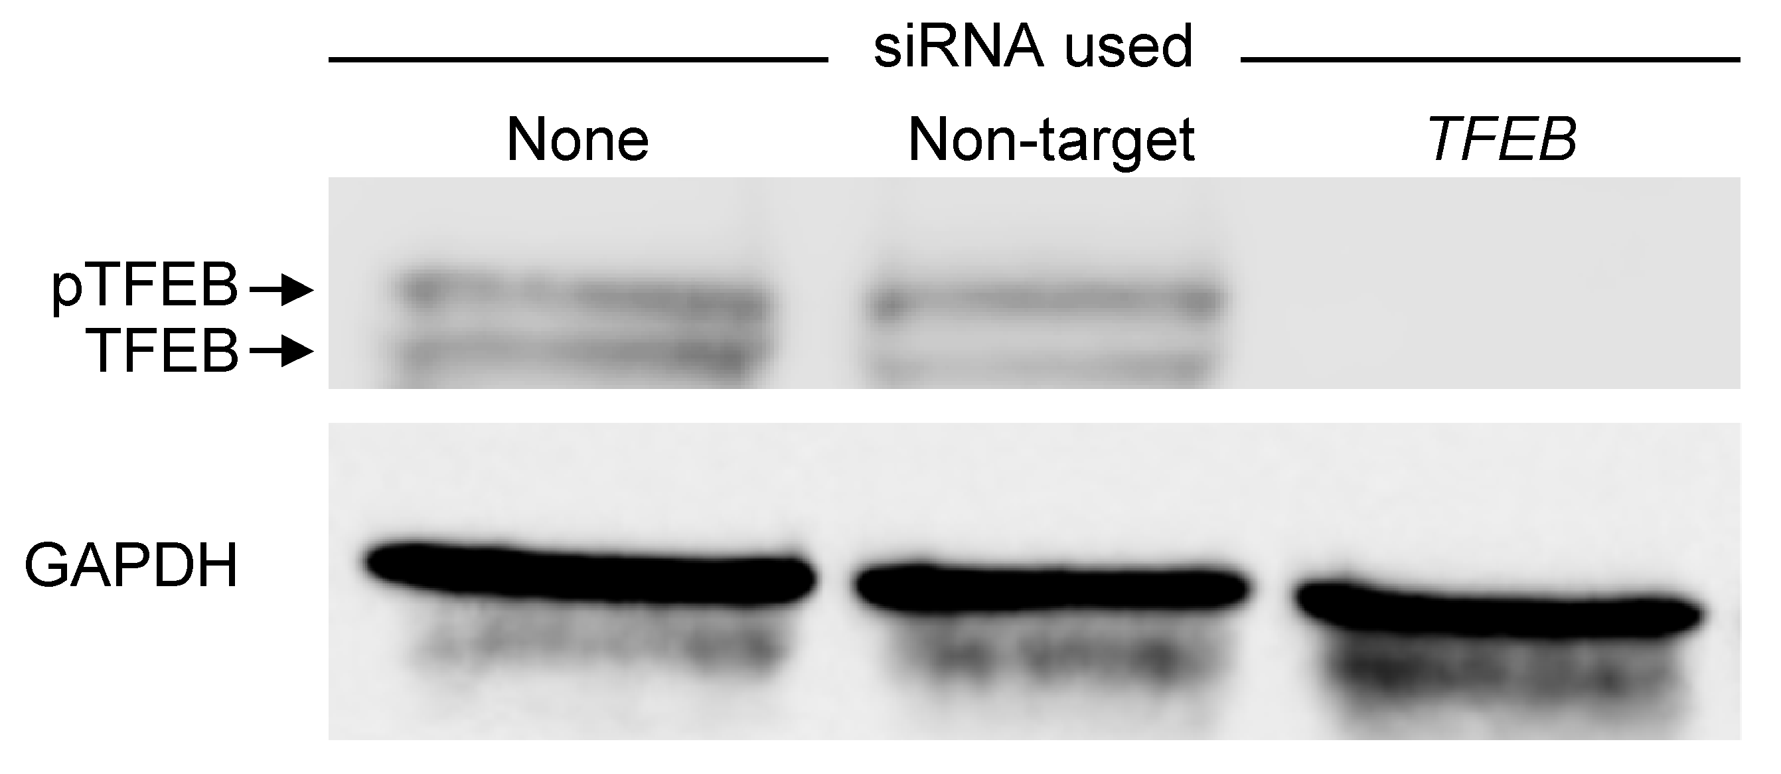

Figure S6. Demonstration of the effectiveness and specificity of the TFEB-targeted siRNA Hela cells were seeded in 6 well plates with antibiotic-free media for 18 h before siRNA transfection (ON-TARGETplus Nontarget and TFEB siRNAs). All transfections were performed for 48 with 50 nM siRNA in complete DMEM containing Dharmafect 1 (T-2001-01, Dharmacon) used according to the manufacturer's instructions. Protein lysates were harvested and consecutively probed with TFEB and GAPDH antibodies. Related to Figure 4.

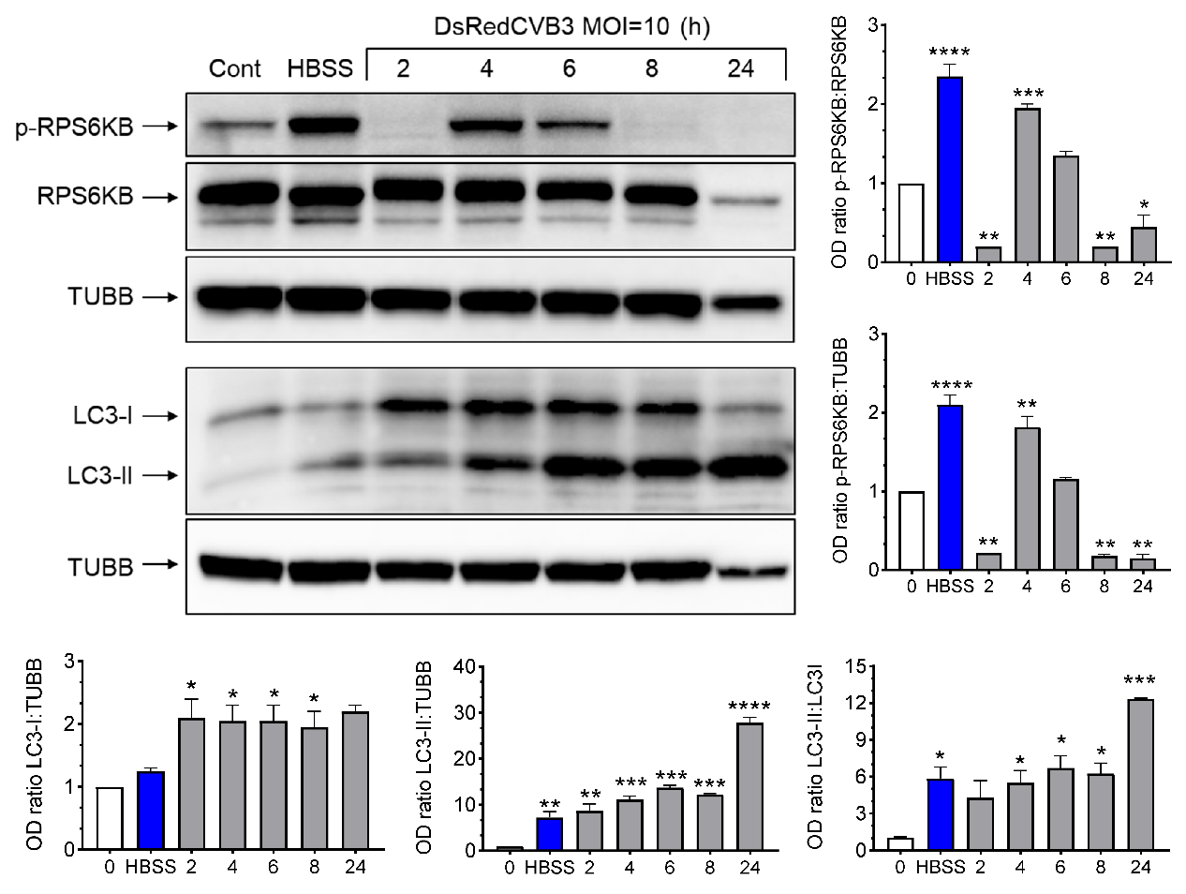

Figure S7. FR and rCVB3 infection independently and synergistically activate autophagy in HeLa cells. Uninfected Hela cells were maintained in complete medium (Lane 1) or in the low-nutrient medium HBSS (lane 2). Lanes 3-7 show HeLa cells (complete medium) at the indicated h p.i. (DsRedCVB3 at MOI=10). Band intensities were determined by densitometry (ImageJ) and are displayed graphically; the data represent 3 different experiments, and results were normalized to untreated control. HeLa cells were grown in nutrient-free medium (Hanks Buffered Salt Solution, HBSS) showed increased p-RPS6KB activity (blue bar, top-right graph). Two h p.i., cells showed a ~5-fold decrease in the ratio of p-RPS6KB:RPS6KB levels which implies that there is MTOR inhibition, which leads to the activation of autophagy. At later time points p.i. (4 to 6 h) RPS6KB activation was higher, consistent with our previous observation that CVB3 infection increases autophagy activity. The LC3-II:LC3-I ratio (bottom-right graph) confirms these conclusions. Nutrient-deprivation (HBSS; blue bar) increased the ratio, as did CVB3 infection, indicating that autophagy is activated. Related to Figure 5A.

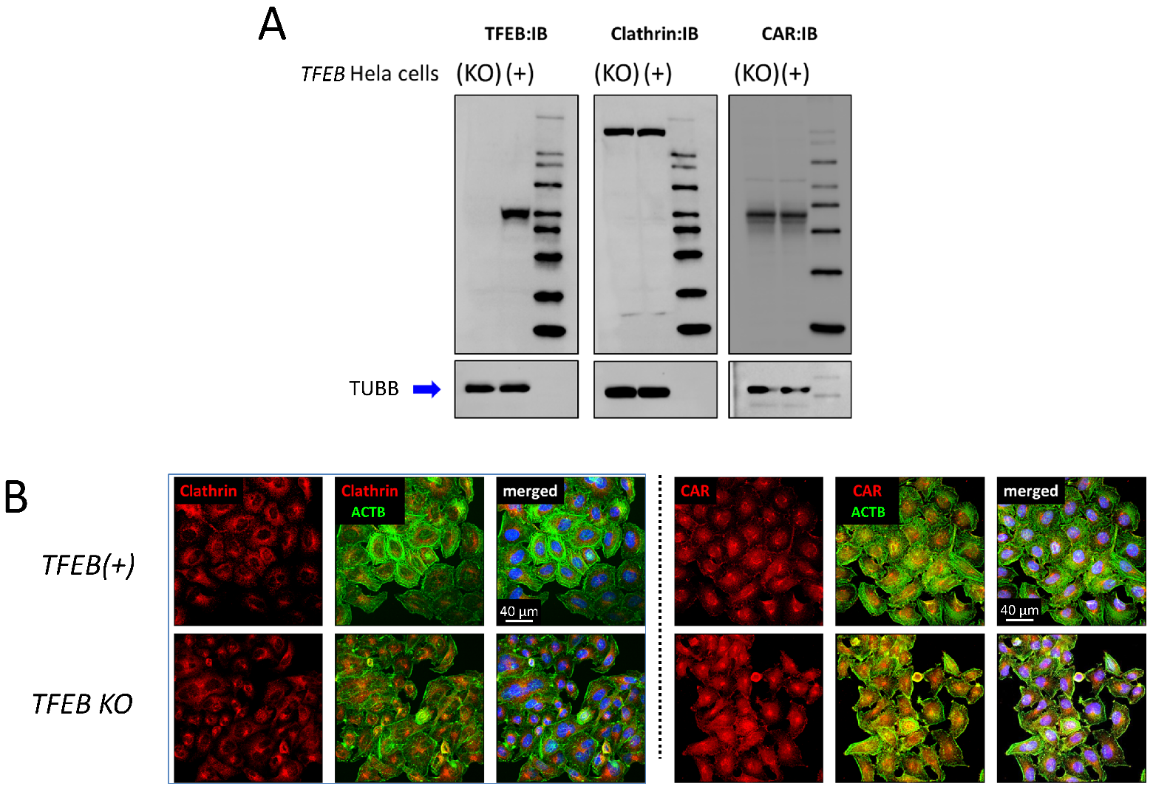

Figure S8. CXADR and clathrin expression levels are similar in TFEB(+) and TFEB KO cells. CRISPR-Cas9 was used to derive a clone of TFEB KO HeLa cells. A TFEB-expressing clone, which had passed through the same drug selection procedures, was used as a control (TFEB[+]). (A). Protein lysates from TFEB KO and TFEB(+) HeLa cells were harvested and TFEB, clathrin and CAR expression levels were evaluated by western blot. TUBB/β-tubulin loading control was also assessed by western blot. (B). Both TFEB KO and TFEB(+) cells were fixed and stained with clathrin (red) and CXADR (red) antibodies and with Alexa Fluor 488 phalloidin (green); nuclei were counterstained using Hoechst 33342 (blue). Confocal images were acquired and representative images from each cell type are presented with IMARIS software. Related to Figure 6 and Figure 7, which employ TFEB KO cells.

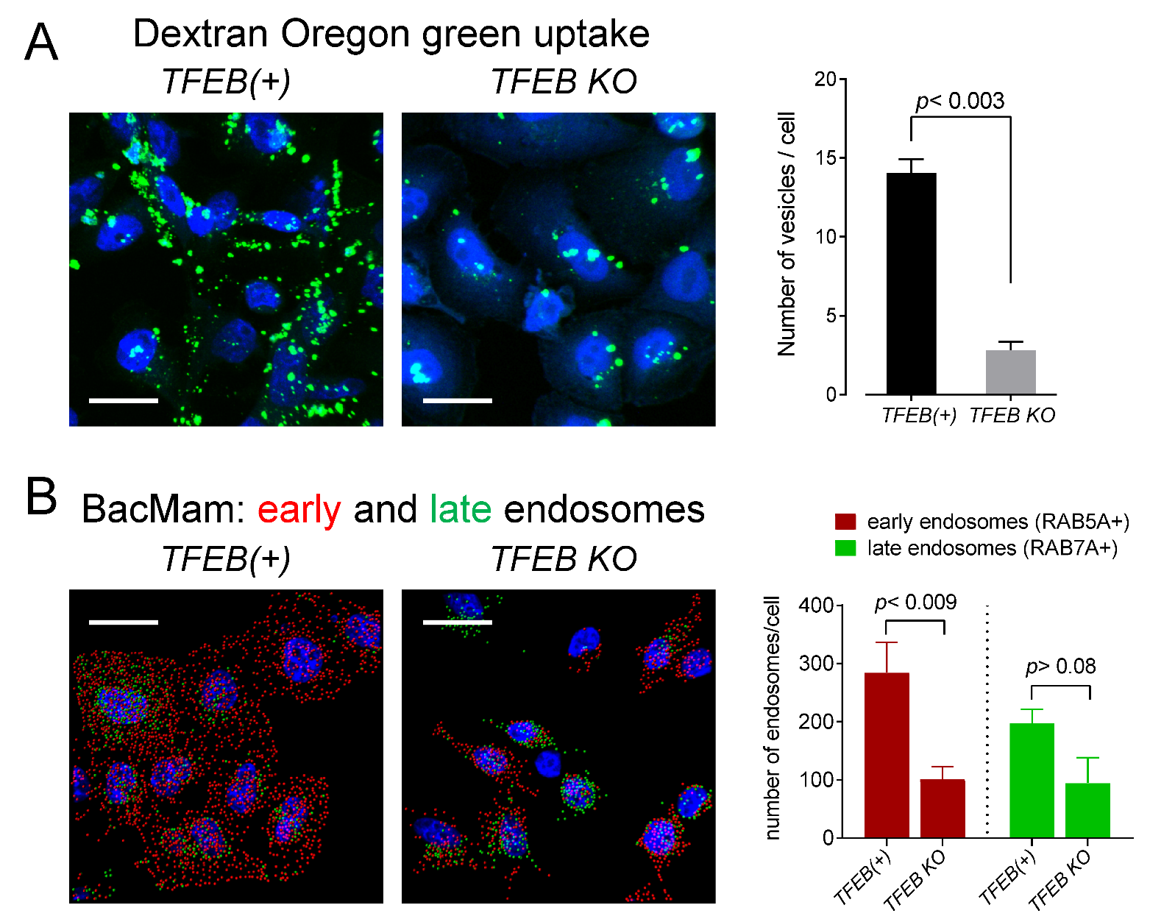

Figure S9. Deletion of TFEB reduces the uptake of extracellular materials into the early endosomal compartment. (A) TFEB(+) and TFEB KO HeLa cells were incubated with Dextran Oregon green 488 for 1 h and chased overnight. Cells were fixed and counterstained using Hoechst 33342 (blue). Confocal images were acquired and endosomes (green puncta) were quantified using the Spot function in Imaris; vesicle numbers (mean + SEM) are displayed in the graph on the right side of the panel. (B) Early and late endosomes are quantified in TFEB(+) and TFEB KO HeLa cells after being exposed overnight to CellLight® Early Endosomes-RFP and Late Endosomes-GFP. Confocal images were acquired and vesicles were quantified as described above. The numbers of early (red) and late (green) endosomes are displayed in the graph (mean + SEM) on the right side of the panel. For both panels, white scale bars: 25 µm. Related to Figure 7.

Supplemental bibliography

1. Klionsky DJ. Cell biology: regulated self-cannibalism. Nature. 2004;431(7004):31-2.
2. Klionsky DJ, Meijer AJ, and Codogno P. Autophagy and p70S6 kinase. Autophagy. 2005;1(1):59-60; discussion -1.
3. Rusten TE, Lindmo K, Juhasz G, Sass M, Seglen PO, Brech A, et al. Programmed autophagy in the Drosophila fat body is induced by ecdysone through regulation of the PI3K pathway. Dev Cell. 2004;7(2):179-92.
4. Zhang J, Gao Z, and Ye J. Phosphorylation and degradation of S6K1 (p70S6K1) in response to persistent JNK1 Activation. Biochim Biophys Acta. 2013;1832(12):1980-8.
5. Halangk W, Lerch MM, Brandt-Nedelev B, Roth W, Ruthenbuerger M, Reinheckel T, et al. Role of cathepsin B in intracellular trypsinogen activation and the onset of acute pancreatitis. J Clin Invest. 2000;106(6):773-81.
6. Jiang Y, Woosley AN, Sivalingam N, Natarajan S, and Howe PH. Cathepsin-B-mediated cleavage of Disabled-2 regulates TGF-beta-induced autophagy. Nat Cell Biol. 2016;18(8):851-63.

