In silico molecular docking and in vitro antioxidant activity studies of novel α-Aminophosphonates bearing 6-amino-1,3-dimethyl uracil
Shaik Nayab Rasoolª, Maddila Suresh^{b}, Potla Krishna Murthy^{c}, Titinchi Salam J. J^{d}, Shaik Thaslim Bashaª, Chintha Venkataramaiah^{e}, Wudayagiri Rajendra^{e}, Nagam Venkateswarlu^{f}, Tartte Vijaya^{f}, Chinnam Sampath*^{g}, and Chamarthi Naga Raju*ª
ªDepartment of Chemistry, Sri Venkateswara University, Tirupati 517502, Andhra Pradesh, India; ^{b}Department of Chemistry, GITAM Institute of Sciences, GITAM University, Vishakapatnam 530045, Andhra Pradesh, India; ^{c}Department of Chemistry, Bapatla Engineering College (Autonomous), Acharya Nagarjuna University Post Graduate Research Centre, Bapatla 522102, Andhra Pradesh, India; ^{d}Department of Chemistry, University of the Western Cape, Bellville, Cape Town, South Africa; ^{e}Department of Zoology, Sri Venkateswara University, Tirupati 517502, Andhra Pradesh, India; ^{f}Department of Botany, Sri Venkateswara University, Tirupati 517502, Andhra Pradesh, India; ^{g}Department of Chemistry, B.M.S. College of Engineering, Bull Temple Road, Bengaluru 560019, India
Correspondence
Chamarthi Naga Raju, Department of Chemistry, Sri Venkateswara University, Tirupati-517502, Andhra Pradesh, India; Email: rajuchamarthi10@gmail.com;
Chinnam Sampath, Department of Chemistry, B.M.S. College of Engineering, Bull Temple Road, Bengaluru 560019, India; Email: sampathchinnam@gmail.com

Diethyl (1,3-dimethyl-2,6-dioxo-1,2,3,6-tetrahydropyrimidin-4-ylamino)(3-nitrophenyl)methyl-phosphonate (4a)
Yellow solid, Yield (%): 85; mp: 206-208 ºC; IR (cm⁻¹, ν_{max}): 3433 (NH_{str}), 1262 (P=O), 759 (P-C_{aliphatic}); ¹H NMR (400 MHz, DMSO-d₆, ppm): δ 7.17-7.08 (m, 3H, Ar-H), 6.95 (d, 1H, J = 8.0 Hz, Ar-H), 5.68 (s, 1H, pyrimidyl-CH), 4.92 (s, 1H, NH), 4.62 (d, 1H, J = 10.2 Hz, P-CH), 3.91-3.82 (m, 4H, OCH₂CH₃), 3.36 (s, 3H, pyrimidyl-CH₃), 3.06 (s, 3H, pyrimidyl-CH₃), 0.97 (t, 3H, J = 7.0 Hz, OCH₂CH₃), 0.92 (t, 3H, J = 7.1 Hz, OCH₂CH₃); ¹³C NMR (100 MHz, DMSO-d₆, ppm): δ 160.5, 158.3, 151.1, 149.0, 138.3, 128.0, 123.6, 88.3, 56.6, 30.7, 29.1, 27.5, 13.6, 13.1; ³¹P NMR (162 MHz, CDCl₃, ppm): δ 20.4; LC-MS m/z (%): Calcd. for C₁₇H₂₃N₄O₇P: 426; Found: 427 [M+H]⁺; Anal. Calcd. for C₁₇H₂₃N₄O₇P: C, 47.89; H, 5.44; and N, 13.14; Found: C, 47.82; H, 5.79; and N, 13.05.
Diethyl (4-chloro-3-nitrophenyl)(1,3-dimethyl-2,6-dioxo-1,2,3,6-tetrahydropyrimidin-4-ylami-no)methylphosphonate (4b)
Pale yellow solid, Yield (%): 88; mp: 202-204 ºC; IR (cm⁻¹, ν_{max}): 3334 (NH_{str}), 1261 (P=O), 762 (P-C_{aliphatic}); ¹H NMR (400 MHz, DMSO-d₆, ppm): δ 7.49 (s, 1H, Ar-H), 7.24 (d, 1H, J = 4.2 Hz, Ar-H), 7.18 (d, 1H, J = 7.2 Hz, Ar-H), 5.84 (s, 1H, pyrimidyl-CH), 5.10 (s, 1H, NH), 4.62 (d, 1H, J = 8.2 Hz, P-CH), 3.91-3.82 (m, 4H, OCH₂CH₃), 3.35 (s, 3H, pyrimidyl-CH₃), 3.06 (s, 3H, pyrimidyl-CH₃), 0.96 (t, 3H, J = 14.1 Hz, OCH₂CH₃), 0.90 (t, 3H, J = 7.1 Hz, OCH₂CH₃); ¹³C NMR (100 MHz, DMSO-d₆, ppm): δ 160.3, 158.2, 156.9, 151.5, 150.0, 136.4, 131.6, 128.6, 127.9, 120.3, 88.2, 57.7, 31.0, 28.9, 27.5, 13.6, 13.1; ³¹P NMR (162 MHz, CDCl₃, ppm): δ 20.8; LC-MS m/z (%): Calcd. for C₁₇H₂₂ClN₄O₇P: 460; Found: 460 [M⁺]; Anal. Calcd. for C₁₇H₂₂ClN₄O₇P: C, 44.31; H, 4.81; and N, 12.16; Found: C, 44.26; H, 4.75; and N, 11.98.
Diethyl (1,3-dimethyl-2,6-dioxo-1,2,3,6-tetrahydropyrimidin-4-ylamino)(4-hydroxy-3-nitrophe-nyl)methylphosphonate (4c)
Pale yellow solid, Yield (%): 83, mp: 196-198 ºC; IR (cm⁻¹, ν_{max}): 3346 (NH_{str}), 1253 (P=O), 759 (P-C_{aliphatic}); ¹H NMR (400 MHz, DMSO-d₆, ppm): δ 9.81 (s, 1H, Ar-OH), 7.48 (s, 1H, Ar-H), 7.24 (d, 1H, J = 5.2 Hz, Ar-H), 7.16 (d, 1H, J = 7.2 Hz, Ar-H), 5.83 (s, 1H, pyrimidyl-CH), 5.11 (s, 1H, NH), 4.61 (d, 1H, J = 8.2 Hz, P-CH), 3.92-3.83 (m, 4H, OCH₂CH₃), 3.34 (s, 3H, pyrimidyl-CH₃), 3.07 (s, 3H, pyrimidyl-CH₃), 0.95 (t, 3H, J = 14.1 Hz, OCH₂CH₃), 0.91-0.88 (t, 3H, J = 7.2 Hz, OCH₂CH₃); ¹³C NMR (100 MHz, DMSO-d₆, ppm): δ 160.5, 159.2, 149.2, 146.1, 135.4, 130.5, 128.6, 125.5, 121.3, 16.8, 76.4, 61.2, 60.2, 51.3, 30.1, 29.6, 17.3; ³¹P NMR (162 MHz, CDCl₃, ppm): δ 22.4; LC-MS m/z (%): Calcd. for C₁₇H₂₃N₄O₈P: 442; Found: 443 [M+H]⁺; Anal. Calcd. for C₁₇H₂₃N₄O₈P: C, 46.16; H, 5.24; and N, 12.67; Found: C, 46.09; H, 5.20; and N, 12.50.
Diethyl(1,3-dimethyl-2,6-dioxo-1,2,3,6-tetrahydropyrimidin-4-ylamino)-3-(4-nitrophen-yl)allylphosphonate (4d)
Pale brown solid, Yield (%): 84; mp: 178-180 ºC; IR (cm⁻¹, ν_{max}): 3341 (NH_{str}), 1248 (P=O), 756 (P-C_{aliphatic}); ¹H NMR (400 MHz, DMSO-d₆, ppm): δ 7.87 (d, 2H, J = 8.3 Hz, Ar-H), 7.33 (d, 2H, J = 7.1 Hz, Ar-H), 6.74 (d, 1H, J = 8.3 Hz, -CH), 6.68 (d, 1H, J = 7.1 Hz, -CH), 5.91 (s, 1H, pyrimidyl-CH), 5.12 (s, 1H, NH), 4.58 (d, 1H, J = 6.2 Hz, P-CH), 3.96-3.85 (m, 4H, OCH₂CH₃), 3.34 (s, 3H, pyrimidyl-CH₃), 3.08 (s, 3H, pyrimidyl-CH₃), 1.03 (t, 3H, J = 7.3 Hz, OCH₂CH₃), 0.91 (t, 3H, J = 7.2 Hz, OCH₂CH₃); ¹³C NMR (100 MHz, DMSO-d₆, ppm): δ 160.4, 158.4, 148.2, 146.6, 134.2, 132.4, 128.9, 128.3, 124.1, 123.7, 123.2, 75.1, 62.4, 60.6, 59.2, 50.2, 31.4, 29.2, 17.2, 16.1; ³¹P NMR (162 MHz, CDCl₃, ppm): δ 23.2; LC-MS m/z (%): Calcd. for C₁₉H₂₅N₄O₇P: 452; Found: 453 [M+H]⁺; Anal. Calcd. for C₁₉H₂₅N₄O₇P: C, 50.44; H, 5.57; and N, 12.38; Found: C, 50.38; H, 5.49; and N, 12.30.
Diethyl (1,3-dimethyl-2,6-dioxo-1,2,3,6-tetrahydropyrimidin-4-ylamino)(5-nitrothiophen-2-yl)-methylphosphonate (4e)
Brown solid, Yield (%): 78; mp: 218-220 ºC; IR (cm⁻¹, ν_{max}): 3352 (NH_{str}), 1258 (P=O), 753 (P-C_{aliphatic}); ¹H NMR (400 MHz, DMSO-d₆, ppm): δ 8.34-8.31 (m, 1H, thiophenyl), 6.94-6.88 (m, 1H, thiophenyl), 5.92 (s, 1H, pyrimidyl-CH), 5.13 (s, 1H, NH), 4.57 (d, 1H, J = 6.2 Hz, P-CH), 3.94-3.88 (m, 4H, OCH₂CH₃), 3.36 (s, 3H, pyrimidyl-CH₃), 3.06 (s, 3H, pyrimidyl-CH₃), 1.04 (t, 3H, J = 7.3 Hz, OCH₂CH₃), 0.92 (t, 3H, J = 7.2 Hz, OCH₂CH₃); ¹³C NMR (100 MHz, DMSO-d₆, ppm): δ 160.5, 159.2, 149.8, 146.1, 135.4, 132.5, 128.8, 128.2, 76.3, 63.0, 48.2, 30.1, 29.2, 17.3, 16.6; ³¹P NMR (162 MHz, CDCl₃, ppm): δ 21.6; LC-MS m/z (%): Calcd. for C₁₅H₂₁N₄O₇PS: 432; Found: 433 [M+H]⁺; Anal. Calcd. for C₁₅H₂₁N₄O₇PS: C, 41.67; H, 4.90; and N, 12.96; Found: C, 41.45; H, 4.82; and N, 12.50.
Diethyl (1,3-dimethyl-2,6-dioxo-1,2,3,6-tetrahydropyrimidin-4-ylamino)(pyridin-4-yl)methyl-phosphonate (4f)
Brown solid, Yield (%): 83; mp: 164-166 ºC; IR (cm⁻¹, ν_{max}): 3352 (NH_{str}), 1254 (P=O), 762 (P-C_{aliphatic}); ¹H NMR (400 MHz, DMSO-d₆, ppm): δ 7.72 (d, 2H, J = 8.3 Hz, Ar-H), 7.47 (d, 1H, J = 8.2 Hz, Ar-H), 5.84 (s, 1H, pyrimidyl-CH), 5.10 (s, 1H, NH), 4.79 (d, 1H, J = 4.3 Hz, P-CH), 3.92-3.83 (m, 4H, OCH₂CH₃), 3.34 (s, 3H, pyrimidyl-CH₃), 3.01 (s, 3H, pyrimidyl-CH₃), 0.95 (t, 3H, J = 14.2 Hz, OCH₂CH₃), 0.91 (t, 3H, J = 14.2 Hz, OCH₂CH₃); ¹³C NMR (100 MHz, DMSO-d₆, ppm): δ 160.3, 158.7, 157.9, 151.4, 149.9, 124.4, 87.5, 57.1, 30.4, 29.0, 27.6, 13.6, 13.1; ³¹P NMR (162 MHz, CDCl₃, ppm): δ 22.1; LC-MS m/z (%): Calcd. for C₁₆H₂₃N₄O₅P: 382; Found: 383 [M+H]⁺; Anal. Calcd. for C₁₆H₂₃N₄O₅P: C, 50.26; H, 6.06; and N, 14.65; Found: C, 50.10; H, 5.99; and N, 14.30.
Diethyl (3,4-difluorophenyl)(1,3-dimethyl-2,6-dioxo-1,2,3,6-tetrahydropyrimidin-4-ylamino)-methylphosphonate (4g)
White solid, Yield (%): 81; mp: 171-173 ºC; IR (cm⁻¹, ν_{max}): 3342 (NH_{str}), 1254 (P=O), 752 (P-C_{aliphatic}); ¹H NMR (400 MHz, DMSO-d₆, ppm): δ 7.43 (d, 2H, J = 8.4 Hz, Ar-H), 7.22 (s, 1H, Ar-H), 5.95 (s, 1H, pyrimidyl-CH), 4.84 (s, 1H, NH), 4.54 (d, 1H, J = 6.4 Hz, P-CH), 3.91-3.82 (m, 4H, OCH₂CH₃), 3.36 (s, 3H, pyrimidyl-CH₃), 3.06 (s, 3H, pyrimidyl-CH₃), 1.03 (t, 3H, J = 7.1 Hz, OCH₂CH₃), 0.90 (t, 3H, J = 7.1 Hz, OCH₂CH₃); ¹³C NMR (100 MHz, DMSO-d₆, ppm): δ 160.3, 157.8, 152.1, 151.2, 149.9, 146.3, 136.9, 123.6, 120.7, 119.0, 88.7, 58.1, 31.0, 29.0, 27.5, 13.72, 13.1; ³¹P NMR (162 MHz, CDCl₃, ppm): δ 20.9; LC-MS m/z (%): Calcd. for C₁₇H₂₂F₂N₃O₅P: 417; Found: 418 [M+H]⁺; Anal. Calcd. for C₁₇H₂₂F₂N₃O₅P: C, 48.92; H, 5.31; and N, 10.07; Found: C, 48.80; H, 5.24; and N, 9.99.

Diethyl (4-chlorophenyl)(1,3-dimethyl-2,6-dioxo-1,2,3,6-tetrahydropyrimidin-4-ylamino)meth-ylphosphonate (4h)
White solid, Yield (%): 90; mp: 182-184 ºC; IR (cm⁻¹, ν_{max}): 3352 (NH_{str}), 1261 (P=O), 756 (P-C_{aliphatic}); ¹H NMR (400 MHz, DMSO-d₆, ppm): δ 7.31 (d, 2H, J = 7.2 Hz, Ar-H), 6.88 (d, 2H, J = 8.8 Hz, Ar-H), 5.92 (s, 1H, pyrimidyl-CH), 5.07 (s, 1H, NH), 4.57 (d, 1H, J = 6.8 Hz, P-CH), 3.97-3.83 (m, 4H, OCH₂CH₃), 3.36 (s, 3H, pyrimidyl-CH₃), 3.07 (s, 3H, pyrimidyl-CH₃), 1.02 (t, 3H, J = 7.0 Hz, OCH₂CH₃), 0.90 (t, 3H, J = 7.1 Hz, OCH₂CH₃); ¹³C NMR (100 MHz, DMSO-d₆, ppm): δ 160.4, 157.5, 151.1, 149.9, 143.5, 131.0, 129.6, 88.2, 58.0, 36.0, 29.0, 27.6, 13.6, 13.1; ³¹P NMR (162 MHz, CDCl₃, ppm): δ 22.2; LC-MS m/z (%): Calcd. for C₁₇H₂₃ClN₃O₅P: 415; Found: 416 [M+H]⁺; Anal. Calcd. for C₁₇H₂₃ClN₃O₅P: C, 49.10; H, 5.58; and N, 10.11; Found: C, 49.03; H, 5.55; and N, 10.06.
Diethyl (1,3-dimethyl-2,6-dioxo-1,2,3,6-tetrahydropyrimidin-4-ylamino)(4-fluorophenyl)meth-ylphosphonate (4i)
White solid, Yield (%): 92; mp: 152-154 ºC; IR (cm⁻¹, ν_{max}): 3359 (NH_{str}), 1258 (P=O), 753 (P-C_{aliphatic}); ¹H NMR (400 MHz, DMSO-d₆, ppm): δ 7.47 (d, 2H, J = 7.2 Hz, Ar-H), 7.21 (d, 2H, J = 8.7 Hz, Ar-H), 5.91 (s, 1H, pyrimidyl-CH), 4.85 (s, 1H, NH), 4.51 (d, 1H, J = 6.5 Hz, P-CH), 3.96-3.81 (m, 4H, OCH₂CH₃), 3.34 (s, 3H, pyrimidyl-CH₃), 3.07 (s, 3H, pyrimidyl-CH₃), 1.03 (t, 3H, J = 7.1 Hz, OCH₂CH₃), 0.89 (t, 3H, J = 7.0 Hz, OCH₂CH₃); ¹³C NMR (100 MHz, DMSO-d₆, ppm): δ 160.3, 158.7, 157.9, 151.4, 128.7, 128.7, 124.4, 118.7, 87.5, 57.1, 30.4, 29.0, 27.6, 13.6, 13.1; ³¹P NMR (162 MHz, CDCl₃, δ, ppm): 21.3; LC-MS m/z (%): Calcd. for C₁₇H₂₃FN₃O₅P: 399; Found: 400 [M+H]⁺; Anal. Calcd. for C₁₇H₂₃FN₃O₅P: C, 51.13; H, 5.81; and N, 10.52; Found: C, 51.10; H, 5.72; and N, 10.51.
Diethyl (1,3-dimethyl-2,6-dioxo-1,2,3,6-tetrahydropyrimidin-4-ylamino)(3-hydroxyphenyl)me-thylphosphonate (4j)
Pale yellow solid, Yield (%): 75; mp: 182-184 ºC; IR (cm⁻¹, ν_{max}): 3363 (NH_{str}), 1265 (P=O), 761 (P-C_{aliphatic}); ¹H NMR (400 MHz, DMSO-d₆, ppm): δ 9.24 (s, 1H, Ar-OH), 7.16-7.11 (m, 3H, Ar-H), 6.94 (d, 1H, J = 7.1 Hz, Ar-H), 5.66 (s, 1H, pyrimidyl-CH), 4.91 (s, 1H, NH), 4.61 (d, 1H, J = 10.3 Hz, P-CH), 3.92-3.85 (m, 4H, OCH₂CH₃), 3.35 (s, 3H, pyrimidyl-CH₃), 3.08 (s, 3H, pyrimidyl-CH₃), 0.96 (t, 3H, J = 7.2 Hz, OCH₂CH₃), 0.93 (t, 3H, J = 7.0 Hz, OCH₂CH₃); ¹³C NMR (100 MHz, DMSO-d₆, ppm): δ 162.5, 157.1, 152.2, 148.2, 138.4, 131.5, 128.8, 128.2, 120.3, 73.1, 62.4, 60.4, 53.5, 29.3, 27.2, 17.1, 16.4; ³¹P NMR (162 MHz, CDCl₃, ppm): δ 20.3; LC-MS m/z (%): Calcd. for C₁₇H₂₄N₃O₆P: 397; Found: 398 [M+H]⁺; Anal. Calcd. for C₁₇H₂₄N₃O₆P: C, 51.38; H, 6.09; and N, 10.57; Found: C, 51.28; H, 5.98; and N, 10.50.

Table S1. Optimization of the model reaction under varied catalyst conditions.
Entry | Catalyst | Solvent | Condition | Time (h) | Yield (%)
1 | -- | -- | R.T | 10.0 | --
2 | -- | -- | Heat | 10.0 | --
3 | FeCl₃ | EtOH | R.T | 4.0 | 21
4 | ZnCl₂ | EtOH | R.T | 4.5 | 18
5 | HCOOH | EtOH | R.T | 4.0 | 25
6 | AcOH | EtOH | R.T | 3.5 | 29
12 | K₂CO₃ | EtOH | R.T | 6.0 | --
13 | NaOH | EtOH | R.T | 7.0 | --
14 | Urea | EtOH | R.T | 6.0 | --
15 | Pyridine | EtOH | R.T | 6.5 | --
16 | NaHCO₃ | EtOH | R.T | 6.0 | --
17 | Eaton’s | -- | Heat | 0.50 | 95
ª All products were characterized by ¹H-NMR, ³¹P NMR, ¹³C-NMR and LC-MS spectral
analysis.
^{b} Isolated yields.
--- no reaction/no catalyst/no solvent

Table S2: Optimization of the temperature conversion of the model reaction.
Entry | Temperature (ºC) | Time (min) | Yield (%)
1 | 30 | 60 | 50
2 | 40 | 45 | 71
3 | 50 | 20 | 95
4 | 60 | 20 | 95
5 | 70 | 20 | 95
6 | 80 | 20 | 94
7 | 90 | 25 | 92
8 | 100 | 25 | 91

Table S3: DPPH radical scavenging activity of novel α-Aminophosphonates 4(a-j).
Compound | DPPH scavenging activity
 | 25 µg/mL | 50 µg/mL | 75 µg/mL | 100 µg/mL
4a | 49.20±0.28 | 56.64±0.28 | 66. 46±0.12 | 76.44±0.18
4b | 36.18±0.24 | 44.14±0.12 | 58.43±0.30 | 64.25±0.24
4c | 41.56±0.22 | 49.64±0.26 | 63.38±0.12 | 73.80±0.40
4d | 48.55±0.32 | 58.76±0.18 | 67.54±0.22 | 79.60±0.32
4e | 40.80±0.42 | 51.48±0.16 | 56.26±0.32 | 76.56±0.24
4f | 41.65±0.20 | 49.20±0.14 | 62.84±0.14 | 67.20±0.18
4g | 42.36±0.40 | 55.82±0.24 | 60.40±0.24 | 77.42±0.28
4h | 42.50±0.25 | 51.86±0.15 | 58.12±0.26 | 75.48±0.20
4i | 38.40±0.12 | 45.52±0.15 | 57.36±0.16 | 65.84±0.40
4j | 35.70± 0.18 | 40.34± 0.12 | 57.50± 0.24 | 66.15± 0.28
Stdª | 74.65 | 82.50 | 90.15 | 94.50
Blank^{b} | ---- | ---- | ---- | ----
ª Standard: Ascorbic acid; ^{b} Blank: DMSO

Table S4: H₂O₂ radical scavenging activity of novel α-Aminophosphonates 4(a-j).
Compound | H₂O₂ scavenging activity
 | 25 µg/mL | 50 µg/mL | 75 µg/mL | 100 µg/mL
4a | 51.68±0.18 | 59.63±0.32 | 66. 46±0.12 | 75.02±0.25
4b | 40.21±0.20 | 50.14±0.18 | 66.43±0.30 | 72.86±0.24
4c | 44.28±0.14 | 56.15±0.22 | 65.74±0.35 | 75.18±0.24
4d | 49.46±0.24 | 62.16±0.18 | 72.42±0.32 | 84.82±0.14
4e | 32.14±0.32 | 47.42±0.12 | 59.29±0.14 | 68.14±0.20
4f | 43.48±0.18 | 56.89±0.24 | 67.14±0.24 | 72.18±0.14
4g | 48.16±0.36 | 59.68±0.28 | 70.32±0.25 | 80.12±0.32
4h | 46.52±0.30 | 54.21±0.25 | 63.12±0.26 | 72.86±0.32
4i | 35.86±0.32 | 43.14±0.24 | 62.14±0.26 | 70.24±0.34
4j | 33.87 ± 0.18 | 48.34 ± 0.22 | 62.14 ± 0.24 | 70.62 ± 0.28
Stdª | 74.84 | 81.68 | 88.14 | 92.42
Blank^{b} | ---- | ---- | ---- | ----
ª Standard: Ascorbic acid; ^{b} Blank: DMSO

Table S5: Docking scores of novel α-Aminophosphonates 4(a-j) against Aromatase enzyme.
 | Compound | Rank | Binding energy  (K cal mol⁻ ¹) | Binding interaction | Bond Length (A^{O}) | Bond Angle (º) | Bond Type
 | 4a | 4 | - 8.1 | Arg 145 CZ… ON  Arg 115 NH…ON  Arg 115 NH... ON  Arg 115 NH...ON  Arg 435 NH…ON  Arg 435 NH…ON | 2.8  2.8  2.2  2.6  2.5  2.6 | 118.3  111.7  120.1  113.5  122.5  118.9 | H- acc  H- acc  H- acc  H- acc  H- acc  H- acc
 | 4b | 5 | - 8.0 | Arg 435 NH…ON  Arg 435 NH…ON  Arg 115 NH…ON | 2.3  2.5  1.9 | 124.9  119.6  58.7 | H- acc  H- acc  H- acc
 | 4c | 7 | - 6.7 | Gly 117 OC…HN | 2.1 | 93.3 | H- don
 | 4d | 2 | - 8.4 | Arg 115 CZ…ON  Arg 438 HN…OP  Arg 439 HN…OP | 2.8  2.2  2.5 | 118.3  115.3  123.4 | H- acc  H- acc  H- acc
 | 4e | 6 | - 7.6 | Pro 429 CA…OC  Trp 141 NE…ON  Arg 435 CZ…ON  Arg 435 CZ…ON  Arg 115 CD….ON  Arg 115 CD…ON | 3.6  2.1  2.5  2.1  2.3  2.0 | 120.3  124.8  122.5  115.6  113.5  120.1 | H- acc  H- acc  H- acc  H- acc  H- acc  H- acc
 | 4f | 6 | - 7.6 | Ala 438 HN…OP  Gly 439 CA…OP | 2.1  2.1 | 121.7  123.4 | H- acc  H- acc
 | 4g | 1 | - 8.6 | Ala 438 CA… OP  Gly 439 HN…OP | 2.1  2.3 | 114.3  121.7 | H- acc  H- acc
 | 4h | 3 | - 8.1 | Ala 438 CA…OC  Ala 438 CA…OP  Gly 439 HN…OP | 2.2  2.6  2.5 | 101.7  115.5  114.3 | H- acc  H- acc  H- acc
 | 4i | 8 | - 6.5 | Glu 357 OE…OC | 3.4 | 116.1 | H- acc
 | 4j | 8 | - 6.5 | Try 361 CZ…HN  Val 422 CA…OC  Val 422 OC…HO  Try 424 HN…HO | 2.2  2.2  2.7  2.2 | 119.4  115.0  120.2  115.4 | H- don  H- acc  H- don  H- don
 | Exe.  (DB00990) | R | - 8.0 | Arg 115 CZ… OC | 2.2 | 120.1 | H- acc

Table S6: Synthesis of novel α-Aminophosphonates 4(a-j)
Compound | Product | Yields (%)
4a |  | 91
4b |  | 88
4c |  | 83
4d |  | 91
4e |  | 78
4f |  | 92
4g |  | 81
4h |  | 93
4i |  | 95
4j |  | 90

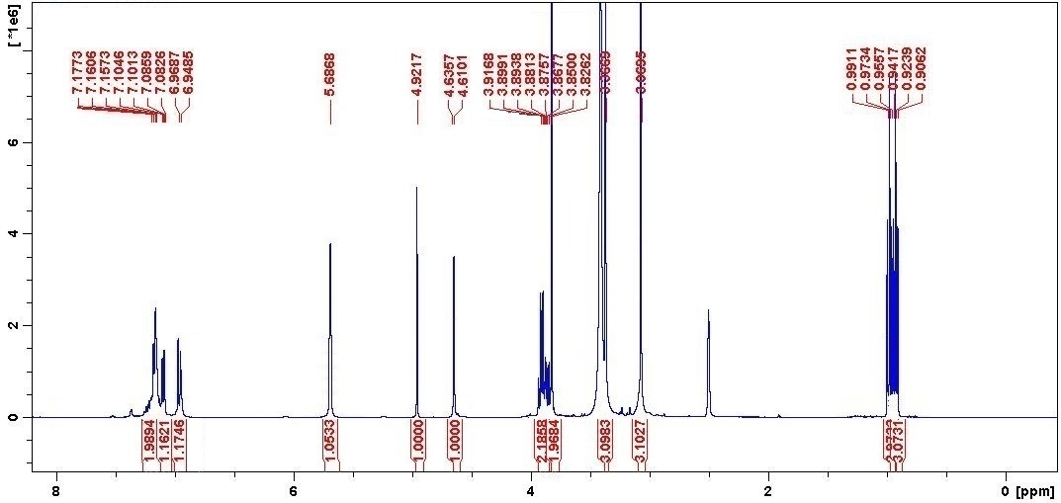
¹H NMR of compound 4a

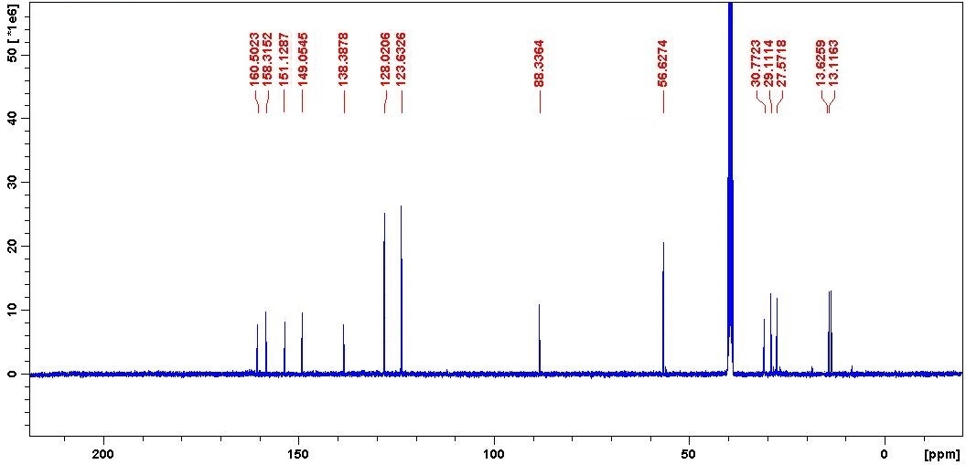 ¹³C NMR of compound 4a

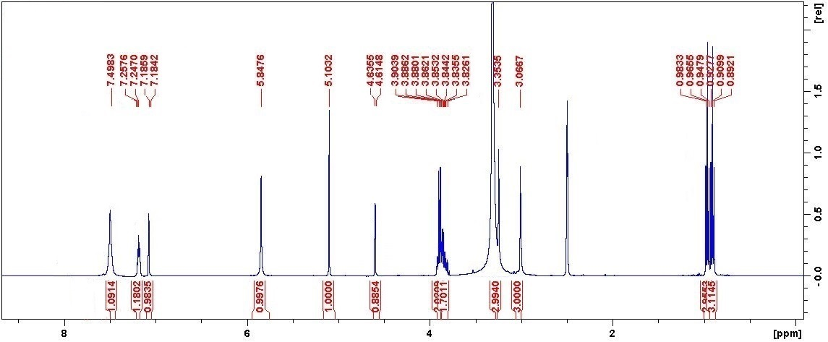 ¹H NMR of compound 4b

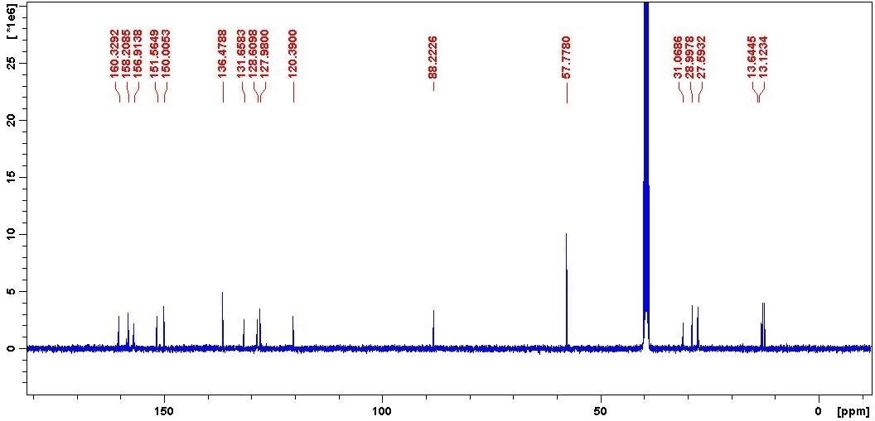¹³C NMR of compound 4b

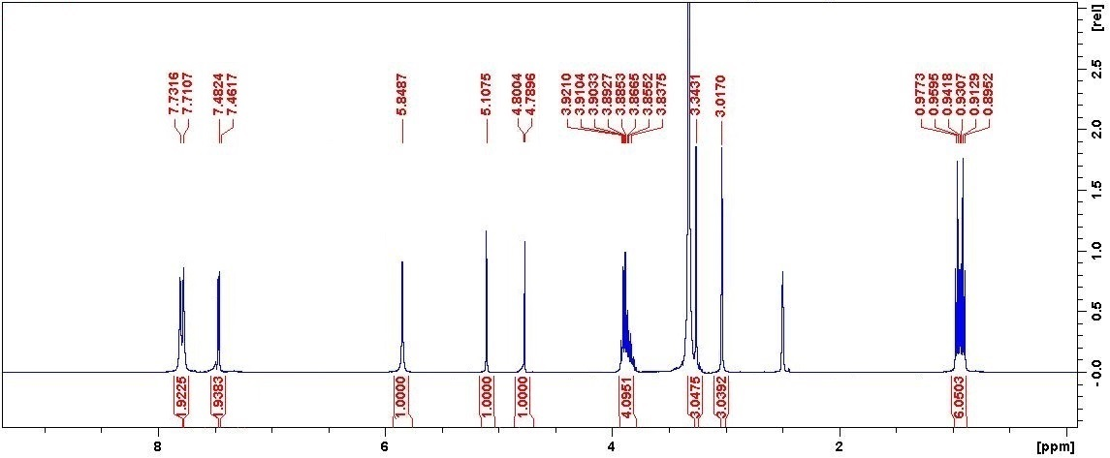
¹H NMR of compound 4f

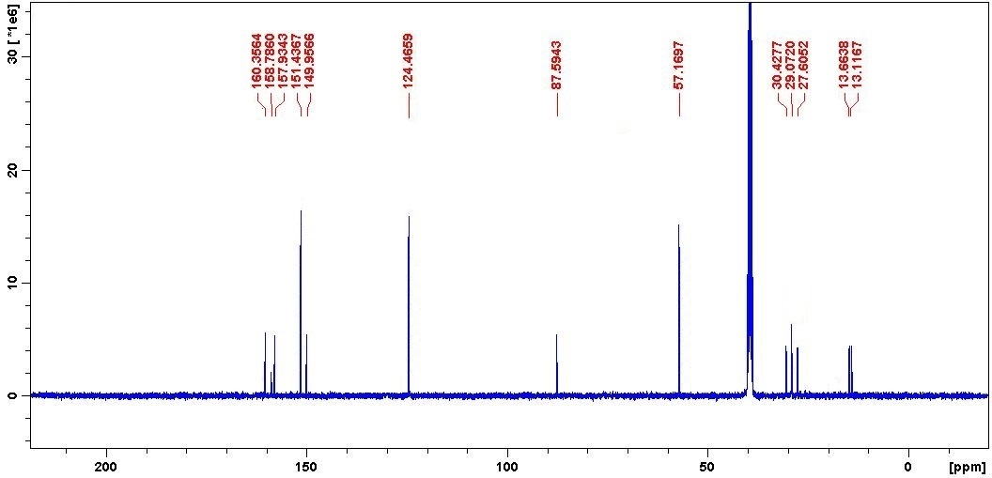
¹³C NMR of compound 4f

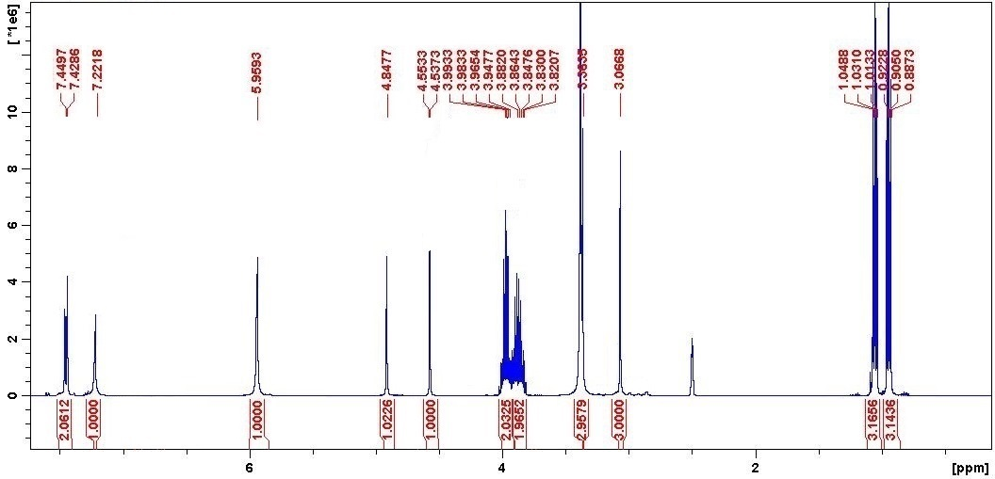 ¹H NMR of compound 4g

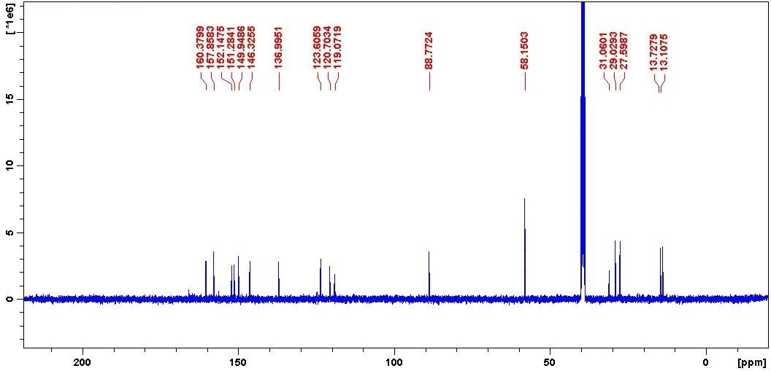
¹³C NMR of compound 4g

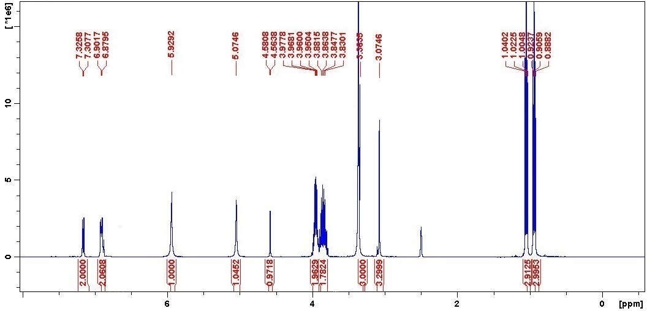
¹H NMR of compound 4h

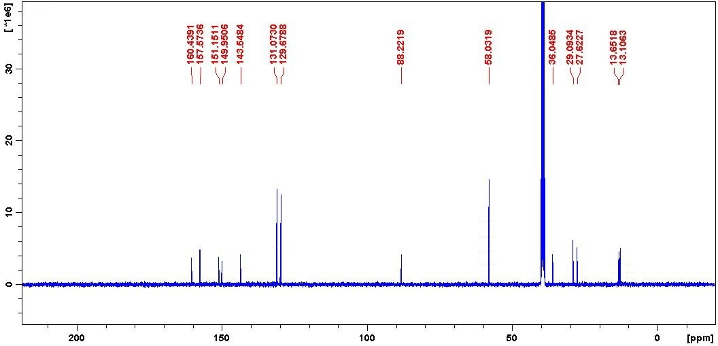
¹³C NMR of compound 4h

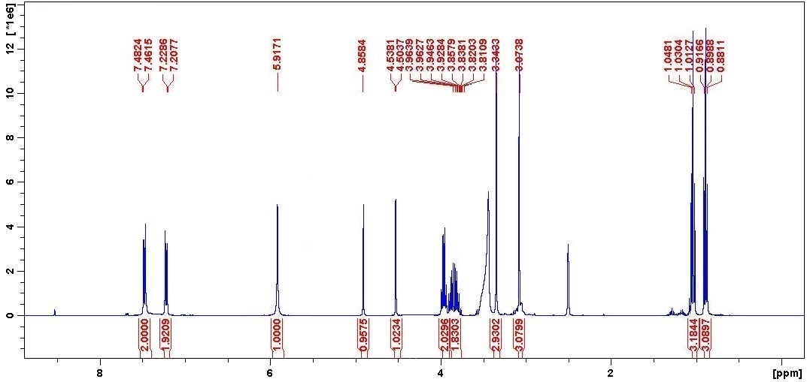
¹H NMR of compound 4i

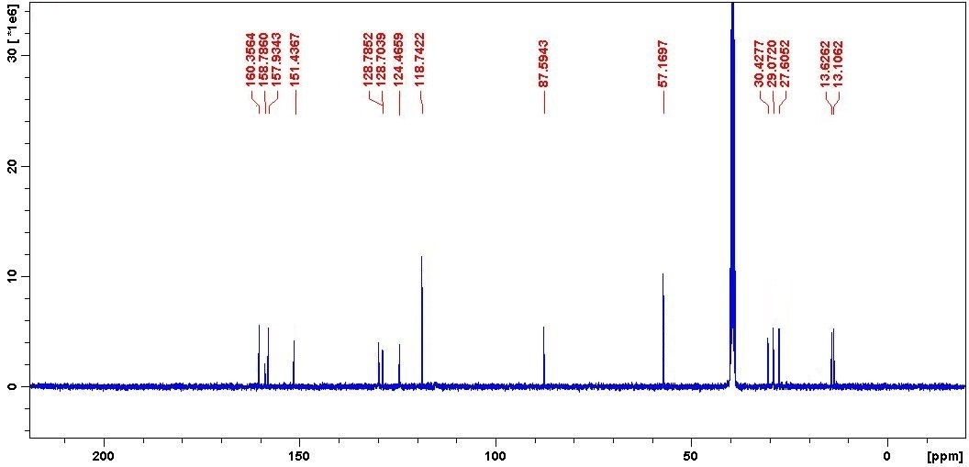

¹³C NMR of compound 4i

