Supplementary material

Geochemical evolution of groundwater in hard rock aquifers of South India using statistical and modelling techniques
Annadasankar Roy et al.
Isotope Hydrology Section, Isotope and Radiation Application Division, Bhabha Atomic Research Centre, Trombay, Mumbai, India

)

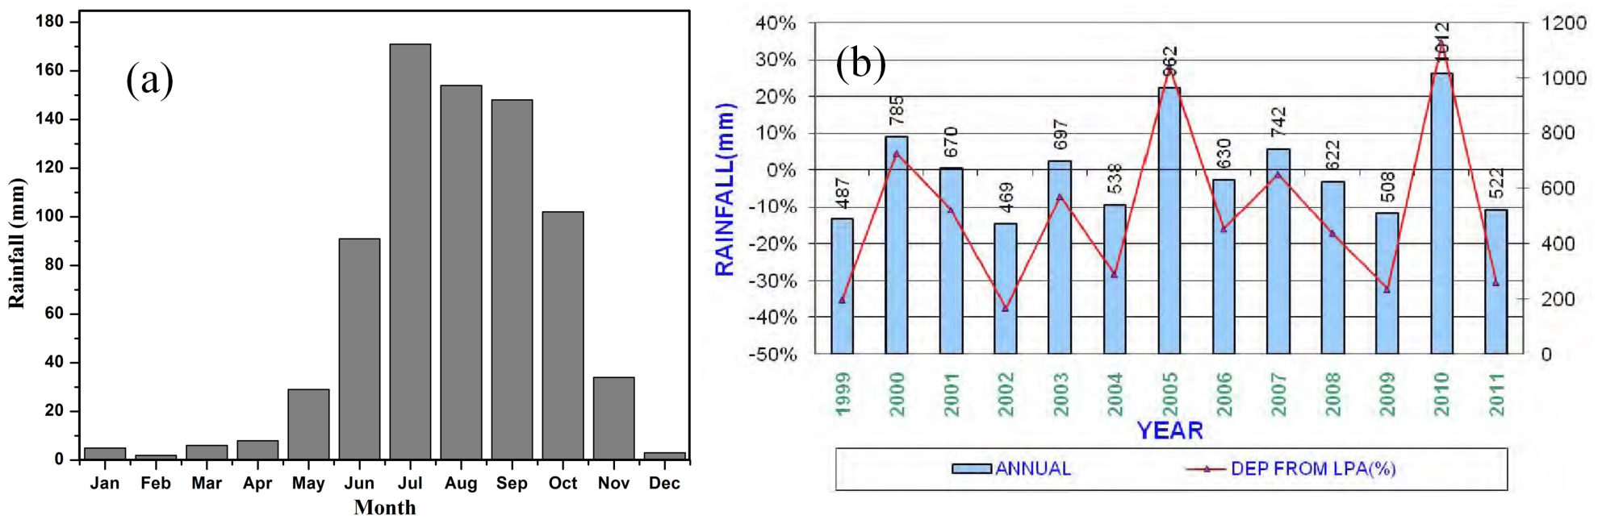
Figure S1. (a) Monthly distribution plot of rainfall; (b) annual average rainfall data for 1999–2011(after CGWB 2013).

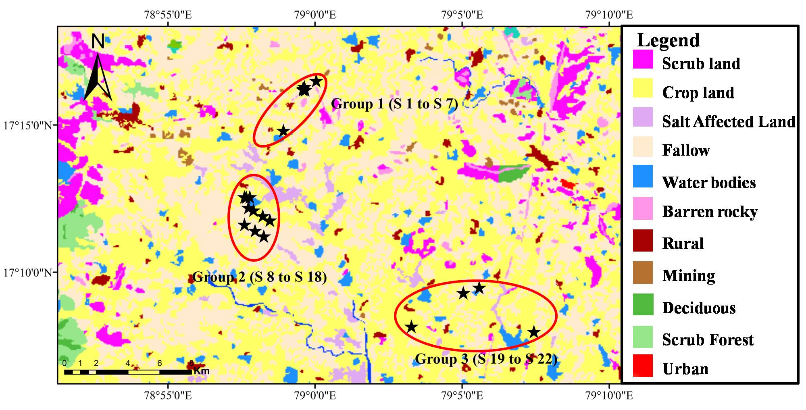
Figure S2. Land use land cover map of the study area (modified after http://bhuvan.nrsc.gov.in).

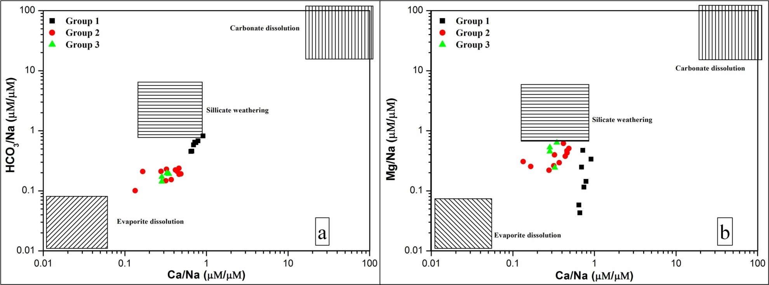
Figure S3. Bivariate plots of Na normalized: (a) HCO₃ (μM/μM) and (b) Mg (μM/μM) vs Ca (μM/μM).

