APPENDIX

Table A1.) Mean (Standard Deviation) and Coefficient of Variation (COV) from five repeated whiplash-like perturbation at a Δv = 4, 8 and 12 km/h with a Δt = 141 ms on the 2004 GM Pontiac Grand AM GMHR seat.
Parameter | Mean (SD) | COV (%) | Mean (SD) | COV (%) | Mean (SD) | COV (%)
Car Seat | GM Pontiac Grand AM (GMHR)
Δv (km/h) | 4 km/h, Δt = 141 ms |  | 8 km/h, Δt = 141 ms |  | 12 km/h, Δt = 141 ms
Δt_{head contact} (ms) | 159.6 (1.7) | 1.1 | 122.8 (2.7) | 1.3 | 108.9 (1.5) | 1.4*
a_{X-sled} (m/s²) | 11.0 (0.7) | 6.2* | 20.5 (0.2) | 0.8 | 28.6 (0.1) | 0.4
a_{X-head} (m/s²) | 37.7 (0.4) | 0.9 | 86.0 (1.6) | 1.9* | 130.4 (1.4) | 1.1
a_{X-T1} (m/s²) | 22.0 (1.2) | 5.3* | 42.1 (0.7) | 1.6 | 51.3 (0.5) | 1.0
F_{X} (N) | 113.3 (4.6) | 4.0 | 222.9 (18.1) | 8.1* | 220.9 (17.5) | 7.9
F_{Z} (N) | 85.4 (3.8) | 4.5 | 562.5 (35.2) | 6.3* | 684.7 (39.5) | 5.8
M_{Y} (Nm) | 1.6 (0.2) | 11.2* | 13.6 (0.6) | 4.2 | 14.0 (0.6) | 4.2
ω_{Y-head} (deg/s) | 238.6 (21.8) | 9.2* | 315.9 (11.6) | 3.7 | 433.1 (12.7) | 2.9
ω_{Y-T1} (deg/s) | 160.1 (13.4) | 8.4* | 305.1 (16.6) | 5.4 | 443.0 (20.6) | 4.7
θ_{head} (deg) | 14.4 (0.3) | 2.4 | 15.2 (0.9) | 5.7* | 17.4 (0.5) | 2.8
R_{X} (mm) | -48.3 (0.8) | 1.7 | -51.0 (2.8) | 5.5* | -54.9 (1.7) | 3.0
NIC (m²/s²) | 3.5 (0.2) | 6.9* | 8.1 (0.4) | 4.3 | 11.0 (0.3) | 3.1
N_{ij} | 0.05 (0.00) | 4.3 | 0.13 (0.01) | 5.3 | 0.14 (0.01) | 5.4*
N_{km} | 0.25 (0.01) | 2.5 | 0.42 (0.03) | 6.7* | 0.42 (0.03) | 6.4
Notes: The underlined COV values indicate a COV rating of acceptable (5% ≤ COV < 10%), the bolded COV values indicate a COV rating of poor (COV > 10%), and all other values are rated good (COV < 5%). * indicates the maximum COV value for each experimental ATD parameter used to determine the 99th percentile corridors.

Table A2.) Mean (Standard deviation) and Coefficient of Variation (COV) from five repeated whiplash-like perturbation at a Δv = 8 km/h with a Δt = 141 ms for the 2005 Volvo S40 WHIPS, 2004 Volvo S60 WHIPS seats, and 2005 Saab 9.3 SAHR.
Parameter | Mean (SD) | COV (%) | Mean (SD) | COV (%) | Mean (SD) | COV (%)
Car Seat | Volvo S40 WHIPS |  | Volvo S60 WHIPS |  | Saab 9.3 SAHR
Δv (km/h) | 8 km/h, Δt = 141 ms |  | 8 km/h, Δt = 141 ms |  | 8 km/h, Δt = 141 ms
Δt_{head contact} (ms) | 96.7 (2.2) | 2.3 | 104.5 (3.8) | 3.6 | 95.1 (1.1) | 1.2
a_{X-sled} (m/s²) | 20.4 (0.2) | 1.0 | 20.3 (0.1) | 0.3 | 19.9 (0.1) | 0.6
a_{X-head} (m/s²) | 87.2 (3.4) | 3.9 | 87.9 (6.1) | 7.0 | 68.4 (1.6) | 2.4
a_{X-T1} (m/s²) | 44.6 (1.1) | 2.5 | 46.5 (0.7) | 1.5 | 42.5 (0.7) | 5.3
F_{X} (N) | 38.1 (6.1) | 15.9 | 2.2 (1.0) | 44.1 | 16.5 (1.8) | 11.1
F_{Z} (N) | 170.6 (19.9) | 11.7 | 241.5 (37.6) | 15.6 | 155.1 (13.6) | 8.8
M_{Y} (Nm) | 4.5 (0.4) | 9.8 | 5.0 (0.4) | 7.5 | 5.8 (0.0) | 0.8
ω_{Y-head} (deg/s) | 220.9 (22.9) | 10.4 | 266.3 (21.5) | 8.1 | 251.1 (9.3) | 3.7
ω_{Y-T1} (deg/s) | 262.8 (15.8) | 6.0 | 292.9 (26.0) | 8.9 | 264.3 (23.4) | 8.8
θ_{head} (deg) | 10.6 (0.6) | 5.3 | 12.4 (0.6) | 5.2 | 11.1 (0.2) | 2.1
R_{X} (mm) | -28.1 (2.2) | 7.9 | -20.9 (2.3) | 10.9 | -25.7 (1.9) | 7.6
NIC (m²/s²) | 5.7 (0.4) | 6.1 | 6.2 (0.4) | 5.6 | 5.4 (0.2) | 4.1
N_{ij} | 0.09 (0.01) | 8.5 | 0.05 (0.00) | 8.2 | 0.15 (0.01) | 9.3
N_{km} | 0.23 (0.02) | 10.0 | 0.16 (0.01) | 5.9 | 0.48 (0.03) | 6.7
Notes: The underlined COV values indicate a COV rating of acceptable (5% ≤ COV < 10%), the bolded COV values indicate a COV rating of poor (COV > 10%), and all other values are rated good (COV < 5%).

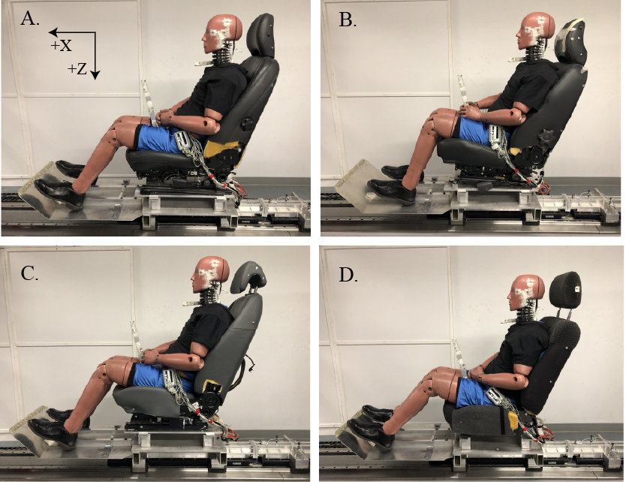
Figure A1. Photographs of the experimental set-up with the BioRID II ATD on the four test seats in the global reference frame (X, Z). A.) 2005 Volvo S40 WHIPS, B.) 2004 Volvo S60 WHIPS, C.) 2005 Saab 9.3 SAHR and D.) 2004 Pontiac Grand Am GMHR.

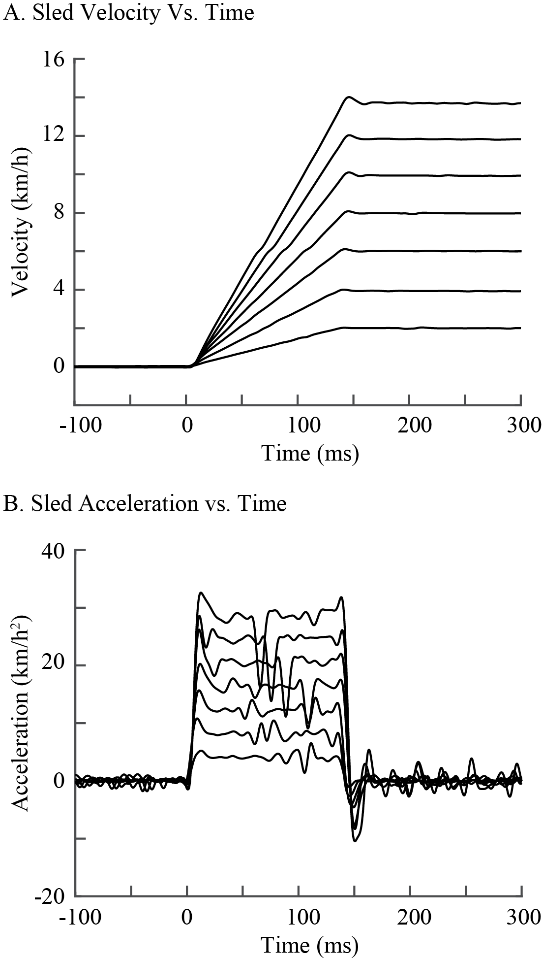
Figure A2. Exemplar sled a) velocity and b) acceleration pulses for increasing collision speeds (Δv = 2, 4, 6, 8, 10, 12 and 14 km/h with a pulse duration (Δt) of 141 ms). Collision onset occurred at time = 0 ms.

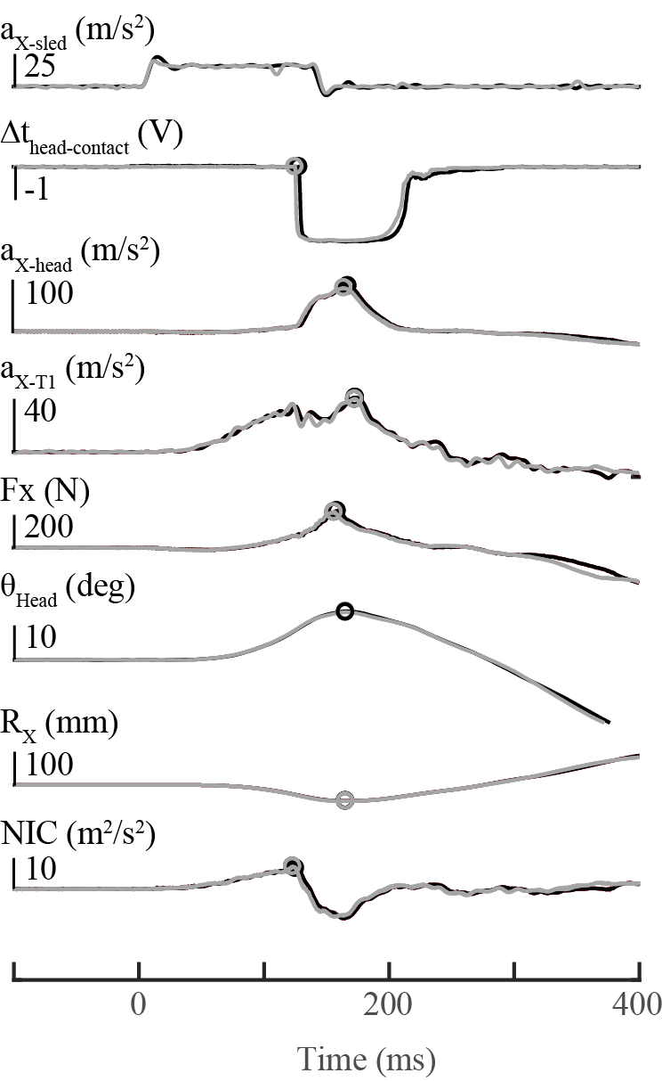
Figure A3. ATD occupant responses comparing an 8 km/h collision severity from a stationary position (grey line) and from a 6 km/h constant rearward speed (black line) on the Pontiac Grand Am GMHR seat. Hollow circles represent peak responses for a given variable.
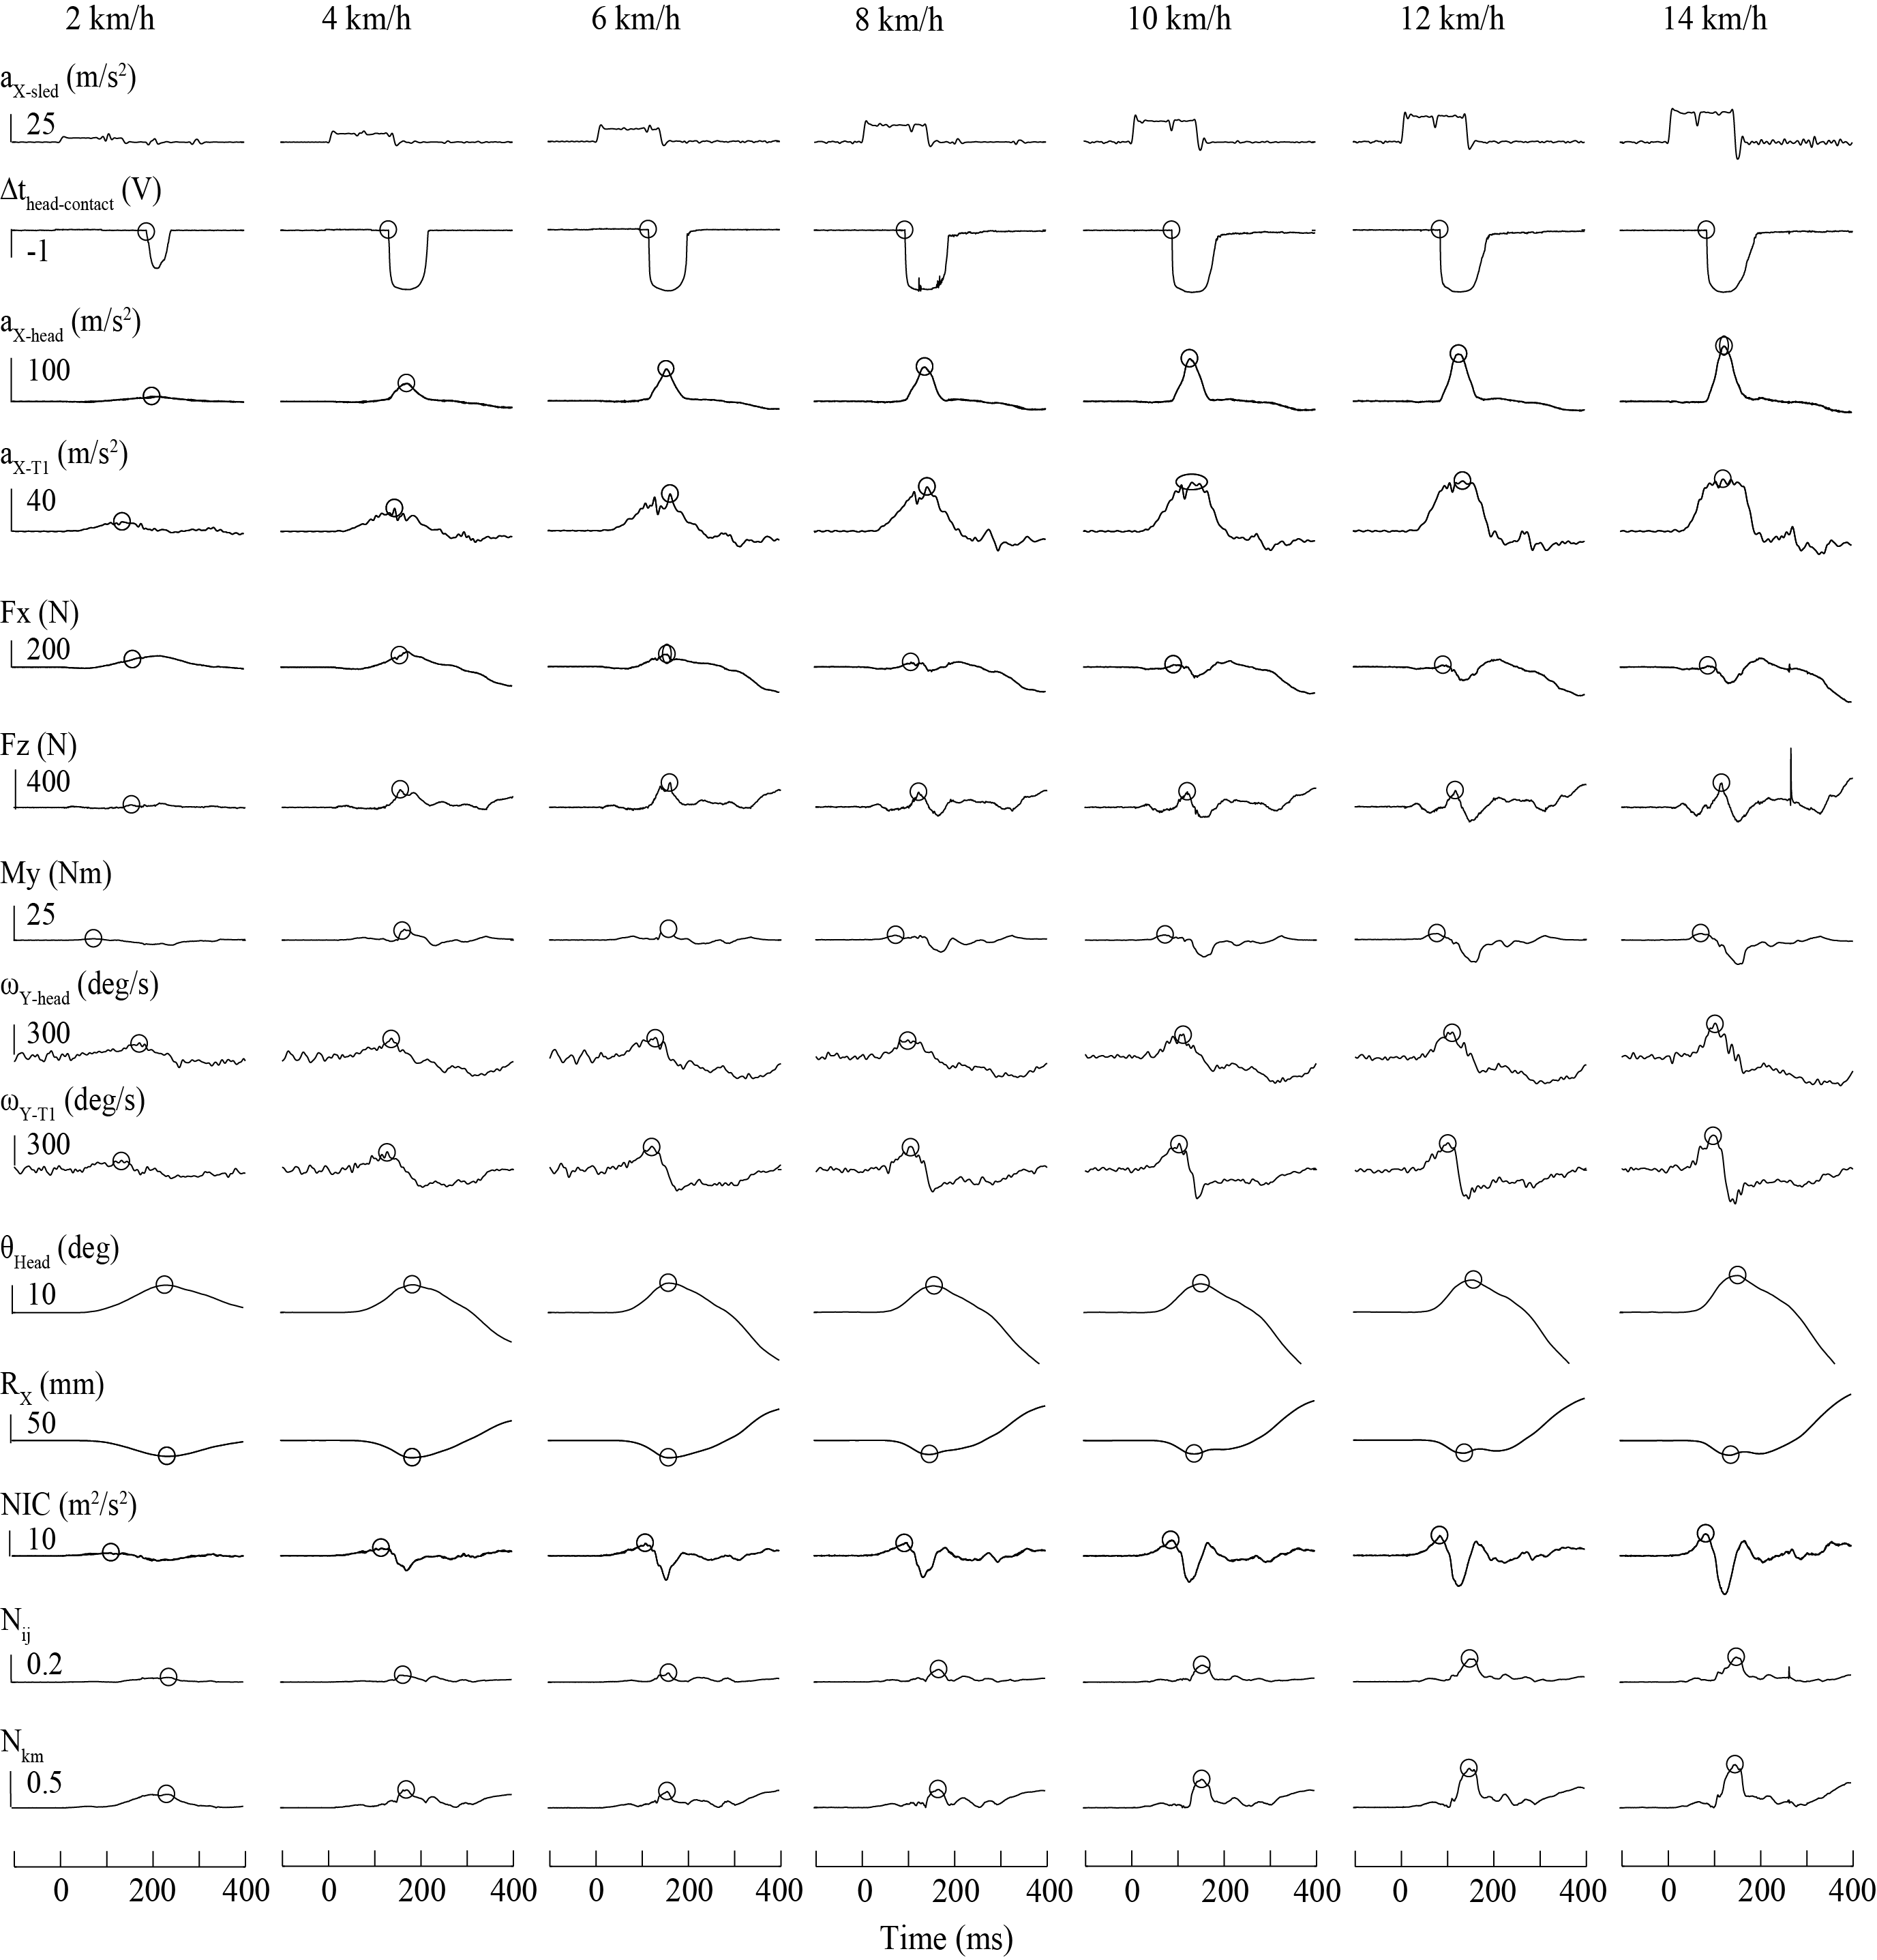

Figure A4.) Experimental data for the BioRID II ATD seated on a 2005 Volvo S40 WHIPS seat. Each column represents occupant responses while exposed to various collision severities (Δv = 2, 4, 6, 8, 10, 12 and 14 km/h with a collision pulse duration (Δt) of 141 ms). Hollow circles represent the onset of head-to-head-restraint contact and peak responses of each ATD response parameter for each trial and condition.

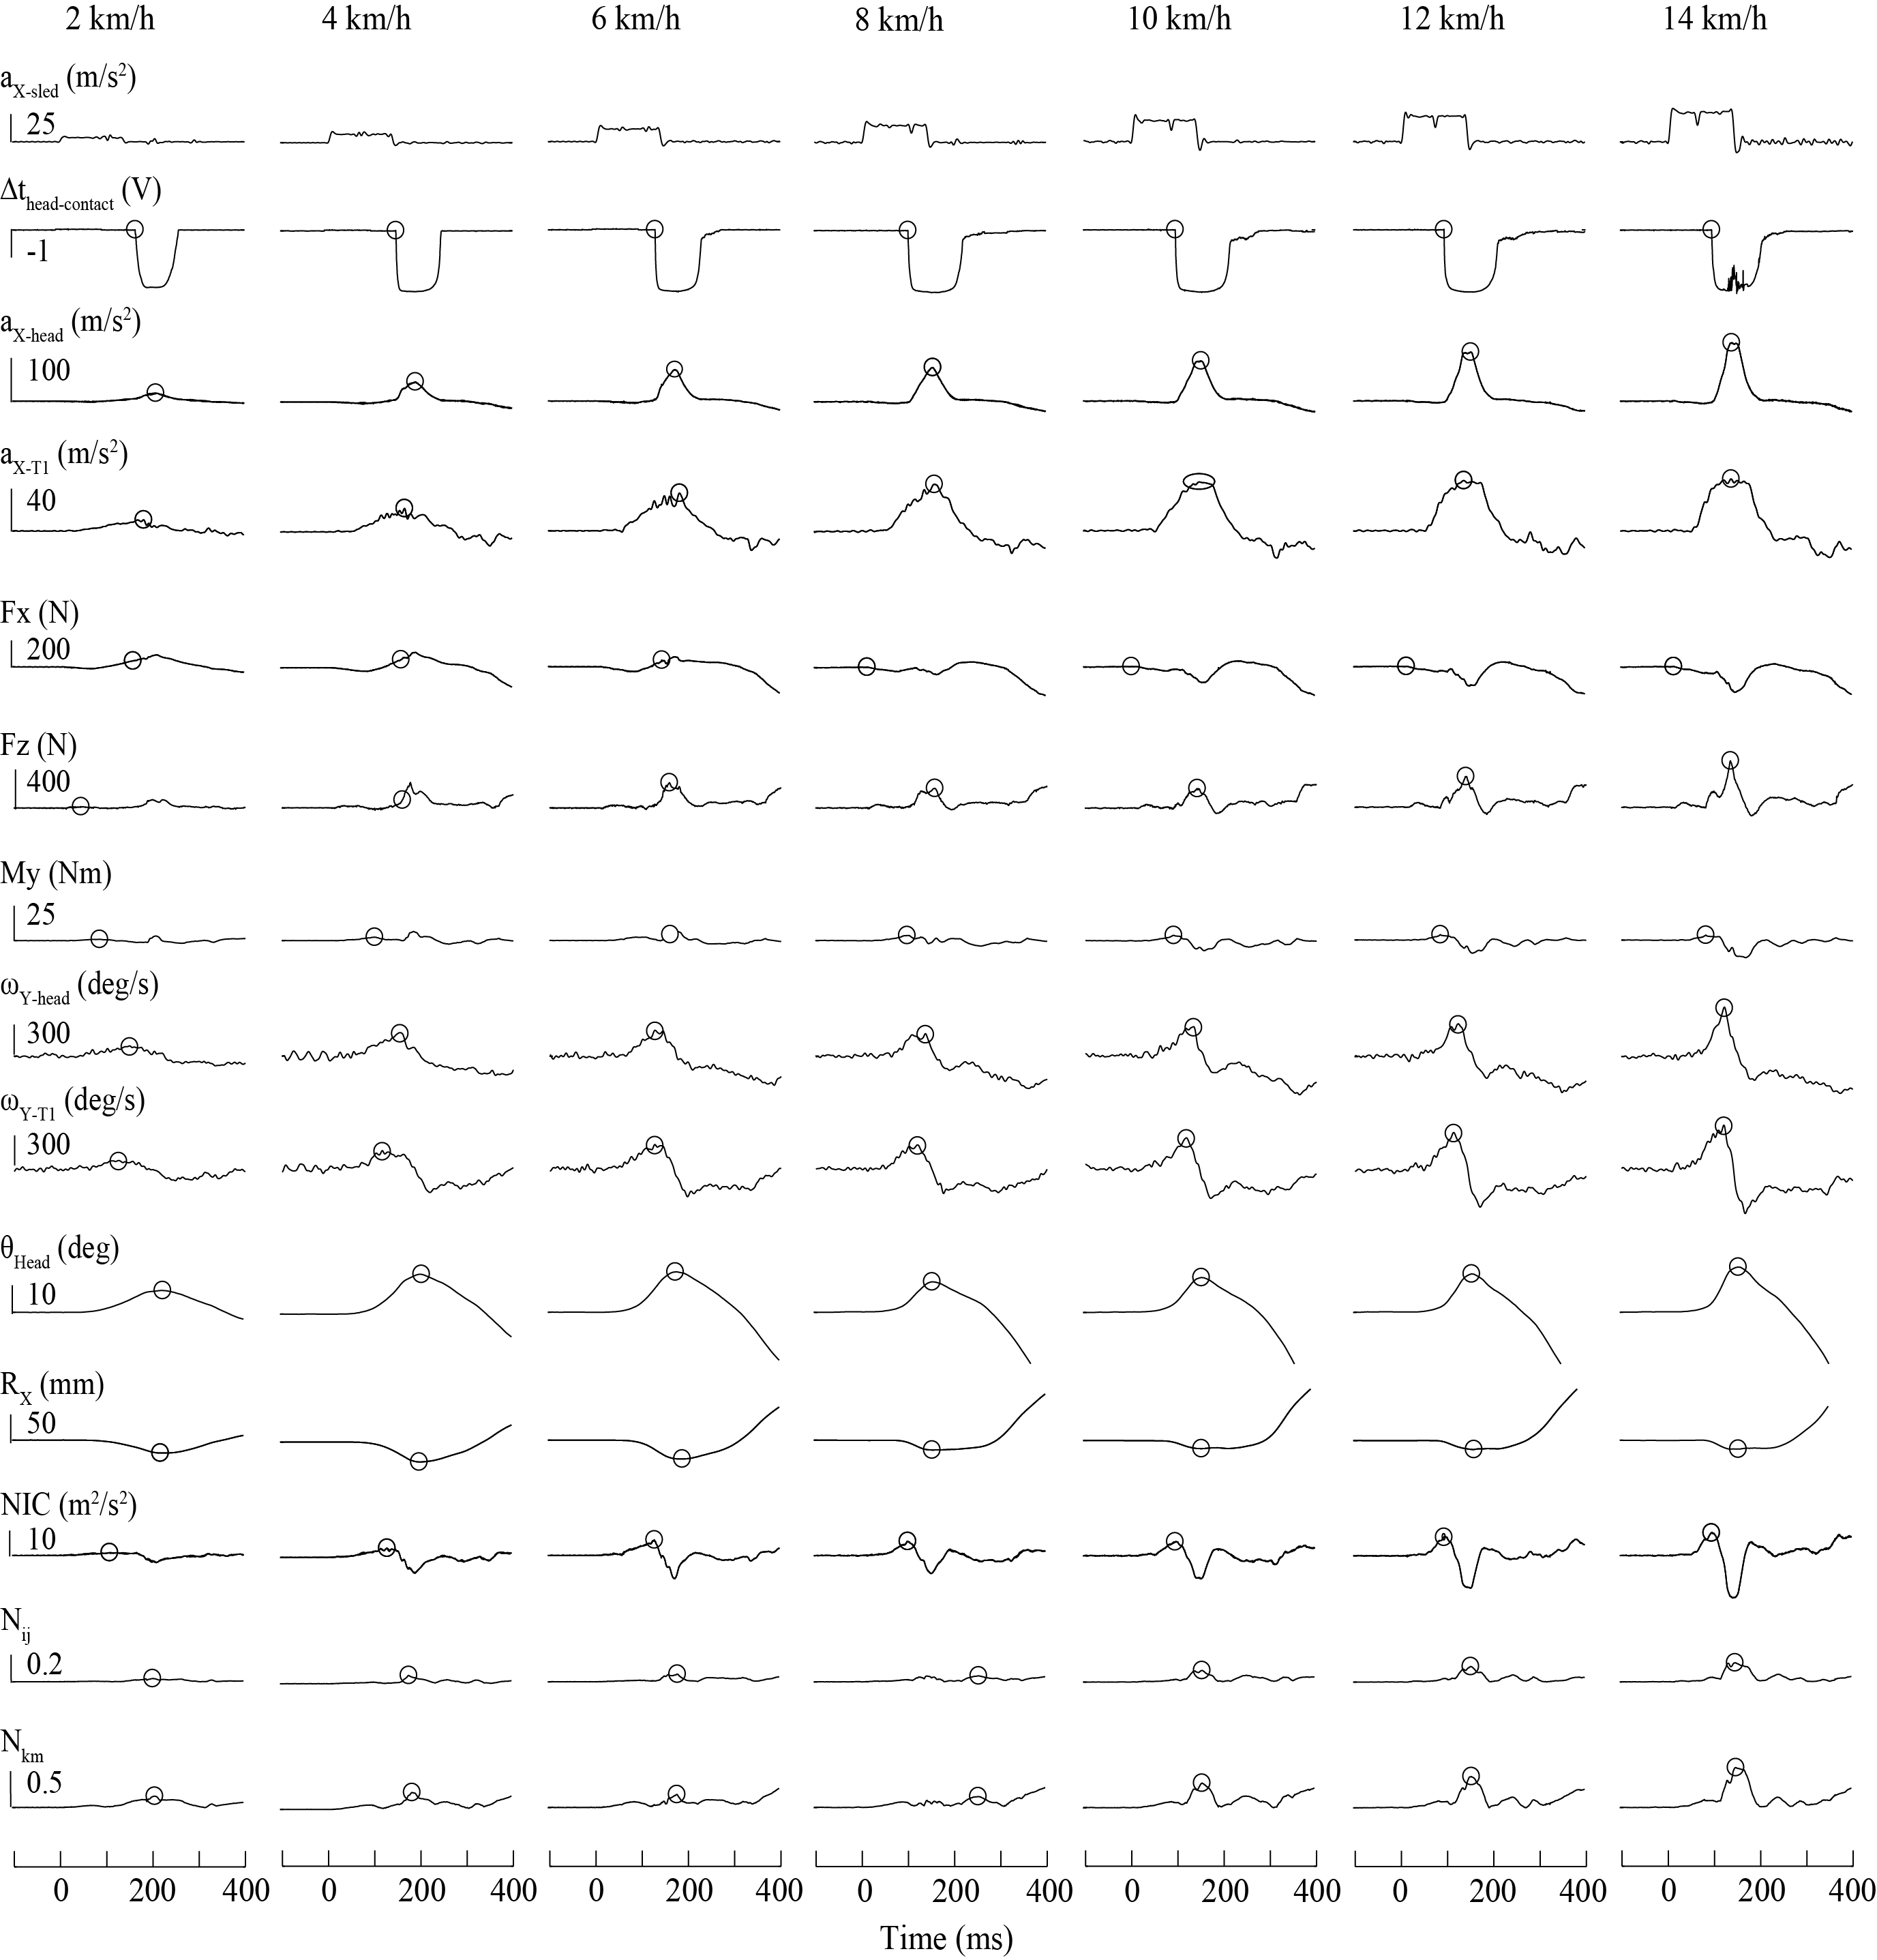

Figure A5.) Experimental data for the BioRID II ATD seated on a 2004 Volvo S60 WHIPS seat. Each column represents occupant responses while exposed to various collision severities (Δv = 2, 4, 6, 8, 10, 12 and 14 km/h with a collision pulse duration (Δt) of 141 ms). Hollow circles represent the onset of head-to-head-restraint contact and peak responses of each ATD response parameter for each trial and condition.

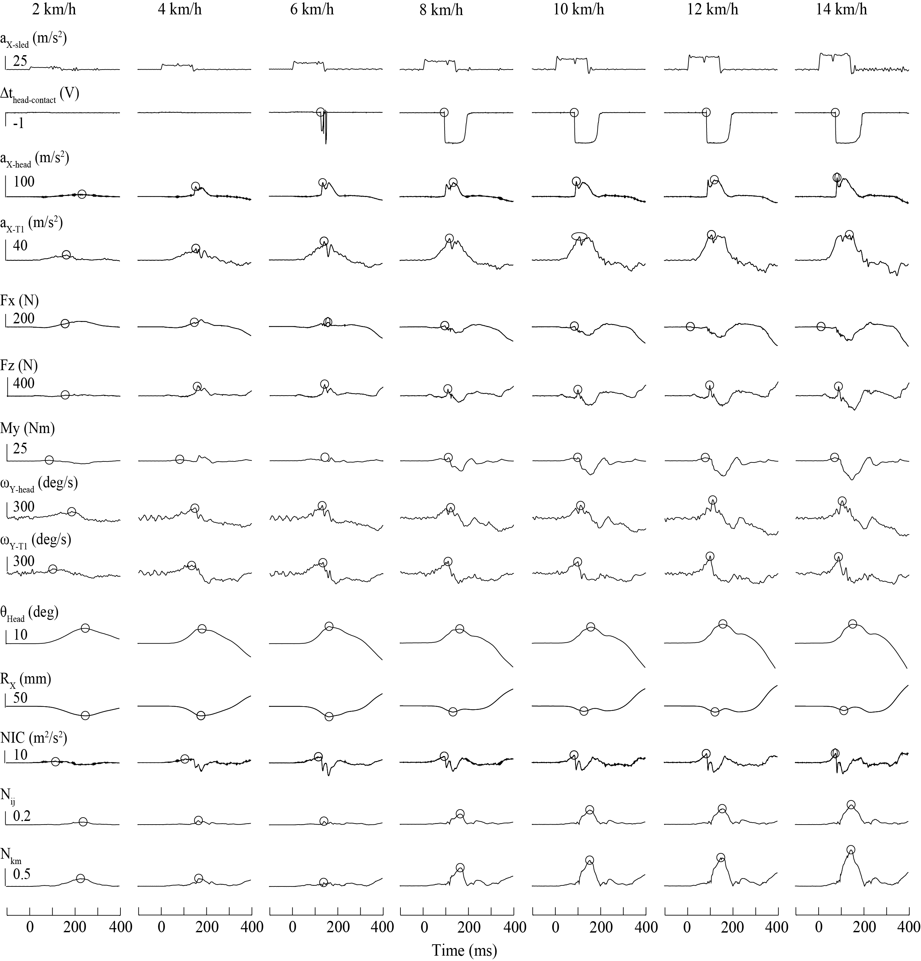

Figure A6.) Experimental data for the BioRID II ATD seated on a 2005 Saab 9.3 SAHR seat. Each column represents occupant responses while exposed to various collision severities (Δv = 2, 4, 6, 8, 10, 12 and 14 km/h with a collision pulse duration (Δt) of 141 ms). Hollow circles represent the onset of head-to-head-restraint contact and peak responses of each ATD response parameter for each trial and condition.

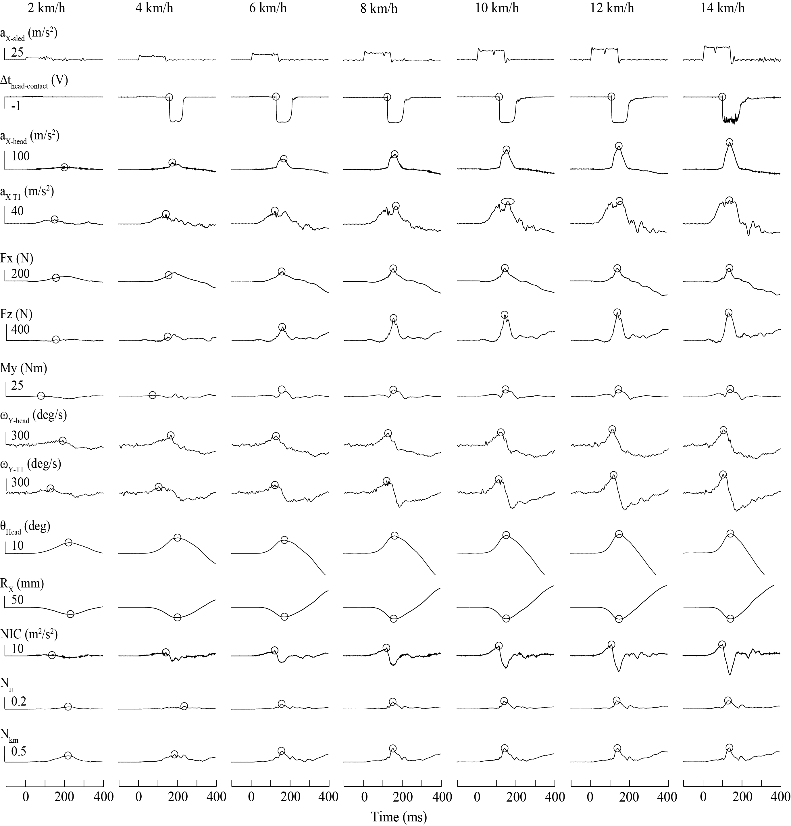

Figure A7.) Experimental data for the BioRID II ATD seated on a 2004 Pontiac Grand Am GMHR seat. Each column represents occupant responses while exposed to various collision severities (Δv = 2, 4, 6, 8, 10, 12 and 14 km/h with a collision pulse duration (Δt) of 141 ms). Hollow circles represent the onset of head-to-head-restraint contact and peak responses of each ATD response parameter for each trial and condition.

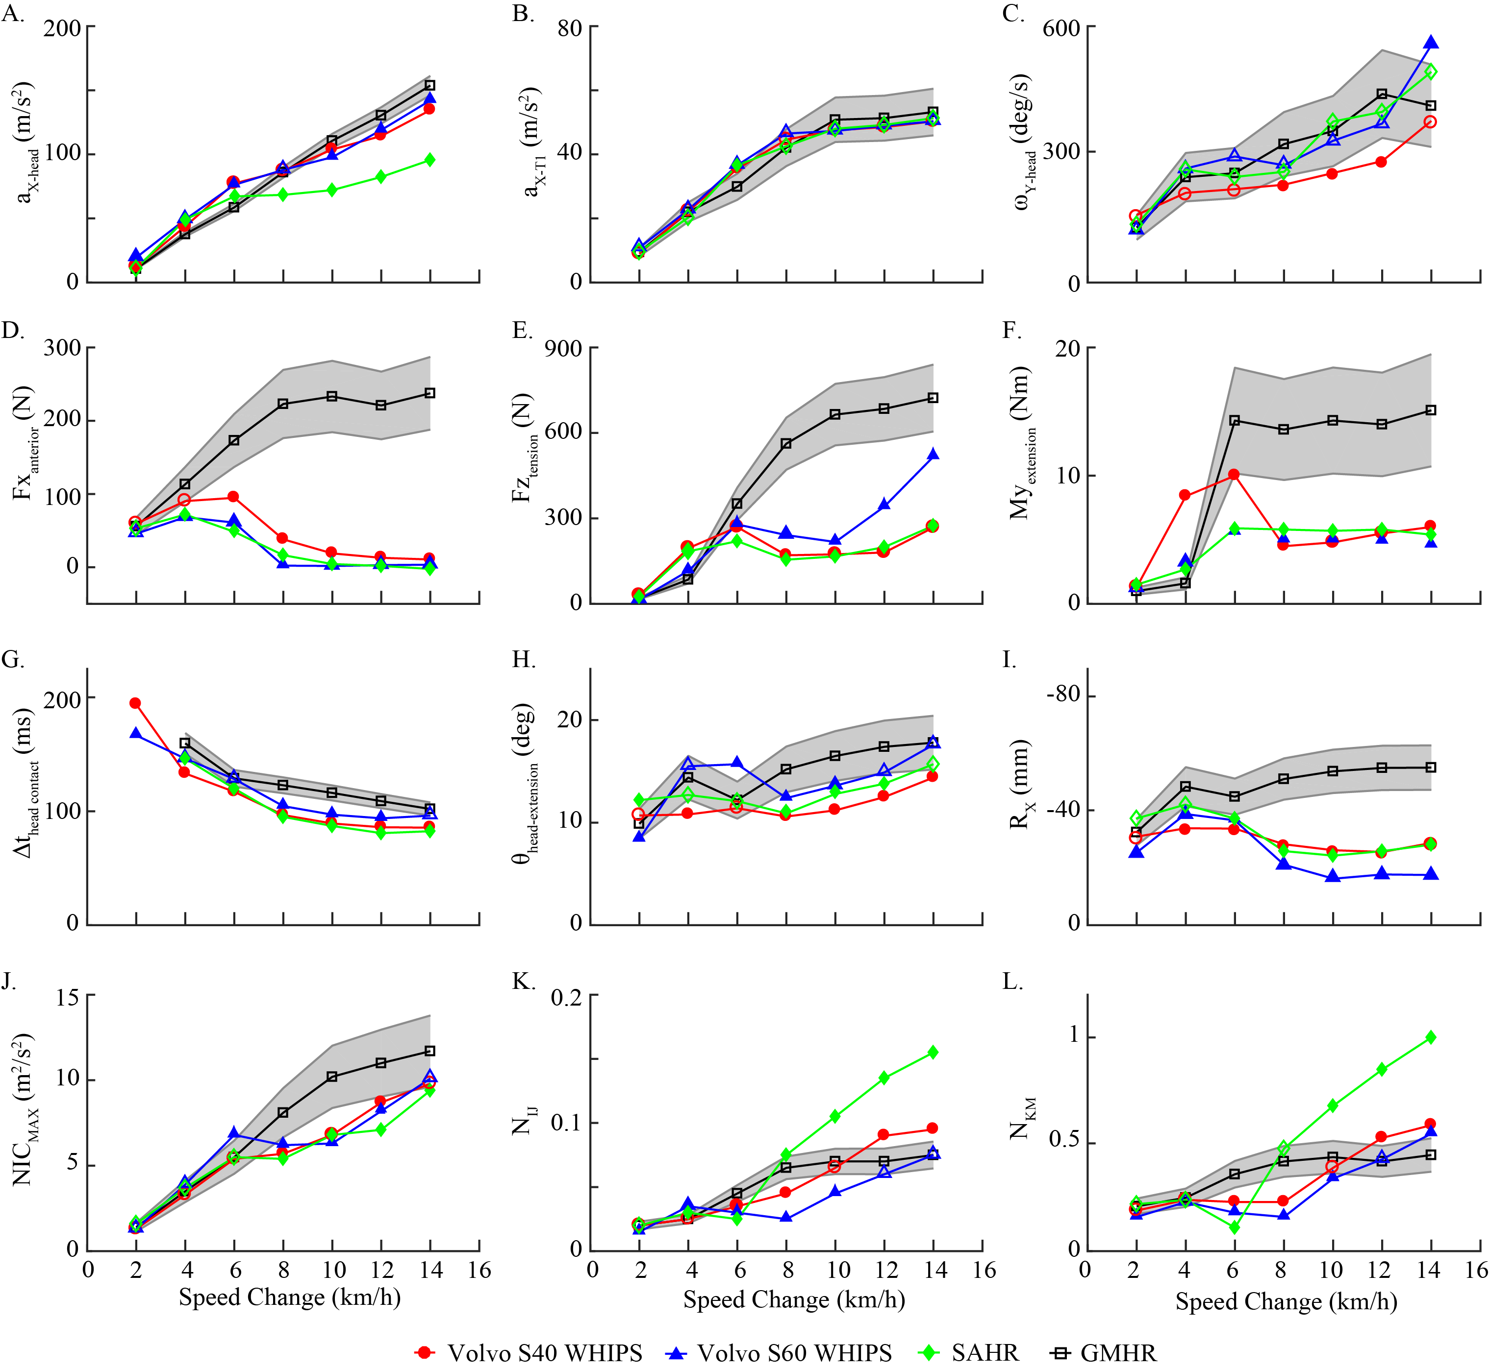

Figure A8. Exemplar experimental results of peak kinematic and kinetic responses for the BioRID II ATD seated on the WHIPS, SAHR and GMHR seats. For all the graphs, red circles represent the Volvo S40 WHIPS seat, blue triangles represent the Volvo S60 WHIPS seat, green diamonds represent the SAHR seat, and black squares represent the GMHR seat. Grey corridors represent 99th percentile corridors for ATD responses on the GMHR seat and the hollow shapes represent ATD responses that were within these 99th percentile corridors. Y-axis for panel I have been inverted for visual purposes to show increasing responses from bottom to top.

