Solar light-driven reduction of crystal violet by a g-C₃N₄, β-Ag₂Se, γ-Fe₂O₃ and graphite composite

Roberto C. Dante, Pablo Martín-Ramos, Pedro Chamorro-Posada, Dario Rutto,
José Vázquez-Cabo, Denisse G. Dante, Riccardo Barberis, Óscar Rubiños-López

SUPPORTING INFORMATION

Infrared spectra
The infrared spectra of the β-Ag₂Se/γ-Fe₂O₃/Graphite/g-C₃N₄ (AgFeCN) composite and of crystal violet (CV⁺) 1 wt% in water are reported in Figure S1. The spectrum of AgFeCN corresponded to that of g-C₃N₄ already discussed in previous works [1,2]. The spectrum of the CV⁺ solution showed intense peaks at 3250 and 1600 cm⁻¹, associated with water, while those of CV⁺ (in the 1500 and 1000 cm⁻¹ region) were very small and did not affect the spectrum of the composite after adsorption.

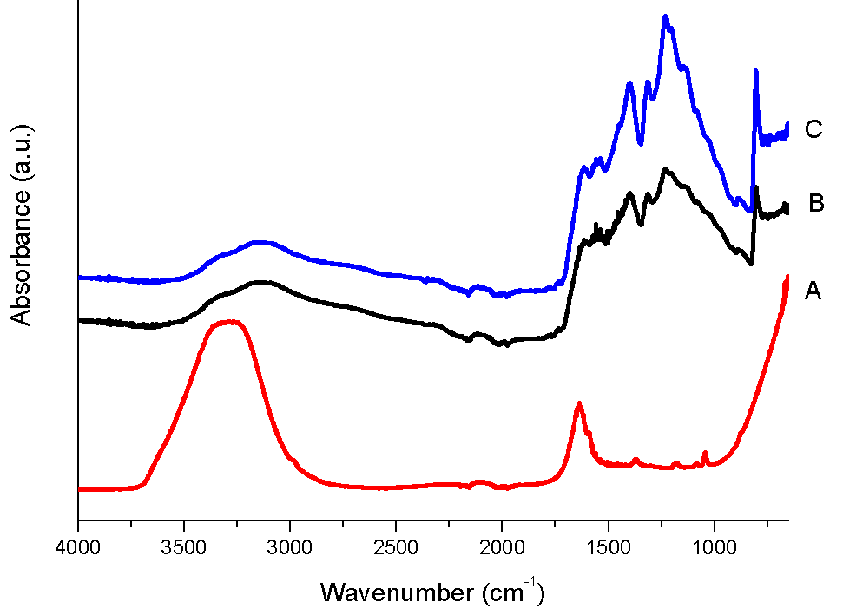
Figure S1. (A) Infrared spectra of CV⁺ in water solution 1 wt%; AgFeCN composite with adsorbed CV⁺; (C) AgFeCN composite as-is.

UV-Vis spectra
The Tauc plots (Figure S2) of the UV-Vis data showed that the optical bandgaps were 3.11 and 3.04 eV for pristine g-C₃N₄ (CN) and the AgFeCN composite, respectively.

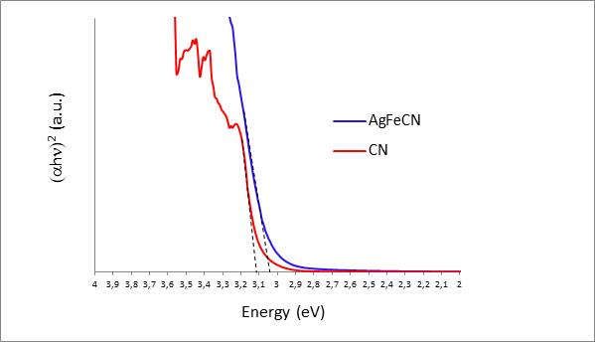
Figure S2. Tauc plots for the AgFeCN composite and pristine g-C₃N₄ (CN). The energy value of the optical bandgap is given by the intersection of the dashed lines with the x-axis (the higher value of 3.11 eV corresponds to CN).

Brunauer-Emmett-Teller (BET) surface area analysis and Barrett-Joyner-Halenda (BJH) pore size and volume analysis
The adsorption and desorption curves for AgFeCN and CN are shown in Figure S3. CN adsorption values were much higher than those of AgFeCN. The Brunauer-Emmett-Teller (BET) estimated surface areas were 74.91 and 4.38 m²·g⁻¹ for CN and AgFeCN, respectively. CN and AgFeCN are both mesoporous materials, with average pore diameters of 35.0 and 41.8 nm. However, CN had a larger pore volume (0.55 cm³·g⁻¹ vs. 0.056 cm³·g⁻¹) as estimated by BJH method. The BJH cumulative surface area of pores were 3.46 m²·g⁻¹ and 68.38 m²·g⁻¹ for AgFeCN and CN, respectively.

Figure S3. BET adsorption and desorption curves of AgFeCN and CN.

Thermal analysis
The thermal gravimetric analysis (TGA) and the differential scanning calorimetry (DSC) of AgFeCN are depicted in Figure S4 and Figure S5, respectively. It is worth noting that in nitrogen atmosphere the decomposition was very sustained from 700 °C, while other weight losses between 400 and 500 °C would probably be connected to residual melamine cyanurate reaction and cross-linking. The sharp endothermic peak detected in the DSC at 719 °C (Figure S5) probably corresponds to the melting point of Ag₂Se. On the other hand, in air the main weight losses were due to oxidation of both carbon nitride and graphite, as it can be inferred from the two exothermic peaks cantered at around 520 °C (g-C₃N₄) and 760 °C (graphite). Moreover, the TGA values in air and nitrogen of the AgFeCN composite revealed that ca. 9 wt% was composed of selenides of Ag and oxides of Fe, while graphite was estimated to be ca. 3.5 wt%. For the TGA and DSC of CN the interested reader is referred to previous works [1,2].

Figure S4. TGA curves in nitrogen and air of AgFeCN composite at a heating rate of 10 °C·min⁻¹.
Figure S5. DSC curves in nitrogen and air of AgFeCN composite at a heating rate of 10 °C·min⁻¹.

Time of flight secondary ion mass spectrometry
TOF-SIMS was used to gain insight into the distribution of Ag and other ionic fragments correlated to carbon nitride and graphite on the surface. From the results (Figure S6), it could be inferred that the distribution of Ag was not homogeneous: it would appear in clusters embedded in the carbon nitride matrix throughout the material surface. Also the distribution of graphite was not homogeneous, as identified by means of the C₇H₁₁O₂⁺ cation containing pure carbon.

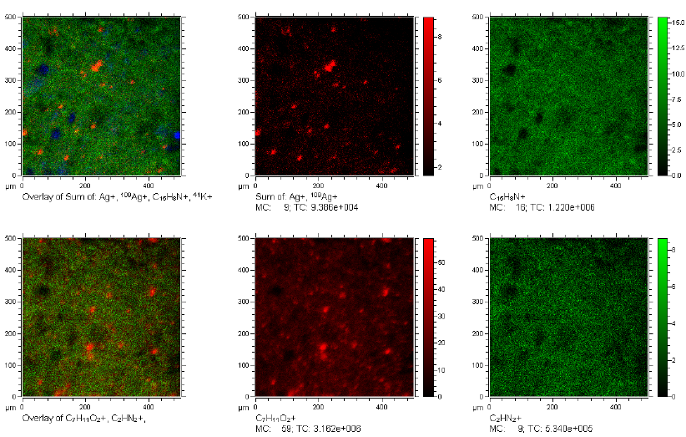
Figure S6. TOF-SIMS maps of some positive ions with overlapping.

X-ray photoelectron spectroscopy
XPS delivered the typical spectra of C1s and N1s for carbon nitride. For the sake of brevity, the interested reader is referred to the discussion presented in previous works by the same group [1,2]. The C1 and C2 deconvolution peaks can be attributed to the presence of graphite.

Figure S7. XPS spectrum of C1s with deconvolution bands.

Figure S8. XPS spectrum of N1s with deconvolution bands.

Much more complex was the Fe2p spectrum (Figure S9). This spectrum was compatible with maghemite (γ-Fe₂O₃), where the Fe2p3/2 B and Fe2p3/2 C bands would be attributed to Fe²⁺ and Fe³⁺ satellites, as the corresponding Fe2p1/2 bands [3,4].

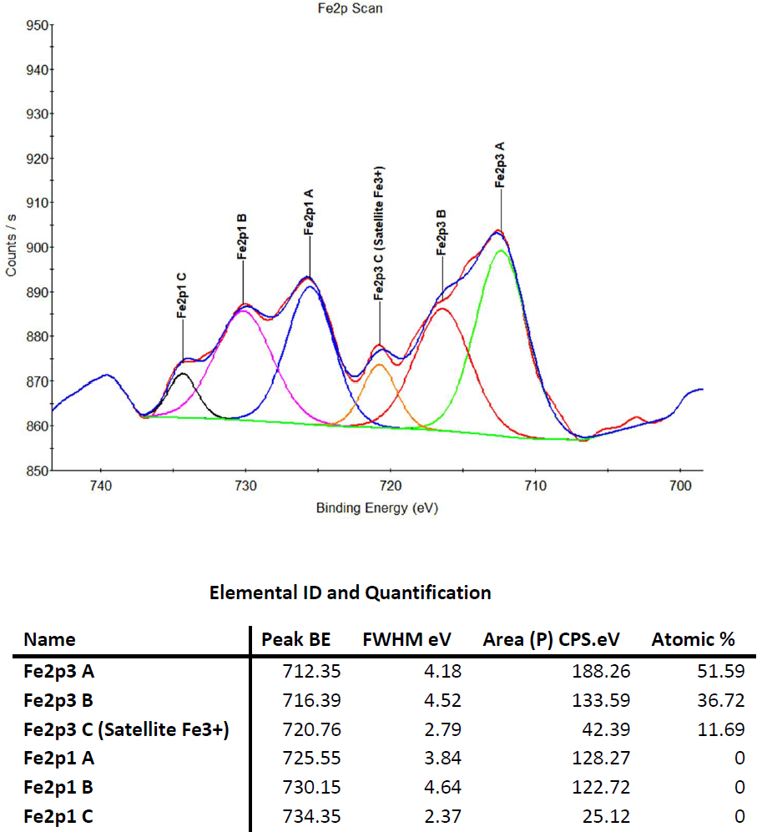
Figure S9. XPS spectrum of Fe2p with deconvolution bands.

References
[1] R.C. Dante, P. Martín-Ramos, F.M. Sánchez-Arévalo, L. Huerta, M. Bizarro, L.M. Navas-Gracia, J. Martín-Gil, Synthesis of crumpled nanosheets of polymeric carbon nitride from melamine cyanurate, J. Solid State Chem., 201 (2013) 153-163.
[2] R.C. Dante, F.M. Sánchez-Arévalo, P. Chamorro-Posada, J. Vázquez-Cabo, L. Huerta, L. Lartundo-Rojas, J. Santoyo-Salazar, O. Solorza-Feria, Supramolecular intermediates in the synthesis of polymeric carbon nitride from melamine cyanurate, J. Solid State Chem., 226 (2015) 170-178.
[3] M. Fondell, M. Gorgoi, M. Boman, A. Lindblad, Surface modification of iron oxides by ion bombardment – Comparing depth profiling by HAXPES and Ar ion sputtering, J. Electron. Spectrosc. Relat. Phenom., 224 (2018) 23-26.
[4] A.P. Grosvenor, B.A. Kobe, M.C. Biesinger, N.S. McIntyre, Investigation of multiplet splitting of Fe 2p XPS spectra and bonding in iron compounds, Surf. Interface Anal., 36 (2004) 1564-1574.

