Supplementary Material

MOR1
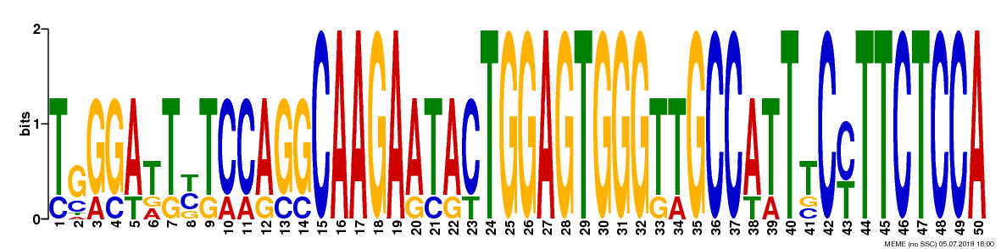
MOR2
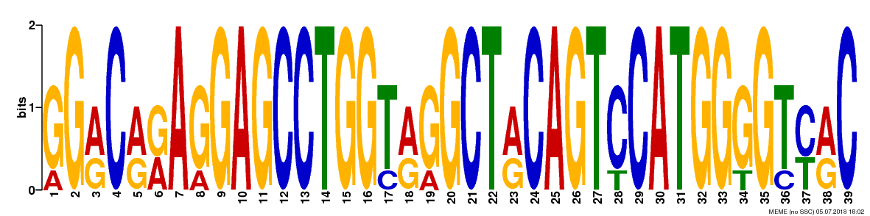
MOR3
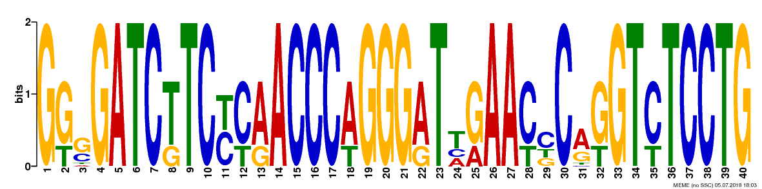
MOR4
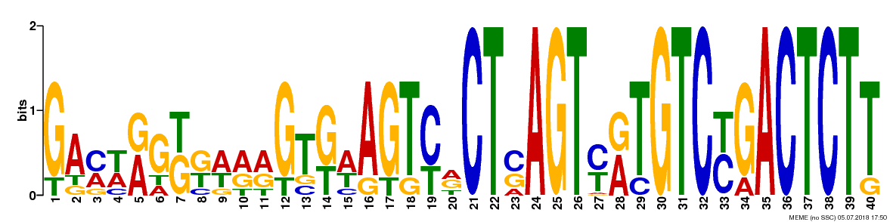
MOR5
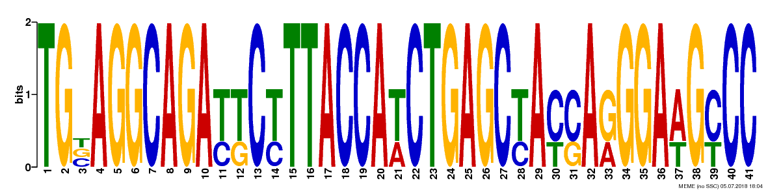
Supplementary Figure 1. Sequence logos for the five motifs found by MEME Suite from the positive strand of cattle ORs promoter region.

