SUPPLEMENTARY INFORMATION FOR:
Realizing p-type NbCoSn half-Heusler compounds with enhanced thermoelectric performance via Sc substitution
Ruijuan Yanª, Wenjie Xie^{a*}, Benjamin Balke^{b}, Guoxing Chenª, Anke Weidenkaff^{a,b}
ªTechnische Universität Darmstadt, Department of Materials Science, Alarich-Weiss-Straße 2, 64287 Darmstadt, Germany
^{b}Fraunhofer Research Institution for Materials Recycling and Resource Strategies IWKS, Rodenbacher Chaussee 4, 63457, Hanau, Brentanostraße 2a, 63755 Alzenau, Germany
*Corresponding Author
E-mail: wenjie.xie@mr.tu-darmstadt.de

Table S1 Physics parameters values: Debye temperature θ_{D}, the sound velocity ν_{s}, Grüneisen parameter γ, deformation potential E_{def}, density of state m_{d}*, the longitudinal sound velocity ν_{l} and grain size d for transport properties calculation.
Parameters | Value | References
θ_{D} | 361 K | [1]
ν_{s} | 3141 m/s | [1]
γ | 1.2 | *
E_{def} | 4.47 | [2]
m_{d}* | 3.4 | **
ν_{l} | 4956 m/s | *
d | 100-500 μm | Figure S1
* fitting data ** calculated data
Table S2 The average atomic mass of the crystal M and the average volume/atom Ω of Nb_{1-z}Sc_{z}CoSn.
Compositions | M | Ω (10⁻³⁰ m³/atom)
Nb_{0.99}Sc_{0.01}CoSn | 90.02 | 70.50
Nb_{0.97}Sc_{0.03}CoSn | 89.70 | 70.52
Nb_{0.96}Sc_{0.04}CoSn | 89.54 | 70.50
Nb_{0.95}Sc_{0.05}CoSn | 89.38 | 70.60
Nb_{0.94}Sc_{0.06}CoSn | 89.22 | 70.70
Nb_{0.93}Sc_{0.07}CoSn | 89.06 | 70.70
Nb_{0.90}Sc_{0.10}CoSn | 88.58 | 71.20

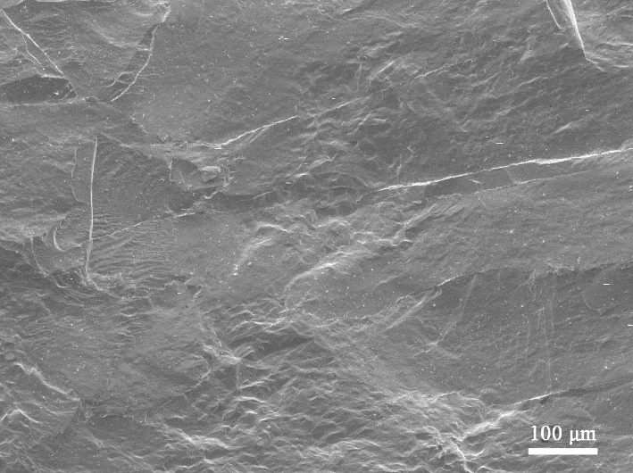
Figure S1 Typical scanning electron microscopy image of Nb_{0.93}Sc_{0.07}CoSn.

References
[1] Ferluccio D A, Smith R I, Buckman J, et al. Impact of Nb vacancies and p-type doping of the NbCoSn-NbCoSb half-Heusler thermoelectrics. Phys Chem Chem Phys. 2018;20:3979-3987.
[2] Zhou J, Zhu H, Liu T-H, et al. Large thermoelectric power factor from crystal symmetry-protected non-bonding orbital in half-Heuslers. Nat Commun. 2018;9:1721.

