Supplemental Information for: Evolution of the Light-absorption Properties of Combustion Brown Carbon Aerosols Following Reaction with Nitrate Radicals
Zezhen Cheng¹, Khairallah M Atwi¹, Zhenhong Yu², Anita Avery², Edward C. Fortner², Leah Williams², Francesca Majluf², Jordan E. Krechmer², Andrew T. Lambe^{2*}, and Rawad Saleh^{1*}
1. Air Quality and Climate Research Laboratory, College of Engineering, University of Georgia, Athens, GA, USA
2. Aerodyne Research, Inc., Billerica, Massachusetts 01821, United States
* To whom correspondence should be addressed. rawad@uga.edu | (706) 542-6110, lambe@aerodyne.com | (978) 663-9500

S1. Estimation of NO₃ exposure levels:
NO₃ exposure levels (NO_{3,exp}) were estimated from the decay of two tracers, butanal and thiophene, that were introduced at the oxidation flow reactor (OFR) inlet and detected with a Vocus Proton Transfer Reaction Time-of-Flight Mass Spectrometer (PTR-MS, Tofwerk/Aerodyne) (Krechmer et al. 2018). Assuming first-order reactive loss to NO₃, the tracer concentration is expressed as:
$\frac{d[tracer]}{dt}=[tracer]_{o}exp⁡(-k_{{NO}_{3}}[NO_{3}]t)$ (S1)
Where [tracer]_{o} and [tracer] are the initial and time-dependent tracer concentrations, respectively, and [NO₃] is the time-independent NO₃ concentration. k_{NO3} is the reaction rate constant with NO₃ reported in the literature (Atkinson 1991; D’Anna et al. 2001). Integrating equation S1 yields:
$-\ln\left(\frac{[tracer]}{[tracer]_{o}}\right)=k_{{NO}_{3}}[NO_{3}]∆t$ (S2)
NO_{3, exp} is the integrated NO₃ concentration over time, and can be obtained as
${NO}_{3,exp}= ln\left(\frac{[tracer]_{o}}{[tracer]}\right)/k_{{NO}_{3}}$ (S3)
where [tracer]_{o} and [tracer] are obtained from the PTR-MS measurements.
S2. Mass balance calculations for main text Section 3.2.3:
We performed elemental (C, N, O) mass balance on the OA measured by the AMS / SP-AMS before and after oxidation to estimate the relative contribution of SOA condensation versus heterogeneous oxidation to the increase in OA mass concentration after oxidation with NO₃. To do so, we converted the O/C, N/C, and H/C obtained from the AMS / SP-AMS measurements (main text Section 3.2.2) to a mass basis. By applying the constraint m_{OA} = m_{C} + m_{N} + m_{O} + m_{H}, where m_{OA} is the OA mass concentration, m_{C} is the carbon mass concentration, etc., we obtained a system of equations and solved for m_{C}, m_{N}, m_{O}, and m_{H} for the unoxidized and oxidized BrC. We then calculated the increase in the mass concentration of each element after oxidation (Δm_{C}, Δm_{N}, Δm_{O}, Δm_{H}). Since heterogeneous oxidation only adds N and O to the particles, Δm_{C} is only associated with SOA condensation.
To apportion the added N- and O-containing functional groups between SOA condensation and heterogeneous oxidation, we assumed that the SOA molecules contained 10-18 carbons, 0-1 nitrogens, and 2-4 oxygens (see main text Section 3.2.3 for the rationale behind these assumptions). For each assumed combination of carbon, nitrogen, and oxygen numbers, the oxygen and nitrogen mass contributed by SOA condensation can be calculated as:
$∆m_{N, SOA}={(N}/{C)_{SOA}}×\frac{14 g {mol}^{-1}}{12 g {mol}^{-1}}×∆m_{C}$ (S4)
$∆m_{O, SOA}={(O}/{C)_{SOA}}×\frac{16 g {mol}^{-1}}{12 g {mol}^{-1}}×∆m_{C}$ (S5)
The contribution of heterogeneous oxidation to the increase in nitrogen and oxygen mass of the oxidized particles can then be calculated as:
$∆m_{N,het}=∆m_{N}-∆m_{N, SOA}$ (S6)
$∆m_{O,het}=∆m_{O}-∆m_{O, SOA}$ (S7)
Finally, the ratios in Figure 6 in the main text are calculated as:
$∆N_{het}/∆N_{tot}=∆m_{N,het}/∆m_{N}$ (S8)
$∆O_{het}/∆O_{tot}=∆m_{O,het}/∆m_{O}$ (S9)
Table S1. Summary of experimental data
 | Light BrC |  | Medium BrC |  | Dark BrC
 | unoxidized | oxidized | unoxidized | oxidized | unoxidized | oxidized
NO₃ exposure (molec cm⁻³ sec) | 0 | 5.2×10¹³ | 0 | 5.2×10¹³ | 0 | 5.2×10¹³
SMPS mass concentration  (μg m⁻³) | 236 | 324 | 261 | 84 | 109 | 145
AMS OA  (μg m⁻³) | 84.1 | 110.5 | 61.7 | 86.1 | 3.5 | 6.2
AMS nitrates  (μg m⁻³) | 1.3 | 7.9 | 1.2 | 11.1 | 0.8 | 1.8
AMS NO⁺:NO₂⁺ | 1.6 | 1.9 | 1.3 | 1.6 | 1.9 | 2.1
AMS O/C ª | 0.15 | 0.24 | 0.17 | 0.34 | 0.90 | 0.94
AMS H/C ^{b} | 0.78 | 0.80 | 0.76 | 0.80 | 1.04 | 0.95
AMS N/C ^{c} | 0.01 | 0.03 | 0.01 | 0.06 | 0.11 | 0.20
SP-AMS OA (μg m⁻³) | 4 | 48.6 | No data | No data | 17.7 | 31.0
SP-AMS nitrates  (μg m⁻³) | 0.2 | 3.0 | No data | No data | 1.8 | 5.0
SP-AMS NO⁺:NO₂⁺ | 2.1 | 1.2 | No data | No data | 1.4 | 1.3
SP-AMS O/C ª | 0.59 | 0.26 | No data | No data | 0.35 | 0.46
SP-AMS H/C ^{b} | 1.04 | 1.00 | No data | No data | 0.88 | 0.97
SP-AMS N/C ^{c} | 0.02 | 0.02 | No data | No data | 0.04 | 0.07
SP-AMS BC  (μg m⁻³) | 0.2 | 0.4 | No data | No data | 4.3 | 6.4
MAC₄₇₁  (g m⁻²) ^{d} | 0.36 ± 8.3% | 0.33 ± 3.0% | 0.92 ± 5.4% | 1.01 ± 1.6% | 1.70 ± 7.1% | 1.86 ± 2.7%
MAC₅₃₂  (g m⁻²) ^{d} | 0.13 ± 7.7% | 0.17 ± 1.8% | 0.41 ± 2.4% | 0.53 ± 2.1% | 1.39 ± 9.4% | 1.34 ± 1.5%
MAC₆₇₁  (g m⁻²) ^{d} | 0.04 ± 5.0% | 0.09 ±4.4% | 0.23 ± 4.3% | 0.27 ± 2.0% | 0.95 ± 9.5% | 0.93 ± 2.2%
AAE ^{d} | 8.0 ± 6.3% | 4.4 ± 2.3% | 5.2 ± 3.8% | 4.3 ± 1.2% | 1.7 ± 5.9% | 2.0 ± 5.0%
k₄₇₃ ^{d} | 0.021 ± 9.5% | 0.019 ± 2.1% | 0.053 ± 3.8% | 0.057 ± 3.5% | 0.099 ± 7.1% | 0.106 ± 2.8%
k₅₃₂ ^{d} | 0.008 ± 3.8% | 0.011 ± 1.8% | 0.026 ± 3.8% | 0.034 ± 2.9% | 0.091 ± 9.9% | 0.088 ± 2.3%
k₆₇₁ ^{d} | 0.004 ± 5.0% | 0.008 ± 5.0% | 0.020 ± 5.0% | 0.024 ± 0.4% | 0.081 ± 9.9% | 0.079 ± 2.5%
w ^{d} | 6.2 ± 8.1% | 2.9 ± 6.9% | 3.6 ± 0.3% | 2.8 ± 3.6% | 0.6 ± 15.7% | 0.8 ± 12.9%
ª ±12% uncertainty in O/C (Canagaratna et al. 2015).
^{b} ±4% uncertainty in H/C (Canagaratna et al. 2015).
^{c} ±12% uncertainty in N/C (Aiken, Decarlo, and Jimenez 2007).
^{d} uncertainties represent the standard deviations over time for one experiment.
Figure S1. Typical SMPS relative volume distribution of unoxidized (blue) and oxidized (red). (a) light BrC. (b) medium BrC. (c) dark BrC.

Figure S2. Time series of toluene and C₁₀-C₁₃ gas-phase PAHs emitted from the combustion source and measured with Vocus PTR-MS.

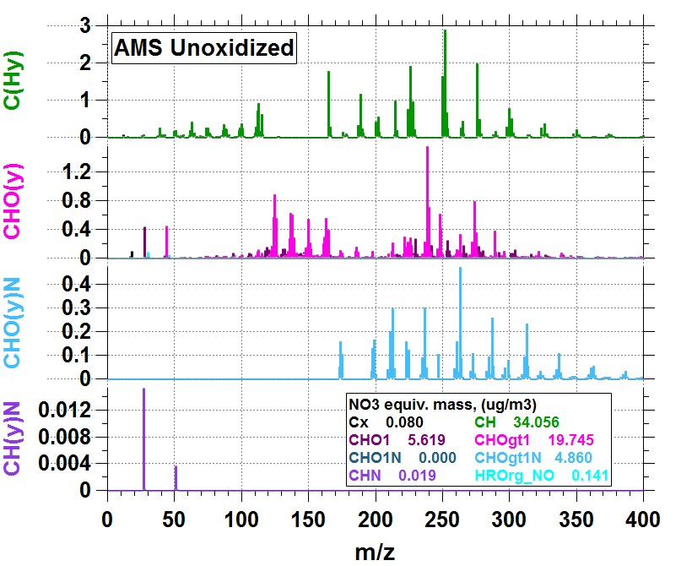
Figure S3. Expanded AMS HR spectrum of oxidized light BrC that corresponds to the AMS HR spectrum shown in Figure 4a of the main paper.

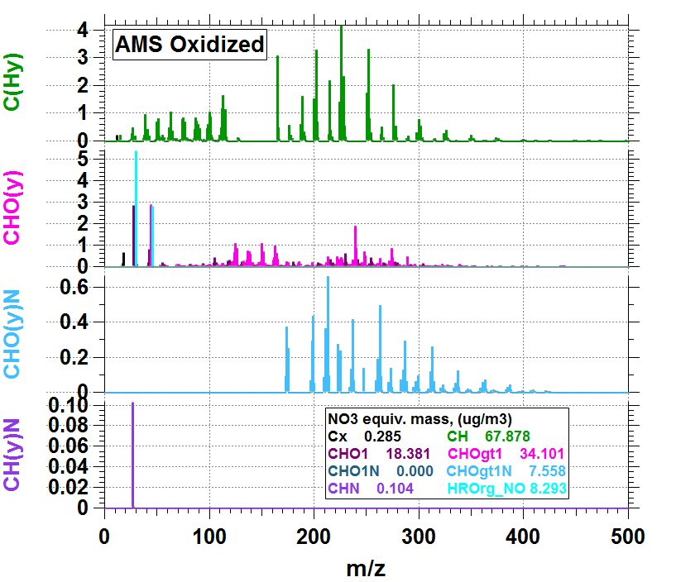
Figure S4. Expanded AMS HR spectrum of oxidized light BrC that corresponds to the AMS HR spectrum shown in Figure 4b of the main paper.

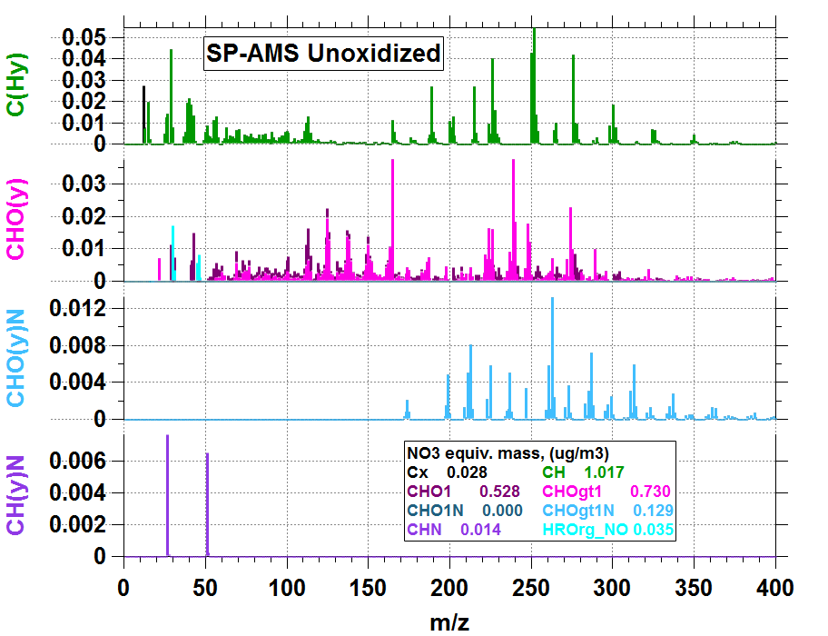
Figure S5. Expanded SP-AMS HR spectrum of oxidized light BrC that corresponds to the SP-AMS HR spectrum shown in Figure 4c of the main paper.

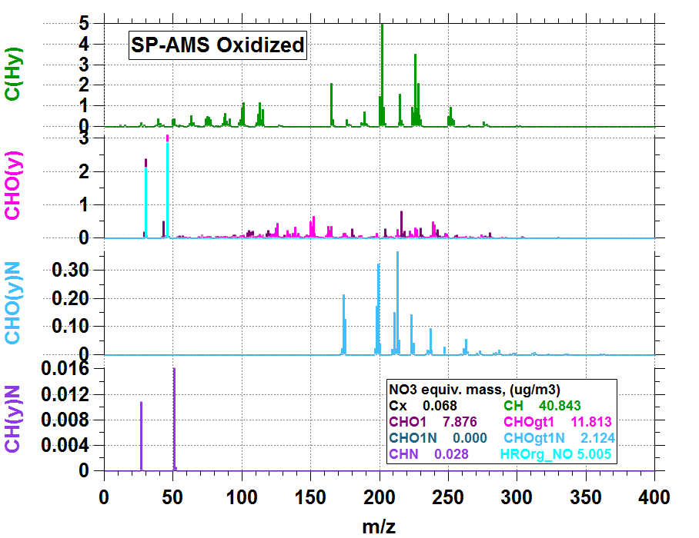
Figure S6. Expanded SP-AMS HR spectrum of oxidized light BrC that corresponds to the SP-AMS HR spectrum shown in Figure 4d of the main paper.

Reference:
Aiken, A. C., P. F. Decarlo, and J. L. Jimenez. 2007. Elemental Analysis of Organic Species with Electron Ionization High-Resolution Mass Spectrometry. Anal. Chem. 79 (21): 8350–58. doi.org/10.1021/ac071150w.
Atkinson, R. 1991. Kinetics and Mechanisms of the Gas-Phase Reactions of the NO3 Radical with Organic Compounds. J. Phys. Chem. Ref. Data 20, 20 (3): 459–506. doi.org/10.1063/1.555887.
Canagaratna, M. R., J. L. Jimenez, J. H. Kroll, Q. Chen, S. H. Kessler, P. Massoli, L. H. Ruiz, et al. 2015. Elemental Ratio Measurements of Organic Compounds Using Aerosol Mass Spectrometry: Characterization, Improved Calibration, and Implications. Atmos. Chem. Phys. 15: 253–72. doi.org/10.5194/acp-15-253-2015.
D’Anna, B., Ø. Andresen, Z. Gefen, and C. J. Nielsen. 2001. Kinetic Study of OH and NO3 Radical Reactions with 14 Aliphatic Aldehydes. Phys. Chem. Chem. Phys. 3: 3057–63.
Krechmer, J., F. Lopez-hilfiker, A. Koss, M. Hutterli, C. Stoermer, B. Deming, J. Kimmel, et al. 2018. Evaluation of a New Reagent-Ion Source and Focusing Ion− Molecule Reactor for Use in Proton-Transfer-Reaction Mass Spectrometry. Anal. Chem. doi.org/10.1021/acs.analchem.8b02641.

