Supporting Information

Synthesis of Spirocyclic 5-7 Cycloheptenes by Rhodium Catalysed Chemo- and Regioselective [3+2+2] Cycloadditions

Bilash Kuila,ª Priyanka Sharma,ª Dinesh Mahajan,^{b} Prabhpreet Singh^{c} and Gaurav Bhargava^{a,}∗

ªDepartmentof Chemical Sciences, IKG Punjab Technical University, Kapurthala 144603, Punjab, India
^{b} Drug Discovery Research Centre, Translational Health Science and Technology Institute, Faridabad-121001, India.
^{c}Department of Chemistry, Guru Nanak Dev University, Amritsar 143005, Punjab, India

Experimental Section
Unless otherwise noted, commercial available materials were used without further purification. Air sensitive reactions were carried out under argon atmosphere. Anhydrous solvents were obtained from Merck. Thin layer chromatography (TLC) was carried out using 0.2 mm Kieselgel F254 (Merck) silica plates and compounds visualized in para-anisaldehyde strain. NMR spectra were recorded on a Bruker 300 MHz spectrometer operating at 300 MHz for ¹H and 75 MHz for ¹³C. Chemical shifts (δ) are quoted in parts per million (ppm) relative to internal solvent reference (CDCl₃; δ = 7.26 for ¹H NMR and δ = 77.0 for ¹³C NMR). Coupling constants are given in Hz and chemical shifts are reported in δ values in ppm. Data are reported as followed: chemical shift, multiplicity (s = singlet, bs = broad singlet, d = doublet, t = triplet, dd = double doublet, m = multiplet), coupling constants (Hz), and integration. High resolution mass spectra were recorded on a Brucker-micrOTOF-Q II mass spec-trometer.
General procedure for synthesis of [3+2+2] cycloadducts (3a-f): To a solution of 1 (1 equiv.) in toluene (3ml), alkynes 2 (10 equiv.) was added and reaction mixture was degassed for 10 minutes under argon atmosphere. This is followed by the addition [Rh(COD)Cl]₂ (0.1 equiv.) and triphenylphosphite (0.25 equiv.). The reaction was heated at 110-130 °C for 20-30 hrs depending on type of alkynes. After completion of reaction, the reaction mixture was concentrated under high vacuum at 35-40 °C to get crude product. Crude product was purified using silica gel (100-200 mesh) column chromatography and 20% ether in hexane as eluent to get compound 3.

Trimethyl 8-methylene-1,3,3a,7,8,8a-hexahydro-2H-spiro[azulene-4,1'-cyclopropane]-2,2,6-tricarboxylate, 3a: Colourless liquid; yield: 41%;¹H NMR (300 MHz, CDCl₃): δ 6.34 (s, 1H), 4.81 (dd, J = 7.5, 2.1 Hz, 2H), 3.98 (s, 3H), 3.94 (s, 3H), 3.72 (s, 3H), 3.26 (t, J = 17.7 Hz, 2H), 3.07 (dd, J = 17.7, 9 Hz,1H), 2.58-2.66 (m, 1H), 2.30 (dd, J = 6.9, 1.5 Hz,1H), 2.11- 2.20 (m, 2H), 1.56-1.64 (m, 1H), 0.65-0.80 (m, 4H); ¹³C NMR (75 MHz, CDCl₃): δ 172.7, 172.1, 167.9, 147.5, 134.6, 131.1, 114.2, 59.5, 52.8, 52.6, 51.9, 50.5, 46.6, 38.6, 38.2, 34.0, 20.3, 17.6, 14.9; LRMS 349.2 (M+1), HRMS calcd for C₁₉H₂₅O₆ (MH+): 349.1651, found: 349.1639.
6-Ethyl 2,2-di-methyl 5-methyl-8-methylene-1,3,3a,7,8,8a-hexahydro-2H-spiro[azulene-4,1'-cyclopropane]-2,2,6-tricarboxylate, 3b: Colourless liquid; yield: 32%; ¹H NMR (300 MHz, CDCl₃): δ 4.83 (dd, J = 7.5, 2.1 Hz, 2H), 4.19 (q, J = 7.5 Hz, 2H), 3.97 (s, 6H),3.26 (t, J = 18.0 Hz, 2H), 3.12 (dd, J = 18.0, 9 Hz,1H), 2.58-2.64 (m, 1H), 2.30 (dd, J = 6.9, 1.2 Hz,1H), 2.12- 2.17 (m, 2H), 1.82 (s, 3H), 1.57-1.65 (m, 1H), 1.32 (t, J = 7.5 Hz, 3H ) 0.66-0.81 (m, 4H); ¹³C NMR (75 MHz, CDCl₃): δ 172.5, 172.2, 168.0, 148.3, 147.3, 131.3, 114.2, 61.2, 59.5, 52.8, 52.3, 50.2, 46.6, 38.7, 38.3, 34.2, 20.5, 17.6, 14.9, 14.0, 12.2; LRMS 377.2 (M+1). HRMS calcd for C₂₁H₂₉O₆ (MH+): 377.1964, found: 377.1959.
6-Ethyl 2,2-dimethyl 5-ethyl-8-methylene-1,3,3a,7,8,8a-hexahydro-2H-spiro[azulene-4,1'-cyclopropane]-2,2,6-tricarboxylate, 3c: Pale yellow liquid; yield:35%;¹H NMR (300 MHz, CDCl₃): δ 4.81 (dd, J = 7.2, 2.1 Hz, 2H), 4.21 (q, J = 7.5 Hz, 2H), 3.95 (s, 6H), 3.26 (t, J = 17.7 Hz, 2H), 3.08 (dd, J = 17.7, 9.3 Hz,1H), 2.58-2.66 (m, 1H), 2.30 (dd, J = 6.9, 1.5 Hz,1H), 2.13- 2.18 (m, 2H), 2.01 (q, J = 7.2 Hz, 2H), 1.59-1.66 (m, 1H), 1.30 (t, J = 7.5 Hz, 3H), 1.08 (t, J = 7.2 Hz, 3H), 0.65-0.83 (m, 4H); ¹³C NMR (75 MHz, CDCl₃): δ 172.7, 172.1, 167.8, 148.5, 147.5, 131.3, 114.4, 61.4, 59.7, 52.6, 52.3, 50.3, 46.6, 38.8, 38.2, 34.3, 20.5, 19.5, 17.7, 15.1, 14.1, 12.9; LRMS 391.3 (M+1), HRMS calcd for C₂₂H₃₁O₆(MH+): 391.2121, found: 391.2125.
6-Ethyl 2,2-methyl 8-methylene-5-phenyl-1,3,3a,7,8,8a-hexahydro-2H-spiro[azulene-4,1'-cyclopropane]-2,2,6-tricarboxylate, 3d: Colourless liquid; yield: 36%;¹H NMR (300 MHz, CDCl₃): δ 7.20-7.35 (m, 5H), 4.81 (dd, J = 7.5, 2.4 Hz, 2H), 4.21 (q, J = 7.5 Hz, 2H), 3.99 (s, 6H), 3.28 (t, J = 18.0 Hz, 2H), 3.10 (dd, J = 18.0, 9 Hz,1H), 2.60-2.63 (m, 1H), 2.32 (dd, J = 6.9, 1.2 Hz,1H), 2.10- 2.19 (m, 2H), 1.58-1.62 (m, 1H), 1.31 (t, J = 7.5 Hz, 3H) 0.69-0.81 (m, 4H); ¹³C NMR (75 MHz, CDCl₃): δ 172.5, 172.2, 168.0, 150.1, 147.4, 139.4, 131.1, 129.2, 128.7, 128.3, 127.0, 113.9, 61.1, 59.7, 52.8, 52.3, 50.3, 46.6, 38.7, 38.0, 34.1, 20.4, 17.7, 15.0, 14.1; LRMS 439.2 (M+1), HRMS calcd for C₂₆H₃₁O₆ (MH+): 439.2121, found: 439.2129.
2,2-Diethyl 6-methyl 8-methylene-1,3,3a,7,8,8a-hexahydro-2H-spiro[azulene-4,1'-cyclopropane]-2,2,6-tricarboxylate, 3e: Colourless liquid; yield: 44%; ¹H NMR (300 MHz, CDCl₃): δ 6.32 (s, 1H), 4.80 (dd, J = 9, 2.1 Hz, 2H), 4.16 (qd, J = 6.9, 2.1 Hz,4H), 3.73 (s, 3H), 3.26 (t, J = 17.7 Hz, 2H), 3.08 (dd, J = 17.7, 9 Hz,1H), 2.57-2.60 (m, 1H), 2.29 (dd, J = 7.2, 1.5 Hz,1H), 2.10- 2.19 (m, 2H), 1.58-1.65 (m, 1H), 1.24 (t, J = 2.1 Hz,6H), 0.64-0.83 (m, 4H); ¹³C NMR (75 MHz, CDCl₃): δ 172.6, 171.9, 168.0, 147.7, 134.5, 131.1, 114.4, 61.3, 59.9, 52.0, 50.6, 46.8, 38.6, 38.3, 34.1, 20.4, 17.6, 15.0, 14.1; LRMS 377.1 (M+1), HRMS calcd for C₂₁H₂₉O₆ (MH+): 377.1964, found: 377.1951.
2,2-Diisopropyl 6-methyl 8-methylene-1,3,3a,7,8,8a-hexahydro-2H-spiro[azulene-4,1'-cyclopropane]-2,2,6-tricarboxylate, 3f: Colourless liquid; yield: 46%; ¹H NMR (300 MHz, CDCl₃): δ 6.34 (s, 1H), 5.06 (m, 2H), 4.81 (dd, J = 10.2, 2.1 Hz, 2H), 3.73 (s, 3H), 3.28 (t, J = 18 Hz, 2H), 3.10 (dd, J= 18, 9.6 Hz, 1H), 2.56-2.62 (m, 1H), 2.25-2.30 (m, 1H), 2.09- 2.18 (m, 2H), 1.60-1.65 (m, 1H), 1.22 (d, J = 6.3 Hz, 12H), 0.65-0.80 (m, 4H); ¹³C NMR (75 MHz, CDCl₃): δ 172.7, 172.0, 167.8, 147.5, 134.5, 131.3, 114.2, 68.5, 60.1, 51.8, 50.7, 46.8, 38.4, 38.1, 34.2, 21.7, 20.3, 17.7, 15.0; LRMS 405.3 (M+1), HRMS calcd for C₂₃H₃₃O₆ (MH⁺): 405.2277, found: 405.2281.

Characterization data:
¹H NMR AND ¹³C NMR SPECTRA
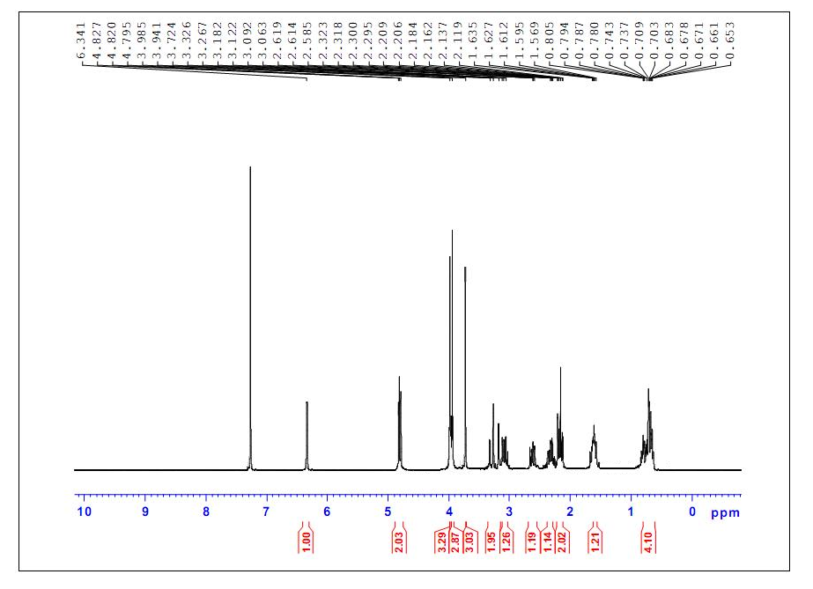
Figure S 1. ¹H NMR (300 MHz, CDCl₃) of 3a
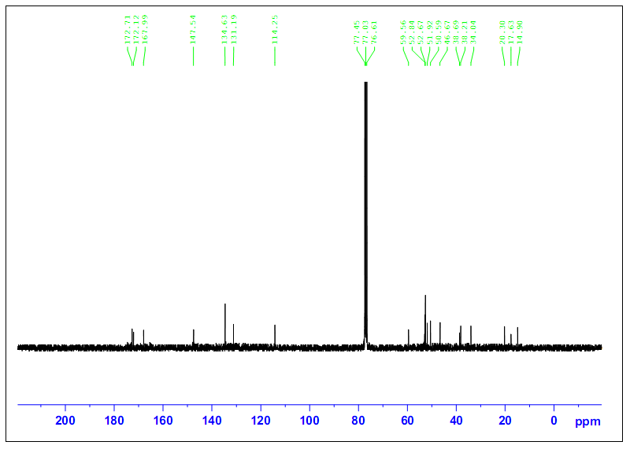
Figure S 2. ¹³C NMR (75 MHz, CDCl₃) of 3a
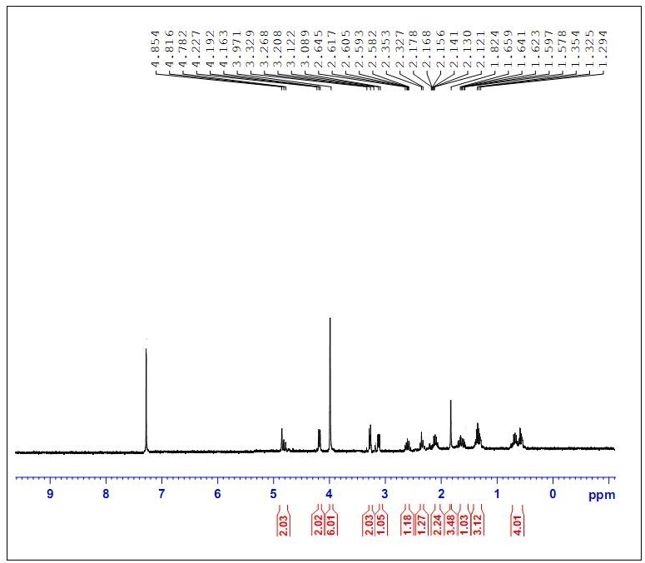
Figure S 3. ¹H NMR (300 MHz, CDCl₃) of 3b
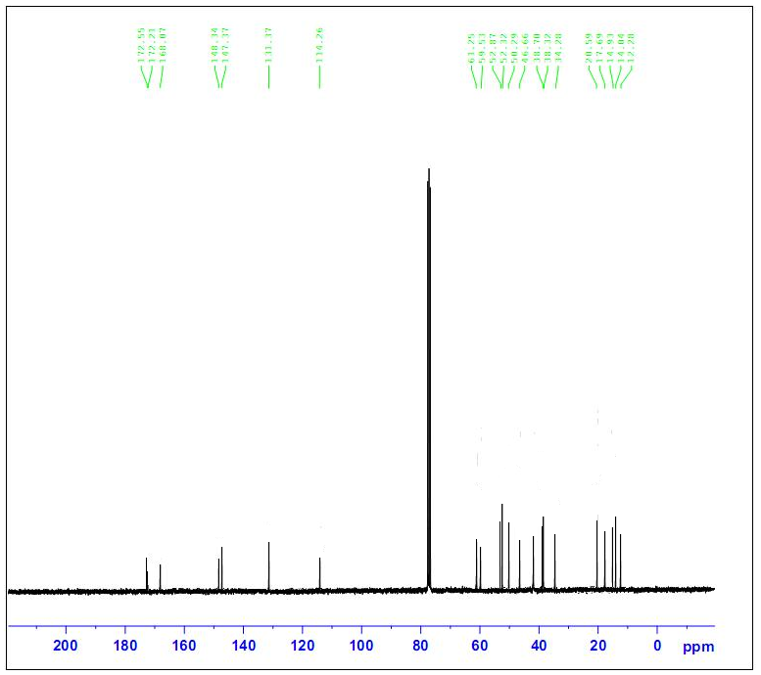
Figure S 4. ¹³C NMR (75 MHz, CDCl₃) of 3b
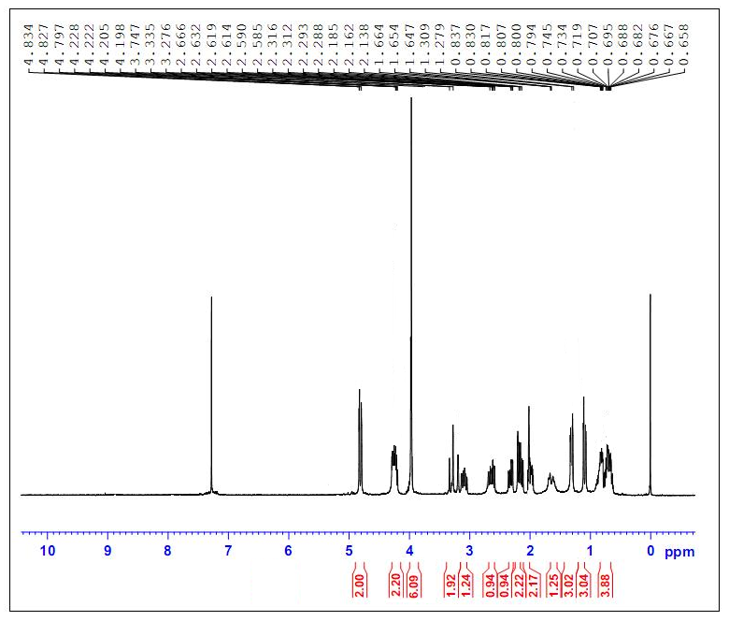
Figure S 5. ¹H NMR (300 MHz, CDCl₃) of 3c
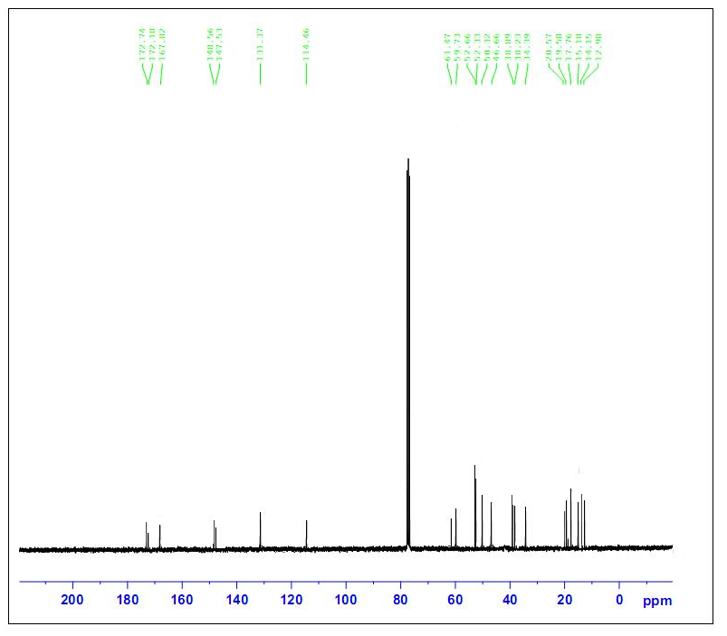
Figure S 6. ¹³C NMR (75 MHz, CDCl₃) of 3c
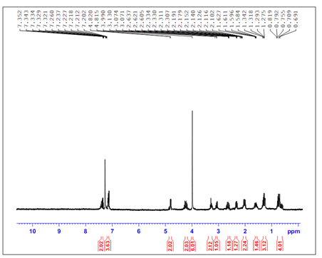
Figure S 7. ¹H NMR (300 MHz, CDCl₃) of 3d
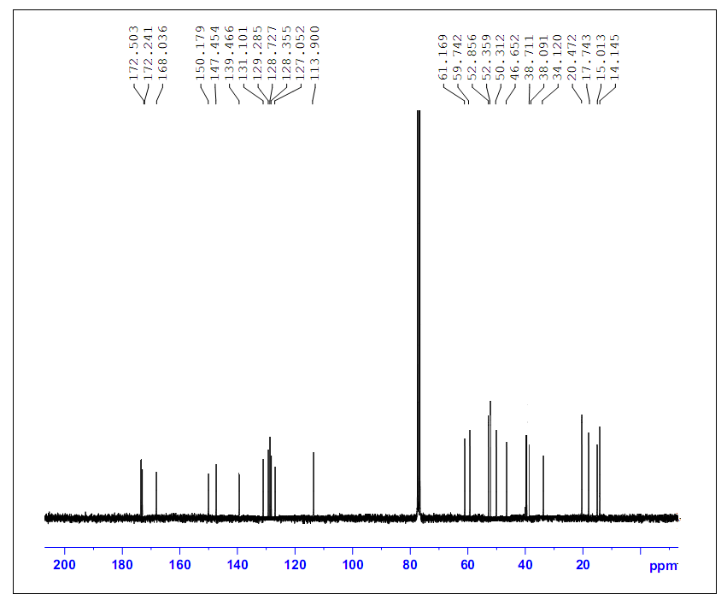
Figure S 8. ¹³C NMR (75 MHz, CDCl₃) of 3d
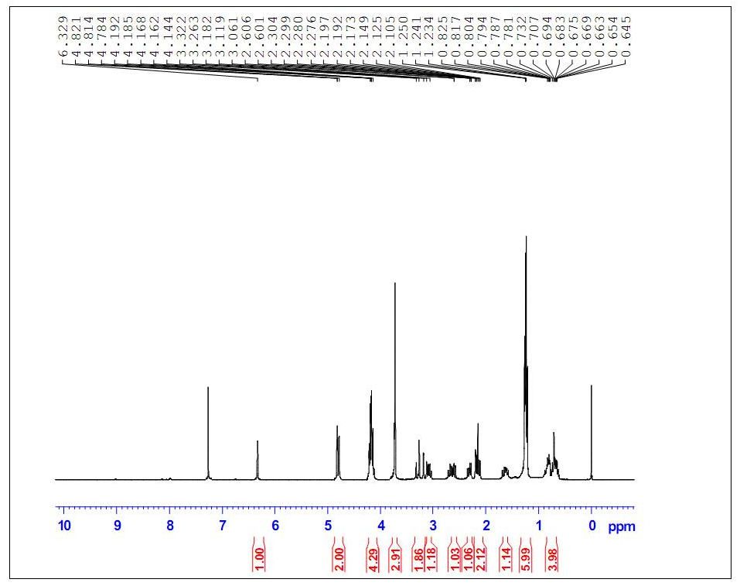
Figure S 9. ¹H NMR (300 MHz, CDCl₃) of 3e
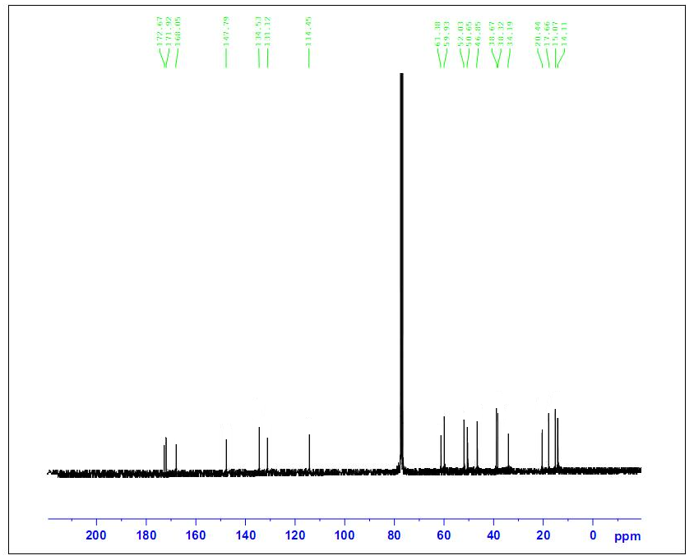
Figure S 10. ¹³C NMR (75 MHz, CDCl₃) of 3e
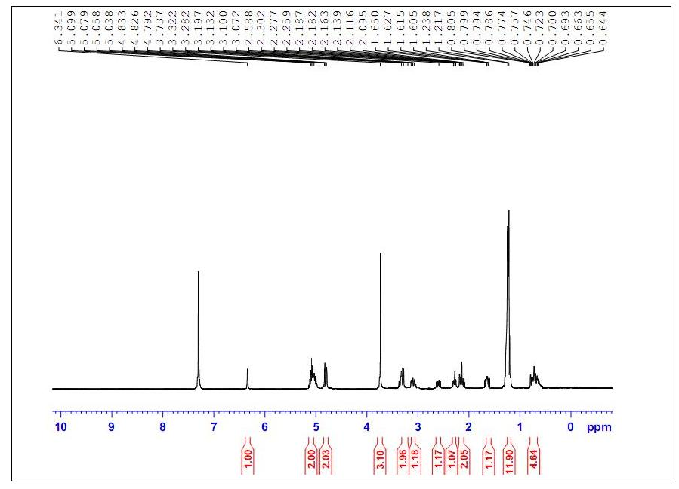
Figure S 11. ¹H NMR (300 MHz, CDCl₃) of 3f
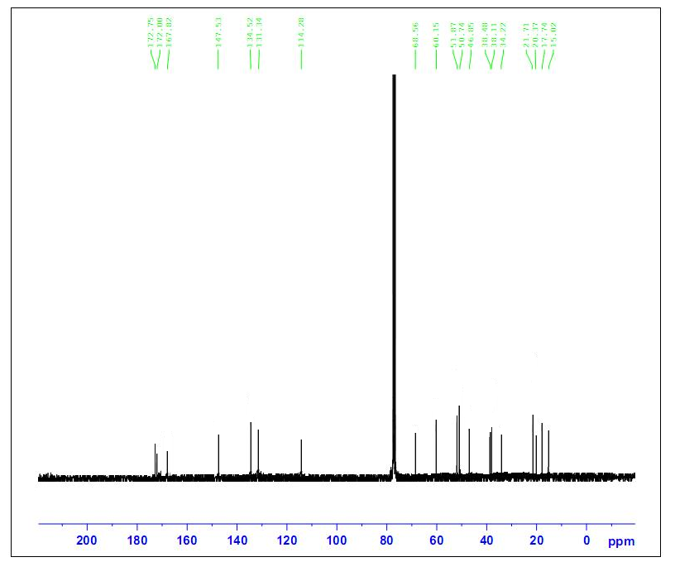
Figure S 12. ¹³C NMR (75 MHz, CDCl₃) of 3f

∗ Corresponding author. Tel.: +91 9478098058; fax: +91-1822255504; e-mail: gaurav@ptu.ac.in (Gaurav Bhargava)

