An Expedient Four Component Synthesis of Substituted Pyrido-pyrimidine Heterocycles in Glycerol: Proline based Low Transition Temperature Mixture (LTTM) and their Antioxidant Activity with Molecular Docking Studies

Priyanka P. Mohireª, Dattatray R. Chandam^{c}, Ajinkya A. Patravale^{d}, Prafulla Choudhari^{e}, Vishram Karandeª, Jai. S. Ghoshª, Madhukar B. Deshmukh*^{a,b}

ªChemistry Research Laboratory, Department of Agrochemicals & Pest Management, Shivaji University, Kolhapur-416004, Maharashtra, India.
^{b}Heterocyclic Chemistry Laboratory, Department of Chemistry, Shivaji University, Kolhapur-416004, Maharashtra, India.
^{c}Department of Chemistry, BhogawatiMahavidyalaya, Kurukali, Kolhapur-416001, Maharashtra, India.
^{d}Department of Chemistry, Vivekananda College Kolhapur-416004, Maharashtra, India.
^{e}Department of Pharmaceutical Chemistry, Bharati Vidyapeeth College of Pharmacy, Kolhapur-416013, Maharashtra, India
Email: shubhlaxmi111@gmail.com
CONTENTS
Sr. No. | Contents | Page no.
1. | Green metrics calculations | 2
2. | Table: Green Chemistry Metrics Calculations of synthesized derivatives 4d₁ to 4d₁₃ | 3
3. | Table 5 DPPH radical scavenging activity of pyrido[2,3-d]pyrimidine derivatives | 4
4. | Fig.1: Significant interaction of molecule 4d₁₂ with myeloperoxidase  Fig.2: Significant interaction of molecule 4d₁₃ with myeloperoxidase | 5
 | Spectroscopic analysis of Synthesized Compounds | 6-26
Green Metrics calculations:
The green metrics such as mass intensity (MI), reaction mass efficiency (RME), carbon efficiency (CE), atom economy (AE) and E-factor have been evaluated for each derivatives using reported literature.¹ It is expected that MI≈1%, RME≈100%, %CE≈100 and %AE≈100 and E-factor≈0. In the calculation, mass of catalyst is excluded as it is recyclable. Green metrics are defined in this manner.

- Mass Intensity (MI) =
Total mass used in the process in g
Mass of product g

∑ Mass of products X 100
∑ Mass of reactant
- Reaction mass efficiency (RME) =
No. of moles of Product X no. of carbons in Product X 100
No. of moles of Reactant X no. of carbons in Reactant

- Carbon efficiency (CE) =

Weight of desired product X 100
∑ Molecular weight of all reactant
- Atom economy (AE) =

Mass of reactant –Mass of product
Mass of product
∑Mass of waste

Mass of product
- E-factor = =

Table 4 Green metrics calculations of synthesized derivatives 4d₁ to 4d₁₃
Entry | Compd.  Code | % Yield | FW Product | Yield (g) | MI | % RME | % CE | % AE | E-  Factor
1. | 4d₁ | 90 | 323.3028 | 290.9725 | 1.23 | 80.83 | 90 | 80.83 | 0.23
2. | 4d₂ | 84 | 357.7478 | 300.5081 | 1.31 | 76.14 | 84 | 76.14 | 0.31
3. | 4d₃ | 88 | 357.7478 | 314.8180 | 1.25 | 79.94 | 88 | 79.94 | 0.25
4. | 4d₄ | 92 | 357.7478 | 329.1279 | 1.19 | 83.50 | 92 | 83.50 | 0.19
5. | 4d₅ | 86 | 368.3003 | 316.7382 | 1.27 | 78.27 | 86 | 78.27 | 0.27
6. | 4d₆ | 90 | 402.1988 | 361.9789 | 1.21 | 82.46 | 90 | 82.46 | 0.21
7. | 4d₇ | 92 | 402.1988 | 370.0228 | 1.18 | 84.28 | 92 | 84.28 | 0.18
8. | 4d₈ | 82 | 353.3288 | 289.7296 | 1.34 | 74.35 | 82 | 74.35 | 0.34
9. | 4d₉ | 92 | 353.3288 | 325.0624 | 1.20 | 83.33 | 92 | 83.33 | 0.20
10. | 4d₁₀ | 86 | 329.3305 | 283.2242 | 1.29 | 77.32 | 86 | 77.32 | 0.29
11. | 4d₁₁ | 90 | 377.3502 | 339.6151 | 1.21 | 82.12 | 90 | 82.12 | 0.21
12. | 4d₁₂ | 80 | 359.2837 | 287.4269 | 1.37 | 72.47 | 80 | 72.47 | 0.37
13. | 4d₁₃ | 92 | 367.3123 | 337.9273 | 1.19 | 83.66 | 92 | 83.66 | 0.19

Table 5 DPPH radical scavenging activity of pyrido[2,3-d]pyrimidine derivatives
Entry | Compd. Code. | (%of Inhibition) at  50 µg/ml | (%of Inhibition) at  100 µg/ml
1. | 4d₁ | 44.31 | 45.57
2. | 4d₂ | 47.17 | 48.18
3. | 4d₃ | 56.18 | 60.48
4. | 4d₄ | 43.80 | 45.49
5. | 4d₅ | 49.36 | 55.09
6. | 4d₆ | 48.27 | 49.95
7. | 4d₇ | 51.64 | 52.90
8. | 4d₈ | 51.22 | 53.32
9. | 4d₉ | 44.65 | 46.25
10. | 4d₁₀ | 44.48 | 46.16
11. | 4d₁₁ | 41.87 | 44.56
12. | 4d₁₂ | 59.22 | 63.43
13. | 4d₁₃ | 60.48 | 60.57
14. | Ascorbic acid | 33.36 | 39.59

Fig.1: Significant interaction of molecule 4d₁₂ with myeloperoxidase

Fig.2: Significant interaction of molecule 4d₁₃ with myeloperoxidase

Spectroscopic analysis of Synthesized Compounds
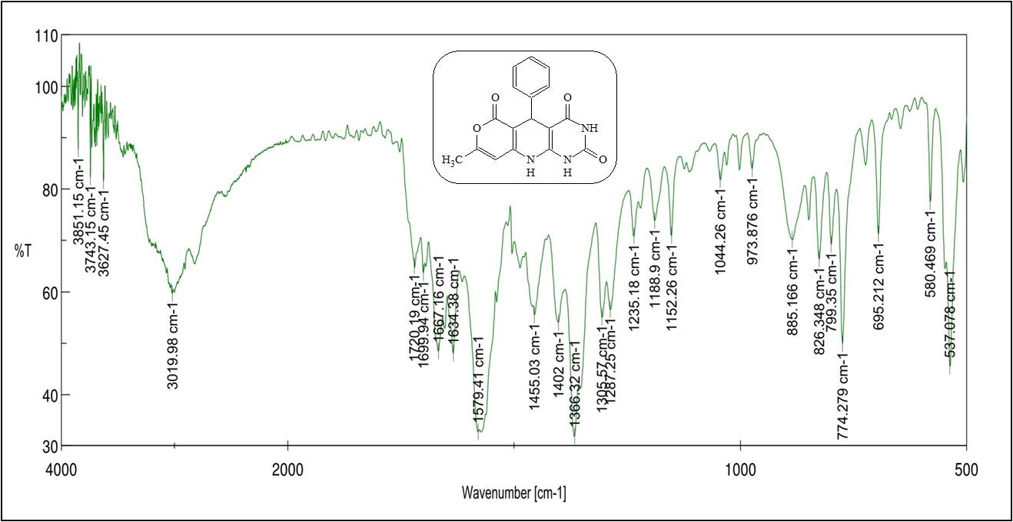
Fig. 3: IR spectrum of 8-methyl-5-phenyl-5,10-dihydro-2H-pyrano[3',4':5,6]pyrido[2,3-d]pyrimidine-2,4,6(1H,3H)-trione (4d₁)
Fig. 4: ¹H NMR spectrum of 8-methyl-5-phenyl-5,10-dihydro-2H-pyrano[3',4':5,6]pyrido[2,3-d]pyrimidine-2,4,6(1H,3H)-trione (4d₁)
Fig. 5: ¹³C NMR spectrum of 8-methyl-5-phenyl-5,10-dihydro-2H-pyrano[3',4':5,6]pyrido[2,3-d]pyrimidine-2,4,6(1H,3H)-trione (4d₁)

Fig. 6: HRMS spectrum of 8-methyl-5-phenyl-5,10-dihydro-2H-pyrano[3',4':5,6]pyrido[2,3-d]pyrimidine-2,4,6(1H,3H)-trione (4d₁)
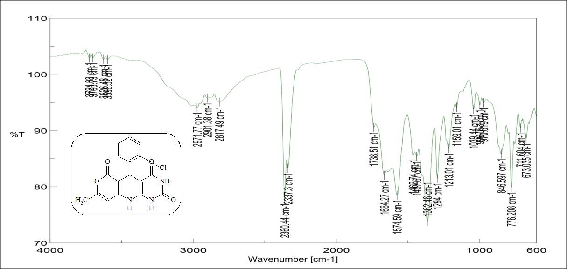
Fig. 7: IR spectrum of 5-(2-chlorophenyl)-8-methyl-5,10-dihydro-2H-pyrano[3',4':5,6]pyrido[2,3-d]pyrimidine-2,4,6(1H,3H)-trione (4d₂)

Fig. 8: ¹H NMR spectrum of 5-(2-chlorophenyl)-8-methyl-5,10-dihydro-2H-pyrano[3',4':5,6]pyrido[2,3-d]pyrimidine-2,4,6(1H,3H)-trione (4d₂)
Fig. 9: ¹³C NMR spectrum of 5-(2-chlorophenyl)-8-methyl-5,10-dihydro-2H-pyrano[3',4':5,6]pyrido[2,3-d]pyrimidine-2,4,6(1H,3H)-trione (4d₂)

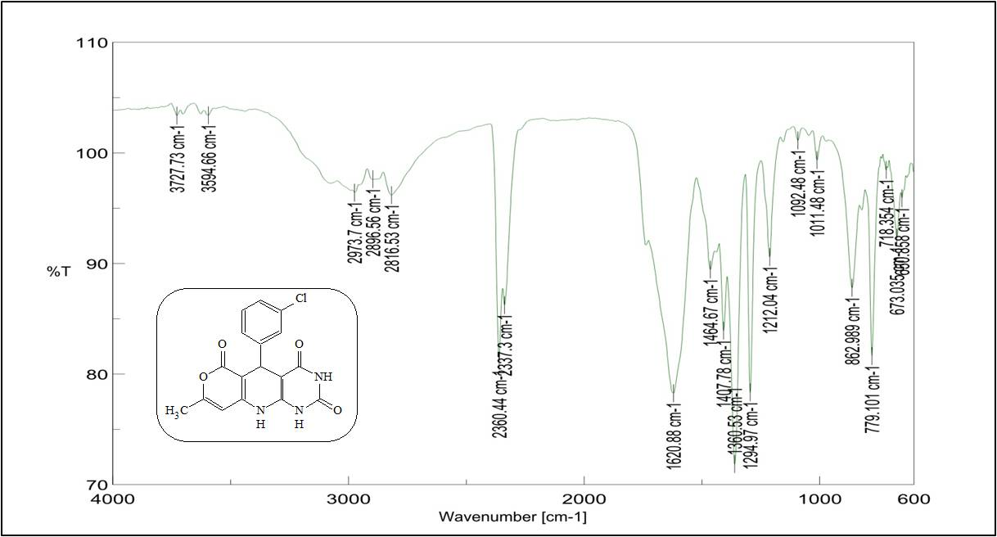
Fig. 10: IR spectrum of 5-(3-chlorophenyl)-8-methyl-5,10-dihydro-2H-pyrano[3',4':5,6]pyrido[2,3-d]pyrimidine-2,4,6(1H,3H)-trione (4d₃)
Fig. 11: ¹H NMR spectrum of 5 -(3-chlorophenyl)-8-methyl-5,10-dihydro-2H-pyrano[3',4':5,6]pyrido[2,3-d]pyrimidine-2,4,6(1H,3H)-trione (4d₃)

Fig. 12: ¹³C NMR spectrum of 5 -(3-chlorophenyl)-8-methyl-5,10-dihydro-2H-pyrano[3',4':5,6]pyrido[2,3-d]pyrimidine-2,4,6(1H,3H)-trione (4d₃)
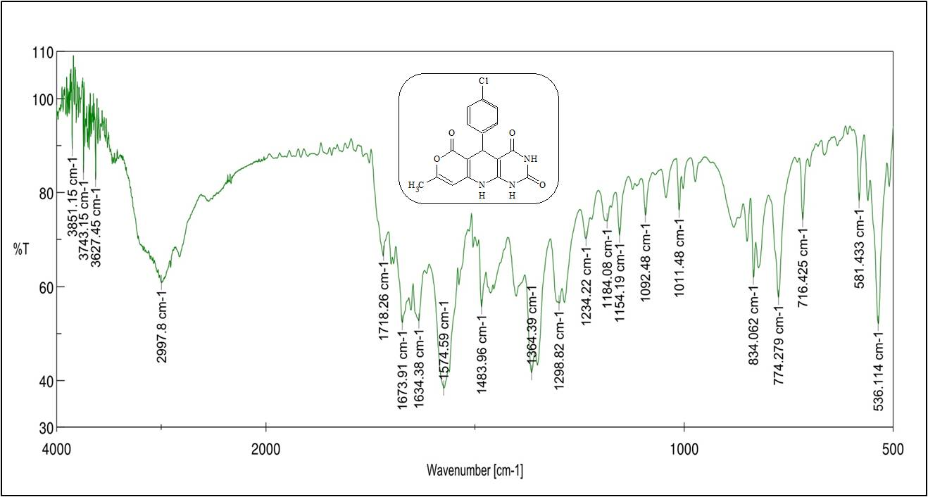
Fig. 13: IR spectrum of 5-(4-chlorophenyl)-8-methyl-5,10-dihydro-2H-pyrano[3',4':5,6]pyrido[2,3-d]pyrimidine-2,4,6(1H,3H)-trione (4d₄)

Fig. 14: ¹H NMR spectrum of 5-(4-chlorophenyl)-8-methyl-5,10-dihydro-2H-pyrano[3',4':5,6]pyrido[2,3-d]pyrimidine-2,4,6(1H,3H)-trione (4d₄)
Fig. 15: ¹³C NMR spectrum of 5-(4-chlorophenyl)-8-methyl-5,10-dihydro-2H-pyrano[3',4':5,6]pyrido[2,3-d]pyrimidine-2,4,6(1H,3H)-trione (4d₄)

Fig. 16: HRMS spectrum of 5-(4-chlorophenyl)-8-methyl-5,10-dihydro-2H-pyrano[3',4':5,6]pyrido[2,3-d]pyrimidine-2,4,6(1H,3H)-trione (4d₄)
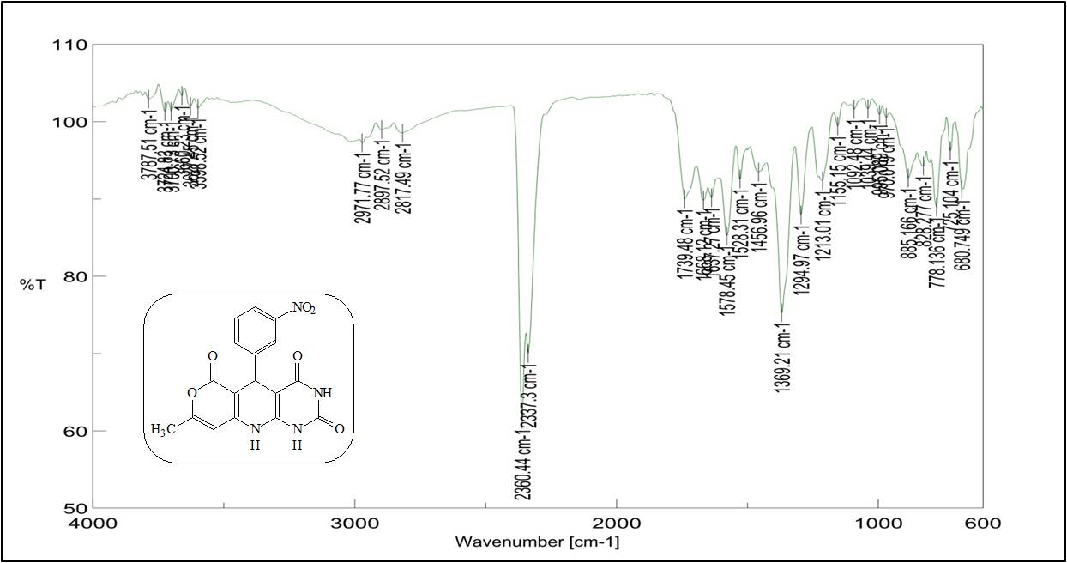
Fig. 17: IR spectrum of 8-methyl-5-(3-nitrophenyl)-5,10-dihydro-2H-pyrano[3',4':5,6]pyrido[2,3-d]pyrimidine-2,4,6(1H,3H)-trione (4d₅)

Fig. 18: ¹H NMR spectrum of8-methyl-5-(3-nitrophenyl)-5,10-dihydro-2H-pyrano[3',4':5,6]pyrido[2,3-d]pyrimidine-2,4,6(1H,3H)-trione (4d₅)

Fig. 19: ¹³C NMR spectrum of 8-methyl-5-(3-nitrophenyl)-5,10-dihydro-2H-pyrano[3',4':5,6]pyrido[2,3-d]pyrimidine-2,4,6(1H,3H)-trione (4d₅)

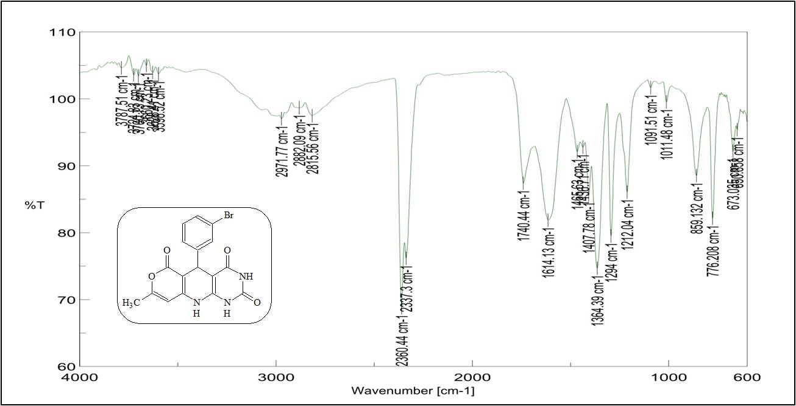

Fig. 20: IR spectrum of 5-(3-bromophenyl)-8-methyl-5,10-dihydro-2H-pyrano[3',4':5,6]pyrido[2,3-d]pyrimidine-2,4,6(1H,3H)-trione (4d₆)

Fig. 21: ¹H NMR spectrum of 5-(3-bromophenyl)-8-methyl-5,10-dihydro-2H-pyrano[3',4':5,6]pyrido[2,3-d]pyrimidine-2,4,6(1H,3H)-trione (4d₆)

Fig. 22: ¹³C NMR spectrum of 5-(3-bromophenyl)-8-methyl-5,10-dihydro-2H-pyrano[3',4':5,6]pyrido[2,3-d]pyrimidine-2,4,6(1H,3H)-trione (4d₆
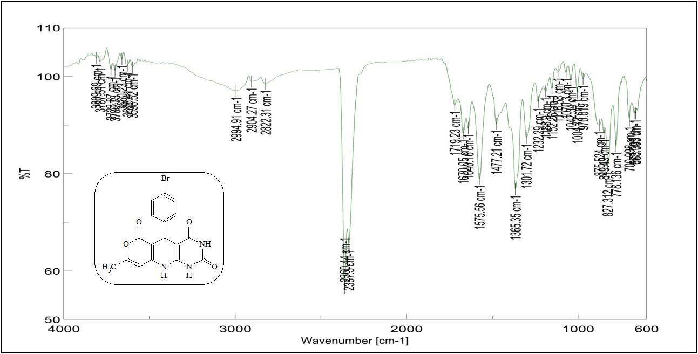
Fig. 23: IR spectrum of 5-(4-bromophenyl)-8-methyl-5,10-dihydro-2H-pyrano[3',4':5,6]pyrido[2,3-d]pyrimidine-2,4,6(1H,3H)-trione (4d₇)

Fig. 24: ¹H NMR spectrum of 5-(4-bromophenyl)-8-methyl-5,10-dihydro-2H-pyrano[3',4':5,6]pyrido[2,3-d]pyrimidine-2,4,6(1H,3H)-trione (4d₇)
Fig. 25: ¹³C NMR spectrum of 5-(4-bromophenyl)-8-methyl-5,10-dihydro-2H-pyrano[3',4':5,6]pyrido[2,3-d]pyrimidine-2,4,6(1H,3H)-trione (4d₇)

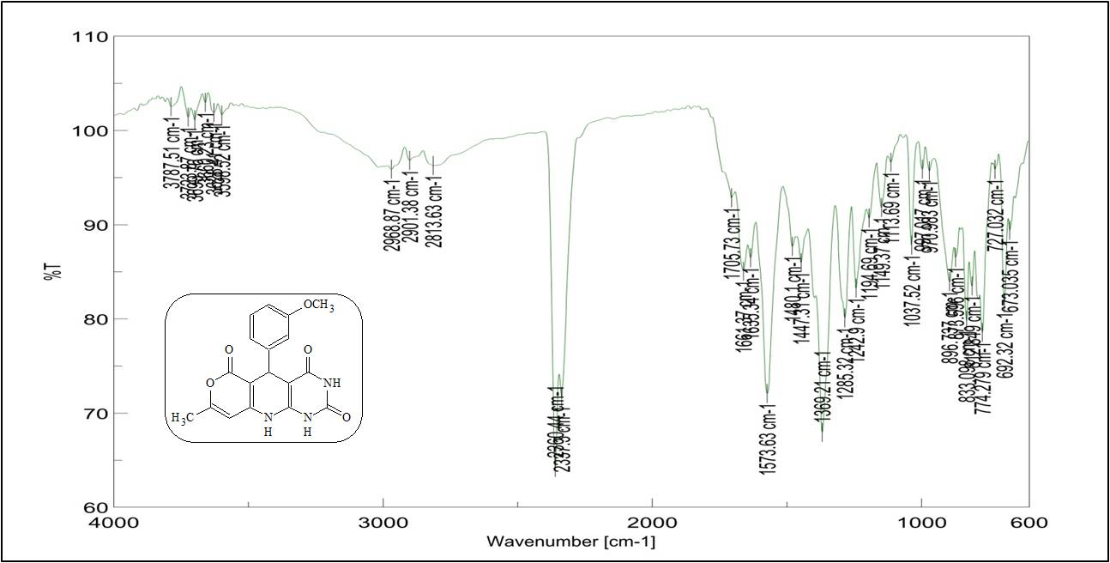
Fig. 26: IR spectrum of 5-(3-methoxyphenyl)-8-methyl-5,10-dihydro-2H-pyrano[3',4':5,6]pyrido[2,3-d]pyrimidine-2,4,6(1H,3H)-trione (4d₈)
Fig. 27: ¹H NMR spectrum of 5-(3-methoxyphenyl)-8-methyl-5,10-dihydro-2H-pyrano[3',4':5,6]pyrido[2,3-d]pyrimidine-2,4,6(1H,3H)-trione (4d₈)

Fig. 28: ¹³C NMR spectrum of 5-(3-methoxyphenyl)-8-methyl-5,10-dihydro-2H-pyrano[3',4':5,6]pyrido[2,3-d]pyrimidine-2,4,6(1H,3H)-trione (4d₈)

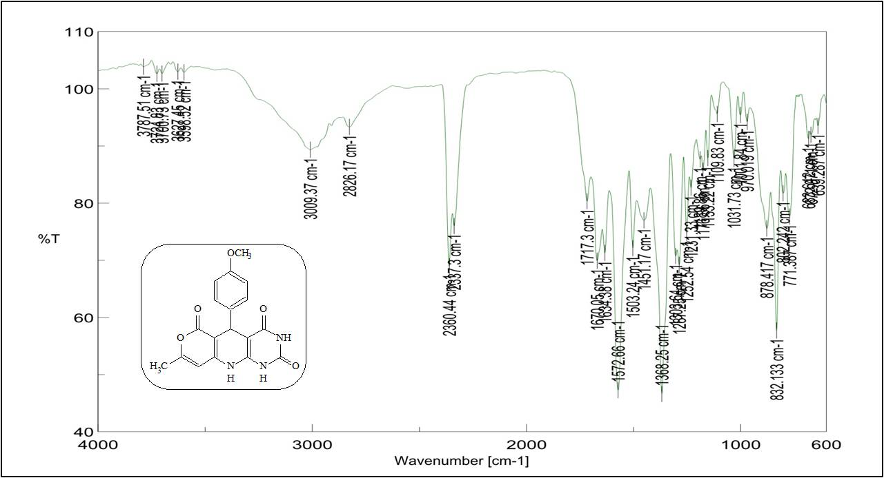
Fig. 29: IR spectrum of 5-(4-methoxyphenyl)-8-methyl-5,10-dihydro-2H-pyrano[3',4':5,6]pyrido[2,3-d]pyrimidine-2,4,6(1H,3H)-trione (4d₉)

Fig. 30: ¹H NMR spectrum of 5-(4-methoxyphenyl)-8-methyl-5,10-dihydro-2H-pyrano[3',4':5,6]pyrido[2,3-d]pyrimidine-2,4,6(1H,3H)-trione (4d₉)

Fig. 31: ¹³C NMR spectrum of 5-(4-methoxyphenyl)-8-methyl-5,10-dihydro-2H-pyrano[3',4':5,6]pyrido[2,3-d]pyrimidine-2,4,6(1H,3H)-trione (4d₉)

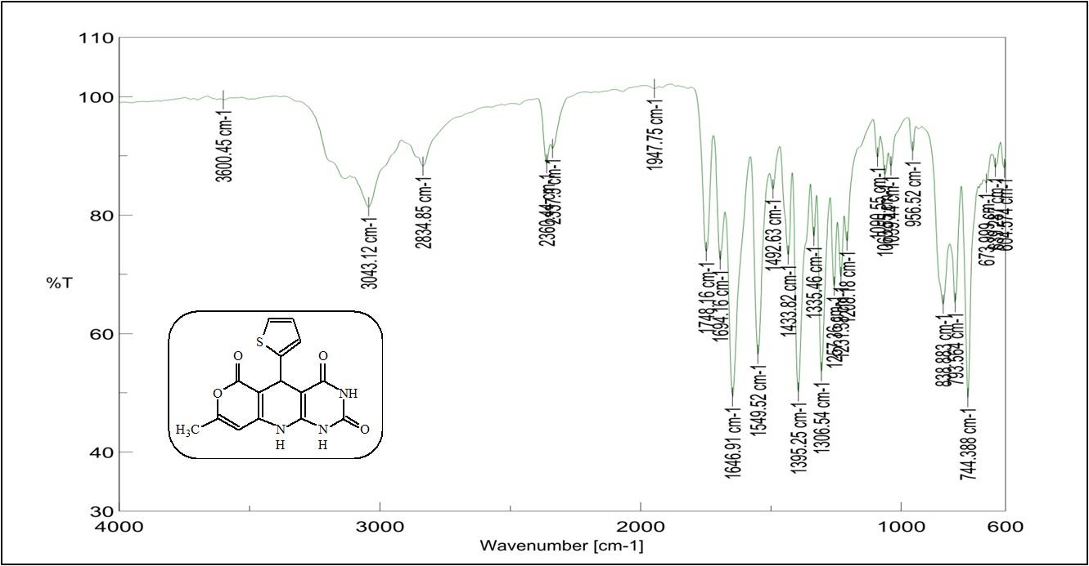
Fig. 32: IR spectrum of 8-methyl-5-(thiophen-2-yl)-5,10-dihydro-2H-pyrano[3',4':5,6]pyrido[2,3-d]pyrimidine-2,4,6(1H,3H)-trione (4d₁₀)
Fig. 33: ¹H NMR spectrum of 8-methyl-5-(thiophen-2-yl)-5,10-dihydro-2H-pyrano[3',4':5,6]pyrido[2,3-d]pyrimidine-2,4,6(1H,3H)-trione (4d₁₀)

Fig. 34: ¹³C NMR spectrum of 8-methyl-5-(thiophen-2-yl)-5,10-dihydro-2H-pyrano[3',4':5,6]pyrido[2,3-d]pyrimidine-2,4,6(1H,3H)-trione (4d₁₀)
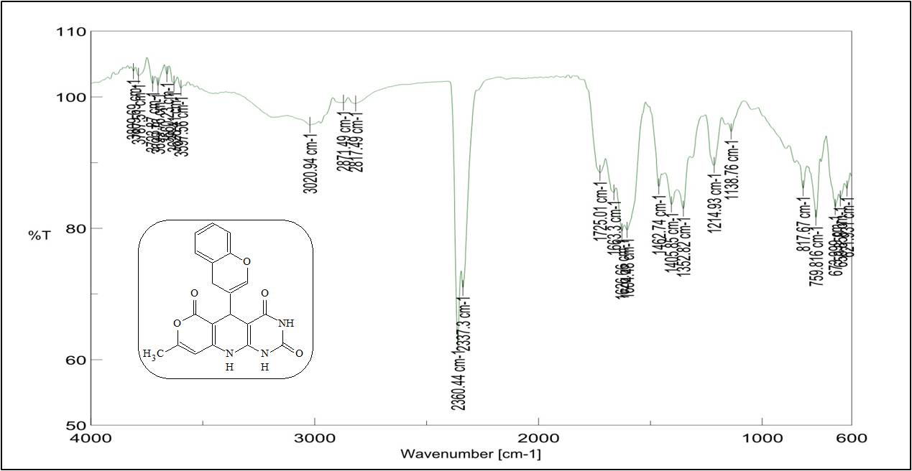

Fig. 35: IR spectrum of 5-(4H-1-benzopyran-3-yl)-8-methyl-5,10-dihydro-2H-pyrano[3',4':5,6] pyrido [2,3-d] pyrimidine-2,4,6(1H,3H)-trione (4d₁₁)

Fig. 36: ¹H NMR spectrum of 5-(4H-1-benzopyran-3-yl)-8-methyl-5,10-dihydro-2H-pyrano[3',4':5,6] pyrido [2,3-d] pyrimidine-2,4,6(1H,3H)-trione (4d₁₁)

Fig. 37: ¹³C NMR spectrum of 5-(4H-1-benzopyran-3-yl)-8-methyl-5,10-dihydro-2H-pyrano[3',4':5,6] pyrido [2,3-d] pyrimidine-2,4,6(1H,3H)-trione (4d₁₁)

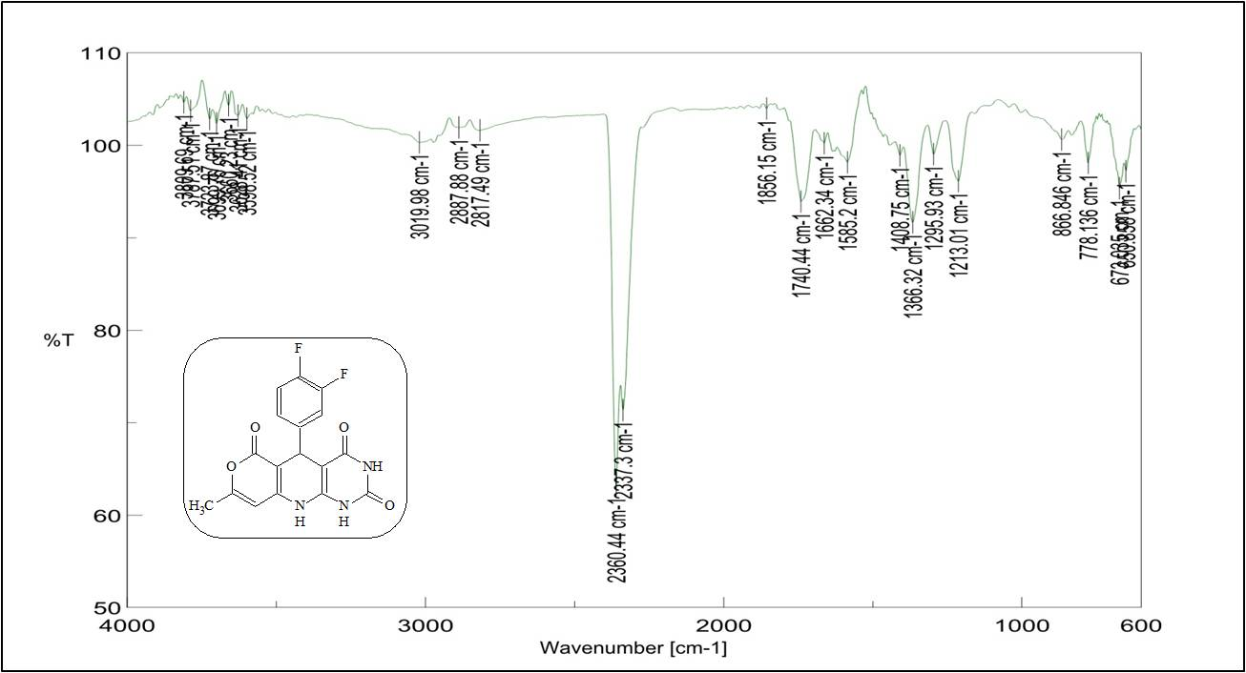
Fig. 38:IR spectrum of 5-(3,4-difluorophenyl)-8-methyl-5,10-dihydro-2H pyrano[3',4':5,6]pyrido[2,3-d]pyrimidine-2,4,6(1H,3H)-trione (4d₁₂)

Fig. 39: ¹H NMR spectrum of 5-(3,4-difluorophenyl)-8-methyl-5,10-dihydro-2H-pyrano[3',4':5,6]pyrido[2,3-d]pyrimidine-2,4,6(1H,3H)-trione (4d₁₂)

Fig. 40: ¹³C NMR spectrum of 5-(3,4-difluorophenyl)-8-methyl-5,10-dihydro-2H-pyrano[3',4':5,6]pyrido[2,3-d]pyrimidine-2,4,6(1H,3H)-trione (4d₁₂)

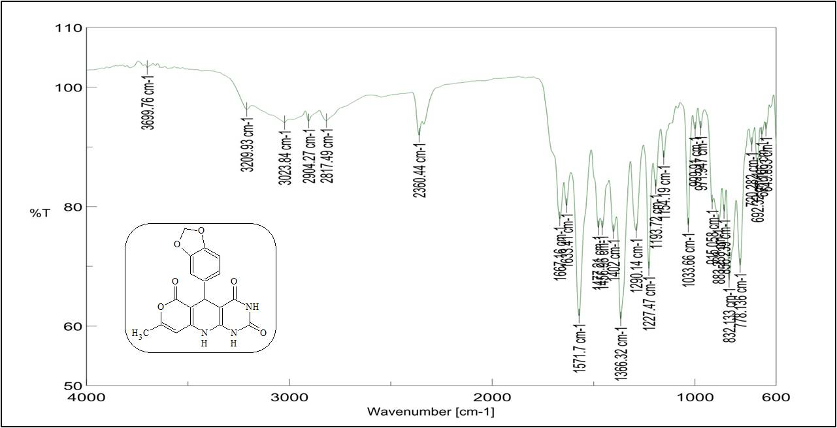
Fig. 41: IR spectrum of 5-(2H-1,3-benzodioxol-5-yl)-8-methyl-5,10-dihydro-2H-pyrano[3',4':5,6]pyrido[2,3-d]pyrimidine-2,4,6(1H,3H)-trione (4d₁₃)

Fig. 42: ¹H NMR spectrum of 5-(2H-1,3-benzodioxol-5-yl)-8-methyl-5,10-dihydro-2H-pyrano[3',4':5,6]pyrido[2,3-d]pyrimidine-2,4,6(1H,3H)-trione (4d₁₃)
Fig. 43: ¹³C NMR spectrum of 5-(2H-1,3-benzodioxol-5-yl)-8-methyl-5,10-dihydro-2H-pyrano[3',4':5,6]pyrido[2,3-d]pyrimidine-2,4,6(1H,3H)-trione (4d₁₃)

