Supplementary material
The technical improvements that were introduced into Radosys Radometer MN-Series in order to optimize its performance are described in this supplementary material.

Optimized autofocusing
Challenge
The effective gleaning of information about object boundaries is of utmost importance. In general, an autofocus algorithm scans through a range of possible distances between object and objective over a given field of view. Each occurring object-image distance is ranked based on the sharpness of the objects visible on that specific plane. The ranking value is calculated with a so-called autofocus function, which is constructed so that its global maximum corresponds to the sharpest plane.
Sun et al (Sun et al. 2004) compared the 18 most frequent autofocus functions and proposed a guideline for selecting the optimal one for different microscopy applications. When subsampled images are used in order to increase execution speed, gradient-based algorithms are advised. Yuchen et al (Yuchen et al 2013) concluded that, for metaphase chromosome images – whose characteristics are similar to the micronucleus images, the Brenner gradient gives the best accuracy compared to manual focusing. The Brenner gradient is based on the sum of the square of the difference between the intensities of the two neighbors of each pixel.
The Radosys Ltd. imaging systems for the detection of alpha and proton tracks on PADC (poly-allyl-diglycol-carbonate) (Hulber 2009; Seimetz et al. 2018) were the inspiration and foundation for the RS-MN. Their autofocusing technique uses subsampling and gradient-based autofocus function.
The used focus function is the following:
$F(z)=\sum_{x,y}{\left|i\left(x,y,z\right)-i(x+d,y,z)\right|}$, (1)
with the criterion $\left|i\left(x,y,z\right)-i(x+d,y,z)\right|> α$, where i(x,y,z) is the intensity of the pixel at the x, y and z coordinates, while d and $α$ are constants.
However, it was found that a simple gradient-based autofocus function has limitations when more than one type of specimen can be found on the same field of view. Dust particles are significantly thicker than the dried fixed cells on the slide surface. They are typically larger in vertical elevation as well, therefore they have longer perimeter and give more contribution to the sum of gradient. If the distance between the focal planes of these larger objects and the cells is bigger than the depth of the field of the optical construction, then in the best ranked plane the cells and nuclei are blurry. This bias can happen also when a large number of smaller particles with prominent contrast are present such as stain residues.
Technical solution
In order to reduce the disturbing effect of these artifact edges, two additional autofocus function elements were introduced. The RS-MN autofocusing algorithm uses a more complex figure of merit that combines the sum of gradient (F from Equation 1.) with the number of bright and dark pixels (G from Equation 2.).
$G(z)=b+w$ (2)
Here b and w represent the number of black and white pixels. The threshold intensities of the black and white pixels are determined relative to the most frequent bin in the intensity histogram (M). So a pixel is considered to be white, if $i\left(x,y\right)>M+20$ and black if $i\left(x,y\right)<M-20$. Basically, the pixels that do not belong to either group are the background. The second restriction is that all black and white pixels taken into account should fulfill the following criterion:
$\min\left(i\left(x,y\right),i\left(x+d,y\right)\right)> β$, where β is a constant. Combining equations (1) and (2) above yields $H\left(z\right)=f∙F\left(z\right)+g∙G\left(z\right)+h,$where f, g and h are empirical constants.
Figure S/1 gives an overview how the used image parameters (black and white pixels, sum of gradients) change with the z-position. The optimal focal plane from the point of view of image processing of MN assay samples burden with artifacts is the one marked with (c) in Figure S/1, where the number of black and white pixels has a minimum. Note, that it does not match with the location of the maximum of the sum of gradients.
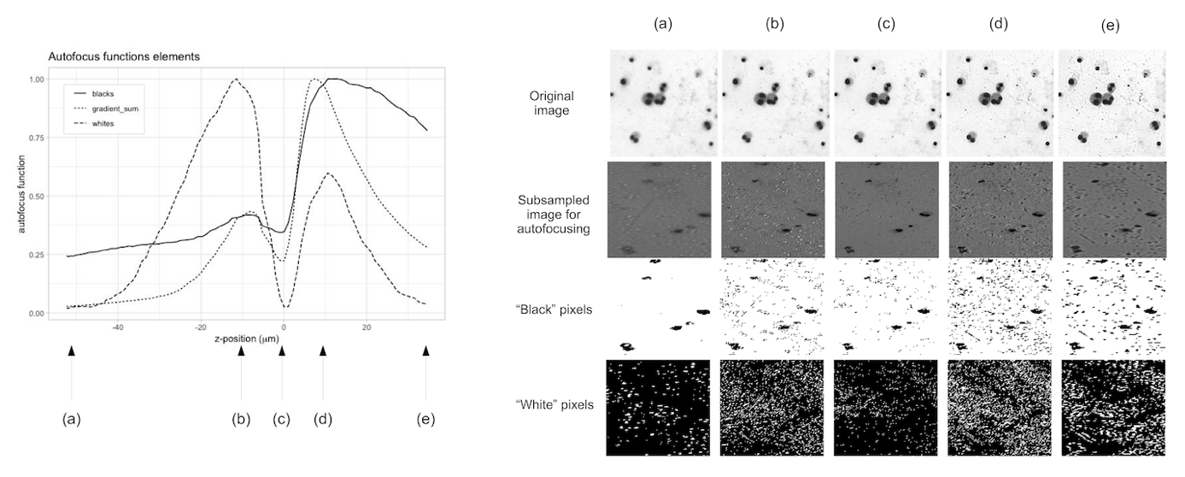
Figure 1 Demonstration of the typical characteristics of the elements used for the complex autofocus function. Left side: Normalized functions of the number of black pixels, white pixels and summary of gradients versus the position of the slide in z-direction compared to the focal plane. Right side: Original and masked images are shown in five different z-positions (a) Blurry image, almost invisible blurred artifacts with low contrast (b) Slightly defocused, lots of refracted artifacts with white centers (c) Sharp image at focal plane, minimal number of white and black pixels (d) Slightly defocused, lots of artifacts with black centers with white contour (e) Blurry image with prominent black artifacts.
A sampling-fitting method is used to speed up the focusing procedure. It consists of the selection of five representative fields of view out of the 392 that are sampled on the surface of each slide. Five ideal focal plane positions are determined for these five selected fields of view by autofocusing. Finally, a plane is fitted through the five centers of the focused fields of view. If the average distance between the central points and the fitted plane is smaller than 6 µm then the fit is considered to be successful. In this case, the remaining 387 fields are not examined separately, and the optimal z-coordinates are interpolated according to the fitted plane. The sampling-fitting method requires 20 s instead of the 270 s needed for autofocusing all fields of view one-by-one.

Multi-layer MN artifact elimination
Challenge
The common features of the MNi and MN-like artifacts are the following: they are both located within the cell boundary from the point of view of linear optical projection; they are both clearly distinguishable from the cytoplasm based on their darker shade; they both fall in the allowed size range relative to the daughter nuclei in the same cell. In the first part of the MN segmentation subroutine all objects that fulfill these criteria are identified and called 'MN-candidates'. There are simple cases when the second part, which is the classification between real MN and MN-like artifacts, is straightforward: that is when i) the stain residue is not circularly shaped, contains bumps on its edges; ii) the stain residue is significantly darker than the darkest area of the main nuclei; iii) the micronucleus size is bigger than the typical size of the stain residues (see examples in Figure S/2). As a result, the allowed range of the next four parameters linked with image features which are used to optimize the micronucleus classifier settings, respectively i) convexity and eccentricity ii) staining intensity iii) minimum size.
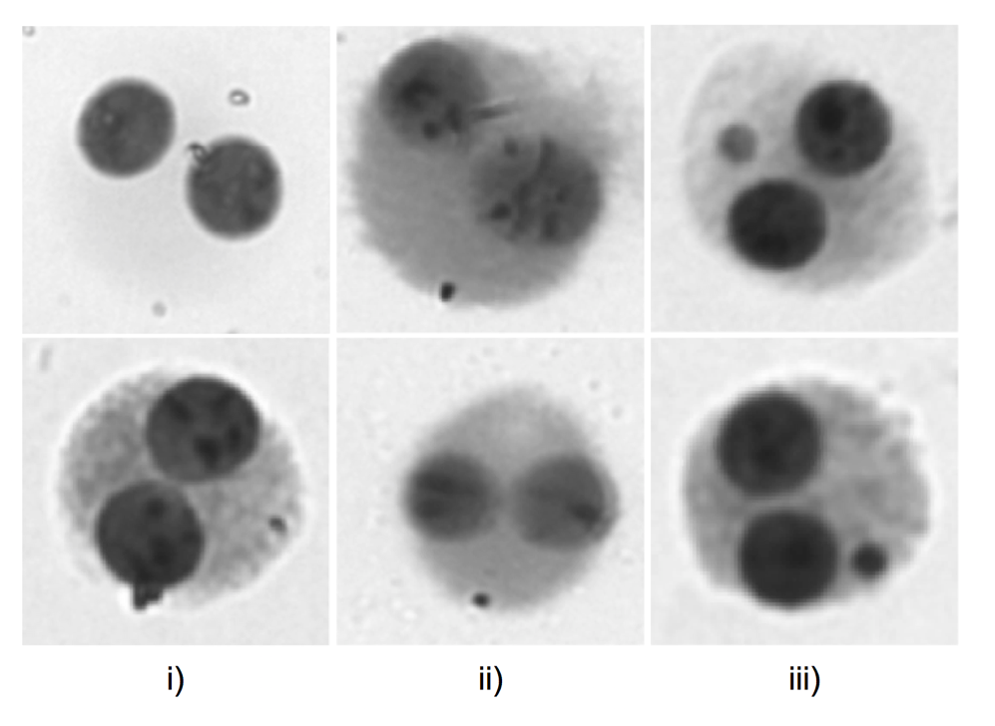
Figure 2 Examples for cases when the separation of real MN and MN-like artifacts are straightforward based on the geometrical and intensity features. Cleary an artifact i) the stain residue is not circularly shaped, contains bumps on its edges ii) the stain residue is significantly darker than the darkest area of the main nuclei. Clearly not an artifact: iii) the micronucleus size is bigger than the typical size of the stain residues
Technical solution
The RS-MN system introduced a so-called multi-layer mode, that takes one image in the regular focal plane and a second image that is defocused. The secondary plane is defocused in a way that the refractive stain residues become significantly lighter, but micronuclei keep almost the same shade. Figure S/3 shows the average intensity difference of a group of typical MN-candidates on the two types of images. It proves that the phenomenon of the MN-artifact refraction becomes detectable. A well-chosen threshold tells the MN-classifier what the largest allowed change in intensity is between focused and defocused image within the edges of the MN-candidate. Although the intensity difference ranges are overlapping, so the distinction between MN and artifact is not 100% effective, the MN-like artifact elimination can be considerably improved.
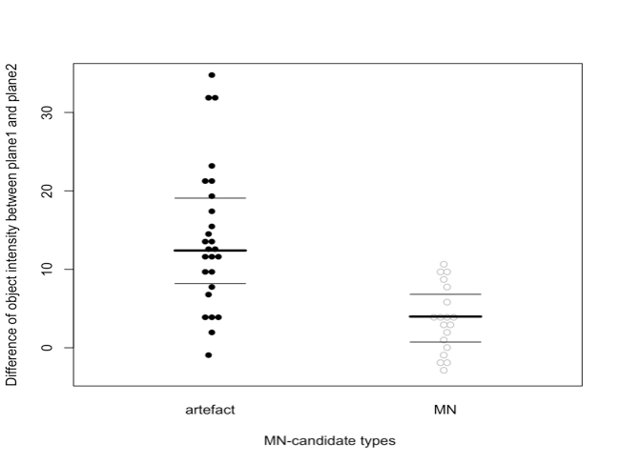
Figure 3 The difference in intensity within the contours of MN-candidates between focused and defocused images. The MN-candidate objects are separated into two classes: real MN and MN-like artifact (mostly stain residues). (the intensity scale of the pixels on the captured images goes from black to white on a 0-255 range) a) shows the variability of the MN-candidates. Bold line marks are the average, the thin horizontal lines mark the 25% and 75%)
The so-called multi-layer mode applied by RS-MN takes not only one but two images from the same field of view in two different planes. The first plane is the regular focal plane optimized by the combined autofocus function, where the boundaries of the cell and nucleus are the sharpest. The secondary plane is defocused by 5 µm. The latter is chosen so that the refractive stain residues become significantly lighter, but micronuclei keep almost the same shade.

Spatial resolution of scoring methods
Challenge
The detection of the MN strongly depends on the resolution (either digital or optical) of the examined image. However, in automated procedures accuracy and speed always have an inverse relationship, so it is not necessarily beneficial to maximize the magnification of the optics of the automated system.
A complex task was equating the resolution of an image from a standard laboratory microscope used by bare eyes and the resolution of an image acquired with a digital microscope and displayed on a monitor screen. With analog microscopy, the total visual magnification is assessed as the ratio of the size of the image projected to the retina and the real dimension of the subject. This is the product of the magnification of the objective, the ocular and optionally the tube. The resolution of a digital microscope is often given in μm/pixel, indicating how many micrometers of the subject fit into one pixel of the digital image. This does not only depend on the optical feature of the digital microscope, but also on the resolution of the camera, the size of the display screen and the zoom factor of the image.
Technical solution
In the case of RS-MN, after multilevel optimization a 20x objective and a tube with 2x factor were chosen. For a fair intercomparison between visual and automated scoring, a so-called medium resolution visual scoring was introduced as well. With this lower magnification, the image quality in the visual evaluation and in the automated were similar.
The semi-automated scoring is an extension of the fully automated method providing the possibility to enhance the detection accuracy of an object by human review. In the reviewing step, one third of the field of view fills the display screen with a resolution of 1280 x 1024 pixels and 3x digital zoom. In our approach, the magnification of the medium-resolution analogue set-up approaches that of the semi-automated RS system when the observer is at 30 cm from the display screen. While the review step requires some extra time, the total duration of the evaluation is still around half of the visual scoring. The time gain is not constant, and it is the highest when undamaged cells are few, when empty fields of view are many, and when cell debris must be manually scrolled over until a scorable binucleated cell is found.

Main steps of the segmentation algorithm
Cell-like objects are identified based on an adaptive thresholding method. All pixels whose intensity is below the threshold are identified as part of a cell candidate. Pixels above the threshold, i.e. the lighter ones, are classified as background. The threshold is determined separately for each field of view. This adaptive threshold calculation is based on the pixel intensity histogram of the field of view. Each cell candidate is processed through a classification filter that decides whether the object is sufficiently similar to a real cell. Five parameters of the cell candidates are computed and checked against the acceptable ranges. The range limits are optimized to maximize the true positive / false positive detection rate for binucleated cells. The optimization is done on a reference blood sample irradiated by 2 Gy of X-rays (Set A / 0 Gy in Table 1.). This dose level is a good choice for creating a reference slide since it produces sufficient MN frequency while keeping the cell structure essentially intact. The parameters that are used for classification are geometrical and intensity features, for example: minor axis of fitted ellipse, average intensity, homogeneity of staining, convexity and elongation.
The inner structure of each cell is then examined for the encompassed nucleus. The core of the nucleus segmenting routine is a modified Hough transform (Smereka and Dulȩba 2008). The dynamic range of nucleus sizes is used to increase the robustness of the segmentation algorithm. The nucleus radius used in the Hough transform is not fixed but varies within a certain range in relation to the cell diameter. Simply using a fixed radius range would be either too narrow to match the possible variability of cells or too wide as an input for the Hough transform that gives artifacts. Other factors that are also involved in the artifact elimination are: the contrast level of a nucleus compared to the cytoplasm and the nucleus size relative to the cell size. If exactly two nuclei are found inside a cell, then the cell is labelled as binucleated (BN) and it is further examined for micronuclei.
The segmentation of MN candidates is a more complex process. It starts with a smoothing step followed by a top-hat transform with a circular structural element using mathematical morphology. This step identifies all the circular darker spots that are inside the cytoplasm but outside the daughter nuclei. A correction step is needed to eliminate the dark spots that are only caused by the inhomogeneities of the cytoplasm. The correction is done by the method of mathematical morphology erosion. Finally, with a watershed process, the touching micronuclei are separated from each other. The second part of the reference set is a sample irradiated with 2 Gy of 250 kV X-rays (sample set A / 2 Gy in Table 1), which was used to optimize the MN identification parameters.

