Appendix

Table A.1. Descriptive statistics of selected variables: National elections

 | N | Mean | St. Dev. | Min |  |  | Max
Turnout | 19,970 | 0.896 | 0.305 | 0 |  |  | 1
Congruence | 19,970 | -1.167 | 2.338 | -9 |  |  | 0
Closest party in national government | 19,970 | 0.339 | 0.473 | 0 |  |  | 1
Closest party: Regionalist | 19,970 | 0.152 | 0.359 | 0 |  |  | 1
Extreme ideology | 19,970 | 0.133 | 0.339 | 0 |  |  | 1
Regional welfare competences (x100) | 19,970 | 13.342 | 4.150 | 4.370 |  |  | 22.140
Regional budget per capita (x100€) | 19,970 | 41.197 | 13.201 | 5.052 |  |  | 84.435
Age | 19,970 | 47.358 | 17.505 | 18 |  |  | 99
Age² | 19,970 | 2,549.181 | 1,777.858 | 324 |  |  | 9,801
Gender | 19,970 | 0.500 | 0.500 | 0 |  |  | 1
Higher education | 19,970 | 0.196 | 0.397 | 0 |  |  | 1
Unemployed | 19,970 | 0.139 | 0.346 | 0 |  |  | 1

Table A.2. Descriptive statistics of selected variables: Regional elections
 | N | Mean | St. Dev. | Min |  |  | Max
Turnout | 50,229 | 0.845 | 0.362 | 0 |  |  | 1
Congruence | 50,229 | -1.413 | 2.649 | -9 |  |  | 0
Closest party in national government | 50,229 | 0.308 | 0.462 | 0 |  |  | 1
Closest party: Regionalist | 50,113 | 0.279 | 0.449 | 0.000 |  |  | 1.000
Extreme ideology | 50,229 | 0.132 | 0.339 | 0 |  |  | 1
Regional welfare competences (x100) | 50,229 | 12.735 | 4.255 | 5.020 |  |  | 22.140
Regional budget per capita (x100€) | 50,229 | 42.713 | 12.653 | 5.052 |  |  | 86.317
Age | 50,229 | 47.759 | 17.480 | 18 |  |  | 99
Age² | 50,229 | 2,586.508 | 1,791.557 | 324 |  |  | 9,801
Gender | 50,229 | 0.494 | 0.500 | 0 |  |  | 1
Higher education | 50,229 | 0.183 | 0.387 | 0 |  |  | 1
Unemployed | 50,229 | 0.133 | 0.339 | 0 |  |  | 1

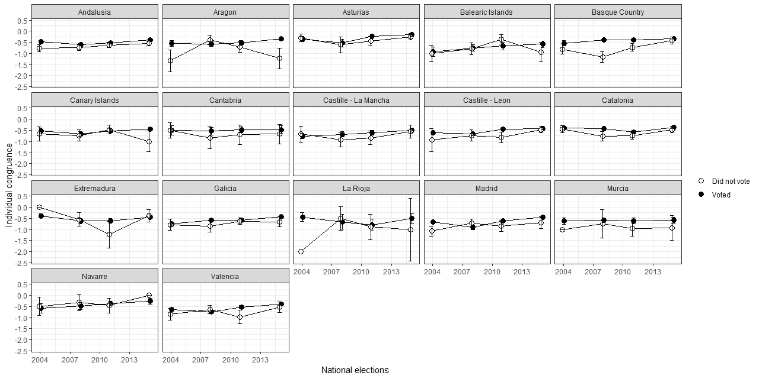

Figure A.1. Citizens perceived distance to closest party by electoral participation in national elections. Observations with ideological congruence from -5 to 0.

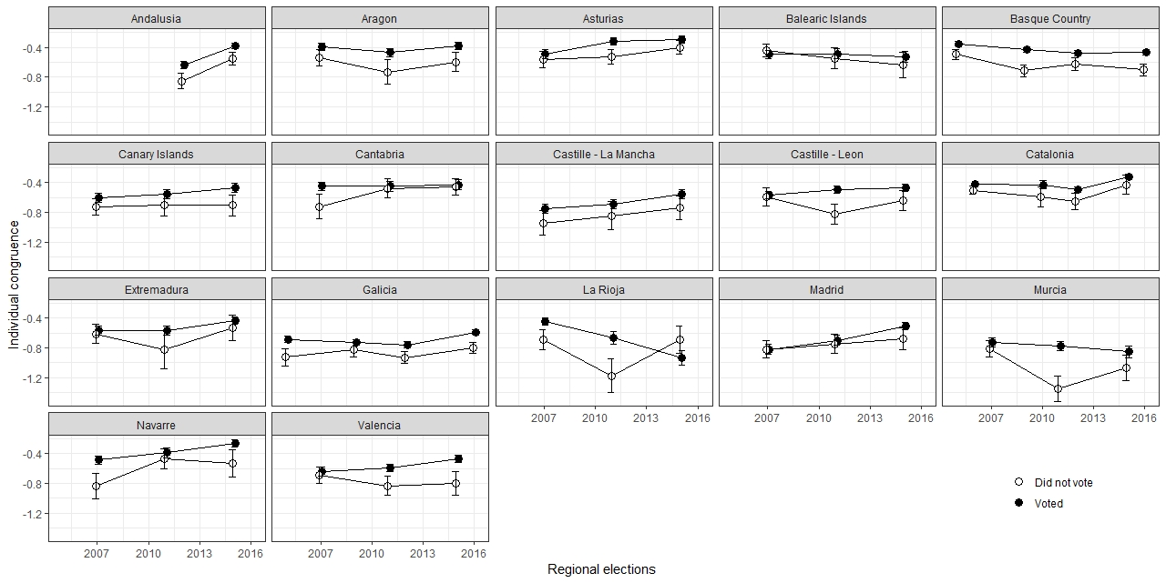
Figure A.2. Citizens perceived distance to closest party by electoral participation in regional elections. Observations with ideological congruence from -5 to 0.

Table A.3. Determinants of individual turnout in national (models 1 and 3) and regional (models 2 and 4) elections. Observations with ideological congruence from -5 to 0.
 | National  (1) | Regional  (2) | National  (3) | Regional  (4)
Congruence (-5 to 0) | 0.25*** | 0.23*** | 0.30*** | 0.24***
 | (0.03) | (0.02) | (0.05) | (0.03)
Extreme ideology |  |  | 0.34*** | 0.41***
 |  |  | (0.10) | (0.06)
Closest party in national government |  |  | -0.26*** | -0.13***
 |  |  | (0.07) | (0.04)
Closest party: Regionalist |  |  | 0.01 | 0.16***
 |  |  | (0.09) | (0.04)
Conguence X extreme ideology |  |  | 0.08 | -0.01
 |  |  | (0.07) | (0.04)
Congruence X closest party in national government |  |  | -0.15* | -0.08*
 |  |  | (0.06) | (0.03)
Congruence X closest party regionalist party |  |  | 0.00 | 0.13***
 |  |  | (0.08) | (0.04)
Age | 0.07*** | 0.06*** | 0.07*** | 0.06***
 | (0.01) | (0.00) | (0.01) | (0.00)
Age² | -0.00*** | -0.00*** | -0.00*** | -0.00***
 | (0.00) | (0.00) | (0.00) | (0.00)
Gender (Female) | 0.01 | 0.04 | 0.02 | 0.05
 | (0.05) | (0.03) | (0.05) | (0.03)
Higher education | 0.41*** | 0.36*** | 0.40*** | 0.35***
 | (0.07) | (0.04) | (0.07) | (0.04)
Unemployed | -0.32*** | -0.36*** | -0.33*** | -0.37***
 | (0.07) | (0.04) | (0.07) | (0.04)
(Intercept) | 0.46* | 0.15 | 0.49** | 0.07
 | (0.18) | (0.11) | (0.18) | (0.11)
AIC | 11313.24 | 35692.24 | 11294.54 | 35457.15
BIC | 11375.84 | 35761.98 | 11404.09 | 35579.16
Log Likelihood | -5648.62 | -17838.12 | -5633.27 | -17714.58
Num. obs. | 18483 | 45138 | 18483 | 45022
Num. groups: election | 68 | 53 | 68 | 53
Var: election (Intercept) | 0.15 | 0.08 | 0.16 | 0.09
Comments: Multilevel logistic regression models with random intercepts at the election level. The dependent variable is coded “1” if the individual voted in the last national (Models 1 and 3) or regional (Models 2 and 4) elections and “0” otherwise; standard errors in parenthesis. In all models, observations are grouped by region and year of the election. ***p < 0.001, **p < 0.01, *p < 0.05

Table A.4. Determinants of individual turnout in national (models 1 and 3) and regional (models 2 and 4) elections. Observations with ideological congruence from -5 to 0. Historic regions not included in the analysis.

 | National  (1) | Regional  (2) | National  (3) | Regional  (4)
Congruence (-5 to 0) | 0.22*** | 0.22*** | 0.33*** | 0.26***
 | (0.04) | (0.02) | (0.05) | (0.03)
Extreme ideology |  |  | 0.42** | 0.41***
 |  |  | (0.14) | (0.09)
Closest party in national government |  |  | -0.29*** | -0.23***
 |  |  | (0.08) | (0.05)
Closest party: Regionalist |  |  | -0.33 | 0.08
 |  |  | (0.19) | (0.07)
Conguence X extreme ideology |  |  | -0.05 | -0.02
 |  |  | (0.09) | (0.06)
Congruence X closest party in national government |  |  | -0.19* | -0.10*
 |  |  | (0.07) | (0.04)
Congruence X closest party regionalist party |  |  | -0.21 | 0.11
 |  |  | (0.17) | (0.07)
Age | 0.07*** | 0.07*** | 0.07*** | 0.07***
 | (0.01) | (0.01) | (0.01) | (0.01)
Age² | -0.00*** | -0.00*** | -0.00*** | -0.00***
 | (0.00) | (0.00) | (0.00) | (0.00)
Gender (Female) | 0.03 | 0.03 | 0.04 | 0.04
 | (0.06) | (0.04) | (0.06) | (0.04)
Higher education | 0.42*** | 0.33*** | 0.41*** | 0.32***
 | (0.09) | (0.05) | (0.09) | (0.05)
Unemployed | -0.34*** | -0.32*** | -0.34*** | -0.32***
 | (0.08) | (0.05) | (0.08) | (0.05)
(Intercept) | 0.51* | -0.01 | 0.59** | 0.03
 | (0.22) | (0.14) | (0.22) | (0.14)
AIC | 7684.37 | 18784.10 | 7660.33 | 18723.93
BIC | 7744.28 | 18848.79 | 7765.18 | 18837.14
Log Likelihood | -3834.18 | -9384.05 | -3816.16 | -9347.97
Num. obs. | 13221 | 24017 | 13221 | 24017
Num. groups: election | 52 | 38 | 52 | 38
Var: election (Intercept) | 0.12 | 0.05 | 0.12 | 0.05
Comments: Multilevel logistic regression models with random intercepts at the election level. The dependent variable is coded “1” if the individual voted in the last national (Models 1 and 3) or regional (Models 2 and 4) elections and “0” otherwise; standard errors in parenthesis.In all models, observations are grouped by region and year of the election. ***p < 0.001, **p < 0.01, *p < 0.05

Table A.5. Determinants of individual turnout in national (models 1 and 3) and regional (models 2 and 4) elections, including cross-level interactions with regional competences on welfare and regional budget per capita.
 | National  (1) | Regional  (2) | National  (3) | Regional  (4)
Congruence | 0.10*** | 0.08*** | 0.10*** | 0.09***
 | (0.03) | (0.01) | (0.03) | (0.02)
Extreme ideology | 0.28** | 0.40*** | 0.28** | 0.40***
 | (0.09) | (0.05) | (0.09) | (0.05)
Closest party in national government | 0.04 | -0.54*** | 0.14 | -0.43***
 | (0.19) | (0.10) | (0.19) | (0.11)
Closest party: Regionalist | -0.14 | -0.01 | -0.02 | -0.04
 | (0.27) | (0.11) | (0.29) | (0.11)
Regional welfare competences | -0.02 | -0.01
 | (0.02) | (0.01)
Conguence X extreme ideology | 0.03 | 0.02 | 0.03 | 0.02
 | (0.03) | (0.01) | (0.03) | (0.01)
Congruence X closest party in national government | 0.02 | 0.04 | 0.02 | 0.04
 | (0.05) | (0.03) | (0.05) | (0.03)
Congruence X closest party regionalist party | 0.14* | 0.20*** | 0.14* | 0.20***
 | (0.07) | (0.03) | (0.07) | (0.03)
Congruence X regional welfare competences | 0.00 | 0.00
 | (0.00) | (0.00)
Regional welfare competences X closest party regionalist | 0.02 | 0.02*
 | (0.02) | (0.01)
Regional welfare competences X closest party in national government | -0.02 | 0.04***
 | (0.01) | (0.01)
Regional budget per capita |  |  | -0.00 | 0.00
 |  |  | (0.00) | (0.00)
Congruence X regional budget per capita |  |  | 0.00 | 0.00
 |  |  | (0.00) | (0.00)
Regional budget per capita X closest party regionalist |  |  | 0.00 | 0.01*
 |  |  | (0.01) | (0.00)
Regional budget per capita X closest party in national government |  |  | -0.01 | 0.01***
 |  |  | (0.00) | (0.00)
Age | 0.07*** | 0.07*** | 0.07*** | 0.06***
 | (0.01) | (0.00) | (0.01) | (0.00)
Age² | -0.00*** | -0.00*** | -0.00*** | -0.00***
 | (0.00) | (0.00) | (0.00) | (0.00)
Gender (Female) | 0.05 | 0.06* | 0.05 | 0.06*
 | (0.05) | (0.03) | (0.05) | (0.03)
Higher education | 0.38*** | 0.35*** | 0.38*** | 0.35***
 | (0.07) | (0.04) | (0.07) | (0.04)
Unemployed | -0.36*** | -0.38*** | -0.37*** | -0.38***
 | (0.06) | (0.04) | (0.06) | (0.04)
(Intercept) | 0.67* | 0.04 | 0.51 | -0.11
 | (0.26) | (0.17) | (0.26) | (0.18)
AIC | 12713.05 | 40904.22 | 12714.52 | 40917.70
BIC | 12855.28 | 41063.01 | 12856.76 | 41076.49
Log Likelihood | -6338.52 | -20434.11 | -6339.26 | -20440.85
Num. obs. | 19970 | 50113 | 19970 | 50113
Num. groups: election | 68 | 53 | 68 | 53
Var: election (Intercept) | 0.15 | 0.08 | 0.16 | 0.08
Comments: Multilevel logistic regression models with random intercepts at the election level. The dependent variable is coded “1” if the individual voted in the last national (Models 1 and 3) or regional (Models 2 and 4) elections and “0” otherwise; standard errors in parenthesis. In all models, observations are grouped by region and year of the election. ***p < 0.001, **p < 0.01, *p < 0.05

Table A.6. Determinants of individual turnout in national (models 1 and 3) and regional (models 2 and 4) elections, including cross-level interactions with regional competences on welfare and regional budget per capita. Observations with ideological congruence from -5 to 0.
 | National  (1) | Regional  (2) | National  (3) | Regional  (4)
Congruence (-5 to 0) | 0.36*** | 0.24*** | 0.43*** | 0.19**
 | (0.10) | (0.06) | (0.10) | (0.06)
Extreme ideology | 0.35*** | 0.39*** | 0.34*** | 0.39***
 | (0.10) | (0.06) | (0.10) | (0.06)
Closest party in national government | -0.07 | -0.60*** | 0.06 | -0.52***
 | (0.20) | (0.10) | (0.20) | (0.11)
Closest party: Regionalist | -0.19 | -0.07 | -0.02 | -0.16
 | (0.28) | (0.11) | (0.30) | (0.12)
Regional welfare competences | -0.03 | -0.01
 | (0.02) | (0.01)
Conguence X extreme ideology | 0.08 | -0.01 | 0.07 | -0.01
 | (0.07) | (0.04) | (0.07) | (0.04)
Congruence X closest party in national government | -0.15* | -0.07* | -0.14* | -0.08*
 | (0.06) | (0.03) | (0.06) | (0.03)
Congruence X closest party regionalist party | 0.01 | 0.13*** | 0.01 | 0.13***
 | (0.08) | (0.04) | (0.08) | (0.04)
Congruence X regional welfare competences | -0.00 | 0.00
 | (0.01) | (0.00)
Regional welfare competences X closest party regionalist | 0.01 | 0.02*
 | (0.02) | (0.01)
Regional welfare competences X closest party in national government | -0.01 | 0.04***
 | (0.01) | (0.01)
Regional budget per capita |  |  | -0.00 | 0.00
 |  |  | (0.00) | (0.00)
Congruence X regional budget per capita |  |  | -0.00 | 0.00
 |  |  | (0.00) | (0.00)
Regional budget per capita X closest party regionalist |  |  | 0.00 | 0.01**
 |  |  | (0.01) | (0.00)
Regional budget per capita X closest party in national government |  |  | -0.01 | 0.01***
 |  |  | (0.00) | (0.00)
Age | 0.07*** | 0.06*** | 0.07*** | 0.06***
 | (0.01) | (0.00) | (0.01) | (0.00)
Age² | -0.00*** | -0.00*** | -0.00*** | -0.00***
 | (0.00) | (0.00) | (0.00) | (0.00)
Gender (Female) | 0.02 | 0.05 | 0.02 | 0.05
 | (0.05) | (0.03) | (0.05) | (0.03)
Higher education | 0.40*** | 0.35*** | 0.40*** | 0.35***
 | (0.07) | (0.04) | (0.07) | (0.04)
Unemployed | -0.32*** | -0.37*** | -0.33*** | -0.37***
 | (0.07) | (0.04) | (0.07) | (0.04)
(Intercept) | 0.80** | 0.16 | 0.61* | 0.01
 | (0.27) | (0.17) | (0.27) | (0.18)
AIC | 11297.08 | 35435.96 | 11297.15 | 35441.44
BIC | 11437.92 | 35592.83 | 11438.00 | 35598.31
Log Likelihood | -5630.54 | -17699.98 | -5630.58 | -17702.72
Num. obs. | 18483 | 45022 | 18483 | 45022
Num. groups: election | 68 | 53 | 68 | 53
Var: election (Intercept) | 0.14 | 0.08 | 0.15 | 0.08
Comments: Multilevel logistic regression models with random intercepts at the election level. The dependent variable is coded “1” if the individual voted in the last national (Models 1 and 3) or regional (Models 2 and 4) elections and “0” otherwise; standard errors in parenthesis. In all models, observations are grouped by region and year of the election. ***p < 0.001, **p < 0.01, *p < 0.05

Table A.7. Determinants of individual turnout in national (models 1 and 3) and regional (models 2 and 4) elections, including cross-level interactions with regional competences on welfare and regional budget per capita. Observations with ideological congruence from -5 to 0. Historic regions not included in the analysis.

 | National  (1) | Regional  (2) | National  (3) | Regional  (4)
Congruence (-5 to 0) | 0.37** | 0.15 | 0.51*** | 0.16
 | (0.13) | (0.08) | (0.13) | (0.09)
Extreme ideology | 0.42** | 0.41*** | 0.42** | 0.41***
 | (0.14) | (0.09) | (0.14) | (0.09)
Closest party in national government | -0.16 | -0.34** | 0.04 | -0.63***
 | (0.24) | (0.13) | (0.24) | (0.15)
Closest party: Regionalist | -0.88 | -0.04 | 0.13 | -0.39
 | (0.49) | (0.18) | (0.80) | (0.25)
Regional welfare competences | -0.02 | 0.01
 | (0.02) | (0.01)
Conguence X extreme ideology | -0.05 | -0.03 | -0.06 | -0.02
 | (0.09) | (0.06) | (0.10) | (0.06)
Congruence X closest party in national government | -0.18* | -0.09* | -0.18* | -0.09*
 | (0.07) | (0.04) | (0.07) | (0.04)
Congruence X closest party regionalist party | -0.21 | 0.12 | -0.19 | 0.11
 | (0.17) | (0.07) | (0.18) | (0.07)
Congruence X regional welfare competences | -0.00 | 0.01
 | (0.01) | (0.01)
Regional welfare competences X closest party regionalist | 0.04 | 0.01
 | (0.04) | (0.02)
Regional welfare competences X closest party in national government | -0.01 | 0.01
 | (0.02) | (0.01)
Regional budget per capita |  |  | -0.00 | 0.01
 |  |  | (0.01) | (0.00)
Congruence X regional budget per capita |  |  | -0.00 | 0.00
 |  |  | (0.00) | (0.00)
Regional budget per capita X closest party regionalist |  |  | -0.01 | 0.01*
 |  |  | (0.02) | (0.01)
Regional budget per capita X closest party in national government |  |  | -0.01 | 0.01**
 |  |  | (0.01) | (0.00)
Age | 0.07*** | 0.07*** | 0.07*** | 0.07***
 | (0.01) | (0.01) | (0.01) | (0.01)
Age² | -0.00*** | -0.00*** | -0.00*** | -0.00***
 | (0.00) | (0.00) | (0.00) | (0.00)
Gender (Female) | 0.04 | 0.05 | 0.04 | 0.04
 | (0.06) | (0.04) | (0.06) | (0.04)
Higher education | 0.40*** | 0.32*** | 0.41*** | 0.32***
 | (0.09) | (0.05) | (0.09) | (0.05)
Unemployed | -0.34*** | -0.33*** | -0.34*** | -0.32***
 | (0.08) | (0.05) | (0.08) | (0.05)
(Intercept) | 0.85** | -0.13 | 0.68* | -0.27
 | (0.33) | (0.20) | (0.32) | (0.22)
AIC | 7664.91 | 18727.18 | 7663.19 | 18711.01
BIC | 7799.73 | 18872.74 | 7798.00 | 18856.57
Log Likelihood | -3814.46 | -9345.59 | -3813.59 | -9337.50
Num. obs. | 13221 | 24017 | 13221 | 24017
Num. groups: election | 52 | 38 | 52 | 38
Var: election (Intercept) | 0.12 | 0.05 | 0.12 | 0.04
Comments: Multilevel logistic regression models with random intercepts at the election level. The dependent variable is coded “1” if the individual voted in the last national (Models 1 and 3) or regional (Models 2 and 4) elections and “0” otherwise; standard errors in parenthesis. In all models, observations are grouped by region and year of the election. ***p < 0.001, **p < 0.01, *p < 0.05

