(a) Zero nutrition

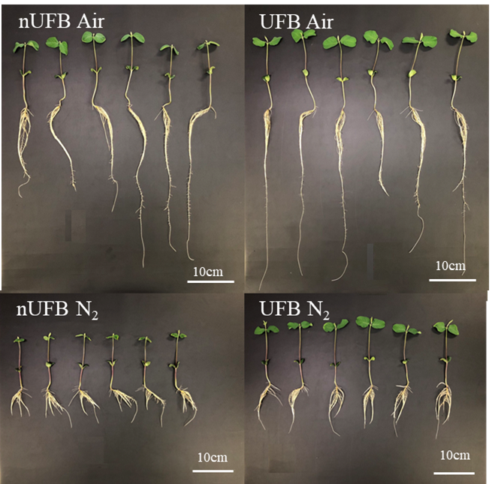

(b) High nutrition

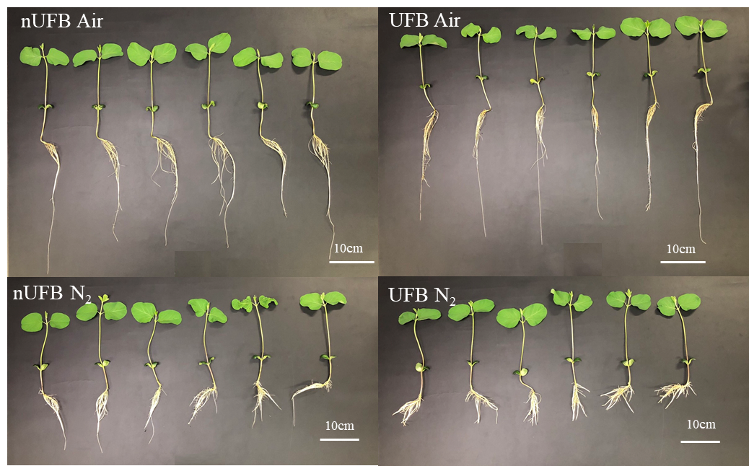

Supplemental Fig. S1. Images of soybean seedlings grown in non-UFB and UFB water under Air or N2 gas treatments, under zero or high nutrition levels.

(a) Zero nutrition



(b) Low nutrition



(c) High nutrition



Supplemental Fig. S2. Tukey-Kramer multiple comparison test for traits showing interaction effects between two treatments (Water\*Gas flow, Water\*Fluid movement) in 3-way ANOVA in Table 1. Means followed by the same lowercase letter were not significantly different at P < 0.05, according to Tukey-Kramer multiple comparison test.