Supplemental material: Specific task information and stimulus examples
Full stimulus series are available from the corresponding author.

1. Rhyme identification task
Participants viewed 3 images and were asked to select the one that represented a word that did not rhyme with one of the other two. In the example below, “bee” and “knee” rhyme, while “horse” does not. Therefore, the correct response was to select the horse. Participants saw a total of 15 trials.
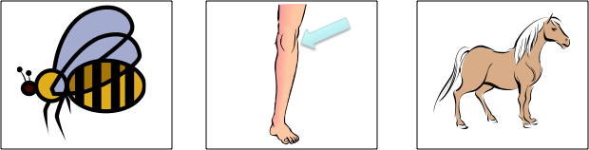

2. Grammaticality judgment task
Participants were told that they needed to help a dinosaur learn English by identifying when the dinosaur’s speech contained an error. Participants then listened to a sentence either containing an error or not. For example, they heard “Peter and Sarah is ready to paint.” Participants saw a smiling face and a frowning face on screen and were instructed to select the smiling face when they believed the sentence was correct and the frowning face when they heard an error. In the example described here, this sentence contains an error in verb agreement. Therefore, the correct response was to select the frowning face. Participants saw a total of 40 trials.

3. Category identification task
Participants viewed 3 images and were asked to examine each one and determine whether together the three were members of a supraordinate category or not (i.e., asked whether they all “go together”). Participants also saw a smiling face and a frowning face on screen and were instructed to select the smiling face if the three images belonged to the same category and to select the frowning face if not. In the example below, an apple, a banana, and grapes are all fruits. Therefore, the correct response was to select the smiley face because all three belonged to a single category. Participants saw a total of 23 trials.
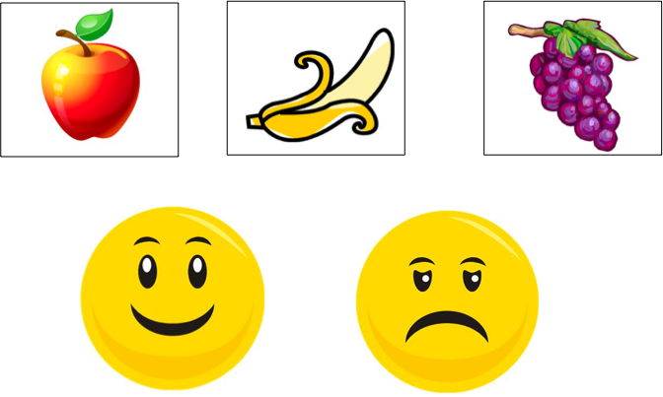

4. Sentence comprehension task
Participants viewed 3 images and were asked to select the one that best represented the meaning described in a sentence presented both on screen and read aloud. In the example below, the sentence “The girl is jumping over the cat under the bridge” was read aloud as it appeared on screen. The images consist of, from left to right, a girl jumping over a cat under a bridge, a girl jumping over a cat over a bridge, and a girl jumping over a cat on a bridge. Therefore, the correct response was to select the first image, as this best reflected the meaning of the sentence. Participants saw a total of 10 trials.

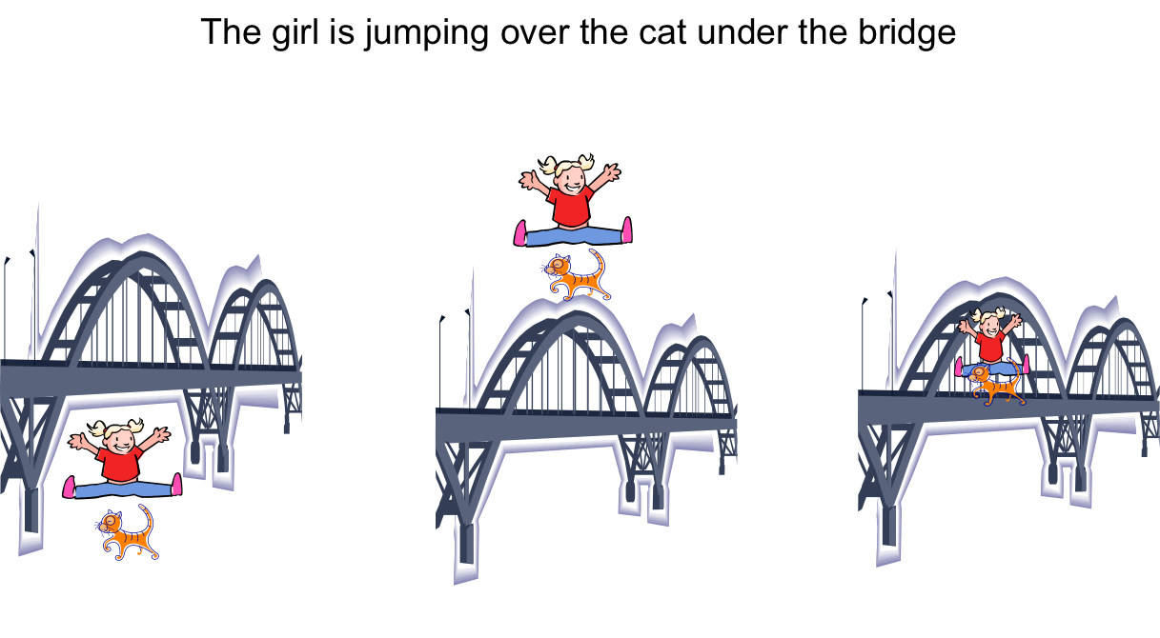

5. Recognition memory task for words presented in a story
Participants first listened to a short story with familiar vocabulary. The story was embedded with specific cues to attend to and remember key target words. The story was only spoken, not presented visually. The story that they heard was as follows: “I woke up this morning. Remember ‘morning.’ I felt something lick my nose. Remember ‘nose.’ It was my cat. Remember ‘cat.’ I put on my glasses. Remember ‘glasses.’ I looked at my clock. Remember ‘clock.’ I was late for school. Remember ‘school.’ I brushed my teeth. Remember ‘teeth.’ I grabbed my books. Remember ‘books.’ I ran out the door. Remember ‘door.’ I was just in time to make the bus. Remember ‘bus.’ Then, I realized I was wearing my pajamas. Remember ‘pajamas.’” This task presentation is similar to the one found on the Scales of Cognitive Ability for Traumatic Brain Injury (SCATBI), though the story utilized here was novel to this study.(41) After hearing the story one time, participants viewed sets of 2 images, one of the target word and one of a reasonable foil, presented in the same sequence as in the original story. In the example below, there is a picture of a cat and a dog. The target word from the story was “cat” from “It was my cat.” Therefore, the correct response was to select the cat. Participants saw a total of 11 trials, one for each target word in the story.

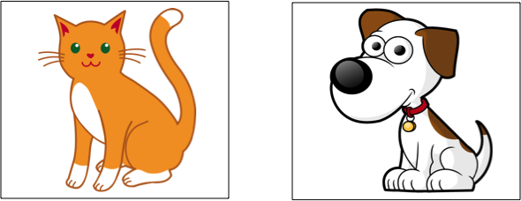

6. Phonological working memory task
Participants listened to two spoken strings of syllables. For example, they may hear “Ba-See-Da” and “Ba-Kee-Da.” Strings of syllables could be between 3 and 8 syllables in length and were each spoken one time. Between the first string and the second string, a two second duration of white noise was included to prevent acoustic memory. Participants saw a smiling face and a frowning face on screen and were instructed to select the smiling face when they believed the two strings were the same and the frowning face when the two strings were different. In the example described here, “Ba-See-Da” and “Ba-Kee-Da” differ in the second syllable. Therefore, the correct response was to select the frowning face. Participants saw a total of 41 trials.

7. Auditory attention task
Participants were told that an eagle and a tiger both were receiving instructions and the participant needed to help the tiger, but not the eagle, reach the correct target among a set of 4 possibilities. Instructions for the tiger and the eagle were spoken simultaneously, such that the participant had to segregate and attend to only the tiger’s instruction to select the correct target. Contrasting instructions could share a target number (“Ready Tiger go to blue seven now.”/”Ready Eagle go to red seven now.”), share a target color (“Ready Tiger go to green nine now.”/”Ready Eagle go to green six now/”), or differ in both color and number. For example, the participant could hear “Ready Tiger go to red two now” and “Ready Eagle go to blue one now” spoken simultaneously and, viewing the matrix below, would have to select the correct response for the tiger. Therefore, the correct response was to select the red two in the bottom left. Participants saw a total of 32 trials.
