SUPPLEMENTARY DATA
Phytosterol-loaded CD44 receptor-targeted PEGylated nano-hybrid phyto-liposomes for synergistic chemotherapy

Figure S1
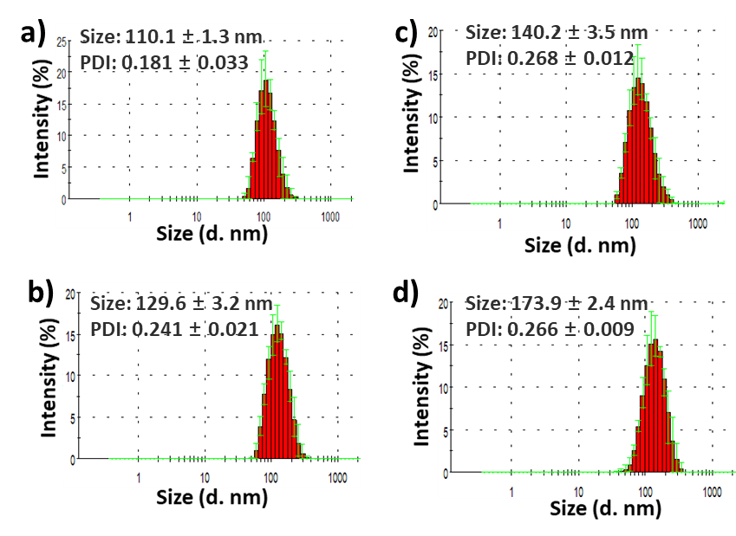

Optimized size distribution from DLS measurement of a) Blank liposome; b) STS-lipo; c) DOX-STS-lipo and d) HA-DOX-STS-lipo formulations. Data are expressed as the mean ± S.D. (n = 3). Abbreviations: DOX-STS-lipo (doxorubicin and stigmasterol-loaded liposomes), HA-DOX-STS-lipo (hyaluronic acid-coated DOX and STS-loaded liposomes)

Figure S2
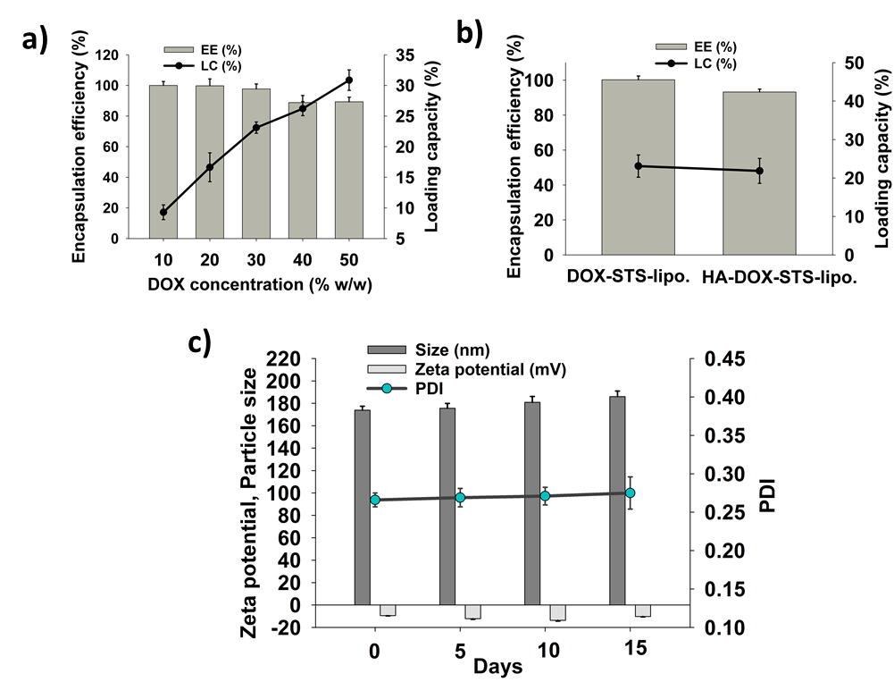
a) The effect of DOX concentrations on entrapment efficiency (EE) and drug-loading capacity (DL) of STS-lipo at different weight percentages. b) The effect of DOX on EE and DL before and after HA coating on DOX-STS-lipo; c) Stability of HA-DOX-STS-lipo for 15 days dispersed on normal saline (pH 7.4) at room temperature.

Figure S3
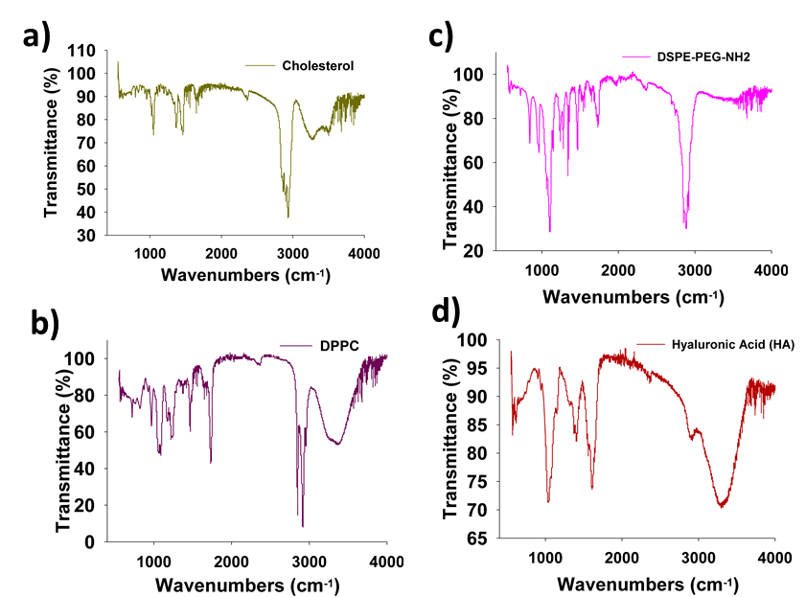
FT-IR analysis of a) Cholesterol; b) DPPC; and c) DSPE-PEG-NH2 d) Hyaluronic Acid

Figure S4
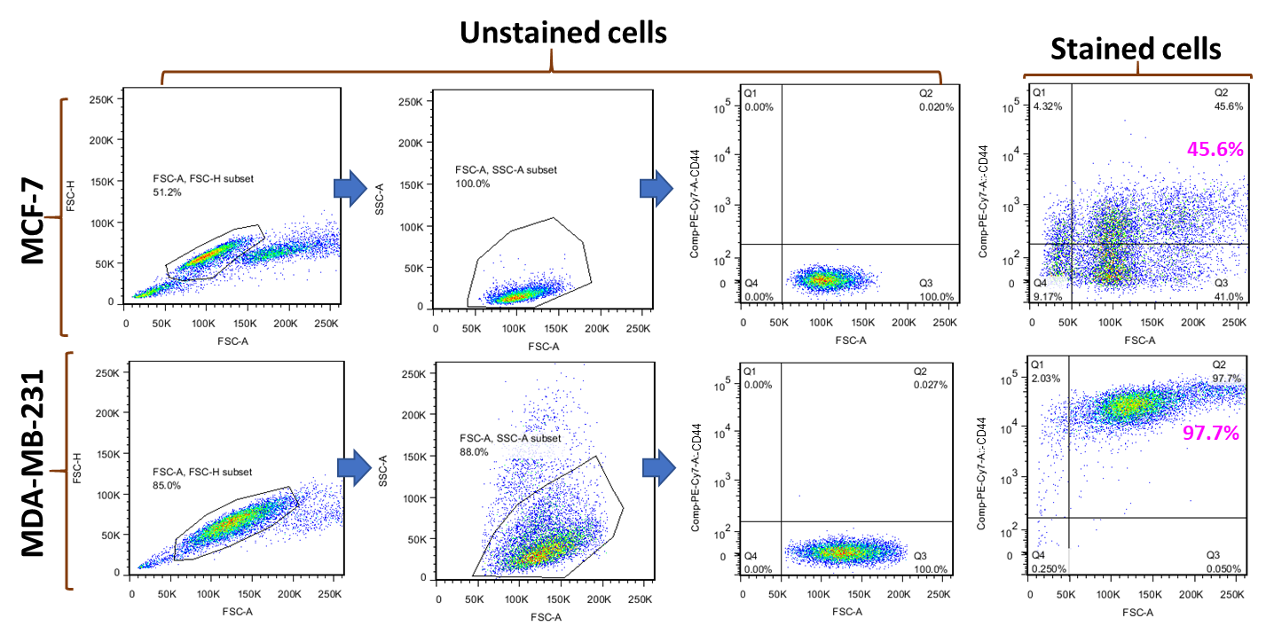
Different expression level of CD44-receptor in MCF-7 and MDA-MB-231 cells. (Cells were labeled with PE/Cy7 anti-mouse/human CD44 antibody and separated as gated by FACS.

Figure S5
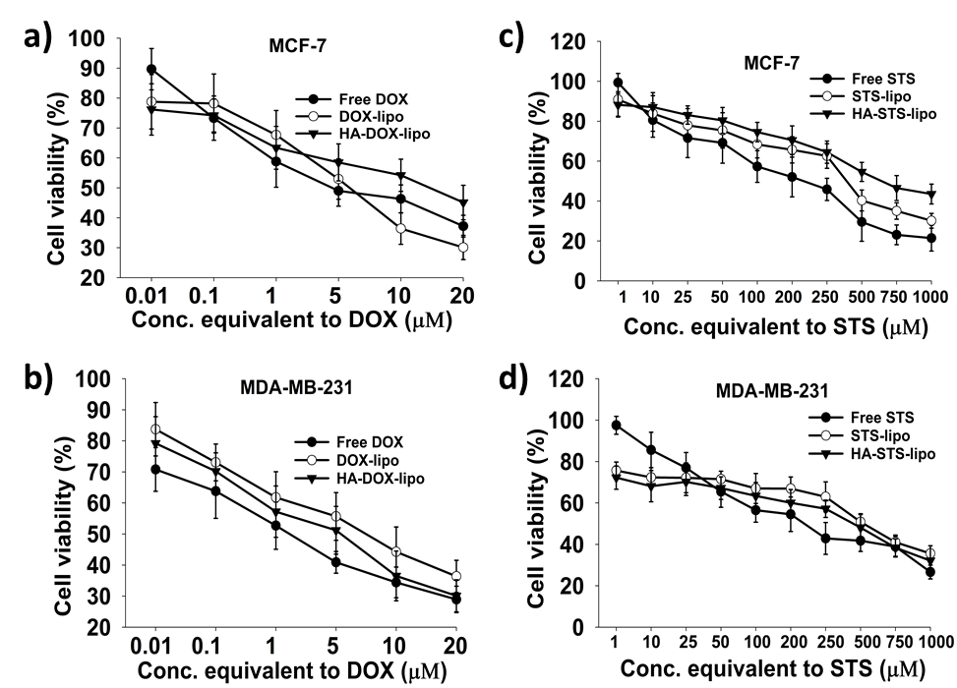

In vitro cytotoxicity assay of different formulation including free drugs in MCF-7 (a & c) an MDA-MB-231 (b & d) cells after 48 h treatment.

Figure S6
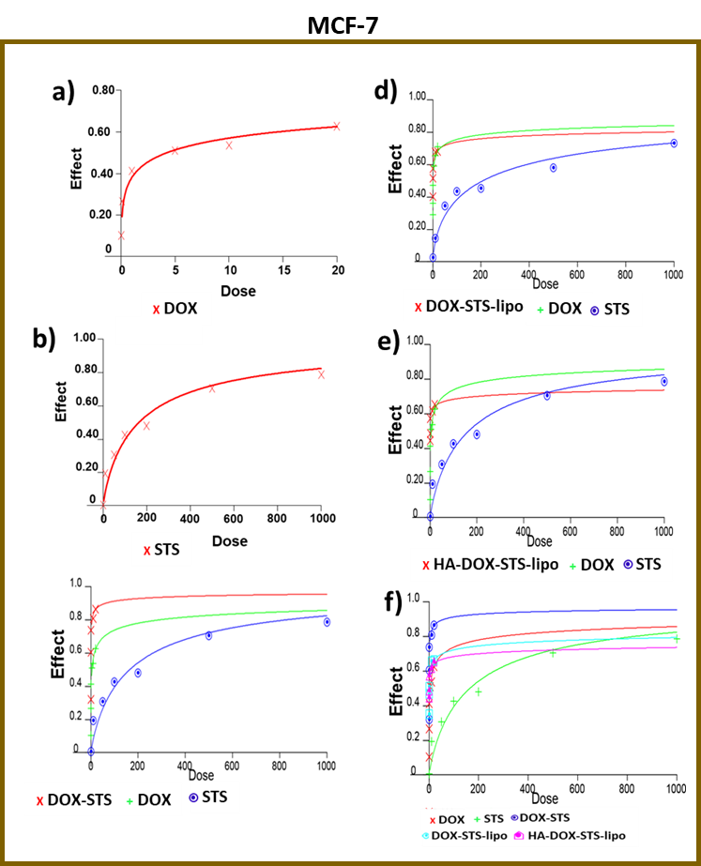

Dose-effect curves. Measurements for a) doxorubicin (DOX); b) stigmasterol (STS); c) DOX, STS, and DOX-STS; d) DOX, STS and DOX-STS-lipo; and e) DOX, STS and hyaluronic acid (HA)-DOX-STS-lipo; as well as a summary graph of f) DOX, STS, DOX-STS, DOX-STS-lipo, and HA-DOX-STS-lipo in MCF-7 cells (dose unit: μM).

Figure S7
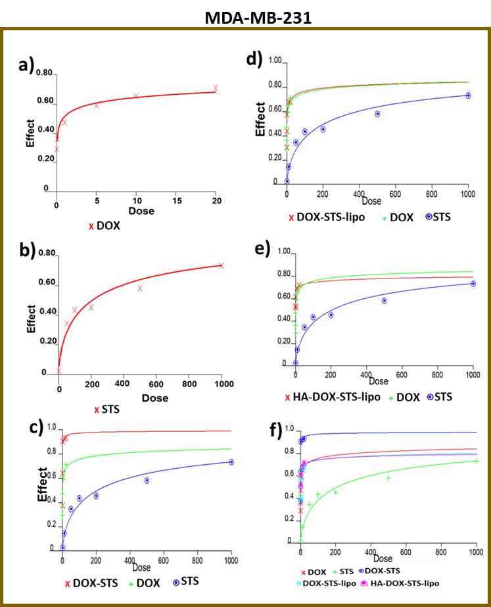

Dose-effect curves. Measurements for a) doxorubicin (DOX); b) stigmasterol (STS); c) DOX, STS, and DOX-STS; d) DOX, STS and DOX-STS-lipo; and e) DOX, STS and hyaluronic acid (HA)-DOX-STS-lipo; as well as a summary graph of f) DOX, STS, DOX-STS, DOX-STS-lipo, and HA-DOX-STS-lipo in MDA-MB-231 cells (dose unit: μM).

Figure S8

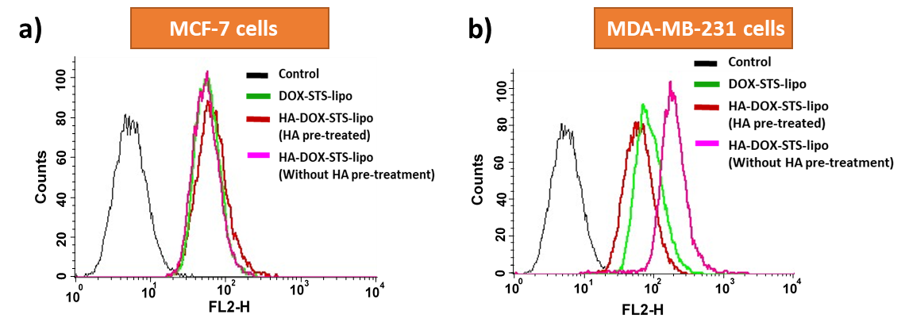
Fluorescence-activated cell sorting (FACS) uptake study in a) MCF-7 and b) MDA-MB-231 cells. Cells were treated with DOX-STS-lipo or HA-DOX-STS-lipo (with and without HA pretreatment, 5 mM for 60 min).

Figure S9
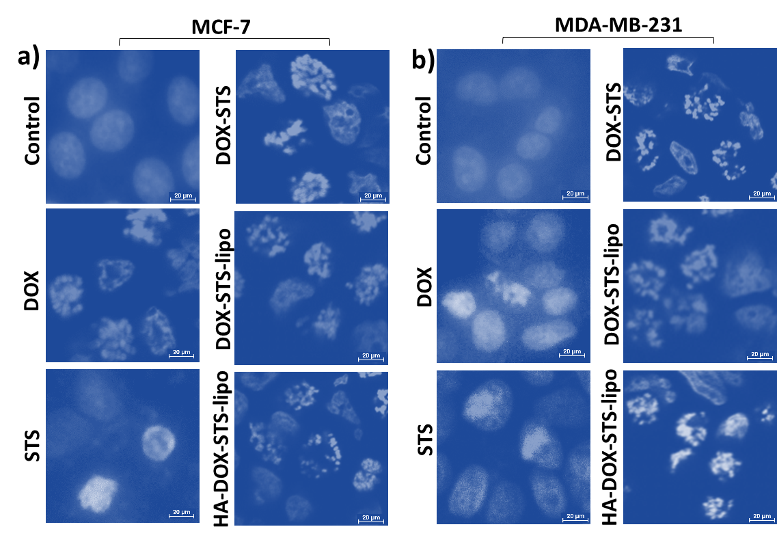

Induction of apoptosis and a nuclear apoptosis assay (Hoechst 33342 staining). Different formulations were tested in a) MCF-7 and b) MDA-MB-231 cells after 48 h. Images of control, doxorubicin (DOX), stigmasterol (STS), DOX-STS, DOX-STS-lipo, and hyaluronic acid (HA)-DOX-STS-lipo were taken with a confocal microscope. Scale bar=20 μM, and magnification: 60X.

Figure S10
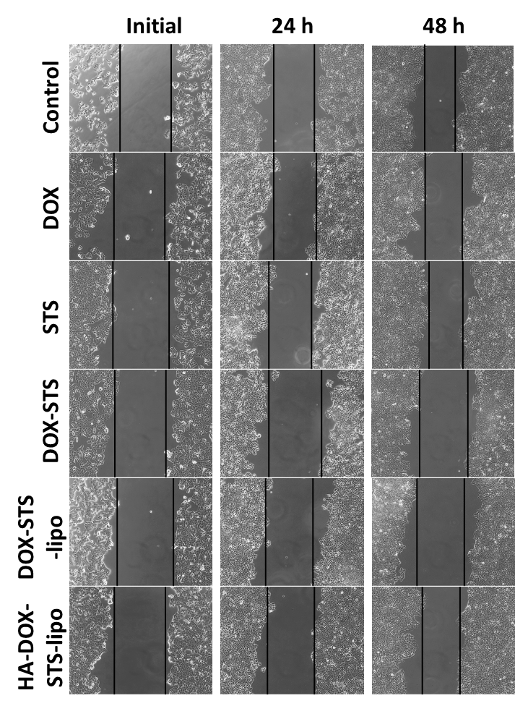

Scratch migration assay of MCF-7 cells treated with DOX, STS, DOX-STS, DOX-STS-lipo, and HA-DOX-STS-lipo at 0, 24, and 48 hours after gap creation (magnification: 20X).

Figure S11
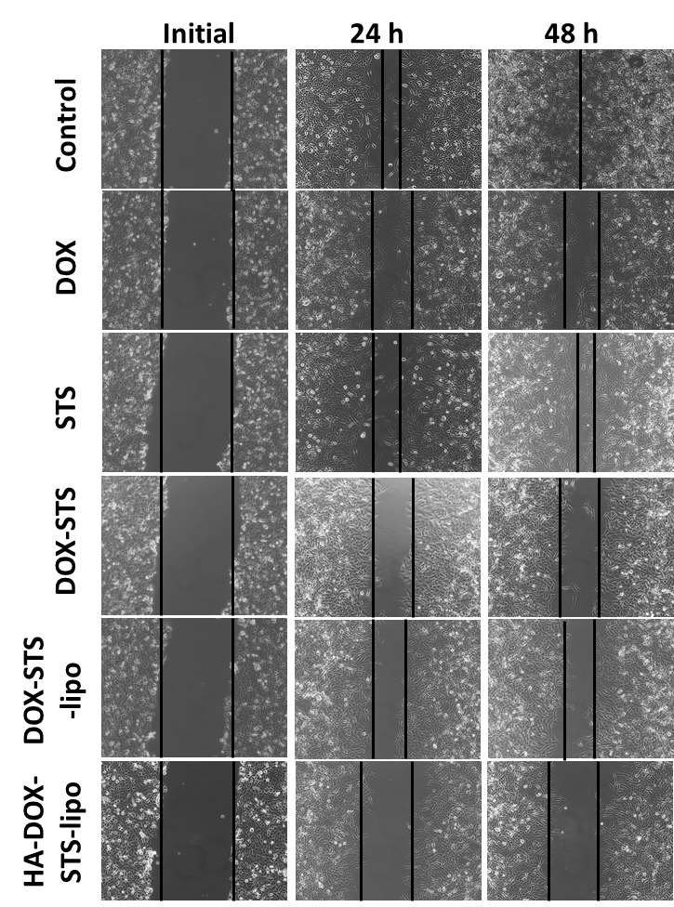
Scratch migration assay of MAD-MB-231 cells treated with DOX, STS, DOX-STS, DOX-STS-lipo, and HA-DOX-STS-lipo at 0, 24, and 48 hours after gap creation (magnification: 20X).

Figure S12
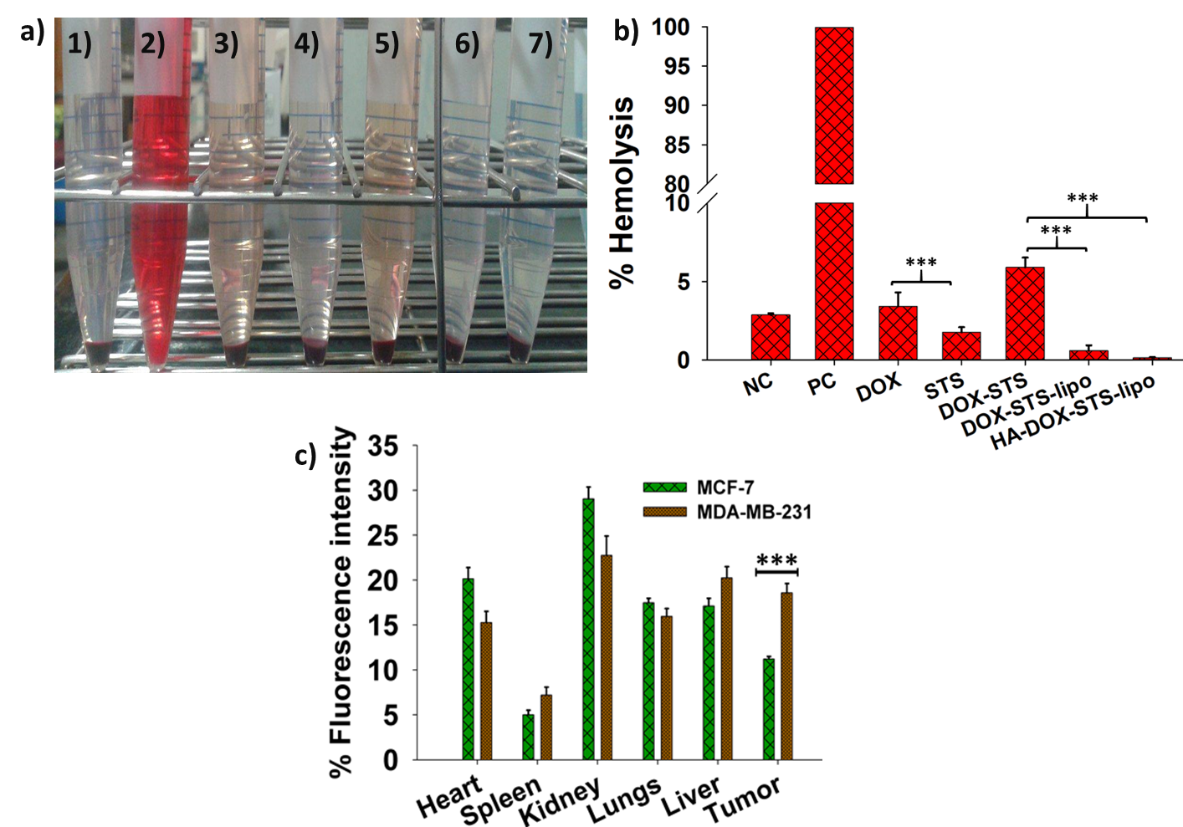

In vitro hemolysis study. a) Images of in vitro red blood cell (RBC) hemolysis after different treatments and incubated for 30 minutes at 37°C. 1) Negative control (NC), 2) positive control (PC), 3) free doxorubicin (DOX), 4) free stigmasterol (STS), 5) DOX-STS combination, 6) DOX-STS-lipo, 7) hyaluronic acid (HA)-DOX-STS-lipo treatments (concentration: 5 µg/mL equivalent to DOX and STS). b) Percentage of hemolysis caused after treatment. The absorbance of samples was measured at 540 nm using a UV-spectrophotometer. c) Fluorescence intensity profile of Cy5.5 loaded HA-DOX-STS-lipo in major organs and tumors of MCF-7 and MDA-MB-231 tumor xenograft mice (n=3), (***p < 0.001).

Figure S13

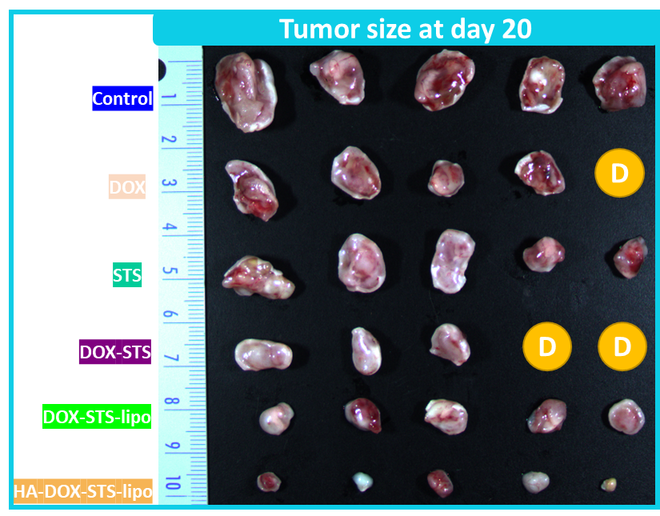

In vivo anti-tumor study. Photo of isolated MDA-MB-231 tumor at the end of the treatment (day 20), n=5. “D” represents number of mice died during treatment period, in DOX treated group mice was died on Day 9 and in DOX-STS treated mice one died at day 8 and another died at day 12.

Table S1. Optimization of blank liposome, STS-lipo, DOX-STS-lipo and HA-DOX-STS-lipo by using DLS.
DPPC: CHO: DSPE-PEG-NH₂ composition (Molar ratio) | Particle size (nm) | PDI | Zeta potential (mV)
22.8:11.5:0.2 | 108.6 ± 2.4 | 0.058 ± 0.04 | -0.482 ± 0.23
30.4:11.5:0.2 | 110.1 ± 1.3 | 0.181 ± 0.03 | -3.25 ± 0.37
35:11.5:0.2 | 115.3 ± 1.1 | 0.212 ± 0.01 | -4.21 ± 0.24
38:11.5:0.2 | 126.9 ± 5.8 | 0.340 ± 0.05 | -5.20 ± 0.36
41:11.5:0.2 | 155.8 ± 4.6 | 0.380 ± 0.03 | -6.03 ± 0.36
DPPC: CHO: DSPE-PEG- NH₂: DOTAP composition (Molar ratio)
30.4:11.5:0.2:1.2 | 112.2 ± 2.5 | 0.184 ± 0.07 | 15.28 ± 1.24
STS-lipo | 129.6 ± 3.2 | 0.241 ± 0.02 | 11.25 ± 1.22
DOX-STS-lipo | 140.2 ± 3.5 | 0.268 ± 0.01 | 17.10 ± 0.81
HA-DOX-STS-lipo | 173.9 ± 2.4 | 0.266 ± 0.009 | -9.48 ± 0.812

Table S2. Summary table of confidence intervals (CI) at a half-maximal effective dose (ED₅₀) and half-maximal inhibitory concentration (IC₅₀) for different drugs and formulations in MCF-7 and MDA-MB-231 cells after 48 h (unit: μM).

Drug or  Formulations | MCF-7 |  | MDA-MB-231
 | CI value at ED₅₀ | IC₅₀ Value | CI value at ED₅₀ | IC₅₀ Value
DOX | N/A | 4.17 | N/A | 0.777
STS | N/A | 163.52 | N/A | 205.91
DOX-STS | 0.047 | 0.055 | 0.037 | 0.021
DOX-STS-lipo | 0.293 | 0.344 | 0.186 | 0.105
HA-DOX-STS-lipo | 0.078 | 0.091 | 0.021 | 0.012

