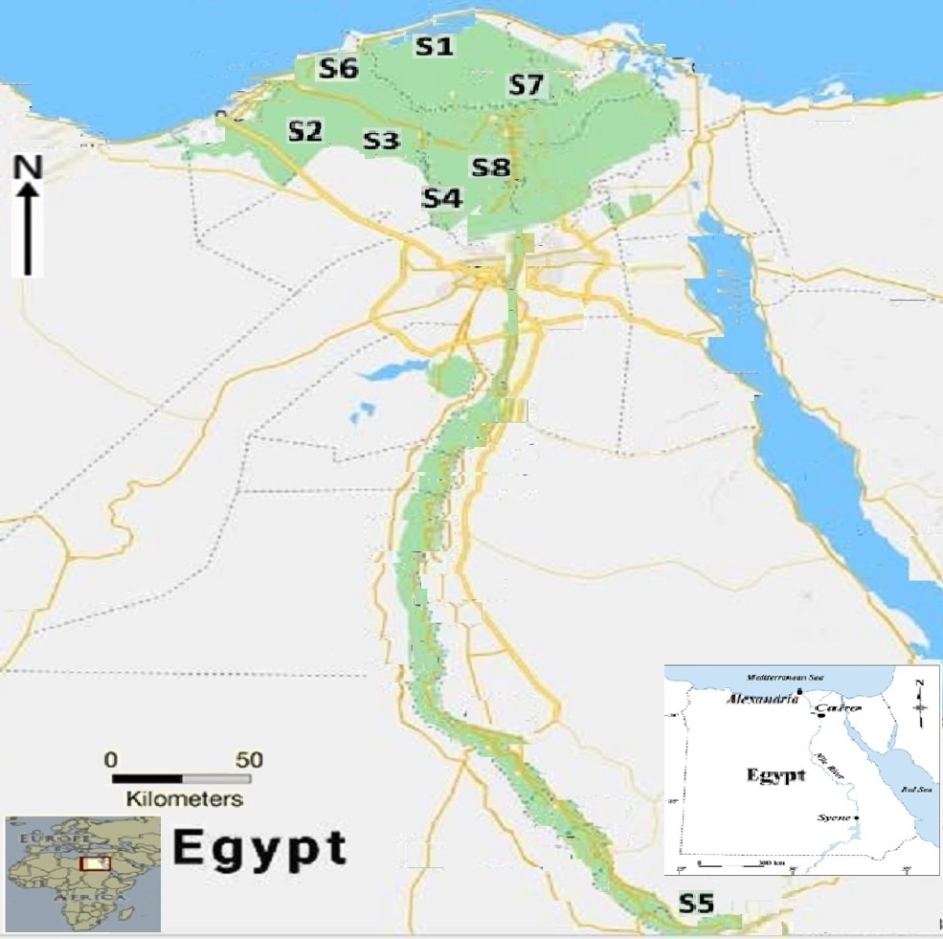

Fig. S1. Sampling locations of different honeys studied in Egypt. (S1) Kafr El Sheikh Governorate, (S2) Abu El Matamir city, (S3) new Nubaria city, (S4) Sadat city, (S5) Qena governorate, (S6) Alexandria governorate and (S7) Dakahlia governorate.

