**Supplementary File**

**S.1 Comparative study**

A comparative study of removal of TNP using pristine rGO, α-Fe2O3, α-Fe2O3/rGO and physical mixture of α-Fe2O3 and rGO was carried out using 25 mg of absorbent per 100 mL of 21.5 mg.L-1 TNP solutions at pH 6 for 4 hours.

**S.2 Effect of pH: Adsorption Isotherms**

*Temkin model*

This model relates the heat of adsorption of molecules in a layer with indirect adsorbent/adsorbate interactions.[47] The model is represented as follows (eq. S1)

$q_{e}=\frac{RT}{b_{T}}lnA_{T}+\frac{RT}{b_{T}}lnC_{e}$ (S1)

where, AT and bT are equilibrium binding and Temkin isotherm constants, respectively. qe and Ce are variables as discussed in the preceding section. T is the temperature and R is the gas constant. The constants extracted from Figure S5 are shown in Table S1. The adsorption energy, bT being positive signifies that the adsorption is exothermic at pH 2 and 6.

*Dubinin-Radushkevich (D-R) isotherm*

The porous nature of adsorbent and the energy involved in adsorption phenomena are examined by D-R isotherm.[48] The isotherm is represented by equation (S2). The behavior of adsorption is depicted by mean adsorption energy (E, kJ.mol-1) as represented by the equation below.[20]

(S2)

$E=\frac{1}{\sqrt{-2β}}$ (S3)

where  is D-R isotherm constant. ε is defined by equation (S4) as

$ԑ=RTln⁡\left(1+\frac{1}{C_{e}}\right)$ (S4)

where R is the universal gas constant.[20] qe and qm, are variables as described in previous sections. The linear plots of ln qe vs 2 at pH 2 and 6 are shown in Figure S6a and S6b, respectively and qm, , E and R2 values are tabulated in Table S1. The energy values at pH 2 and 6 are 0.85 and 8.84 kJ.mol-1, respectively, which indicates physisorption.[47]

*Redlich-Peterson (R-P) isotherm*

The nature of adsorption being homogeneous or heterogeneous can also be ascertained through R-P isotherm model.[49] The linearised R-P isotherm is represented as follows.

$\frac{C_{e}}{q_{e}}=\frac{1}{b_{R-P}q_{mon}}+\frac{C_{e}^{α}}{q_{mon}}$ (S5)

where bR-P, α and qmon are constants.[20] Ce and qe, are variables as discussed in preceding sections. The adsorption is considered homogeneous when α → 1 and heterogeneous when α → 0.The values of α lie in the range 0.82-0.75 (tending to 1) for adsorption at pH 2 (Figure S6c) which shows that adsorption of TNP followed Langmuir monolayer adsorption. However, an opposite trend was observed at pH 6 (Figure S6d), where the optimum α values were ranging from 0.01 to 0.05 (tending to 0) which indicated that the adsorption followed Freundlich multilayer adsorption.

**Figure Captions**

**Figure S1.** Calibration Curve for determination of concentration of TNP at pH2

**Figure S2.** XRD pattern of α-Fe2O3

**Figure S3.** FESEM image of α-Fe2O3

**Figure S4.** Comparative plot of qe against time (a) rGO (b) α-Fe2O3 /rGO, (c) bare α-Fe2O3 (d) Physically mixed rGO & α-Fe2O3 and

**Figure S5.** Effect of pH: Temkin adsorption isotherm for TNP sorption on α-Fe2O3/rGO at 30oC at pH 2 and 6

**Figure S6.** Effect of pH: Dubinin-Radushkevich adsorption isotherm at (a) pH 2 and (b) pH 6; Redlich-Peterson adsorption isotherm at (c) pH 2 and (d) pH 6 for sorption of TNP on α-Fe2O3/rGO at 30 oC

**Figure S7.** Time dependent UV-Visible Spectra depicting TNP removal using α-Fe2O3 /rGO

**Figure S8.** Reusability of α-Fe2O3 /rGO

**Figure S9.** Isoelectric titration plot of -Fe2O3/rGO



Slope = 0.058

R2 ­= 0.9993

**Figure S1**

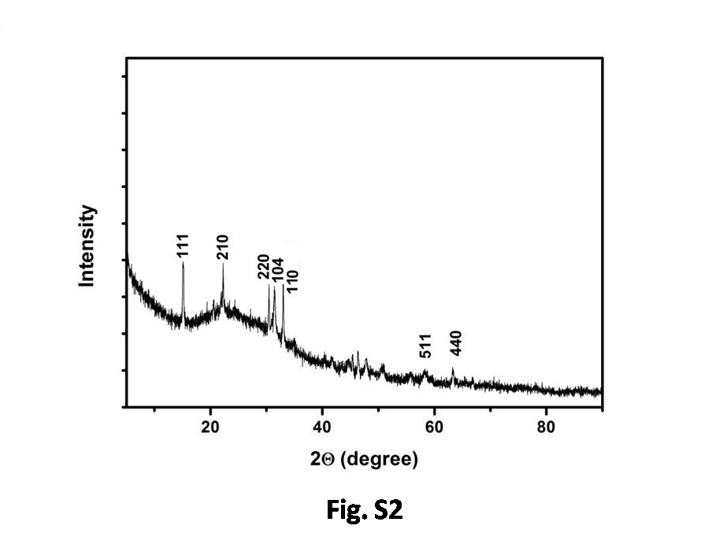

**Figure S2**

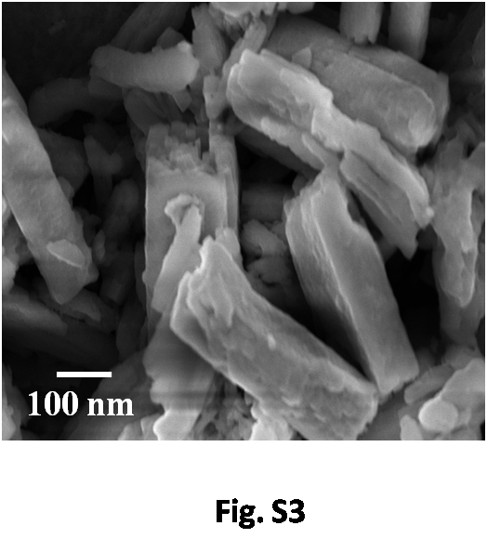

**Figure S3**

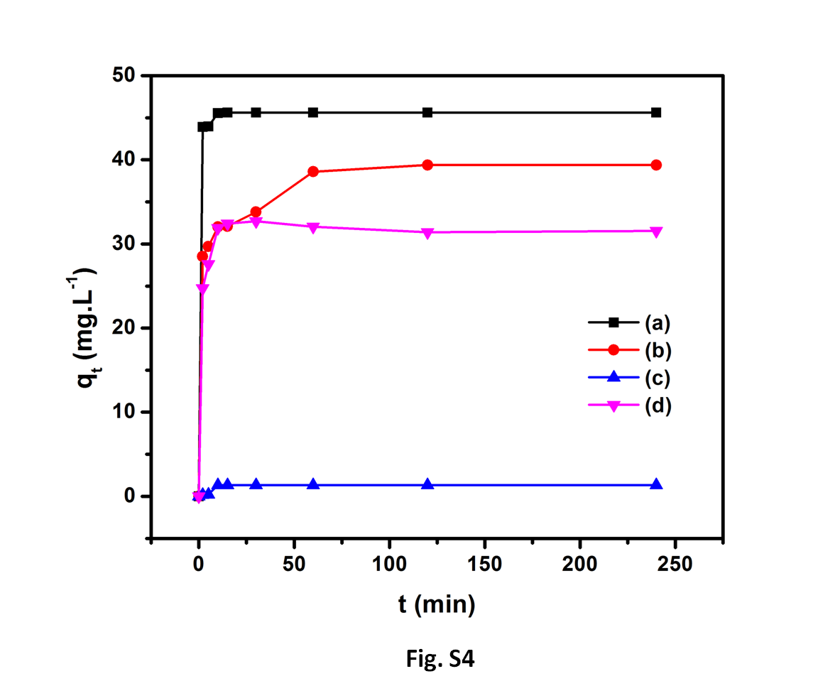

**Figure S4**



**Figure S5**



**Figure S6**



**Figure S7**



**Figure S8**

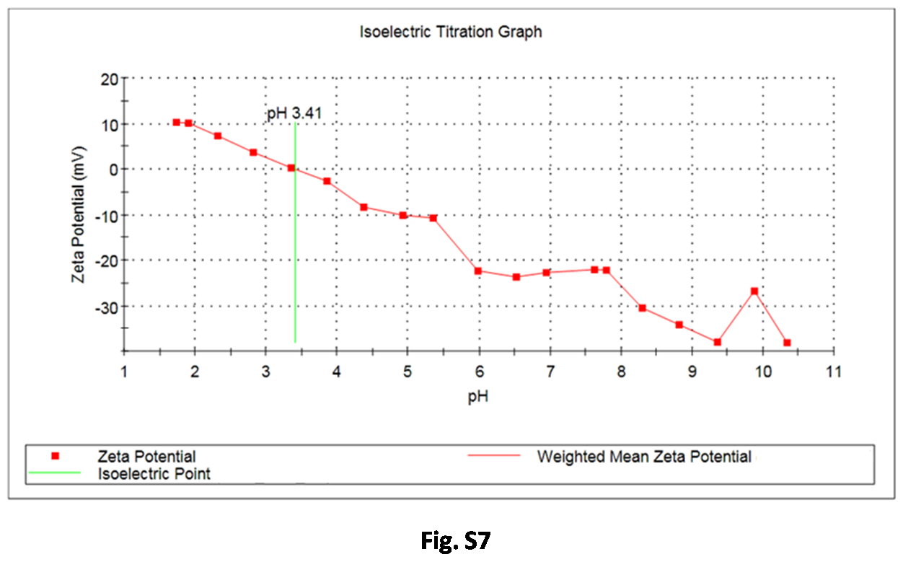

**Figure S9**

**Table Caption**

**Table S1.** Langmuir, Freundlich, Temkin, Dubinin-Radushkevich, and Redlich-Peterson isotherm model constants and correlation coefficients for sorption of TNP on -Fe2O3/rGO at 30 oC

**Table S1**

|  |  |  |  |  |
| --- | --- | --- | --- | --- |
| **Langmuir Isotherm** | | | | |
|  | *pH 2* | | *pH 6* | |
| qmax (mg.g-1) | 48.31 | | 18.38 | |
| KL(L.mg-1) | 0.4849 | | 2.8313 | |
| R2 | 0.9842 | | 0.9951 | |
|  | Conc.  (mg.L-1)  ( *pH 2)* | RL | Conc.  (mg.L-1)  ( *pH 6)* | RL |
|  | 8.3 | 0.1990 | 8.3 | 0.0408 |
| 19.9 | 0.0941 | 19.9 | 0.0174 |
| 34.3 | 0.0567 | 27.05 | 0.0129 |
| 63.4 | 0.0315 | 32.15 | 0.0109 |
| **Freundlich Isotherm** | | | | |
|  | *pH 2* | | *pH 6* | |
| KF  (mg 1-1/n.L1/n.g-1) | 37.63 | | 13.32 | |
| n | 28.86 | | 8.54 | |
| R2 | 0.6601 | | 0.9969 | |
| **Temkin Isotherm** | | | | |
|  | *pH 2* | | *pH 6* | |
| AT (L.g-1) | 2.19×1012 | | 3.49×103 | |
| bT (kJ.mol-1) | 1.87 | | 1.73 | |
| R2 | 0.5820 | | 0.9831 | |
| **Dubinin-Radushkevich Isotherm** | | | | |
|  | *pH 2* | | *pH 6* | |
| β (mol2.J-2) | 6.89×10-7 | | 6.95×10-9 | |
| qm (mg.g-1) | 40.08 | | 17.07 | |
| E (kJ.mol-1) | 0.85 | | 8.84 | |
| R2 | 0.9893 | | 0.9486 | |
| **Redlich-Peterson Isotherm** | | | | |
|  | *pH 2* | | *pH 6* | |
| qmon (mg.g-1) | 22.98 | | 4.85 | |
| bRP (L.mg-1) | 6.3985 | | 0.2604 | |
| α | 0.82 | | 0.01 | |
| R2 | 0.9978 | | 0.9995 | |