**Online Appendix**

**Investigating Emergent Nested Geographic Structure in Consumer Purchases: A Bayesian Dynamic Multiscale Spatiotemporal Modeling Approach**

**Part I: Spatiotemporal clustering Algorithm (Ferreira et al. 2011)**

The Ferreira et al. 2011algorithm includes five steps to cluster regions at a given multi-scale level.

Step 1: Estimate the discrepancy measurement model (DMM). Assume the observations at time $t$ in two different sub-regions at multiscale level $l$ is denoted as $y_{t1}$ and $y_{t2}$, respectively, for $t=1, …, T, l=2, …,L.$ The DMM is defined as follows in the current study

$\left({y_{t1} \atop y_{t2}}\right)=\left(\begin{matrix}σ_{1}^{2}/(σ_{1}^{2}+σ_{2}^{2}) & 1 \\ σ_{2}^{2}/(σ_{1}^{2}+σ_{2}^{2}) & -1\end{matrix}\right)\left({µ_{t} \atop ∆_{t}}\right)+v_{t}$**(1)**

$\left({µ_{t} \atop ∆_{t}}\right)=\left({µ_{t-1} \atop ∆_{t-1}}\right)+w_{t}$**(2)**

where $v_{t} \sim N(0, V)$, $w_{t} \sim N(0, W)$, $V=diag(σ_{1}^{2}, σ_{2}^{2})$, $W=diag(W_{µ}, W_{∆})$, $σ_{1}^{2}$ and $σ_{2}^{2}$ are the observational variances in observations $y_{t1}$ and $y_{t2}$, $W_{µ}$ and $W_{∆}$ are the systematic variances in the two systematic parameters $µ_{t}$ and $∆_{t}$. In equation (1), it shows that $µ_{t}$ is the shared mean process with weights $σ_{1}^{2}/(σ_{1}^{2}+σ_{2}^{2})$ and $σ_{2}^{2}/(σ_{1}^{2}+σ_{2}^{2})$ between the two times series of observations, while $∆_{t}$ is the discrepancy between series of observations from the two subregions. The variance components $W_{µ}$ and $W_{∆}$ can be estimated from MLE method for the above dynamic linear model (equation (1) and (2)).

Step 2: The relative discrepancy between the two sub-regions are defined as the ratio between the two variance components $W_{µ}$ and $W_{∆}$, that is, $W_{∆}$/ $W_{µ}$. The smaller the ratio, the more similar the two sub-regions are.

Step 3: For each sub-region $j$ in the multiscale level $l (j=1, …, n_{l }, l=2, …, L)$, calculate the relative discrepancy between $j$ and all its neighboring sub-regions. Build a link between subregion $j$ and its neighboring sub-region that has the smallest relative discrepancy (highest similarity).

Step 4: If two sub-regions at the multi-scale level $l$ are connected through a path (one link or a sequence of links), these two subregions are defined as in the same cluster. If there is no path between two sub-regions, these two sub-regions are defined as in different clusters. Thus the clustering structure is defined at the multi-scale level $l$.

Step 5: Start Step 1- Step 4 at the finest level $L$ and recursively repeated for the immediately coarser level of resolution till $l=2.$

**Part II: MCMC algorithm for the multiscale spatiotemporal model**

In the following discussion, we will present detailed derivation of the MCMC algorithm for parameters in the multi-scale model. The standard Bayesian theorem applies and by the conjugacy of the prior distribution, full conditional posterior distributions can be obtained and Gibbs sampling can be easily implemented.

1. The signal-to-noise coefficients $ξ_{k}$ for the latent mean process at the coarsest level $l=1 and k=1, …, n_{1}$.

The full conditional posterior distribution of $ξ_{k}$ is

$p\left(ξ_{k} | ⋅\right)∝p\left(μ_{t1k} | μ_{t-1,1k}, ξ_{k}, σ_{1k}^{2}\right)p\left(ξ_{k}\right)$,

where $\left(μ_{t1k} | μ_{t-1,1k}, ξ_{k}, σ_{1k}^{2}\right) \sim N\left(μ_{t-1,1k}, ξ_{k}σ_{1k}^{2}\right),$ $ξ_{k} \sim IG\left(a_{0}^{ξ}, b_{0}^{ξ}\right)$ and

$$p\left(ξ_{k}\right)=\frac{{\left(b_{0}^{ξ}\right)}^{a_{0}^{ξ}}}{Γ\left(a_{0}^{ξ}\right)} ξ_{k}^{-a_{0}^{ξ}-1}\exp\left(-\frac{b_{0}^{ξ}}{ξ_{k} }\right)$$

with mean equal to $b_{0}^{ξ}/(a_{0}^{ξ}-1)$ and variance equal to ${\left(b_{0}^{ξ}\right)}^{2} /{\left(a_{0}^{ξ}-1\right)}^{2}\left(a_{0}^{ξ}-2\right)$. The hyper-parameter $a_{0}^{ξ}$ = 3 and $b_{0}^{ξ}=0.2$. By conjugacy, the conditional posterior distribution of $ξ_{k}$ ($k=1, 2, …, n_{1})$ is also inverse gamma distribution $IG\left(a_{0}^{ξ_{k}}, b_{0}^{ξ_{k}}\right)$ with

$$a_{0}^{ξ_{k}}=a_{0}^{ξ}+\frac{T}{2},$$

$$b_{0}^{ξ_{k}}=b_{0}^{ξ}+\sum_{t=1}^{T}{{\left(μ_{t1k}-μ_{t-1, 1k}\right)}^{2}/ (2σ_{1k}^{2})}.$$

1. The signal-to-noise ratio of the multi-scale coefficients $ψ_{lk}$. The full conditional posterior distribution is as the form

$$p\left(ψ_{lk} | ⋅\right)∝\prod_{t=1}^{T}{p(}θ_{tlk}|θ_{t-1,lk}, ψ_{lk}, Ω_{lk})p(ψ_{lk})$$

With $\left(θ_{tlk}\right|θ_{t-1, lk}, ψ_{lk}, Ω_{lk}) \sim N(θ_{t-1, lk},ψ_{lk}Ω_{lk}$) and $ψ_{lk}\sim IG(a_{0}^{ψ}, b_{0}^{ψ})$ with mean equal $b_{0}^{ψ}/(a_{0}^{ψ}-1)$ and variance equal to ${\left(b_{0}^{ψ}\right)}^{2}/{\left(a_{0}^{ψ}-1\right)}^{2}(a_{0}^{ψ}-2)$, the conditional posterior distribution of $ψ_{lk}$ is an inverse gamma distribution $IG(a_{0}^{ψ_{lk}}, b_{0}^{ψ_{lk}})$ with

$$a_{0}^{ψ_{lk}}=a_{0}^{ψ}+\frac{T\left(d_{lk}-1\right)}{2},$$

$$b_{0}^{ψ_{lk}}=b_{0}^{ψ}+\frac{\sum_{t=1}^{T}{{\left(θ_{tlk}-θ_{t-1, lk}\right)}^{'}Ω_{lk}^{-}\left(θ_{tlk}-θ_{t-1, lk}\right)}}{2}$$

where is the generalized inverse of $Ω_{lk}$.

The posterior estimation on $μ_{0:T, 1k}, k=1, …, n_{1}$ is obtained by the standard forward filtering, backward smoothing methods as specified in (West and Harrison 1995 page 570). The details are specified as follows. Under the multi-scale structure, two sets of dynamic linear models (DLM) are constructed to model the temporal evolutions. The first DLM is on the coarsest multi-scale level for $y_{t1}$ and the latent mean process $μ_{t1}$ as

$$y_{t1}=μ_{t1}+ν_{t1}^{μ}, ω_{t1}^{μ} \sim N⁡⁡(0, V_{1})$$

$$μ_{t1}=μ_{t-1, 1}+ω_{t1}^{μ}, ω_{t1}^{μ} \sim N⁡⁡(0, W_{1})$$

where $V_{1}=diag⁡(σ_{11}^{2},σ_{12}^{2}, …, σ_{1n_{1}}^{2})$ and $W_{1}={diag⁡ ⁡(ξ}_{1}σ_{11}^{2},{ ξ_{2}σ}_{12}^{2}, …, {{ ξ}_{n_{1}}σ}_{1n_{1}}^{2}).$ The parameters $ξ_{k}$’s, $k=1, …, n_{1}$, have the implication of signal-to-noise ratios.

The second DLM is on the multi-scale coefficients with the following observational equation on $θ_{tlk}^{e}$ and the system equation on $θ_{tlk}$ as

$$θ_{tlk}^{e}=θ_{tlk}+ω_{tlk}^{e} , ω_{tlk}^{e} \sim N\left(0, Ω_{lk}\right);$$

$$θ_{tlk}=θ_{t-1, lk}+ω_{tlk}^{θ} , ω_{tlk}^{θ} \sim N\left(0, Υ_{lk}\right)$$

with $Υ_{lk}={ψ_{lk}Ω}_{lk}$**,** where $ψ_{lk}$ serves as a signal-to-noise ratio, $l=1, …, L-1$ and $k=1, …, n_{l}$.

1. First, run the standard analysis forward from $t=0$ to $t=T$ as in the following steps (1)-(4). At each stage $t$, compute and save the quantities $m_{t, 1k}, { C}_{t, 1k}, a_{t, 1k}, { R}_{t, 1k}$.
2. Posterior at $t-1$, $μ_{t-1, 1k} |D_{t-1} \sim N(m_{t-1,1k}, C_{t-1,1k} )$;
3. Prior at $t$, $μ_{t, 1k} |D_{t-1} \sim N(a_{t, 1k}, R_{t,1k})$, where $a_{t,1k}=m_{t-1,1k}$ and $R_{t,1k}=C_{t-1, 1k}+W_{1k}$;
4. One-step forecast: ${\hat{Y}}_{t, 1k}|D_{t-1}\sim N(f_{t,1k}, Q_{t,1k})$ where $f_{t,1k}=a_{t,1k}$ and $Q_{t,1k}=R_{t, 1k}+σ_{1k}^{2}$;
5. Posterior at $t$: $μ_{t, 1k}|D_{t} \sim N(m_{t, 1k}, C_{t, 1k})$ where $m_{t, 1k}=Q_{t,1k}+A_{t, 1k}e_{t, 1k}$ and $C_{t, 1k}=R_{t, 1k}-A_{t, 1k}^{2}Q_{t,1k}$, $A_{t, 1k}=R_{t, 1k}/Q_{t, 1k} , e_{t, 1k}=Y_{t, 1k}-f_{t, 1k}$.
6. At time $t=T,$ a vector of $μ_{T,1}$ is sampled, then sequence backward from $t=T$ to $t=0,$ compute the element $h_{t, 1k}$ and $H_{t, 1k}$ at each stage and generating a value of $μ_{t, 1k}$ by $μ_{t, 1k}|μ_{t+1, 1k}, D_{t} \sim N\left(h_{t, 1k}, H_{t, 1k}\right),$ where $h_{t, 1k}=m_{t, 1k}+B_{t, 1k}\left(μ_{t+1, 1k}-a_{t+1, 1k}\right)$, $H_{t, 1k}=C_{t, 1k}-B_{t, 1k}^{2}R_{t+1, 1k}$, and $B_{t, 1k}=C_{t, 1k}/R_{t+1, 1k}$.
7. The posterior estimation of the multi-scale parameters $θ_{lk}.$ Since $θ_{lk}$ is distributed as a singular Gaussian distribution, the usual FFBS algorithm as in part 3 cannot be directly applied. FHB (2011) and FBH(2010) developed a revised version of FFBS which they term Singular Forward Filter Backward Sampler (SFFBS). We include the details from FBH (2010) and theorem 2 in FHB(2011) for reference.
8. Posterior at $t-1$, $θ_{t-1, lk}|D_{t-1} \sim N(m_{t-1, lk}, C_{t-1, lk}Ω_{lk})$;
9. Prior at $t$, $θ_{t, lk}|D_{t-1} \sim N\left(a_{t, lk}, R_{t,lk}Ω_{lk}\right)$, where $a_{t, lk}=m_{t-1, lk}$ and $R_{t,lk}=C_{t-1, lk}+ψ_{lk}$;
10. Posterior at $t$, $θ_{t, lk}|D_{t} \sim N(m_{t, lk}, C_{t, lk}Ω_{lk})$, where $C_{t, lk}={\left(1+R_{t, lk}^{-1}\right)}^{-1}$ and $m_{t, lk}=C_{t, lk}(θ_{t,lk}^{e}+R_{t, lk}^{-1}a_{t,lk})$;
11. Through step 1-3, a vector of $θ_{0:T, lk}$ is obtained by the usual forward filtering from $t=0$ to $T.$ Then sequence from $t=T,$ sampling $θ_{T, lk}$ from the posterior at $T,$ $θ_{T, lk}|D_{T} \sim N(m_{T, lk}, C_{T, lk}Ω_{lk})$ and then sequence backward from $t=T$ to $t=0$, sampling $θ_{t, lk}$ according to $N\left(h_{tlk}, H_{tlk}\right), t=T-1, …, 0,$ where

$H_{t, lk}={\left(C_{t, lk}^{-1}+ψ_{lk}^{-1}\right)}^{-1}$;

$h_{tlk}=H_{tlk}(C_{tlk}^{-1} m_{tlk}+ψ_{lk}^{-1}θ_{t+1, lk})$.

**Table 1 Three level clusters and the counties included**

|  |  |  |
| --- | --- | --- |
| **Level 1** | **Level 2** | **Level 3 (county)** |
| **1** | 1 | massachusetts,nantucket |
|  |  |  |
| **2** | 2 | new york,clinton |
|  |  |  |
| **3** | 3 | new york,new york |
|  |  |  |
| **4** | 34 | new york,kings ; new york,nassau ; new york,queens ; new york,suffolk |
|  |  |  |
| **5** | 4 | connecticut,fairfield ; connecticut,litchfield ; massachusetts,hampden ; massachusetts,hampshire |
| 5 | connecticut,hartford ; connecticut,middlesex ; connecticut,new haven ; connecticut,new london ; connecticut,tolland ; connecticut,windham ; massachusetts,worcester |
| 16 | massachusetts,barnstable ; massachusetts,norfolk ; massachusetts,plymouth |
| 18 | massachusetts,bristol ; rhode island,kent ; rhode island,newport ; rhode island,washington |
| 19 | massachusetts,essex ; massachusetts,middlesex ; massachusetts,suffolk |
| 49 | rhode island,bristol ; rhode island,providence |
| **6** | 6 | delaware,kent ; maryland,kent |
| 7 | delaware,new castle ; maryland,cecil ; maryland,harford |
| 8 | delaware,sussex ; maryland,somerset ; maryland,wicomico ; maryland,worcester |
| 14 | maryland,queen annes ; maryland,talbot |
| **7** | 9 | maryland,allegany ; pennsylvania,bedford ; pennsylvania,blair ; pennsylvania,cambria ; pennsylvania,huntingdon |
| 40 | pennsylvania,allegheny ; pennsylvania,armstrong ; pennsylvania,beaver ; pennsylvania,butler ; pennsylvania,clarion ; pennsylvania,crawford ; pennsylvania,erie ; pennsylvania,indiana ; pennsylvania,lawrence ; pennsylvania,mercer |
| 46 | pennsylvania,elk ; pennsylvania,warren |
| 47 | pennsylvania,fayette ; pennsylvania,greene ; pennsylvania,somerset ; pennsylvania,washington ; pennsylvania,westmoreland |
| **8** | 10 | maryland,anne arundel ; maryland,baltimore ; maryland,baltimore city ; maryland,calvert ; pennsylvania,york |
| 11 | maryland,carroll ; maryland,frederick |
| 12 | maryland,charles ; maryland,st marys |
| 13 | maryland,howard ; maryland,montgomery ; maryland,prince georges |
| 15 | maryland,washington ; pennsylvania,adams ; pennsylvania,franklin |
| 42 | pennsylvania,centre ; pennsylvania,clinton ; pennsylvania,columbia ; pennsylvania,lycoming |
| 44 | pennsylvania,cumberland ; pennsylvania,perry |
| 45 | pennsylvania,dauphin ; pennsylvania,lebanon ; pennsylvania,northumberland |
| 48 | pennsylvania,lackawanna ; pennsylvania,luzerne ; pennsylvania,monroe ; pennsylvania,pike ; pennsylvania,wayne ; pennsylvania,wyoming |
| **9** | 17 | massachusetts,berkshire ; massachusetts,franklin ; new york,columbia ; new york,rensselaer ; new york,washington |
| 28 | new york,albany ; new york,fulton ; new york,montgomery ; new york,saratoga ; new york,warren |
| 32 | new york,dutchess ; new york,greene ; new york,ulster |
| 38 | new york,schenectady ; new york,schoharie |
| **10** | 20 | new jersey,atlantic ; new jersey,cape may ; new jersey,cumberland |
| 21 | new jersey,bergen ; new jersey,hudson ; new york,bronx |
| 22 | new jersey,burlington ; new jersey,mercer ; new jersey,somerset |
| 23 | new jersey,camden ; new jersey,gloucester ; new jersey,hunterdon ; new jersey,salem ; pennsylvania,bucks ; pennsylvania,delaware ; pennsylvania,philadelphia |
| 24 | new jersey,essex ; new jersey,passaic |
| 25 | new jersey,middlesex ; new jersey,monmouth ; new jersey,ocean |
| 26 | new jersey,morris ; new jersey,sussex ; new jersey,warren ; pennsylvania,lehigh ; pennsylvania,montgomery ; pennsylvania,northampton |
| 27 | new jersey,union ; new york,richmond |
| 36 | new york,orange ; new york,putnam ; new york,sullivan |
| 37 | new york,rockland ; new york,westchester |
| 41 | pennsylvania,berks ; pennsylvania,carbon ; pennsylvania,schuylkill |
| 43 | pennsylvania,chester ; pennsylvania,lancaster |
| **11** | 29 | new york,broome ; new york,chenango ; new york,cortland ; new york,madison ; new york,onondaga |
| 33 | new york,herkimer ; new york,jefferson ; new york,oneida ; new york,oswego |
| **12** | 30 | new york,cattaraugus ; new york,chautauqua ; new york,erie ; new york,niagara ; pennsylvania,mckean |
| 31 | new york,chemung ; new york,genesee ; new york,livingston ; new york,monroe ; new york,steuben ; new york,wayne ; pennsylvania,bradford |
| 35 | new york,ontario ; new york,seneca ; new york,yates |
| 39 | new york,tioga ; new york,tompkins |



Figure 1 The study area. There are a total of 204 counties. 31 counties (grey) are excluded because either is no order (10 counties) or there are less than three years with order history between 1997-2001. The areas with blue are those with no neighbors (not connected by land within the study area.

**Figure 2 (legend at the end)**

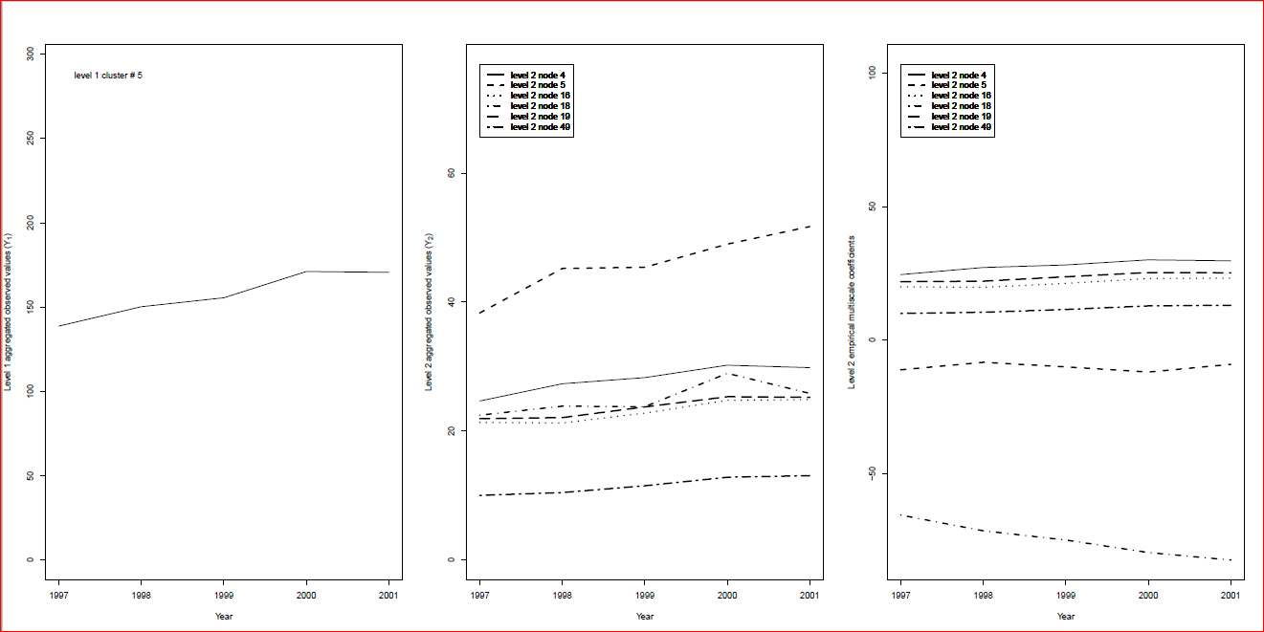

1. (b) (c)

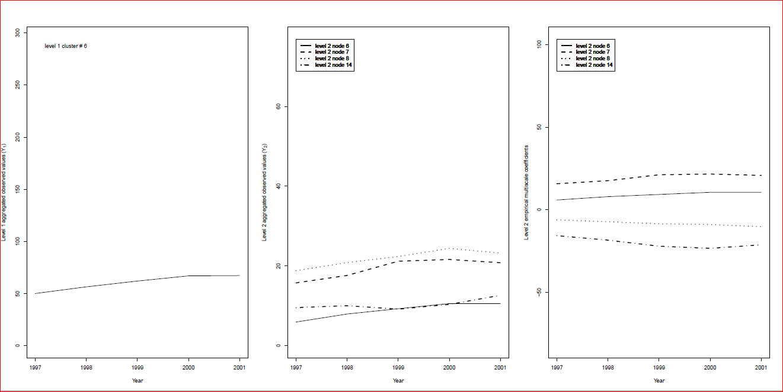

(d) (e) (f)

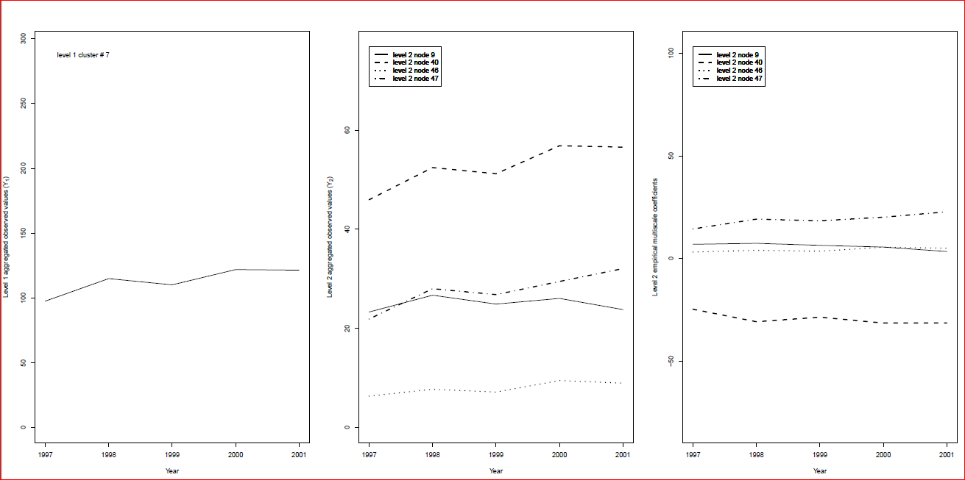

(g) (h) (i)

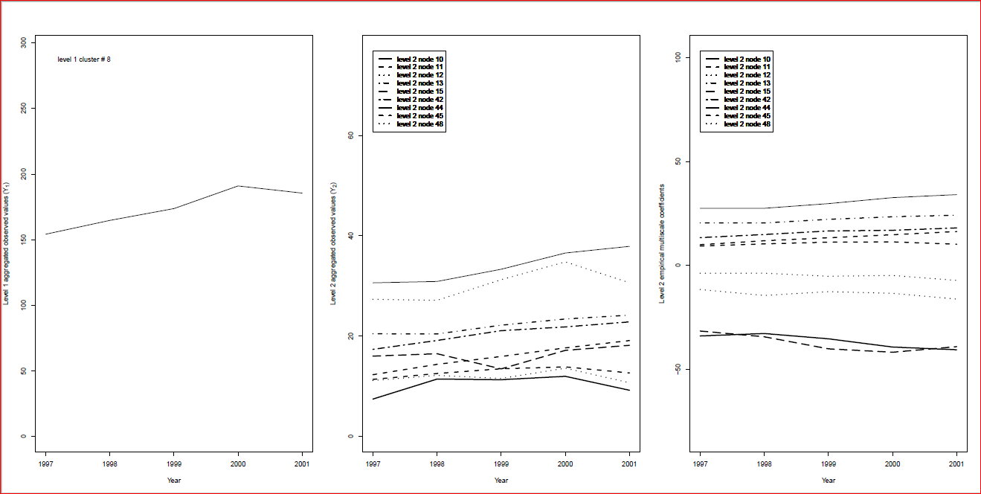

(j) (k) (l)

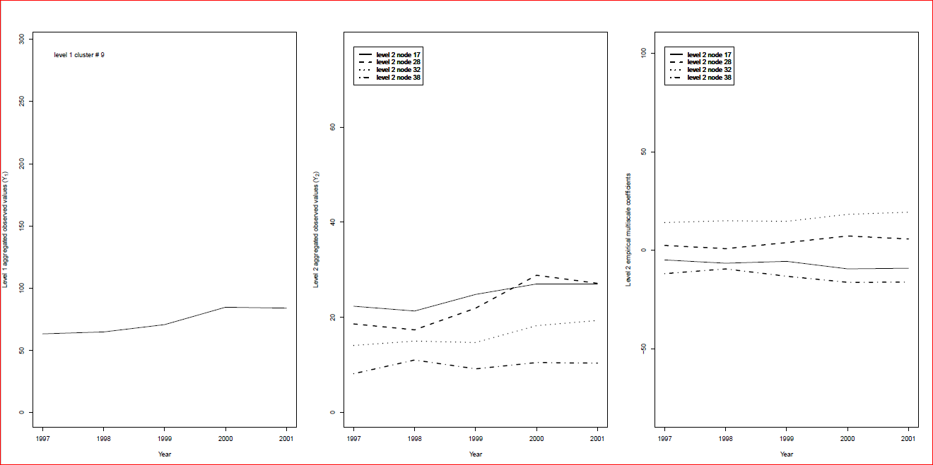

(m) (n) (o)

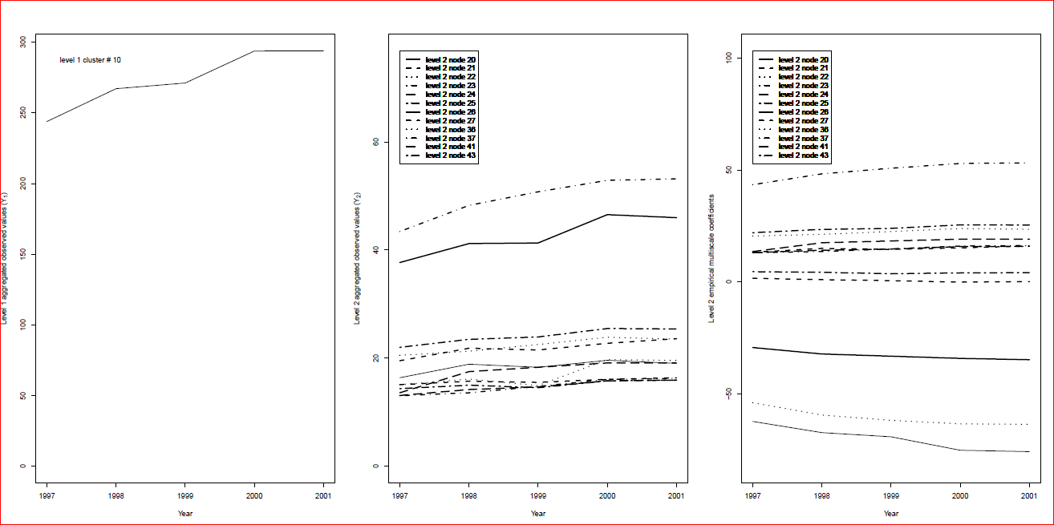

(p) (q) (r)

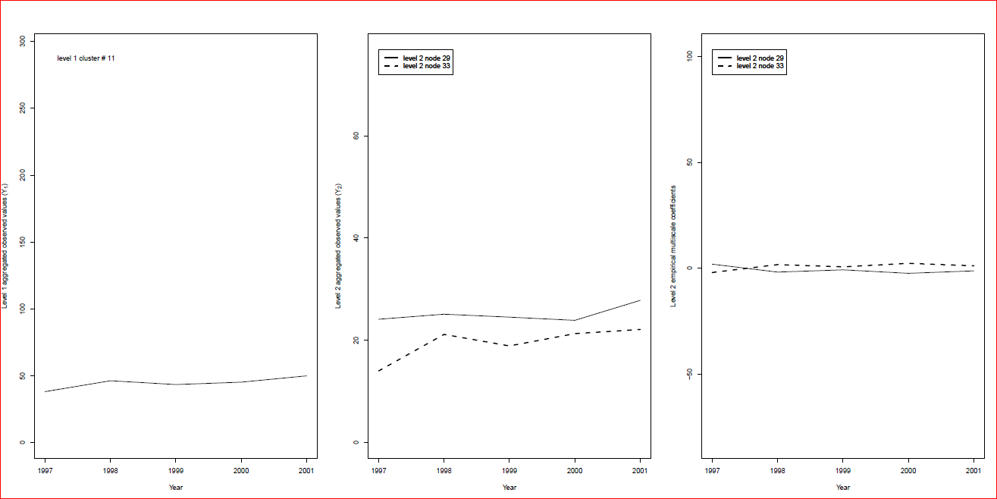

(s) (t) (u)

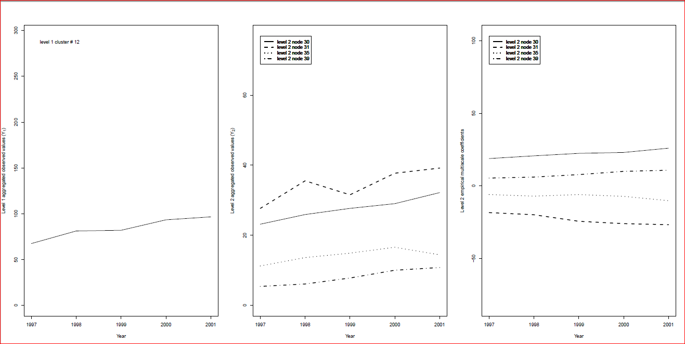

(v) (w) (x)

Figure 2: The sum of log order values (y-axix) at level 1 clusters in the study area in Year 1997-2001 (x-axis). Each row represents one cluster from Level 1 from cluster 5-12. The first 4 clusters are not shown here as there are clustered because they do not have geographical neighborhood. Column one shows Level 1 total (a, d, g, j, m, p, s, v); Level one total disaggregated by Level Two clusters as shown in the second column (b, e, h, k, n, q, t,w); the empirical multiscale coefficients are shown in the third column (c, f, I, l, o, r, u,x).