First-principles perspectives on detection properties of sulfur mustard gas using novel electroresistive ε-Arsenene nanosheet device

R. Bhuvaneswari, J. Princy Maria, V. Nagarajan, R. Chandiramouli*
School of Electrical & Electronics Engineering
SASTRA Deemed University, Tirumalaisamudram, Thanjavur -613 401, India

Supplementary information
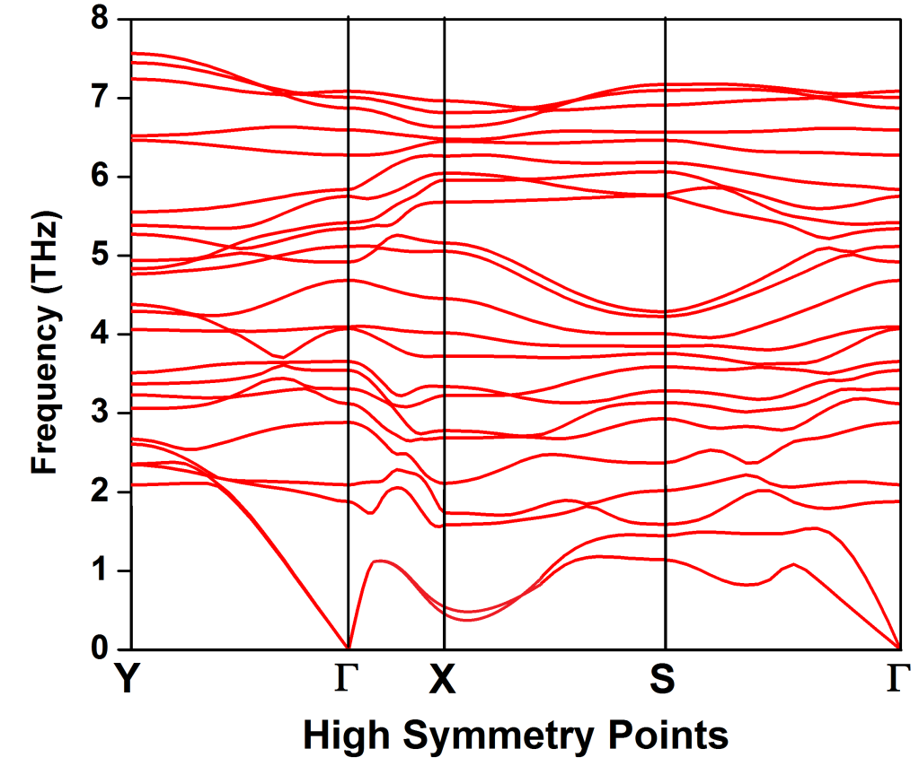
Fig. S1 Phonon-band-spectrum of pristine ε-As nanosheet.

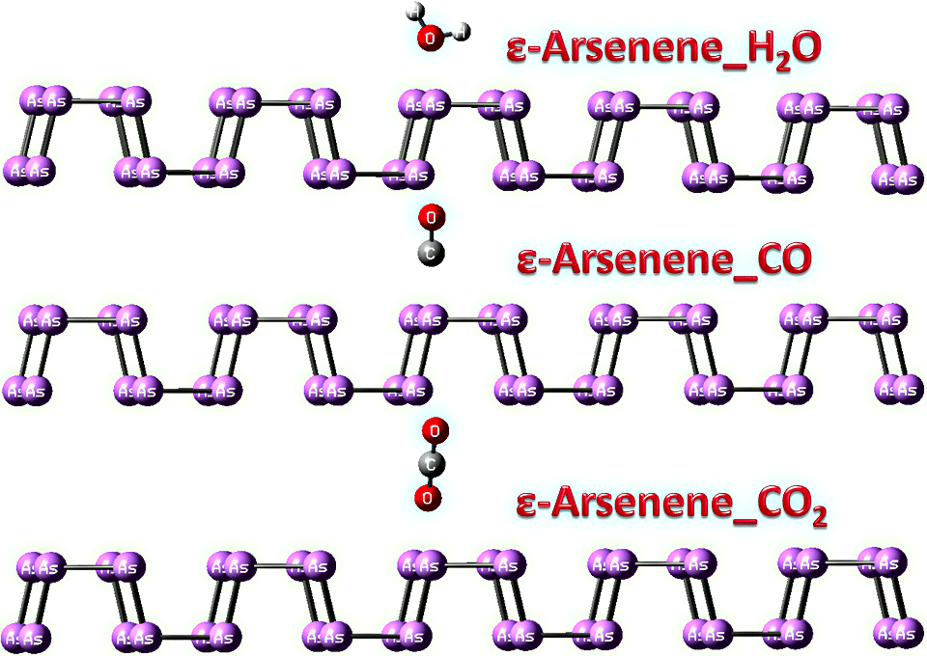
Fig. S2 Adsorption of H₂O, CO and CO₂ molecules on ε-As nanosheet.

Fig. S3 Bands and PDOS maps - ε-As nanosheet_H₂O.
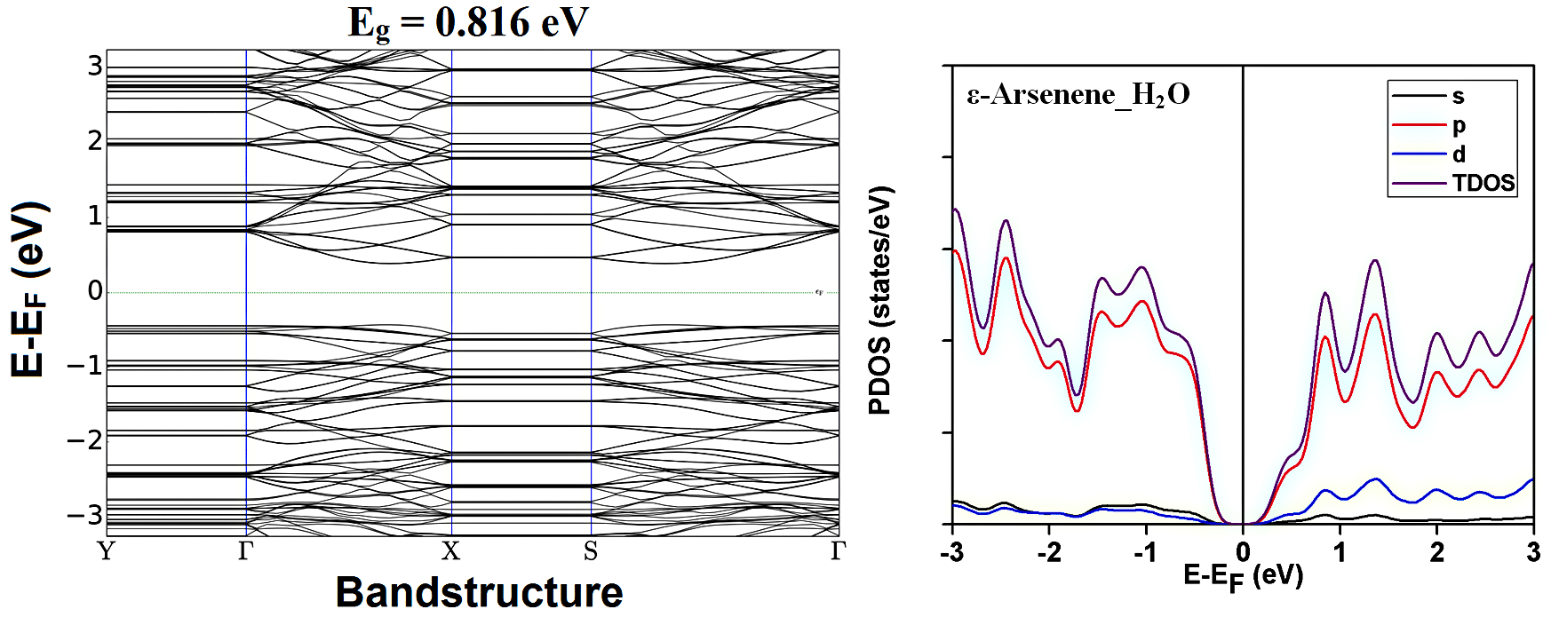
Fig. S4 Bands and PDOS maps - ε-As nanosheet_CO.
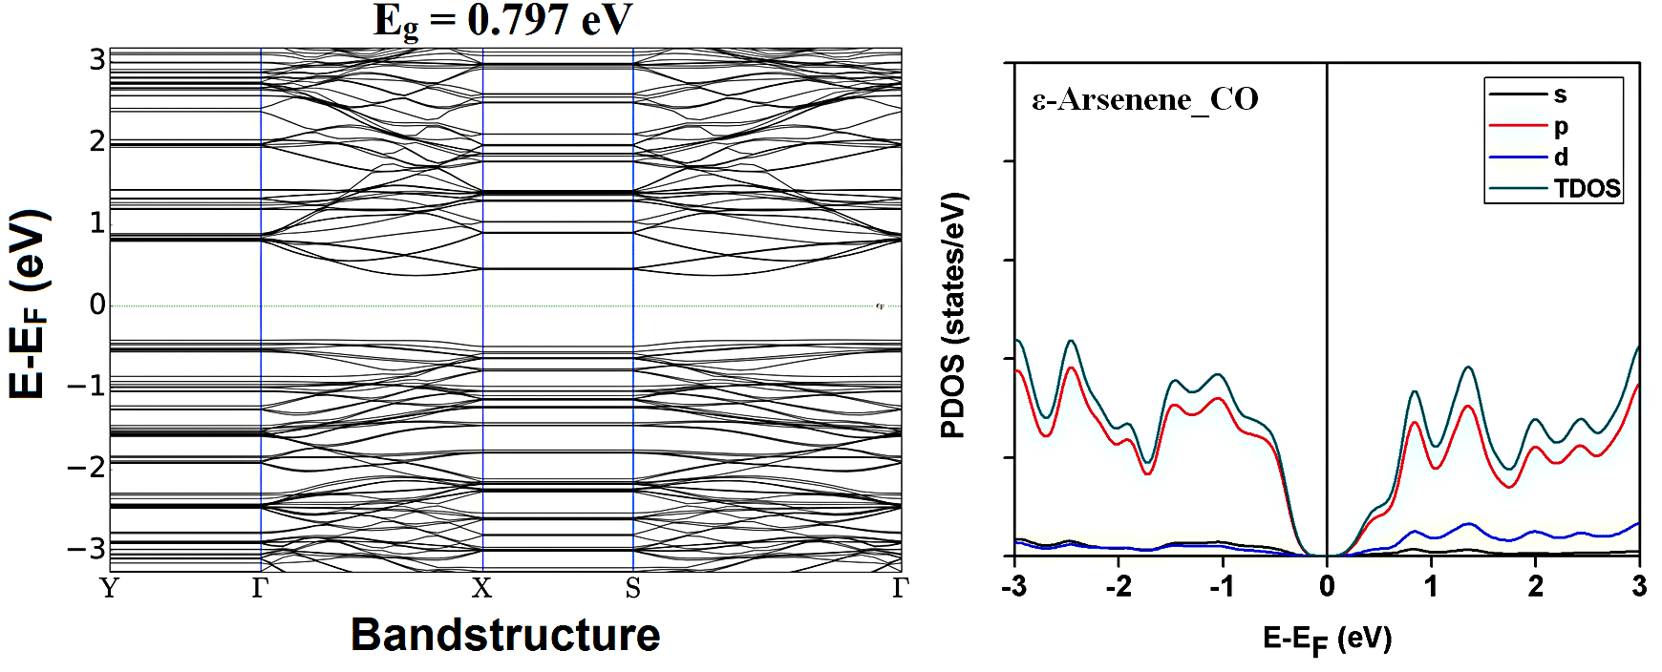
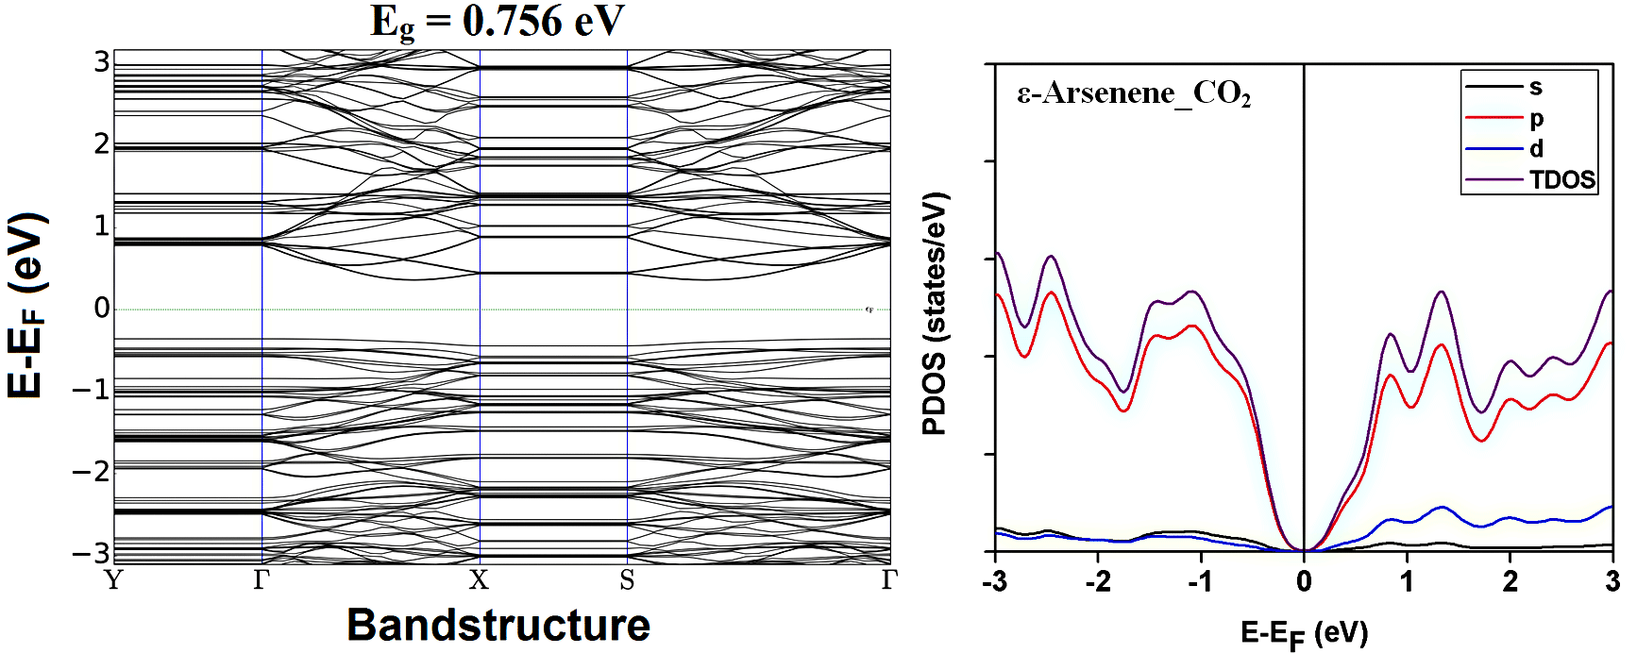
Fig. S5 Bands and PDOS maps - ε-As nanosheet_CO₂.

