Supporting Information
Folic Acid-Modified Celastrol Nanoparticles: Synthesis, Characterization, Anticancer Activity in 2D and 3D Breast Cancer Models

Siukan Law^{1,2,4}, Albert Wingnang Leung³, Chuanshan Xu^{1*}
1. Key Laboratory of Molecular Target and Clinical Pharmacology, State Key Laboratory of Respiratory Disease, School of Pharmaceutical Sciences & Fifth Affiliated Hospital, Guangzhou Medical University, Guangzhou 511436, China
2. School of Chinese Medicine, Faculty of Medicine, The Chinese University of Hong Kong, Shatin, Hong Kong
3. Asia-Pacific Institute of Aging Studies, Lingnan University, Tuen Mun, Hong Kong
4. Department of Science, School of Science and Technology, The Open University of Hong Kong, Ho Man Tin, Kowloon, Hong Kong
*Correspondence to Professor Chuanshan Xu (xcshan@163.com)

Table S1 The attenuated total reflection fourier transform infrared spectrum of (i) folic acid, (ii) celastrol,
(iii) PVP-co-2-dimethylaminoethyl methacrylate and (iv) CA and (v) FCA.

 | Wavelength (cm⁻¹) | Groups | Compound class
(i) Folic acid  (Supporting Information, Fig. S1) | 3542 cm⁻¹  3415 cm⁻¹  3321 cm⁻¹  3099 cm⁻¹  2926 cm⁻¹  1690 cm⁻¹ | N-H stretching  N-H stretching  N-H stretching  N-H stretching  O-H stretching  C=O stretching | Primary amine  Aliphatic amine  Aliphatic amine  Amine  Carboxylic acid  Conjugated aldehyde
(ii) Celastrol  (Supporting Information, Fig. S2) | 3401 cm⁻¹  2943 cm⁻¹  2873 cm⁻¹ | O-H stretching  O-H stretching  O-H stretching | Alcohol  Carboxylic acid  Alcohol
(iii) PVP-co-2-dimethylaminoethyl  methacrylate  (Supporting Information, Fig. S3) | 3274 cm⁻¹  1637 cm⁻¹ | C-H stretching  N-H bending | Alkane  Amine
(iv) CA  (Supporting Information, Fig. S4) | 3262 cm⁻¹  1643 cm⁻¹  1296 cm⁻¹ | C-H / O-H stretching  N-H bending  C-O stretching | Carboxylic acid  Amine  Aromatic ester
(v) FCA  (Supporting Information, Fig. S5) | 3269 cm⁻¹  1635 cm⁻¹  1295 cm⁻¹  1044 cm⁻¹ | C-H / O-H stretching  N-H bending  C-O stretching  CO-O-CO stretching | Carboxylic acid  Amine  Aromatic ester  Anhydride

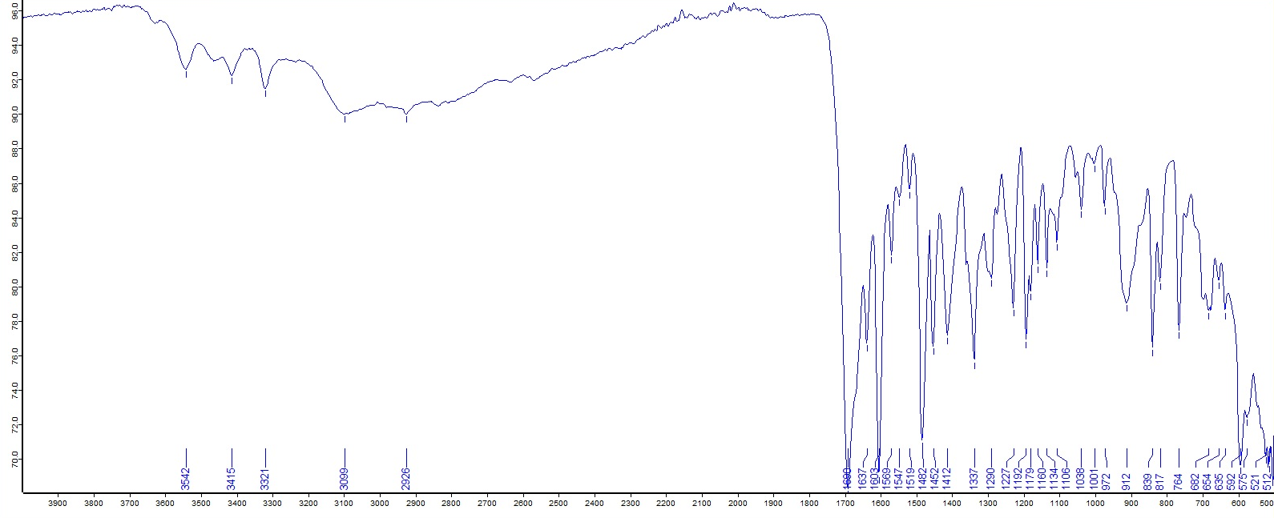Fig. S1. The attenuated total reflection fourier transform infrared spectrum of folic acid.

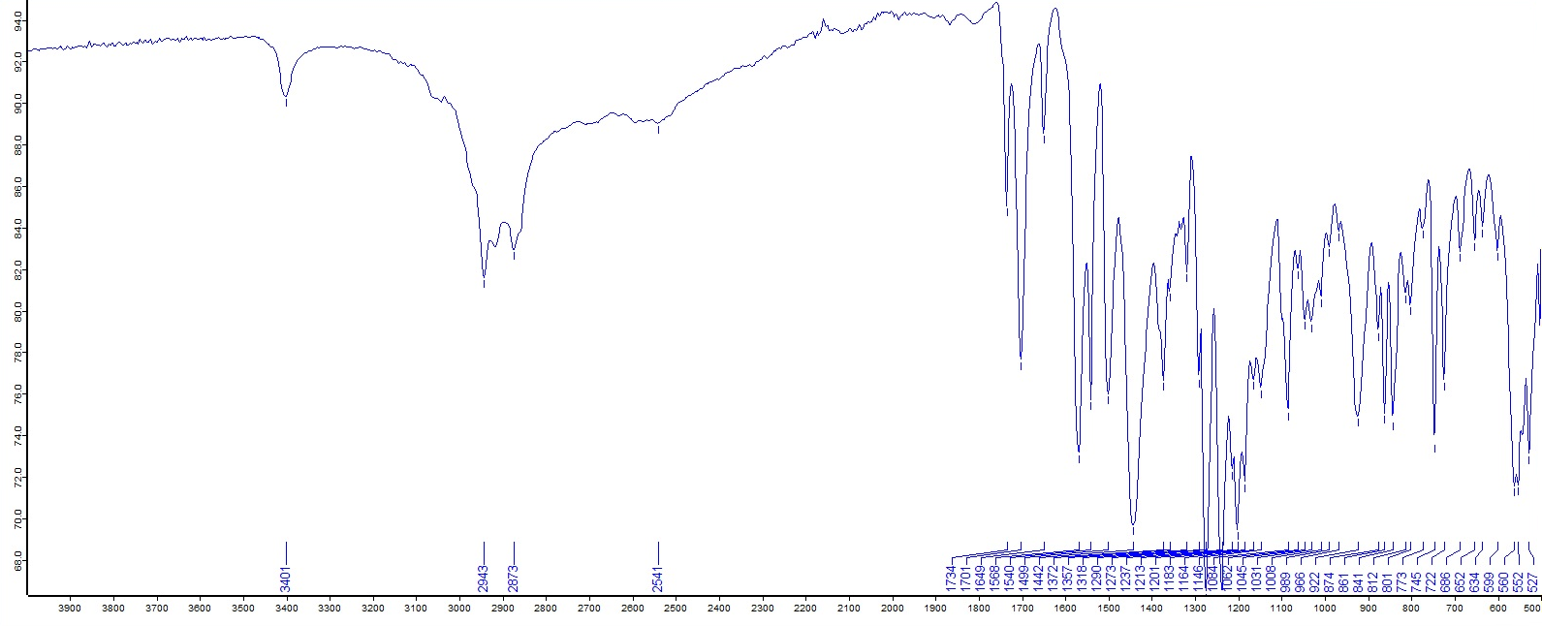
Fig. S2. The attenuated total reflection fourier transform infrared spectrum of celastrol.

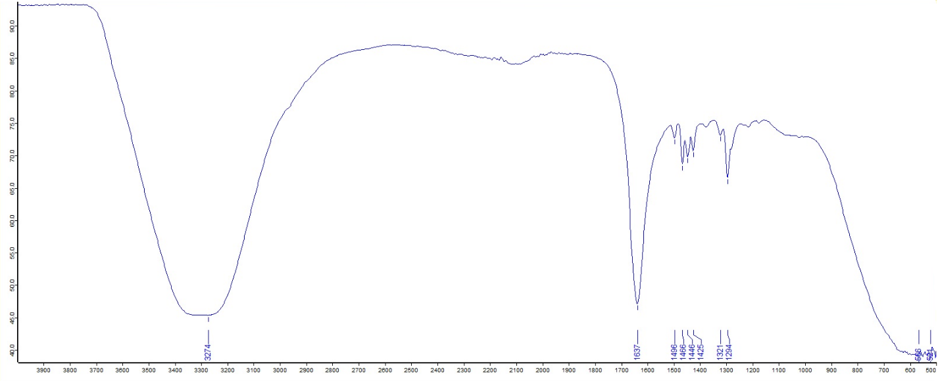Fig. S3. The attenuated total reflection fourier transform infrared spectrum of
PVP-co-2-dimethylaminoethyl methacrylate.

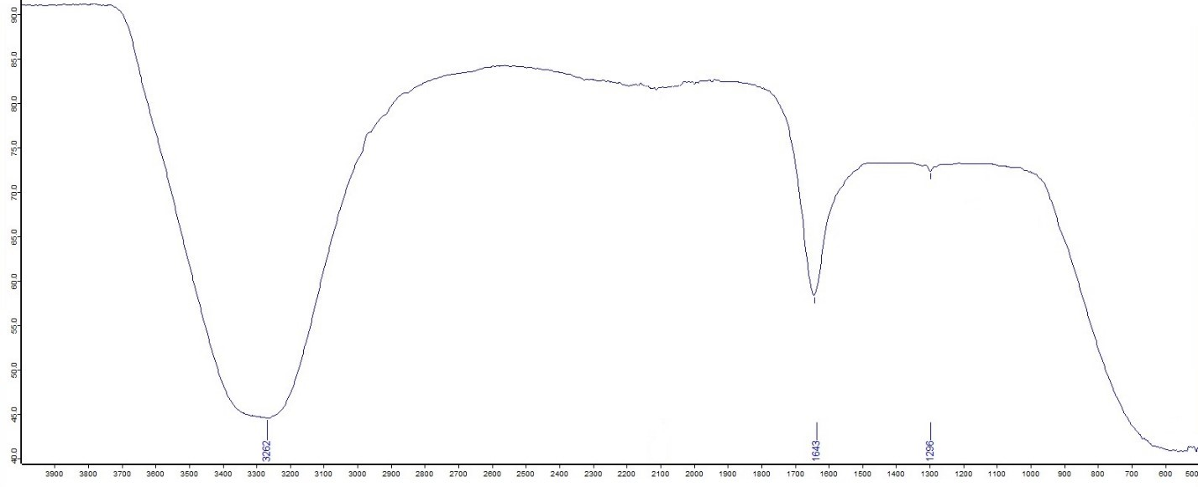Fig. S4. The attenuated total reflection fourier transform infrared spectrum of Celastrol AuNP (CA).

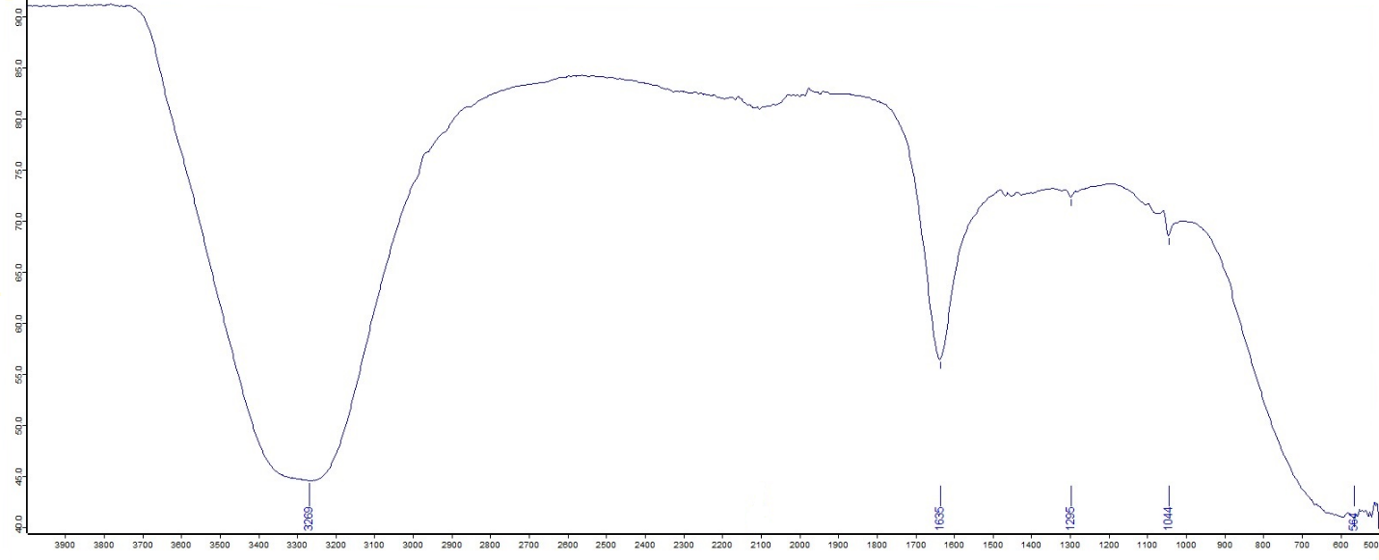Fig. S5. The attenuated total reflection fourier transform infrared spectrum of
folate receptor targeted celastrol AuNP (FCA).

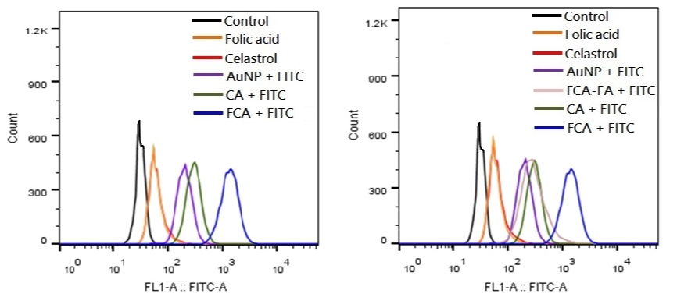
Fig. S6. Summarized flow cytometry
quantitative analysis.
(Lack of FCA-FA treatment group)

Fig. S7. Summarized flow cytometry
quantitative analysis.

Table S2 Relative FITC Green Fluorescence Intensity for control group, folic acid treatment group, celastrol treatment group, gold nanoparticle (AuNP) treatment group, folate receptor targeted celastrol AuNP and folic acid (FCA-FA) treatment group, celastrol AuNP (CA) treatment group and folate receptor targeted celastrol AuNP (FCA) treatment group.
Relative FITC Green Fluorescence Intensity
 | Trial 1 | Trial 2 | Trial 3 | AVE | SD
Control | 0.081 | 0.025 | 0.068 | 0.06 | 0.03
Folic acid | 1.08 | 0.36 | 0.85 | 0.76 | 0.37
Celastrol | 0.12 | 1.81 | 0.83 | 0.92 | 0.85
AuNP | 22.7 | 27.1 | 25.7 | 25.17 | 2.25
FCA-FA | 59.3 | 45.4 | 51.4 | 52.03 | 6.97
CA | 74.2 | 73.6 | 69.4 | 72.40 | 2.62
FCA | 99.96 | 99.97 | 99.96 | 99.96 | 0.01

*

Fig. S8. Relative FITC Green Fluorescence Intensity for control group, folic acid treatment group, celastrol treatment group, gold nanoparticle (AuNP) treatment group, folate receptor targeted celastrol AuNP and folic acid (FCA-FA) treatment group, celastrol AuNP (CA) treatment group and folate receptor targeted celastrol AuNP (FCA) treatment group. Data were expressed as mean$±$SD (n=3), *P < 0.05 versus control, one-way ANOVA.

*
Fig. S9. Cytotoxicity assay of folic acid in breast cancer MCF-7 cells for 24 h.

*
Fig. S10. Cytotoxicity assay of gold nanoparticle (AuNP) in breast cancer cells for 24 h.

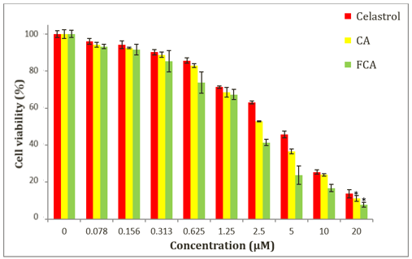

Fig. S11. Cytotoxicity assay of celastrol, celastrol AuNP (CA) and folate receptor targeted celastrol AuNP (FCA) in breast cancer MCF-7 cells at 20 μM for 24 h. MTT assay was expressed as mean$±$SD (n=3), *P < 0.05 versus celastrol, two-way ANOVA.

Table S3 Cell viability (%) of breast cancer MCF-7 cells after incubation for 24 hours with different concentrations from 0 to 20 μM of the celastrol, celastrol AuNP (CA) and folate receptor targeted celastrol AuNP (FCA). MTT assay was expressed as mean$±$SD (n=3), *P < 0.05 versus celastrol, two-way ANOVA.
Concentration (μM) | Celastrol | CA | FCA
0 | 100 | 100 | 100
0.078 | 96.00$±$1.48 | 94.13$±$1.44 | 93.20$±$1.23
0.156 | 94.26$±$2.05 | 92.49$±$0.41 | 91.65$±$2.92
0.313 | 90.15$±$1.44 | 88.76$±$1.49 | 85.29$±$5.78
0.625 | 85.64$±$1.52 | 82.89$±$1.03 | 73.68$±$5.77
1.25 | 71.28$±$0.77 | 68.53$±$2.66 | 67.31$±$2.82
2.5 | 63.01$±$0.74 | 52.74$±$0.25 | 41.41$±$1.76
5 | 45.83$±$1.87 | 36.68$±$1.32 | 23.70$±$5.04
10 | 25.39$±$1.22 | 23.90$±$0.74 | 16.75$±$1.98
20 | 13.74$±$2.23 | *11.13$±$1.55 | *7.76$±$1.35

