Supplementary figure 1
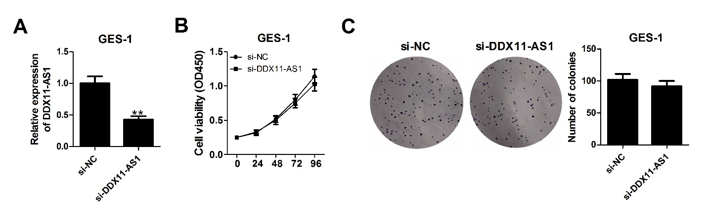
Supplemental Figure 1. Effect of DDX11-AS1 knockdown on the proliferation of normal gastric epithelium cells GES-1. (A) DDX11-AS1 expression in GES-1 cells after transfection with si-DDX11-AS1. (B and C) CCK-8 assay and clone formation assay were used to determine the effect of DDX11-AS1 knockdown on GES-1 cell proliferation.

