# One step selective partition of ε-polylysine present in broth cultures in ionic liquid based aqueous biphasic systems

Rosy Alphons Sequeira, *a,b* Mukesh Sharma, *b* Matheus M. Pereira, c Nripat Singh, *a,b* Sourish Bhattacharya *d* , Nishith A Chudasama a & Kamalesh Prasad * *a,b*

*a Natural Products & Green Chemistry Division, CSIR-Central Salt & Marine Chemicals Research Institute, G. B Marg, Bhavnagar-364002 (Gujarat), India. (Tel : +91-278-2567760 ; Fax : +91-278-2567562 ; e-mail :* [*kamlesh@csmcri.res.in*](mailto:kamlesh@csmcri.res.in)[*/drkamaleshp@gmail.com*](mailto:/drkamaleshp@gmail.com)

*b Academy of Scientific and Innovative Research (AcSIR), Ghaziabad- 201002, India.*

*c CICECO - Aveiro Institute of Materials, Department of Chemistry, University of Aveiro, 3810-193 Aveiro, Portugal*

*d Process design and Engineering Division, CSIR-Central Salt & Marine Chemicals Research Institute, G. B Marg, Bhavnagar-364002 (Gujarat), India.*

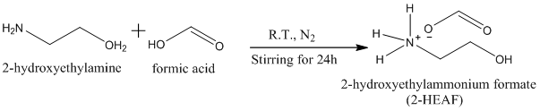

Scheme S1 : Synthesis of 2-HEAF

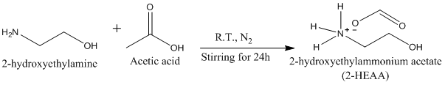

Scheme S2 : Synthesis of 2-HEAA

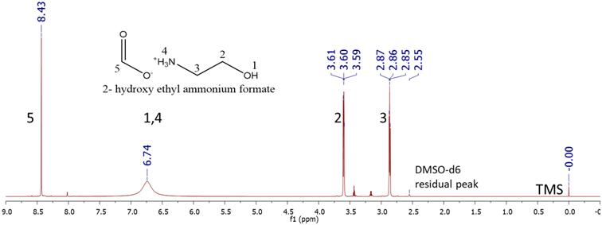

Figure S1: 1H NMR of 2-HEAF (DMSO-d6, 600 MHz, δ/ppm relative to TMS): 8.43 (s, 1H, H–COO); 6.74 (s, 4H, –NH3 +OH); 3.60 (t, 2H, –O–CH2–); 2.86 (t, 2H, –CH2–N); 2.55 (DMSO-d6 solvent residual peak)

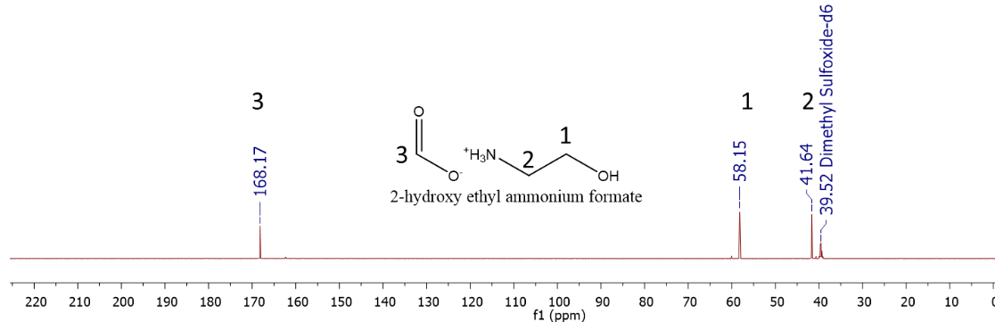

Figure S2: 13C NMR of 2-HEAF (DMSO solvent, δ/ppm relative to TMS): 168.17 (s, -CH-); 58.15 (s, -CH2-); 41.64 (s, -CH2-); 39.52 (DMSO solvent peak)

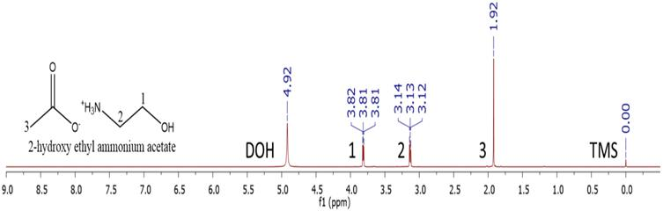

Figure S3: 1H NMR of 2-HEAA (D2O, 600 MHz, δ/ppm relative to TMS): 1.92 (s,3H, -CH3– COO); 3.13 (t, 2H, –CH2-NH3+); 3.81 (t, 2H, ––CH2-OH); 4.92 (D2O solvent)

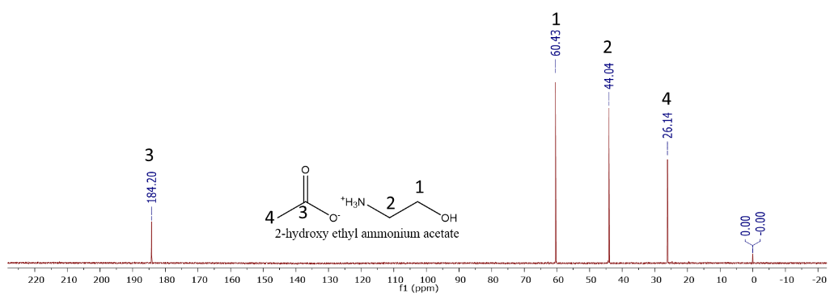

Figure S4: 13C NMR of 2-HEAA (D2O solvent, δ/ppm relative to TMS): 184.20 (s, -COO); 60.43 (s, -CH2-); 44.04 (s, -CH2-); 26.14 (s, -CH3)

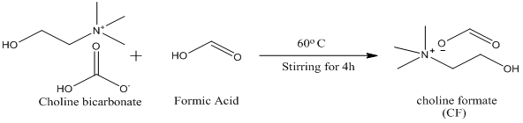

Scheme S3: Reaction scheme for the synthesis of choline formate

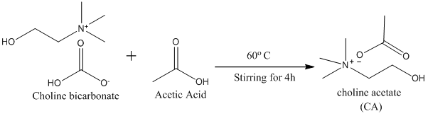

Scheme S4: Reaction scheme for the synthesis of choline acetate

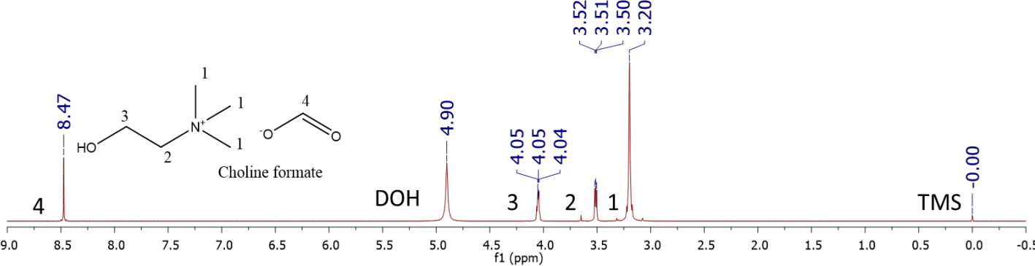Figure S5: 1H NMR of choline formate (D2O, 600 MHz, δ/ppm relative to TMS): 3.20 (s, 9H, -N-CH3), 3.51 (t, 2H, -CH2-N-), 4.05 (t, 2H, -O-CH2-), 8.47 (s, 1H, HCOO-), 4.90 (D2O Solvent).

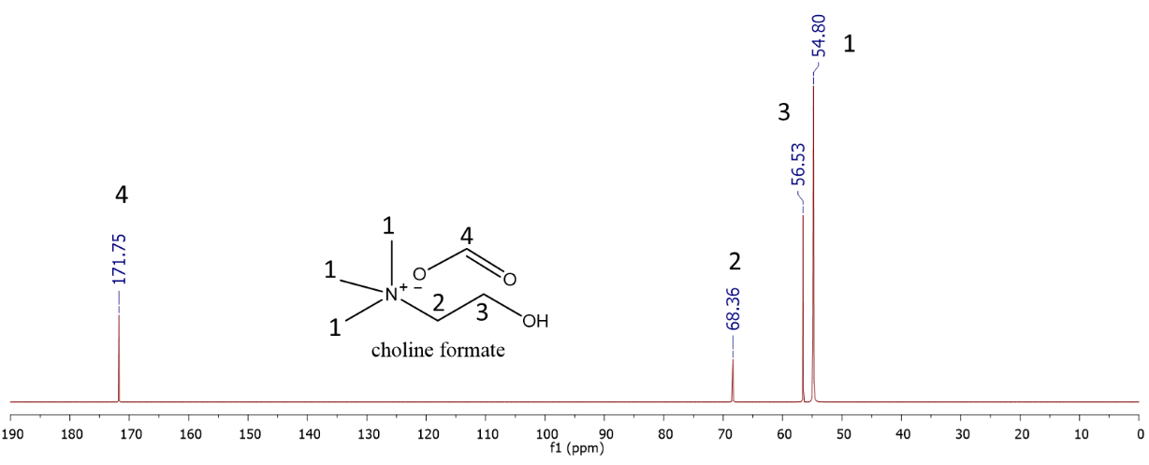

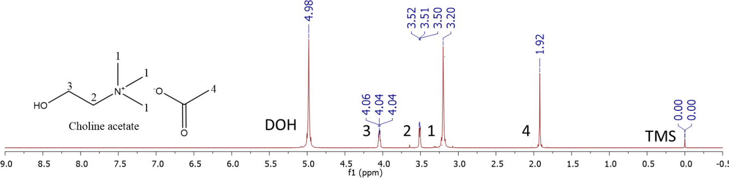Figure S6: 13CNMR of choline formate (D2O solvent, δ/ppm relative to TMS): 171.75 (s, -CH); 68.36 (s, -CH2-); 56.53 (s, -CH2-); 54.80 (s, -CH3)

Figure S7: 1H NMR of choline acetate (D2O, 600 MHz, δ/ppm relative to TMS): 1.92 (s, 3H, -CO-CH3), 3.20 (s, 9H, -NCH3), 3.51 (t, 2H, -CH2-N-), 4.04 (t, 2H, -O-CH2), 4.98 (D2O Solvent).

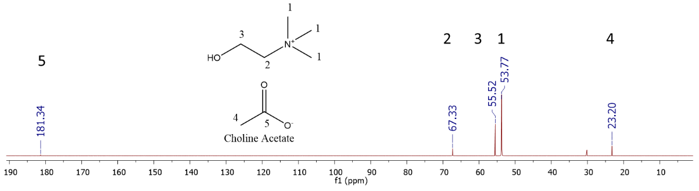

Figure S8: 13NMR of choline acetate (D2O solvent, δ/ppm relative to TMS): 181.34 (s, -C-); 67.33 (s, -CH2-); 55.52 (s, -CH2-); 53.77 (s, -CH3); 23.20 (s, -CH3)



Table S1 : Experimental weight fraction data for the systems composed of IL (1) + PPG400 (2) +

H2O (3) at 25 ºC



Figure S9: Phase diagrams of ABS composed of 2-HEAF + PPG 400 + H2O in wt%



Figure S10: Phase diagrams of ABS composed of 2-HEAA + PPG 400 + H2O in wt%



Figure S11: Phase diagrams of ABS composed of ChoF + PPG 400 + H2O in wt%



Figure S12 : Phase diagrams of ABS composed of ChoAA + PPG 400 + H2O in wt %



Figure S13: Phase diagrams of ABS composed of 2-HEAF + PPG 400 + H2O in molality



Figure S14: Phase diagrams of ABS composed of 2-HEAA + PPG 400 + H2O in molality



Figure S15: Phase diagrams of ABS composed of ChoF + PPG 400 + H2O in molality



Figure S16: Phase diagrams of ABS composed of ChoAA + PPG 400 + H2O in molality

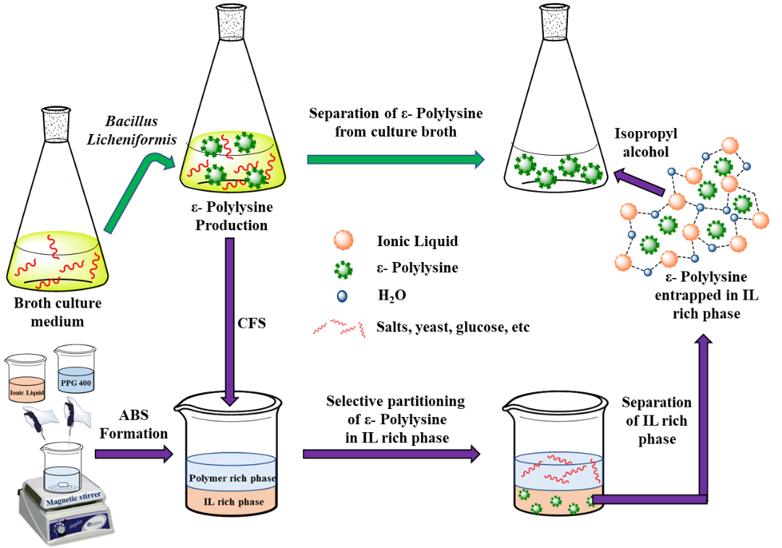

Figure S17: Graphical representation for the partition of ε-PL from culture broth using aqueous biphasic systems.

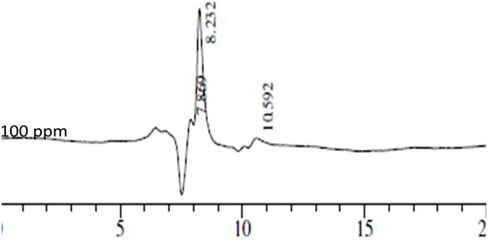

Figure S18 : HPLC chromatogram of ε- PL aqueous solution (100 ppm)

The concentration vs peak area for different retention times were plotted

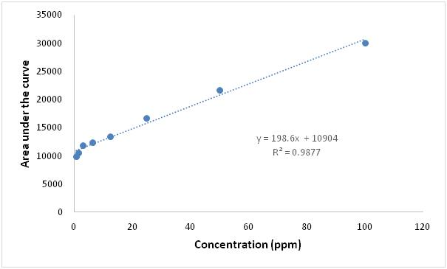

Retention Time: 7.8 min

Figure S19: The concentration vs peak area for retention time of 7.8 min.

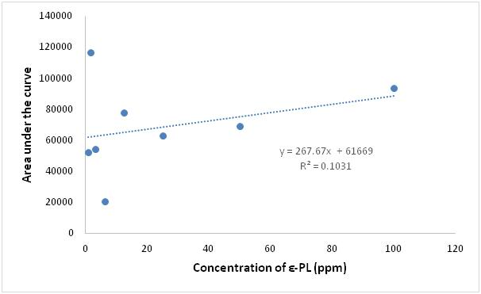

Retention Time: 8.2 min

Figure S20: The concentration vs peak area for retention time of 8.2 min.

Retention Time: 10.5 min

Figure S21 : The concentration vs peak area for retention time of 10.5 min.

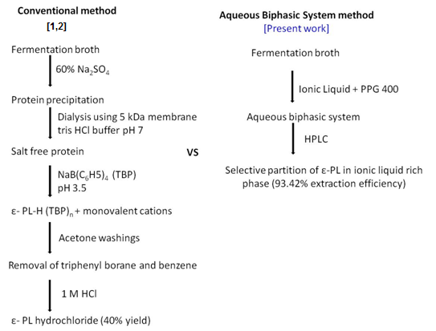

Scheme S5: Comparison of the extraction of ε-PL from culture broth using conventional method and the ABS based method.

Reference

# 1. Bhattacharya, S., Pramanik, S. K., Gehlot, P. S., Patel, H., Gajaria, T., Mishra, S., & Kumar, A. (2017). Process for preparing value-added products from microalgae using textile effluent through a biorefinery approach. *ACS Sustainable Chemistry & Engineering*, *5*(11), 10019-10028.

2. Katano, H., Yoneoka, T., Kito, N., Maruyama, C., & Hamano, Y. (2012). Separation and Purification of ε-Poly-L-lysine from the Culture Broth Based on Precipitation with the Tetraphenylborate Anion. *Analytical Sciences*, *28*(12), 1153-1157.