Supporting Information
Decarboxylation of Indole-3-carboxylic Acids under Metal-free Conditions
Xia Chen and Xiao-Yu Zhou*
School of Chemistry and Materials Engineering, Liupanshui Normal University, Liupanshui, 553004, China
Zhouxiaoyu20062006@126.com (X.-Y. Zhou)
Table of Contents
1. General and Materials………………………………………………………..……..…S1
2. The Typical Procedure for the Decarboxylation of Indole-3-carboxylic Acids…… S1-4
3. References………………………………………………………………………………S4
4. Copy of NMR for Indoles……………………………………………...…............…….S5-16

1. General and Materials.
General: The chemical shifts for ¹H NMR were recorded in ppm downfield from tetramethylsilane (TMS) with the solvent resonance as the internal standard. The chemical shifts for ¹³C NMR were recorded in ppm downfield using the central peak of d-dimethyl sulfoxide (39.6 ppm) or d-chloroform (77.23 ppm) as the internal standard. Coupling constants (J) are reported in Hz and refer to apparent peak multiplications. Flash column chromatography was performed on silica gel (200-300 mesh). TLC analysis was performed using glass-backed plates coated with 0.2 mm silica.
Materials: All commercially available reagents were used without further purification. The starting materials 1a-1n are commercially available.

2. The Typical Procedure for the Decarboxylation of Indole-3-carboxylic Acids
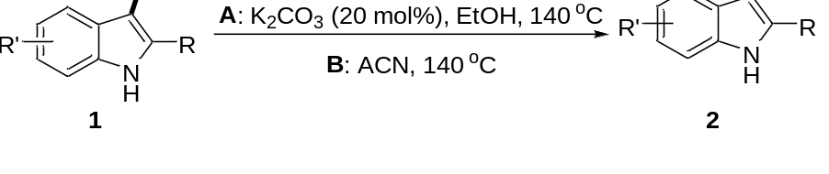
Procedure A: A mixture of indole-3-carboxylic acid 1 (0.50 mmol) and K₂CO₃ (13.8 mg, 0.10 mmol, 20 mol%) in EtOH (3 mL) was added into a Schlenk flask (25 mL) and stirred at 140 °C. The reaction was monitored by thin layer chromatography until the disappearance of starting material 1. Then the solvent was evaporated under reduced pressure and the residue was purified by column chromatography (petroleum ether/ethyl acetate 20:1 to 10:1).
Procedure B: A mixture of indole-3-carboxylic acid 1 (0.50 mmol) in CH₃CN (3 mL) was added into a Schlenk flask (25 mL) and stirred at 140 °C. The reaction was monitored by thin layer chromatography until the disappearance of starting material 1. Then the solvent was evaporated under reduced pressure and the residue was purified by column chromatography (petroleum ether/ethyl acetate 20:1 to 10:1).
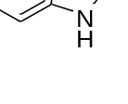
1H-indole (2a)^{[1]}
Yield A: > 99%, 59.0 mg; Yield B: > 99%, 59.0 mg. White solid, mp 50-52 °C, R_{f} 0.51 (Hexane/EtOAc, 10:1). ¹H NMR (600 MHz, CDCl₃) δ 8.08 (s, 1H), 7.74 (d, J = 7.9 Hz, 1H), 7.43 (dd, J = 8.1, 0.6 Hz, 1H), 7.31-7.26 (m, 1H), 7.24-7.19 (m, 2H), 6.64 (t, J = 2.1 Hz, 1H); ¹³C NMR (151 MHz, CDCl₃) δ 135.8, 127.9, 124.2, 122.0, 120.8, 119.9, 111.1, 102.6.
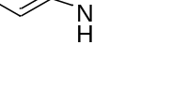
2-methyl-1H-indole (2b) ^{[1]}
Yield A: 95%, 62.0 mg; Yield B: 89%, 58.4 mg. White solid, mp 53-55 °C, R_{f} 0.51 (Hexane/EtOAc, 10:1). ¹H NMR (600 MHz, CDCl₃) δ 7.71 (s, 1H), 7.57-7.46 (m, 1H), 7.24 (d, J = 7.9 Hz, 1H), 7.17-7.01 (m, 2H), 6.22 (s, 1H), 2.40 (s, 3H); ¹³C NMR (151 MHz, CDCl₃) δ 136.1, 135.1, 129.1, 121.0, 119.7, 110.3, 100.4, 13.7.
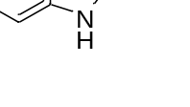
2-phenyl-1H-indole (2c) ^{[1]}
Yield A: 91%, 87.5 mg; Yield B: 98%, 94.5 mg. White solid, mp 183-185 °C, R_{f} 0.53 (Hexane/EtOAc, 10:1). ¹H NMR (600 MHz, CDCl₃) δ 8.35 (s, 1H), 7.70 (dd, J = 8.2, 1.3 Hz, 3H), 7.49 (t, J = 7.8 Hz, 2H), 7.44 (dd, J = 8.0, 0.4 Hz, 1H), 7.38 (t, J = 7.4 Hz, 1H), 7.27-7.24 (m, 1H), 7.21-7.17 (m, 1H), 6.88 (d, J = 1.4 Hz, 1H); ¹³C NMR (151 MHz, CDCl₃) δ 138.0, 136.9, 132.4, 129.3, 129.1, 127.8, 125.2, 122.4, 120.7, 120.3, 111.0, 100.0.
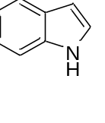
1H-indole-4-carbonitrile (2d) ^{[2]}
Yield A: > 99%, 73.0 mg; Yield B: 97%, 69.2 mg. White solid, mp 119-121 °C, R_{f} 0.42 (Hexane/EtOAc, 10:1). ¹H NMR (600 MHz, CDCl₃) δ 8.82 (s, 1H), 7.69 (d, J = 8.2 Hz, 1H), 7.51 (d, J = 7.4 Hz, 1H), 7.44 (t, J = 2.8 Hz, 1H), 7.26 (t, J = 7.8 Hz, 1H), 6.79 (s, 1H); ¹³C NMR (151 MHz, CDCl₃) δ 135.6, 129.3, 127.2, 125.4, 121.6, 119.1, 116.2, 102.7, 101.5.
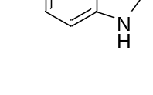
5-methyl-1H-indole (2e) ^{[1]}
Yield A: 97%, 63.6 mg; Yield B: > 99%, 65.5 mg. White solid, mp 63-65 °C, R_{f} 0.51 (Hexane/EtOAc, 10:1). ¹H NMR (600 MHz, CDCl₃) δ 7.87 (s, 1H), 7.42 (s, 1H), 7.22 (d, J = 8.3 Hz, 1H), 7.08 (t, J = 2.8 Hz, 1H), 7.01 (dd, J = 8.3, 1.0 Hz, 1H), 6.45 (t, J = 2.1 Hz, 1H), 2.44 (s, 3H); ¹³C NMR (151 MHz, CDCl₃) δ 134.2, 129.1, 128.2, 124.4, 123.7, 120.4, 110.8, 102.1, 21.5.
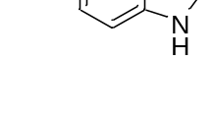
5-methoxy-1H-indole (2f) ^{[1]}
Yield A: > 99%, 74.0 mg; Yield B: > 99%, 73.2 mg. White solid, mp 56-58 °C, R_{f} 0.47 (Hexane/EtOAc, 10:1). ¹H NMR (600 MHz, CDCl₃) δ 8.11 (s, 1H), 7.30 (d, J = 8.6 Hz, 1H), 7.19 (s, 2H), 6.95 (d, J = 8.6 Hz, 1H), 6.55 (s, 1H), 3.92 (s, 3H); ¹³C NMR (151 MHz, CDCl₃) δ 154.2, 131.1, 128.3, 125.1, 112.4, 111.9, 102.4, 102.3, 55.9.
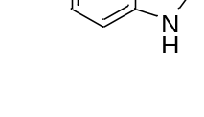
5-(benzyloxy)-1H-indole (2g) ^{[3]}
Yield A: 96%, 107.0 mg; Yield B: > 99%, 111.9 mg. White solid, mp 108-110 °C, R_{f} 0.45 (Hexane/EtOAc, 10:1). ¹H NMR (600 MHz, CDCl₃) δ 7.99 (s, 1H), 7.47 (d, J = 7.4 Hz, 2H), 7.37 (t, J = 7.5 Hz, 2H), 7.31 (t, J = 7.3 Hz, 1H), 7.24 (t, J = 7.5 Hz, 1H), 7.17 (t, J = 4.4 Hz, 1H), 7.11 (t, J = 2.7 Hz, 1H), 6.93 (dd, J = 8.8, 2.3 Hz, 1H), 6.50-6.40 (m, 1H), 5.09 (s, 2H); ¹³C NMR (151 MHz, CDCl₃) δ 153.4, 137.8, 131.2, 129.1, 128.6, 128.3, 127.9, 127.7, 125.4, 125.0, 113.1, 111.8, 104.0, 102.5, 71.0.
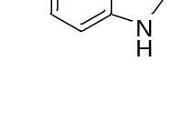
1H-indole-5-carbonitrile (2h) ^{[2]}
Yield A: > 99%, 71.5 mg; Yield B: 99%, 70.2 mg. White solid, mp 103-105 °C, R_{f} 0.39 (Hexane/EtOAc, 10:1). ¹H NMR (600 MHz, CDCl₃) δ 8.90 (s, 1H), 8.02 (s, 1H), 7.55-7.35 (m, 3H), 6.65 (s, 1H); ¹³C NMR (151 MHz, CDCl₃) δ 137.6, 127.7, 126.7, 126.4, 124.8, 121.1, 112.2, 103.3, 102.5.
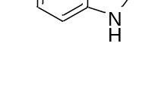
5-bromo-1H-indole (2i) ^{[1]}
Yield A: > 99%, 97.4 mg; Yield B: 93%, 90.7 mg. White solid, mp 85-87 °C, R_{f} 0.54 (Hexane/EtOAc, 10:1). ¹H NMR (600 MHz, CDCl₃) δ 8.19 (s, 1H), 7.87-7.77 (m, 1H), 7.33-7.28 (m, 2H), 7.25-7.20 (m, 1H), 6.54-6.53 (m, 1H); ¹³C NMR (151 MHz, CDCl₃) δ 134.4, 129.7, 125.4, 124.9, 123.2, 113.0, 112.5, 102.3.
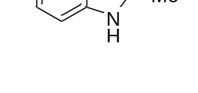
2,5-dimethyl-1H-indole (2j) ^{[4]}
Yield A: 91%, 87.5 mg; Yield B: > 99%, 77.0 mg. White solid, mp 118-120 °C, R_{f} 0.56 (Hexane/EtOAc, 10:1). ¹H NMR (600 MHz, CDCl₃) δ 7.70 (s, 1H), 7.36 (s, 1H), 7.19 (d, J = 8.2 Hz, 1H), 6.99 (dd, J = 8.2, 1.3 Hz, 1H), 6.23-6.15 (m, 1H), 2.49 (s, 3H), 2.45 (s, 3H); ¹³C NMR (151 MHz, CDCl₃) δ 135.2, 134.4, 129.4, 128.8, 122.4, 119.4, 109.9, 100.0, 21.5, 13.7.
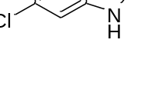
6-chloro-1H-indole (2k) ^{[5]}
Yield A: > 99%, 76.0 mg; Yield B: > 99%, 75.8 mg. White solid, mp 82-84 °C, R_{f} 0.60 (Hexane/EtOAc, 10:1). ¹H NMR (600 MHz, CDCl₃) δ 8.14 (s, 1H), 7.58 (d, J = 8.4 Hz, 1H), 7.41 (s, 1H), 7.25-7.18 (m, 1H), 7.14 (dd, J = 8.4, 1.8 Hz, 1H), 6.62-6.53 (m, 1H); ¹³C NMR (151 MHz, CDCl₃) δ 136.2, 127.9, 126.5, 124.9, 121.6, 120.6, 111.0, 102.8.
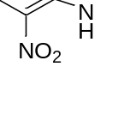
7-nitro-1H-indole (2l) ^{[6]}
Yield A: 96%, 78.0 mg; Yield B: 98%, 79.0 mg. Yellow solid, mp 90-92 °C, R_{f} 0.35 (Hexane/EtOAc, 10:1). ¹H NMR (600 MHz, CDCl₃) δ 9.99 (s, 1H), 8.18 (d, J = 8.1 Hz, 1H), 7.99 (d, J = 7.7 Hz, 1H), 7.48-7.38 (m, 1H), 7.22 (t, J = 7.9 Hz, 1H), 6.79-6.69 (m, 1H); ¹³C NMR (151 MHz, CDCl₃) δ 133.0, 131.7, 129.2, 129.0, 126.7, 119.2, 119.2, 104.0.

3. References
[1] Söederberg, B. C.; Shriver, J. A. J. Org. Chem. 1997, 62, 5838.
[2] Littke, A.; Soumeillant, M.; Kaltenbach III, R. F.; Cherney, R. J.; Tarby, C. M.; Kiau, S. Org. Lett. 2007, 9, 1711.
[3] Buemi, M. R.; De Luca, L.; Chimirri, A.; Ferro, S.; Gitto, R.; Alvarez-Builla, J.; Alajarin, R. Bioorg. Med. Chem. 2013, 21, 4575.
[4] Shore, G.; Morin, S.; Mallik, D.; Organ, M. G. Chem. Eur. J. 2008, 14, 1351.
[5] Tsuji, Y.; Kotachi, S.; Huh, K. T.; Watanabe, Y. J. Org. Chem. 1990, 55, 580.
[6] Fors, B. P.; Buchwald, S. L. J. Am. Chem. Soc. 2009, 131, 12898.
4. Copy of NMR for Indoles
¹H-NMR of 2a
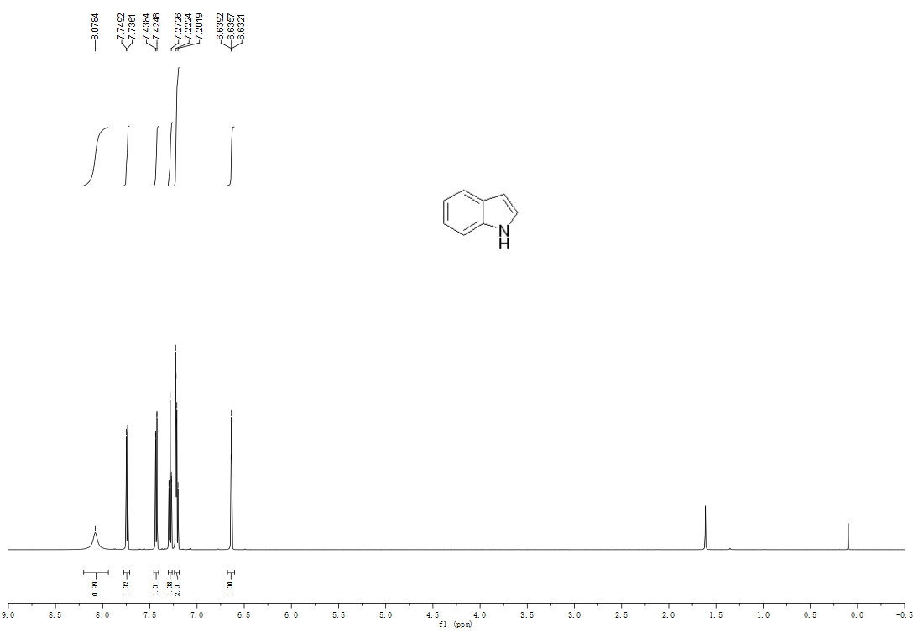
¹³C-NMR of 2a
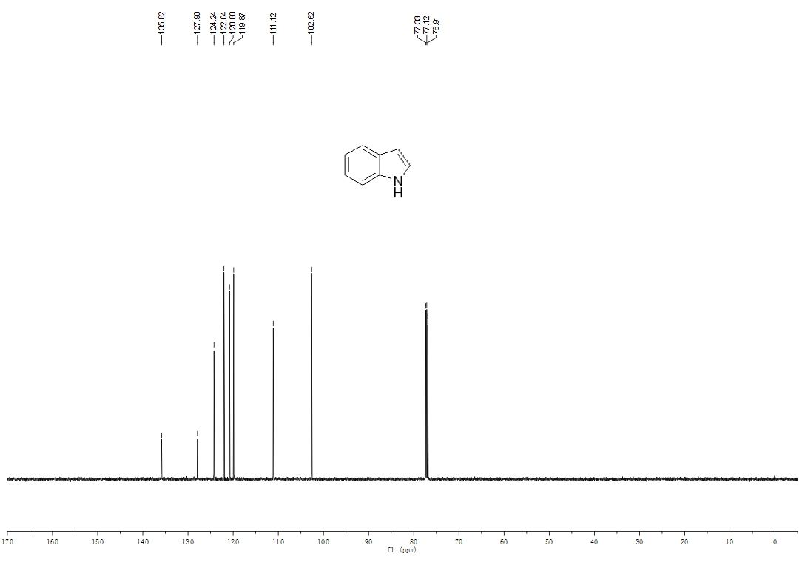
¹H-NMR of 2b
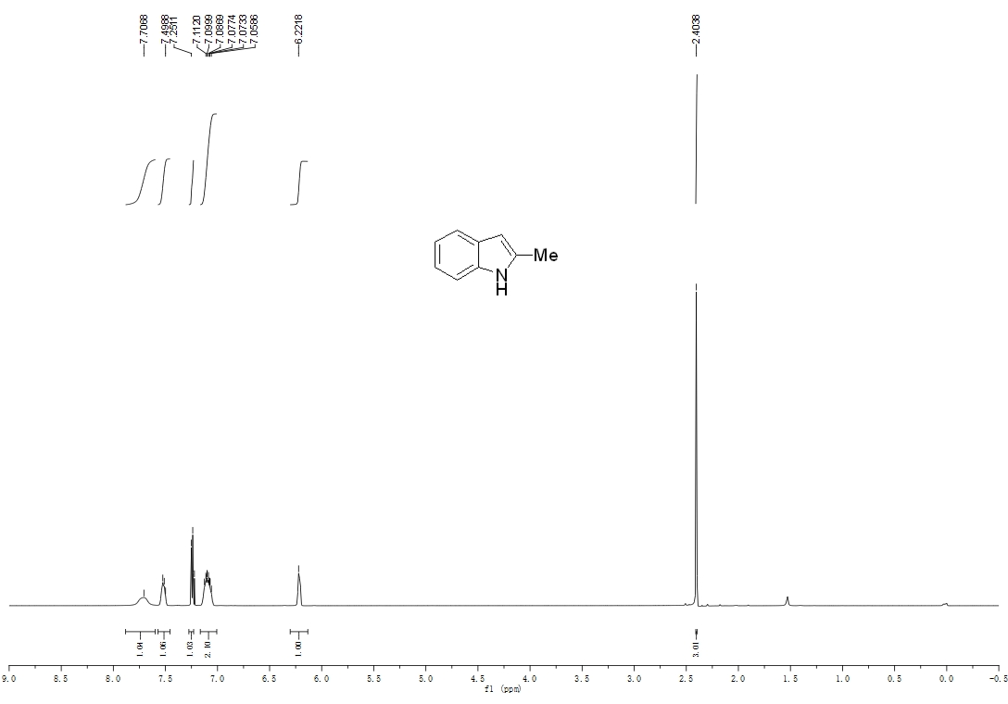
¹³C-NMR of 2b
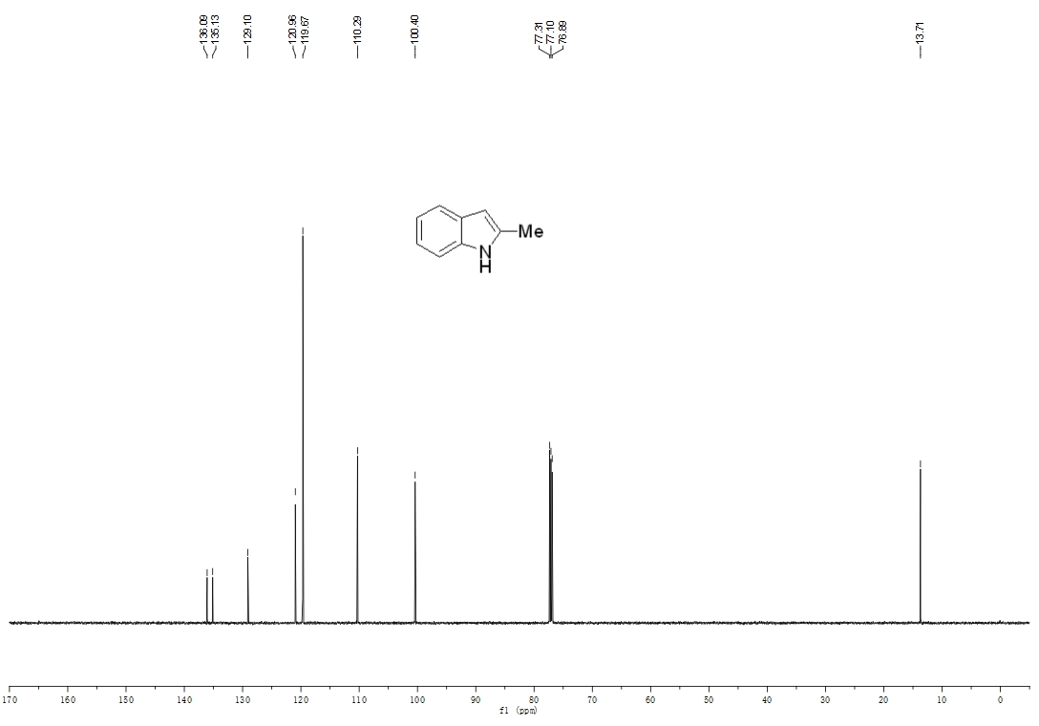

¹H-NMR of 2c
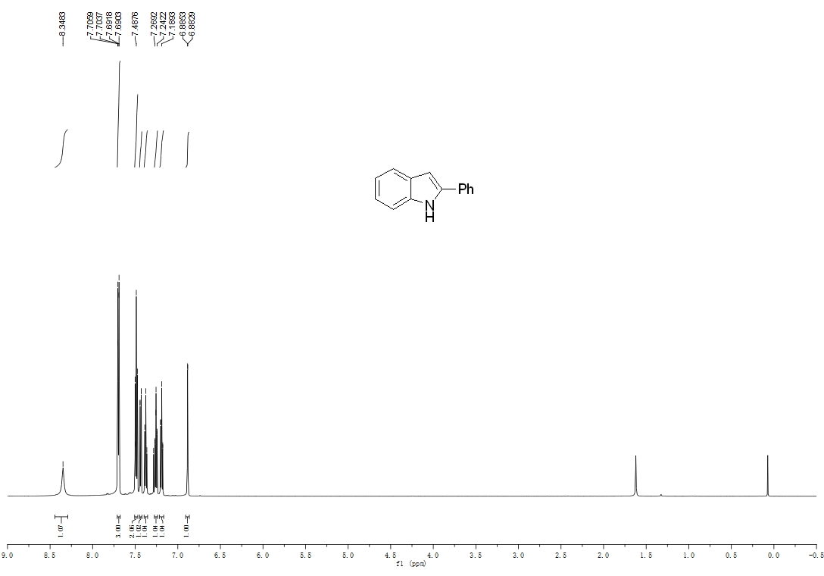
¹³C-NMR of 2c
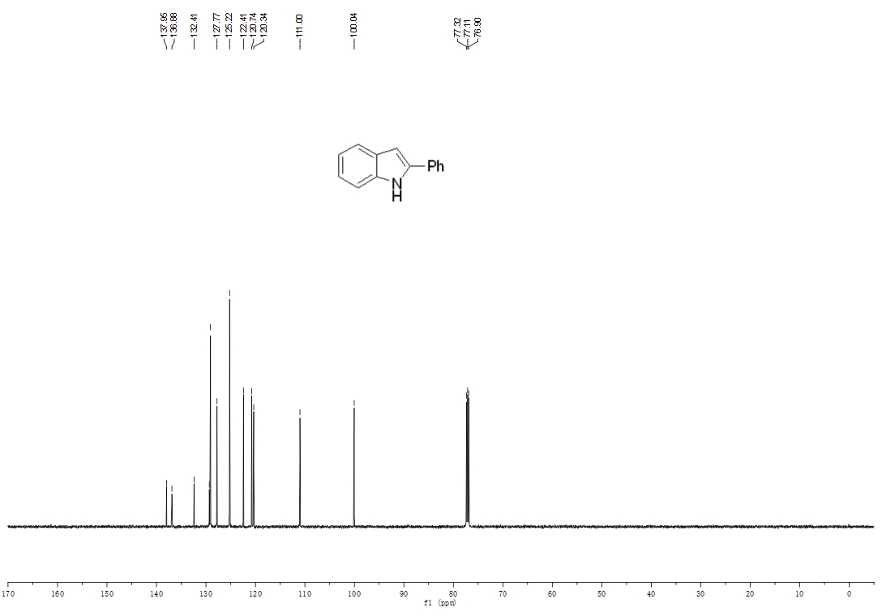
¹H-NMR of 2d
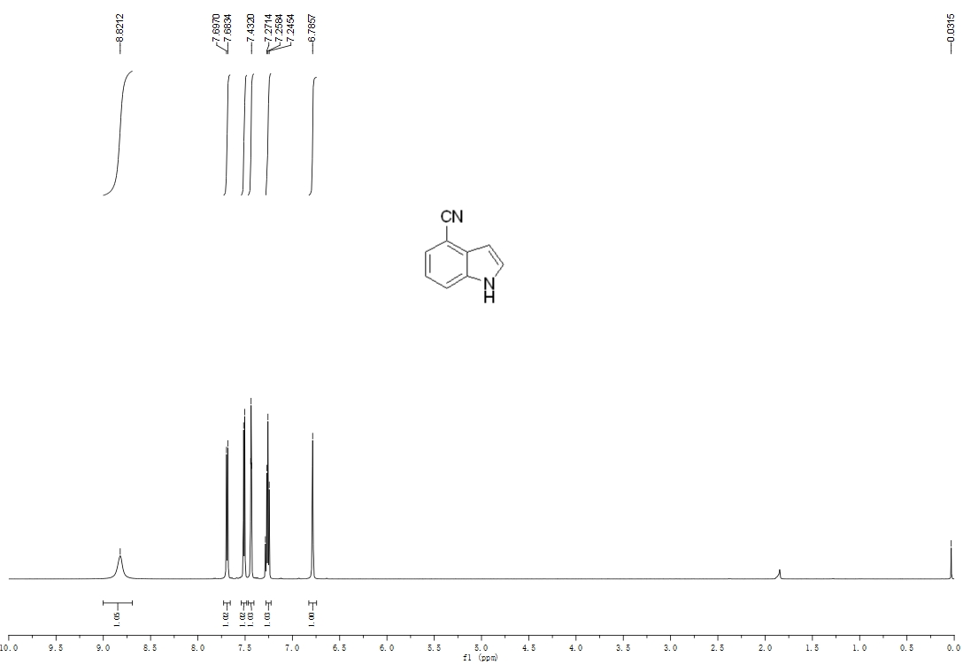
¹³C-NMR of 2d
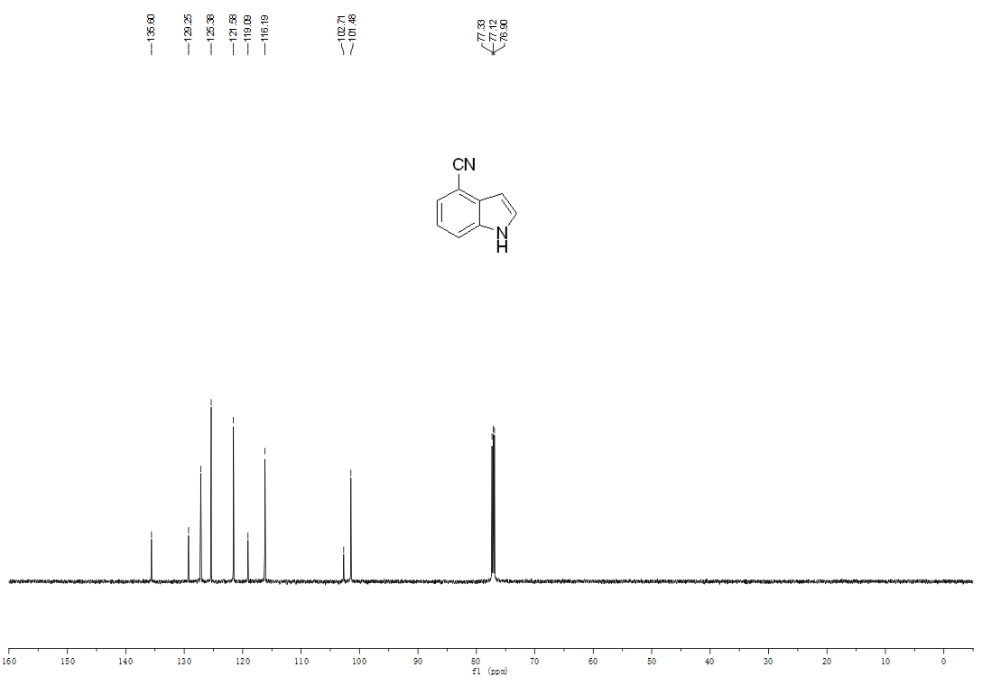
¹H-NMR of 2e
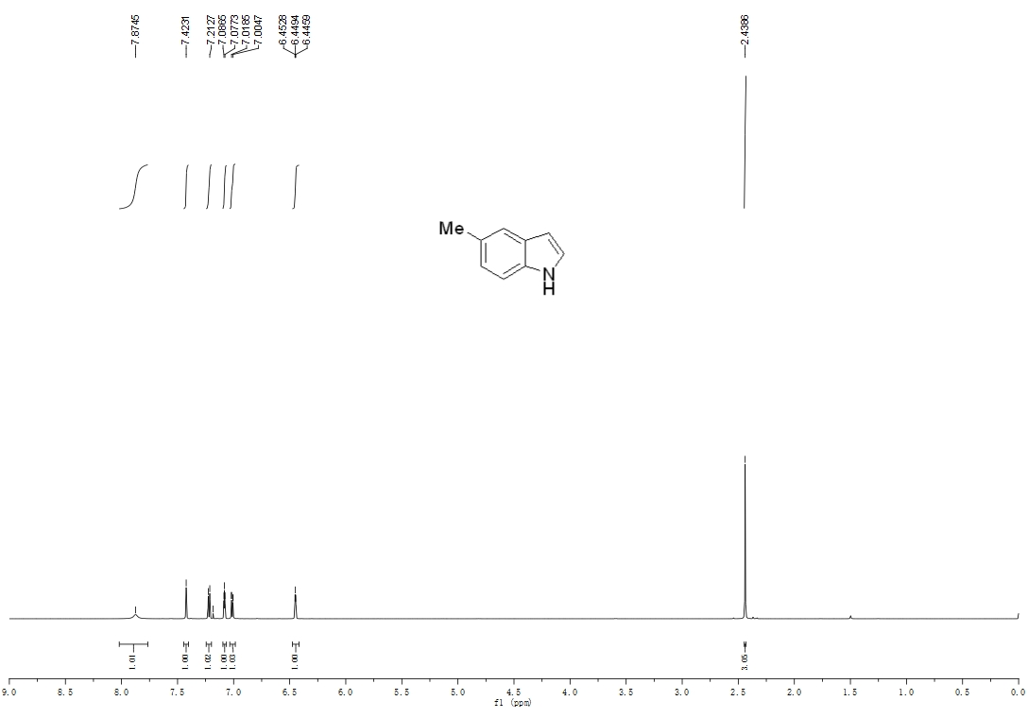
¹³C-NMR of 2e
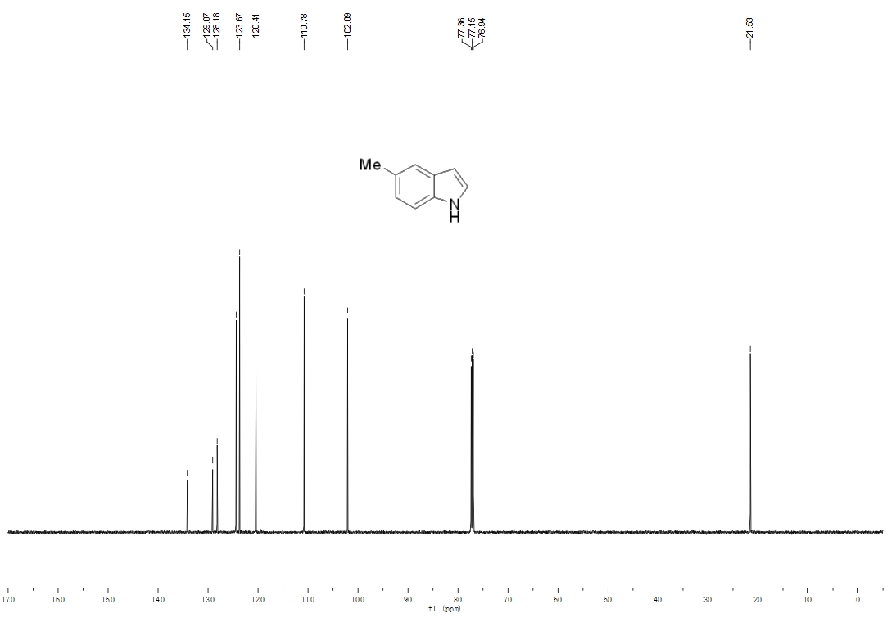
¹H-NMR of 2f
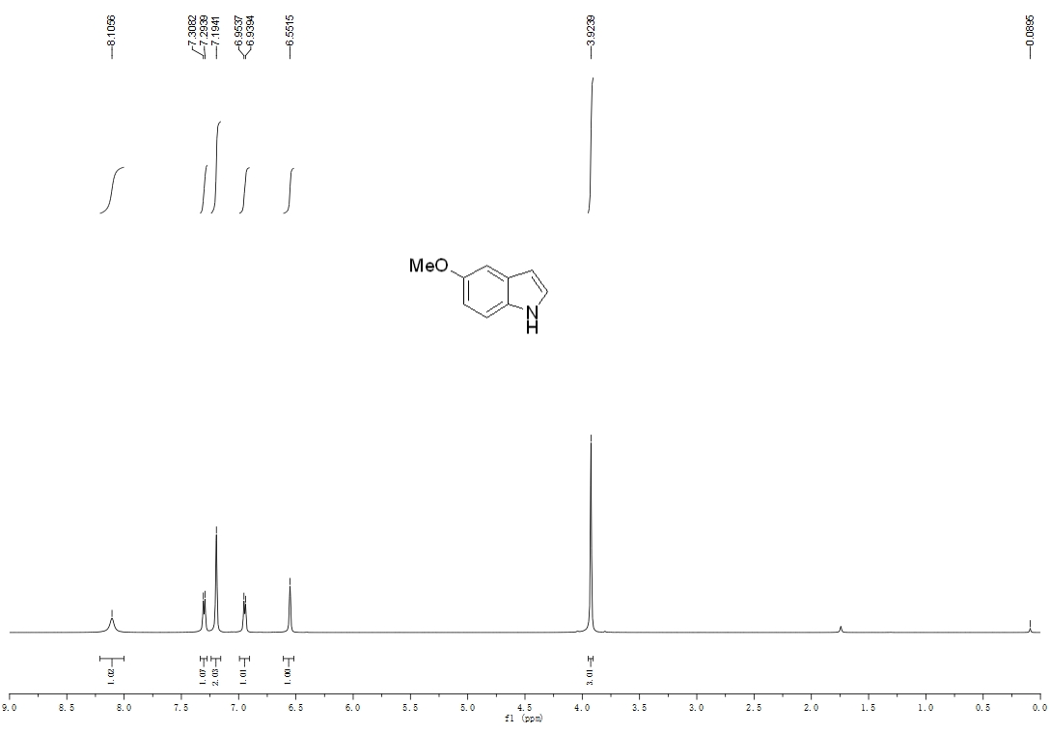
¹³C-NMR of 2f
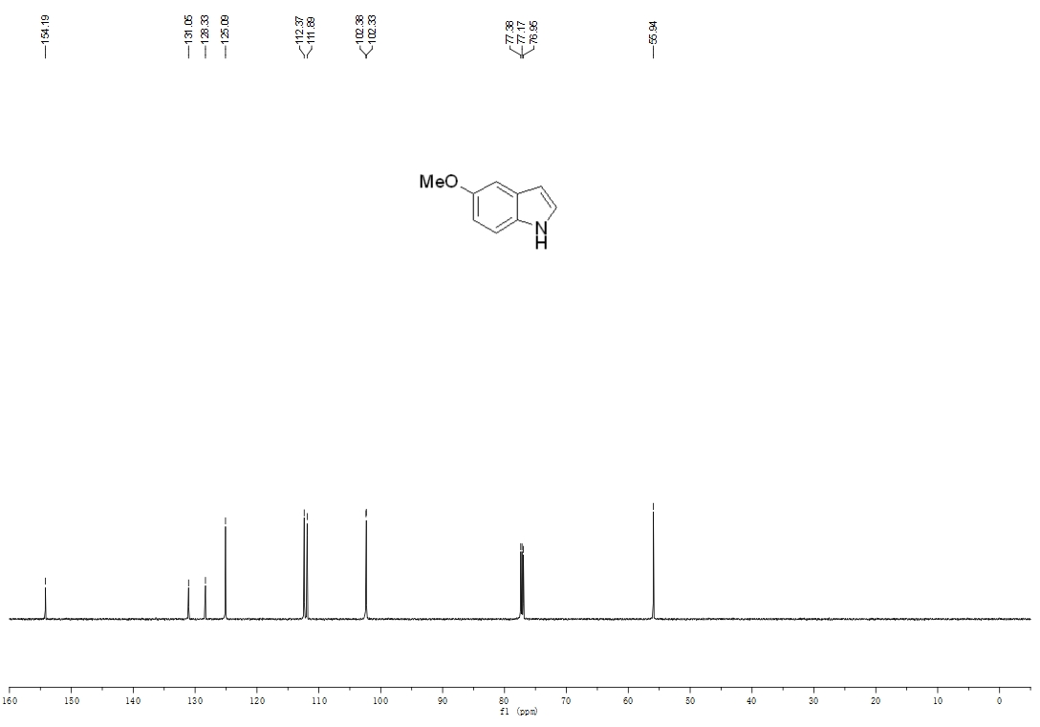
¹H-NMR of 2g
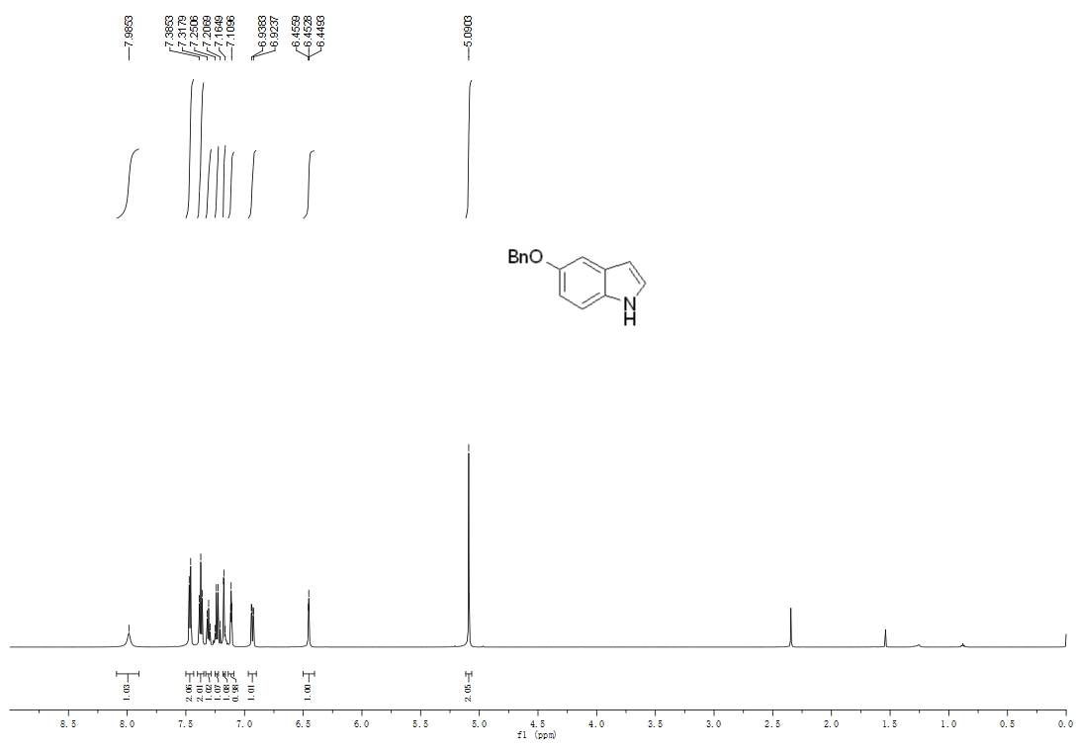
¹³C-NMR of 2g
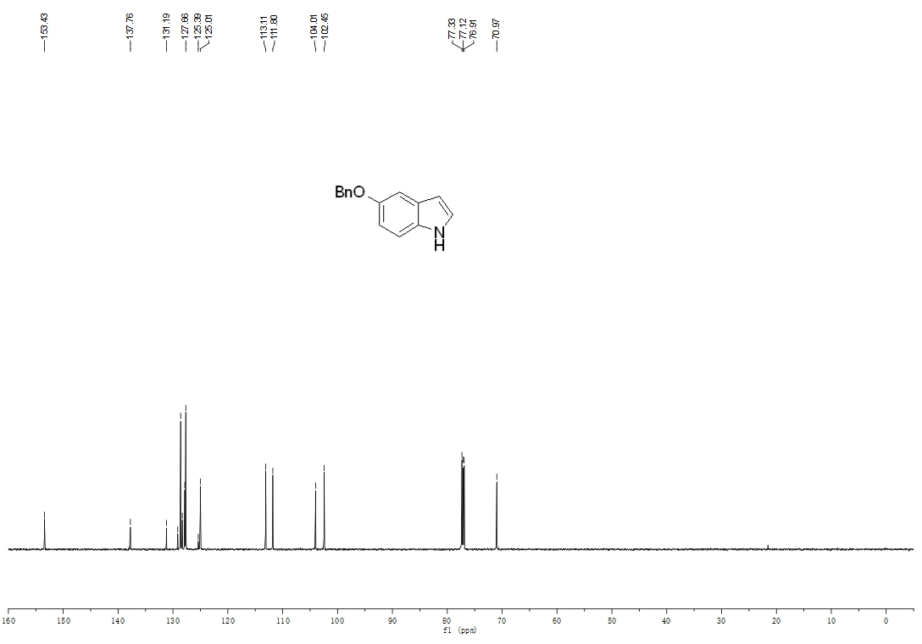
¹H-NMR of 2h
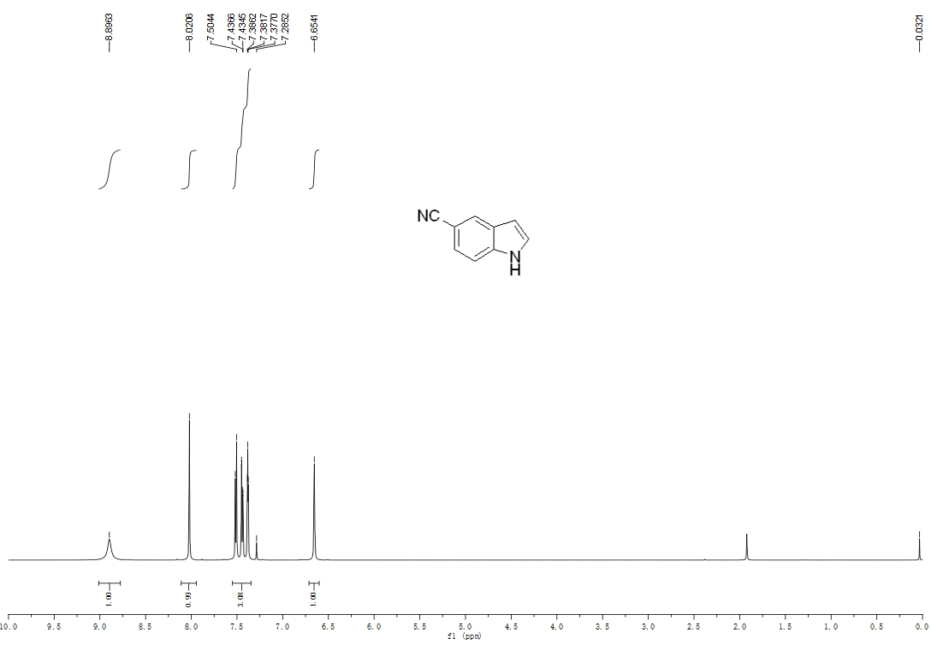
¹³C-NMR of 2h
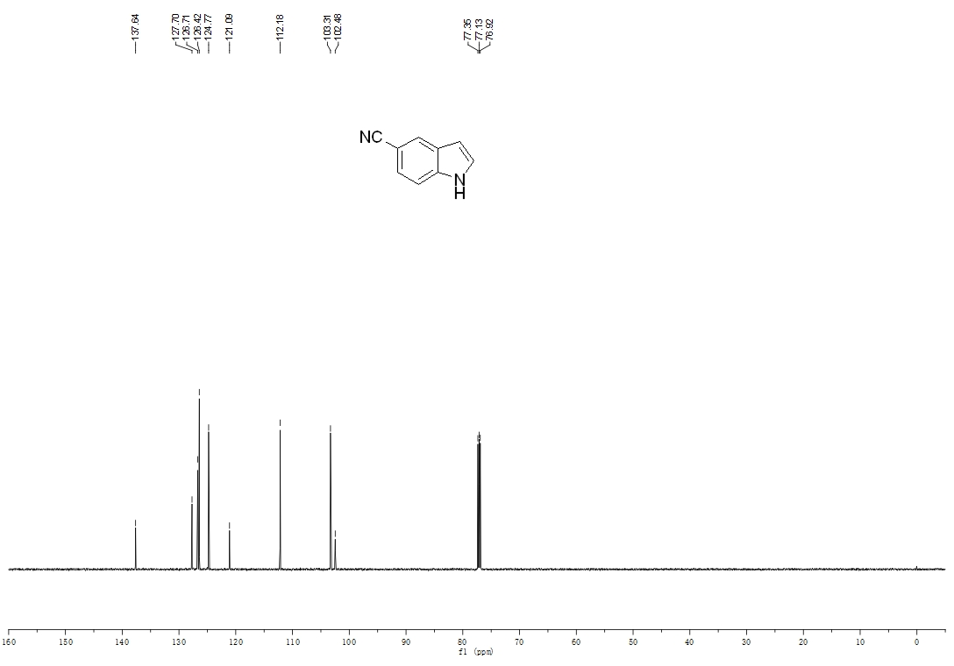
¹H-NMR of 2i
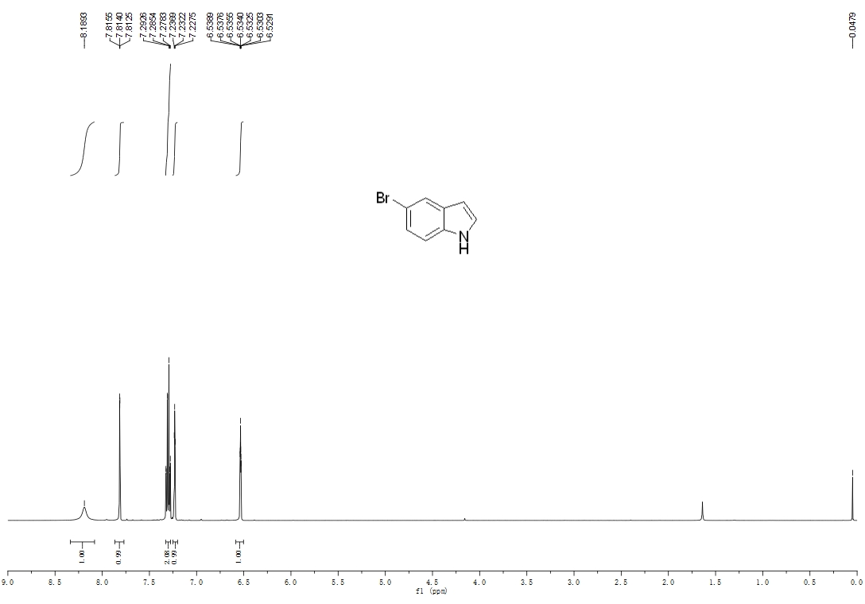
¹³C-NMR of 2i
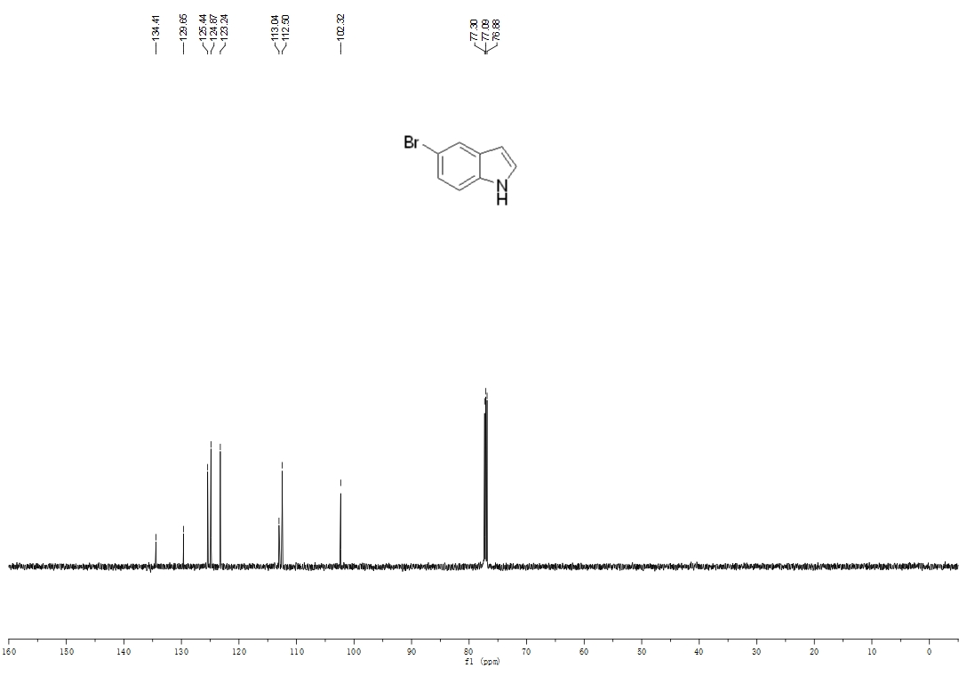

¹H-NMR of 2j
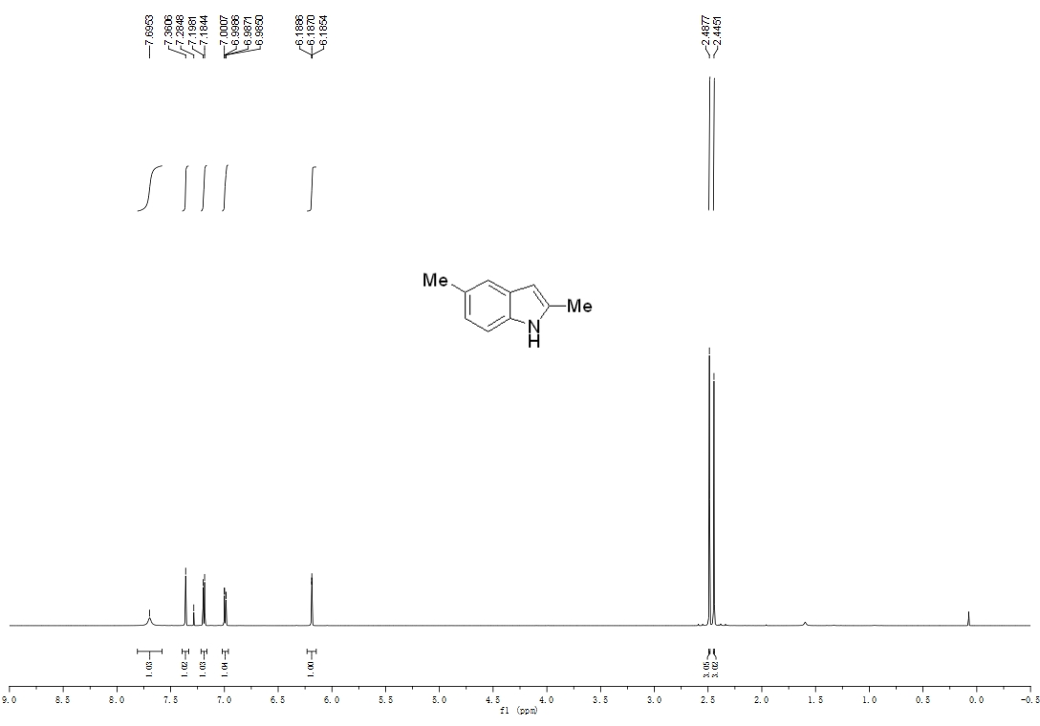
¹³C-NMR of 2j
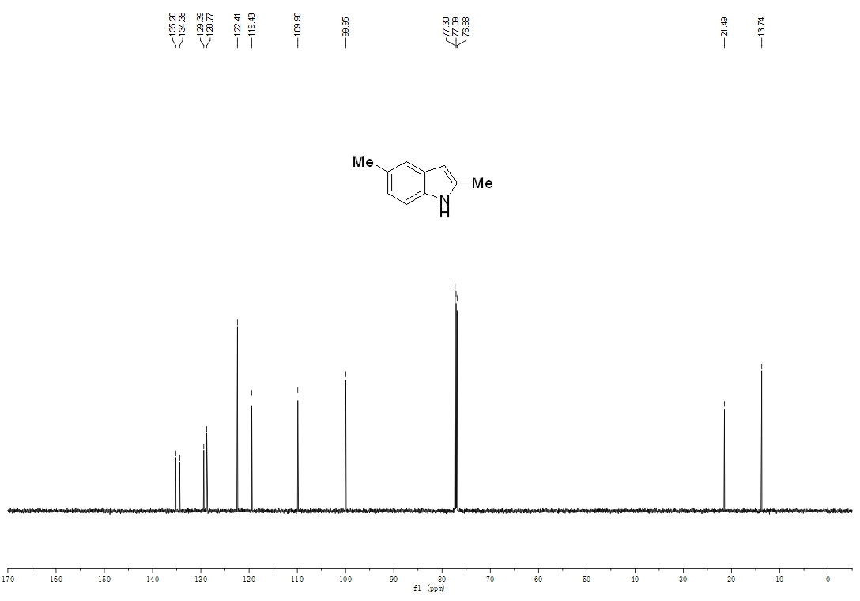

¹H-NMR of 2k
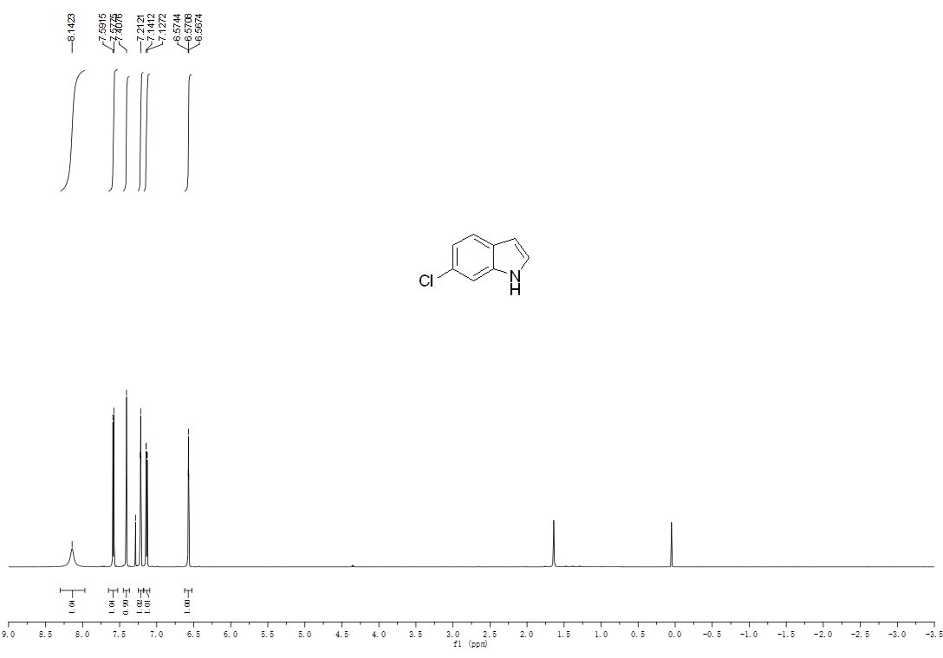
¹³C-NMR of 2k
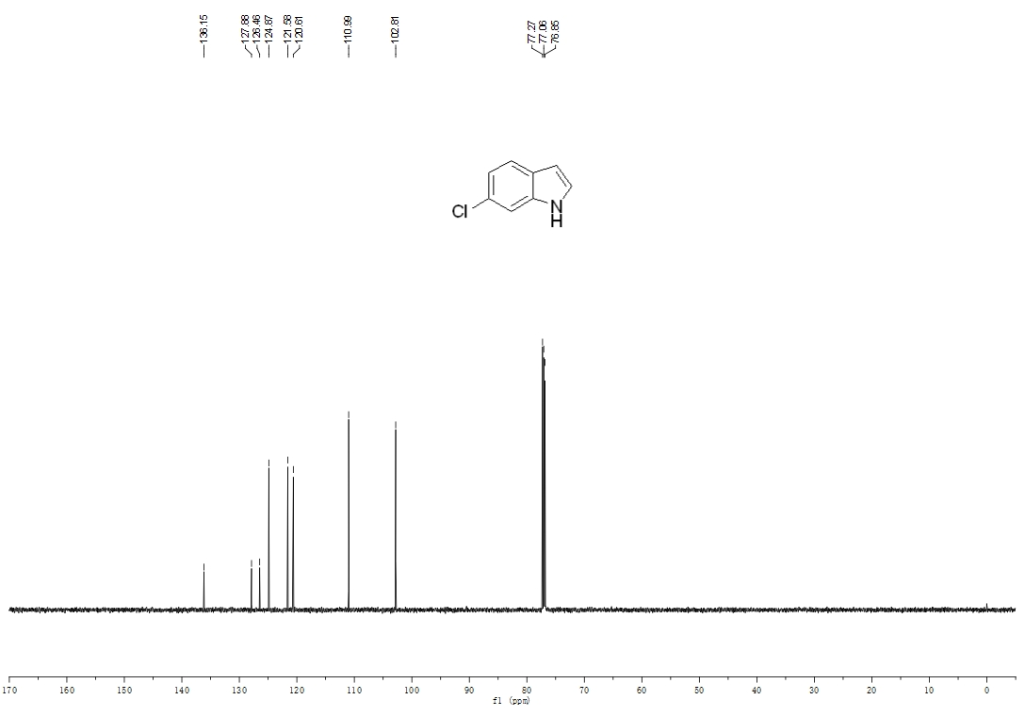
¹H-NMR of 2l
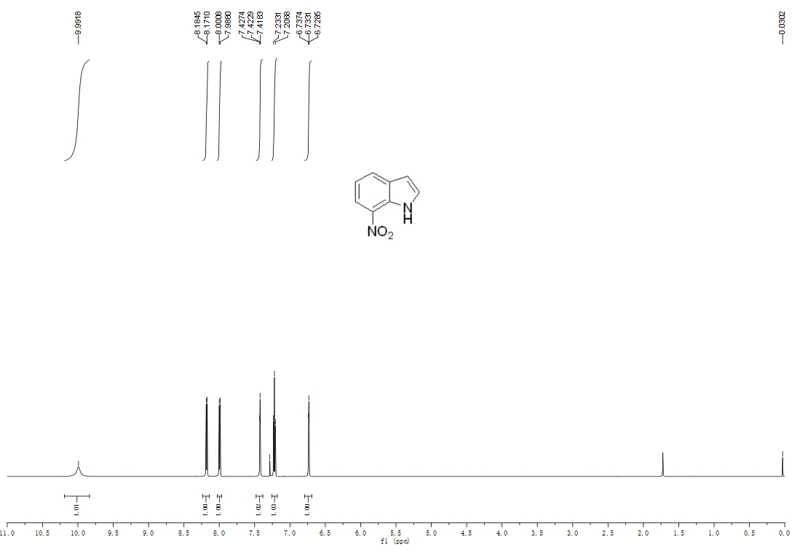
¹³C-NMR of 2l


