SUPPORTING INFORMATION

Synthesis, Characterization of Novel Quinoline-2-Carboxamide Based Chalcone Derivatives and Their Molecular Docking, Photochemical Studies
C. Thirumurugan ^{ac}, P. Vadivel ^{b}, A. Lalitha ^{c}, S. Lakshmanan ^{d}
ª Sri Vidya Mandir Arts and Science College, Uthangarai, Krishnagiri, Tamill Nadu, India.
^{b} Department of Chemistry, Salem Sowdeswari College, Salem-636010, Tamil Nadu, India.
^{c} Department of Chemistry, Periyar University, Periyar Palkalai Nagar, Salem-636011, Tamil Nadu, India.
^{d} Department of Chemistry, BIHER, Bharath University, Chennai 600 073, Tamil Nadu, India.
Email: vadivel123@gmail.com

(E)-N-(3-(3-(4-chlorophenyl)acryloyl)phenyl)quinoline-2-carboxamide (5a)
Colorless solid, Yield (86%), M.P. 208-210ºC; ¹H NMR (400MHz, DMSO-d₆): δ 9.86 (s, 1H), 8.31 (d, J = 15.3 Hz, 1H), 7.38 (d, J = 15.6 Hz, 1H), 7.09-7.24 (m, 2H), 6.94 – 6.98 (m, 3H), 6.81– 6.85 (m, 3H), 6.69 – 6.78 (m, 6H). ¹³C NMR (75 MHz, DMSO-d₆) δ187.98, 160.29, 156.52, 154.57, 149.23, 144.71, 134.56, 132.63, 131.97, 131.70, 129.78, 129.15, 127.89, 120.25, 118.34, 117.03. ESI-MS (M⁺ +1) calculated m/z 412.10 Found 413.12 Anal. Calcd for: C₂₇H₁₇N₂O₂: C, 72.73; H, 4.15; N, 6.97% found: C, 72.75; H, 4.12; N, 6.94%.
N-(3-cinnamoylphenyl)quinoline-2-carboxamide (5b)
Colorless solid, Yield (90%), M.P. 216-218ºC; ¹H NMR (400 MHz, DMSO-d₆) δ 9.85 (s, 1H), 8.54 (d, J = 18.2 Hz, 1H), 7.39 (d, J = 16.0 Hz, 1H), 7.23 – 7.08 (m, 2H), 7.02 – 6.92 (m, 4H), 6.84 (d, J = 7.8 Hz, 3H), 6.77 (d, J = 7.5 Hz, 3H), 6.72 (d, J = 7.7 Hz, 3H). ¹³C NMR (75 MHz, CDCl₃) δ187.13, 163.31, 158.46, 144.40, 142.79, 138.53, 134.36, 132.68, 130.12, 128.79, 126.78, 124.26, 122.92, 119.62. ESI-MS (M⁺ +1) calculated m/z 378.14 Found 378.54 Anal. Calcd for: C₂₅H₁₈N₂O₂: C, 79.35; H, 4.79; N, 7.40% found: C, 79.38; H, 4.76; N, 7.39%
(E)-N-(3-(3-(2-methoxyphenyl)acryloyl)phenyl)quinoline-2-carboxamide (5c)
Colorless solid, Yield (80%), M.P. 230-232ºC; ¹H NMR (400MHz, DMSO-d₆): δ 9.12 (s, 1H), 3.85 (s, 3H), 8.40 (d, J = 15.4 Hz, 1H), 7.89 (d, J = 15.0 Hz, 3H), 7.88 (m, J = 10.0 Hz, 1H), 7.41 –7.43 (m, 4H), 7.18 (s, 3H), 7.06 (s, 2H), 6.94-6.96 (d, 1H), 6.83-6.85 (d, 1H). ¹³C NMR (75 MHz, CDCl₃) δ189.52, 163.79, 153.92, 148.46, 142.48, 134.17, 128.30, 126.74, 125.25, 123.03, 116.88,114.00, 64.83. ESI-MS (M⁺ +1) calculated m/z 408.46 Found 409.15 Anal. Calcd for: C₂₆H₂₀N₂O₃: C, 76.46; H, 4.94; N, 6.86% found: C, 76.48; H, 4.95; N, 6.88%
(E)-N-(3-(3-(3,4,5-trimethoxyphenyl)acryloyl)phenyl)quinoline-2-carboxamide (5d)
Colorless solid, Yield (92%), M.P. 224-226ºC; ¹H NMR (400 MHz, DMSO-d₆) δ 10.02 (s, 1H), 7.97 (d, J = 16.0 Hz, 1H), 7.88 (d, J = 15.6 Hz, 1H ), 7.39 (dd, J = 6.6 Hz, 2H), 7.35 (s, 1H), 7.02 (d, J = 8.2 Hz, 2H), 6.81 (d, J = 8.2 Hz, 3H), 6.11 (s, 1H), 6.92 (d, J = 8.2 Hz, 2H), 5.77 (s, 1H), 3.83 (s, 6H), 3.67 (s, 3H). ESI-MS (M⁺ +1) calculated m/z 468.17 Found 469.84 Anal. Calcd for: C₂₈H₂₄N₂O₅: C, 77.78; H, 5.16; N, 5.98% found: C, 77.76; H, 5.18; N, 6.04%.
(E)-N-(3-(3-(4-hydroxyphenyl)acryloyl)phenyl)quinoline-2-carboxamide (5e)
Colorless solid, Yield (90%), M.P. 204-206ºC; ¹H NMR (400 MHz, DMSO-d₆) δ 12.30 (s, 1H), 8.17 (d, J = 14.4 Hz, 1H), 7.97 (d, J = 15.7 Hz, 2H), 7.84 (d, J = 14.7 Hz, 1H), 7.50 (d, J = 3.0 Hz, 2H), 7.14 (d, J = 15.3 Hz, 2H), 7.14 (s, 1H), 7.01 (d, J = 6.0 Hz, 2H), 6.91-6.93 (t, 1H), 6.71 (s, 1H). ESI-MS (M⁺ +1) calculated m/z 394.13 Found 395.08 Anal. Calcd for: C₂₅H₁₈N₂O₃: C, 76.13; H, 4.60; N, 7.10% found: C, 76.15; H, 4.58; N, 7.12%.
(E)-N-(3-(3-(4-bromophenyl)acryloyl)phenyl)quinoline-2-carboxamide (5f)
Colorless solid, Yield (86%), M.P. 224-226ºC; ¹H NMR (400 MHz, DMSO-d₆) δ 9.88 (s, 1H), 8.20 (d, J = 16.0 Hz, 1H), 7.62 (d, J = 15.4 Hz, 1H), 7.36 (d, J = 9.9 Hz, 1H), 7.34 (d, J = 9.0 Hz, 2H), 7.10 –7.17 (m, 3H). 6.93-7.05 (m, 6H). ESI-MS (M⁺ +1) calculated m/z 456.05 Found 457.16 Anal. Calcd for: C₂₅H₁₇BrN₂O₂: C, 65.66; H, 3.75; N, 6.13% found: C, 65.64; H, 3.76; N, 6.15%.

(E)-N-(3-(3-(4-methoxyphenyl)acryloyl)phenyl)quinoline-2-carboxamide (5g)
Colorless solid, Yield (84%), M.P. 226-228ºC; ¹H NMR (400 MHz, DMSO-d₆) δ 9.06 (s, 1H), 8.11 (d, J = 18.0 Hz, 1H), 7.89-7.90 (m, 4H), 7.88 (d, J = 15.5 Hz, 1H), 7.18 (t, 3H), 7.06 (s, 3H), 6.94 (d, J = 8.2 Hz, 2H), 6.83 (d, J = 8.2 Hz, 2H), 3.77 (s, 3H). ESI-MS (M⁺ +1) calculated m/z 408.1 Found 409.02 Anal. Calcd for: C₂₆H₂₀N₂O₃: C, 76.46; H, 4.94; N, 6.86% found: C, 76.48; H, 4.95; N, 6.89%.

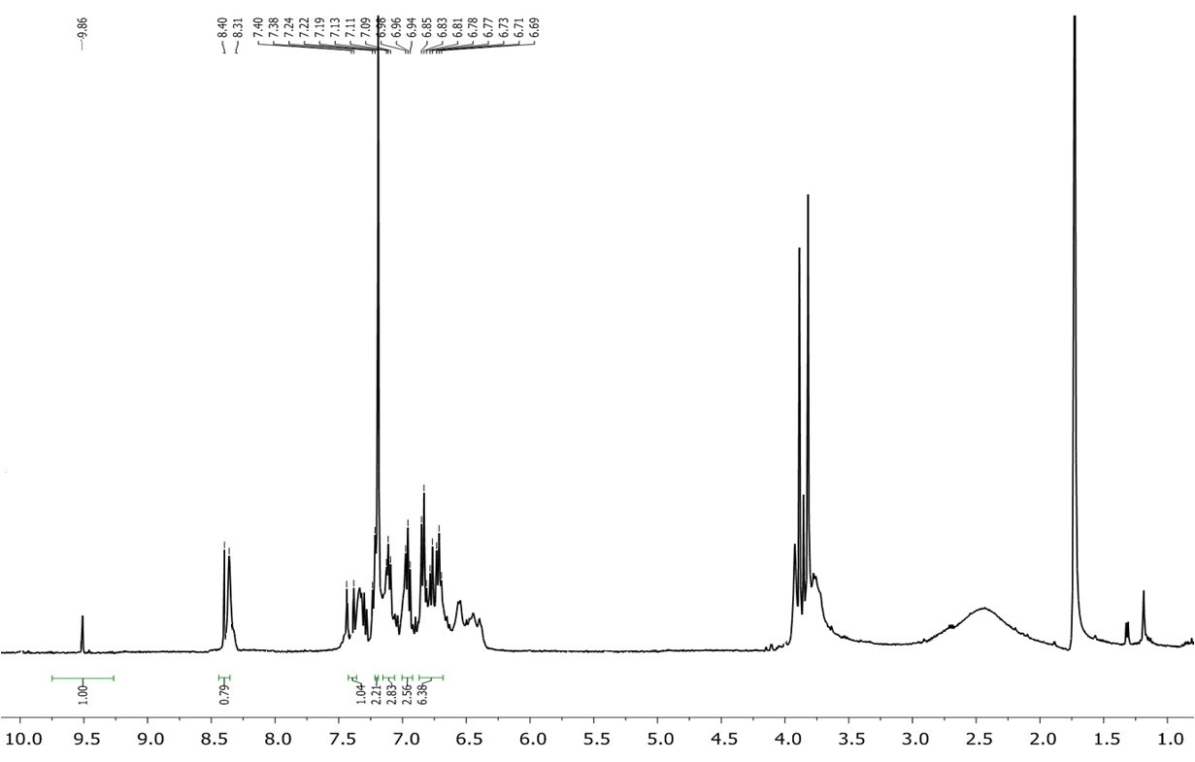
Fig.S1. ¹H -NMR spectrum of compound 5a
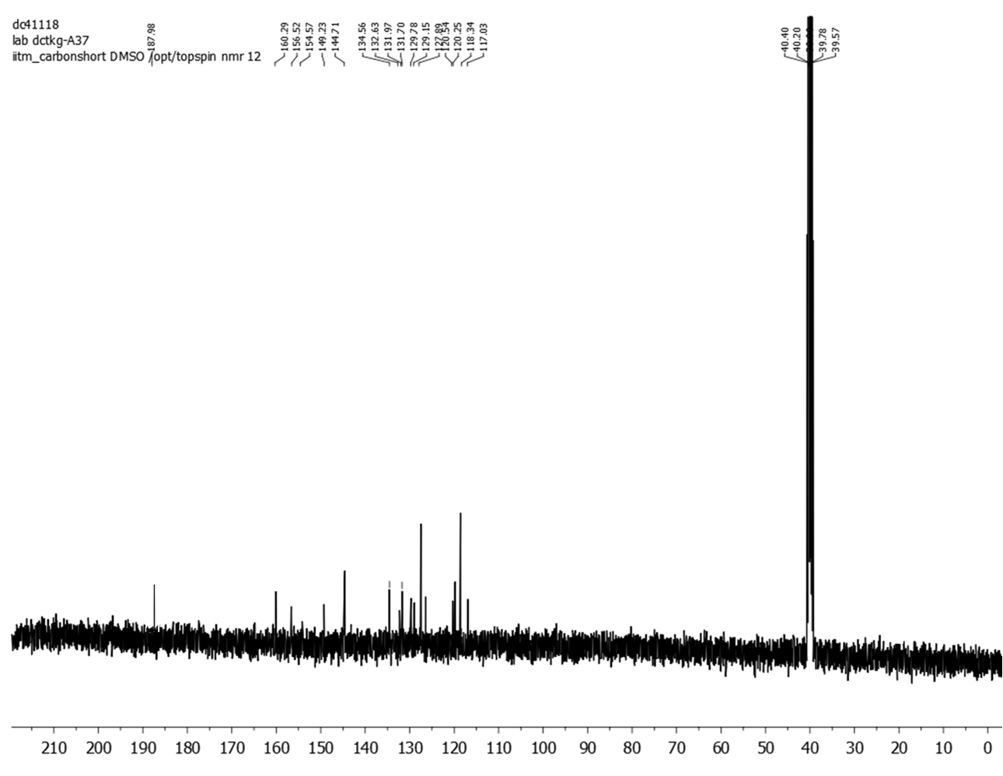
Fig.S2. ¹³C -NMR spectrum of compound 5a

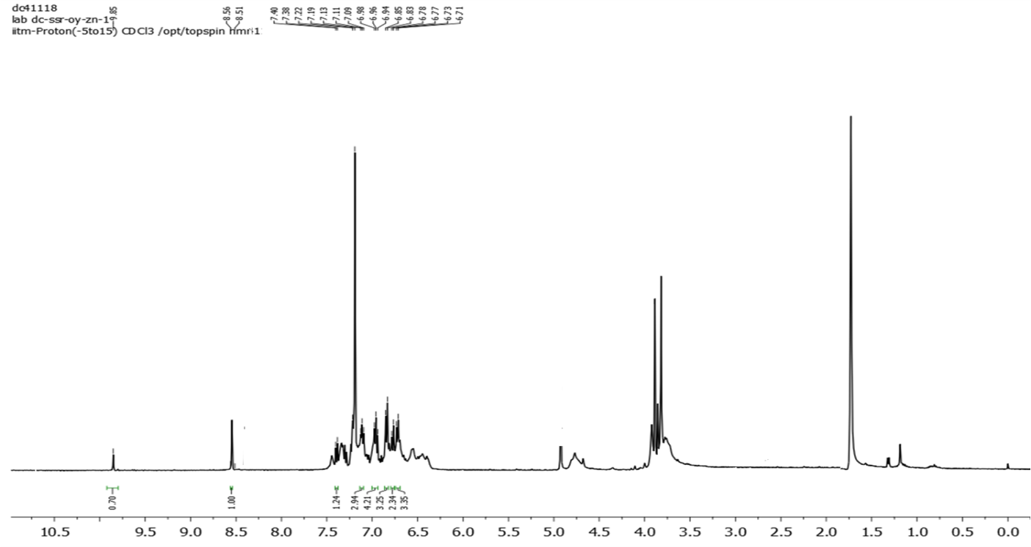
Fig.S3. ¹H -NMR spectrum of compound 5b

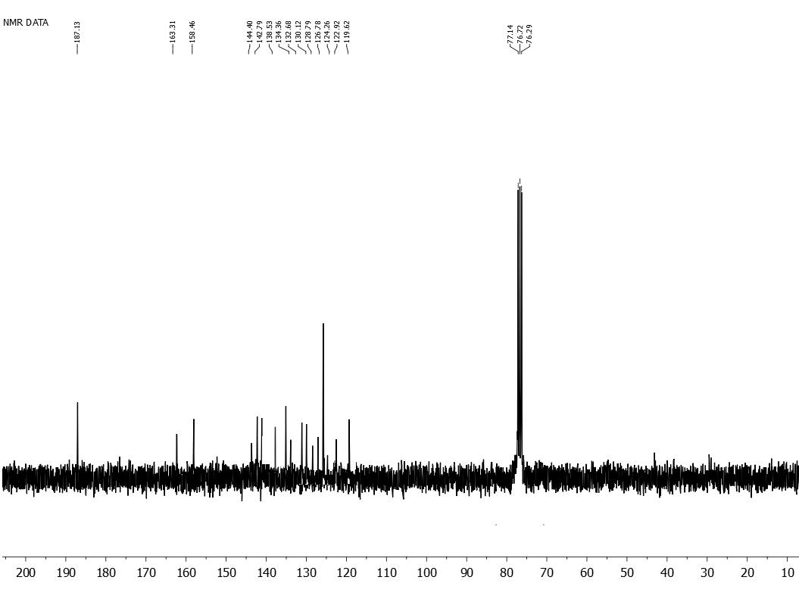
Fig.S4. ¹³C-NMR spectrum of compound 5b

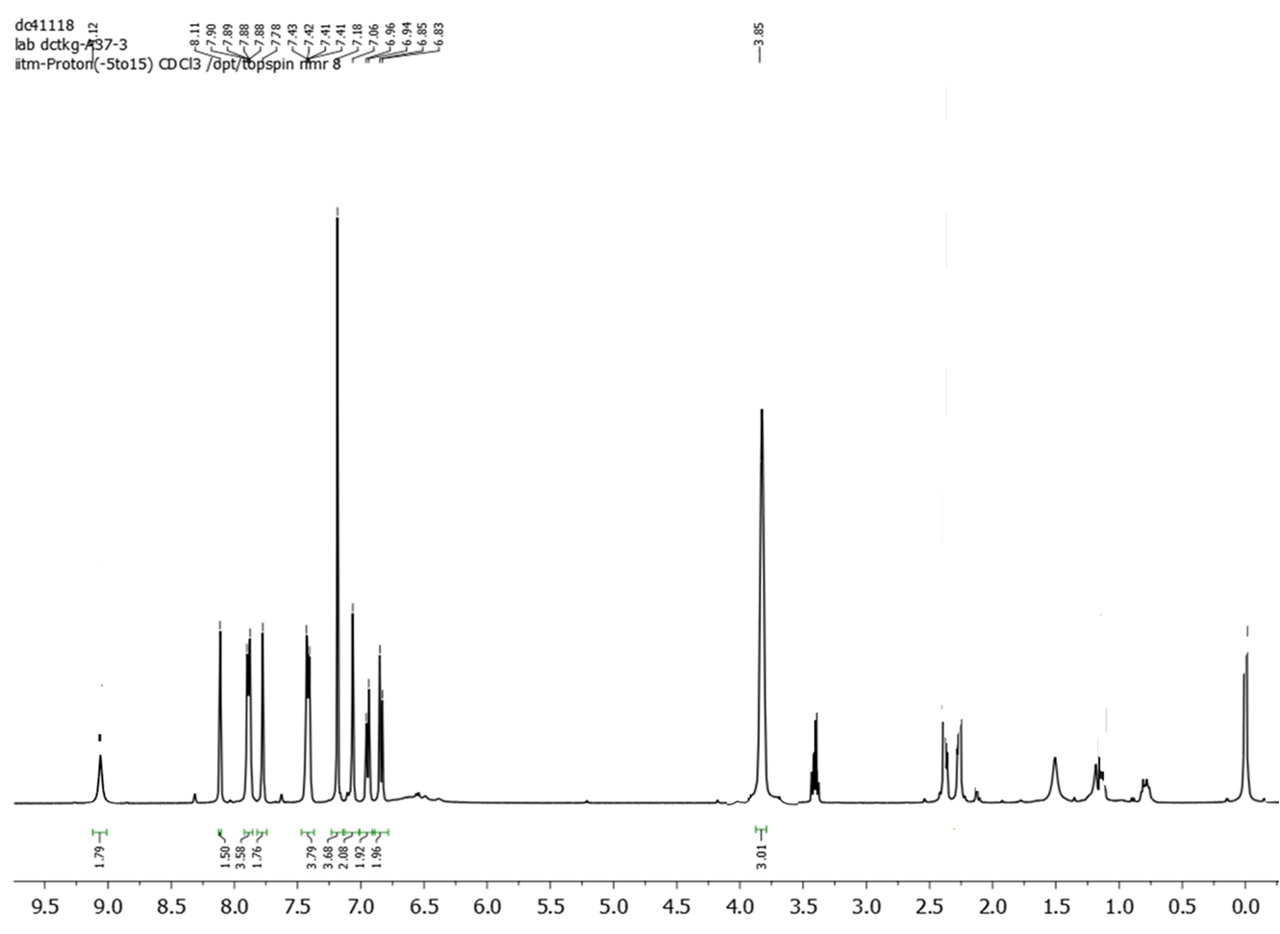
Fig.S5. ¹H-NMR spectrum of compound 5c

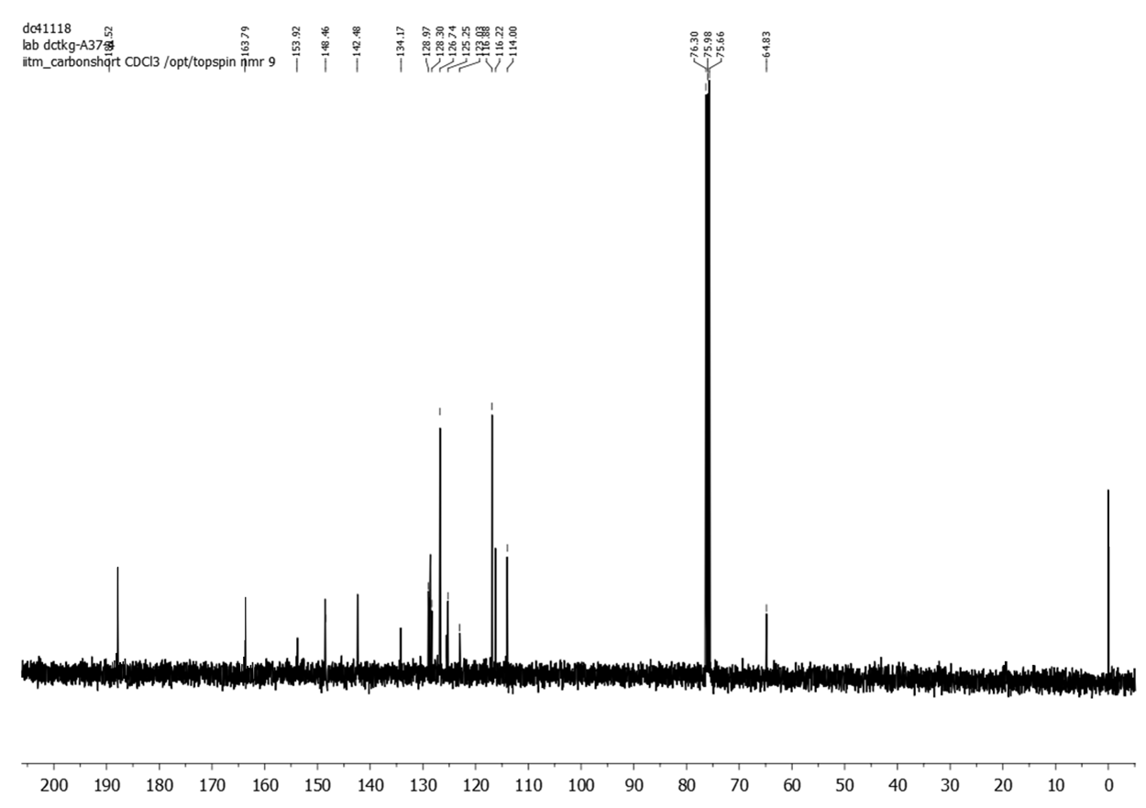
Fig.S6. ¹³C-NMR spectrum of compound 5c

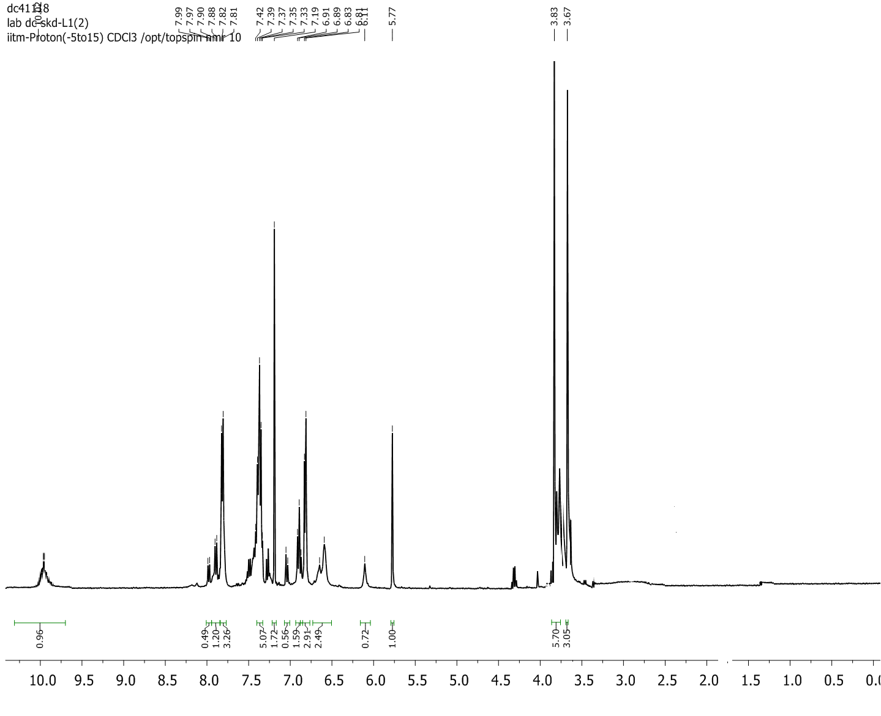
Fig.S7. ¹H-NMR spectrum of compound 5d

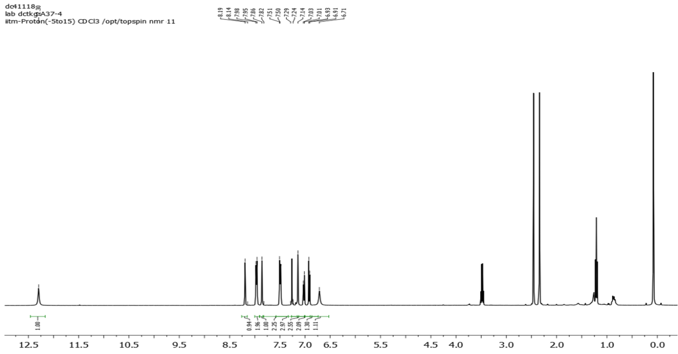
Fig.S8. ¹H-NMR spectrum of compound 5e

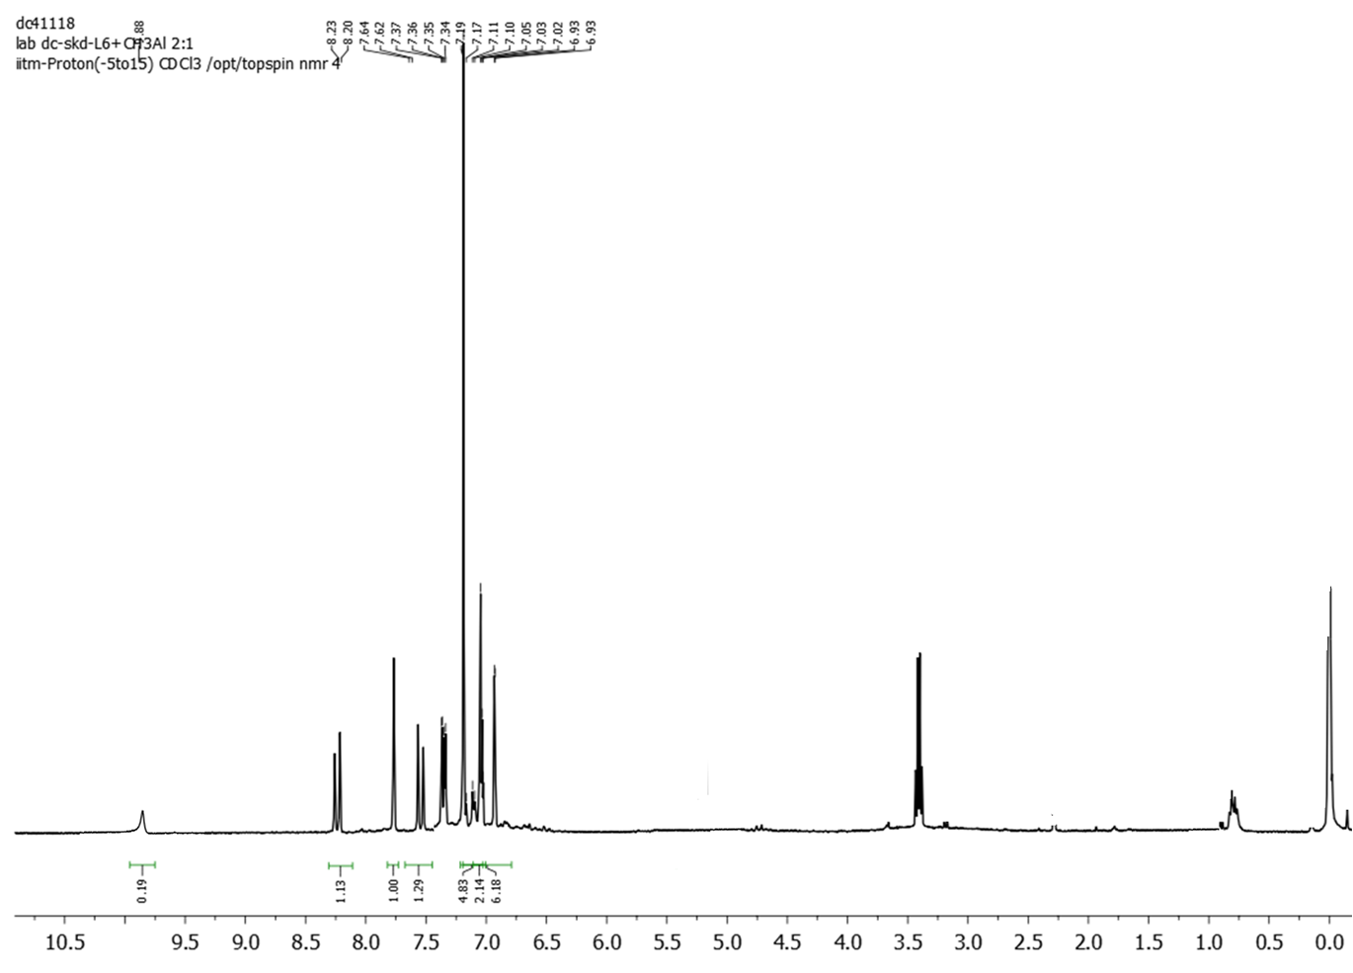
Fig.S9. ¹H-NMR spectrum of compound 5f

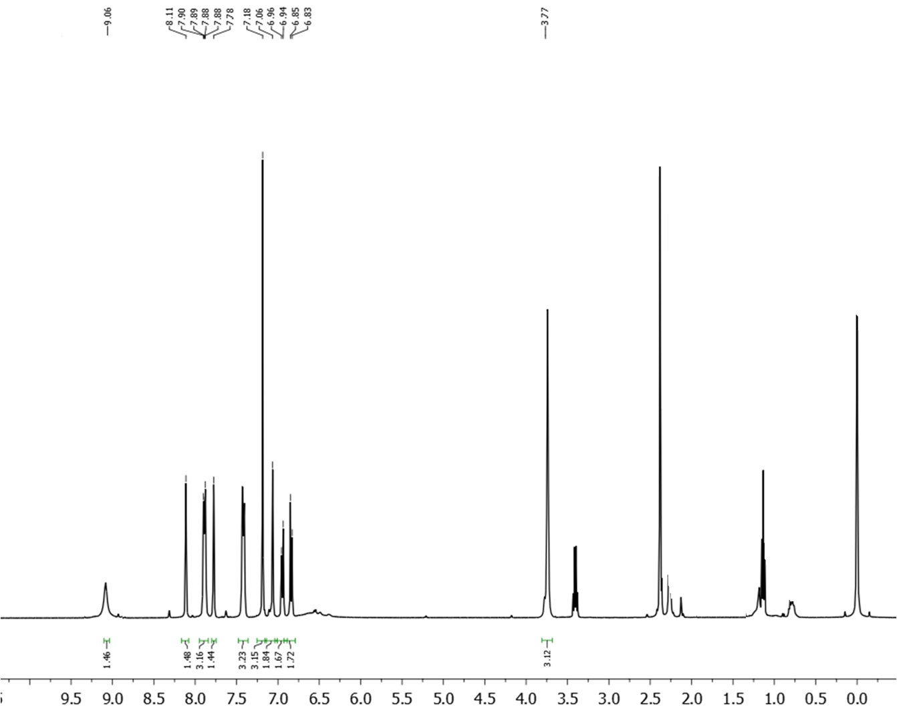
Fig.S10. ¹H-NMR spectrum of compound 5g

