Experimental
General: Melting points were determined in open glass capillaries with a Gallenkamp apparatus. The infrared spectra were recorded in potassium bromide disks on a Pye Unicam SP 3-300 and Shimaduz FTIR 8101 PC infrared spectrophotometer. ¹H and ¹³C NMR spectra were measured using Bruker Ultrashield 400 MHz or Ascend 400 MHz (¹H: 400 MHz, ¹³C: 100.6 MHz) instruments. Chemical shifts (δ) are referenced to residual solvent signals as internal standards. Mass spectra (EI) were obtained at 70 eV with a type Shimadzu GCMQP 1000 EX spectrometer. Elemental analyses (CHN) were carried out at Hannover university, with an element Vario EL instrument with acetanilide as the standard. Analytical thin-layer chromatography was performed using pre-coated silica gel 60778 plates (Fluka), and the spots were visualized with UV light at 254 nm. Microwave experiments were carried out using a CEM Discover LabmateTM microwave apparatus (300 W with ChemDriverTM Software).
General procedure for the synthesis of compounds 8a-f
Method ‘A’ (conventional method)
A mixture of bis(aldehydes) 10 (1 mmol), dimedone 2 (2 mmol) and 4H-1,2,4-triazol-3-amine 3 (2 mmol) in DMF (5 mL) was heated at reflux for 1 h. The formed solid was ﬁltered off, washed with ethanol, and recrystallized from proper solvent.
Method ‘B’ (microwave method).
A mixture of bis(aldehyde) 10 (1 mmol), dimedone 2 (2 mmol) and 4H-1,2,4-triazol-3-amine 3 (2 mmol) DMF (1 mL) was put in a 10-mL glass microwave reaction vessel containing a stirring bar. The reaction vessel was sealed with a cap and then placed into the microwave cavity. The microwave unit was adjusted to heat the reaction mixture to 160 °C under auto-generated pressure for 10 min. The reaction was accomplished and the vessel was cooled using a flow of compressed air. The crude material was ﬁltered off, washed with ethanol, and recrystallized from proper solvent.
N,N'-(Ethane-1,2-diyl)bis(2-(2-(6,6-dimethyl-8-oxo-4,5,6,7,8,9-hexahydro-[1,2,4]triazolo[5,1-b]quinazolin-9-yl)phenoxy)acetamide) 8a
Colorless crystal (DMSO/H₂O). Mp < 300 ºC; IR (KBr, υ cm⁻¹): 3387 (NH), 1675, 1643 (2 CO).¹H NMR (400 MHz, DMSO-d₆): δ = 1.00 (s, 6H, 2CH₃), 1.05 (s, 6H, 2CH₃), 2.05-2.22 (m, 4H, 2CH₂), 2.73-2.89 (m, 4H, 2CH₂), 3.24-3.28 (m, 4H, 2NCH₂), 4.55-4.57 (m, 4H, 2OCH₂), 6.68 (s, 2H, 2 pyrimidine-H), 6.82-7.18 (m, 8H, ArH), 7.66 (s, 2H, 2 triazole-H), 8.41 (br. s, 2H, 2NH), 11.02 (br. s, 2H, 2NH) ppm; Anal. For C₄₀H₄₄N₁₀O₆ (760.86) Calcd: C, 63.14; H, 5.83; N, 18.41. Found: C, 63.26; H, 5.25; N, 18.79%.
N,N'-(Ethane-1,2-diyl)bis(2-(4-(6,6-dimethyl-8-oxo-4,5,6,7,8,9-hexahydro-[1,2,4]triazolo[5,1-b]quinazolin-9-yl)phenoxy)acetamide) 8b
Colorless crystal [Ethanol/H₂O (3:1)]. Mp = 218-222 ºC; IR (KBr, υ cm⁻¹): 3425(NH), 1675,1639 (CO).¹H NMR (400 MHz, DMSO-d6): δ = 0.94 (s, 6H, 2CH₃), 1.01 (s, 6H, 2CH₃), 1.96-2.16 (m, 4H, 2CH₂), 2.52 (s, 4H, 2CH₂), 3.17 (s, 4H, 2NCH₂), 4.34-4.37 (m, 4H, 2OCH₂), 6.13 (s, 2H, 2 pyrimidine-H), 6.83 (d, 4H, ArH, J = 8.4), 7.08 (d, 4H, ArH, J = 8.4), 7.63 (s, 2H, 2 triazole-H), 8.19 (br. s, 2H, 2NH), 11.12 (br. s, 2H, 2NH) ppm; ¹³C NMR (100 MHz, DMSO-d₆): δ = 27.4, 28.9, 32.6, 38.5, 50.3, 57.7, 60.2, 67.3, 106.1, 114.9, 128.6, 135.0, 147.2, 150.5, 150.8, 157.6, 168.4, 193.4. Anal. For C₄₀H₄₄N₁₀O₆ (760.86) Calcd: C, 63.14; H, 5.83; N, 18.41. Found: C, 63.23; H, 5.35; N, 18.73%.
N,N'-(Propane-1,3-diyl)bis(2-(2-(6,6-dimethyl-8-oxo-4,5,6,7,8,9-hexahydro-[1,2,4]triazolo[5,1-b]quinazolin-9-yl)phenoxy)acetamide) 8c
Colorless crystal (Ethanol). Mp = 260-264 ºC; IR (KBr, υ cm⁻¹): 3379 (NH), 1675, 1647 (CO).¹H NMR (400 MHz, DMSO-d6): δ = 1.02 (s, 6H, 2CH₃), 1.05 (s, 6H, 2CH₃), 1.51-1.55 (m, 2H, CH₂), 2.08-2.24 (m, 4H, 2CH₂), 2.56 (s, 4H, 2CH₂), 3.05-3.08 (m, 4H, 2NCH₂), 4.59-4.67 (m, 4H, 2OCH₂), 6.72 (s, 2H, 2 pyrimidine-H), 6.73-7.67 (m, 8H, ArH), 8.25 (s, 2H, 2 triazole-H), 8.42 (br. s, 2H, 2NH), 11.12 (s, 2H, 2NH) ppm; ¹³C NMR (100 MHz, DMSO-d₆): δ = 27.6, 28.8, 29.4, 32.7, 36.4, 50.2, 51.6, 67.1, 105.6, 111.8, 121.8, 128.2, 129.8, 130.2, 147.2, 150.5, 151.8, 154.5, 168.1, 193.8. Anal. For C₄₁H₄₆N₁₀O₆ (774.88) Calcd: C, 63.55; H, 5.98; N, 18.08. Found: C, 63.61; H, 4.25; N, 18.19%.
N,N'-(Propane-1,3-diyl)bis(2-(4-(6,6-dimethyl-8-oxo-4,5,6,7,8,9-hexahydro-[1,2,4]triazolo[5,1-b]quinazolin-9-yl)phenoxy)acetamide) 8d
Colorless crystal [Ethanol/H₂O (3:1)]. Mp = 110-113 ºC (Decompose); IR (KBr, υ cm⁻¹): 3420 (NH), 1643 (CO). ¹H NMR (400 MHz, DMSO-d6): δ = 0.97 (s, 6H, 2CH₃), 1.04 (s, 6H, 2CH₃), 1.53-1.56 (m, 2H, 2CH₂), 2.06-2.24 (m, 4H, 2CH₂), 2.55 (s, 4H, 2CH₂), 3.07-3.11 (m, 4H, 2NCH₂), 4.39-4.42 (m, 4H, 2OCH₂), 6.16 (s, 2H, 2 pyrimidine-H), 6.86 (d, 4H, ArH, J = 8.4), 7.13 (d, 4H, ArH, J = 8.4), 7.66 (s, 2H, 2 triazole-H), 8.07 (br. s, 2H, 2NH), 11.09 (br. s, 2H, 2NH) ppm; ¹³C NMR (100 MHz, DMSO-d₆): δ = 27.3, 28.9, 29.6, 32.6, 36.2, 50.2, 57.8, 60.2, 67.48, 106.1, 114.9, 128.6, 135.1, 147.2, 150.4, 150.6, 157.6, 168.1, 193.4. Anal. For C₄₁H₄₆N₁₀O₆ (774.88) Calcd: C, 63.55; H, 5.98; N, 18.08. Found: C, 63.67; H, 5.82; N, 18.29%.
N,N'-(Butane-1,4-diyl)bis(2-(2-(6,6-dimethyl-8-oxo-4,5,6,7,8,9-hexahydro-[1,2,4]triazolo[5,1-b]quinazolin-9-yl)phenoxy)acetamide) 8e
Colorless crystal (Ethanol). Mp = 215-220 ºC; IR (KBr, υ cm⁻¹): 3421 (NH), 1639 (CO).¹H NMR (400 MHz, DMSO-d6): δ = 1.02 (s, 6H, 2CH₃), 1.05 (s, 6H, 2CH₃), 1.19 (br. s, 4H, 2CH₂), 2.08-2.25 (m, 4H, 2CH₂), 2.57 (s, 4H, 2CH₂), 3.05-3.07 (m, 4H, 2NCH₂), 4.54-4.69 (m, 4H, 2OCH₂), 6.73 (s, 2H, 2 pyrimidine-H), 6.73-7.68 (m, 8H, ArH), 8.20 (s, 2H, 2 triazole-H), 8.43 (br. s, 2H, 2NH), 11.15 (s, 2H, 2NH) ppm; Anal. For C₄₂H₄₈N₁₀O₆ (788.91) Calcd: C, 63.94; H, 6.13; N, 17.75. Found: C, 63.90; H, 6.19; N, 17.86%.
N,N'-(1,3-Phenylenebis(methylene))bis(2-(2-(6,6-dimethyl-8-oxo-4,5,6,7,8,9-hexahydro-[1,2,4]triazolo[5,1-b]quinazolin-9-yl)phenoxy)acetamide) 8f
Colorless crystal [Ethanol/H₂O (3:1)]. Mp = 208-212 ºC; IR (KBr, υ cm⁻¹): 3425 (NH), 1732, 1639 (CO).¹H NMR (400 MHz, DMSO-d6): δ = 1.00 (s, 6H, 2CH₃), 1.03 (s, 6H, 2CH₃), 2.03-2.21 (m, 4H, 2CH₂), 2.57 (s, 4H, 2CH₂), 4.27-4.28 (m, 4H, 2NCH₂), 4.69-4.79 (m, 4H, 2OCH₂), 6.73 (s, 2H, 2 pyrimidine-H), 6.86-7.38 (m, 8H, ArH), 7.39 (s, 2H, 2 triazole-H), 8.86 (br. s, 2H, 2NH), 11.21 (s, 2H, 2NH) ppm; Anal. For C₄₆H₄₈N₁₀O₆ (836.95) Calcd: C, 66.01; H, 5.78; N, 16.74. Found: C, 66.28; H, 5.69; N, 16.68%.
General procedure for the synthesis of compounds 12a-i
Method ‘A’ (conventional method)
A mixture of bis(aldehydes) 10 (1 mmol), dimedone 2 (2 mmol) and 2-aminobenzimidazole 11 (2 mmol) in DMF (5 mL) was heated at reflux for 1 h. The formed solid was ﬁltered off, washed with ethanol, and recrystallized from proper solvent.
Method ‘B’ (microwave method)
A mixture of bis(aldehydes) 10 (1 mmol), dimedone 2 (2 mmol) and 2-aminobenzimidazole 11 (2 mmol) DMF (1 mL) was put in a 10-mL glass microwave reaction vessel containing a stirring bar. The reaction vessel was sealed with a cap and then placed into the microwave cavity. The microwave unit was adjusted to heat the reaction mixture to 160 °C under auto-generated pressure for 10 min. The reaction was accomplished and the vessel was cooled using a flow of compressed air. The crude material was ﬁltered off, washed with ethanol, and recrystallized from proper solvent.

N,N'-(Ethane-1,2-diyl)bis(2-(4-(3,3-dimethyl-1-oxo-1,2,3,4,5,12-hexahydrobenzo[4,5]imidazo[2,1-b]quinazolin-12-yl)phenoxy)acetamide) 12a
Colorless crystal (DMF). Mp = 290-294 ºC; IR (KBr, υ cm⁻¹): 3417 (NH), 1658 (CO).¹H NMR (400 MHz, DMSO-d6): δ = 0.91 (s, 6H, 2CH₃), 1.03 (s, 6H, 2CH₃), 2.00-2.25 (m, 4H, 2CH₂), 2.51-2.86 (m, 4H, 2CH₂), 3.12-3.13 (m, 4H, 2NCH₂), 4.31 (br. s, 4H, 2OCH₂), 6.33 (s, 2H, 2 pyrimidine-H), 6.77-7.34 (m, 16H, ArH), 8.05 (br. s, 2H, 2NH), 11.04 (br. s, 2H, 2NH) ppm; Anal. For C₅₀H₅₀N₈O₆ (859.00) Calcd: C, 69.91; H, 5.87; N, 13.04. Found: C, 69.86; H, 5.93; N, 12.97%.
N,N'-(Propane-1,3-diyl)bis(2-(2-(3,3-dimethyl-1-oxo-1,2,3,4,5,12-hexahydrobenzo[4,5]imidazo[2,1-b]quinazolin-12-yl)phenoxy)acetamide) 12b
Colorless crystal [Acetic acid/Ethanol (10:1)]. Mp = 206-208 ºC; IR (KBr, υ cm⁻¹): 3325 (NH), 1643 (CO).¹H NMR (400 MHz, DMSO-d6): δ = 0.94 (s, 6H, 2CH₃), 1.04 (s, 6H, 2CH₃), 1.54-1.57 (m, 2H, CH₂), 2.04-2.26 (m, 4H, 2CH₂), 2.50-2.59 (m, 4H, 2CH₂), 3.05-3.15 (m, 4H, 2NCH₂), 4.72 (br. s, 4H, 2OCH₂), 6.82 (s, 2H, 2 pyrimidine-H), 6.83-7.37 (m, 16H, ArH), 8.16 (br. s, 2H, 2NH), 11.21 (br. s, 2H, 2NH) ppm; ¹³C NMR (100 MHz, DMSO-d₆): δ = 26.9, 27.1, 29.0, 29.4, 32.7, 32.8, 36.6, 50.3, 67.6, 106.6, 109.8, 112.1, 117.4, 121.1, 121.6, 122.2, 122.3, 129.6, 130.4, 132.5, 142.1, 145.5, 151.7, 154.3, 168.1, 193.8. Anal. For C₅₁H₅₂N₈O₆ (873.03) Calcd: C, 70.17; H, 6.00; N, 12.84. Found: C, C, 70.03; H, 6.15; N, 12.64%.
N,N'-(Propane-1,3-diyl)bis(2-(4-(3,3-dimethyl-1-oxo-1,2,3,4,5,12-hexahydrobenzo[4,5]imidazo[2,1-b]quinazolin-12-yl)phenoxy)acetamide) 12c
Colorless crystal [Ethanol/Acetic acid (10:1)]. Mp = 236-240 ºC; IR (KBr, υ cm⁻¹): 3421 (NH), 1651 (CO).¹H NMR (400 MHz, DMSO-d6): δ = 0.94 (s, 6H, 2CH₃), 1.05 (s, 6H, 2CH₃), 1.46-1.50 (m, 2H, CH₂), 2.03-2.27 (m, 4H, 2CH₂), 2.60-2.89 (m, 4H, 2CH₂), 3.01-3.06 (m, 4H, 2NCH₂), 4.37 (br. s, 4H, 2OCH₂), 6.37 (s, 2H, 2 pyrimidine-H), 6.81-7.37 (m, 16H, ArH), 8.00 (br. s, 2H, 2NH), 11.07 (br. s, 2H, 2NH) ppm; ¹³C NMR (100 MHz, DMSO-d₆): δ = 27.1, 29.2, 29.6, 32.7, 36.1, 50.4, 53.9, 67.4, 106.8, 110.5, 114.8, 117.3, 120.8, 122.2, 128.6, 132.3, 134.8, 142.4, 145.7, 150.5, 157.4, 168.0, 193.0. Anal. For C₅₁H₅₂N₈O₆ (873.03) Calcd: C, 70.17; H, 6.00; N, 12.84. Found: C, 70.27; H, 6.19; N, 12.67%.
N,N'-(Butane-1,4-diyl)bis(2-(2-(3,3-dimethyl-1-oxo-1,2,3,4,5,12-hexahydrobenzo[4,5]imidazo[2,1-b]quinazolin-12-yl)phenoxy)acetamide) 12d
Colorless crystal (Ethanol). Mp = 220-225 ºC; IR (KBr, υ cm⁻¹): 3313 (NH), 1735, 1624 (CO).¹H NMR (400 MHz, DMSO-d6): δ = 0.95 (s, 6H, 2CH₃), 1.04 (s, 6H, 2CH₃), 1.13-1.14 (br. s, 4H, 2CH₂), 2.03-2.29 (m, 4H, 2CH₂), 2.51-2.73 (m, 4H, 2CH₂), 2.89-3.00 (m, 4H, 2NCH₂), 4.76 (br. s, 4H, 2OCH₂), 6.80 (s, 2H, 2 pyrimidine-H), 6.87-7.37 (m, 16H, ArH), 8.10 (br. s, 2H, 2NH), 11.19 (br. s, 2H, 2NH) ppm; Anal. For C₅₂H₅₄N₈O₆ (887.05) Calcd: C, 70.41; H, 6.14; N, 12.63. Found: C, 70.19; H, 6.03; N, 12.78%.
N,N'-(Butane-1,4-diyl)bis(2-(3-(3,3-dimethyl-1-oxo-1,2,3,4,5,12-hexahydrobenzo[4,5]imidazo[2,1-b]quinazolin-12-yl)phenoxy)acetamide) 12e
Colorless crystal (Ethanol). Mp = 204-206 ºC; IR (KBr, υ cm⁻¹): 3421 (NH), 1651 (CO).¹H NMR (400 MHz, DMSO-d6): δ = 0.92 (s, 6H, 2CH₃), 1.03 (s, 6H, 2CH₃), 1.36 (br. s, 4H, 2CH₂), 2.03-2.24 (m, 4H, 2CH₂), 2.48-2.71 (m, 4H, 2CH₂), 2.86-3.06 (m, 4H, 2NCH₂), 4.33 (br. s, 4H, 2OCH₂), 6.35 (s, 2H, 2 pyrimidine-H), 6.71-7.36 (m, 16H, ArH), 8.03 (br. s, 2H, 2NH), 11.08 (br. s, 2H, 2NH) ppm; Anal. For C₅₂H₅₄N₈O₆ (887.05) Calcd: C, 70.41; H, 6.14; N, 12.63. Found: C, 70.33; H, 6.29; N, 12.75%.
N,N'-(Butane-1,4-diyl)bis(2-(4-(3,3-dimethyl-1-oxo-1,2,3,4,5,12-hexahydrobenzo[4,5]imidazo[2,1-b]quinazolin-12-yl)phenoxy)acetamide) 12f
Colorless crystal (DMF). Mp = 224-226 ºC; IR (KBr, υ cm⁻¹): 3425 (NH), 1654 (CO).¹H NMR (400 MHz, DMSO-d6): δ = 0.91 (s, 6H, 2CH₃), 1.03 (s, 6H, 2CH₃), 1.31 (br. s, 4H, 2CH₂), 2.01-2.25 (m, 4H, 2CH₂), 2.51-2.86 (m, 4H, 2CH₂), 3.02-3.03 (m, 4H, 2NCH₂), 4.31 (br. s, 4H, 2OCH₂), 6.34 (s, 2H, 2 pyrimidine-H), 6.77-7.34 (m, 16H, ArH), 7.95 (br. s, 2H, 2NH), 11.04 (br. s, 2H, 2NH) ppm; ¹³C NMR (100 MHz, DMSO-d₆): δ = 26.8, 27.1, 29.2, 32.7, 38.3, 50.3, 53.9, 67.4, 106.8, 110.4, 114.8, 117.3, 120.8, 122.2, 128.6, 132.3, 134.8, 142.4, 145.7, 150.5, 157.4, 167.8, 193.0. Anal. For C₅₂H₅₄N₈O₆ (887.05) Calcd: C, 70.41; H, 6.14; N, 12.63. Found: C, 70.35; H, 6.04; N, 12.86%.
N,N'-(1,3-Phenylenebis(methylene))bis(2-(2-(3,3-dimethyl-1-oxo-1,2,3,4,5,12-hexahydrobenzo[4,5]imidazo[2,1-b]quinazolin-12-yl)phenoxy)acetamide) 12g
Colorless crystal (Methanol). Mp = 204-208 ºC (Decompose); IR (KBr, υ cm⁻¹): 3421 (NH), 1740, 1643 (CO).¹H NMR (400 MHz, DMSO-d6): δ = 0.91 (s, 6H, 2CH₃), 1.03 (s, 6H, 2CH₃), 1.92-2.23 (m, 4H, 2CH₂), 2.59-2.89 (m, 4H, 2CH₂), 4.21-4.35 (m, 4H, 2NCH₂), 4.84 (br. s, 4H, 2OCH₂), 6.84-7.36 (m, 18H, ArH and 2 pyrimidine-H), 8.72 (br. s, 2H, 2NH), 11.17 (br. s, 2H, 2NH) ppm; Anal. For C₅₆H₅₄N₈O₆ (935.10) Calcd: C, 71.93; H, 5.82; N, 11.98. Found: C, 71.97; H, 5.73; N, 12.12%.
N,N'-(1,3-Phenylenebis(methylene))bis(2-(3-(3,3-dimethyl-1-oxo-1,2,3,4,5,12-hexahydrobenzo[4,5]imidazo[2,1-b]quinazolin-12-yl)phenoxy)acetamide) 12h
Colorless crystal [Ethanol/Acetic acid (10:1)]. Mp = 200-204 ºC; IR (KBr, υ cm⁻¹): 3425 (NH), 1651 (CO).¹H NMR (400 MHz, DMSO-d6): δ = 0.92 (s, 6H, 2CH₃), 1.03 (s, 6H, 2CH₃), 2.03-2.24 (m, 4H, 2CH₂), 2.53-2.87 (m, 4H, 2CH₂), 4.26-4.27 (m, 4H, 2NCH₂), 4.43 (br. s, 4H, 2OCH₂), 6.36 (s, 2H, 2 pyrimidine-H), 6.71-7.36 (m, 16H, ArH), 8.61 (br. s, 2H, 2NH), 11.08 (br. s, 2H, 2NH) ppm; ¹³C NMR (100 MHz, DMSO-d₆): δ = 27.2, 29.0, 32.7, 42.2, 50.4, 54.4, 67.4, 106.5, 110.4, 113.5, 114.8, 117.4, 120.3, 120.9, 122.3, 126.2, 126.7, 128.7, 129.9, 132.3, 139.7, 142.4, 143.5, 145.7, 150.8, 158.0, 167.9, 193.0 . Anal. For C₅₆H₅₄N₈O₆ (935.10) Calcd: C, 71.93; H, 5.82; N, 11.98. Found: C, 71.89; H, 5.92; N, 11.78%.
N,N'-(1,3-Phenylenebis(methylene))bis(2-(4-(3,3-dimethyl-1-oxo-1,2,3,4,5,12-hexahydrobenzo[4,5]imidazo[2,1-b]quinazolin-12-yl)phenoxy)acetamide) 12i
Colorless crystal (DMF). Mp = 244-248 ºC; IR (KBr, υ cm⁻¹): 3425 (NH), 1654 (CO).¹H NMR (400 MHz, DMSO-d6): δ = 0.91 (s, 6H, 2CH₃), 1.03 (s, 6H, 2CH₃), 2.01-2.25 (m, 4H, 2CH₂), 2.58-2.86 (m, 4H, 2CH₂), 4.22-4.24 (m, 4H, 2NCH₂), 4.41 (br. s, 4H, 2OCH₂), 6.35 (s, 2H, 2 pyrimidine-H), 6.79-7.35 (m, 16H, ArH), 8.53 (br. s, 2H, 2NH), 11.15 (br. s, 2H, 2NH) ppm; ¹³C NMR (100 MHz, DMSO-d₆): δ = 27.1, 29.1, 32.7, 36.2, 42.1, 50.3, 53.9, 67.3, 106.8, 110.5, 114.8, 117.3, 120.8, 122.2, 126.0, 126.5, 128.6, 132.3, 134.8, 139.6, 142.4, 145.8, 150.5, 157.4, 168.1, 193.0. Anal. For C₅₆H₅₄N₈O₆ (935.10) Calcd: C, 71.93; H, 5.82; N, 11.98. Found: C, 71.79; H, 5.87; N, 11.92%.

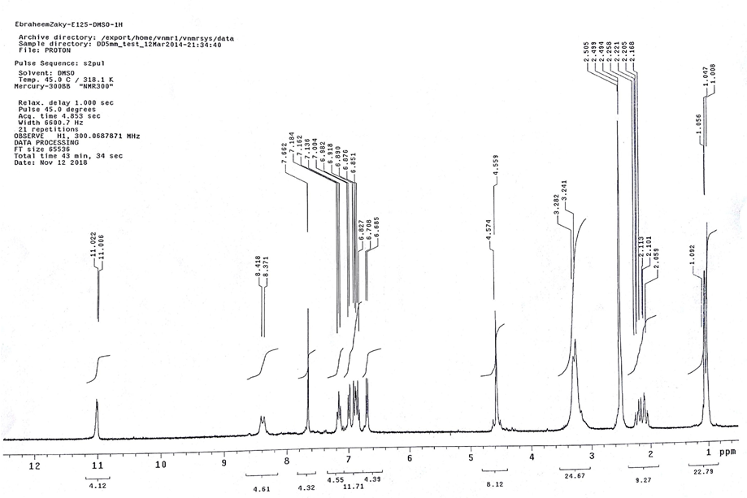
CHART 1: ¹H NMR spectrum of compound 8a
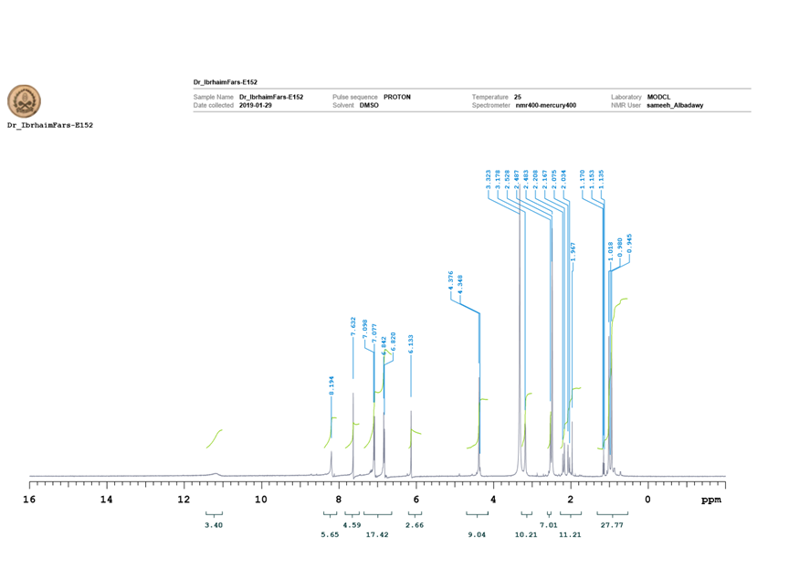
CHART 2: ¹H NMR spectrum of compound 8b
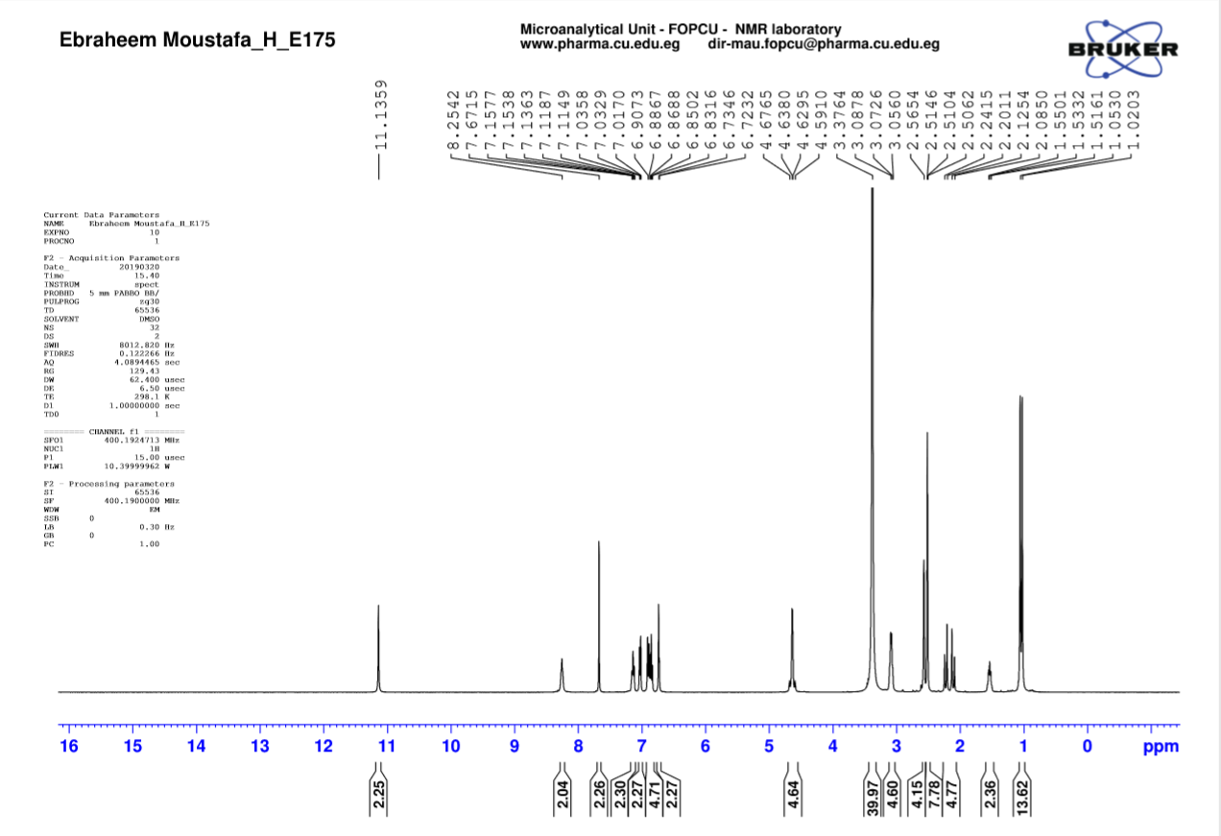
CHART 3: ¹H NMR spectrum of compound 8c
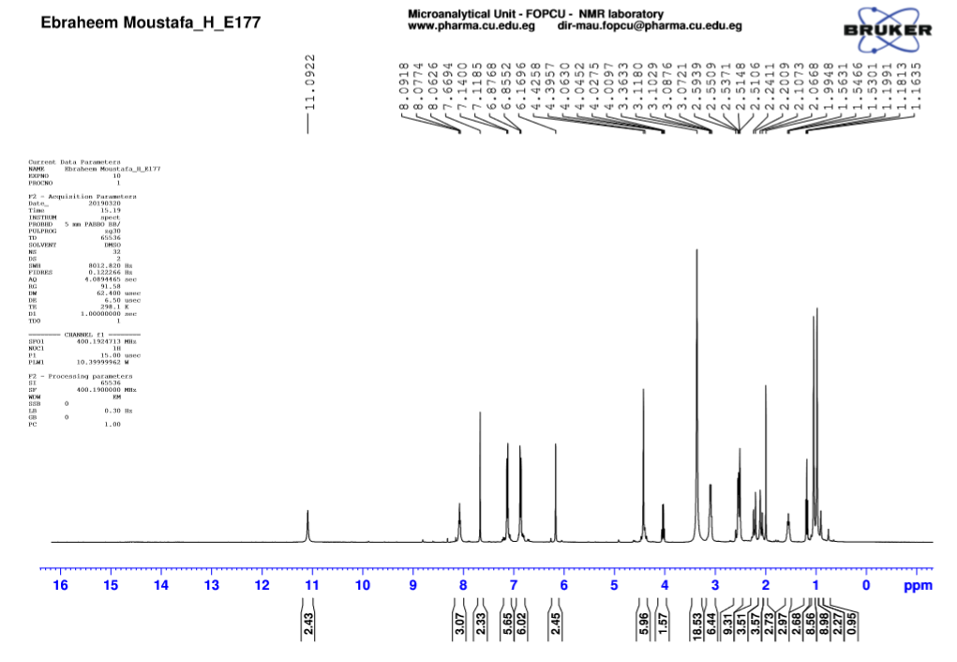

CHART 4: ¹H NMR spectrum of compound 8d
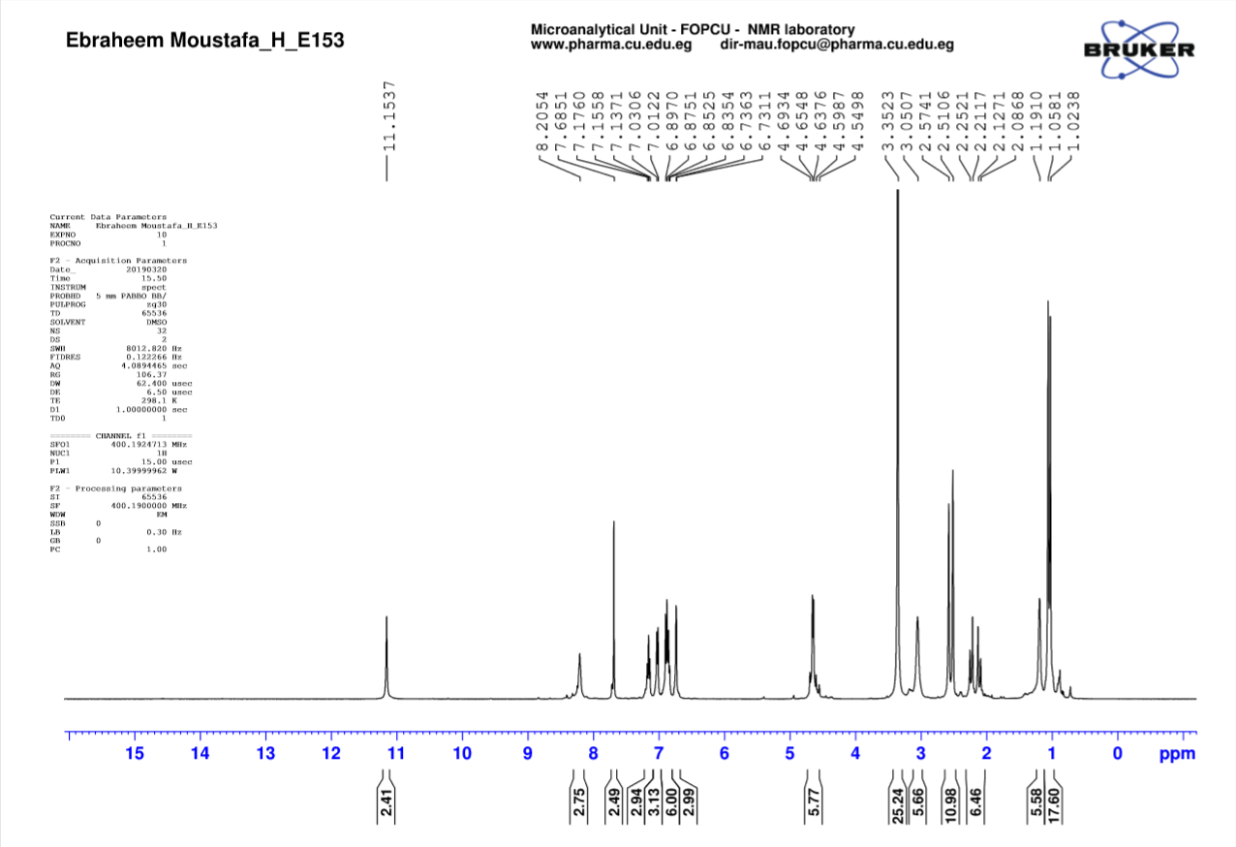
CHART 5: ¹H NMR spectrum of compound 8e
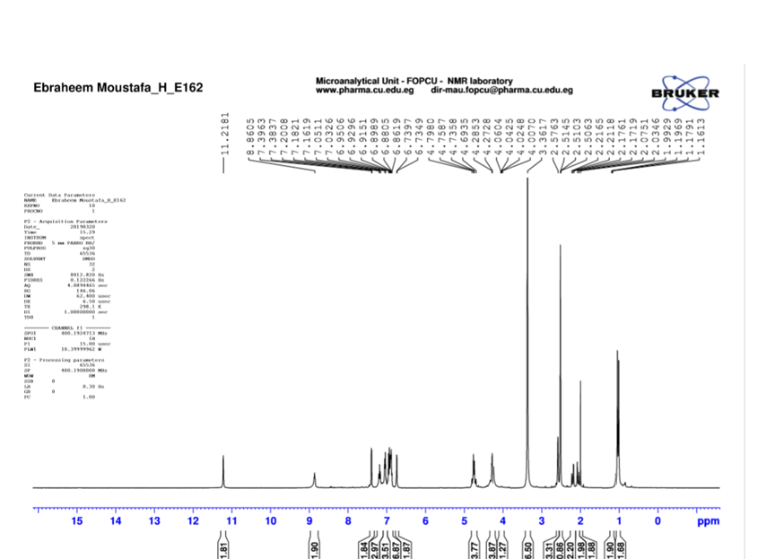
CHART 6: ¹H NMR spectrum of compound 8f
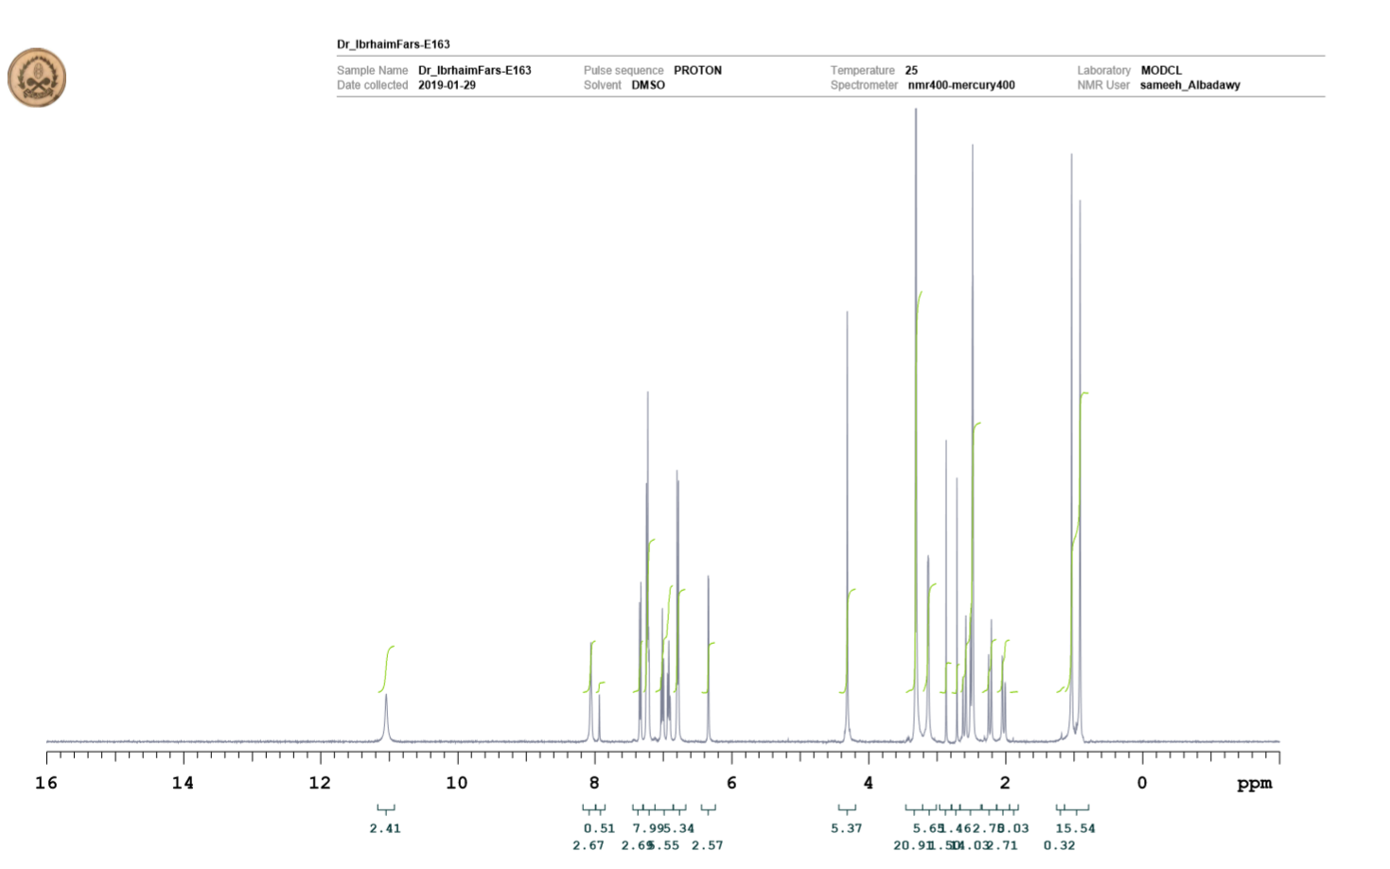

CHART 7: ¹H NMR spectrum of compound 12a
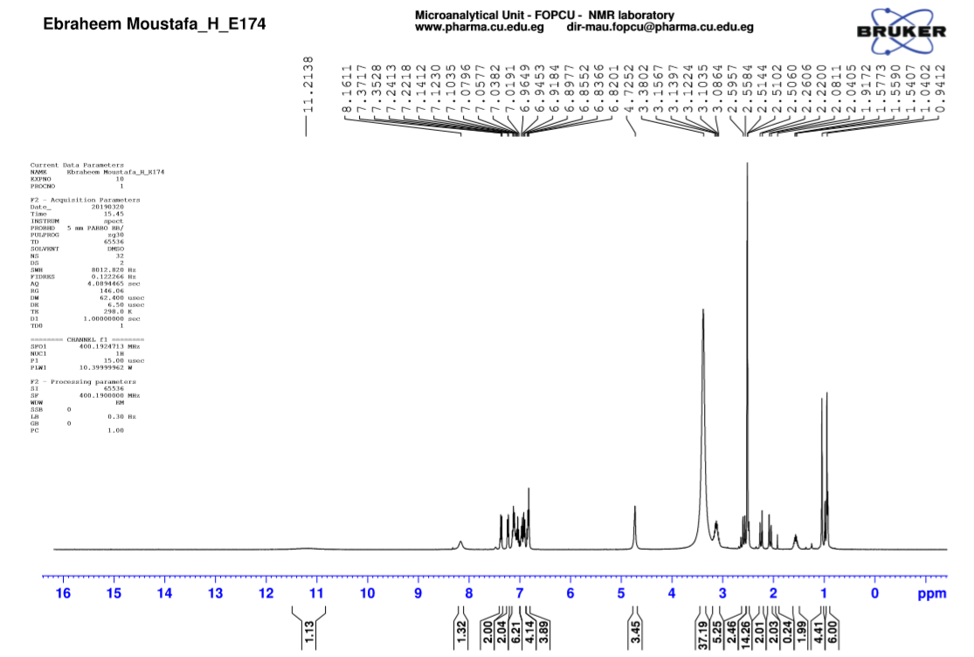

CHART 8: ¹H NMR spectrum of compound 12b
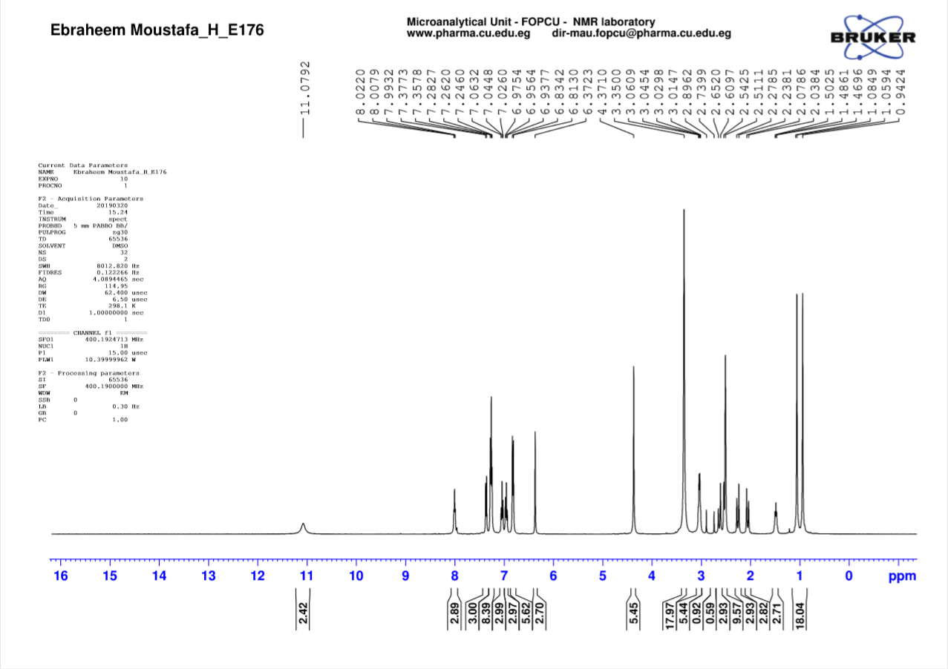
CHART 9: ¹H NMR spectrum of compound 12c
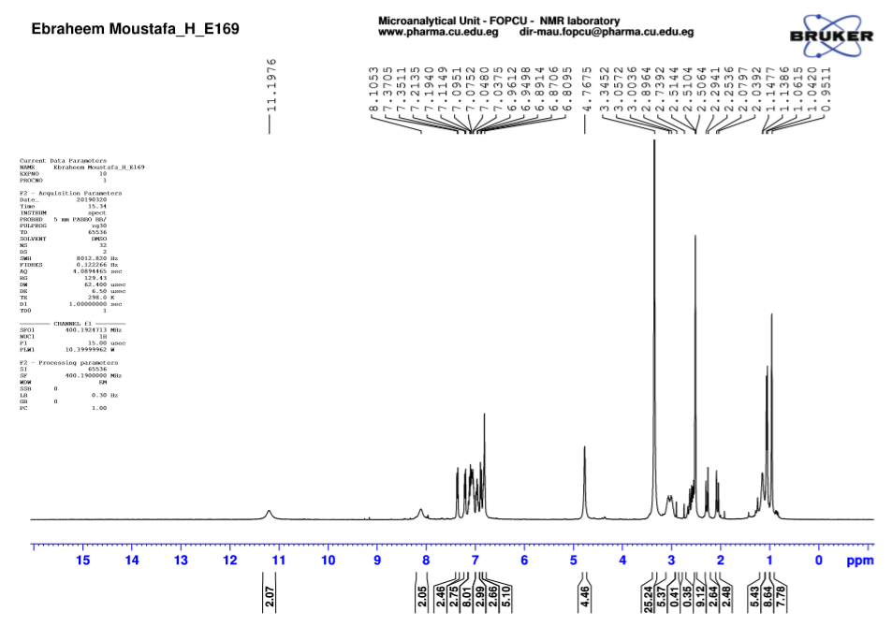
CHART 10: ¹H NMR spectrum of compound 12d
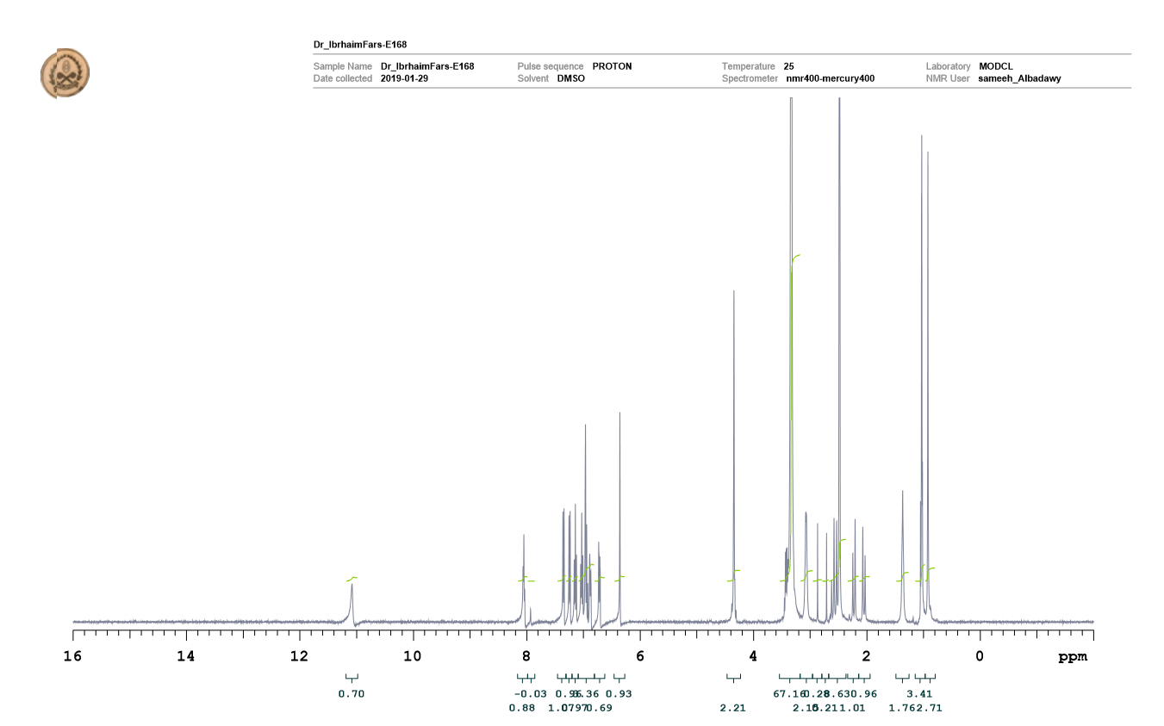
CHART 11: ¹H NMR spectrum of compound 12e
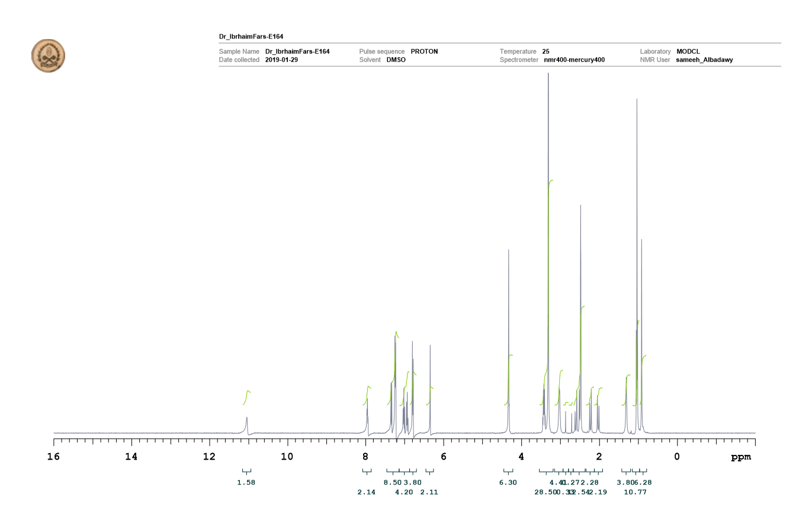 CHART 12: ¹H NMR spectrum of compound 12f

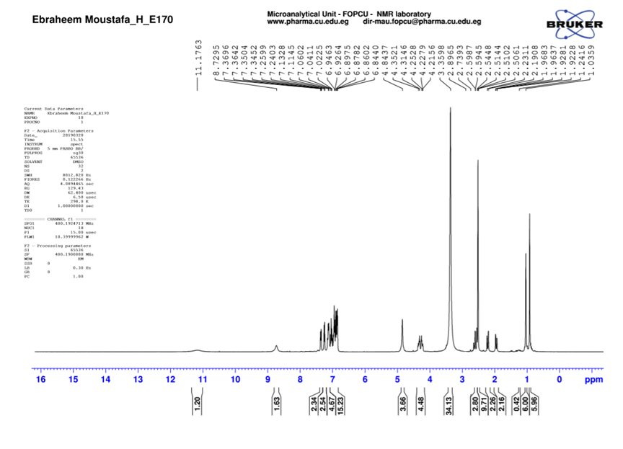
CHART 13: ¹H NMR spectrum of compound 12g
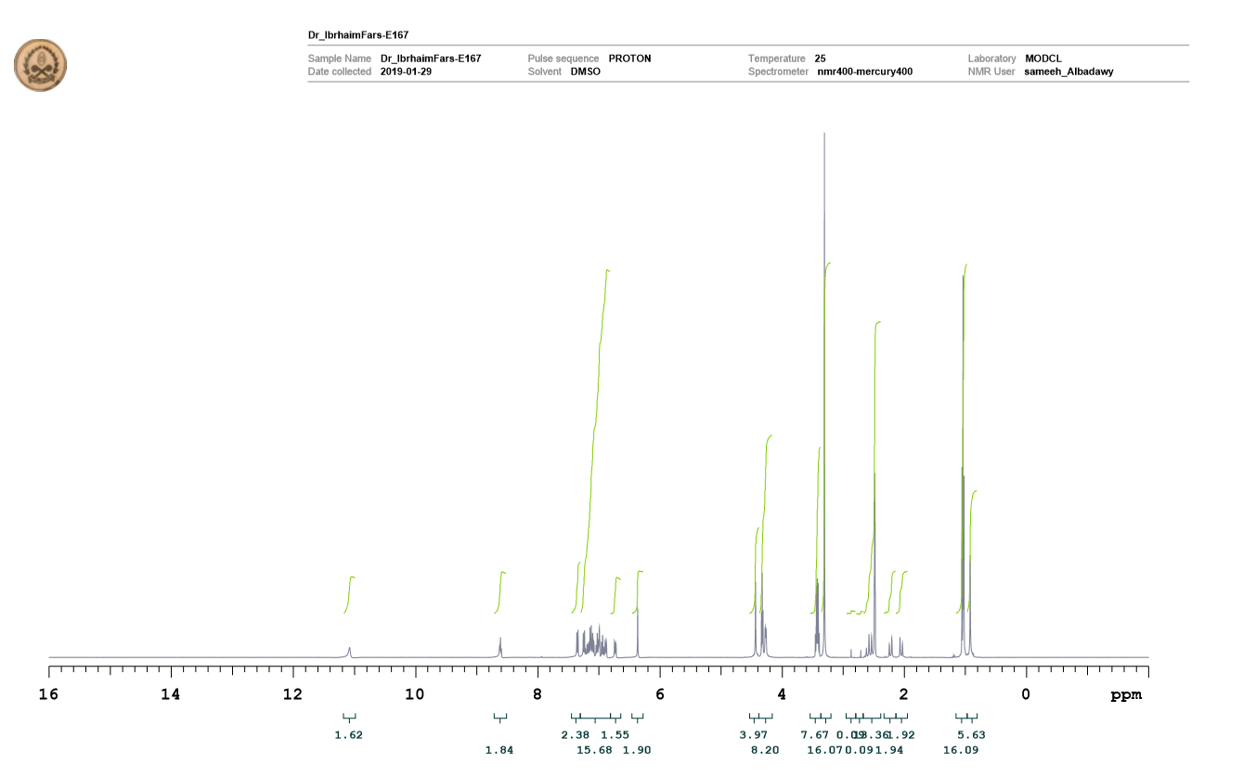
CHART 14: ¹H NMR spectrum of compound 12h

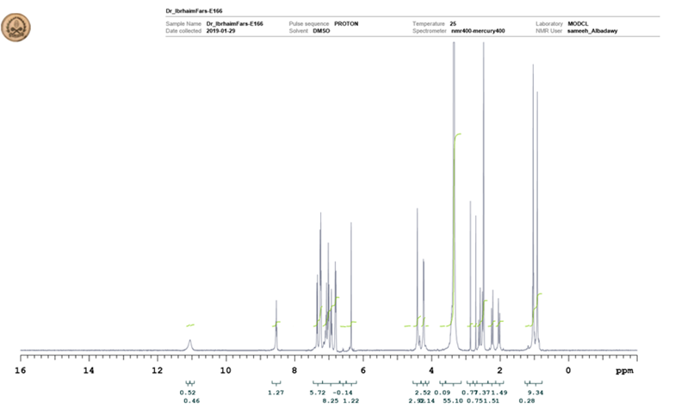
CHART 15: ¹H NMR spectrum of compound 12i
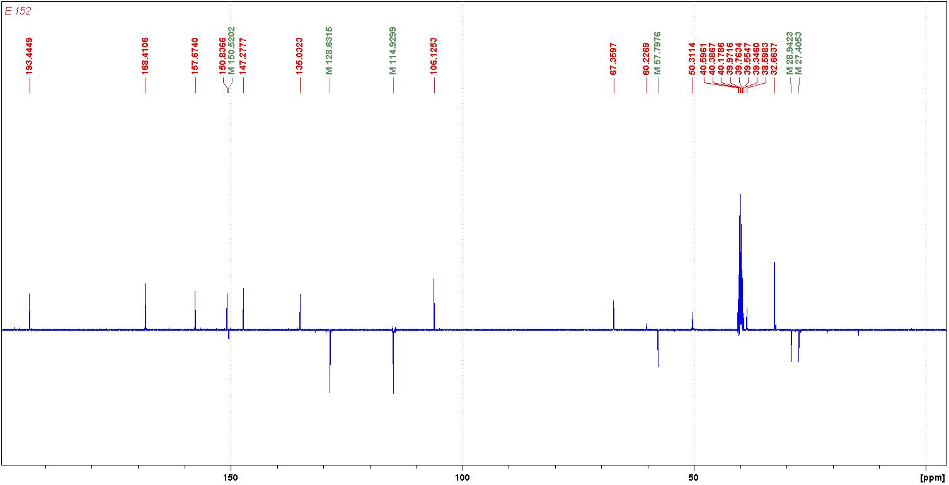

CHART 16: ¹³C NMR spectrum of compound 8b

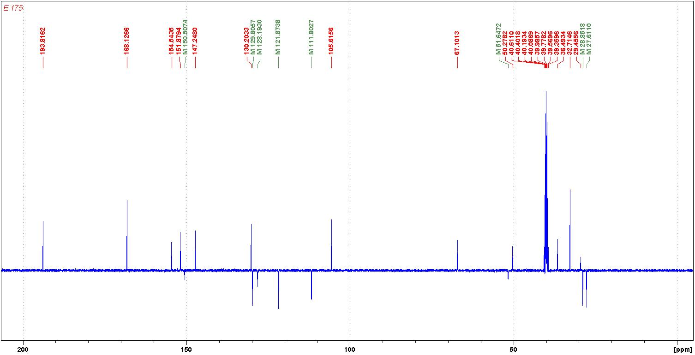

CHART 17: ¹³C NMR spectrum of compound 8c

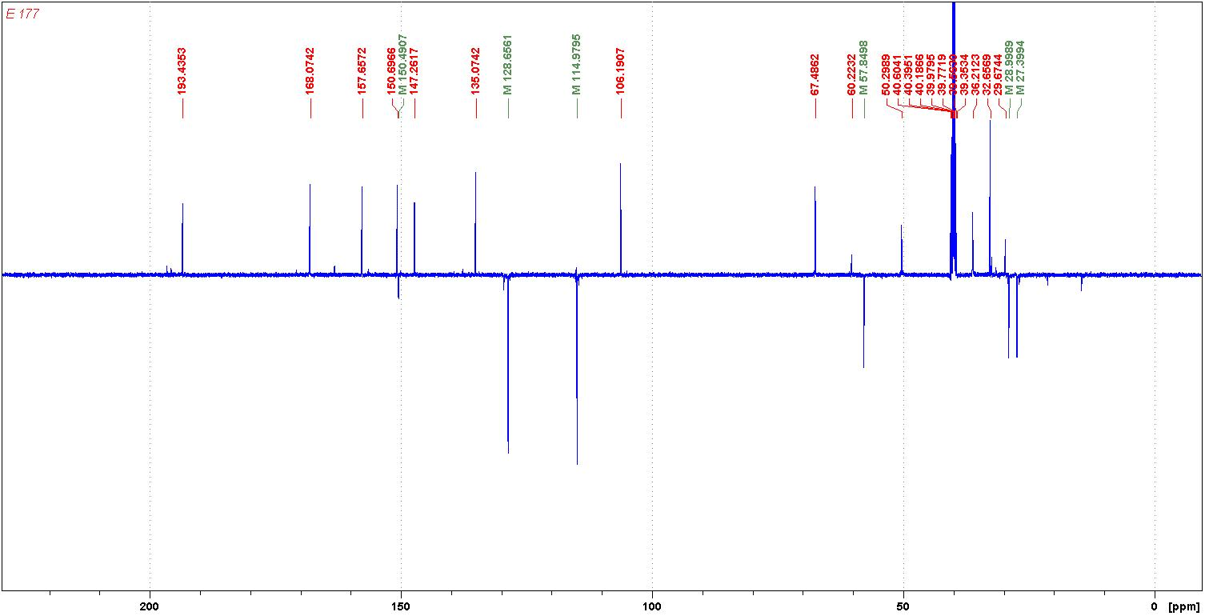
CHART 18: ¹³C NMR spectrum of compound 8d

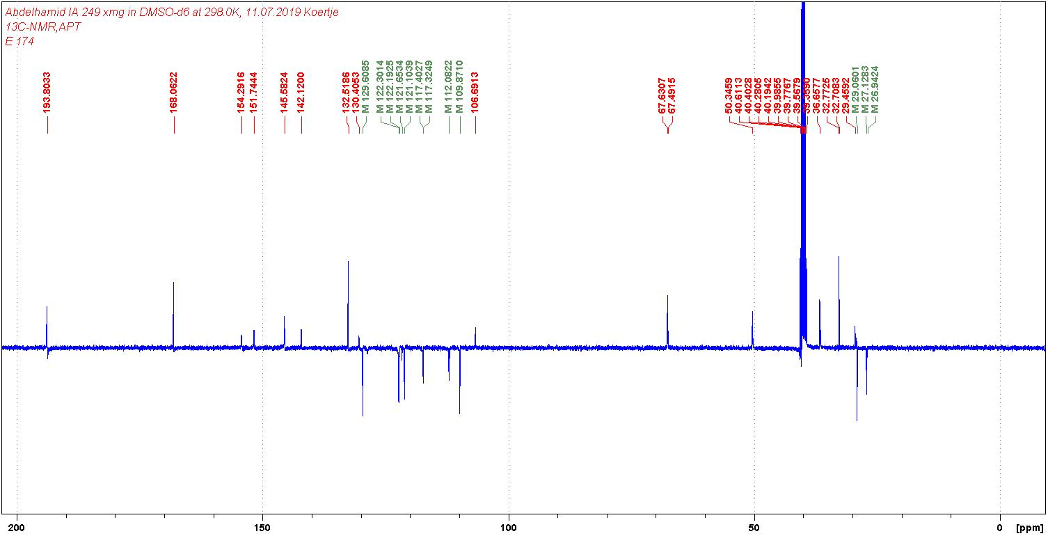
CHART 19: ¹³C NMR spectrum of compound 12b

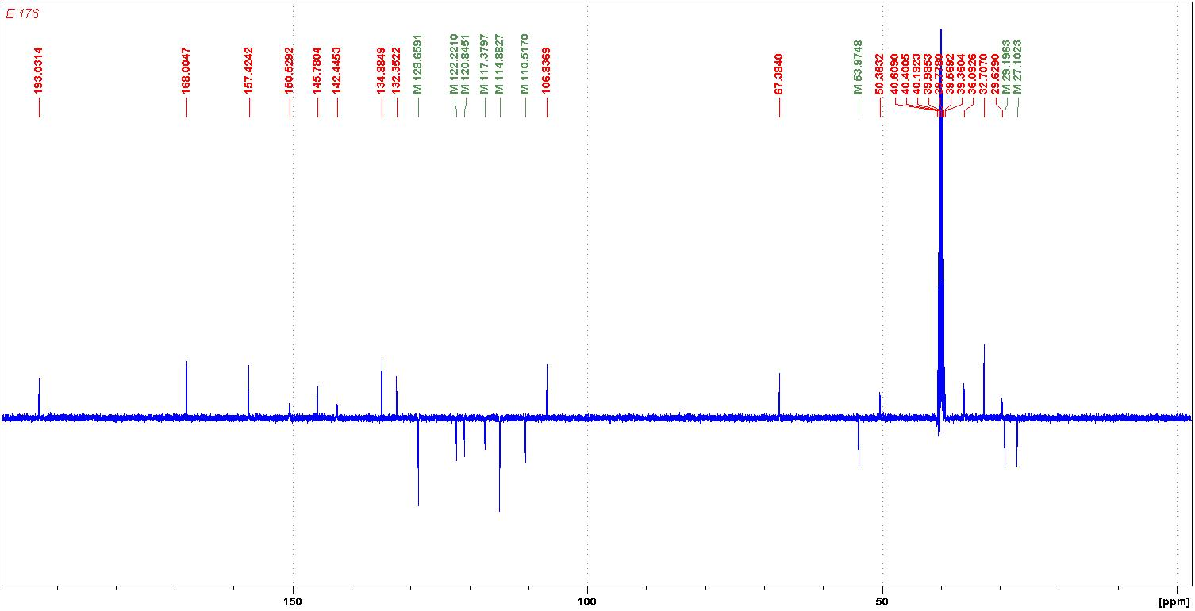

CHART 20: ¹³C NMR spectrum of compound 12c

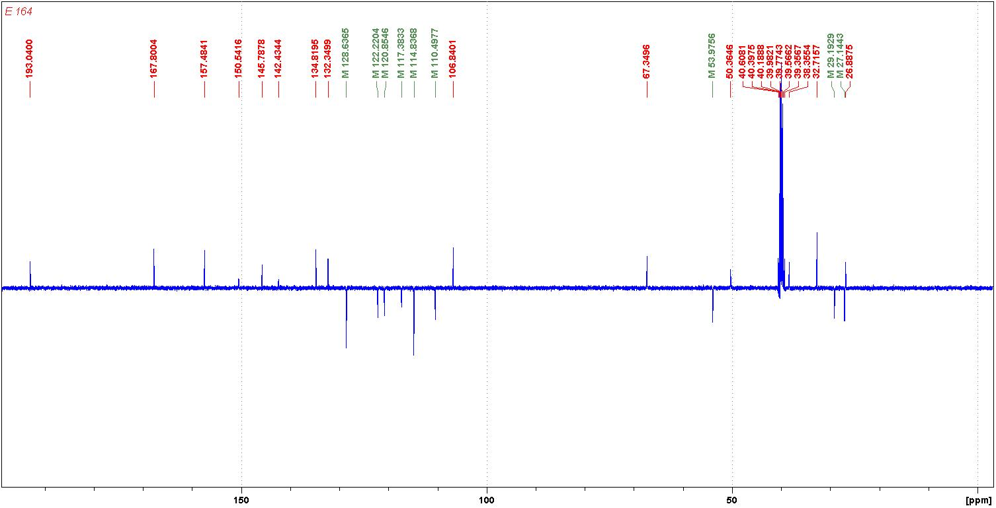
CHART 21: ¹³C NMR spectrum of compound 12f

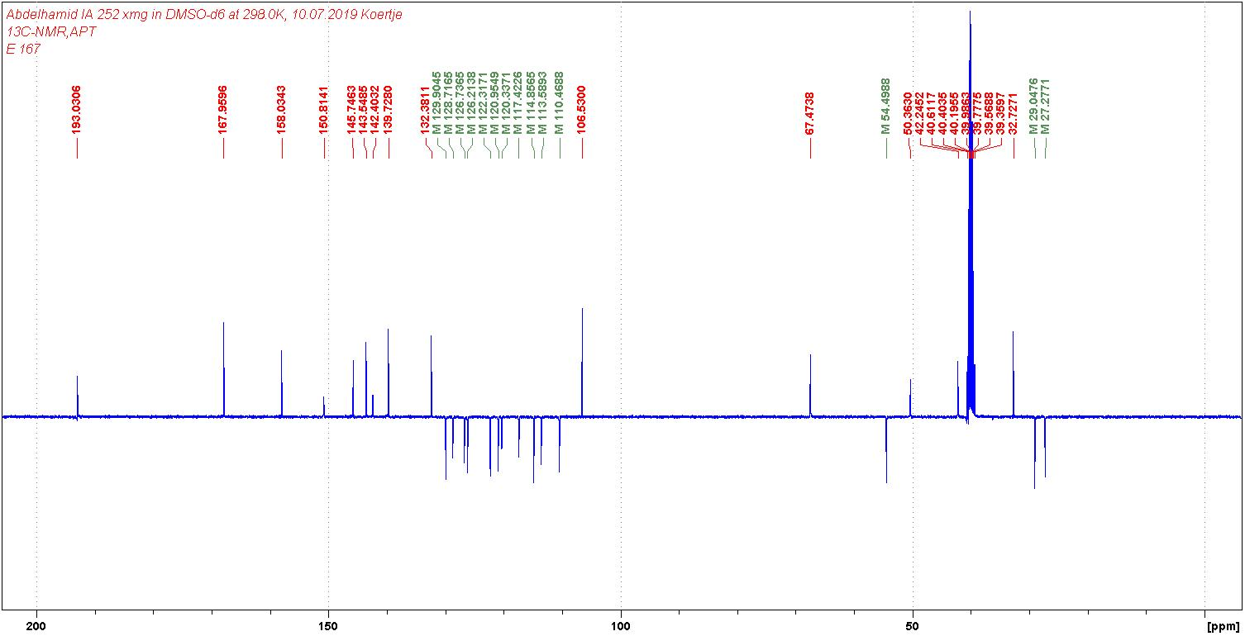

CHART 22: ¹³C NMR spectrum of compound 12h

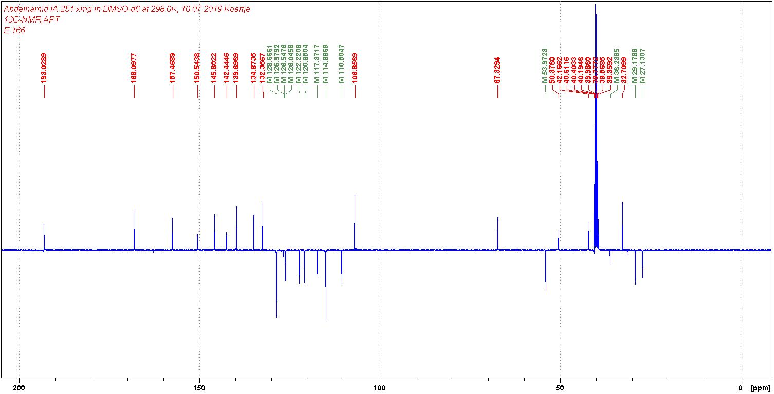
CHART 23: ¹³C NMR spectrum of compound 12i

