Supplementary Material

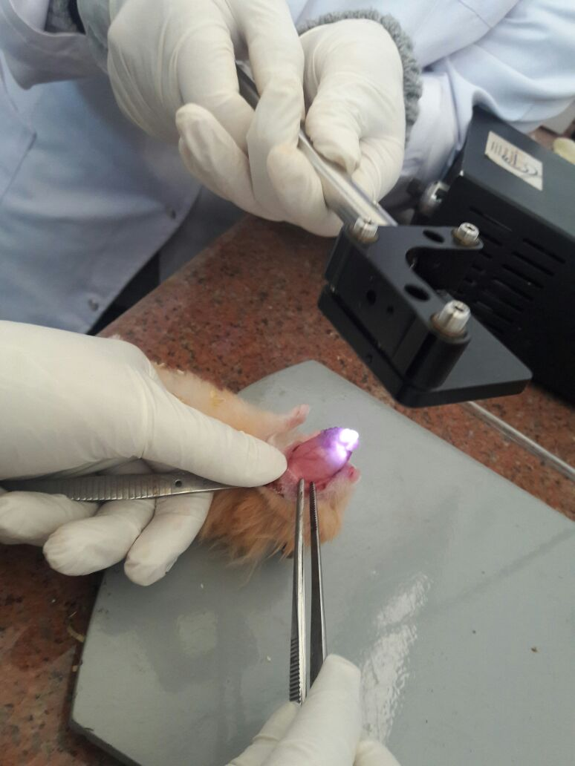
Fig. S1. Exposure of hamster with OSCC to near-infrared laser.

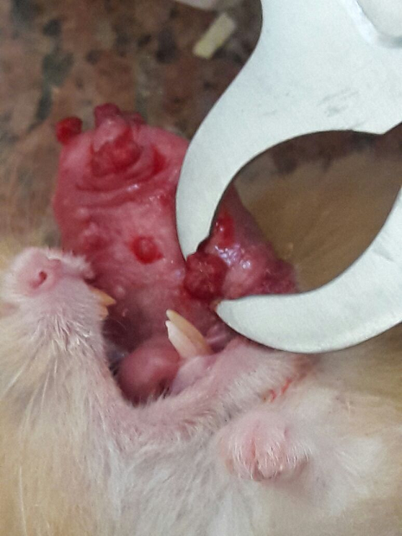
Fig. S1. Tumor size measurements with a caliber.

Grading of epithelial dysplasia was carried out according to Banoczy and Sciba (1976) and modified by El-Dakhakhny et al (2010) due to thin nature of hamsters’ epithelial lining. Epithelial dysplasia was graded into mild, moderate, severe, and carcinoma in situ.
Mild: when less than 3 dysplastic criteria were present.
Moderate: when 3-7 changes are present.
Severe: when more than 7 changes were present.
Carcinoma in situ: when dysplastic criteria distributed from top to bottom with intact basement membrane.

Grading of squamous cell carcinoma was carried out according to Broder’s classification. Tumors were graded on the basis of degree of differentiation and keratinisation of tumor cells into:
Grade I: well differentiated tumors (75-100%) of cells are differentiated.
Grade II: moderately differentiated tumors (50-75%) of cells are differentiated.
Grade III: poorly differentiated tumors (25-50%) of cells are differentiated.
Grade IV: anaplastic tumors (0-25%) of cells are differentiated.

