**Appendix**

In this Appendix, we provide additional information evidence on attitudes towards Scottish independence and evidence to support the topic model evaluations. IN the first section, I discuss evidence to support the main argument. I then go on to discuss additional validation of the STM results comparing qualitative evidence, topic correlations and estimates from a hierarchical topic model.

*Background information on Scottish Politics*

Foremost, Figure A1 shows the broad support for independence from the Scottish Social Attitudes survey since the foundation of the Scottish Parliament in 1999. As can be seen, attitudes remained fairly stable prior to 2011 among party supporters, except for a slight increase in 2004 that reverted to more unionist positions following the election. The bigger change occurs following the 2011 election leading up to the independence referendum in 2014 among SNP supporters and the public more broadly. The results are largely consistent with the analysis of party identifiers in Table 1 in the main analysis.

Figure A2 provides additional background on the parties’ relative positions. As discussed in the main text, Labour and the SNP held relatively close positions on the left-right dimension whereas the Conservative Party hold more distant preferences. The biggest issue separating Labour and the SNP is over their Scottish Independence priorities as shown in Figure 3.

Figure A3 shows the change in salience of the centre-periphery dimension as measured by the Regional Manifesto Project. As discussed in the main text, the SNP far prefers powers to the periphery relative to the other parties. These hand-coded estimates from the RMP capture a related, but slightly different dynamic, although the correlate strongly with the estimated positions from the STM.

Figure A4 presents the proportion of respondents listing independence as the most important issue in the open-ended questions from the BES for partisan identifiers and independents. Clearly, the SNP identifiers hold the issue as more important than other parties’ identifiers, as predicted. Consistent with the main argument, the overall attention decreases in 2016 after the 2014 referendum as the SNP’s emphasis on the issue decreases in the elections that year. In most years, economic issues and the EU (in 2016) otherwise dominate public opinion.

*Validating the STM*

Table A1, provides an overview of the most frequent and exclusive (FREX) words for each of the estimated topics presented in the main analysis. Following Roberts et al. (2013), these words can be used to evaluate the content of the estimated topics. FREX words are those that are most frequent in the dataset, but that are most exclusive to the topic; they do not occur regularly in other topics. The three topics linked to the constitutional question are topics 1, 3 and 7. As is highlighted in Table A1, the references to these terms pull out different frames for describing independence.

Table A2 presents a set of qualitative examples of quotes from SNP and Conservative manifestos which exemplify the key constitutional issue topics identified by the STM. These statements not only provide further validation for the model, but clearly illustrate the dynamics it is detecting. These quotes also demonstrate the multifaceted nature of independence-related appeals. The issue is clearly linked to outcomes (whether positive or negative), couched in emotive language and explicitly linked to other issues.

As the qualitative assessment suggests, the independence topics relate to multiple ways or frames for discussing the issue. Figure A5 demonstrates further evidence of how the topics correlate. Topic 1 is mostly closely connected to the underlying independence concept, but is discussed in isolation from other domestic politics issues. This contrasts Topic 7, which more directly relates to other topics emphasizing domestic, devolved powers including education and health care. On the other hand, Topic 3 more closely links to economic policies, likely reflect the Tory’ framing of independence as negative for the Scottish economy.

Finally, Figure A6 presents the results of a hierarchical topic model. As the number of splits between the programme and the other Tory platforms show, the dendogram illustrates that the Conservative 2016 manifesto reflects a categorically different type of manifesto. On the other hand, the 2011 and 2016 SNP manifestos reflect the changing language of independence as they focused on the lead up to and the fall out from the 2014 referendum. In both cases, the dendogram suggests that those manifestos written following the SNP’s 2007 surprise victory reflect a different language than those manifestos that preceded them.

**Figure A1. Voter Support for Independence from Scottish Social Attitudes.**



**Figure A2. Left-Right Positions from the Regional Manifestos Project.**



Figure A3. Salience of the Centre-Periphery dimension from the Regional Manifestos Project.



**Figure A4. Percentage of party identifiers reporting Independence as MII**



**Figure A5. Topic Correlations from 10 topic model**

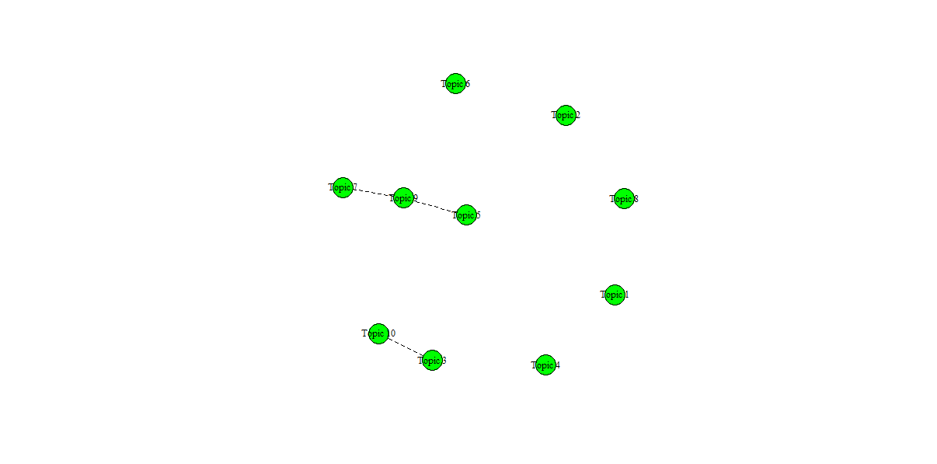

**Figure A6. Hierarchical Clustering**

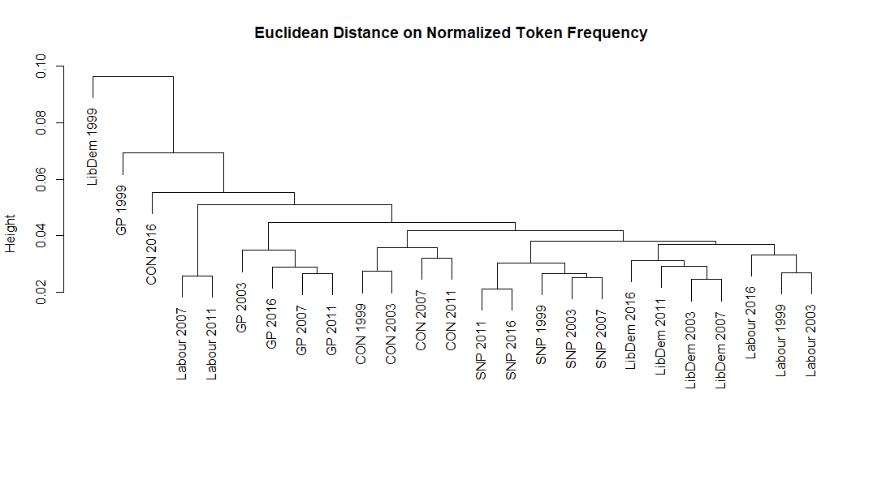

**Figure A7. Predicted Party Attention to Constitutional Issues over Time**

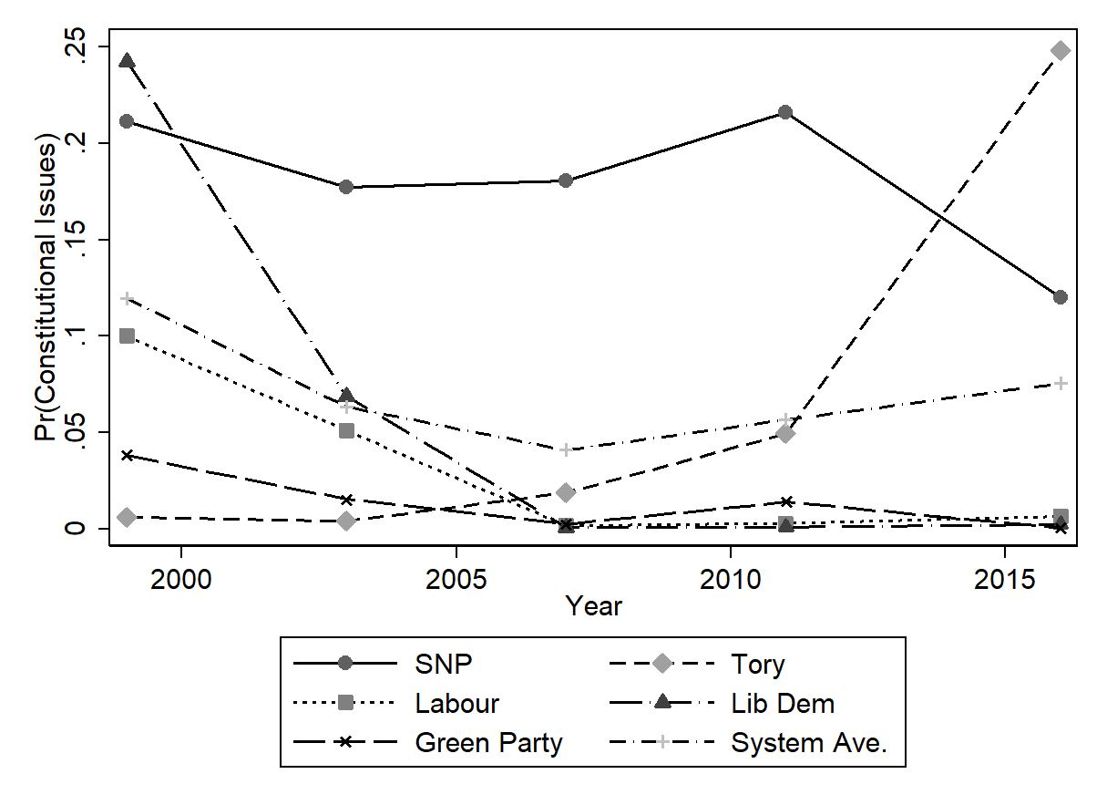**Table A1. Structural Topic Model, Topic Content**

|  |
| --- |
| **Topic 1 Top Words:** |
| Highest Prob: develop, nation, educ, parliament, eu, peopl, govern, hous, polici, scots_gov, standard, communiti, resourc, school, public_servic, elect, promot, public, servic, area |
| FREX: elect, fish, eu, parliament, lifelong, public_servic, deal, key, administr, **indyref**, assist, modern, water, differ, voluntari, polici, resourc, bed, abolish, three |
| **Topic 2 Top Words:** |
| Highest Prob: greens, green_msp, peopl, communiti, scots_gov, public, local, land, energi, right, campaign, access, equal, care, fund, hous, power, educ, tax, protect |
| FREX: green_msp, push, call, greens, campaign, gender, equal, land, democraci, rent, women, citizen, inequ, fight, divers, properti, carer, transit, human, candid |
| **Topic 3 Top Words:** |
| Highest Prob: tori, **unionist**, snp, strong, tax, scots_gov, govern, school, communiti, fund, addit, busi, continu, parliament, develop, time, well, invest, everi, hous |
| FREX: tori, **unionist**, strong, addit, snp, decid, cooper, hold, alway, properti, last, business_r, focus, well, afford, scottish_govern, result, **devolution**, competit, exampl |
| **Topic 4 Top Words:** |
| Highest Prob: labour, communiti, build, school, peopl, continu, children, develop, invest, opportun, take, busi, time, famili, nation, introduc, skill, servic, commit, improv |
| FREX: labour, build, realli, famili, matter, learn, music, young, behaviour, prosper, excel, fight, improv, victim, children, expand, skill, believ, step, talent |
| **Topic 5 Top Words:** |
| Highest Prob: communiti, libdem, peopl, school, local, develop, reduc, energi, health, busi, fund, children, time, includ, young_peopl, plan, invest, servic, power, govern |
| FREX: libdem, per_cent, youth, young_peopl, facil, wait, involv, reduc, major, primari, rang, train, sport, offend, pilot, cycl, import, think, crime, centr |
| **Topic 6 Top Words:** |
| Highest Prob: greens, communiti, develop, energi, local, peopl, scots_gov, power, public, includ, reduc, educ, food, social, renew, chang, fund, transport, build, environ |
| FREX: greens, pollut, anim, wast, organ, section, environment, emiss, space, oppos, nuclear, recycl, food, imag, public_transport, traffic, reduct, climat, trade, credit |
| **Topic 7 Top Words:** |
| Highest Prob: snp, communiti, nation, continu, fund, take, develop, includ, invest, build, govern, part, school, energi, plan, protect, futur, access, improv, local |
| FREX: snp, success, nation, alreadi, take, part, continu, wider, **indyref**, made, drink, creation, ahead, creativ, public_sector, project, includ, examin, import, fisheri |
| **Topic 8 Top Words:** |
| Highest Prob: school, local, labour, crime, tori, peopl, communiti, patient, time, govern, tax, council, drug, give, fund, nhs, reduc, mani, rural, busi |
| FREX: patient, politician, state, bureaucraci, run, far, sentenc, rehabilit, money, drug, scottish_execut, fishermen, choic, crimin, farmer, tourist, head, burden, crime, neighbourhood |
| **Topic 9 Top Words:** |
| Highest Prob: invest, peopl, labour, communiti, develop, power, children, futur, tax, educ, cut, protect, servic, fund, school, right, continu, care, govern, public |
| FREX: women, stop, mental_health, fair, cancer, fairer, human, inequ, labour, workforc, abus, wage, cut, invest, disabl, workplac, futur, colleg, gap, transform |
| **Topic 10 Top Words:** |
| Highest Prob: busi, develop, communiti, local, job, fund, give, reform, solut, servic, encourag, creat, invest, educ, opportun, school, economi, peopl, care, nation |
| FREX: solut, action_plan, scienc, bank, busi, export, region, alcohol, grow, scope, innov, reform, revolut, colleg, intervent, keep, public_sector, procur, group, help |

**Table A2. Qualitative validation of STM estimates**

|  |
| --- |
| **Topic 1** |
| “The only way to determine Scotland’s constitutional future is by **referendum**, because only a **referendum** allows a clear choice on a constitutional matter that often crosses party divides. In any **referendum** the Scottish Green Party will campaign for the **Scottish Parliament** to have the same powers as any other member state in an increasingly interdependent **Europea**n **Union**. However, we do not wish to see the replacement of one centralised state with another. Greater power needs to be shifted to **communities**, to ensure that decisions are taken at the level closest to those affected by them.” (Green 2007)  “The major new powers of the Scottish **Parliament** mean we can make different decisions, and act in the best interest of the people of Scotland by rejecting further cuts to **public services**. We rule out another **referendum** on **independence** during the lifetime of the next **Parliament**. We believe the UK remaining part of the **European Union** is the best way to protect jobs and rights for workers in Scotland. We will campaign for a ‘remain’ vote in the **EU** **referendum** on 23 June 2016.” (Labour 2016)  “To be the best again we need a strong economy, fair tax and good **public services**. That’s why we support continued membership of the **European Union**, a reformed tax system that makes work pay and investment in good **public services**. And finally, to be the best again, we will move on from the **independence** debate to bring unity, healing the divisions of the **referendum**. I am a strong supporter of the UK, and always will be” (Lib Dem 2016)  "With the use of our own **resources**, Scotland could be the 7th most prosperous **nation** in the world a **nation** that can use its wealth for its own priorities.” (SNP 1999)  “A country that looks after its **public services** looks after its **people**. After all, what is more important than the health and **education** of our population and a justice system that is fair and equal? The SNP want high quality **public services** that Scotland can be proud of… Our **public services** are vital and a benchmark for any **developed** country.” (SNP 2003)  “With **Independence** we can once again take our full and rightful place in the international **community**. Even under the limited powers of the current **Parliament** we will press for a greater say in external relations, and make as full a contribution as possible to the international **community** of **nations**.” (SNP 2003)  “We believe that the Scottish **Parliament** should have the right to hold another **referendum** if there is clear and sustained evidence that **independence** has become the preferred option of a majority of the Scottish **people** – or if there is a significant and material change in the circumstances that prevailed in 2014, such as Scotland being taken out of the **EU** against our will.” (SNP 2016) |
| **Topic 3** |
| “One reason why the **government** has been allowed to waste money on such a grand scale is that there is a lack of accountability and responsibility over the **funding** it receives. **Conservatives** acknowledge that there is a debate to be had about the powers of the **Scottish Parliament**. We believe that **devolution** is a process, not an event, and so we would welcome this debate.” (Conservative 2007)  “The **Business Rates** Reform Bill will not increase the burden of **business**  **rates**, and will prohibit sector specific supplements such as the **tax** on retail  jobs recently proposed by the **SNP**, and stopped by the Scottish **Conservatives**. We will extend the scope of the small **business rates** relief scheme over the life of the **Parliament** as the public finances allow.” (Conservative 2011)  “We will oppose any attempt by the **SNP** to **hold** a 2nd referendum during this parliament – no matter the **result** of the EU referendum this June. We will support a fresh, positive drive to promote the benefits of the **Union**. In our view, this should not **focus** on the downsides of **independence** - though there are many - but on the **strength** and values of the **Union**.” (Conservative 2016)  “We support **devolving** more responsibilities to the Scottish **Parliament**, including capital borrowing powers and new **tax** powers, such as stamp duty on property and landfill **tax**. We also support responsibility for setting the drink-drive limit and the speed limit in Scotland being **devolved** to the Scottish **Parliament**” (Labour 2011)  “Our commitment to remain in both the **UK** and **European Unions**, which are so important for our economy, provides the certainty **business** needs. We must move on from the arguments of the past to provide **business** with stability for the future.” (Labour 2016)  “The Steel Commission is right to call for a second constitutional convention to consider the best ways to **devolve** new powers, including **taxation** powers, to the **Scottish Parliament**.” (Lib Dem 2007)  “Standing up for Scotland is what we do. We never shy away from an opportunity to make this country even **stronger**. The **SNP** government stepped in to save Scottish steel, Prestwick Airport, and the Ferguson shipyard. And when the **Tories** tried to cut Scotland’s budget by £7 billion, we saw them off.” (SNP 2016) |
| **Topic 7** |
| “This is a clear breach of the Edinburgh Agreement, which tied both sides in the **referendum** to “respect” the result. Worse, it will **create** further uncertainty in Scotland and will prevent better **government**. The **Scottish** **Government** should focus on the issues that affect us every day – **improving** our health service, creating better **schools**, and **building** a more secure country for us all. Instead, reading standards have declined, our farming **communities** have suffered from the **SNP’s** IT fiasco, and the move to a centralised police force hasn’t worked.” (Conservative 2016)  “We support calls for Scottish **independence**, not out of **nationalistic** fervour, but as a means to **create** a more **locally**-based, sustainable, and democratic society.” (Green 2007)   “Swapping a centralised UK **Government** for a centralised Scottish **Government** isn’t the radical change that many wanted. **Local** **community** empowerment is an agenda **Holyrood** must embrace instead of seeing it as a threat. We’ll argue for a multi-option **referendum** with choices including the status quo, a stronger **Scottish Parliament** with powers defined through a participative process, and full **independence** based on a written constitution, and  we will back this third option. We’ll also put the case for the decentralisation of power from **Holyrood** and **local** authorities.” (Green 2011)  “Labour's London **government** has not scrapped tuition fees or introduced free personal care. The **SNP** will put **independence** as a priority before  **schools** and hospitals. The **Conservatives** only propose to cut services to pay  for tax cuts.” (Lib Dem 2003)  “Our five years will be focused on making Scotland the best again, transforming opportunity for children, and our economy, by additional **investment** in education, skills and mental health. We will not support a second **referendum** on **independence** in the next **parliamentary** term. Full stop.” (Lib Dem 2016)  “**Independence** is the natural state for **nations** like our own. Scotland has the people, the talent and potential to become one of the big **success** stories of the 21st century. We can match the **success** of **independent** Norway – according to the UN the best place in the world to live. We can do as well as **independent** Ireland, now the fourth most prosperous **nation** on the planet. With **independence** Scotland will be free to flourish and grow. We can give our **nation** a competitive edge.” (SNP 2007)  “We want to see Scotland have responsibility for its own destiny and **take** its rightful place among small, **successful** **independent** countries. There is so much more we could do with the powers of any other **nation**.” (SNP 2011)  “We want our rural **communities** to prosper and be well supported by high quality public services. We want more young people to have the opportunity to **build** careers and **successful** **futures** in the areas where they grow up. We want to **build** rural Scotland’s **future**, **investing** in homes, infrastructure and connectivity.” (SNP 2016) |