Supporting information

Ag/BiOI/C enhanced photocatalytic activity under visible light irradiation

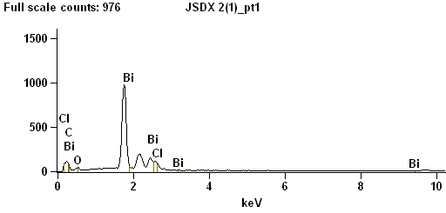
Fig. S1 EDS spectra over Ag/BiOI/C (0.5:2:3) composite.

Fig. S2 MB adsorption on different samples.

Fig. S3 The degradation efficiency (a) and plots of -ln(C/C₀) versus time (b) over BiOI/C composites under visible light.

