**Supporting Information**

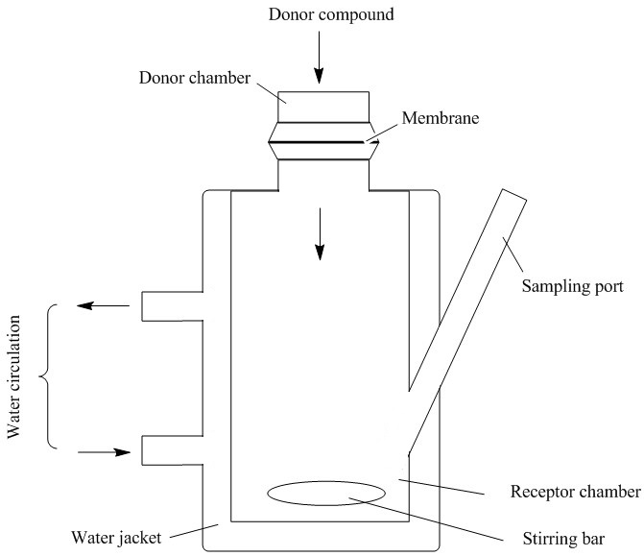

Figure S1. Ex vivo diffusion system (the Franz diffusion chamber).



Figure S2. Absorption spectra of silver nanoparticles after 2, 3, 4, 5 and 6 weeks of the synthesis.

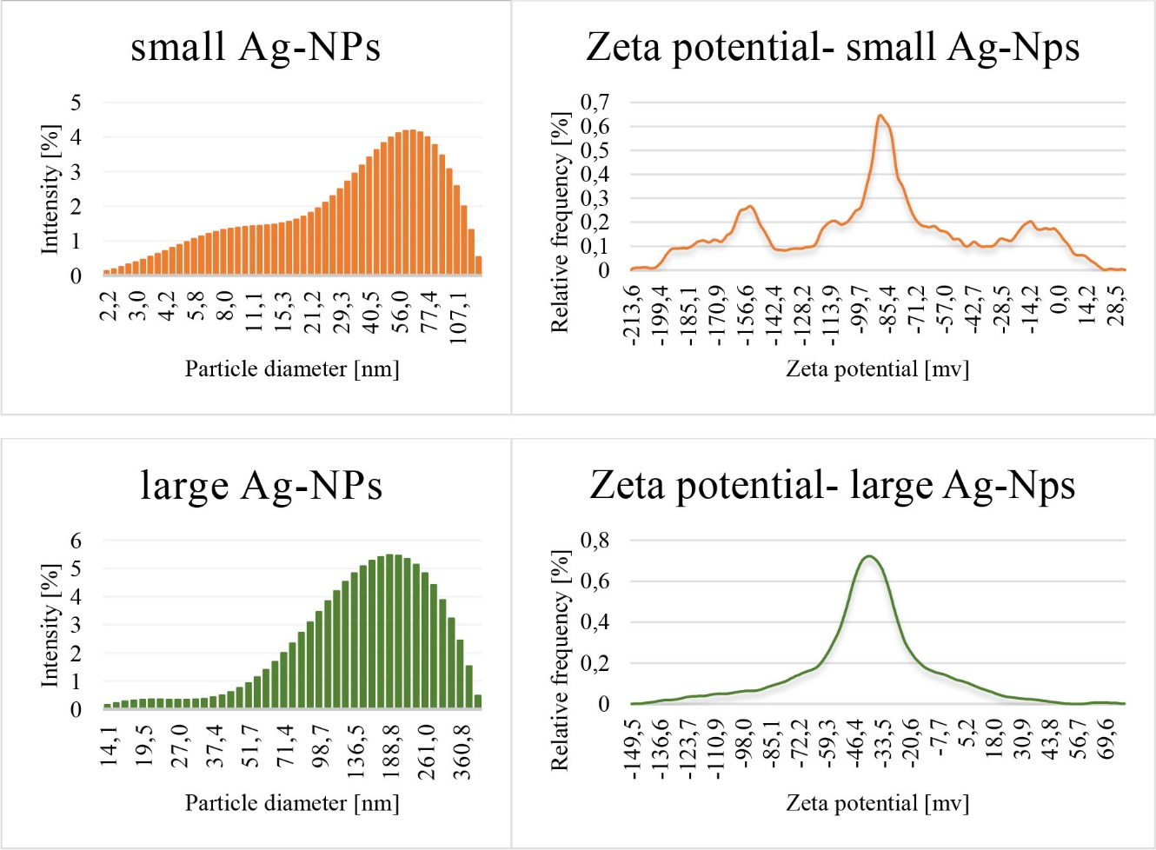Figure S3. Diagrams of the particle diameter and zeta potential for both Ag-NPs.