Supplemental Material
Nyilitya et al. Land use controls Kenyan riverine nitrate discharge into Lake Victoria – evidence from Nyando, Nzoia and Sondu Miriu river catchments
(a)
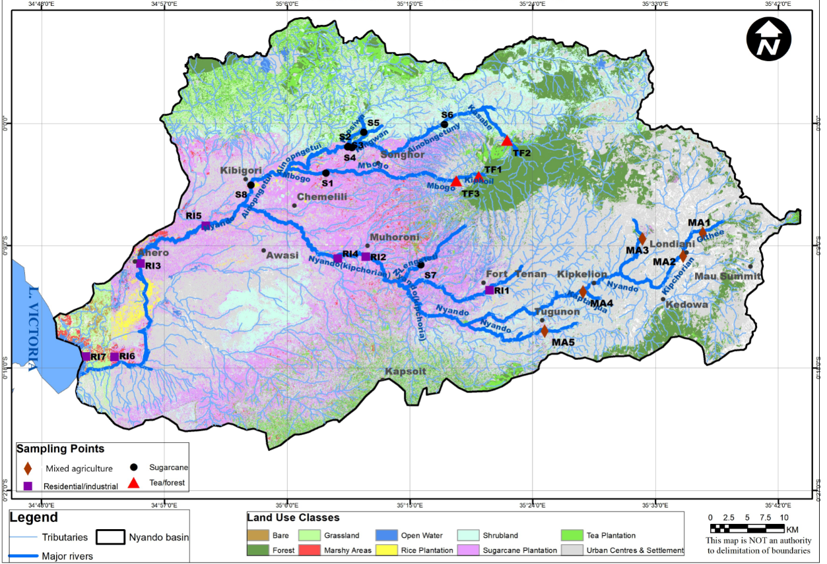

(b)
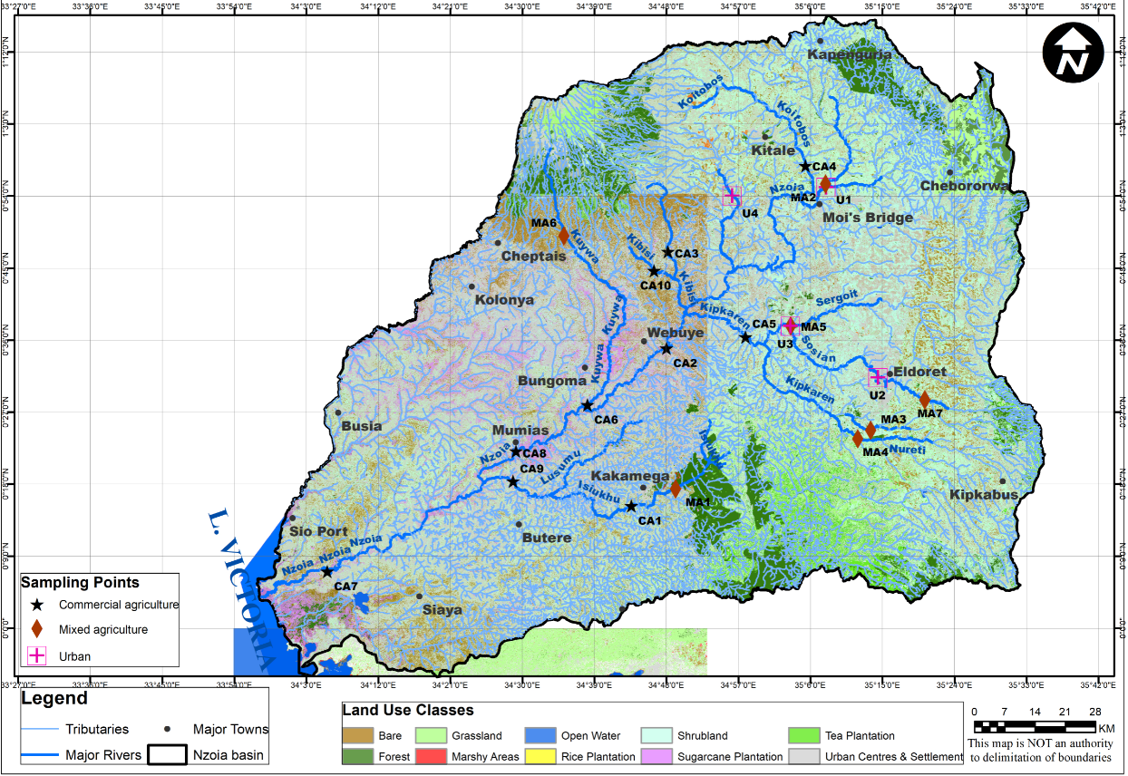

(c)
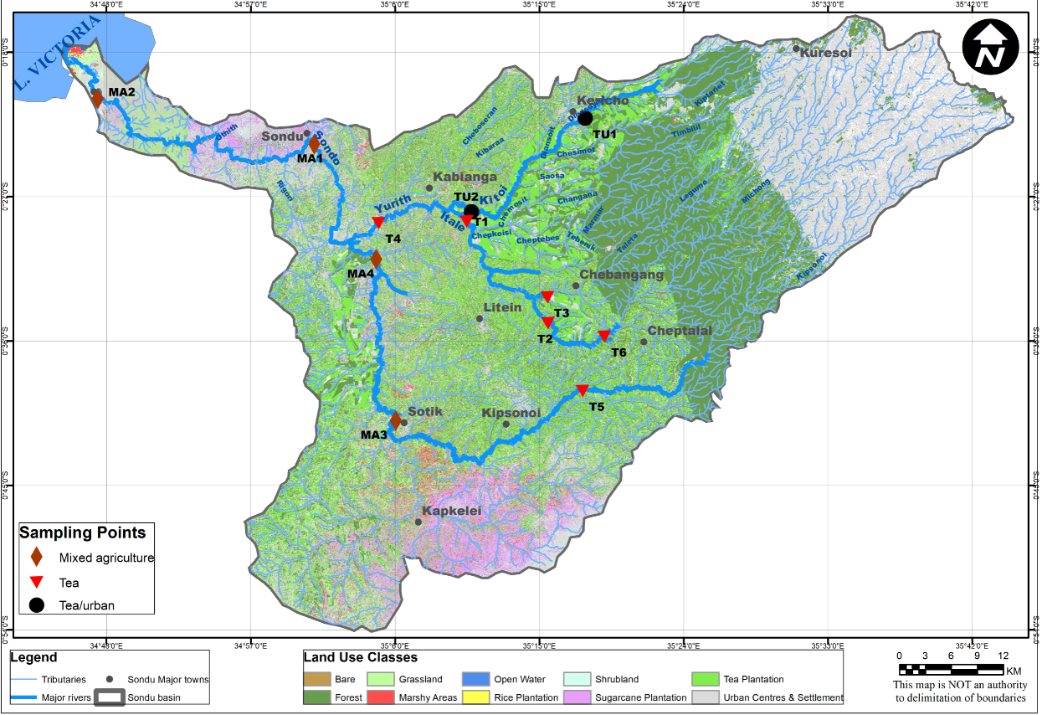
Supplementary Figure 1. Land use maps of Nyando (a), Nzoia (b), and Sondu Miriu (c) river catchments of Lake Victoria basin, Kenya.
Spatial sampling stations are indicated by bullets and labelled using land use cluster IDs: Nyando: MA1‒MA5: mixed agriculture, RI1‒RI7: residential and industrial, S1- S8: sugarcane, TF1‒TF3: tea and forest; Nzoia: CA1‒CA10: commercial agriculture, MA1‒MA7: mixed agriculture, U1‒U4: urban; Sondu Miriu: MA1‒MA4: mixed agriculture, T1‒T6: tea, TU1‒TU2: tea and urban.
Supplementary Table 1. Physicochemical data of the spatial sampling stations in the Nyando catchment during the start wet (SW), peak wet (PW), end wet (EW) and the dry (D) seasons

Start wet season
Land use | Station ID | Na⁺  (mgL⁻¹) | K⁺  (mgL-1) | Ca²⁺ (mgL⁻¹) | Mg²⁺ (mgL⁻¹) | Cl‒(mgL⁻¹) | NO₃‒  (mgL⁻¹) | SO₄²⁻ (mgL⁻¹) | pH | EC  (µS cm⁻¹) | Temp (°C) | DO  (mg O₂ L⁻¹) | δ¹⁵N  (‰) | δ¹⁸O  (‰)
Sugarcane | S1 | 15.6 | 5.3 | 9.6 | 14.4 | 2.9 | 0.8 | 0.4 | 8.2 | 304 | 25.7 | 5.8 | 8.9 | 6.5
 | S2 | 17.2 | 5.3 | 12.3 | 8.0 | 2.8 | 0.4 | 0.4 | 8.2 | 280 | 22.4 | 5.4 | 9.0 | 9.1
 | S3 | 16.0 | 5.5 | 9.8 | 11.9 | 1.4 | 0.6 | 0.3 | 8.4 | 320 | 22.7 | 6.2 | 8.8 | 5.5
 | S4 | 15.4 | 5.4 | 8.3 | 12.7 | 1.8 | 1.0 | 0.4 | 8.5 | 328 | 23.0 | 5.8 | 9.4 | 5.9
 | S5 | 19.2 | 9.0 | 13.4 | 8.0 | 2.9 | 0.9 | 0.4 | 8.0 | 334 | 20.8 | 5.7 | 7.3 | 7.1
 | S6 | 13.5 | 4.8 | 6.8 | 10.1 | 3.1 | 1.8 | 0.7 | 8.5 | 288 | 20.5 | 3.2 | 9.6 | 6.2
 | S7 | 17.0 | 8.0 | 13.1 | 14.4 | 1.4 | 0.4 | 0.5 | 8.4 | 403 | 26.5 | 6.1 | 9.6 | 5.5
Tea & Forest | TF1 | 7.6 | 3.6 | 9.6 | 8.2 | 2.0 | 2.9 | 1.3 | 8.2 | 194 | 16.6 | 4.5 | 8.8 | 4.8
 | TF2 | 7.6 | 4.3 | 10.7 | 9.1 | 2.0 | 2.1 | 0.6 | 8.1 | 206 | 18.0 | 5.0 | 6.4 | 4.7
 | TF3 | 7.3 | 4.0 | 10.6 | 7.9 | 2.2 | 2.5 | 1.1 | 7.8 | 188 | 20.8 | 4.3 | 9.0 | 5.0
Mixed agriculture | MA1 | 14.9 | 6.4 | 6.3 | 1.5 | 6.0 | 6.1 | 3.0 | 5.1 | 114 | 18.4 | 6.0 | 8.9 | 3.4
 | MA2 | 16.1 | 7.0 | 5.8 | 1.6 | 6.6 | 4.4 | 3.1 | 6.0 | 124 | 18.7 | 5.6 | 8.9 | 2.3
 | MA3 | 21.3 | 7.2 | 9.2 | 6.4 | 3.1 | - | 1.6 | 5.8 | 221 | 18.9 | 6.0 | 13.9 | 17.0
 | MA4 | 36.6 | 10.5 | 7.3 | 2.5 | 4.2 | 0.6 | 1.8 | 6.1 | 254 | 24.0 | 6.2 | 9.4 | 1.0
 | MA5 | 15.9 | 11.4 | 9.0 | 1.9 | 4.4 | 8.5 | 2.7 | 7.5 | 168 | 22.9 | 5.3 | 5.3 | 9.1
Residential & Industrial | RI1 | 47.2 | 9.9 | 8.5 | 9.7 | 4.3 | 1.1 | 1.1 | 8.4 | 434 | 25.4 | 5.7 | 11.8 | 6.0
 | RI2 | 30.8 | 8.4 | 9.6 | 7.3 | 3.7 | 1.0 | 1.2 | 8.4 | 321 | 27.6 | 4.8 | 8.2 | 3.4
 | RI3 | 15.7 | 12.9 | 12.7 | 5.3 | 3.5 | 3.2 | 3.2 | 7.8 | 240 | 25.3 | 4.4 | 8.2 | 8.6
 | RI4 | 28.3 | 19.8 | 14.8 | 7.7 | 3.9 | 1.9 | 1.4 | 7.8 | 476 | 27.9 | 5.3 | 9.1 | 4.5
 | RI5 | 30.3 | 13.4 | 11.2 | 10.3 | 4.3 | 0.9 | 1.2 | 7.8 | 356 | 26.7 | 4.9 | 7.8 | 0.2
 | RI6 | 21.2 | 16.6 | 12.5 | 6.4 | 4.7 | 2.8 | 2.7 | 8.0 | 299 | 27.3 | 5.7 | 9.2 | 4.4
 | RI7 | 20.4 | 16.0 | 13.0 | 6.3 | 3.9 | 2.3 | 2.0 | 7.7 | 292 | 28.8 | 4.8 | 9.3 | 4.4

Supplementary Table 1 (cont.)
Peak wet season
Land use | Station ID | Na⁺  (mgL⁻¹) | K⁺  (mgL-1) | Ca²⁺ (mgL⁻¹) | Mg²⁺ (mgL⁻¹) | Cl‒  (mgL-1) | NO₃‒ (mgL⁻¹) | SO₄²⁻ (mgL⁻¹) | pH | EC  (µS cm⁻¹) | Temp (°C) | DO  (mg O₂ L⁻¹) | δ¹⁵N  (‰) | δ¹⁸O  (‰)
Sugarcane | S1 | 9.5 | 2.6 | 10.8 | 8.6 | 3.0 | 2.4 | 0.9 | 7.9 | 231 | 21.0 | 7.3 | 7.4 | 7.9
 | S2 | 15.6 | 3.5 | 7.6 | 6.4 | 2.9 | 3.4 | 0.8 | 8.1 | 272 | 20.9 | 7.7 | 10.0 | 8.4
 | S3 | 16.0 | 4.6 | 8.6 | 7.4 | 3.3 | 3.1 | 1.3 | 8.3 | 280 | 21.4 | 7.5 | 8.8 | 6.8
 | S4 | 16.1 | 4.7 | 7.6 | 7.5 | 2.6 | 2.6 | 1.1 | 8.4 | 280 | 21.8 | 7.5 | 9.1 | 6.2
 | S5 | 17.6 | 3.8 | 7.1 | 6.9 | 2.4 | 1.6 | 0.4 | 8.1 | 299 | 21.7 | 7.4 | 10.0 | 9.0
 | S6 | 14.8 | 4.4 | 11.0 | 5.7 | 3.9 | 3.5 | 1.9 | 8.3 | 236 | 18.9 | 7.8 | 9.2 | 8.8
 | S7 | 11.2 | 4.5 | 13.6 | 9.7 | 2.7 | 2.5 | 1.5 | 8.4 | 323 | 21.9 | 7.2 | 10.2 | 12.5
Tea & Forest | TF1 | 7.3 | 1.5 | 10.2 | 5.4 | 3.2 | 3.3 | 1.5 | 7.8 | 147 | 16.1 | 7.7 | 7.4 | 8.6
 | TF2 | 6.5 | 2.4 | 9.5 | 5.1 | 1.7 | 2.5 | 0.6 | 7.8 | 137 | 16.6 | 7.7 | 5.1 | 8.6
 | TF3 | 5.9 | 2.3 | 9.0 | 5.6 | 2.7 | 3.8 | 1.6 | 7.8 | 148. | 19.6 | 7.2 | 6.4 | 5.0
Mixed agriculture | MA1 | 17.3 | 5.4 | 7.5 | 1.6 | 5.4 | 7.6 | 2.4 | 7.3 | 146 | 15.2 | 7.3 | 9.6 | 11.5
 | MA2 | 16.9 | 5.9 | 6.3 | 2.4 | 9.3 | 6.4 | 3.9 | 7.2 | 149 | 15.8 | 7.0 | 9.5 | 9.4
 | MA3 | 18.9 | 5.5 | 6.8 | 2.9 | 4.6 | 5.6 | 1.3 | 7.4 | 168 | 19.4 | 6.7 | 14.0 | 19.6
 | MA4 | 19.5 | 6.8 | 8.6 | 1.8 | 8.2 | 4.0 | 4.4 | 7.8 | 180 | 18.8 | 7.4 | 8.8 | 10.3
 | MA5 | 11.9 | 6.6 | 9.0 | 3.0 | 5.9 | 2.3 | 2.9 | 7.8 | 153 | 16.5 | 7.6 | 11.8 | 9.1
Residential & Industrial | RI1 | 25.5 | 5.9 | 11.3 | 4.7 | 4.5 | 1.7 | 1.2 | 8.2 | 271 | 20.3 | 7.5 | 10.3 | 10.7
 | RI2 | 21.7 | 5.9 | 10.8 | 3.4 | 6.2 | 3.3 | 2.3 | 8.2 | 216 | 22.5 | 7.3 | 8.9 | 9.1
 | RI3 | 14.3 | 4.8 | 10.8 | 2.9 | 4.1 | 1.4 | 2.0 | 7.6 | 162 | 21.9 | 6.8 | 6.3 | 12.0
 | RI4 | 21.5 | 8.5 | 11.7 | 4.0 | 7.0 | 3.6 | 3.1 | 7.9 | 241 | 22.7 | 6.7 | 9.3 | 10.5
 | RI5 | 16.2 | 6.6 | 13.5 | 4.1 | 5.0 | 1.5 | 2.0 | 7.8 | 215 | 20.3 | 7.9 | 8.0 | 8.4
 | RI6 | 16.3 | 6.1 | 11.0 | 3.8 | 4.4 | 2.8 | 2.2 | 8.0 | 213 | 22.6 | 7.0 | 9.2 | 11.4
 | RI7 | 17.0 | 6.1 | 11.8 | 3.8 | 5.0 | 1.9 | 2.0 | 7.9 | 216 | 23.0 | 6.9 | 8.6 | 10.6

Supplementary Table 1 (cont.)
End wet Season
Land use | Station ID | Na⁺  (mgL⁻¹) | K⁺  (mgL-1) | Ca²⁺ (mgL⁻¹) | Mg²⁺ (mgL⁻¹) | Cl‒(mgL⁻¹) | NO₃‒ (mgL⁻¹) | SO₄²⁻ (mgL⁻¹) | pH | EC  (µS cm⁻¹) | Temp (°C) | DO  (mg O₂ L⁻¹) | δ¹⁵N  (‰) | δ¹⁸O  (‰)
Sugarcane | S1 | 10.0 | 3.6 | 18.1 | 9.6 | 1.0 | 0.3 | 0.2 | 8.3 | 259 | 24.9 | 7.2 | 7.9 | 12.7
 | S2 | 14.2 | 3.7 | 10.6 | 5.9 | 1.6 | 1.3 | 0.3 | 8.2 | 253 | 20.5 | 7.9 | 8.6 | 9.6
 | S3 | 14.6 | 4.7 | 12.4 | 6.2 | 4.1 | 2.7 | 1.7 | 8.4 | 242 | 20.5 | 7.8 | 6.1 | 9.0
 | S4 | 14.2 | 4.6 | 12.4 | 6.1 | 3.6 | 2.4 | 1.5 | 8.2 | 242 | 20.7 | 7.8 | 8.1 | 8.7
 | S5 | 16.6 | 4.4 | 15.0 | 7.3 | 3.7 | 2.3 | 1.0 | 8.2 | 300 | 20.3 | 8.2 | 7.6 | 6.2
 | S6 | 13.5 | 4.5 | 13.6 | 4.8 | 4.0 | 2.7 | 1.7 | 8.4 | 205 | 18.6 | 7.8 | 9.1 | 8.5
 | S7 | 10.2 | 5.4 | 21.9 | 9.6 | 2.4 | 1.2 | 1.4 | 8.3 | 304 | 22.5 | 7.1 | 10.5 | 8.0
Tea & Forest | TF1 | 5.6 | 2.4 | 11.6 | 5.6 | 1.4 | 1.9 | 1.0 | 7.9 | 137 | 16.2 | 7.7 | 5.4 | 4.1
 | TF2 | 6.0 | 3.0 | 10.8 | 4.9 | 2.2 | 2.9 | 1.2 | 7.6 | 134 | 15.8 | 7.8 | 3.8 | 3.4
 | TF3 | 5.8 | 2.5 | 13.3 | 5.9 | 2.2 | 2.5 | 1.9 | 8.1 | 153 | 18.2 | 7.5 | 7.0 | 6.6
Mixed agriculture | MA1 | 16.5 | 11.3 | 5.9 | 1.4 | 6.9 | 10.4 | 4.1 | 7.5 | 143 | 15.3 | 7.0 | 8.1 | 5.1
 | MA2 | 17.2 | 11.0 | 8.3 | 1.9 | 8.9 | 5.6 | 4.6 | 7.5 | 167 | 14.6 | 6.8 | 9.8 | 11.8
 | MA3 | 15.9 | 6.5 | 12.2 | 4.9 | 4.3 | 11.6 | 1.7 | 7.5 | 196 | 16.7 | 7.0 | 9.0 | 11.1
 | MA4 | 25.3 | 8.6 | 9.6 | 2.5 | 5.3 | 3.1 | 3.0 | 8.3 | 225 | 18.2 | 7.4 | 6.8 | 2.4
 | MA5 | 14.5 | 7.2 | 9.7 | 2.4 | 2.6 | 1.0 | 0.7 | 7.7 | 183 | 16.2 | 7.1 | 7.3 | -1.1
Residential & Industrial | RI1 | 20.2 | 7.0 | 12.4 | 4.3 | 5.1 | 3.8 | 2.6 | 8.3 | 232 | 19.6 | 7.5 | 8.4 | 6.9
 | RI2 | 19.0 | 6.6 | 15.5 | 4.2 | 5.8 | 3.4 | 3.1 | 8.4 | 218 | 22.4 | 7.3 | 9.4 | 8.8
 | RI3 | 17.3 | 10.7 | 12.7 | 5.3 | 5.1 | 1.8 | 2.7 | 7.8 | 247 | 22.5 | 6.7 | 7.5 | 5.8
 | RI4 | 21.3 | 17.5 | 18.1 | 5.5 | 6.2 | 2.6 | 2.9 | 8.0 | 287 | 23.4 | 4.1 | 8.6 | 8.1
 | RI5 | 19.1 | 10.1 | 14.9 | 5.0 | 5.1 | 3.4 | 2.5 | 7.9 | 259 | 21.4 | 7.4 | 9.0 | 3.1
 | RI6 | 18.9 | 9.1 | 17.2 | 5.1 | 2.9 | 1.1 | 1.6 | 8.0 | 248 | 23.0 | 6.6 | 7.1 | 4.5
 | RI7 | 17.8 | 9.8 | 13.8 | 5.4 | 3.8 | 2.0 | 1.5 | 8.0 | 258 | 23.6 | 6.6 | 8.8 | 6.3

Supplementary Table 1 (cont.)
Dry season (December 2016)
Land use | Station ID | Na⁺  (mgL⁻¹) | K⁺  (mgL-1) | Ca²⁺ (mgL⁻¹) | Mg²⁺ (mgL⁻¹) | Cl‒(mgL⁻¹) | NO₃‒ (mgL⁻¹) | SO₄²⁻ (mgL⁻¹) | pH | EC  (µS cm⁻¹) | Temp (°C) | DO  (mg O₂ L⁻¹) | δ¹⁵N  (‰) | δ¹⁸O  (‰)
Sugarcane | S1 | 12.9 | 4.1 | 14.2 | 13.2 | 2.7 | 0.6 | 0.6 | 8.1 | 330 | 22.1 | 7.8 | 9.8 | 3.8
 | S2 | 15.5 | 4.2 | 13.7 | 7.1 | 2.3 | 1.5 | 0.4 | 8.3 | 274 | 20.7 | 8.0 | 8.6 | 9.7
 | S3 | 16.6 | 4.9 | 16.4 | 10.4 | 3.3 | 1.4 | 0.8 | 8.6 | 323 | 21.3 | 8.1 | 10.4 | 10.2
 | S4 | 17.0 | 5.2 | 11.2 | 11.0 | 3.5 | 1.4 | 0.9 | 8.5 | 333 | 23.0 | 7.4 | 8.5 | 7.6
 | S5 | 16.8 | 5.2 | 17.6 | 8.1 | 3.1 | 1.2 | 0.4 | 8.4 | 329 | 22.9 | 7.1 | 9.4 | 2.8
 | S6 | 15.7 | 4.8 | 11.3 | 8.4 | 3.9 | 1.9 | 1.1 | 8.5 | 285 | 19.0 | 7.7 | 8.6 | 9.7
 | S7 | 15.3 | 7.2 | 18.5 | 14.0 | 2.5 | 1.4 | 1.0 | 8.5 | 424 | 23.4 | 7.3 | 11.8 | 15.6
Tea & Forest | TF1 | 6.9 | 2.5 | 9.4 | 7.6 | 1.5 | 1.9 | 1.5 | 8.1 | 193 | 15.2 | 7.7 | 6.6 | 5.7
 | TF2 | 6.8 | 2.8 | 9.2 | 7.7 | 1.7 | 1.5 | 1.2 | 8.1 | 187 | 15.5 | 7.8 | 7.2 | 10.6
 | TF3 | 6.6 | 2.6 | 10.3 | 7.5 | 1.5 | 1.6 | 1.3 | 7.9 | 186 | 17.9 | 7.3 | 8.9 | 12.0
Mixed agriculture | MA1 | 15.8 | 6.3 | 5.9 | 1.4 | 7.1 | 8.1 | 4.0 | 7.5 | 141 | 15.4 | 7.1 | 8.6 | 11.0
 | MA2 | 16.4 | 7.0 | 6.6 | 1.6 | 7.3 | 7.0 | 3.3 | 7.7 | 152 | 15.5 | 7.2 | 8.8 | 10.2
 | MA3 | 20.9 | 5.9 | 11.1 | 5.7 | 4.6 | - | 4.7 | 7.1 | 235 | 18.1 | 5.1 | 9.5 | 16.6
 | MA4 | 33.6 | 10.7 | 8.1 | 2.6 | 9.3 | 2.4 | 5.1 | 8.6 | 266 | 22.1 | 6.9 | 12.4 | 11.7
 | MA5 | 23.1 | 11.3 | 14.3 | 4.0 | 5.1 | 1.0 | 2.3 | 8.0 | 299 | 20.7 | 7.1 | 4.8 | -4.5
Residential & Industrial | RI1 | 35.7 | 11.6 | 16.4 | 9.4 | 6.0 | 1.0 | 1.7 | 8.4 | 424 | 21.4 | 6.7 | 10.9 | 9.3
 | RI2 | 32.6 | 9.4 | 13.6 | 8.4 | 5.3 | 0.4 | 1.9 | 8.6 | 376 | 25.4 | 7.6 | 12.1 | 8.9
 | RI3 | 26.1 | 19.8 | 19.7 | 10.1 | 5.8 | 0.2 | 1.9 | 8.3 | 400 | 22.6 | 7.7 | 8.3 | 1.6
 | RI4 | 35.2 | 69.4 | 26.2 | 12.7 | 12.3 | 0.1 | 2.7 | 8.1 | 621 | 27.0 | 0.1 | 8.2 | 12.5
 | RI5 | 24.7 | 20.4 | 18.5 | 9.8 | 5.6 | 0.5 | 1.4 | 8.3 | 389 | 23.2 | 6.8 | 15.1 | 7.2
 | RI6 | 26.6 | 20.2 | 18.0 | 9.2 | 5.9 | 0.3 | 2.3 | 8.3 | 399 | 26.0 | 5.6 | 11.1 | 4.8
 | RI7 | 26.8 | 20.2 | 18.6 | 9.6 | 6.4 | 0.2 | 2.3 | 7.9 | 412 | 25.7 | 3.5 | 8.6 | 1.4

Supplementary Table 2. Physicochemical data of the spatial sampling stations in the Sondu Miriu River catchment during the start wet (SW), peak wet (PW), end wet (EW) and the dry (D) seasons
Start wet season
Land use | Station ID | Na⁺  (mgL⁻¹) | K⁺  (mgL-1) | Ca²⁺ (mgL⁻¹) | Mg²⁺ (mgL⁻¹) | Cl‒(mgL⁻¹) | NO₃‒ (mgL⁻¹) | SO₄^{2‒} (mgL⁻¹) | pH | EC  (µS cm⁻¹ | Temp (°C) | DO  (mg O₂ L⁻¹) | δ¹⁵N  (‰) | δ¹⁸O  (‰)
Tea | T1 | 4.8 | 3.9 | 3.4 | 0.9 | 1.9 | 2.1 | 1.0 | 7.5 | 52 | 21 | 7 | 7.6 | 6.1
 | T2 | 5.2 | 4.1 | 3.3 | 1.0 | 2.1 | 2.3 | 1.2 | 7.5 | 59 | 20 | 7 | 6.4 | 6.4
 | T3 | 2.8 | 3.2 | 2.4 | 0.7 | 1.5 | 1.6 | 0.7 | 7.6 | 38 | 21 | 7 | 5.3 | 4.7
 | T4 | 9.3 | 3.6 | 2.9 | 1.1 | 2.4 | 3.3 | 1.4 | 7.5 | 57 | 24 | 5 | 8.4 | 6.0
 | T5 | 8.0 | 4.6 | 4.2 | 1.1 | 2.4 | 1.5 | 1.1 | 7.2 | 66 | 17 | 7 | 8.7 | 3.6
 | T6 | 5.8 | 4.3 | 4.8 | 1.1 | 2.0 | 1.7 | 1.1 | 7.0 | 59 | 19 | 6 | 6.4 | 2.9
Tea & Urban | TU1 | 9.2 | 3.2 | 3.6 | 0.8 | 1.8 | 3.8 | 0.7 | 7.2 | 67 | 19 | 6 | 7.7 | 5.9
 | TU2 | 5.5 | 3.7 | 3.6 | 0.8 | 2.7 | 6.8 | 1.5 | 7.0 | 60 | 22 | 7 | 9.6 | 7.8
Mixed agriculture | MA1 | 7.9 | 4.3 | 4.8 | 1.5 | 3.5 | 4.3 | 2.0 | 7.8 | 82 | 26 | 5 | 8.7 | 5.5
 | MA2 | 8.7 | 4.6 | 6.1 | 1.6 | 3.7 | 4.3 | 2.2 | 7.2 | 92 | 27 | 5 | 9.0 | 6.4
 | MA3 | 10.2 | 6.3 | 5.6 | 1.4 | 4.3 | 3.7 | 2.6 | 7.4 | 103 | 24 | 5 | 9.6 | 8.3
 | MA4 | 9.4 | 5.2 | 6.2 | 1.6 | 4.4 | 5.6 | 2.6 | 7.8 | 100 | 24 | 4 | 9.1 | 5.1

Supplementary Table 2 (cont.)
Peak wet season
Land use | Station ID | Na⁺  (mgL⁻¹) | K⁺  (mgL-1) | Ca²⁺ (mgL⁻¹) | Mg²⁺ (mgL⁻¹) | Cl‒(mgL⁻¹) | NO₃‒ (mgL⁻¹) | SO₄^{2‒} (mgL⁻¹) | pH | EC  (µS cm⁻¹ | Temp (°C) | DO  (mg O₂ L⁻¹) | δ¹⁵N  (‰) | δ¹⁸O  (‰)
Tea | T1 | 4.1 | 1.9 | 1.8 | BDL | 1.7 | 2.5 | 0.5 | 7.0 | 39.7 | 15.8 | 8.2 | 5.5 | 5.9
 | T2 | 4.6 | 2.2 | 2.0 | BDL | 2.1 | 2.9 | 0.7 | 7.2 | 43.3 | 15.7 | 8.1 | 6.8 | 6.8
 | T3 | 3.4 | 1.6 | 2.4 | BDL | 2.0 | 2.4 | 0.7 | 7.0 | 30.1 | 15.4 | 8.3 | 6.1 | 7.6
 | T4 | 4.6 | 1.9 | 2.0 | BDL | 2.2 | 3.0 | 0.6 | 7.2 | 43.0 | 18.4 | 8.1 | 4.7 | 5.4
 | T5 | 4.8 | 2.2 | 2.4 | BDL | 2.2 | 2.8 | 0.7 | 7.2 | 45 | 17.7 | 8.1 | 6.7 | 7.4
 | T6 | 3.6 | 1.6 | 1.8 | BDL | 1.8 | 2.6 | 0.5 | 7.0 | 33 | 14.9 | 8.2 | 4.9 | 5.4
Tea & Urban | TU.1 | 5.3 | 2.2 | 2.5 | BDL | 2.3 | 5.2 | 0.5 | 6.7 | 52.1 | 16.1 | 7.3 | 6.8 | 11.6
 | TU.2 | 5.0 | 2.1 | 2.4 | BDL | 3.4 | 8.0 | 0.8 | 6.9 | 46.6 | 16.5 | 7.9 | 6.4 | 10.1
Mixed agriculture | MA.1 | 5.4 | 2.2 | 2.2 | BDL | 2.6 | 3.6 | 0.8 | 6.9 | 51.9 | 19.9 | 7.7 | 6.9 | 10.9
 | MA.2 | 6.2 | 2.2 | 2.9 | BDL | 2.8 | 3.6 | 0.9 | 7.0 | 57.5 | 21.9 | 7.3 | 9.1 | 13.7
 | MA.3 | 6.4 | 2.9 | 2.7 | BDL | 3.3 | 3.5 | 1.1 | 7.1 | 60.1 | 17.8 | 7.7 | 9.1 | 6.7
 | MA.4 | 7.6 | 2.8 | 3.5 | BDL | 3.0 | 3.3 | 1.0 | 7.5 | 71.1 | 19.5 | 7.9 | 7.7 | 7.0

Supplementary Table 2 (cont.)
End wet season
Land use | Station ID | Na⁺  (mgL⁻¹) | K⁺  (mgL-1) | Ca²⁺ (mgL⁻¹) | Mg²⁺ (mgL⁻¹) | Cl‒(mgL⁻¹) | NO₃‒ (mgL⁻¹) | SO₄^{2‒} (mgL⁻¹) | pH | EC  (µS cm⁻¹ | Temp (°C) | DO  (mg O₂ L⁻¹) | δ¹⁵N  (‰) | δ¹⁸O  (‰)
Tea | T1 | 3.6 | 2.5 | 2.1 | BDL | 2.2 | 3.2 | 1.2 | 6.9 | 37.5 | 18.7 | 7.6 | 6.1 | 7.7
 | T2 | 4.1 | 2.7 | 2.3 | BDL | 2.0 | 2.7 | 1.0 | 6.9 | 41.5 | 16.9 | 7.8 | 6.3 | 6.3
 | T3 | 2.8 | 1.9 | 2.1 | BDL | 2.0 | 2.6 | 1.0 | 6.6 | 29.9 | 17.9 | 7.6 | 2.8 | 2.2
 | T4 | 4.2 | 2.4 | 2.6 | BDL | 2.3 | 3.9 | 1.2 | 7.5 | 42.8 | 18.8 | 8.1 | 7.1 | 8.6
 | T5 | 4.1 | 2.7 | 2.3 | BDL | 2.3 | 2.7 | 1.5 | 6.8 | 39.0 | 18.1 | 7.6 | 5.9 | 5.1
 | T6 | 4.4 | 2.8 | 2.7 | BDL | 2.3 | 4.1 | 1.4 | 6.7 | 44.6 | 17.8 | 7.6 | 7.3 | 9.4
Tea & Urban | TU1 | 4.7 | 2.6 | 3.1 | BDL | 2.4 | 6.1 | 1.0 | 7.0 | 51.2 | 16.6 | 7.4 | 8.5 | 10.8
 | TU2 | 4.1 | 2.5 | 2.9 | BDL | 2.6 | 6.1 | 1.2 | 6.8 | 45.6 | 18.1 | 7.6 | 8.1 | 9.5
Mixed agriculture | MA1 | 4.6 | 2.9 | 2.7 | BDL | 2.6 | 3.6 | 1.0 | 7.9 | 47.4 | 21.1 | 8.0 | 7.6 | 8.5
 | MA2 | 5.2 | 2.9 | 3.3 | 0.8 | 2.7 | 3.8 | 1.4 | 7.2 | 52.4 | 22.0 | 7.5 | 7.2 | 5.4
 | MA3 | 4.8 | 3.6 | 3.1 | BDL | 2.3 | 2.3 | 1.3 | 7.0 | 50.3 | 19.7 | 7.4 | 7.7 | 7.4
 | MA4 | 6.5 | 3.5 | 4.1 | BDL | 3.5 | 4.0 | 1.7 | 8.0 | 66.6 | 22.5 | 7.6 | 7.6 | 8.2

Supplementary Table 2 (cont.)
Dry season
Land use | Station ID | Na⁺  (mgL⁻¹) | K⁺  (mgL-1) | Ca²⁺ (mgL⁻¹) | Mg²⁺ (mgL⁻¹) | Cl‒(mgL⁻¹) | NO₃‒ (mgL⁻¹) | SO₄^{2‒} (mgL⁻¹) | pH | EC  (µS cm⁻¹) | Temp (°C) | DO  (mg O₂ L⁻¹) | δ¹⁵N  (‰) | δ¹⁸O  (‰)
Tea | T1 | 4.1 | 2.6 | 2.3 | 0.6 | 1.5 | 3.0 | 0.8 | 7.0 | 45.2 | 18.1 | 8.0 | 6.6 | 8.5
 | T2 | 4.3 | 2.8 | 2.3 | 0.6 | 1.5 | 2.8 | 0.9 | 7.4 | 48.3 | 16.2 | 7.9 | 6.3 | 9.5
 | T3 | 2.7 | 2.0 | 1.8 | 0.5 | 1.1 | 2.7 | 0.6 | 7.2 | 35.3 | 15.5 | 8.2 | 5.8 | 7.8
 | T4 | 4.7 | 2.6 | 2.9 | 0.7 | 1.7 | 3.4 | 0.8 | 7.2 | 49.9 | 21.0 | 8.0 | 7.7 | 9.7
 | T5 | 4.5 | 2.9 | 2.3 | 0.6 | 1.9 | 3.8 | 1.2 | 7.1 | 49.0 | 15.3 | 8.1 | 7.5 | 9.9
 | T6 | 4.5 | 2.8 | 3.1 | 0.8 | 1.5 | 2.2 | 0.9 | 6.6 | 47.9 | 15.7 | 7.5 | 7.1 | 7.7
Tea & Urban | TU1 | 5.6 | 2.5 | 2.4 | 0.6 | 1.6 | 5.4 | 0.5 | 6.5 | 54.3 | 16.5 | 7.6 | 6.8 | 11.1
 | TU2 | 4.7 | 2.8 | 2.5 | 0.6 | 2.1 | 6.9 | 0.8 | 7.2 | 54.7 | 19.5 | 7.7 | 7.1 | 11.1
Mixed agriculture | MA1 | 5.6 | 2.9 | 3.4 | 1.0 | 1.8 | 2.7 | 0.9 | 8.1 | 63.4 | 21.4 | 8.1 | 9.0 | 8.3
 | MA2 | 10.7 | 3.2 | 4.4 | 1.2 | 3.1 | 3.3 | 1.5 | 6.8 | 94.2 | 23.3 | 6.9 | 8.3 | 9.7
 | MA3 | 7.0 | 3.8 | 6.2 | 1.2 | 4.1 | 4.1 | 3.6 | 7.2 | 66.0 | 22.0 | 7.3 | 8.3 | 6.7
 | MA4 | 7.2 | 3.7 | 5.1 | 1.4 | 2.8 | 3.5 | 1.3 | 8.0 | 84.2 | 21.9 | 8.0 | 9.0 | 8.9

Supplementary Table 3. Physicochemical data of the spatial sampling stations in the Nzoia catchment during the start wet (SW), peak wet (PW), end wet (EW) and the dry (D) seasons
Start wet season
Land use | Station ID | Na⁺  (mgL⁻¹) | K⁺  (mgL-1) | Ca²⁺ (mgL⁻¹) | Mg²⁺ (mgL⁻¹) | Cl‒(mgL⁻¹) | NO₃‒ (mgL⁻¹) | SO₄^{2‒} (mgL⁻¹) | pH | EC  (µS cm⁻¹) | Temp (°C) | DO  (mg O₂ L⁻¹) | δ¹⁵N  (‰) | δ¹⁸O  (‰)
Commercial agriculture | CA1 | 5.3 | 2.7 | 7.2 | 3.8 | 2.5 | 4.1 | 1.6 | 7.2 | 95 | 22.8 | 6.4 | 8.5 | 4.4
 | CA2 | 9.6 | 3.8 | 7.3 | 2.8 | 3.9 | 4.7 | 1.7 | 7.6 | 110 | 23.9 | 6.7 | 7.0 | 6.0
 | CA3 | 10.3 | 3.2 | 9.6 | 4.0 | 2.9 | 5.9 | 1.8 | 7.6 | 148 | 23.9 | 6.5 | 9.4 | 7.9
 | CA4 | 12.0 | 4.2 | 10.7 | 4.8 | 5.5 | 2.0 | 1.3 | 7.8 | 166 | 24.0 | 5.5 | 8.4 | 4.5
 | CA5 | 8.4 | 3.4 | 8.2 | 3.5 | 3.2 | 3.9 | 1.8 | 8.6 | 138 | 24.6 | 7.8 | 8.2 | 5.6
 | CA6 | 8.6 | 4.4 | 8.3 | 3.4 | 3.0 | 3.7 | 1.6 | 8.3 | 124 | 26.5 | 6.7 | 7.5 | 2.4
 | CA7 | 7.7 | 2.8 | 6.6 | 2.6 | 2.6 | 5.0 | 3.1 | 7.4 | 94 | 26.5 | 6.0 | 6.2 | 5.1
 | CA8 | 8.2 | 4.2 | 7.7 | 2.8 | 3.3 | 1.6 | 2.0 | 7.1 | 107 | 25.8 | 4.3 | 10.7 | 8.7
 | CA9 | 6.5 | 2.0 | 6.3 | 2.9 | 2.2 | 6.0 | 2.2 | 7.3 | 88 | 24.6 | 7.5 | 7.4 | 5.9
 | CA10 | 7.7 | 3.2 | 9.9 | 4.0 | 3.2 | 2.3 | 1.1 | 7.6 | 133 | 22.8 | 6.2 | 8.4 | 4.8
Mixed agriculture | MA1 | 5.1 | 2.8 | 6.6 | 3.1 | 1.8 | 2.3 | 0.8 | 6.9 | 86 | 22.0 | 6.4 | 5.9 | 5.2
 | MA2 | 6.8 | 3.4 | 6.5 | 2.3 | 2.9 | 2.1 | 1.1 | 7.6 | 87 | 21.8 | 6.3 | 6.0 | 3.3
 | MA3 | 30.8 | 4.0 | 3.1 | 1.1 | 4.5 | 0.4 | 0.7 | 7.4 | 160 | 16.5 | 6.0 | 6.6 | 3.5
 | MA4 | 10.0 | 4.0 | 5.4 | 1.5 | 1.8 | 0.7 | 0.2 | 7.2 | 89 | 17.0 | 6.8 | 5.6 | 0.2
 | MA5 | 14.6 | 4.2 | 6.7 | 2.0 | 3.9 | 2.0 | 1.0 | 7.4 | 116 | 22.3 | 4.6 | 8.4 | 6.3
 | MA6 | 9.6 | 3.0 | 3.3 | 1.6 | 1.7 | 1.0 | 0.6 | 7.9 | 94 | 24.5 | 5.9 | 7 | 4.3
 | MA7 | 8.1 | 4.0 | 3.3 | 1.1 | 3.1 | 2.1 | 1.0 | 7.2 | 71 | 17.0 | 6.1 | 14.2 | 13.7
Urban | U1 | 21.0 | 5.8 | 12.2 | 7.9 | 12.3 | 2.8 | 3.8 | 8.2 | 274 | 24.0 | 6.4 | 8.8 | 5.1
 | U2 | 21.8 | 8.3 | 9.9 | 2.2 | 12.9 | 0.4 | 3.5 | 7.7 | 206 | 26.6 | 3.0 | 10.7 | 5.6
 | U3 | 18.8 | 6.8 | 11.0 | 4.9 | 10.8 | 2.7 | 3.9 | 8.4 | 260 | 22.3 | 7.7 | 8.7 | 5.2
 | U4 | 13.7 | 6.4 | 11.0 | 4.6 | 7.1 | 4.9 | 4.4 | 7.8 | 185 | 22.6 | 6.1 | 10.6 | 5.6

Supplementary Table 3 (cont.)
Peak wet season
Land use | Station ID | Na⁺  (mgL⁻¹) | K⁺  (mgL-1) | Ca²⁺ (mgL⁻¹) | Mg²⁺ (mgL⁻¹) | Cl‒(mgL⁻¹) | NO₃‒ (mgL⁻¹) | SO₄^{2‒} (mgL⁻¹) | pH | EC  (µS cm⁻¹) | Temp (°C) | DO  (mg O₂ L⁻¹) | δ¹⁵N  (‰) | δ¹⁸O  (‰)
Commercial agriculture | CA1 | 5.5 | 1.2 | 4.9 | 2.9 | 2.7 | 3.0 | 0.7 | 7.2 | 84 | 20.0 | 7.6 | 8.3 | 9.7
 | CA2 | 10.6 | 2.7 | 6.3 | 2.3 | 3.8 | 1.7 | 1.0 | 7.8 | 114 | 19.8 | 8.3 | 10.1 | 12.1
 | CA3 | 9.0 | 3.0 | 10.9 | 3.7 | 2.4 | 3.7 | 0.6 | 7.6 | 113 | 20.0 | 7.3 | 9.2 | 10.7
 | CA4 | 12.6 | 3.4 | 10.1 | 3.9 | 0.2 | 0.3 | 0.0 | 7.2 | 161 | 19.2 | 6.2 | 5.5 | 14.9
 | CA5 | 10.5 | 3.0 | 4.5 | 1.3 | 4.2 | 0.7 | 0.8 | 7.9 | 89 | 19.8 | 7.7 | 11.9 | 12.2
 | CA6 | 6.9 | 2.0 | 8.1 | 2.9 | 1.3 | 0.6 | 0.3 | 7.7 | 106 | 23.0 | 7.3 | 8.6 | 12.6
 | CA7 | 9.9 | 2.5 | 5.9 | 2.5 | 4.2 | 1.4 | 1.4 | 7.4 | 112 | 21.4 | 7.1 | 8.6 | 11.7
 | CA8 | 10.5 | 2.7 | 6.5 | 2.4 | 3.5 | 0.9 | 0.8 | 7.5 | 117 | 21.3 | 7.4 | 10.8 | 11.6
 | CA9 | 11 | 2.9 | 8.2 | 3.0 | 3.2 | 1.7 | 0.9 | 7.4 | 89 | 22.5 | 7.5 | 7.4 | 11.4
 | CA10 | 7.8 | 2.3 | 6.0 | 2.6 | 2.4 | 1.3 | 0.5 | 7.5 | 109 | 20.8 | 7.4 | 8.9 | 11.9
Mixed agriculture | MA1 | 4.7 | 1.4 | 3.4 | 1.6 | 2.2 | 2.2 | 0.6 | 7.0 | 60 | 19.6 | 7.2 | 6.1 | 14.5
 | MA2 | 6.5 | 1.8 | 5.8 | 1.9 | 2.3 | 0.6 | 1.3 | 6.9 | 78 | 18.7 | 6.2 | 8.7 | 11.7
 | MA3 | 9.1 | 2.3 | 2.6 | 0.9 | 2.8 | 0.1 | 0.2 | 6.9 | 67 | 16.8 | 7.1 | 6.4 | 13.9
 | MA4 | 10.0 | 3.3 | 4.0 | 1.0 | 2.4 | 0.4 | 0.4 | 7.5 | 82 | 17.8 | 7.5 | 3.2 | 13.0
 | MA5 | 9.8 | 2.7 | 3.8 | 1.2 | 2.8 | 0.2 | 0.2 | 7.3 | 87 | 18.7 | 7.6 | 5.8 | 13.1
 | MA6 | 4.6 | 2.0 | 6.5 | 2.0 | 2.5 | 0.1 | 0.8 | 7.3 | 79 | 17.0 | 7.6 | 6.5 | 14.7
 | MA7 | 7.5 | 2.2 | 4.3 | 1.4 | 2.5 | 0.6 | 0.6 | 7.1 | 76 | 18.1 | 7.2 | 6.1 | 13.5
Urban | U1 | 20.1 | 4.0 | 10.7 | 4.9 | 2.2 | 0.4 | 0.3 | 7.7 | 222 | 18.3 | 7.4 | 6.2 | 9.1
 | U2 | 11.7 | 4.2 | 5.2 | 1.2 | 7.7 | 4.8 | 2.8 | 7.3 | 105 | 18.0 | 7.4 | 14.3 | 14.0
 | U3 | 11.8 | 3.8 | 5.3 | 1.4 | 4.8 | 2.9 | 1.1 | 7.1 | 111 | 18.7 | 7.4 | 10.3 | 3.7
 | U4 | 14.5 | 4.0 | 7.1 | 2.5 | 4.9 | 2.7 | 1.4 | 7.3 | 145.6 | 18.3 | 7.4 | 10.3 | 8.9

Supplementary Table 3 (cont.)
End wet season
Land use | Station ID | Na⁺  (mgL⁻¹) | K⁺  (mgL-1) | Ca²⁺ (mgL⁻¹) | Mg²⁺ (mgL⁻¹) | Cl‒(mgL⁻¹) | NO₃‒ (mgL⁻¹) | SO₄^{2‒} (mgL⁻¹) | pH | EC  (µS cm⁻¹) | Temp (°C) | DO  (mg O₂ L⁻¹) | δ¹⁵N  (‰) | δ¹⁸O  (‰)
Commercial agriculture | CA1 | 5.4 | 2.3 | 5.2 | 2.9 | 4.4 | 3.3 | 30.7 | 7.4 | 78 | 20.1 | 7.5 | 7.7 | 5.6
 | CA2 | 10.8 | 3.3 | 9.0 | 3.1 | 4.9 | 2.8 | 6.4 | 8.0 | 122 | 20.0 | 8.1 | 8.3 | -0.9
 | CA3 | 10.8 | 3.1 | 15.3 | 5.8 | 5.3 | 6.3 | 7.0 | 7.7 | 180 | 20.8 | 7.2 | 9.9 | 6.7
 | CA4 | 11.6 | 3.8 | 11.8 | 4.2 | 7.5 | 2.0 | 6.9 | 7.3 | 151 | 18.5 | 6.6 | 8.0 | 3.3
 | CA5 | 10.8 | 3.7 | 5.7 | 1.9 | 5.6 | 3.0 | 7.5 | 7.7 | 101 | 20.3 | 7.4 | 10.7 | 3.0
 | CA6 | 5.9 | 3.0 | 5.4 | 2.6 | 4.7 | 1.7 | 6.7 | 7.8 | 92 | 21.1 | 7.5 | 5.4 | -2.2
 | CA7 | 8.9 | 2.9 | 6.7 | 2.7 | 5.4 | 2.6 | 6.6 | 7.4 | 104 | 22.6 | 6.9 | 7.8 | 5.3
 | CA8 | 10.4 | 3.5 | 8.4 | 2.9 | 5.7 | 2.4 | 7.8 | 7.5 | 117 | 21.8 | 7.2 | 5.4 | -4.8
 | CA9 | 6.5 | 2.0 | 5.7 | 3.0 | 3.8 | 2.8 | 7.5 | 7.4 | 92 | 23.7 | 7.2 | 8.0 | 5.4
 | CA10 | 6.4 | 2.2 | 8.0 | 4.1 | 3.7 | 1.9 | 6.9 | 7.5 | 131 | 18.9 | 7.4 | 8.4 | 3.2
Mixed agriculture | MA1 | 5.6 | 1.8 | 5.0 | 2.8 | 3.3 | 2.5 | 6.9 | 7.2 | 79 | 20.3 | 7.4 | 8.4 | 3.6
 | MA2 | 7.1 | 2.3 | 6.6 | 2.4 | 4.2 | 2.6 | 9.6 | 7.1 | 95 | 17.7 | 7.2 | 6.1 | 1.6
 | MA3 | 9.7 | 2.8 | 3.0 | 1.2 | 3.2 | 0.3 | 6.9 | 7.1 | 79 | 18.1 | 7.4 | 7.6 | 2.8
 | MA4 | 9.6 | 3.6 | 3.6 | 1.2 | 4.0 | 0.5 | 5.9 | 7.8 | 83 | 18.5 | 7.6 | 9.0 | 3.6
 | MA5 | 11.3 | 3.5 | 4.9 | 1.7 | 5.1 | 0.9 | 7.9 | 7.7 | 99 | 18.9 | 7.6 | 10.7 | -6.4
 | MA6 | 3.0 | 2.0 | 5.5 | 1.8 | 2.7 | 0.8 | 7.5 | 7.8 | 62 | 14.0 | 8.3 | 4.3 | -5.4
 | MA7 | 7.0 | 3.2 | 3.1 | 0.9 | 3.9 | 1.8 | 9.5 | 6.8 | 64 | 18.4 | 7.5 | 12.1 | 8.7
Urban | U1 | 20.8 | 5.3 | 9.4 | 5.9 | 13.1 | 2.5 | 7.3 | 7.7 | 222 | 17.6 | 7.5 | 9.0 | 1.9
 | U2 | 11.9 | 5.7 | 4.6 | 1.5 | 8.5 | 4.4 | 5.9 | 8.0 | 112 | 20.2 | 7.6 | 14.5 | 2.8
 | U3 | 13.1 | 5.0 | 5.9 | 2.1 | 7.9 | 6.2 | 6.1 | 7.1 | 123 | 18.9 | 7.3 | 9.8 | -1.7
 | U4 | 12.4 | 4.9 | 12.8 | 5.0 | 7.5 | 3.6 | 6.6 | 7.5 | 184 | 18.6 | 7.3 | 11.6 | 5.2

Supplementary Table 3 (cont.)
Dry season
Land use | Station ID | Na⁺  (mgL⁻¹) | K⁺  (mgL-1) | Ca²⁺ (mgL⁻¹) | Mg²⁺ (mgL⁻¹) | Cl‒(mgL⁻¹) | NO₃‒ (mgL⁻¹) | SO₄^{2‒} (mgL⁻¹) | pH | EC  (µS cm⁻¹) | Temp (°C) | DO  (mg O₂ L⁻¹) | δ¹⁵N  (‰) | δ¹⁸O  (‰)
Commercial agriculture | CA1 | 5.7 | 1.7 | 7.6 | 4.5 | 2.0 | 3.3 | 0.5 | 7.7 | 114 | 19.4 | 7.7 | 8.2 | 11.3
 | CA2 | 11.1 | 2.9 | 9.3 | 3.9 | 3.5 | 2.8 | 0.9 | 8.2 | 147 | 21.5 | 8.2 | 10.7 | 10.6
 | CA3 | 11.6 | 3.5 | 13.5 | 6.1 | 2.8 | 3.7 | 0.7 | 8.1 | 204 | 21.2 | 8.2 | 8.6 | 10.6
 | CA4 | 11.5 | 2.7 | 11.4 | 4.9 | 2.8 | 1.6 | 0.4 | 7.8 | 170 | 18.8 | 7.1 | 8.8 | 10.0
 | CA5 | 12.2 | 3.6 | 6.7 | 2.6 | 4.2 | 4.8 | 0.9 | 8.1 | 122 | 19.5 | 8.6 | 14.0 | 9.3
 | CA6 | 7.7 | 2.9 | 9.7 | 3.9 | 2.5 | 2.5 | 0.9 | 7.7 | 128 | 22.4 | 7.6 | 7.1 | 5.5
 | CA7 | 10.0 | 2.6 | 8.0 | 4.1 | 3.1 | 2.3 | 1.1 | 7.8 | 137 | 24.7 | 6.6 | 10.2 | 6.9
 | CA8 | 10.5 | 2.9 | 9.7 | 3.9 | 3.1 | 2.1 | 0.8 | 8.0 | 142 | 22.5 | 6.0 | 11.0 | 10.0
 | CA9 | 7.9 | 1.6 | 9.2 | 4.6 | 2.2 | 2.8 | 0.7 | 7.9 | 121 | 22.0 | 7.4 | 8.8 | 10.1
 | CA10 | 7.7 | 3.1 | 10.8 | 4.7 | 2.7 | 0.9 | 0.8 | 7.8 | 157 | 20.3 | 7.4 | 9.8 | 11.9
Mixed agriculture | MA1 | 5.6 | 2.3 | 7.0 | 4.1 | 2.4 | 1.9 | 0.4 | 7.6 | 105 | 19.0 | 8.7 | 8.3 | 10.6
 | MA2 | 7.2 | 1.8 | 7.3 | 2.6 | 1.8 | 3.0 | 0.6 | 7.5 | 96 | 18.2 | 7.4 | 5.8 | 7.6
 | MA3 | 15.9 | 2.9 | 4.0 | 1.2 | 1.7 | 0.5 | 0.2 | 7.2 | 111 | 15.6 | 7.3 | 7.5 | 7.4
 | MA4 | 9.5 | 3.2 | 4.1 | 1.3 | 1.9 | 0.5 | 0.4 | 7.2 | 88 | 15.5 | 7.6 | 10.2 | 9.4
 | MA5 | 13.7 | 4.2 | 8.0 | 2.2 | 3.5 | 1.0 | 0.5 | 7.4 | 122 | 19.0 | 6.8 | 10.0 | 4.8
 | MA6 | 4.5 | 2.6 | 7.8 | 2.4 | 1.7 | 1.2 | 1.0 | 7.2 | 82 | 19.4 | 7.2 | 5.2 | 4.9
 | MA7 | 10.3 | 4.6 | 5.0 | 1.5 | 3.7 | 6.7 | 1.6 | 6.6 | 98 | 15.6 | 5.8 | 16.5 | 19.2
Urban | U1 | 17.0 | 3.2 | 11.7 | 6.6 | 6.0 | 3.5 | 2.1 | 8.0 | 240 | 19.8 | 7.6 | 7.6 | 9.1
 | U2 | 22.6 | 7.8 | 9.9 | 2.3 | 11.3 | 1.4 | 2.8 | 7.8 | 206 | 17.5 | 6.4 | 16.2 | 15.4
 | U3 | 20.9 | 9.4 | 15.0 | 4.2 | 13.2 | 9.6 | 4.8 | 8.2 | 196 | 19.0 | 7.4 | 16.0 | 6.9
 | U4 | 13.9 | 4.2 | 13.0 | 5.8 | 3.4 | 2.7 | 0.7 | 8.0 | 212 | 18.7 | 8.0 | 12.5 | 11.3

Supplementary Table 4. Nitrate and isotope results from laboratory incubations of Nyando and Sondu Miriu River bed sediments for determination of denitrification enrichment factors.
 | Time (Hours) | 0 | 4 | 8 | 24 | 30 | 48 | %Carbon
Nyando (MA4) | NO₃‒(mgL⁻¹) | 9.5 | 6.9 | 4.4 | 0.1 | - | - | 4
 | δ¹⁵N(‰) | 13.7 | 22.6 | 25.8 | - | - | -
 | δ¹⁸O(‰) | 12.1 | 19.7 | 23.6 | - | - | -
Nyando (MA5) | NO₃‒(mgL⁻¹) | 79 | 77 | 58 | 51 | 33 | 2 | 6
 | δ¹⁵N(‰) | 6.5 | 7.6 | 9.8 | 13.8 | 22.3 | -
 | δ¹⁸O(‰) | 22.9 | 23.4 | 25.3 | 30.3 | 36.6 | -
Sondu wetland (near TU1) | NO₃‒(mgL⁻¹) | 78 | 74 | 68 | 64 | 51 | - | 8
 | δ¹⁵N(‰) | 5.0 | - | 6.9 | 8.7 | 9.4 | -
 | δ¹⁸O(‰) | 23.3 | - | 23.4 | 25.2 | 26.7 | -
Sondu (MA1) | NO₃‒(mgL⁻¹) | 23.0 | 22.5 | 21.4 | 12.4 | 11.7 | 10.7 | 0.8
 | δ¹⁵N(‰) | 9.5 | 9.9 | 11.5 | 23.6 | 24.8 | 26.1
 | δ¹⁸O(‰) | 24.0 | 23.4 | 26.7 | 38.1 | 39.1 | 39.4
Sondu (TU2) | NO₃‒(mgL⁻¹) | 20.4 | 20.4 | 20.0 | 11.3 | 9.9 | 7.8 | 1
 | δ¹⁵N(‰) | 9.4 | 10.1 | 11.2 | 28.1 | 31.2 | 36.9
 | δ¹⁸O(‰) | 24.3 | 25.7 | 26.7 | 41.7 | 45.1 | 50.3

