Materials and methods
Released kinetic models:
$\frac{M_{t}}{M_{∞}}=Kt^{n}$ (Korsmeyer-Peppas)
$\frac{M_{t}}{M_{∞}}=Kt^{0.5}$ (Higuchi)
$M_{t}=M_{0}$ +Kt (Zero order)
Where, M_{t} and M∞ denote, respectively, released drug levels at time t and an infinite time; K exhibits the release rate constant and n means the release exponent that shows the drug release mechanism.

Table S1: Primer sequence used for quantitative RT-PCR gene expression
Gene | Sequence
 | Forward (5ʹ→3ʹ) | Reverse (5ʹ→3ʹ)
HPRT | CCTGGCGTCGTGATTAGTG | TCAGTCCTGTCCATAATTAGTCC
RUNX2 | GCCTTCAAGGTGGTAGCCC | CGTTACCCGCCATGACAGTA
Collagen I | AGCCAGCAGATCGAGAACAT | ACACAGGTCTCACCGGTTTC
ALP | ATGTCTGGAACCGCACTGAA | CGCCTGGTAGTTGTTGTGAGCATAG
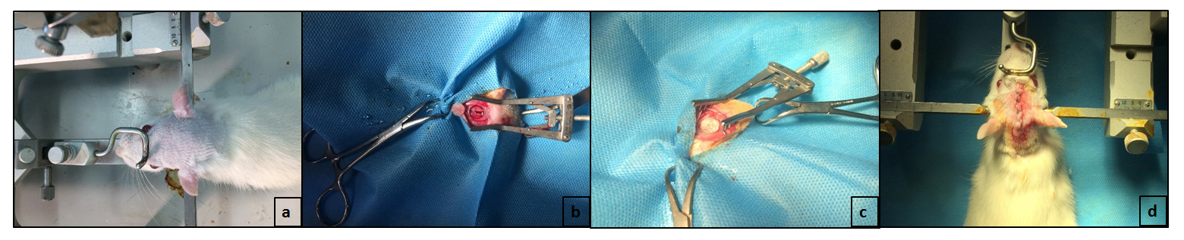

Figure S1. Implantation procedure of the scaffolds; (a) shaving and scrubbing the surgical site, (b) making a critical size defect (7 mm in diameter) by using a saline-cooled trephine drill, (c) filling the defect by prepared scaffold, (d) reclosing the periosteum and skin by suture.
Micro-CT evaluation
Due to the inhomogeneity of the generated new skull, it is difficult to calculate a relative value of new bone density when comparing with original bone. Therefore, in this study the relative density map was applied to investigate the SrR effects on new bone generation. Thus, the color map in the defect area is calculated by dividing the entire image by the mean value of skull intensity out of the defect. So, the yellow areas are over the mean skull density value and the blue ones are below this mean value (Fig. 5).

Table S2. Histopathological scoring table
New Bone Formation(NB) | Level
No evidence of new bone formation | 0
Formation of new bone up to 25% of defect area | 1
Formation of new bone 25- 50% of defect area | 2
Formation of new bone 50 - 75% of defect area | 3
Formation of new bone more than 75% of defect area | 4
Remnant Scaffold(RS) | Level
residual Scaffold more than 75% | 0
residual Scaffold 50-75% | 1
residual Scaffold 25-50% | 2
residual scaffold less than 25% | 3
No evidence of residual scaffold | 4
Type of tissue components (TC) | Level
No tissue formation (only scaffold remained) | 0
Mostly adipose tissue | 1
Mostly fibrous tissue | 2
Equal amount of fibrous and bone tissue | 3
Mostly bone tissue | 4
New Vascularization (NV) | Level
No new vessels | 1
New vascular formation at the periphery of defect | 2
New vascular formation at the center of defect | 3
New vascular formation at the center and periphery of defect | 4
Inflammatory Response (IR)
Sever inflammatory response | 1
Moderate inflammatory response | 2
Mild inflammatory response | 3
No evidence of inflammatory response | 4

Results
Table S3. modeled in vitro release kinetics
Sample | Zero order |  | First order |  | Higuchi |  | Krosmeyer-Peppas
 | K | R² | K | R² | K | R² | n | R²
Gel/HNT-SrR | 0.313 | 0.9561 | 0.0082 | 0.9979 | 6.387 | 0.9995 | 0.4179 | 0.9999

