SUPPLEMENTARY INFORMATION
SUPPLEMENTAL FIGURES
SUPPLEMENTAL TABLE LEGENDS

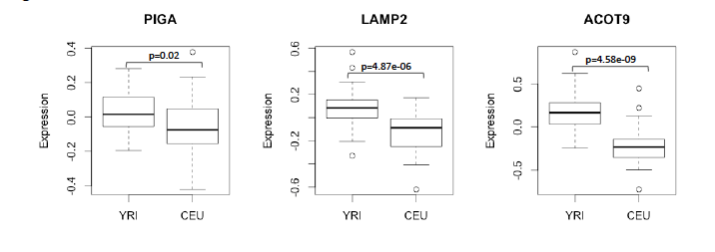

Fig. S1. Three genes with at least two CpGs showing differential modification between CEU and YRI females also show population-specific gene expression levels. P-value was calculated using the Wilcoxon rank-sum test.
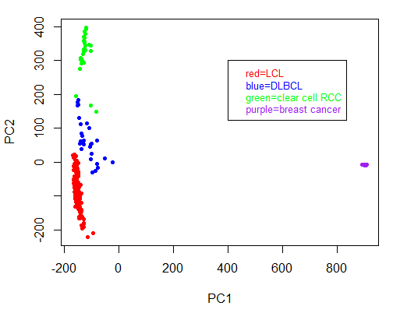

Fig. S2. Principal Component Analysis of LCLs with DLBCLs, renal cell carcinomas, and breast carcinomas. The LCLs cluster most closely with the other hematopoietic cell type, DLBCL, compared with renal and breast carcinoma samples, demonstrating the conservation of tissue-specific DNA methylation patterns.

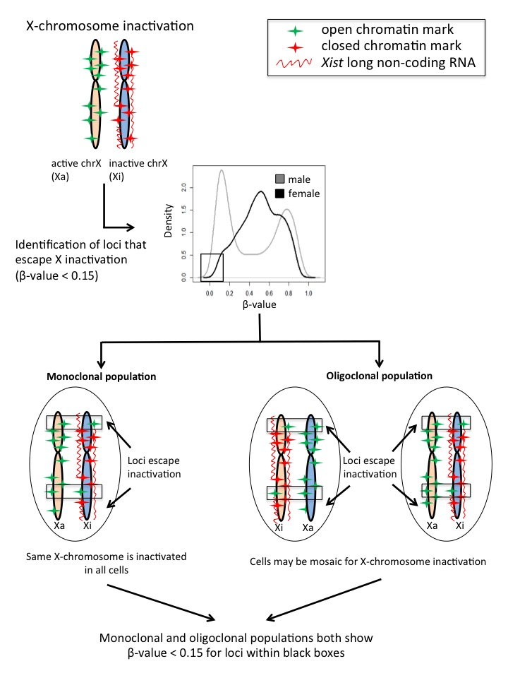

Fig. S3. Mono- and oligoclonal representation of X-chromosome inactivation. LCLs may have mosaic X-chromosome inactivation, and the decision tree used for identifying CpGs escaping methylation on the Xi does not distinguish between mono or oligoclonal inactivation.

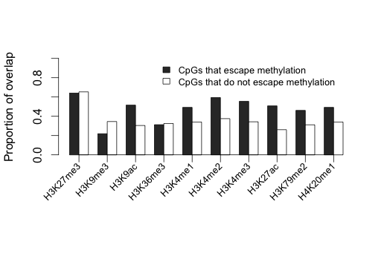

Fig. S4. CpGs that escape methylation that are located outside of TSSs co-localize with histone modifications differently than CpGs outside of TSSs that do not escape methylation. Similar to the CpGs within TSSs, these CpGs also co-localize with activating histone marks and not with repressive marks.

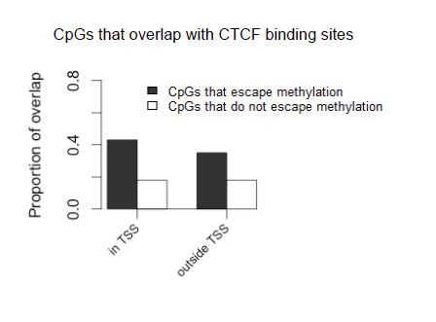

Fig. S5. CpGs that escape methylation are enriched in CTCF binding sites regardless of whether they are located within at TSS or outside a TSS compared with CpGs that are subject to methylation on the Xi.

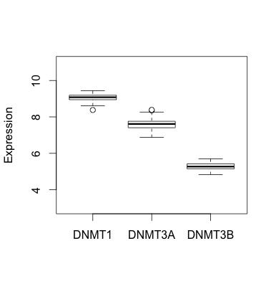

Fig. S6. Expression levels of DNMT1, DNMT3A, and DNMT3B in CEU and YRI LCLs.
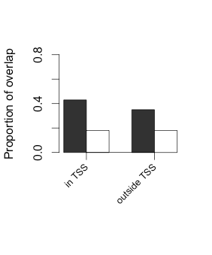

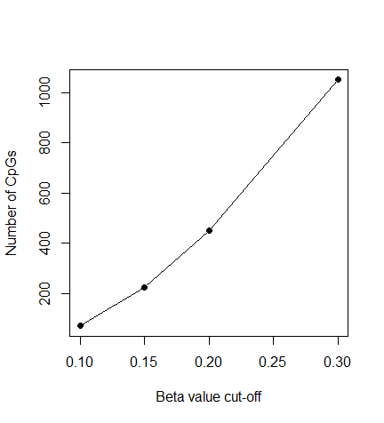
Figure S7. Plot of β-values vs. number of CpGs within each cut-off.
The number of CpGs whose averaged β-value is less than 0.1, 0.15, 0.2, and 0.3 in both males and females are plotted to show the range of cut-offs for predicting sites that escape X chromosome methylation.

Table S1. CpGs differentially modified between CEU and YRI female LCLs. A list of all CpGs detected as being differentially modified at FDR<0.01 (left) and Bonferroni p<0.05 by the Wilcoxon rank-sum test (right). Position denotes the coordinate of the CpG according to the hg19 alignment of the human reference genome.
Table S2. CpGs differentially modified between CEU and YRI male LCLs. A list of all CpGs detected as being differentially modified at FDR<0.01 (left) and Bonferroni p<0.05 by the Wilcoxon rank-sum test (right). Position denotes the coordinate of the CpG according to the hg19 alignment of the human reference genome.
Table S3. CpGs located in pseudoautosomal regions. A list of the CpG IDs and genomic coordinates (hg19) of the 13 CpGs located in pseudoautosomal regions on the X-chromosome.
Table S4. CpGs identified as escaping methylation on the Xi. Average β-values in females and males are listed for each CpG found to be <15% methylated in female and male LCLs. Genic location and CpG island information is taken from the 450K annotation file. The final four columns denote genes that were also predicted to escape inactivation on the Xi in four previous studies. The highlighted CpGs are located in genes not found in the other studies.
Table S5. X-chromosome β-values for four LCLs treated with DMSO vehicle control or JQ1. Each cell line's DMSO control and JQ1-treated β-values is listed followed by the difference between the control and the JQ1-treated values.
Table S6. List of ChIP-seq datasets obtained from ENCODE. All ChIP-seq datasets obtained from the GM12878 female LCL Tier 1 ENCODE database that were used in analyses are included in this table along with a description of their functions.
Table S7. Primer sequences and melting temperature. Primers were designed to surround a CpG included in the 450K array that was predicted to escape inactivation on the Xi in other studies but not ours. The gene name, CpG identification number, forward primer sequence, reverse primer sequence, and melting temperature for each gene is listed.

