SUPPLEMENTARY APPENDIX: ADDITIONAL TABLES AND FIGURES

Appendix 1: Sample of Analysis
Appendix 2: Descriptive Trends
Appendix 3: Analyses using Regional Authority Index (RAI)
Appendix 4: Analyses without Clustering
Appendix 5: Analyses with Contemporaneous Values

APPENDIX 1: SAMPLE OF ANALYSIS

Table A.1: Sample of analysis
Country | Elections | Parties | Period
Italy | Regional Elections | Democrazia Cristiana, Partito Comunista, Partito Socialista, Forza Italia, Partito Democratico dell Sinistra, Alleanza Nazionale (and MSI), Popolo della Libertá, Partito Democráico | 1947-2010
Spain | Autonomous Communities Elections | PSOE, PP, UCD | 1980-2010

APPENDIX 2: DESCRIPTIVE TRENDS

FIGURE A.1: Evolution of National and Regional Electoral Shares, PP, Spain
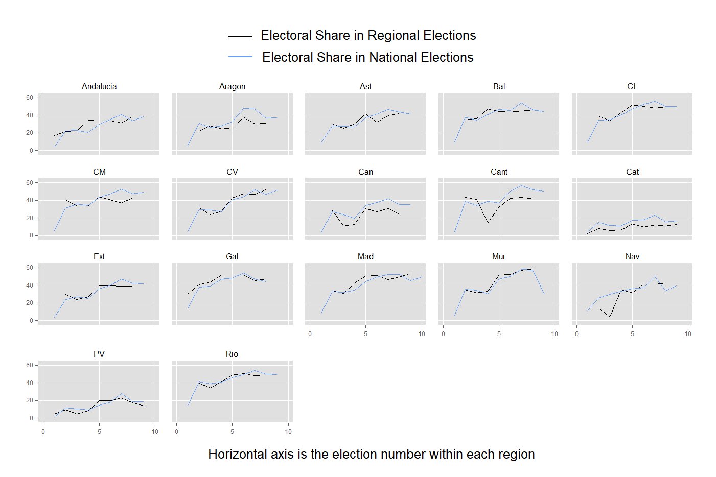

FIGURE A.2: Evolution of National and Regional Electoral Shares, PSOE, Spain
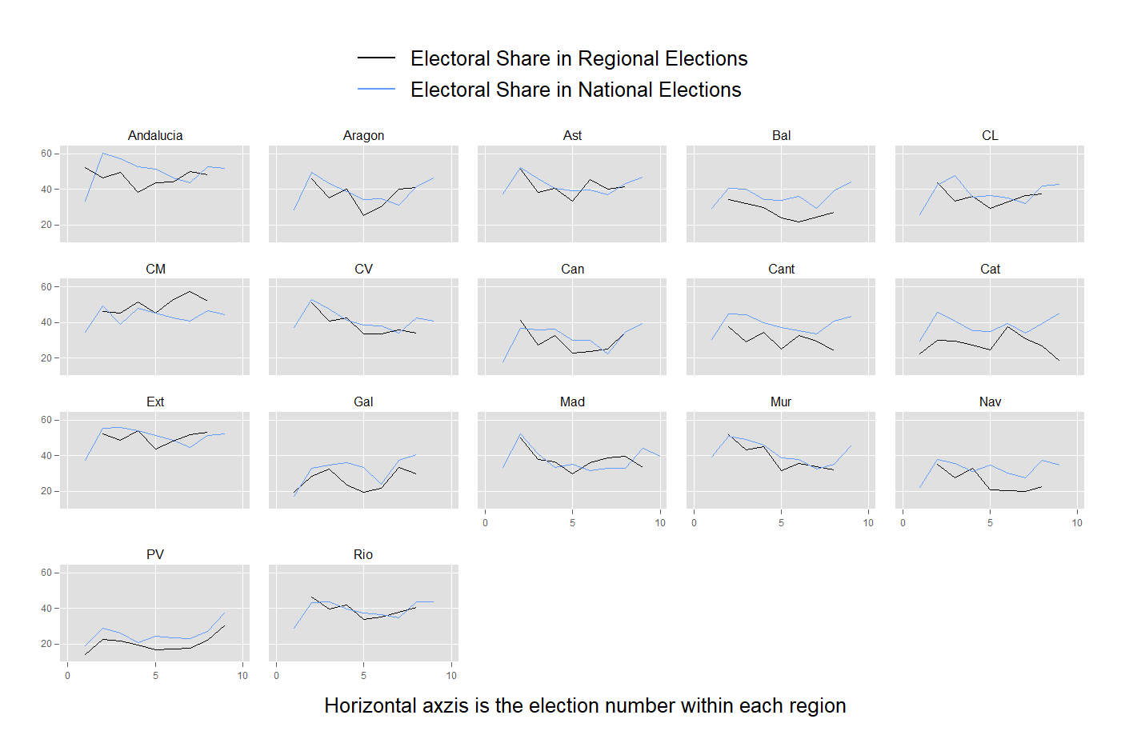

FIGURE A.3: Evolution Regional Authority Index and Self Rule Index in Spain
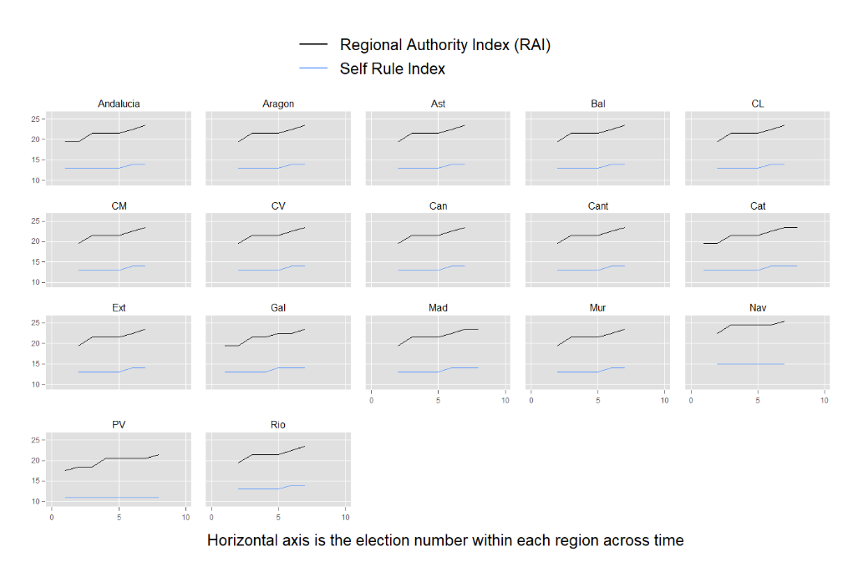

FIGURE A.4: Evolution Regional Authority Index and Self Rule Index in Italy
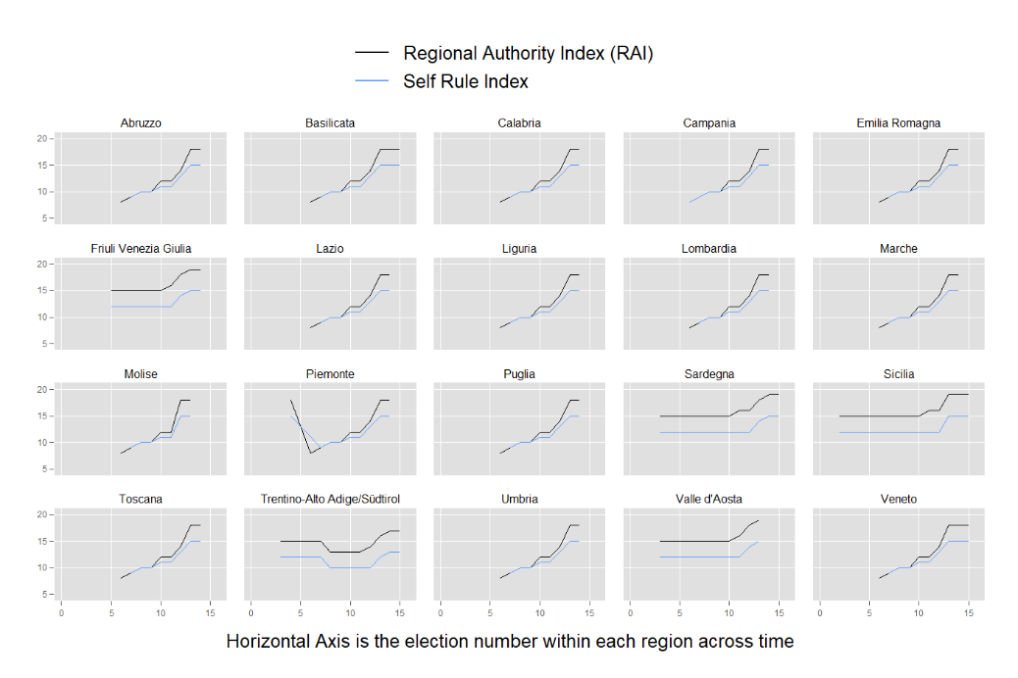

FIGURE A.5: Evolution of Regionalist Parties Electoral Shares in Spain
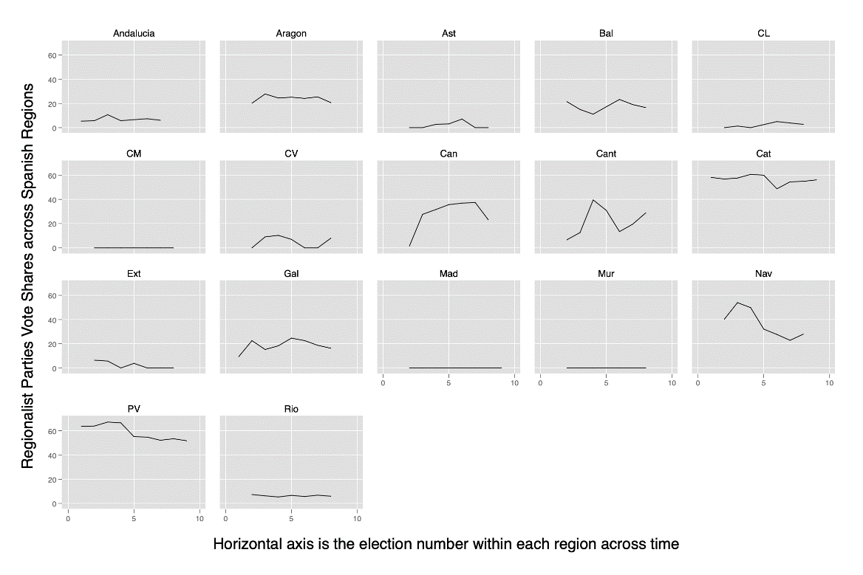

FIGURE A.6: Evolution of Regionalist Parties Electoral Shares in Italy
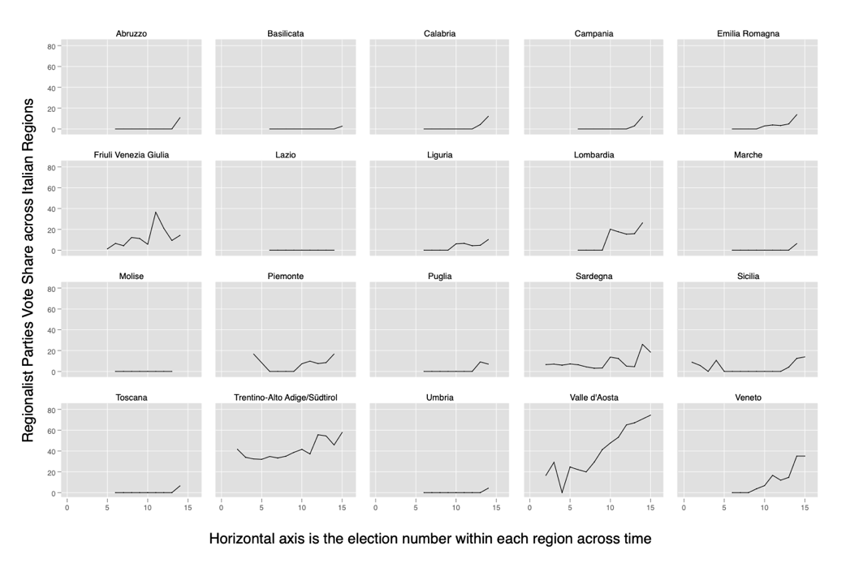

APPENDIX 3: ANALYSES WITH REGIONAL AUTHORITY INDEX

Table A.2
SPAIN: Contamination Effects | Model 1 | Model 2 | Model 3
National Electoral Share | 1.327*** | 1.436*** | 1.397***
 | (0.379) | (0.396) | (0.370)
RAI Index (lag) | 2.157*** | 2.256 | 2.071
 | (0.743) | (1.359) | (1.424)
National Electoral Share X RAI Index (lag) | -0.036* | -0.041** | -0.031*
 | (0.018) | (0.019) | (0.018)
Regional Prime Minister |  |  | 8.321***
 |  |  | (1.661)
Affiliated |  |  | 0.200
 |  |  | (2.059)
Regional PM X Affiliated |  |  | -4.859*
 |  |  | (2.752)
Coalition Member |  |  | -3.415***
 |  |  | (1.038)
Days Passed |  |  | 0.007*
 |  |  | (0.004)
National Electoral Share X Days |  |  | -0.000
 |  |  | (0.000)
Constant | -32.399** | -35.185 | -39.059
 | (15.257) | (27.157) | (27.306)
Region-Party Fixed Effects | YES | YES | YES
Period Fixed Effects | NO | YES | YES
Observations | 212 | 212 | 212
R-squared | 0.446 | 0.468 | 0.531
Number of RP (party-regions) | 33 | 33 | 33
Clustered standard errors at the region-party level in parentheses
*** p<0.01, ** p<0.05, * p<0.1

Table A.3
ITALY: Contamination Effects | Model 1 | Model 2 | Model 3
National Electoral Share | 1.088*** | 1.153*** | 1.041***
 | (0.088) | (0.094) | (0.103)
RAI Index (lag) | 0.102 | -0.059 | -0.265
 | (0.187) | (0.210) | (0.194)
National Electoral Share X RAI Index (lag) | -0.032*** | -0.036*** | -0.020*
 | (0.009) | (0.010) | (0.011)
Regional Prime Minister |  |  | 3.294***
 |  |  | (1.203)
Affiliated |  |  | 1.330***
 |  |  | (0.486)
Regional PM X Affiliated |  |  | -1.862**
 |  |  | (0.931)
Coalition Member |  |  | 1.434***
 |  |  | (0.462)
Days Passed |  |  | 0.001
 |  |  | (0.001)
National Electoral Share X Days |  |  | -0.000*
 |  |  | (0.000)
Constant | 4.380** | 7.718*** | 6.356***
 | (2.044) | (2.533) | (2.303)
Region-Party Fixed Effects | NO | NO | NO
Period Fixed Effects | NO | YES | YES
Observations | 411 | 411 | 340
Number of RP (party-regions) | 124 | 124 | 117
Clustered standard errors at the party-region level in parentheses
*** p<0.01, ** p<0.05, * p<0.1

Figure A.7 Interaction effects with Regional Authority index (RAI)

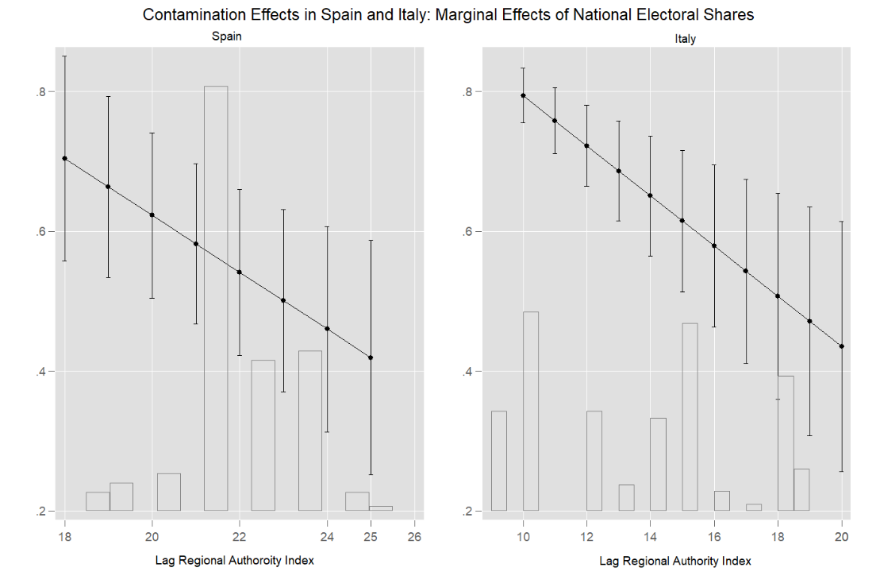

APPENDIX 4: ANALYSES WITHOUT CLUSTERING

Table A.4: Robustness Check. Spain without clustering at the region-party level

Table A43 ROBUSTNESS. SPAIN
No clustering | Model 1 | Model 2 | Model 3 | Model 4
National Electoral Share | 2.669*** | 3.698*** | 2.862*** | 3.379***
 | (0.787) | (0.915) | (0.876) | (0.931)
Self-Rule Index (lag) | 7.778*** | 10.500*** | 8.937** | 8.450**
 | (2.531) | (2.816) | (3.655) | (3.743)
National Electoral Share X Self Rule Index (lag) | -0.158*** | -0.229*** | -0.163** | -0.192***
 | (0.059) | (0.067) | (0.069) | (0.071)
Regionalist Parties Share (lag) |  | 0.309*** |  | 0.293**
 |  | (0.116) |  | (0.129)
National Electoral Share X Reg. Parties Share (lag) |  | -0.006** |  | -0.006*
 |  | (0.003) |  | (0.003)
Constant | -89.545*** | -131.003*** | -113.318** | -113.076**
 | (33.197) | (37.898) | (46.922) | (48.100)
Covariates | NO | NO | YES | YES
Region-Party Fixed Effects | YES | YES | YES | YES
Period Fixed Effects | NO | NO | YES | YES
Observations | 212 | 211 | 212 | 211
R-squared | 0.442 | 0.463 | 0.543 | 0.555
Number of RP (party-regions) | 33 | 33 | 33 | 33
Standard errors in parentheses, not clustered
*** p<0.01, ** p<0.05, * p<0.1

Table A.5: Robustness Check. Italy without clustering at the region-party level

Table A.5 ROBUSTNESS. ITALY
No Clustering | Model 1 | Model 2 | Model 3 | Model 4
National Electoral Share | 1.715*** | 1.638*** | 1.437*** | 1.236***
 | (0.215) | (0.215) | (0.210) | (0.212)
Self-Rule Index (lag) | 1.381*** | 1.332*** | 0.606 | 0.473
 | (0.494) | (0.495) | (0.573) | (0.565)
National Electoral Share X Self Rule Index (lag) | -0.090*** | -0.082*** | -0.063*** | -0.041**
 | (0.019) | (0.020) | (0.020) | (0.021)
Regionalist Parties Share (lag) |  | -0.051 |  | 0.016
 |  | (0.056) |  | (0.049)
National Electoral Share X Regionalist Parties Share (lag) |  | -0.003 |  | -0.006***
 |  | (0.002) |  | (0.002)
Constant | -10.376* | -9.363* | -2.785 | -0.666
 | (5.632) | (5.554) | (6.453) | (6.306)
Covariates | NO | NO | YES | YES
Region-Party Fixed Effects | NO | NO | NO | NO
Period Fixed Effects | NO | NO | YES | YES
Observations | 369 | 369 | 298 | 298
Number of RP (party-regions) | 124 | 124 | 117 | 117
Standard errors in parentheses
*** p<0.01, ** p<0.05, * p<0.1

APPENDIX 5: ANALYSES WITH CONTEMPORANEOUS VALUES

Table A.6: Robustness Check. Spain with contemporaneous values.

Table A.6 ROBUSTNESS. SPAIN
Contemporaneous values | Model 1 | Model 2
National Electoral Share | 1.226 | 1.464
 | (0.911) | (0.997)
Self-Rule Index (contemporaneous) | 3.601 | 5.229
 | (4.567) | (5.153)
National Electoral Share X Self Rule Index (contemporaneous) | -0.033 | -0.048
 | (0.072) | (0.077)
Regionalist Parties Share (contemporaneous) |  | -0.056
 |  | (0.207)
National Electoral Share X Self Rule Index (contemporaneous) |  | -0.002
 |  | (0.003)
Constant | -45.217 | -65.343
 | (59.342) | (65.535)
Covariates | YES | YESs
Region-Party Fixed Effects | YES | YES
Period Fixed Effects | YES | YES
Observations | 179 | 179
R-squared | 0.520 | 0.530
Number of RP (party-regions) | 33 | 33
Clustered standard errors at the region-party level in parentheses
*** p<0.01, ** p<0.05, * p<0.1

Table A.7: Robustness Check. Italy with contemporaneous values.

Table A.7 ROBUSTNESS. ITALY
Contemporaneous values | Model 1 | Model 2
National Electoral Share | 1.287*** | 0.958***
 | (0.187) | (0.151)
Self-Rule Index (contemporaneous value) | 0.008 | -0.202
 | (0.425) | (0.363)
National Electoral Share X Self Rule Index (contemporaneous value) | -0.046** | -0.011
 | (0.019) | (0.015)
Regionalist Parties Share (contemporaneous value) |  | 0.042
 |  | (0.039)
National Electoral Share X Regionalist Parties Share (contemporaneous) |  | -0.010***
 |  | (0.002)
Constant | 5.769 | 8.713
 | (8.515) | (7.984)
Covariates | YES | YES
Region-Party Fixed Effects | NO | NO
Period Fixed Effects | YES | YES
Observations | 409 | 409
Number of RP (party-regions) | 120 | 120
Clustered standard errors at the region-party level in parentheses
*** p<0.01, ** p<0.05, * p<0.1

