Evaluating the 2018 Extreme Flood Hazard Events in Kerala, India

Preet Lal^{1,7}, Aniket Prakash¹, Amit Kumar*^{,1,6}, Prashant K. Srivastava²,
Parul Srivastava³, Purabi Saikia^{4,6}, A.C. Pandey¹ and M.L. Khan^{5,6}
¹Department of Geoinformatics, Central University of Jharkhand, Ranchi – 835205, India
²Institute of Environment and Sustainable Development, Banaras Hindu University, Varanasi-221005, India
³IORA Ecological Solution Limited, New Delhi, India
⁴Department of Environmental Sciences, Central University of Jharkhand, Ranchi – 835205, India
⁵Department of Botany, Dr Harisingh Gour Vishwavidyalaya (A Central University) Sagar, Madhya Pradesh-470003, India
⁶IUCN Commission of Ecosystem Management
⁷Department of Earth and Environmental Sciences, Indian Institute of Science Education and Research Bhopal – 462066, India
*Corresponding Author (e-mail: amit.kumar@cuj.ac.in; amit.iirs@gmail.com; +91 7004773095

Supplementary Files

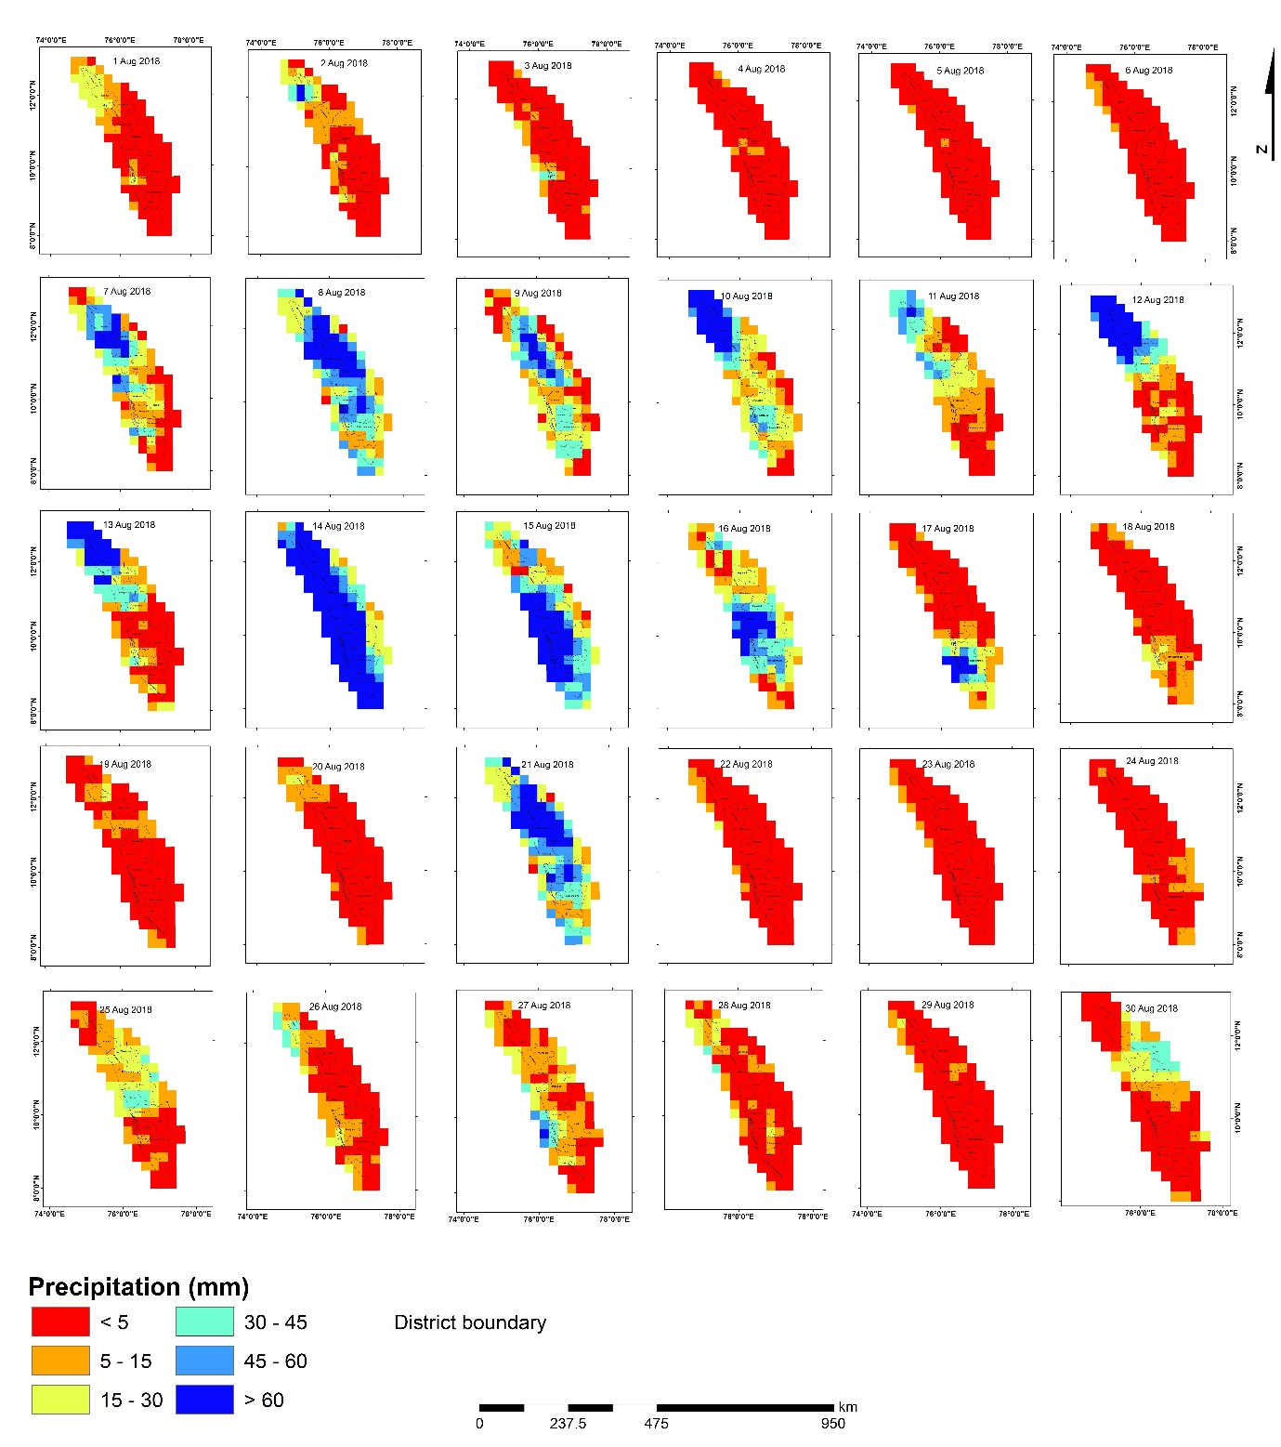
Figure S1: TRMM based daily cumulative precipitation in Kerala State during August 2018 (mm day^{–1})
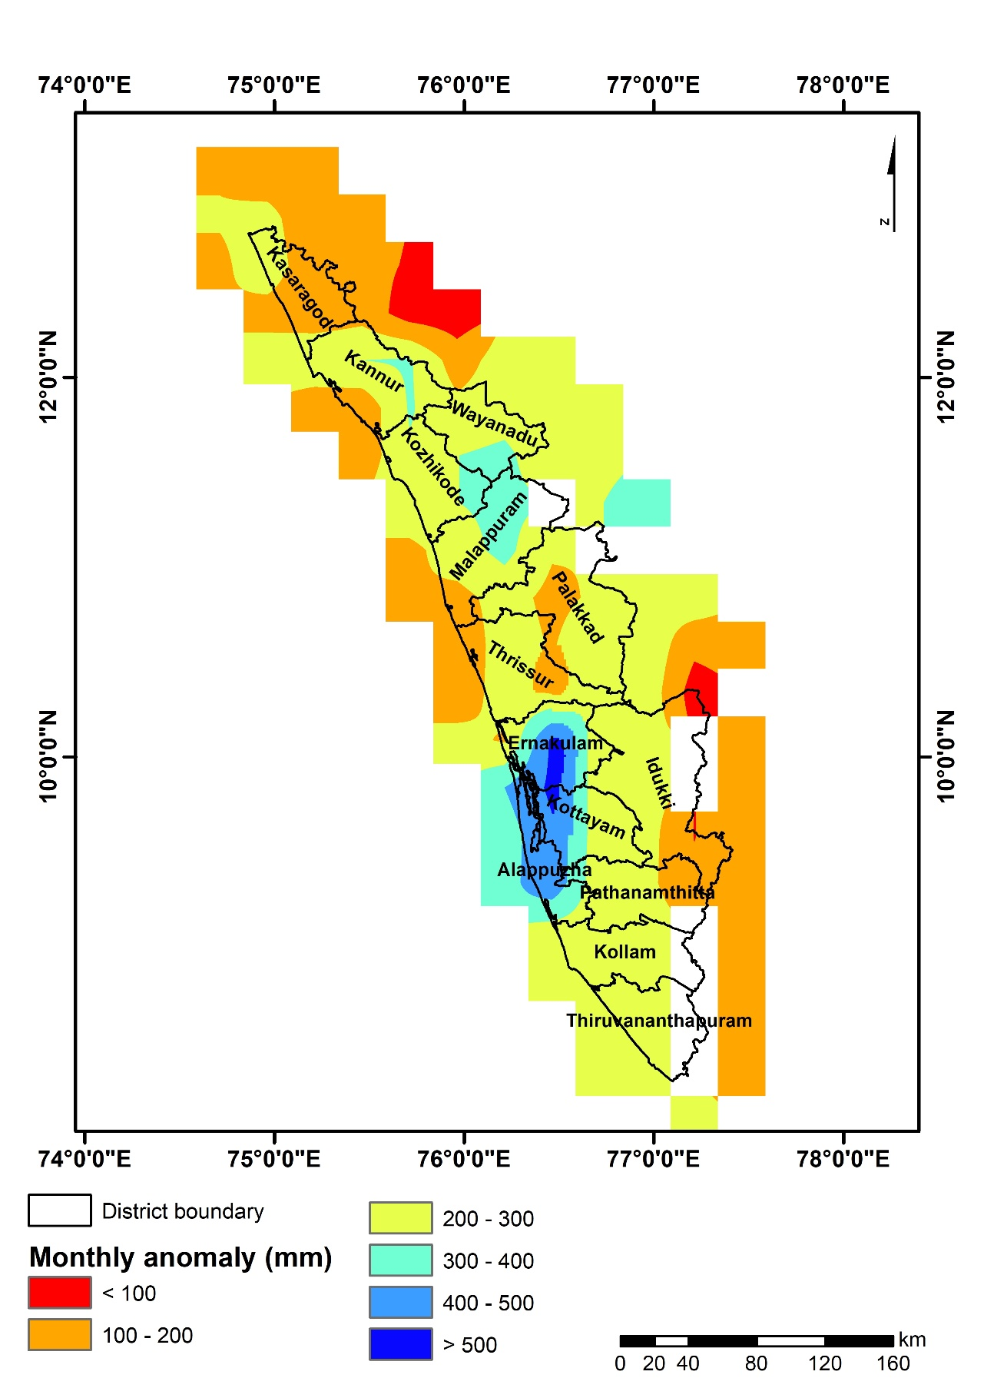
Figure S2: TRMM based precipitation anomaly of August 2018 with reference to long term mean (1901-2017)

