Supplementary Figure

Control for Loading Bias Between Diagnoses.
In addition to alternating control and schizophrenia cases when loading gels, we tested for loading bias between diagnoses by simultaneously probing both the SMAD2 and SMAD4 blots for a negative control protein, ACTB, which we have previously shown does not vary between schizophrenia and control samples in BA 9 (Parkin et al. 2019, doi: 10.1002/elps.201800328). During the western blot assay, 1:200,000 mouse anti-ACTB antibody (MAB1501, Chemicon, USA) was added to the SMAD primary antibody solution. Following Chemiluminescent detection of SMAD, the membrane was washed 4 x 5 min in TTBS, incubated for 1:2000 HRP-conjugated goat anti-mouse (P0447, DAKO, USA), washed 4 x 5 min in TTBS and ACTB was visualised by chemiluminescence.
The unadjusted signal intensities of ACTB in the Western immunoassays used to measure the levels of SMAD4 in (A) BA 46 and (B) BA 24 and SMAD2 in (C) BA 46 and (D) BA 24 are shown. Levels of ACTB did not differ between Control and Schizophrenia groups in either BA 46 or BA 24 (p > 0.05). Hence, the lack of change in ACTB in the same crude homogenate used to measure levels of SMAD4 would suggest that the variance in levels of this protein with diagnoses was not due to a systematic variation in protein loaded onto each gel.

A B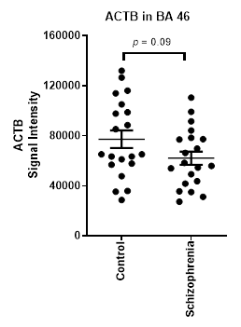 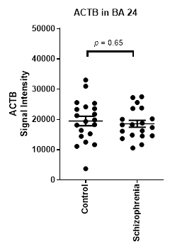
C D