Supplementary Information
Novel 4-(1H-1,2,3-triazol-4-yl)methoxy)cinnolines as Potent Antibacterial agents: Synthesis and Molecular Docking Study
Bommagani Mohan Babu, Mokenapelli Sudhakar, Boda Sathish Kumar, Chitneni Prasad Rao*
Natural Products Laboratory, Department of Chemistry, Osmania University, Hyderabad-500007, Telangana, India
*E-mail id: prasadraoou@yahoo.com

Contents : pages

Experimental Procedure&Antimicrobial Activity | 2-9
¹H NMR ,¹³C NMR&Mass spectra | 10-49

Experimental
Instrumentation and Chemicals General experimental methods
All chemicals used were of laboratory grade and used without further purification. Melting points of compounds were determined in open capillary tubes in a silicon oil bath using a Veego melting point apparatus and are uncorrected. The purity of compounds was monitored by TLC on silica F254 coated aluminum plates (Merck) as adsorbent and U.V. light and iodine as visualizing agents. ¹H and¹³C NMR spectra were recorded on Varian mercury TH-300 operating at 400 MHz (¹H NMR) and 101.6 MHz (¹³C NMR) using CDCl₃ and DMSO-d₆ as solvents and TMS as an internal standard (Chemical shift in ppm).
Synthesis of 4-(prop-2-yn-1-yloxy)cinnoline(4a-d)
Cinnolin-4(1H)-one (5.0 g, 34.24 mol) was added to the K₂CO₃ ( 7.08 g, 51.36 mol) and 3- bromoprop-1-yne (3.11 mL, 41.09 mol) in ACN (20 mL) and the mixture stirred at 80 °C for 4-8 h then reaction mixture was cool to rt. The mixture was concentrated, diluted with H₂O (30 mL), and extracted with EtOAc (3 × 50 mL). The combined organic layers were dried (MgSO₄), filtered and concentrated. Flash chromatography gave 4-(prop-2-yn-1-yloxy)cinnoline (13a).
Synthesis of 4-(prop-2-yn-1-yloxy)cinnoline (4a).
Yield (2.60 g, 65.5%). m.p.100-110 °C. Colourless solid.¹H NMR (400 MHz, CDCl₃) δ 8.34 (dd, J = 1.2, 1.2 Hz, 1H, Ar), 7.81-7.77 (m, 2H, Ar), 7.60 (d, J = 8.8 Hz, 1H, Ar), 7.46 (t, J = 8.0 Hz,1H, Ar), 5.14 (d, J = 2.4 Hz, 1H, -OCH2), 2.51 (t, J = 2.4 Hz, 1H, Alky). ¹³C NMR (100 MHz, CDCl₃) δ 171.2, 140.6, 140.1, 134.0, 126.0, 125.2, 124.6, 115.1, 76.0, 75.7, 46.2. ESI-MS: m/z 185.27 [M+H]⁺. Anal. Calc. (C₁₁H₈N₂O) C: 71.73; H: 4.38; N: 15.21. Found C: 71.80; H: 4.04; N: 15.28%.
Synthesis of 8-methoxy-4-(prop-2-yn-1-yloxy)cinnoline (4b)
Yield (2.6 g, 63.23%). m.p.105-115 °C. Colourless solid.¹H NMR (400 MHz, CDCl₃) δ 7.93 (dd, J = 1.2, 1.2 Hz, 1H, Ar), 7.82 (s, 1H, Ar), 7.36 (t, J = 8.0 Hz, 1H, Ar), 7.22 (dd, J = 7.6, 8.0 Hz, 1H, Ar), 5.47 (d, J = 2.4 Hz, 2H, -OCH2), 4.02 (s, 3H, -OCH3) 2.41 (t, J = 2.4 Hz, 1H, Alky).¹³C NMR (100 MHz, CDCl₃) δ 170.4, 148.1, 140.0, 132.5, 126.8, 125.5, 117.6, 114.9, 78.3 73.9, 56.8, 51.6. ESI-MS: m/z 215.42 [M+H]⁺. Anal. Calc. (C₁₂H₁₀N₂O₂) C: 67.28; H: 4.71; N: 13.08Found Found C: 67.36; H: 4.49; N: 13.16. %.
Synthesis of 6-bromo-4-(prop-2-yn-1-yloxy)cinnoline (4c)
Yield (2.80 g, 66.6%). m.p.120-130 °C colourless solid. ¹H NMR (400 MHz, CDCl₃) δ 8.36 (d, J = 2.0 Hz, 1H, Ar), 7.78 (dd, J = 8.8, 9.2 Hz, 1H, Ar), 7.72 (s, 1H, Ar), 7.42 (d, J = 9.2 Hz, 1H, Ar), 5.05 (d, J = 2.4 Hz, 2H, -OCH2), 2.45 (t, J = 2.4 Hz, 1H, Alky).¹³C NMR (100 MHz, CDCl₃) δ 169.9, 140.8, 138.8, 137.1, 128.5, 125.7,119.1, 117.1, 76.1,75.6, 46.4. ESI-MS: m/z 263.42 [M+H]⁺. Anal. Calc. (C₁₁H₇BrN₂O) C: 50.22; H: 2.68; N: 10.Found C: 50.35; H: 2.31; N: 10.72. 65%.
General procedure for synthesis of azidses (6a-d and 8)
Imidazole-1-sulfonyl azide hydrochloride (2.343 g, 11.21 mol) was added to the phenylmethanamine (1.0 g 9.345 mol), K₂CO₃ (2.57 g, 18.69 mol) and CuSO₄.5H₂O (2.5 mg, 10 µmol) in MeOH (5 mL) and the mixture stirred at room temperature for 6-16 h. Then filter through celite bed filtrate was evaporated gave the crude azide was used without purification for next step.
Synthesis of 4-(1H-1,2,3-triazol-yl)methoxy)cinnoline conjugates (9a-o and 10a-d)
To a 50 mL of round-bottom flask 4-(prop-2-yn-1-yloxy)cinnoline (150 mg, 0.81 mol) was added to the azidomethyl benzene (162 mg, 1.22 mol), and sodium ascorbate (807 mg, 4.07 mol) CuSO₄.5H₂O (405 mg, 1.63 mol) in H₂O:t-BuOH (1:1) and the mixture stirred at room temperature for 6-16 h then diluted with H₂O (10 mL), and extracted with DCM (3 × 10 mL). The combined organic layers were dried (MgSO₄), filtered and concentrated. Flash chromatography gave 120 mg of 4-((1-benzyl-1H-1,2,3-triazol-4-yl)methoxy)cinnoline Scheme-3 (18a)
Synthesis of 4-((1-benzyl-1H-1,2,3-triazol-4-yl)methoxy)cinnoline (9a)
Yield (46.5%), m.p.120-130 °C. Brown solid.¹H NMR (400 MHz, CDCl₃) δ 8.24 (s, 1H, Ar), 8.11 (d, J = 8.0 Hz, 1H, Ar), 7.96 (d, J = 8.8 Hz, 1H, Ar), 7.83 (d, J = 7.2 Hz, 2H, Ar), 7.49 (t, J = 7.6 Hz, 1H, Ar), 7.33 (t, J = 7.2 Hz, 3H, Ar), 7.26 (d, J = 6.8 Hz, 2H, Ar), 5.76 (s, 2H, -OCH2), 5.55 (s, 2H, -NCH2).¹³C NMR (100 MHz, CDCl₃) δ 171.1, 142.7, 140.5, 140.4, 134.1, 134.0, 129.2, 128.9, 128.1, 125.7, 125.1, 124.6, 122.5, 115.6, 54.4, 51.6. ESI-MS: m/z 318.0 [M+H]⁺. Anal. Calcd for (C₁₈H₁₅N₅O). C: 68.13; H: 4.76; N: 22.07. Found. C: 68.20; H: 4.41; N: 22.20%.
4-((1-benzyl-1H-1,2,3-triazol-4-yl)methoxy)cinnoline (9b)
Yield (57.6%), m.p.135-145 °C. Brown solid.¹H NMR (400 MHz, CDCl₃) δ 7.99 (dd, J = 8.0, 8.0 Hz, 1H, Ar), 7.84 (s, 1H, Ar), 7.33 (d, J = 6.4 Hz, 4H, Ar), 7.23 (s, 1H, Ar), 7.21-7.13 (m, 2H, Ar), 7.11 (d, J = 1.2 Hz, 1H, Ar), 6.04 (s, 2H, -OCH2), 5.45 (s, 2H, -NCH2).¹³C NMR (100 MHz, CDCl₃) δ 170.2, 148.0, 145.1, 140.0, 134.4, 132.9, 129.0, 128.7, 126.9, 125.4, 121.7, 117.4, 11.6, 56.6, 56.3, 54.1. ESI-MS: m/z 348.0 [M+H]⁺. Anal. Calc. (C₁₉H₁₇N₅O₂) C: 65.69; H: 4.93; N: 20.16. Found. C: 65.71; H: 4.62; N: 20.21%.
4-((1-benzyl-1H-1,2,3-triazol-4-yl)methoxy)-6-bromocinnoline (9c)
Yield (63.8%), m.p.125-135 °C. Brown solid.¹H NMR (400 MHz, CDCl₃) δ 8.24 (s, 1H, Ar), 7.80 (d, J = 4.4 Hz, 3H, Ar), 7.44 (s, 1H, Ar), 7.36 (t, J = 3.6 Hz, 3H, Ar), 7.23 (d, J = 3.6 Hz, 2H, Ar), 5.62 (s, 2H, -OCH2), 5.47 (s, 2H, -NCH2).¹³C NMR (100 MHz, CDCl₃) δ 169.8, 142.3, 140.7, 139.2, 137.2, 133.9, 129.2, 129.0, 128.2, 128.1, 125.7, 122.6, 119.1, 117.8, 54.4, 51.8. ESI-MS: m/z 397.0 [M+H]⁺. Anal. Calc. (C₁₈H₁₄BrN₅O). C: 54.56; H: 3.56; N: 17.67. Found: C:54.61; H: 3.20; N: 17.75%.
4-(1-(4-methoxybenzyl)-1H-1,2,3-triazol-4-yl)methoxy)cinnoline (9d)
Yield (53.1%). m.p.140-150°C.Brown solid.¹H NMR (400 MHz, CDCl₃) δ 8.29 (dd, J = 8.0, 8.0 Hz, 1H, Ar), 7.84 (d, J = 8.8 Hz, 1H, Ar), 7.80 (s, 1H, Ar), 7.74-7.70 (m, 1H, Ar), 7.41 (d, J = 8.0 Hz, 2H, Ar),7.18 (dd, J = 6.4, 6.4 Hz, 2H, Ar), 6.86 (dd, J = 6.4, 6.8 Hz, 2H, Ar), 5.65 (s, 2H, -OCH2), 5.40 (s, 2H, -NCH2), 3.79(s, 3H, -OCH3). ¹³C NMR (100 MHz, CDCl₃) δ 171.1, 160.5, 142.6, 140.5, 140.4, 134.1, 129.7, 125.9, 125.7, 125.1, 124.6, 122.2, 115.2, 114.5, 55.3, 53.9, 51.6. ESI-MS: m/z 348.0 [M+H]⁺. Anal. Calc. (C₁₉H₁₇N₅O₂₎ C: 65.69; H: 4.93; N: 20.16. Found. C: 65.72; H: 4.61; N: 20.23%.
8-methoxy-4-((1-(4-methoxybenzyl)-1H-1,2,3-triazol-4-yl)methoxy)cinnoline (9e)
Yield (64.3%), m.p.120-130 °C. Brown solid, ¹H NMR (400 MHz, CDCl₃) δ 7.83 (dd, J = 8.0, 8.4 Hz, 1H, Ar), 7.27 (s, 1H, Ar), 7.24 (d, J = 8.0 Hz, 1H, Ar), 7.13 (s, 1H, Ar), 7.10-7.04 (m, 3H, Ar), 6.79 (t, J = 2.0 Hz, 2H, Ar), 5.96 (s, 2H, -OCH2), 5.30 (s, 2H, -NCH2), 3.83 (s, 3H, -OCH3), 3.72 (s, 3H, -OCH3). ¹³C NMR (100 MHz, CDCl₃) δ 170.3, 159.9, 148.0, 145.0, 140.0, 132.9, 129.5, 126.9, 126.3, 120.4, 121.4, 117.4, 114.6, 114.4, 56.6, 56.3, 55.3, 53.7. ESI-MS: m/z 378.0 [M+H]⁺. Anal. Calc. (C₂₀H₁₉N₅O₃) C: 63.65; H: 5.07; N: 18.56. Found. C: 63.70; H: 4.82; N: 18.61%.
6-bromo-4-((1-(4-methoxybenzyl)-1H-1,2,3-triazol-4-yl)methoxy)cinnoline (9f)
Yield (65.5%), m.p.185-195 °C. Brown solid, ¹H NMR (400 MHz, CDCl₃) δ 8.41 (d, J = 4.4 Hz, 1H, Ar), 7.95 (t, J = 5.6 Hz, 3H, Ar), 7.40 (s, 1H, Ar), 7.19 (d, J = 6.8 Hz, 2H, Ar), 6.88 (d, J = 6.8 Hz, 2H, Ar), 5.61 (s, 2H, -OCH2), 5.40 (s, 2H, -NCH2), 3.80 (s, 3H, -OCH3). ¹³C NMR (100 MHz, CDCl₃) δ 169.8, 160.0, 142.2, 140.6, 139.2, 137.2, 129.8, 128.2, 125.8, 125.7, 122.3, 119.1, 117.8, 114.5, 55.3, 54.0, 51.8. ESI-MS:m/z 426.0 [M+H]⁺. Anal. Calc. (C₁₉H₁₆BrN₅O₂₎ C: 53.54; H: 3.78; N: 16.43. Found. C: 53.62; H: 3.60; N: 16.61%.
5-fluoro-4-((1-(4-methoxybenzyl)-1H-1,2,3-triazol-4-yl)methoxy)cinnoline (9g)
Yield (44.2%), m.p.160-170 °C. Brown solid, ¹H NMR (400 MHz, CDCl₃) δ 7.63 (s, 1H, Ar), 7.56 (d, J = 6.8 Hz, 2H, Ar), 7.33(s, 1H, Ar), 7.12 (d, J = 8.8 Hz, 2H, Ar), 6.95-6.91 (m, 1H, Ar), 6.81 (d, J = 6.8 Hz, 2H, Ar), 5.52 (s, 2H, -OCH2), 5.34 (s, 2H, -NCH2), 3.73 (s, 3H, -OCH3).¹³C NMR (100 MHz, CDCl₃) δ 169.5, 62.3, 160.0, 142.3, 141.8, 134.6, 134.5, 129.8, 125.8, 114.5, 111.4, 111.3, 110.9, 110.7, 55.3, 53.9, 52.2. ESI-MS: m/z 366.0 [M+H]⁺.Anal. Calc. (C₁₉H₁₆FN₅O₂) C: 62.46; H: 4.41; N: 19.17; Found C: 62.51; H: 4.10; N: 19.21%.
4-((1-(4-(trifluoromethyl)benzyl)-1H-1,2,3-triazol-4-yl)methoxy)cinnoline (9h)
Yield (57.5%), m.p.175-185 °C. Brown solid.¹H NMR (400 MHz, CDCl₃) δ 8.23 (dd, J = 8.0, 8.0 Hz, 1H, Ar), 7.74 (t, J = 10.8 Hz, 2H, Ar), 7.68-7.64 (m, 1H, Ar), 7.55 (d, J = 8.0 Hz, 2H, Ar), 7.41 (s, 1H, Ar), 7.37 (t, J = 7.6 Hz, 1H, Ar), 7.27 (d, J = 8.0 Hz, 2H, Ar), 5.61 (s, 2H, -OCH2), 5.47 (s, 2H, -NCH2). ¹³C NMR (100 MHz, CDCl₃) δ 171.1, 143.1, 140.5, 138.0, 134.2, 128.3, 126.2, 126.2, 126.1, 126.1, 125.8, 125.2, 124.6, 122.7, 115.5, 53.6, 51.5. ESI-MS: m/z 386.0 [M+H]⁺. Anal. Calc. (C₁₉H₁₄F₃N₅O) C: 59.22; H: 3.66; N: 18.17. Found. C: 59.31; H: 3.29; N: 18.21%.
8-methoxy-4-((1-(4-(trifluoromethyl)benzyl)-1H-1,2,3-triazol-4-yl)methoxy)cinnoline (9i)
Yield (68.9%), m.p.160-170 °C. Brown Solid, ¹H NMR (400 MHz, CDCl₃) δ 7.84 (dd, J = 8.0, 8.0 Hz, 1H, Ar), 7.78 (s, 1H, Ar), 7.53 (d, J = 8.0 Hz, 2H, Ar), 7.28-7.22 (m, 4H, Ar), 7.07 (t, J = 6.8 Hz, 1H, Ar), 5.99 (s, 2H, -OCH2), 5.45 (s, 2H, -NCH2), 3.85 (s, 3H, -OCH3). ¹³C NMR (100 MHz, CDCl₃) δ 171.3, 148.0, 140.5, 140.1, 138.4, 132.9, 128.9, 126.1, 126.1, 126.0, 125.5, 121.9, 117.5, 114.6, 56.5, 56.4, 53.5. ESI-MS: m/z 416.0 [M+H]⁺.Anal. Calc. (C₂₀H₁₆F₃N₅O₂) C: 57.83; H: 3.88; N: 16.86. Found. C: 57.88; H: 3.42; N: 16.91%.
6-bromo-4-((1-(4-(trifluoromethyl)benzyl)-1H-1,2,3-triazol-4-
yl)methoxy)cinnoline (18j)
Yield (67.6%), m.p.185-195 °C. Brown solid.¹H NMR (400 MHz, CDCl₃) δ 8.35 (d, J = 8.0 Hz, 1H, Ar), 7.73 (d, J = 8.8 Hz, 3H, Ar), 7.56 (d, J = 8.0 Hz, 2H, Ar), 7.43 (s, 1H, Ar), 7.28 (d, J = 8.0Hz, 2H, Ar), 5.57 (s, 2H, -OCH2), 5.47 (s, 2H, -NCH2).¹³C NM, R (100 MHz, CDCl₃) δ 169.8, 142.6, 140.7, 139.2, 137.8, 137.2, 128.3, 128.2, 127.5, 126.2, 126.2, 125.7, 122.7, 119.2, 117.6, 53.7, 51.6. ESI-MS:m/z 464.0 [M+H]⁺. Anal. Calc. (C₁₉H₁₃BrF₃N₅O) C: 49.16; H: 2.82; N, 15.09. Found. C: 49.21; H: 2.60; N: 15.12%.
5-fluoro-4-((1-(4-(trifluoromethyl)benzyl)-1H-1,2,3-triazol-4-
yl)methoxy)cinnoline (9k)
Yield (40.1%), m.p.180-190 °C. Brown solid.¹H NMR (400 MHz, CDCl₃) δ 7.64 (s, 1H, Ar), 7.61-7.53 (m, 4H, Ar), 7.44 (s, 1H, Ar), 7.28 (d, J = 8.0 Hz, 2H, Ar), 6.96-6.92 (m, 1H, Ar), 5.55 (s, 2H, -OCH2), 5.48 (s, 2H, -NCH2). ¹³C NMR (100 MHz, CDCl₃) δ 169.5, 162.3, 142.7, 141.9, 138.0, 134.6, 134.5, 128.3, 126.2, 126.1, 122.8, 111.2, 111.2, 110.9, 110.7, 53.7, 52.0. ESI-MS: m/z 404.0 [M+H]⁺. Anal. Calc. (C₁₉H₁₃F₄N₅O). C: 56.58; H: 3.25; N: 17.36; O: 3.97. Found. C: 56.61; H: 2.80; N: 17.39%.
4-((1-(2-(trifluoromethyl)benzyl)-1H-1,2,3-triazol-4-yl)methoxy)cinnoline (9l)
Yield (54.3%), m.p.175-185 °C. Brown solid.¹H NMR (400 MHz, CDCl₃) δ 8.22 (d, J = 8.1 Hz, 1H, Ar), 7.75 (d, J = 7.2 Hz, 2H, Ar), 7.66 (t, J = 8.1 Hz, 1H, Ar), 7.55 (d, J = 7.8 Hz, 1H, Ar), 7.43 (d, J = 9.6 Hz, 3H, Ar), 7.34 (t, J = 7.2 Hz, 2H, Ar), 5.62 (s, 2H, -OCH2), 5.46 (s, 2H, -NCH2). ¹³C NMR (100 MHz, CDCl₃) δ 171.1, 143.1, 140.5, 135.1, 134.2, 131.7, 131.3, 129.8, 125.8, 125.2, 124.7, 124.7, 124.6, 122.6, 115.5, 53.7, 51.5. ESI-MS: m/z 386.0 [M+H]⁺. Anal. Calc.(C₁₉H₁₄F₃N₅O) C: 59.22; H: 3.66; N, 18.17. Found. C: 59.30; H: 3.41; N: 18.20%.
8-methoxy-4-((1-(2-(trifluoromethyl)benzyl)-1H-1,2,3-triazol-4- yl)methoxy)cinnoline (9m)
Yield (65.5%), m.p.140-150 °C. Brown solid.¹H NMR (400 MHz, CDCl₃) δ 7.84 (dd, J = 8.4, 8.0 Hz, 1H, Ar), 7.78 (s, 1H, Ar), 7.53 (d, J = 7.6 Hz, 1H, Ar), 7.41 (t, J = 8.0 Hz, 1H, Ar), 7.36 (s, 1H, Ar), 7.31 (d, J = 7.6 Hz, 1H, Ar), 7.24 (d, J = 16.0 Hz, 2H, Ar) , 7.06 (dd, J = 8.0, 8.0 Hz, 1H, Ar), 5.99 (s, 2H, -OCH2), 5.45 (s, 2H, -NCH2), 3.83 (s, 3H, -OCH3).¹³C NMR (100 MHz, CDCl₃) δ 170.2, 147.9, 145.5, 140.0, 135.6, 132.8, 131.2, 131.1, 129.7, 126.8, 125.6, 125.4, 124.5, 121.9, 117.4, 114.6, 56.6, 56.3, 53.4. ESI-MS: m/z 416.0 [M+H]⁺. Anal. Calc. (C₂₀H₁₆F₃N₅O₂). C: 57.83; H: 3.88; N: 16.86. Found C: 57.91; H: 3.60; N: 16.89%.
6-bromo-4-((1-(3-(trifluoromethyl)benzyl)-1H-1,2,3-triazol-4-yl)methoxy)cinnoline (9n)
Yield (60.1%), m.p.135-145 °C. Brown solid.¹H NMR (400 MHz, CDCl₃) δ 8.35 (s, 1H, Ar), 7.73 (d, J = 9.3Hz, 3H, Ar), 7.56 (d, J = 7.8 Hz, 1H, Ar), 7.43 (t, J = 7.2 Hz, 3H, Ar), 7.34 (d, J = 7.5 Hz, 1H, Ar), 5.58 (s, 2H, -OCH2), 5.47 (s, 2H, -NCH2).¹³C NMR (100 MHz, CDCl₃) δ 169.8, 142.7, 140.7, 139.2, 137.2, 135.0, 131.3, 129.8, 128.3, 125.9, 125.9, 125.7, 124.7, 122.7, 119.1, 117.6, 53.7, 51.7. ESI-MS: m/z 464.0 [M+H]⁺. Anal. Calc. (C₁₉H₁₃BrF₃N₅O) C: 49.16; H: 2.82; N: 15.09. Found. C: 49.21; H, 2.53; N: 15.12%.
5-fluoro-4-((1-(3-(trifluoromethyl)benzyl)-1H-1,2,3-triazol-4-
yl)methoxy)cinnoline (9o)
Yield (43.4%), m.p.160-170 °C. Brown solid.¹H NMR (400 MHz, CDCl₃) δ 7.64 (s, 1H, Ar), 7.60-7.51 (m, 3H, Ar), 7.43 (t, J = 7.2 Hz, 3H, Ar), 7.35 (d, J = 8.0 Hz, 1H, Ar), 6.96-6.91 (m, 1H, Ar), 5.56 (s, 2H, -OCH2), 5.48 (s, 2H, -NCH2).¹³C NMR (100 MHz, CDCl₃) δ 169.4, 162.2, 142.7, 141.8, 135.2, 134.6, 131.3, 129.8, 125.8, 124.7, 122.9, 114.7, 111.3, 111.3, 110.9, 110.7, 53.6, 52.1. ESI-MS: m/z 404.0 [M+H]⁺.Anal. Calc. (C₁₉H₁₃F₄N₅O). C: 56.58; H: 3.25; N: 17.36. Found.C: 56.61; H: 2.80; N: 17.42%.
4-(3-(4-((cinnolin-4-yloxy)methyl)-1H-1,2,3-triazol-1-yl)propyl)morpholine (10a)
Yield (41.6%), m.p.150-160 °C. Brown solid, ¹H NMR (400 MHz, CDCl₃) δ 8.30 (dd, J = 8.4, 8.0 Hz, 1H, Ar), 7.84 (t, J = 2.0 Hz, 2H, Ar), 7.75-7.71 (m,1H, Ar), 7.51 (s, 1H, Ar), 7.44-7.40 (m, 1H, Ar), 5.70 (s, 2H, -OCH2), 4.39 (t, J = 6.8 Hz, 2H, -CH2), 3.63 (t, J = 4.4 Hz, 4H, morp), 2.31 (t, J = 4.4 Hz, 4H, morp), 2.24 (t, J = 6.8 Hz, 2H, -CH2), 2.04 (q, J = 6.8 Hz, 2H, -CH2-CH2-). ¹³C NMR (100 MHz, CDCl₃) δ 171.0, 142.1, 140.5, 140.4, 134.2, 125.7, 125.2, 124.6, 123.0, 115.6, 66.8, 54.7, 53.4, 51.7, 48.2, 26.7. ESI-MS: m/z 355.0 [M+H]⁺. Anal. Calc. (C₁₈H₂₂N₆O₂). C: 61.00; H: 6.26; N: 23.71. Found. C: 61.10; H: 5.81; N: 23.79%.
4-(3-(4-(((8-methoxycinnolin-4-yl)oxy)methyl)-1H-1,2,3-triazol-1- yl)propyl)morpholine (10b)
Yield (44.3%), m.p.155-165 °C. Red solid, ¹H NMR (400 MHz, CDCl₃) δ 7.92 (dd, J = 8.4, 8.0 Hz, 1H, Ar), 7.87 (s, 1H, Ar), 7.34 (t, J = 8.0 Hz, 2H, Ar), 7.15 (dd, J = 8.0, 8.0 Hz, 1H, Ar), 6.08 (s, 2H, -OCH2), 4.36 (t, J = 6.8 Hz, 2H, -CH2-), 3.95 (s, 3H, -OCH3), 3.63 (t, J = 4.4 Hz, 4H, morp), 2.31 (t, J = 4.4 Hz, 4H, morp), 2.23 (t, J = 6.8 Hz, 2H, -CH2- ), 2.04 (q, J = 12.8 Hz, 2H, -CH2-CH2-).¹³C NMR (100 MHz, CDCl₃) δ 171.0, 148.0, 144.3, 139.8, 132.7, 126.7, 125.4, 122.2, 117.2, 114.6, 66.7, 56.6, 56.4, 54.7, 53.3, 47.9, 26.7. ESI-MS: m/z 386.0 [M+H]⁺. Anal. Calc. (C₁₉H₂₄N₆O₃). C: 59.36; H: 6.29; N: 21.86. Found. C: 59.52; H: 6.02; N: 21.93%.
4-(3-(4-(((6-bromocinnolin-4-yl)oxy)methyl)-1H-1,2,3-triazol-1- yl)propyl)morpholine (10c)
Yield (44.1%), m.p.150-160 °C. Brown Solid, ¹H NMR (400 MHz, CDCl₃) δ 8.43 (t, J =1.2Hz, 1H, Ar ), 7.84 (s, 1H, Ar), 7.79 (d, J = 1.2 Hz, 2H, Ar), 7.53 (s, 1H, Ar), 5.66 (s, 2H, -OCH2), 4.39 (t, J = 7.2 Hz, 2H, -CH2 ), 3.65 (t, J = 4.4 Hz, 4H, morp ), 2.34 (t, J = 4.0 Hz, 4H, morp ), 2.26 (t, J = 6.8 Hz, 2H, -CH2-CH2-), 2.03 (t, J = 6.8 Hz, 2H, -CH2-CH2-). ¹³C NMR (100 MHz, CDCl₃) δ 169.6, 141.7, 140.5, 139.2, 137.1, 128.0, 125.6, 123.1, 119.0, 117.8, 66.7, 54.8, 53.4, 51.7, 48.3, 26.7. ESI-MS: m/z 385.0 [M+H]⁺. Anal. Calc. (C₁₈H₂₁BrN₆O₂). C: 49.89; H: 4.88; N: 19.40. Found C: 49.92; H: 4.50; N: 19.42%.
4-(3-(4-(((5-fluorocinnolin-4-yl)oxy)methyl)-1H-1,2,3-triazol-1-
yl)propyl)morpholine (10d)
Yield (38.9%), m.p.160-170 °C. Red solid, ¹H NMR (400 MHz, CDCl₃) δ 7.63 (s, 1H, Ar), 7.56-7.53 (m, 3H, Ar), 6.94-6.89 (m, 1H, Ar), 5.57 (s, 2H, Ar), 4.33 (t, J = 6.8 Hz, 2H, Ar), 3.57 (t, J = 4.4 Hz, 4H, morp), 2.27 (t, J = 4.0 Hz, 4H, morp), 2.20 (t, J = 6.8 Hz, 2H, -CH2-CH2-), 1.98 (q, J = 6.8 Hz, 2H, -CH2-CH2-).¹³C NMR (100 MHz, CDCl₃) δ 169.4, 162.3, 159.6, 141.8, 134.6, 123.0, 114.8, 111.3, 111.3, 110.8, 110.6, 66.8, 54.8, 53.4, 52.1, 48.3, 26.7, ESI-MS: m/z 432.0 [M + H]. ¹³C NMR (100 MHz, CDCl₃) δ 169.6, 141.7, 140.5, 139.2, 137.1, 128.0, 125.6, 123.1, 119.0, 117.8, 66.7, 54.8, 53.4, 51.7, 48.3, 26.7. ESI-MS: m/z 385.0 [M+H]⁺. Anal. Calc. (C₁₈H₂₁FN₆O₂). C: 58.05; H: 5.68; N: 22.57. Found C: 58.10; H: 5.46; N: 22.51%.
Antimicrobial Activity by Paper Disc method
Media Preparation:
LB Broth: NaCl: 10 gr /Lit
Tryptone: 10 gr/lit
Yeast Extract: 5gr/lit
Autoclave at 121 ⁰c and 15 lb Pressure
LB agar: NaCl: 10 gr /Lit
Tryptone: 10 gr/lit
Yeast Extract: 5gr/lit
Agar Agar: 15 gr /lit
The above constituents were weighed and dissolved in water. The mixture was warmed on water bath till agar dissolved. This was then sterilized in an autoclave at 15 lbs pressure and 121 ⁰C for fifteen minutes. The sterilized medium (20 ml) was poured in sterilized Petri dishes under aseptic condition, allowing them to solidify on a plane table.
Bacterial Strains:
Inoculum’s preparation

The inoculum was standardized at 1* 106 CFU/ml comparing with turbidity standard (0.5 MacFarland tube)

Pseudomonas aeruginosa (gram-negative) MTCC – 424
Escherichia coli (E. coli) (gram-negative) MTCC – 443
Bacillus subtilis (Gram-positive)
Staphylococcus aureus (gram-positive) MTCC – 96
Swabs preparation
A supply of cotton wool swabs on wooden applicator sticks was prepared. They were sterilized in tins, culture tubes, or on paper, either in the autoclave or by dry heat.

5 mm disks were prepared by using wt men filter paper and autoclaved
Methodology:
Inoculation of Pseudomonas aeruginosa (gram-negative), Escherichia coli (E. coli) (gram-negative), Bacillus subtilis (Gram-positive), Staphylococcus aureus (gram-positive ) all microbes obtain from Microbial Type Culture Collection –MTCC In auto calved LB broth media and Incubate over night at 37º C in shaker for Bacterial growth. From that 0.3ml of bacterial culture was taken and inoculated by using spreader on freshly prepared auto calved agar plates i.e Petri dishes. After drying of plate 5 mm sample disc which are dissolved in DMSO solvent were kept onmicrobial plate along with positive controls NX(Norfloxacin) for Staphylococcus, Pseudomonas and OF (ofloxacin) for Bacillus and E.coli.Incubation over night at 37º C in BOD incubator. After overnight incubation zone of inhibition is measured by measuring scale

Compound | Gram-Positive bacteria |  | Gram-Negative bacteria
Compound | Bacillus  subtilis | Pseudomonas  aeruginosa | Staphylococcus  aureus | Escherichia  coli
9a | - | - | - | -
9b | - | - | - | -
9c | - | - | - | -
9d | 4.1 | 4.5 | 3.8 | 4.2
9e | - | - | - | -
9f | - | - | - | -
9g | 3.1 | - | - | 4.0
9h | - | - | - | -
9i | - | - | - | -
9j | - | - | - | -
9k | 3.0 | 3.0 | - | -
9l | - | - | - | -
9m | - | - | - | -
9n | 3.0 | - | - | -
9o | - | - | - | -
10a | 3.5 | 4.2 | 4.0 | 3.7
10b | 5.2 | 5.5 | 5.6 | 4.8
10c | 4.0 | 4.6 | 3.1 | 3.8
10d | 3.9 | 3.5 | - | -
Norfloxacin | 6.1 | 6 | 6.4 | 7
ªZone of inhibition (mm) 10 µg/mL concentrations
Table S1.Anti-bacterial activity of compounds 9a-o and 10a-d.ª

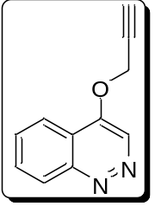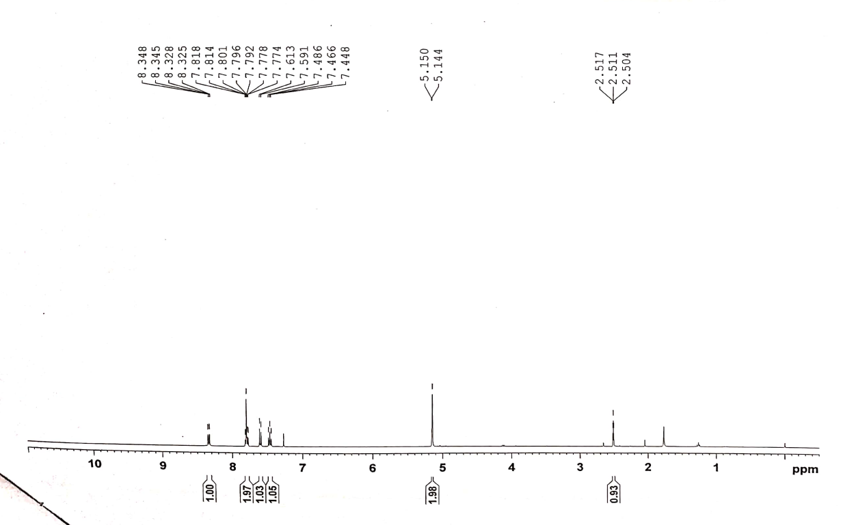
Figure S2: ¹H-NMR spectrum of compound 4a

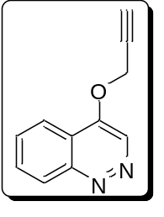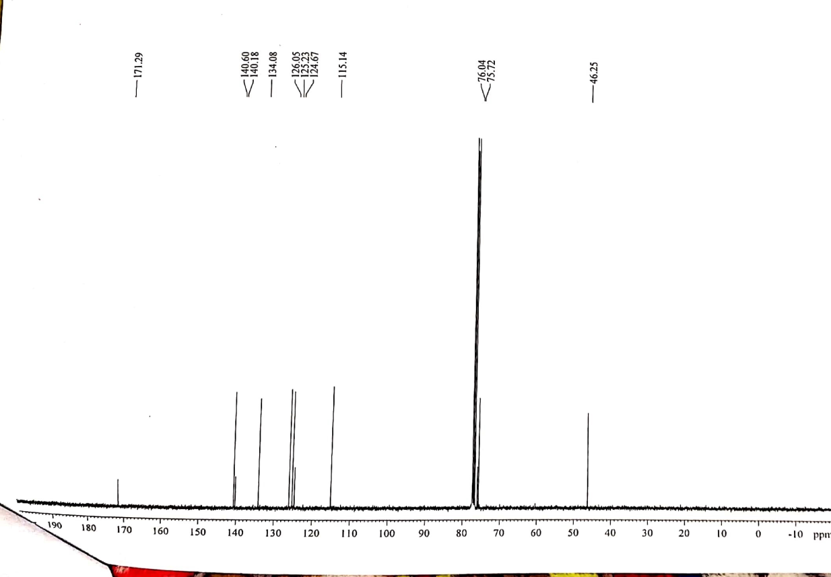
Figure S3: ¹³C- NMR spectrum of compound 4a

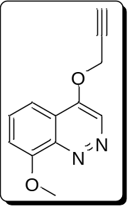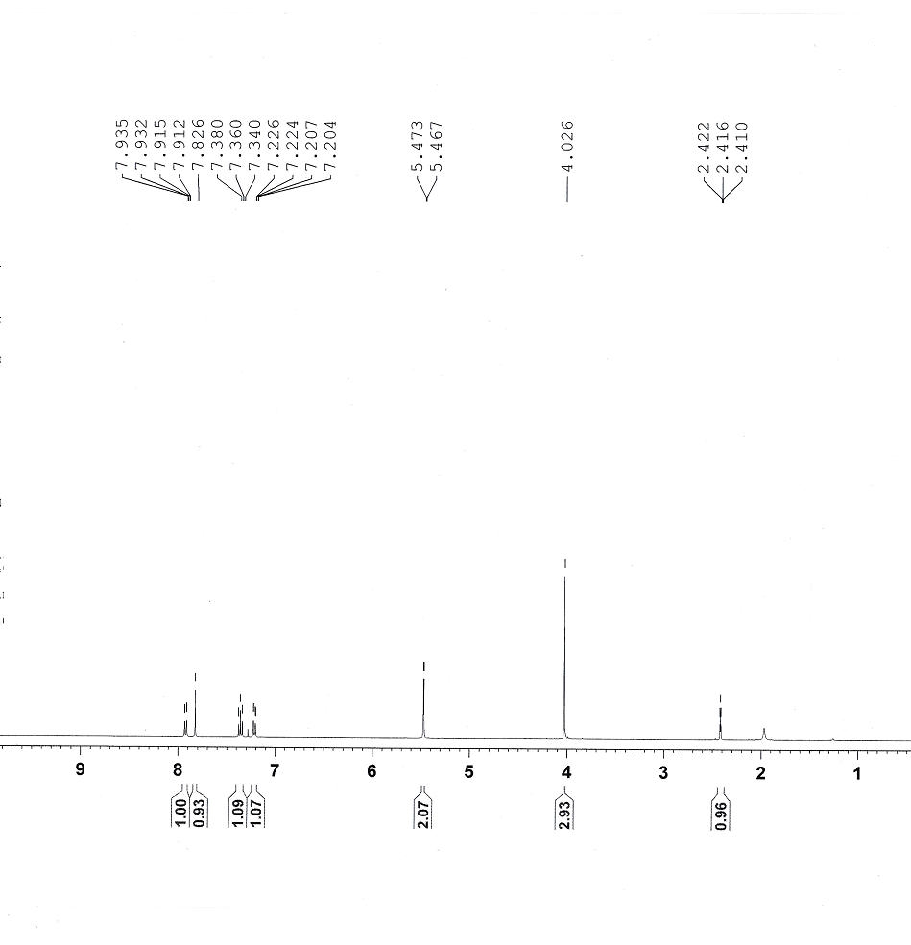 Figure S4: ¹³C- NMR spectrum of compound 4b

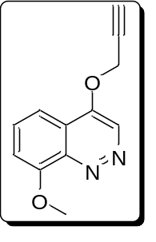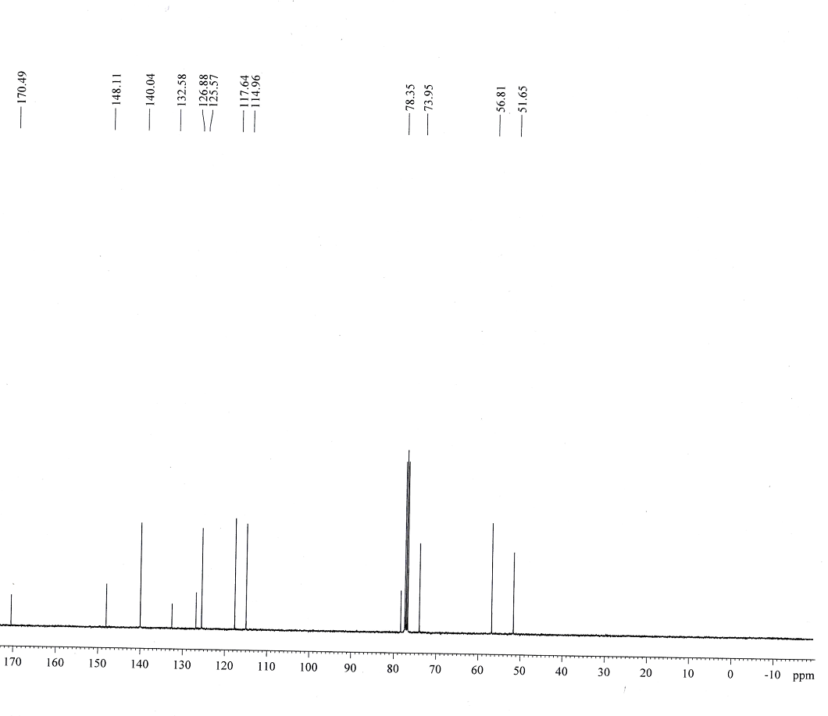
Figure S5: ¹³C- NMR spectrum of compound 4b

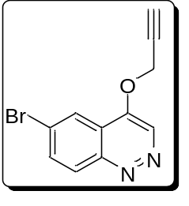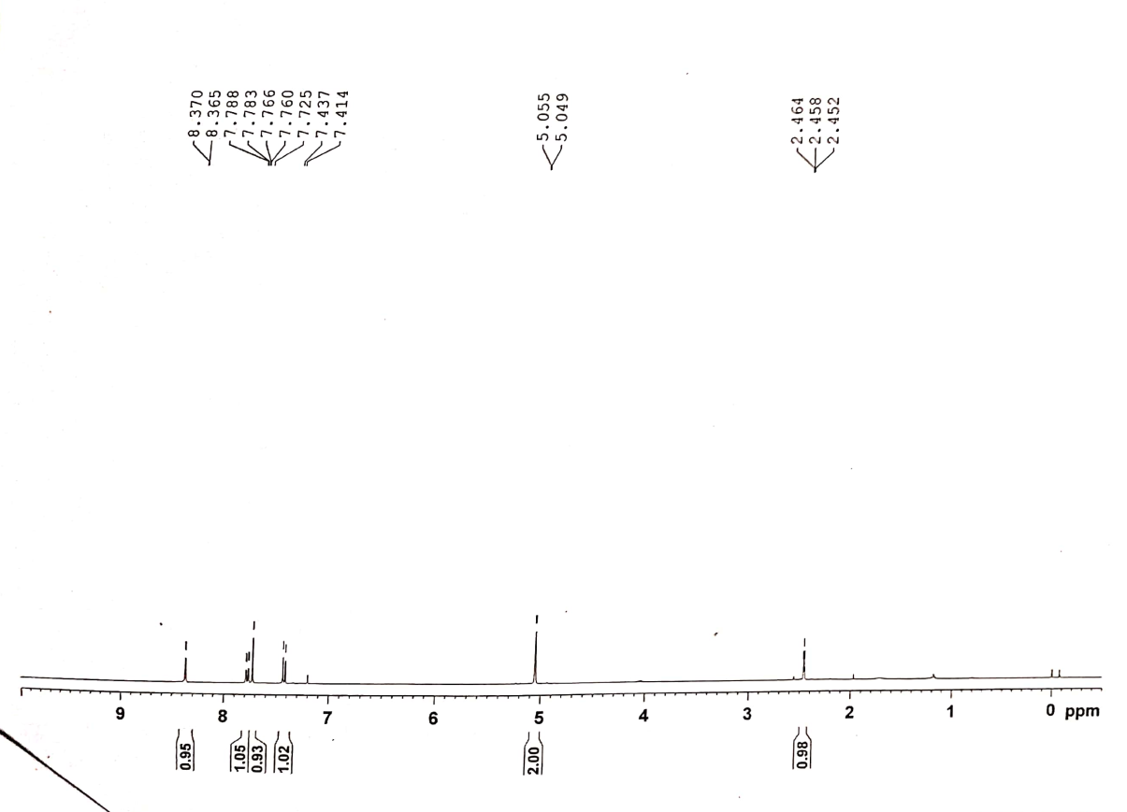 Figure S6: ¹H-NMR spectrum of compound 4c

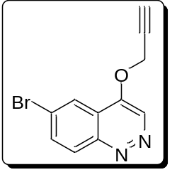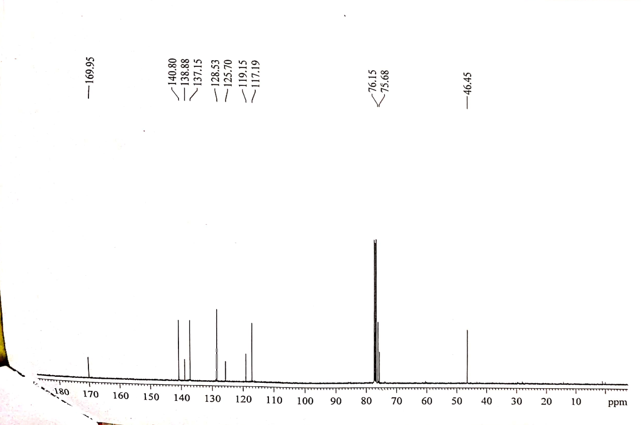
Figure S7: ¹³C- NMR spectrum of compound 4c
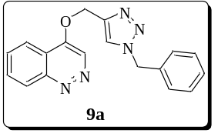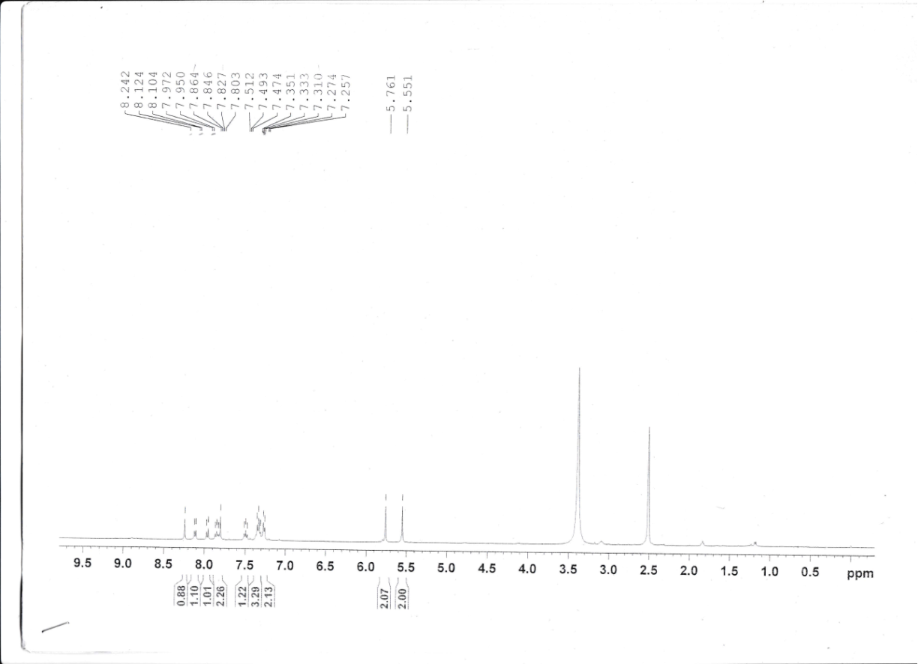
Figure S8: ¹H-NMR spectrum of compound 9a
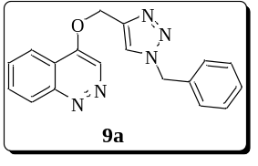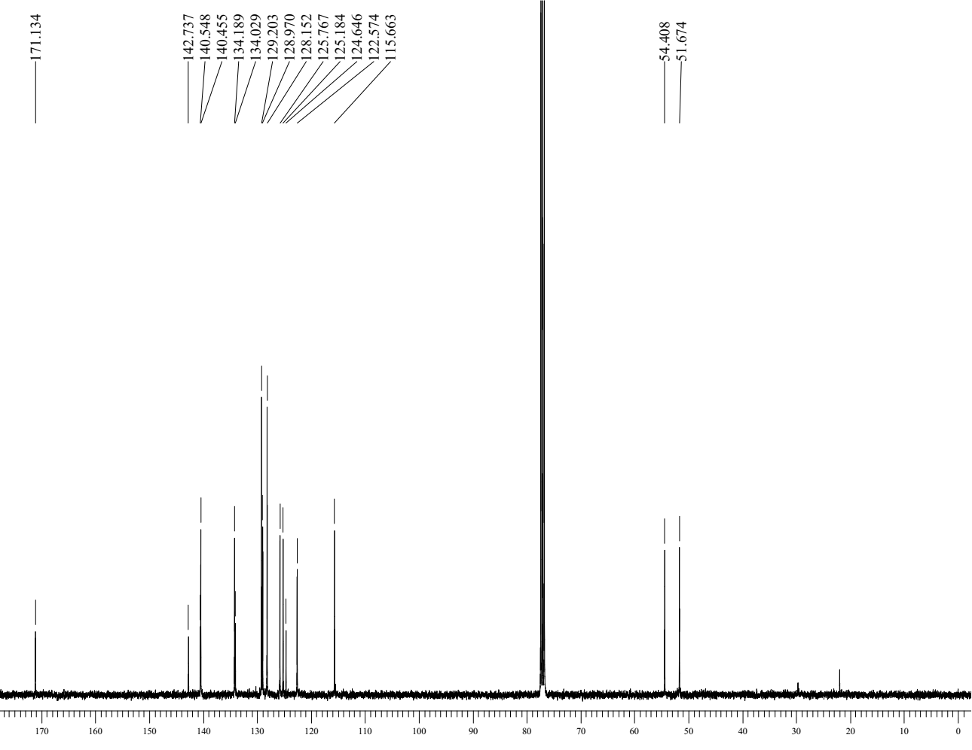
Figure S9: ¹³C- NMR spectrum of compound 9a

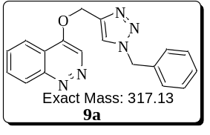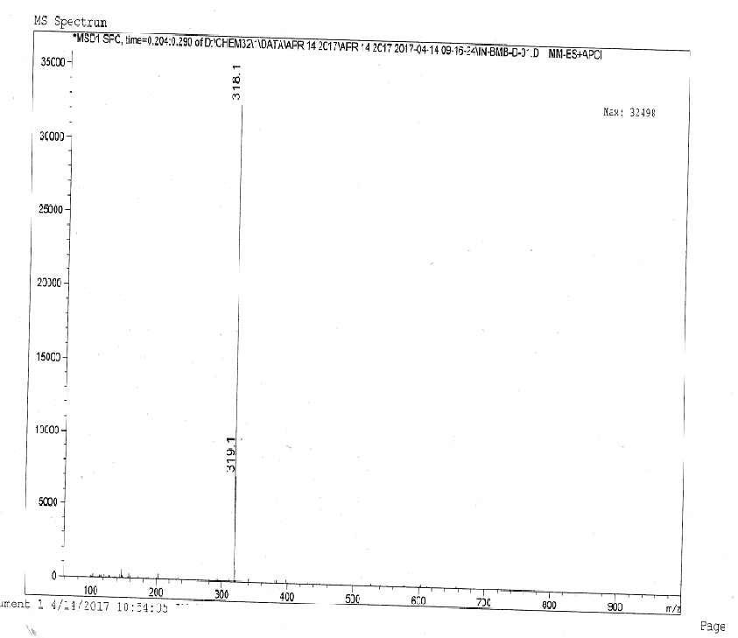
Figure S10: ESI Mass spectrum of compound 9a
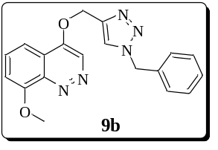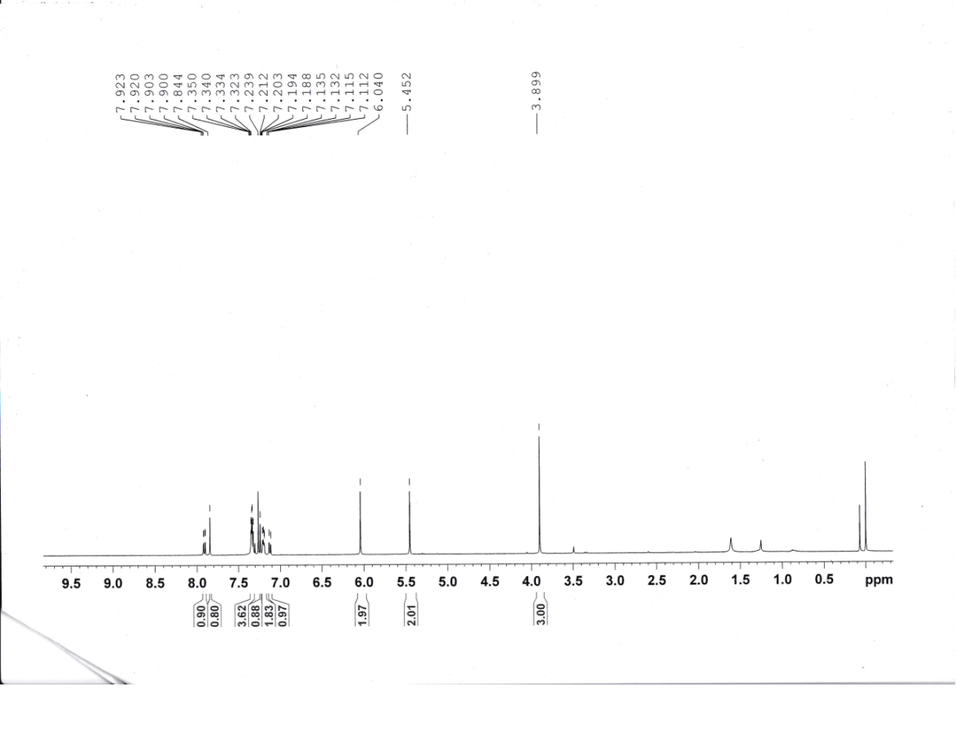
Figure S11: ¹H-NMR spectrum of compound 9b
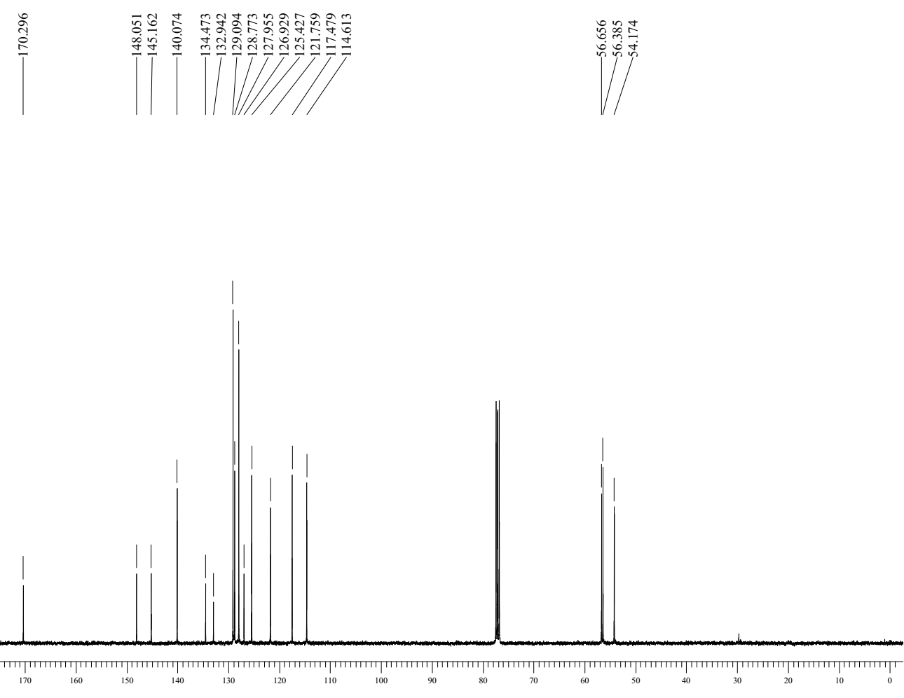
Figure S12: ¹³C- NMR spectrum of compound 9b

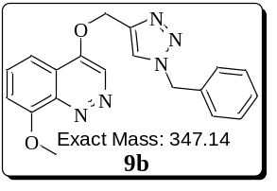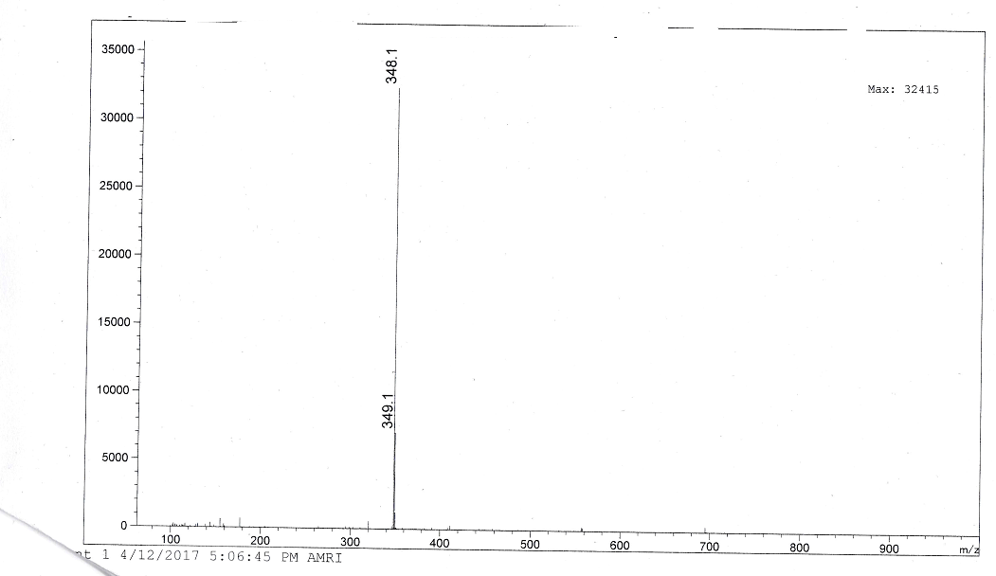
Figure S13: ESI Mass spectrum of compound 9b

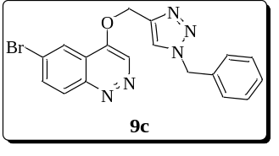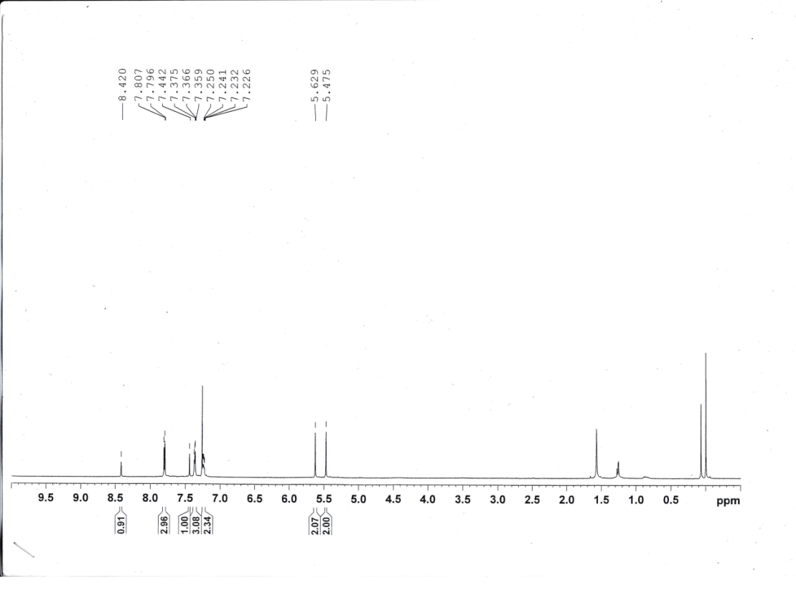
Figure S14: ¹H-NMR spectrum of compound 9c
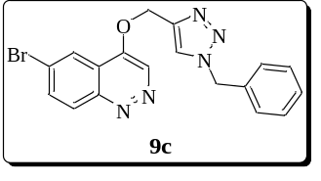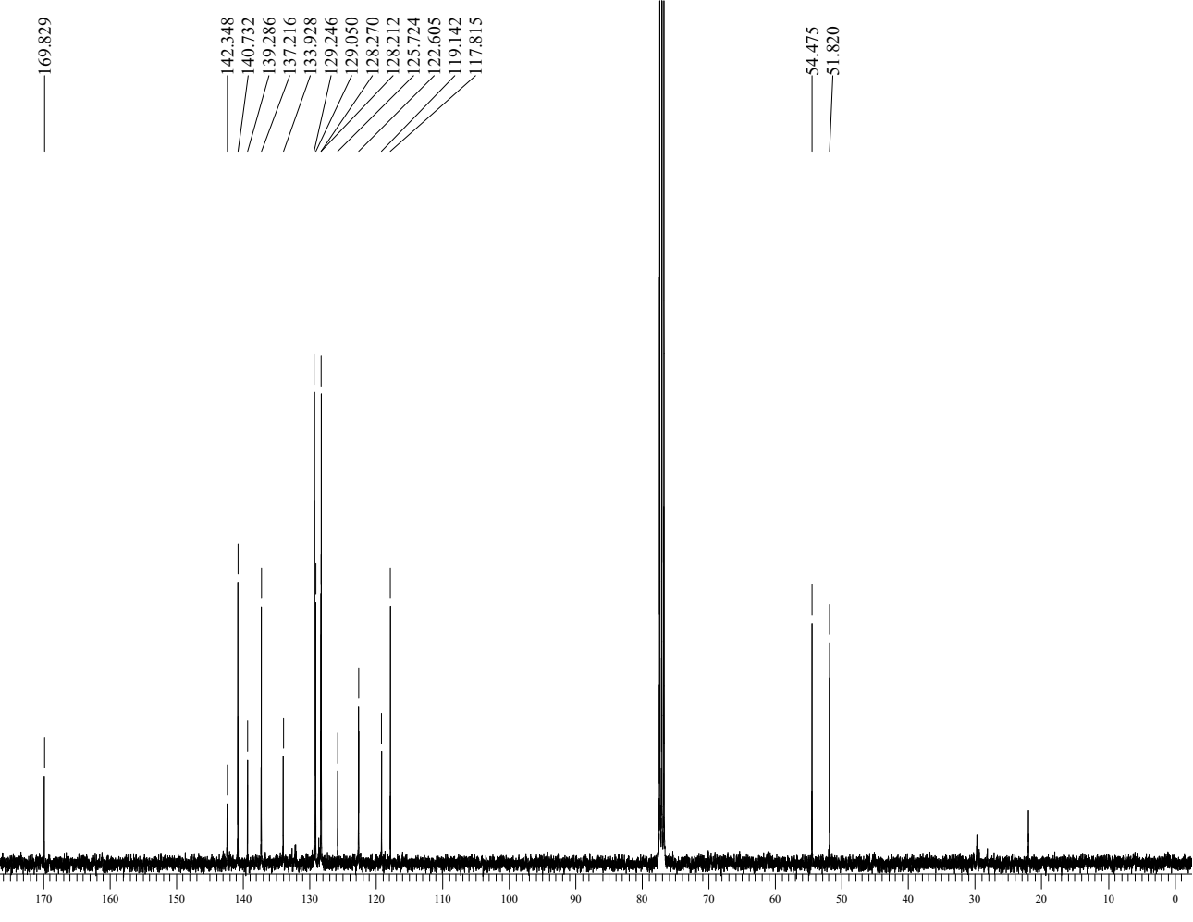
Figure S15: ¹³C- NMR spectrum of compound 9c

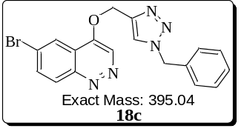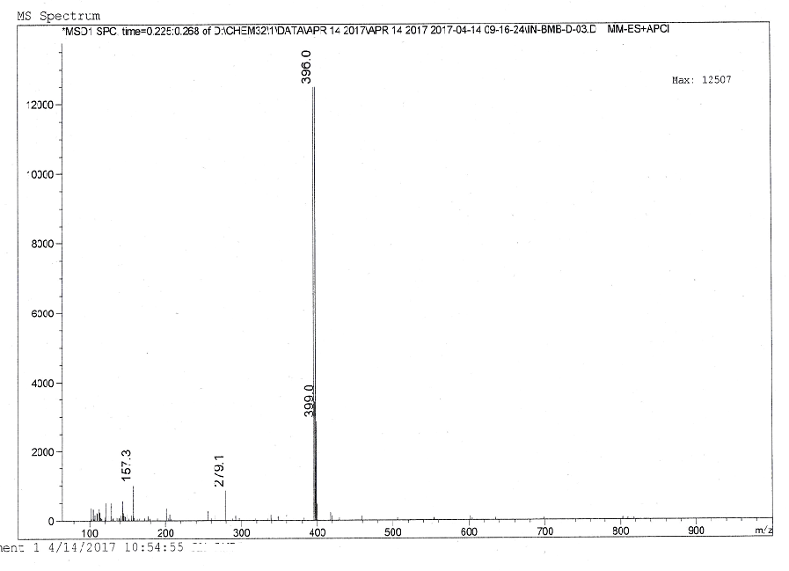
Figure S16: ESI Mass spectrum of compound 9c
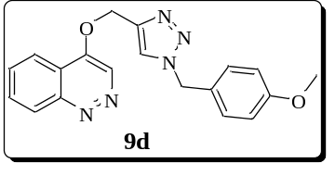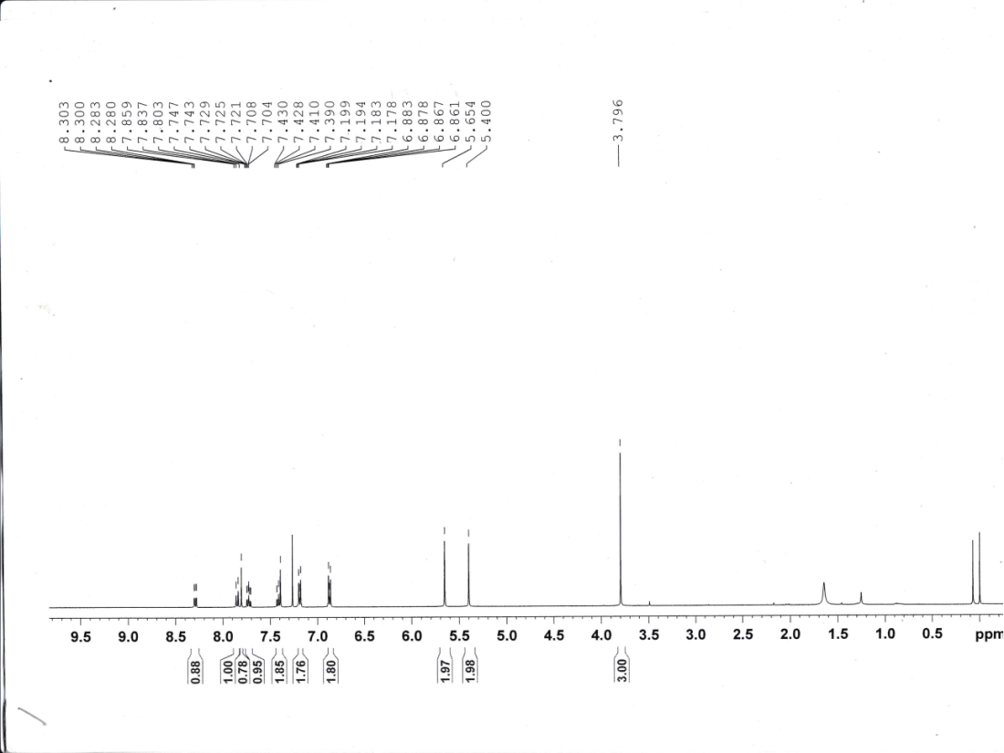
Figure S17: ¹H-NMR spectrum of compound 9d
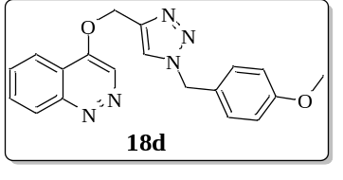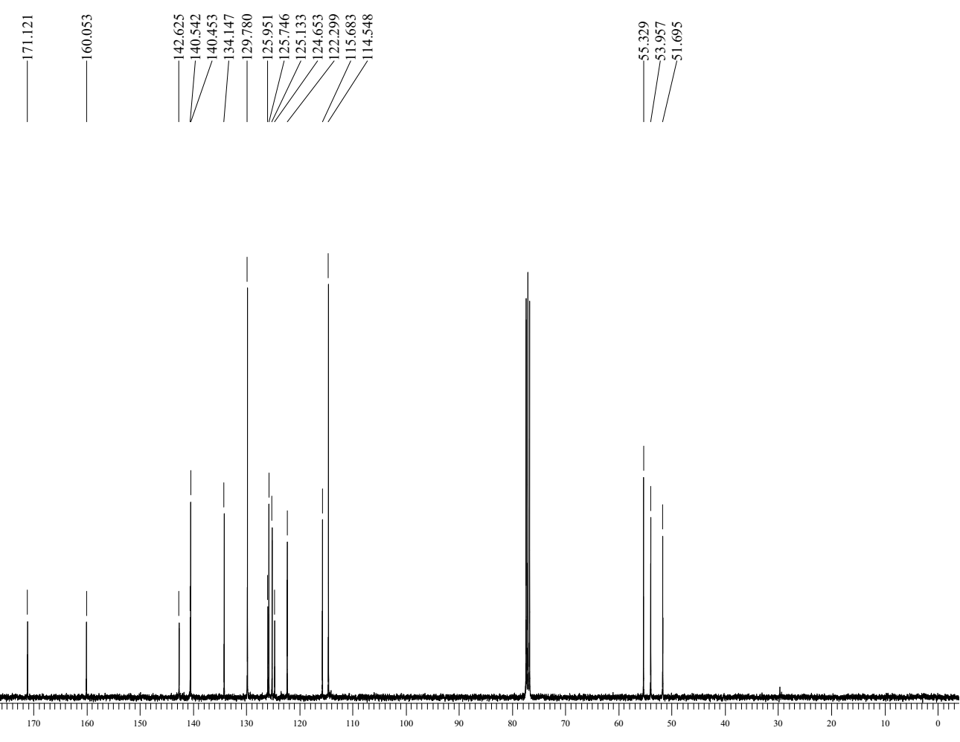
Figure S18: ¹³C- NMR spectrum of compound 9d

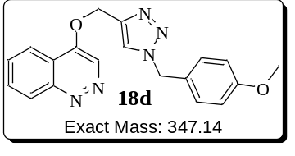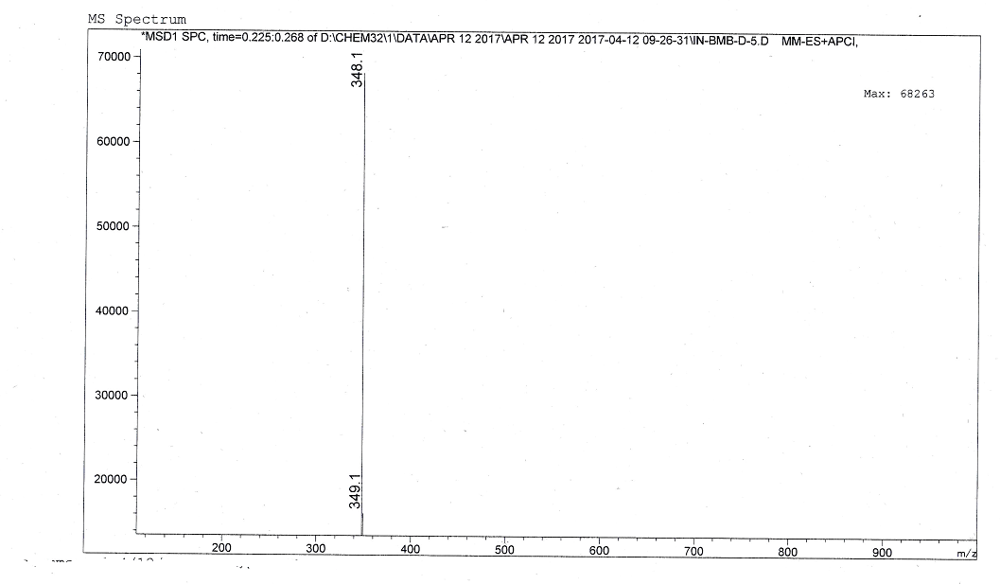
Figure S19: ESI Mass spectrum of compound 9d

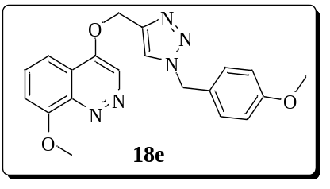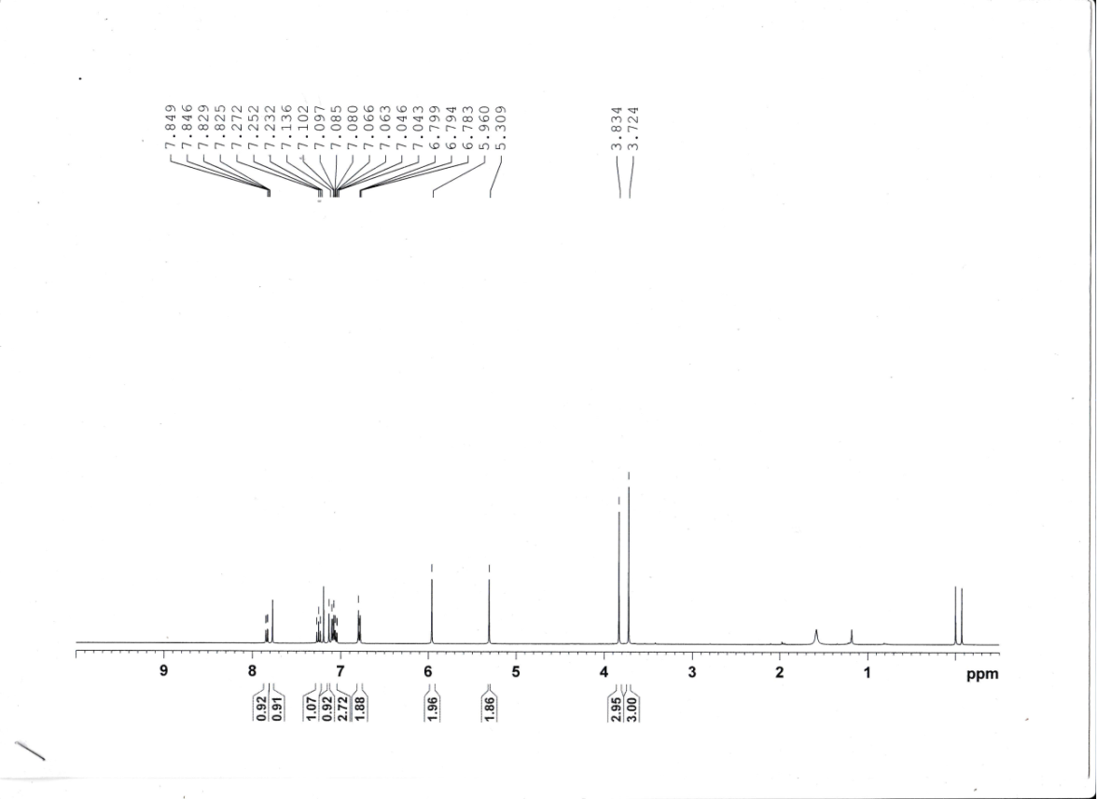
Figure S20: ¹H-NMR spectrum of compound 9e
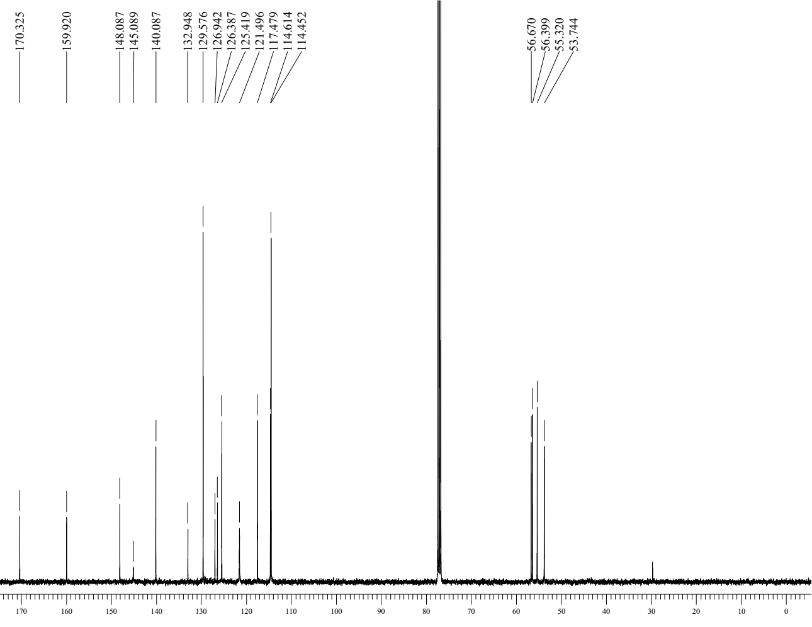
Figure S21: ¹³C- NMR spectrum of compound 9e

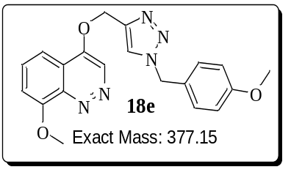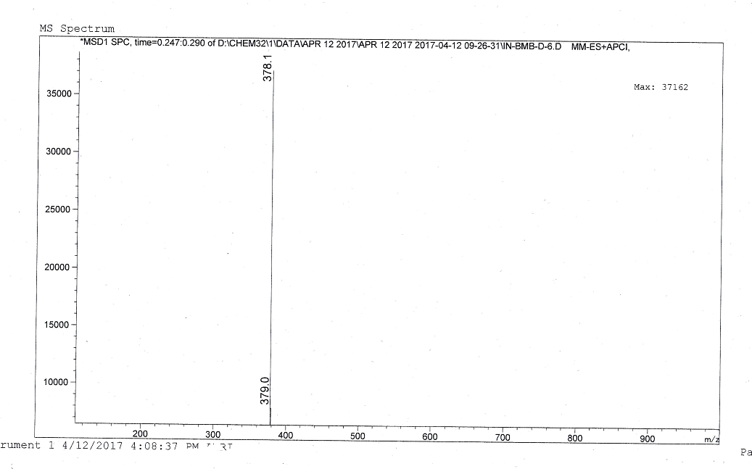
Figure S22: ESI Mass spectrum of compound 9e
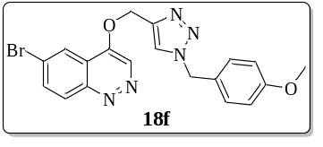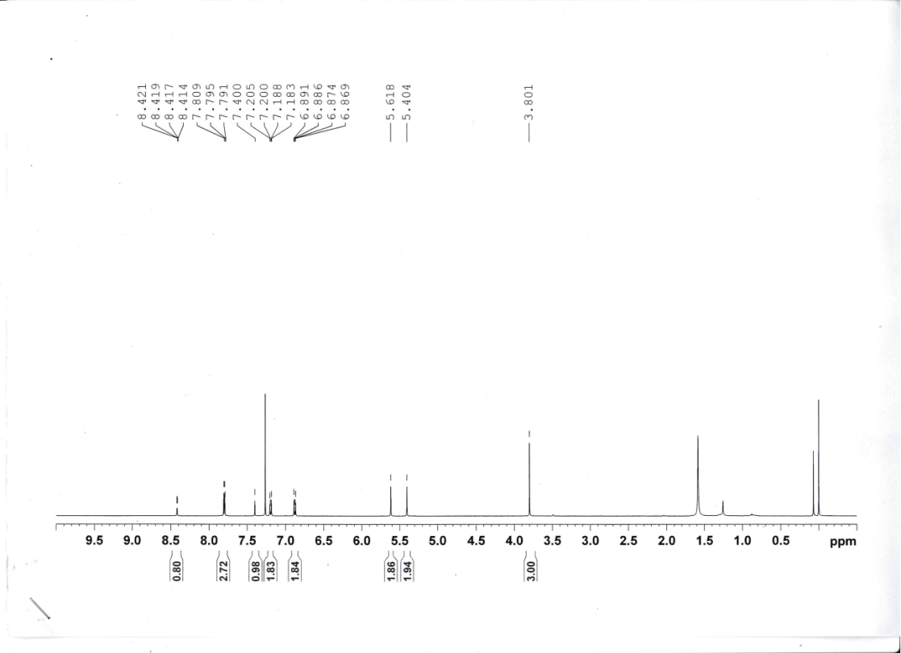
Figure S23: ¹H-NMR spectrum of compound 9f
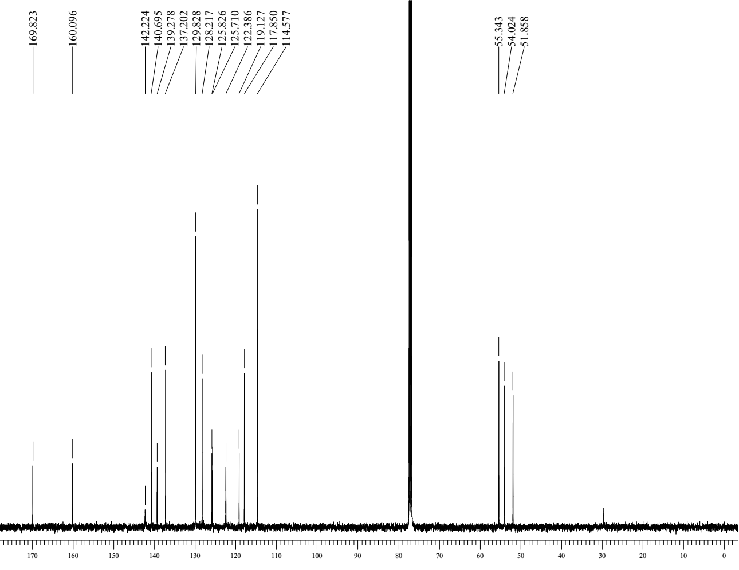
Figure S24: ¹³C- NMR spectrum of compound 9f

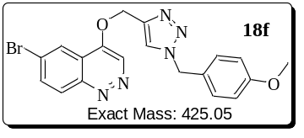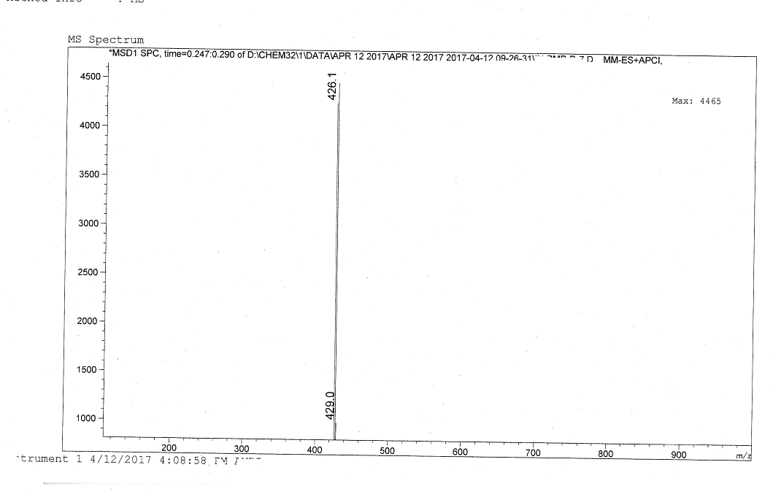
Figure S25: ESI Mass spectrum of compound 9f

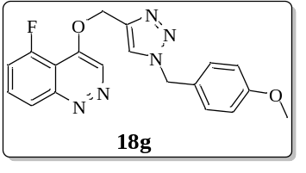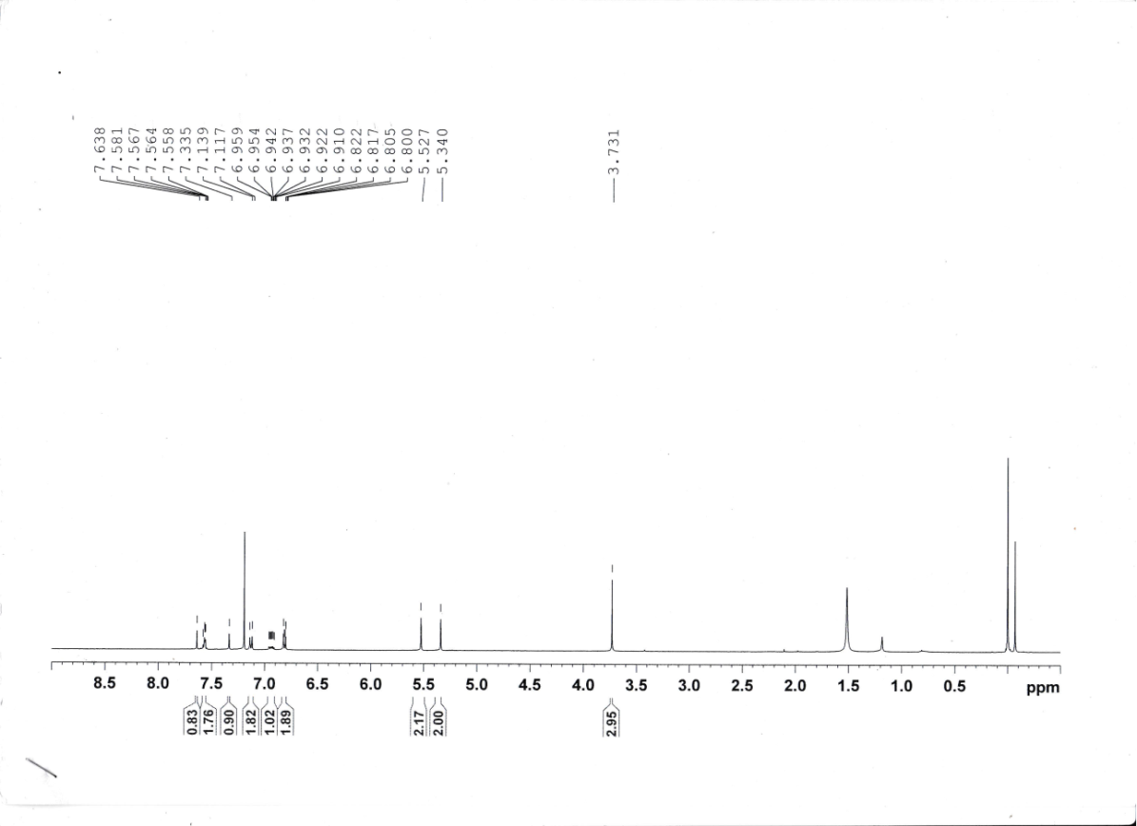
Figure S26: ¹H-NMR spectrum of compound 9g
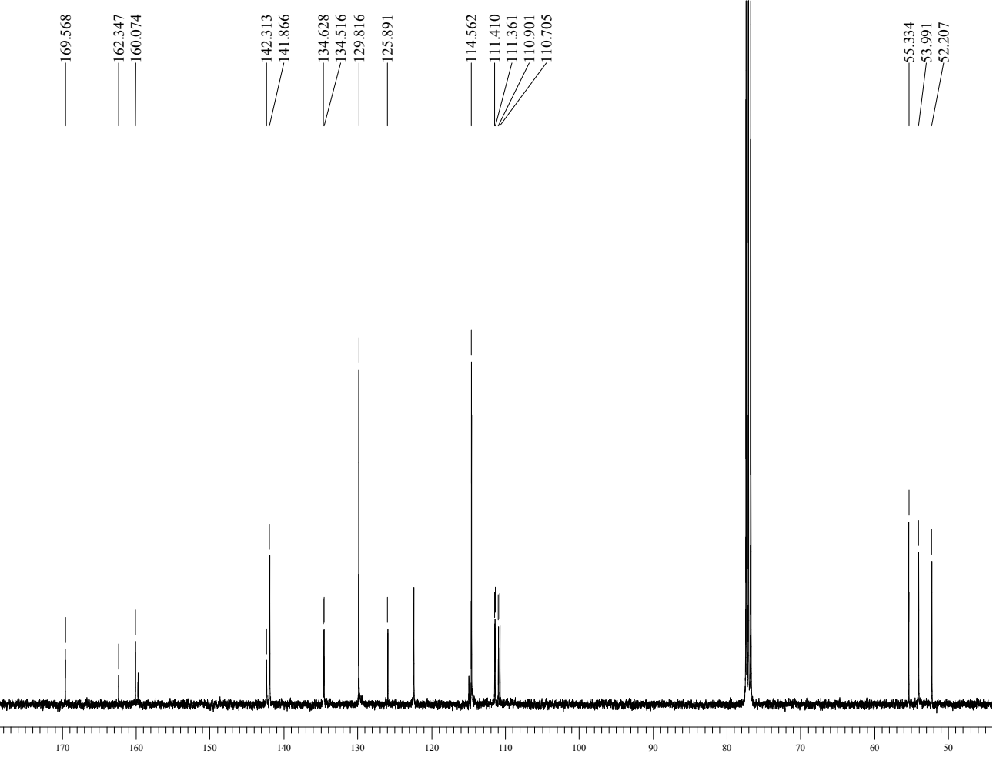
Figure S27: ¹³C- NMR spectrum of compound 9f

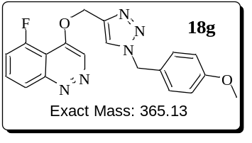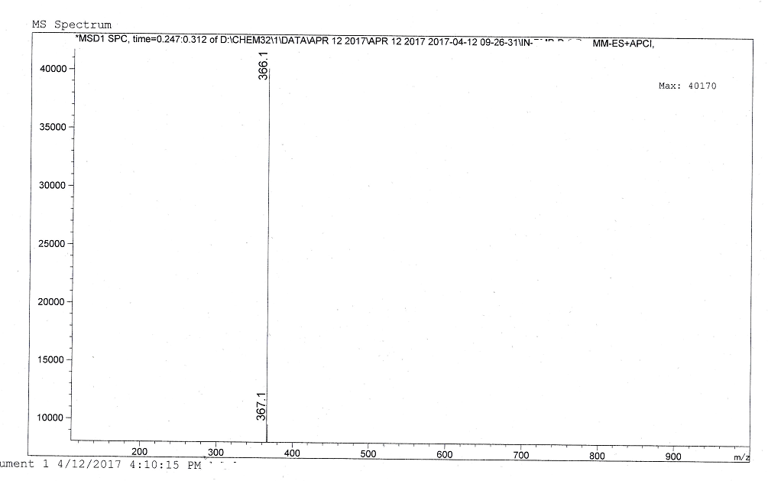
Figure S28: ESI Mass spectrum of compound 9f

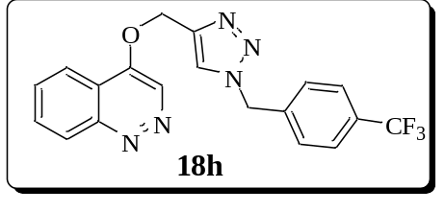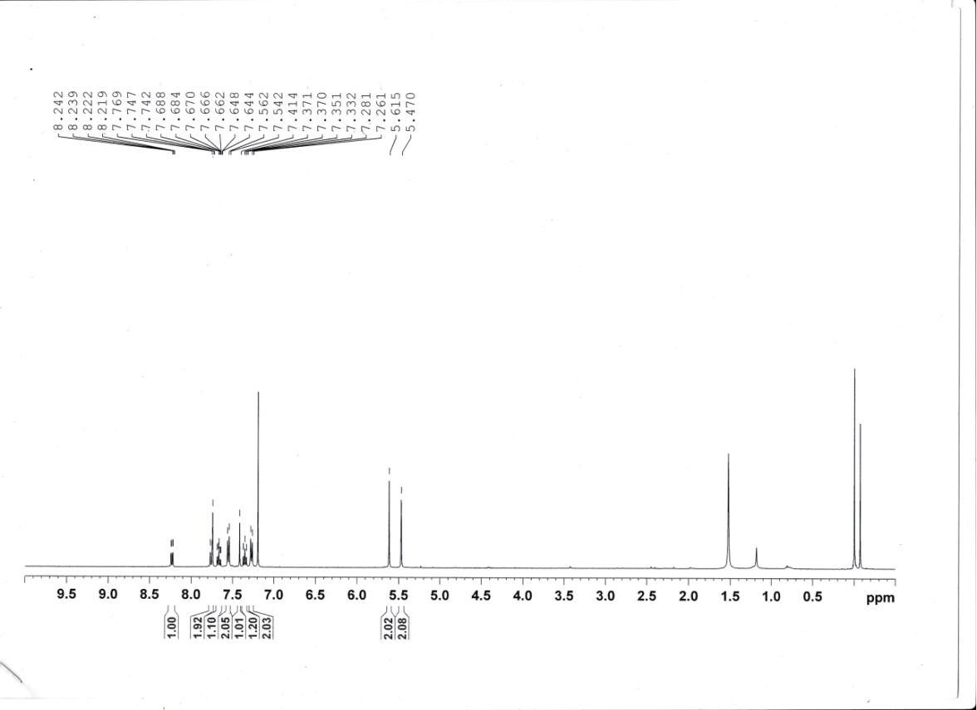
Figure S29: ¹H-NMR spectrum of compound 9h
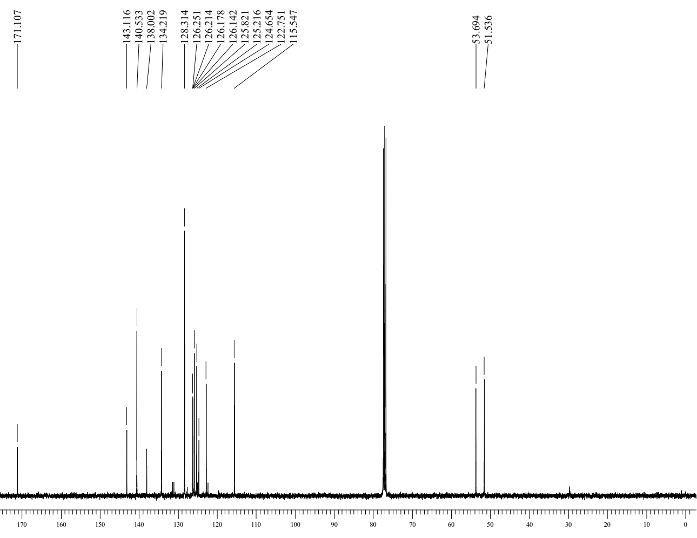
Figure S30: ¹³C- NMR spectrum of compound 9h

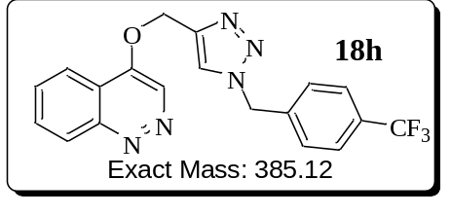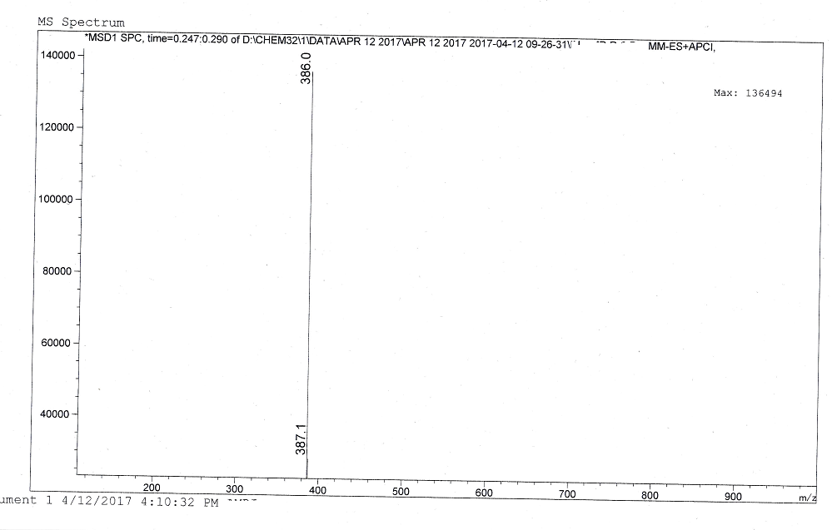
Figure S31: ESI Mass spectrum of compound 9h
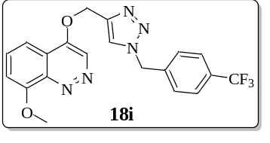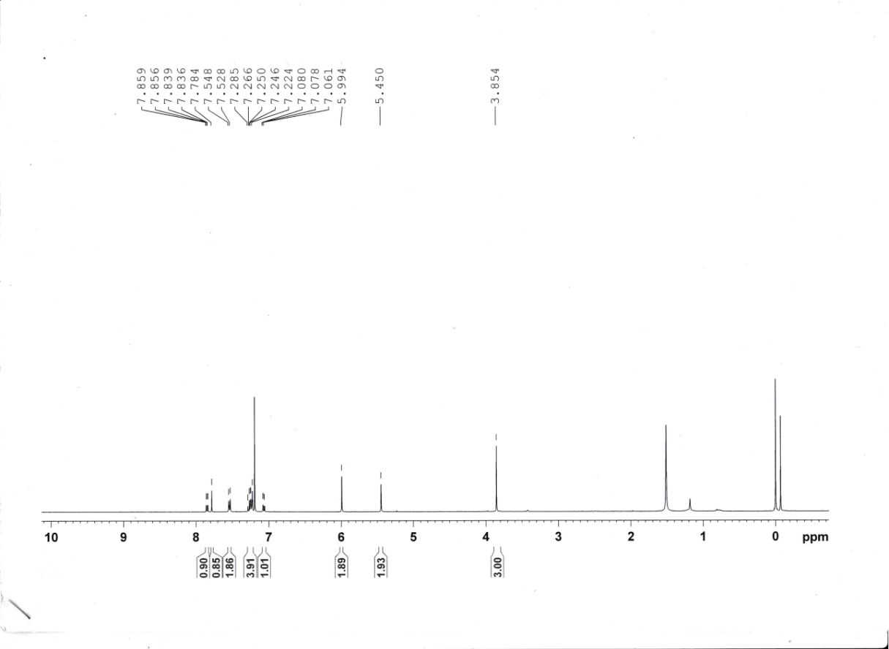
Figure S32: ¹H-NMR spectrum of compound 9i
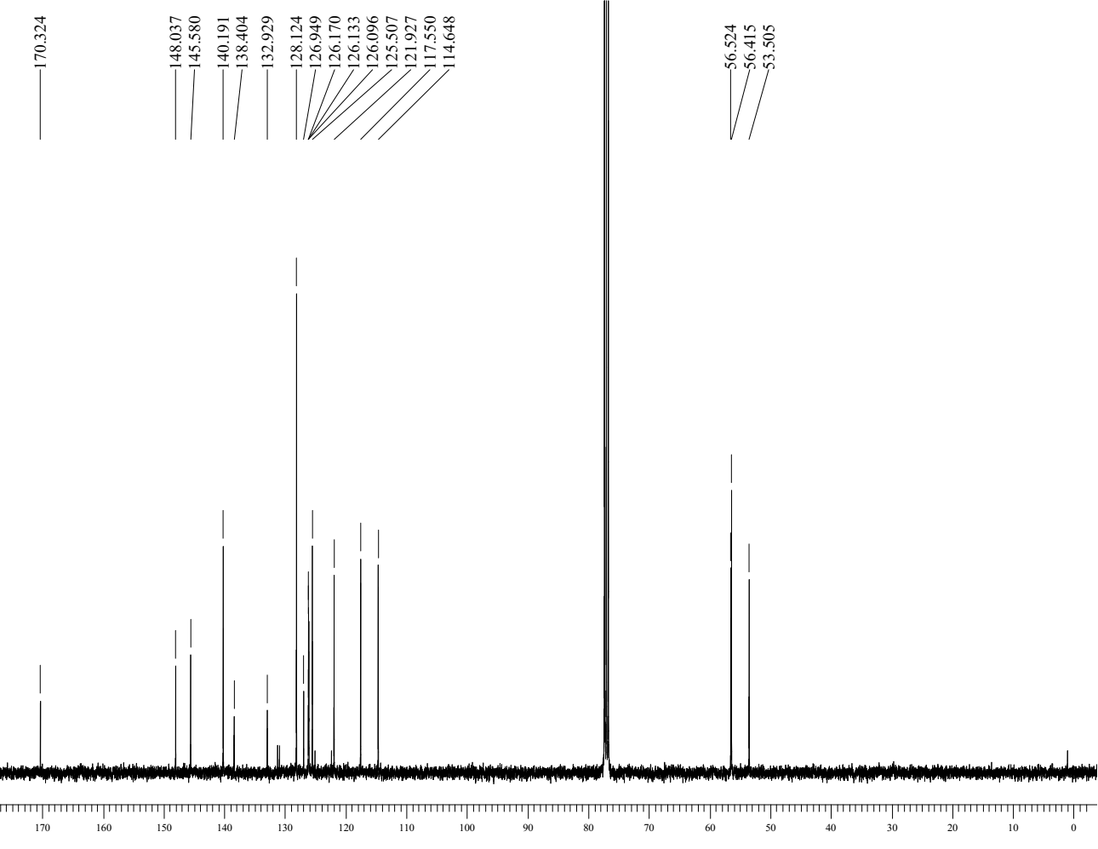
Figure S33: ¹³C- NMR spectrum of compound 9i

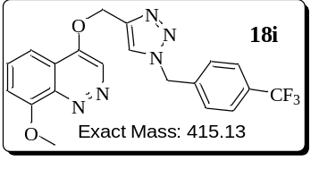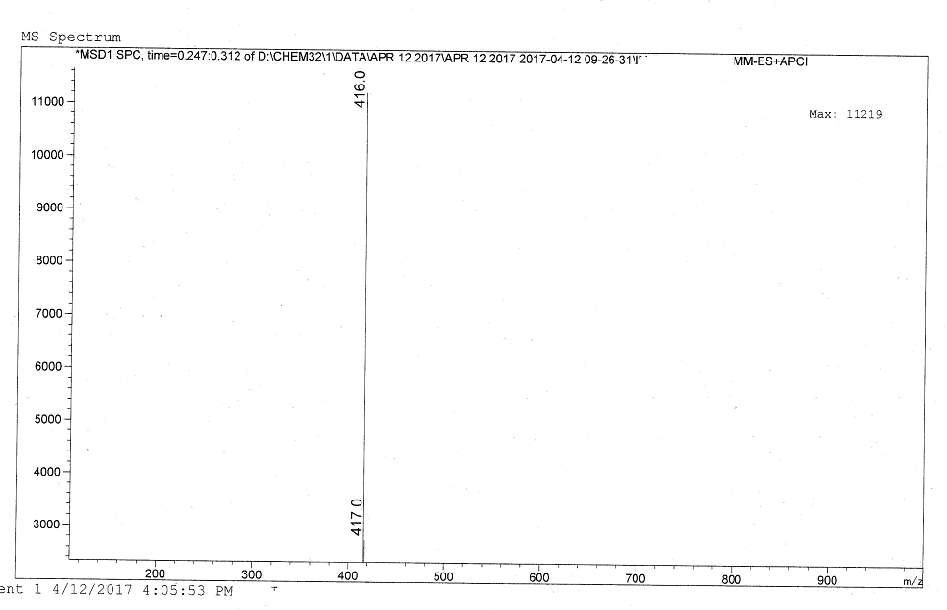
Figure S34: ESI Mass spectrum of compound 9i
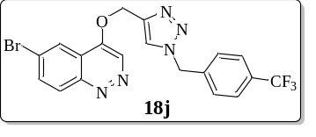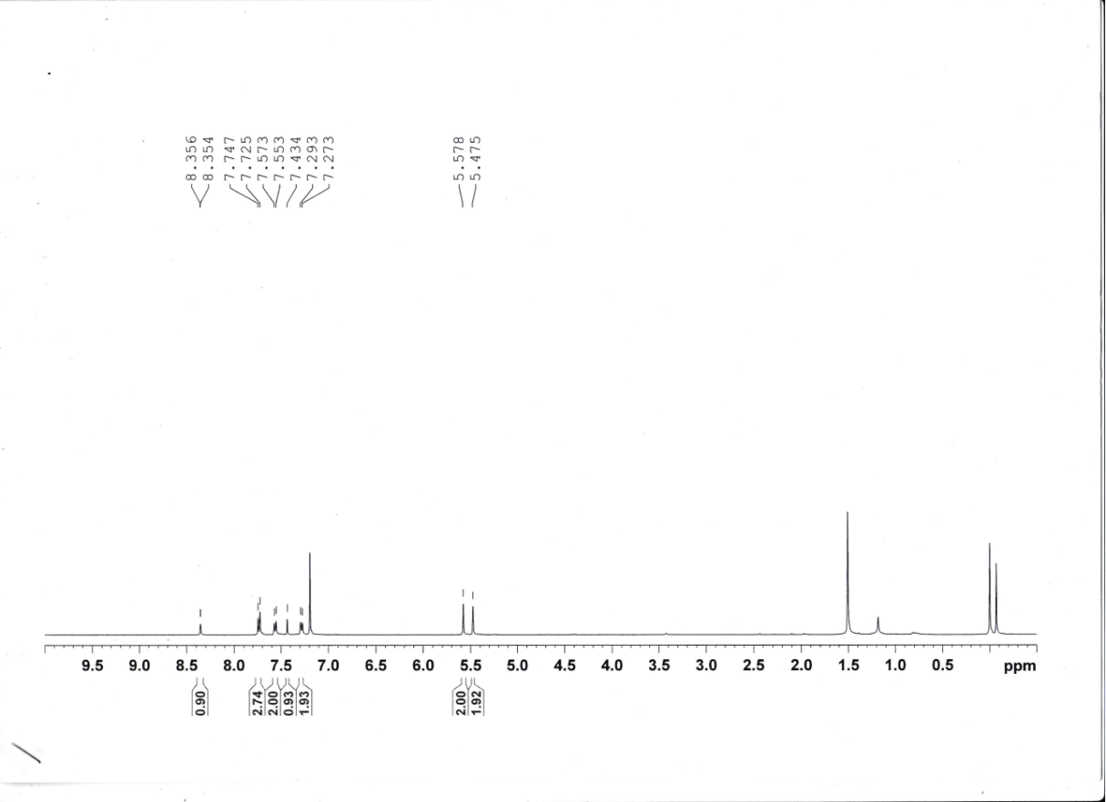
Figure S35: ¹H-NMR spectrum of compound 9j
Figure S36: ¹³C- NMR spectrum of compound 9j

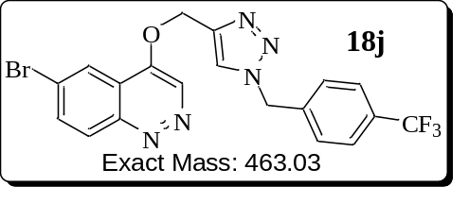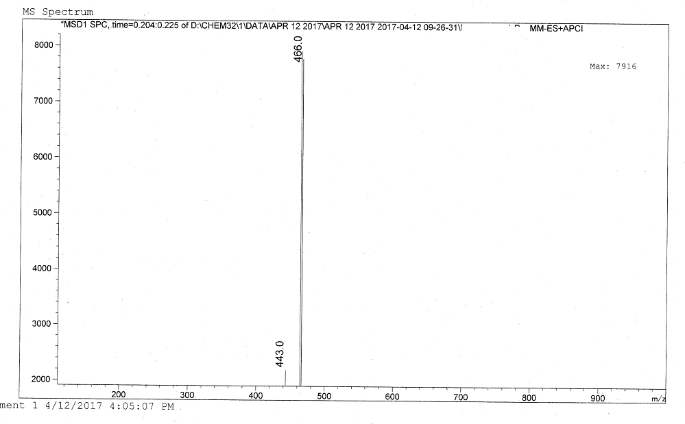
Figure S37: ESI Mass spectrum of compound 9j

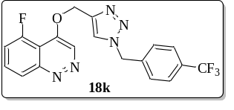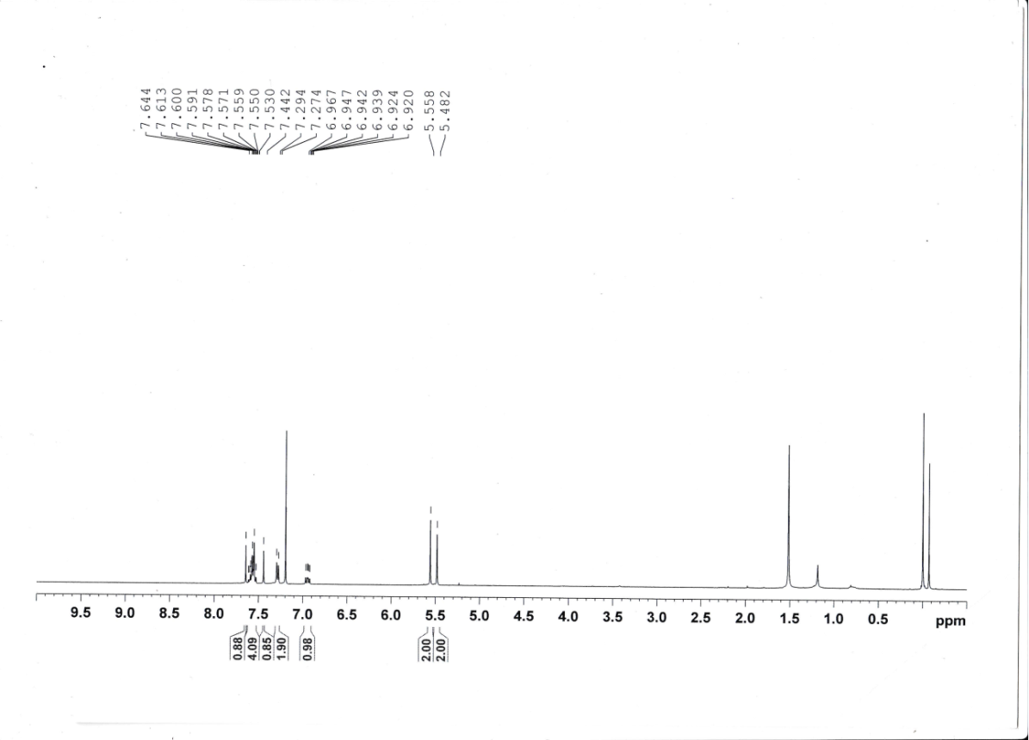
Figure S38: ¹H-NMR spectrum of compound 9k
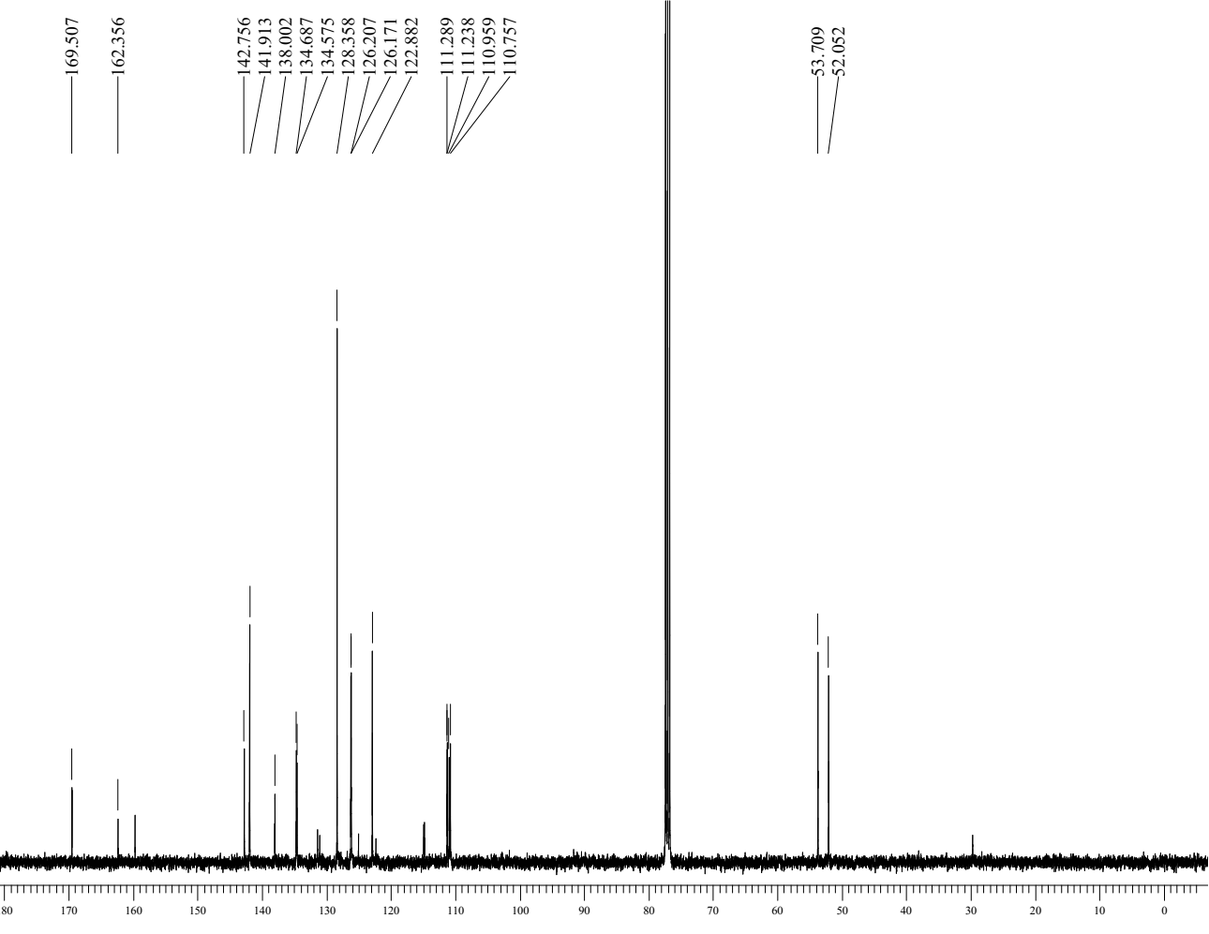
Figure S39: ¹³C- NMR spectrum of compound 9k

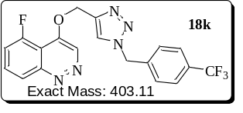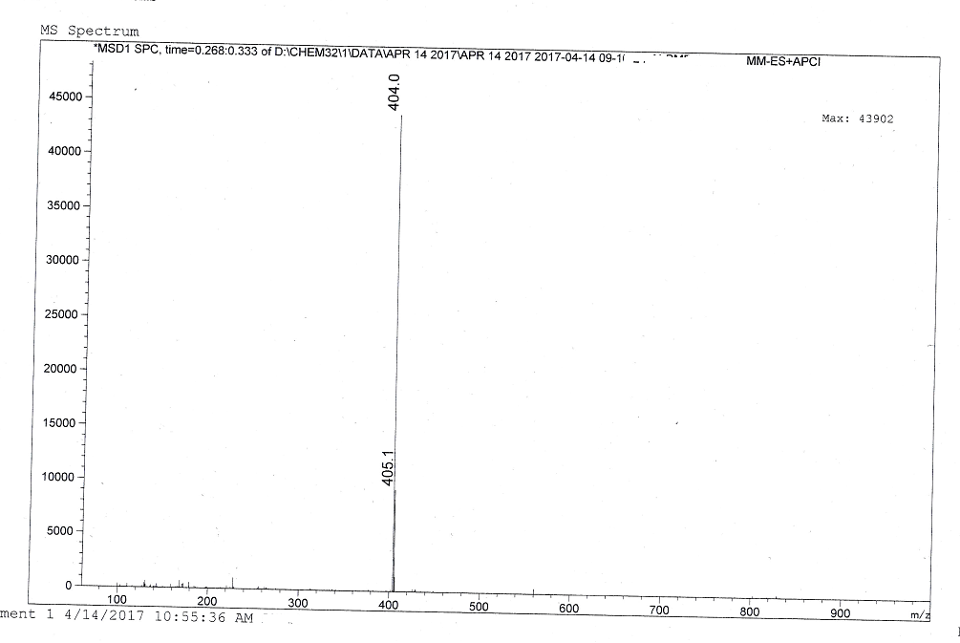
Figure S40: ESI Mass spectrum of compound 9k

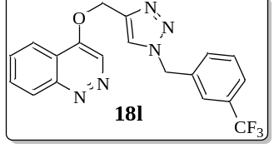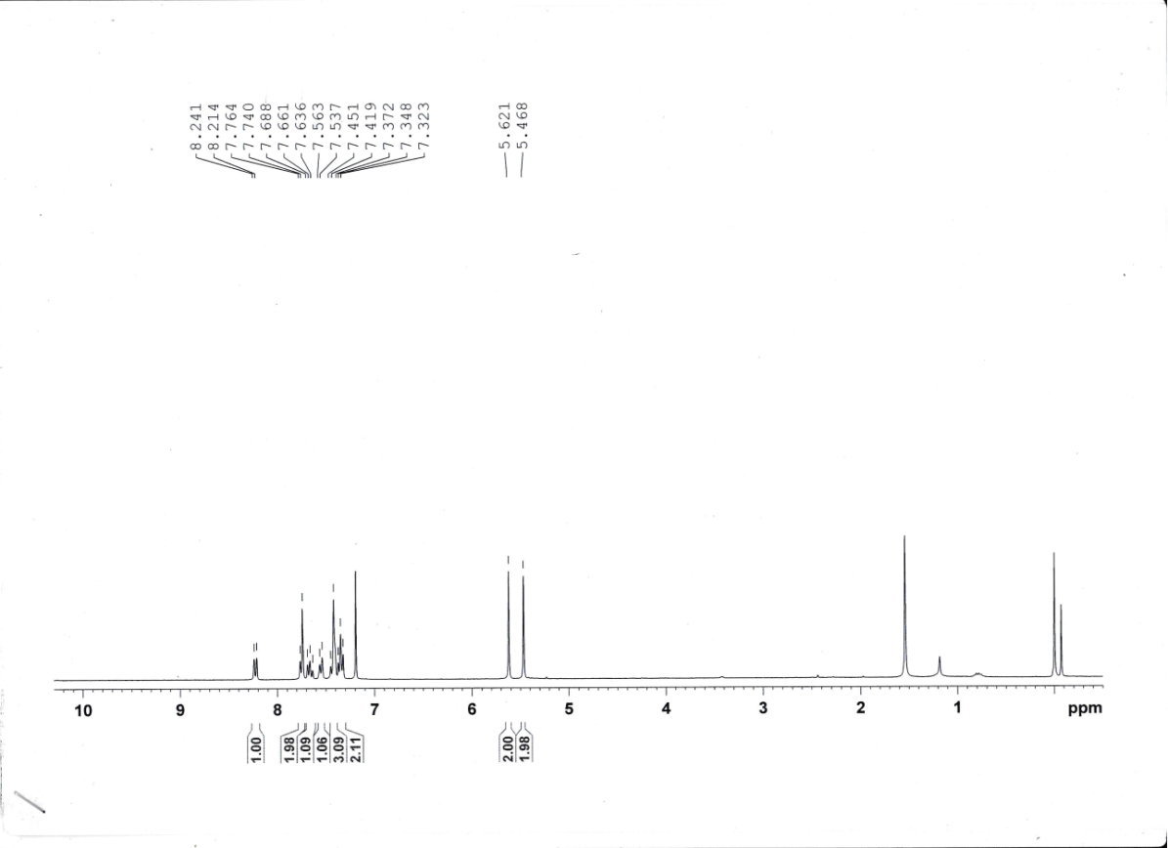
Figure S41: ¹H-NMR spectrum of compound 9l
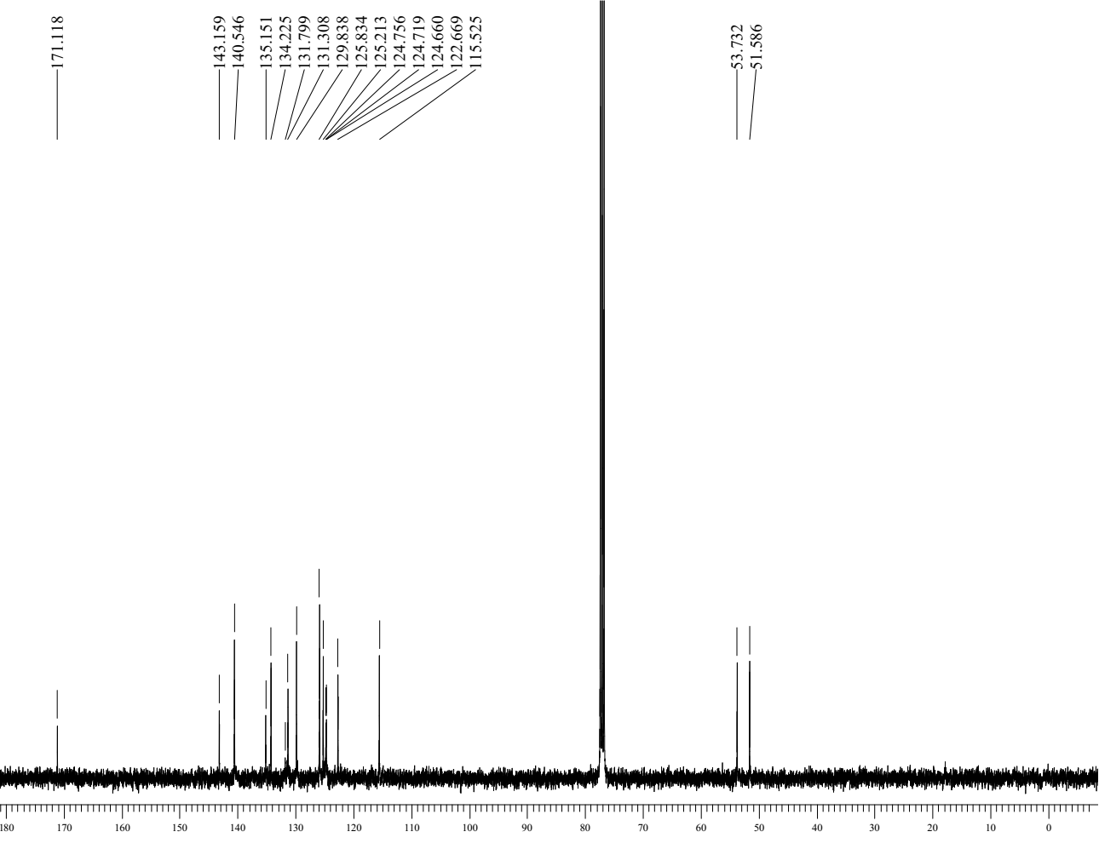
Figure S42: ¹³C- NMR spectrum of compound 9l

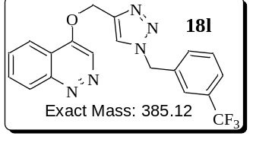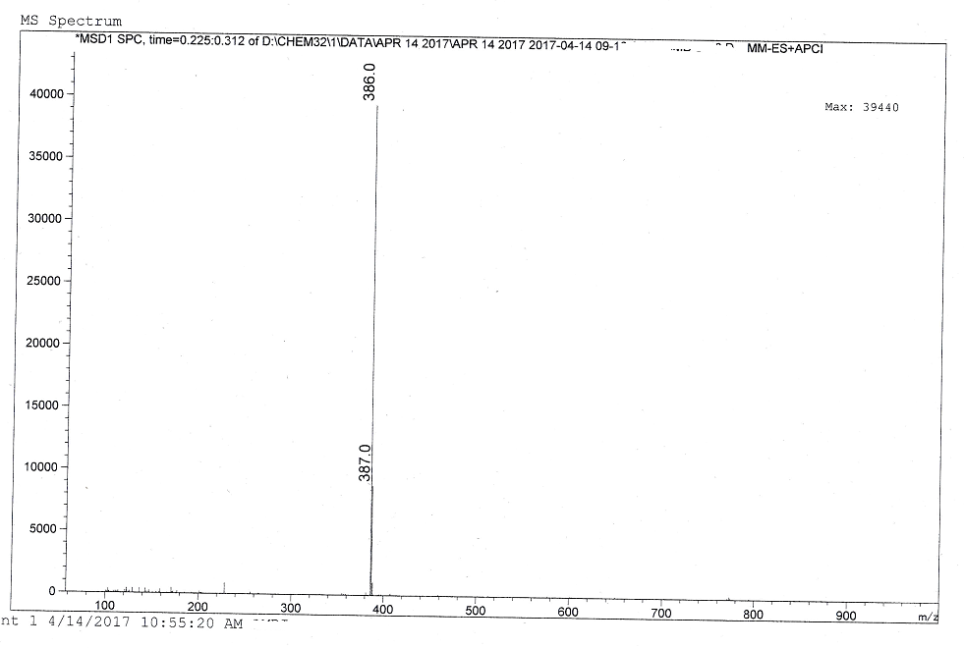
Figure S43: ESI Mass spectrum of compound 9l
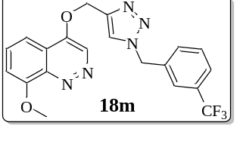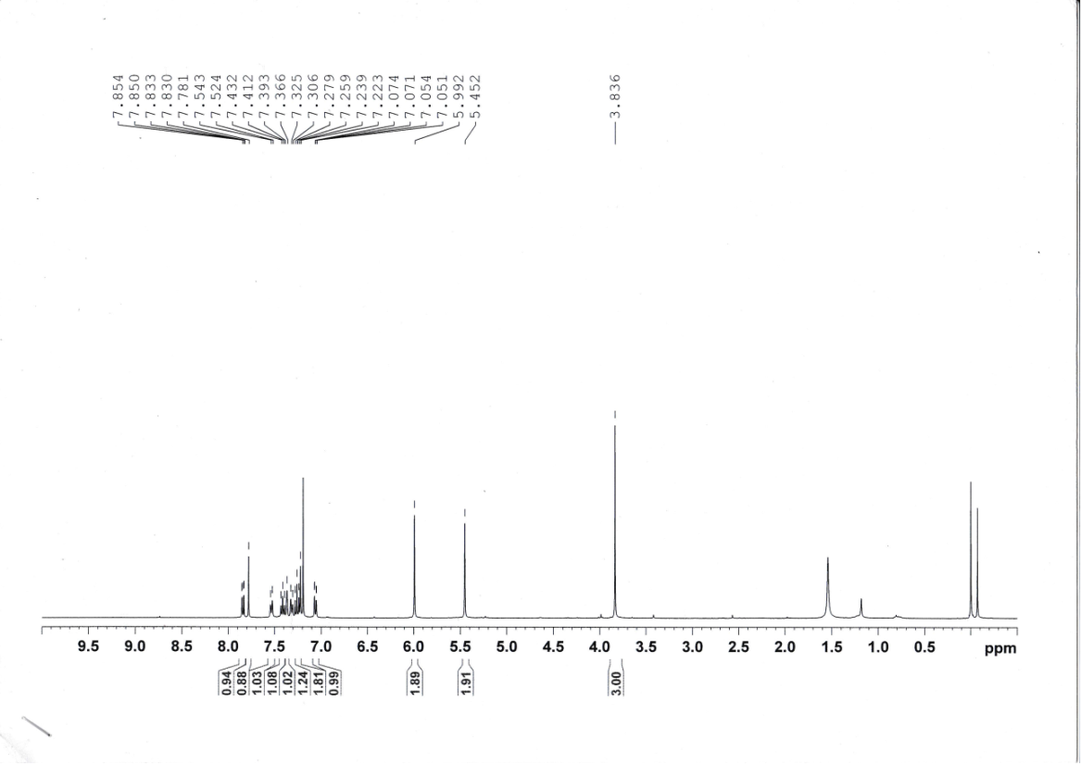
Figure S44: ¹H-NMR spectrum of compound 9m
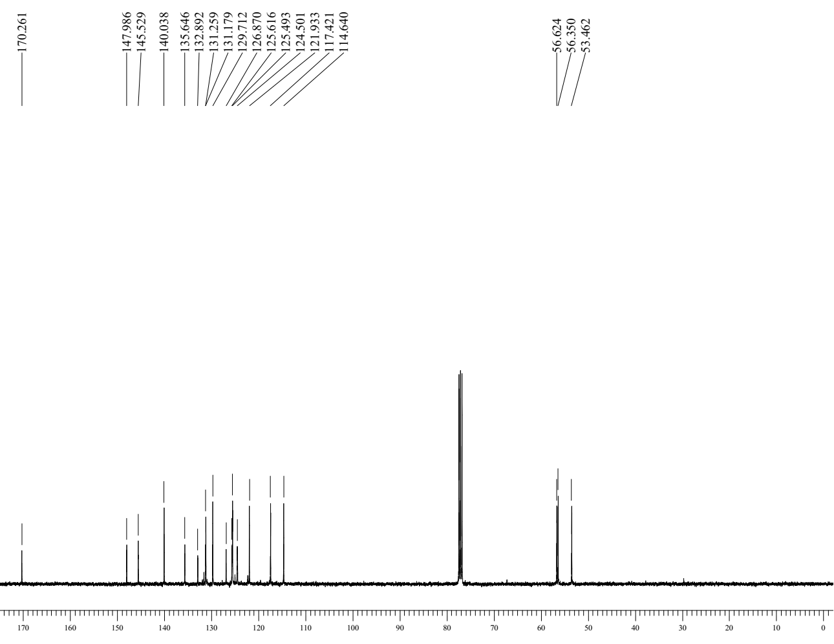
Figure S45: ¹³C- NMR spectrum of compound 9m

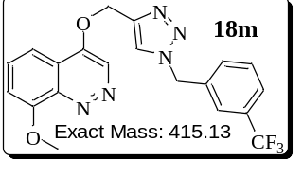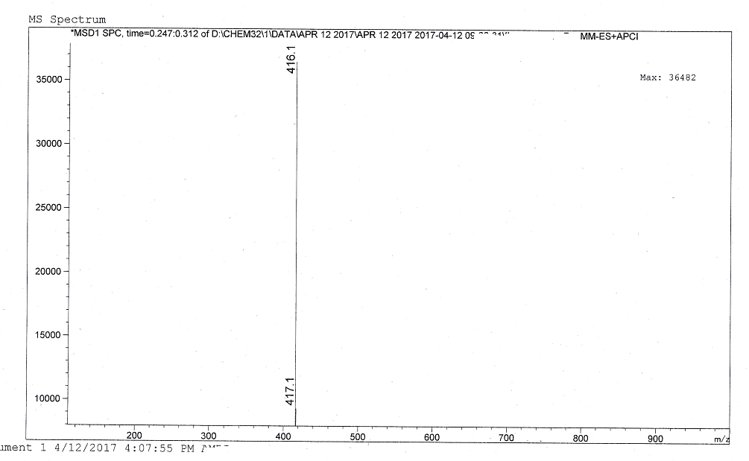
Figure S46: ESI Mass spectrum of compound 9m

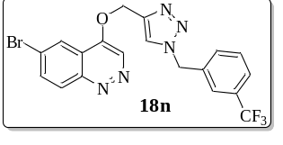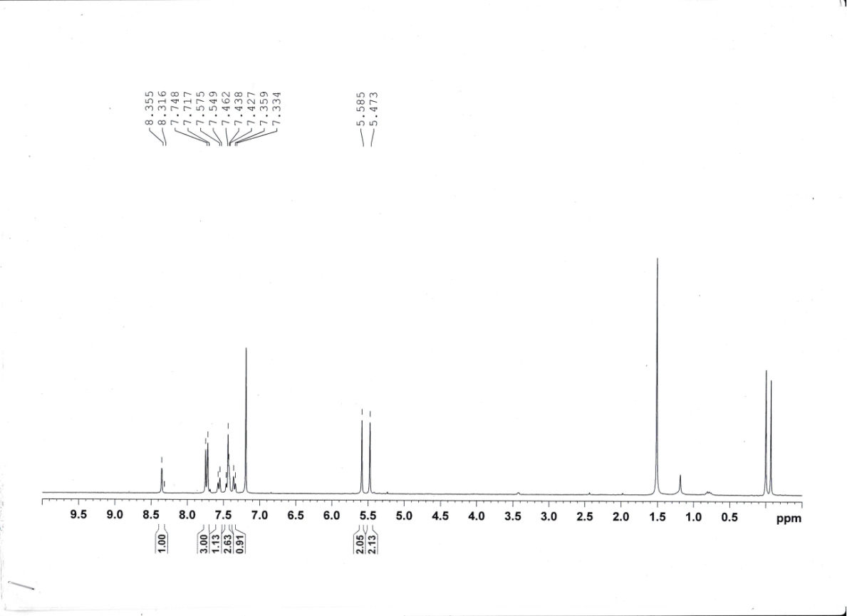
Figure S47: ¹H-NMR spectrum of compound 9n
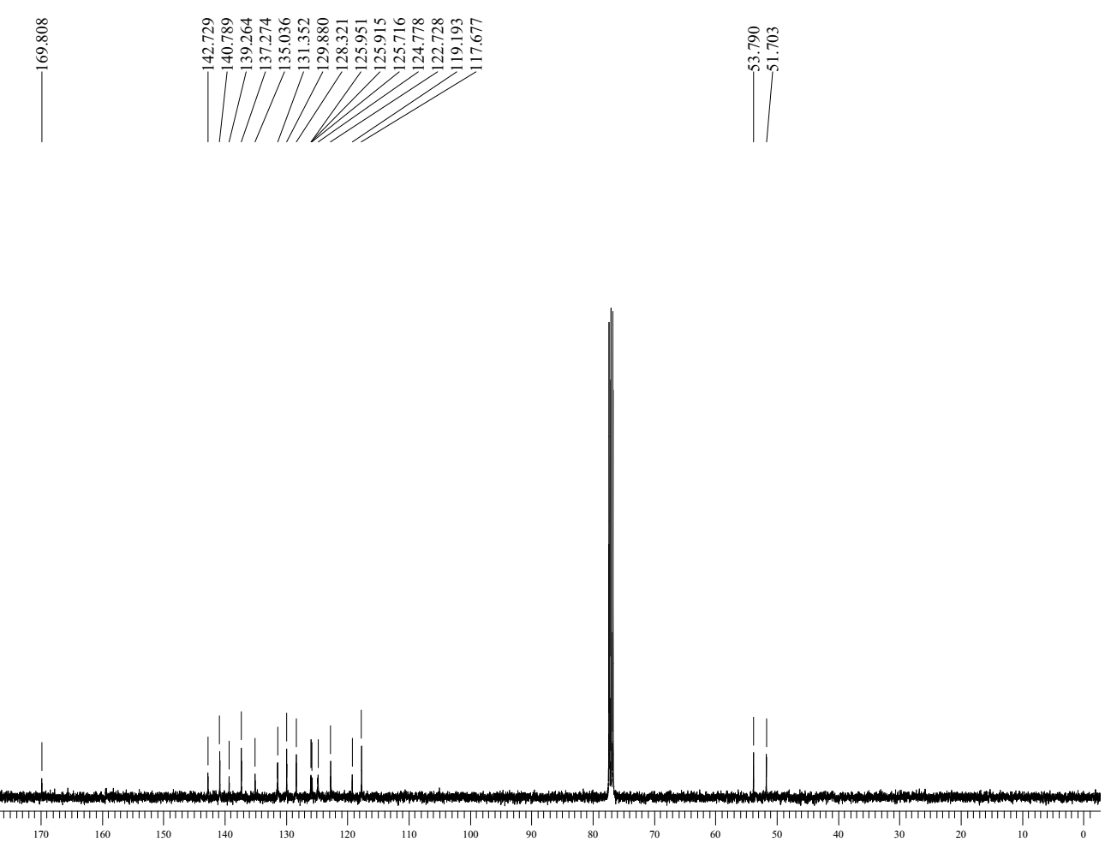
Figure S48: ¹³C- NMR spectrum of compound 9n

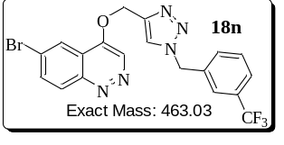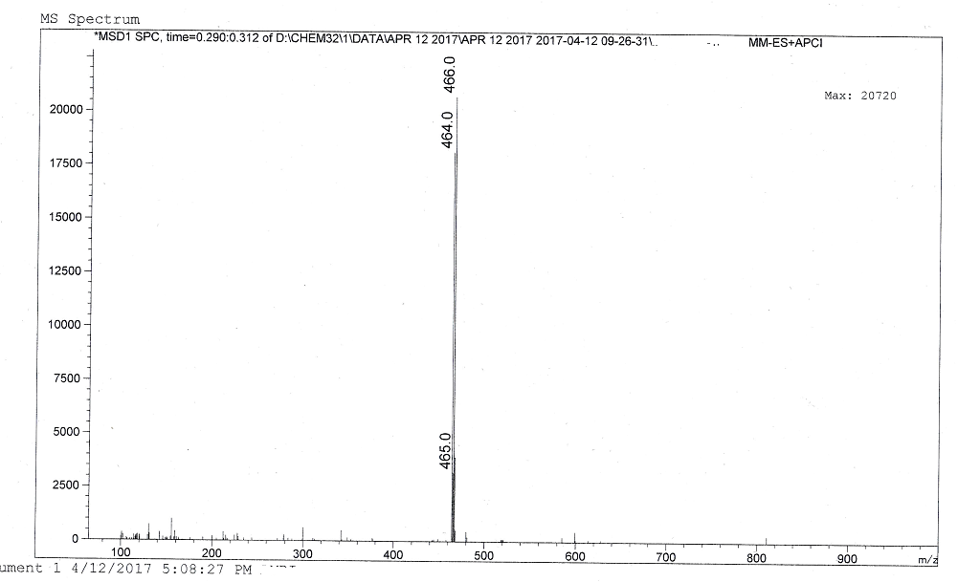
Figure S49: ESI Mass spectrum of compound 9n

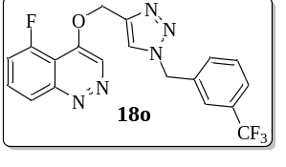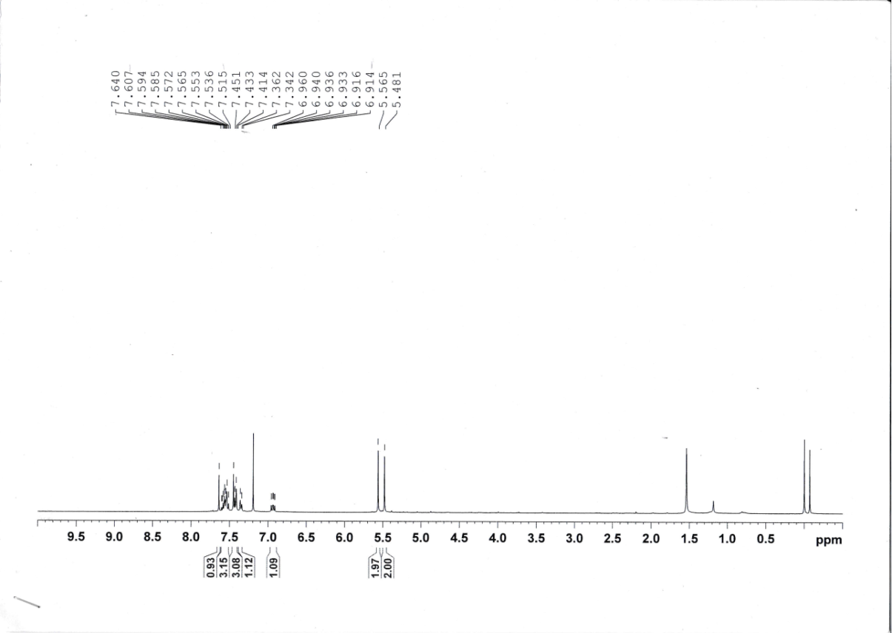
Figure S50: ¹H-NMR spectrum of compound 9o
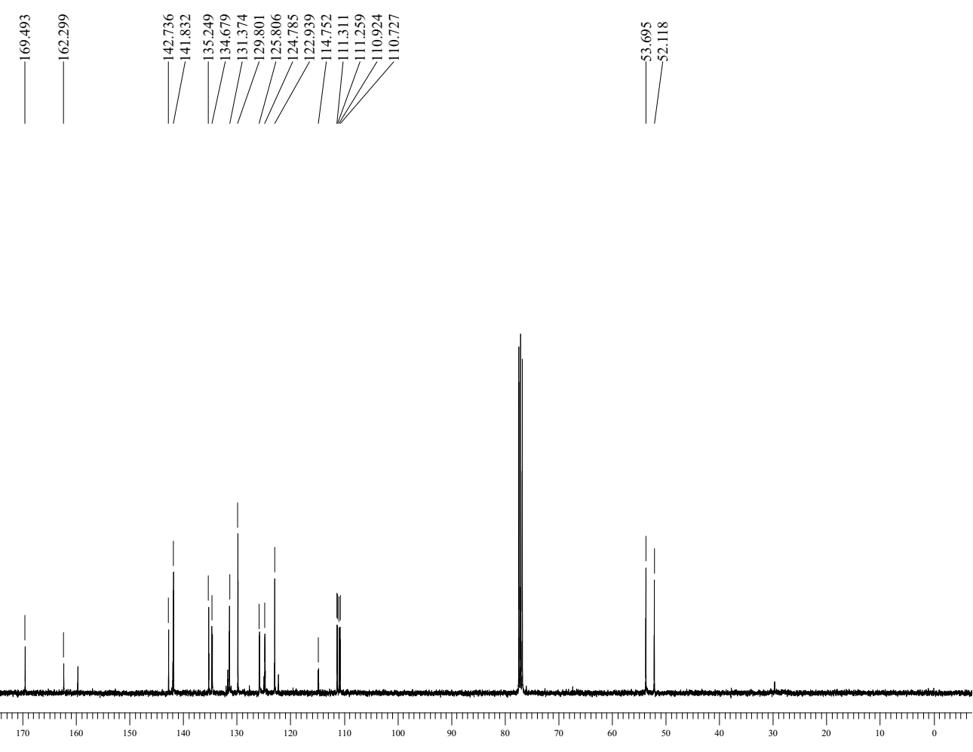
Figure S51: ¹³C- NMR spectrum of compound 9o

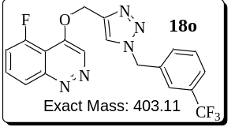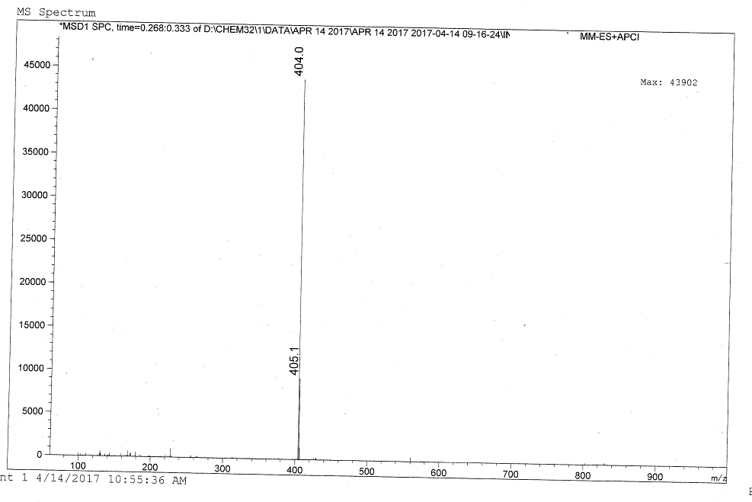
Figure S52: ESI Mass spectrum of compound 9o

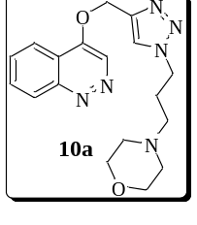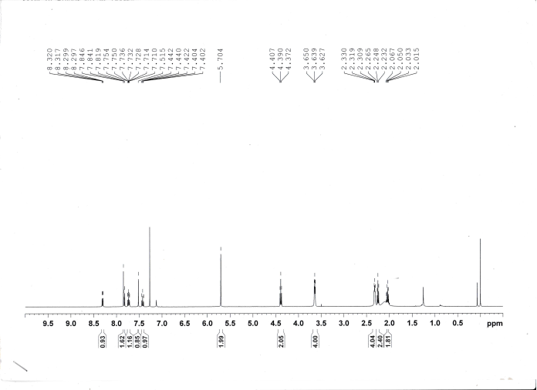
Figure S53: ¹H-NMR spectrum of compound 10a
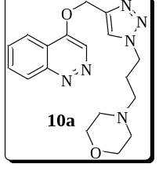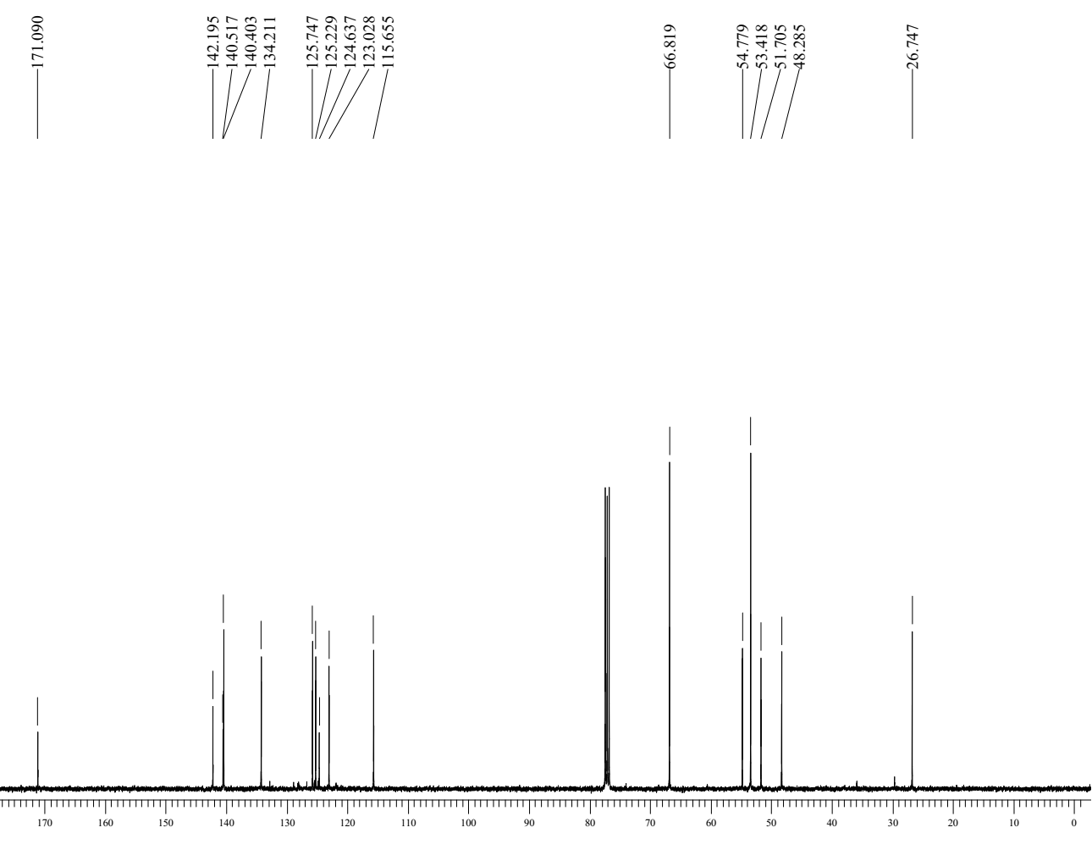
Figure S54: ¹³C- NMR spectrum of compound 10a

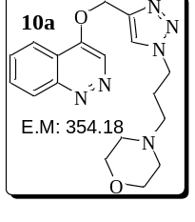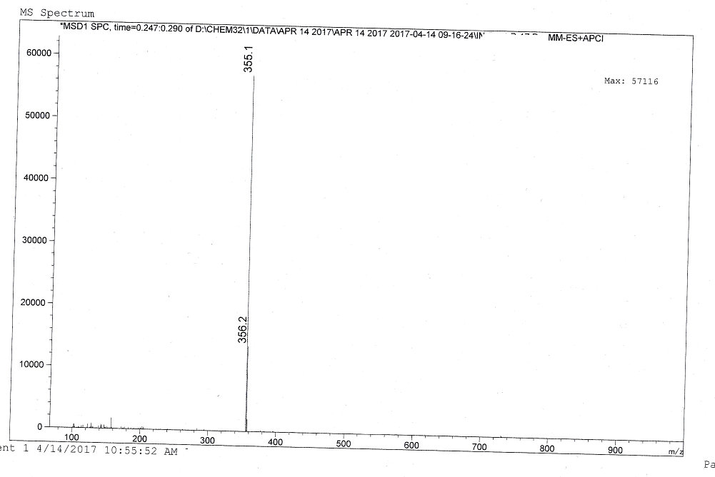
Figure S56: ESI Mass spectrum of compound 10a
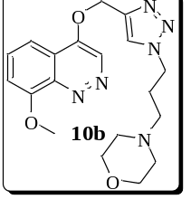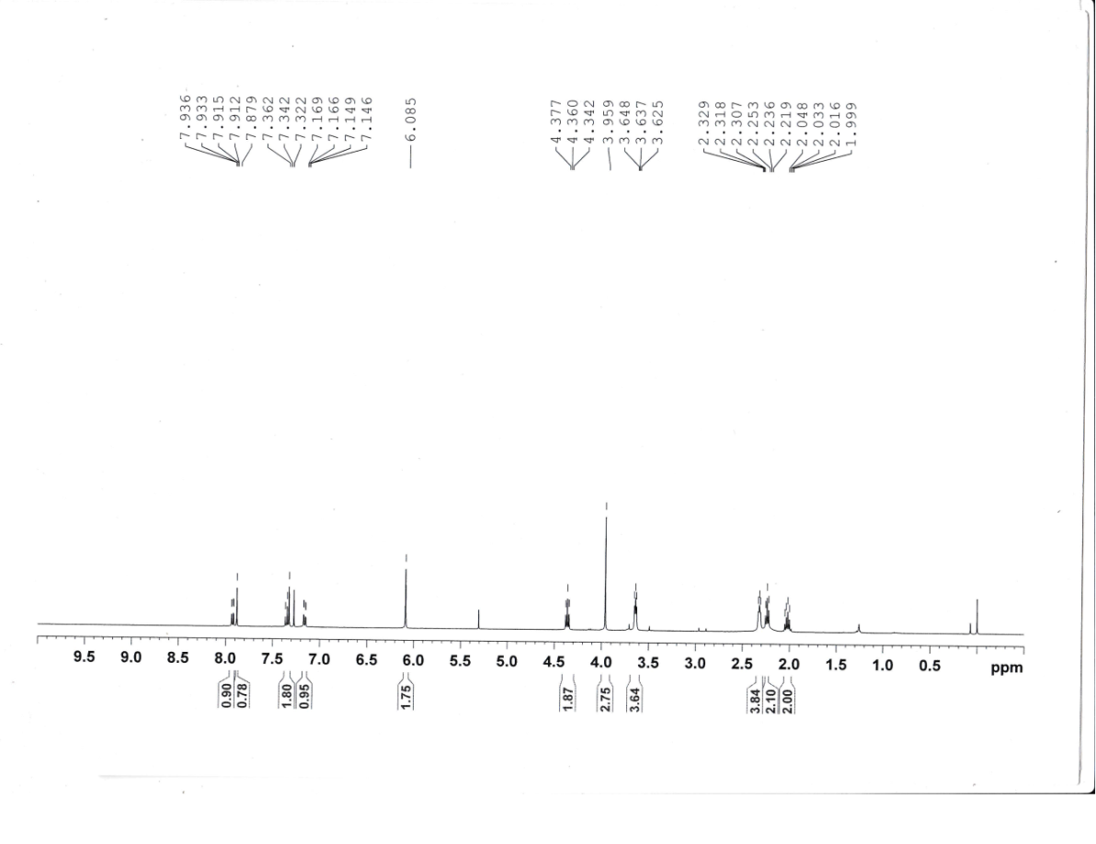
Figure S57: ¹H-NMR spectrum of compound 10b
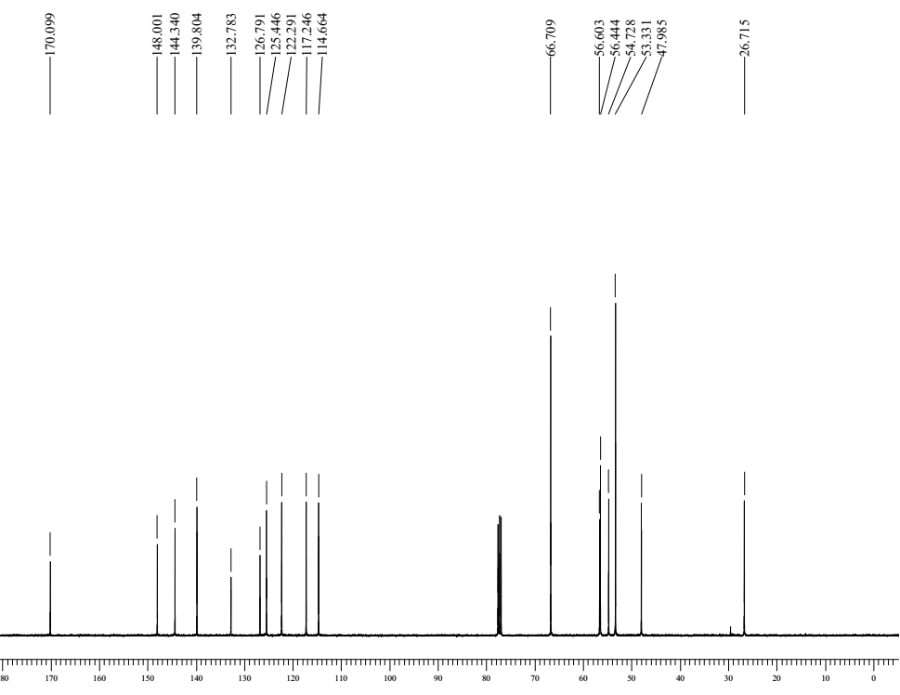
Figure S58: ¹³C- NMR spectrum of compound 10b

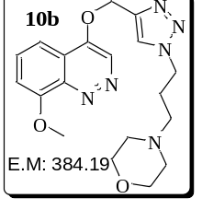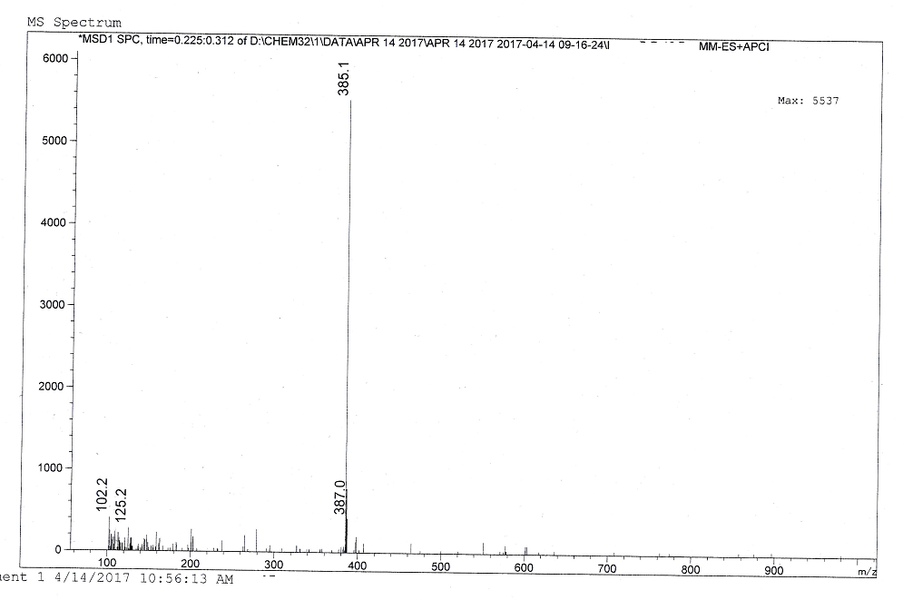
Figure S59: ESI Mass spectrum of compound 10b
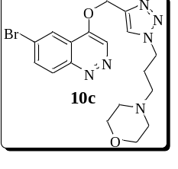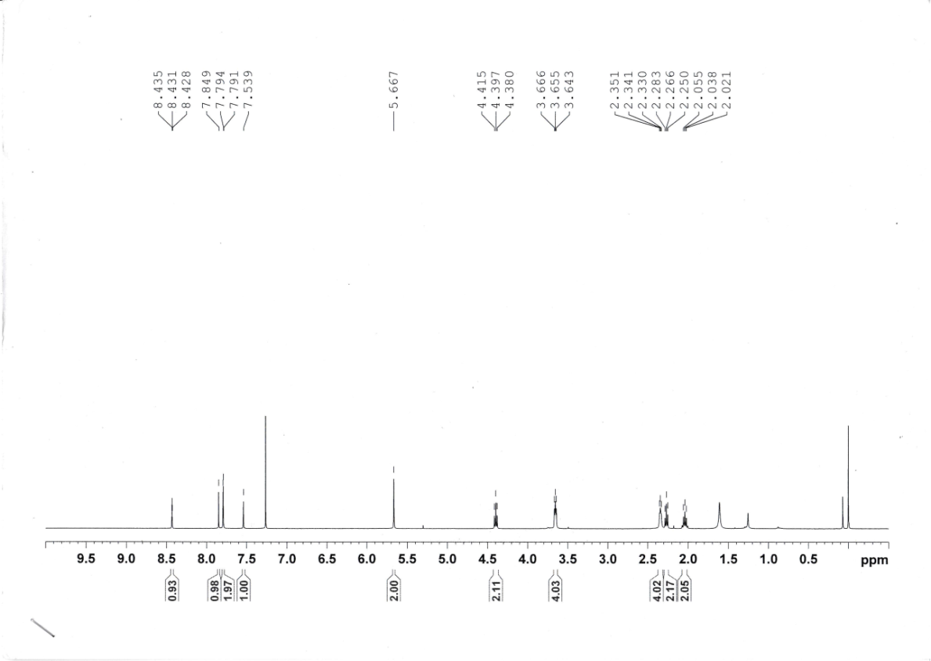
Figure S60: ¹H-NMR spectrum of compound 10c
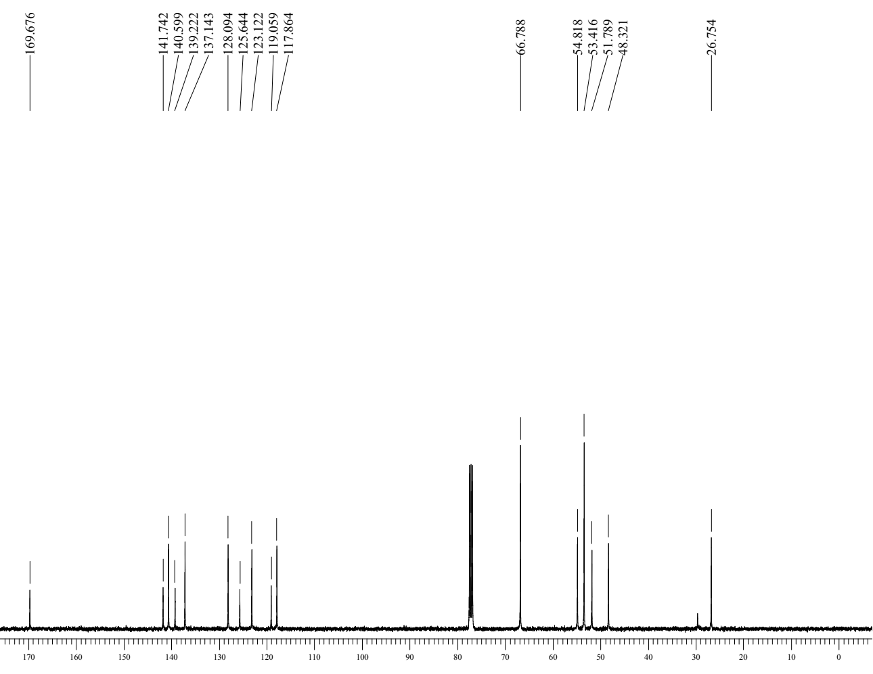
Figure S61: ¹³C- NMR spectrum of compound 10c

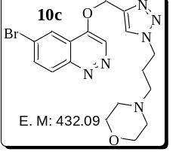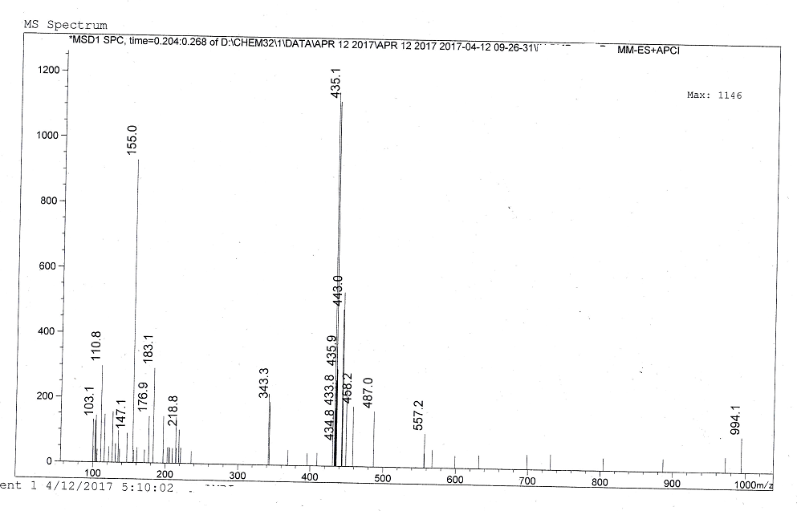
Figure S62: ESI Mass spectrum of compound 10c
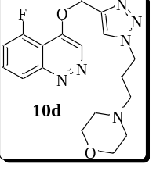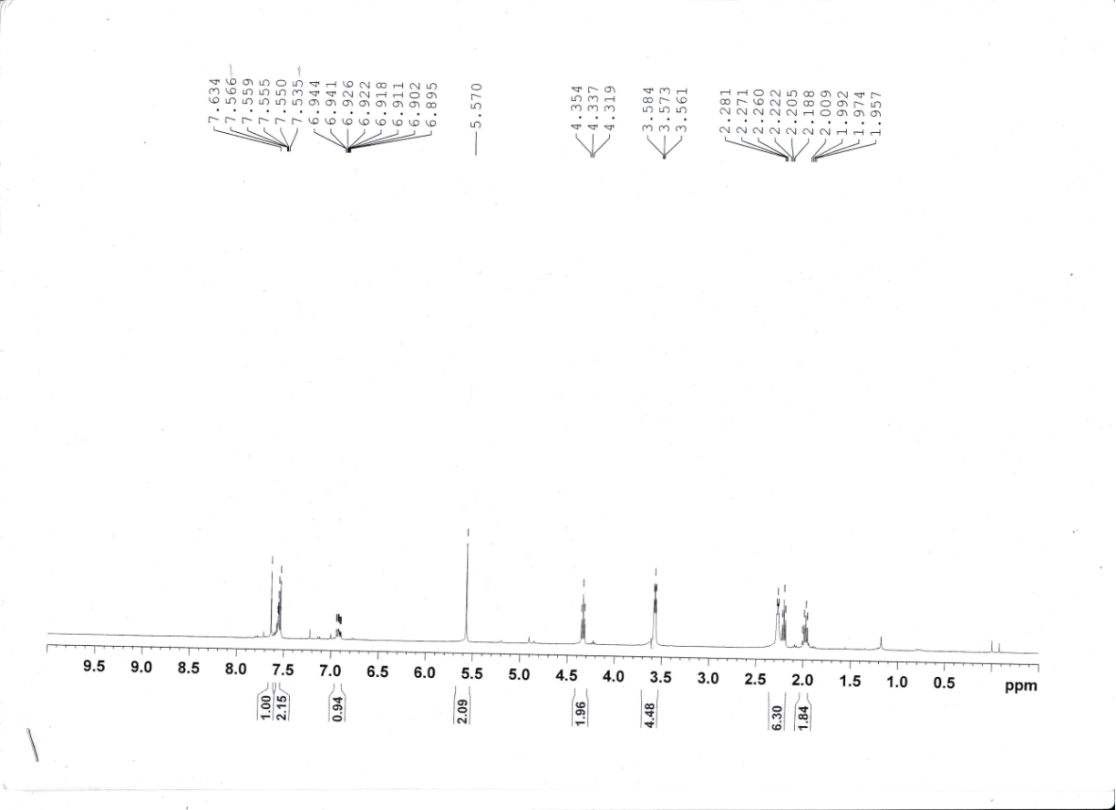
Figure S63: ¹H-NMR spectrum of compound 10d
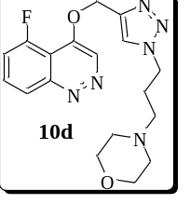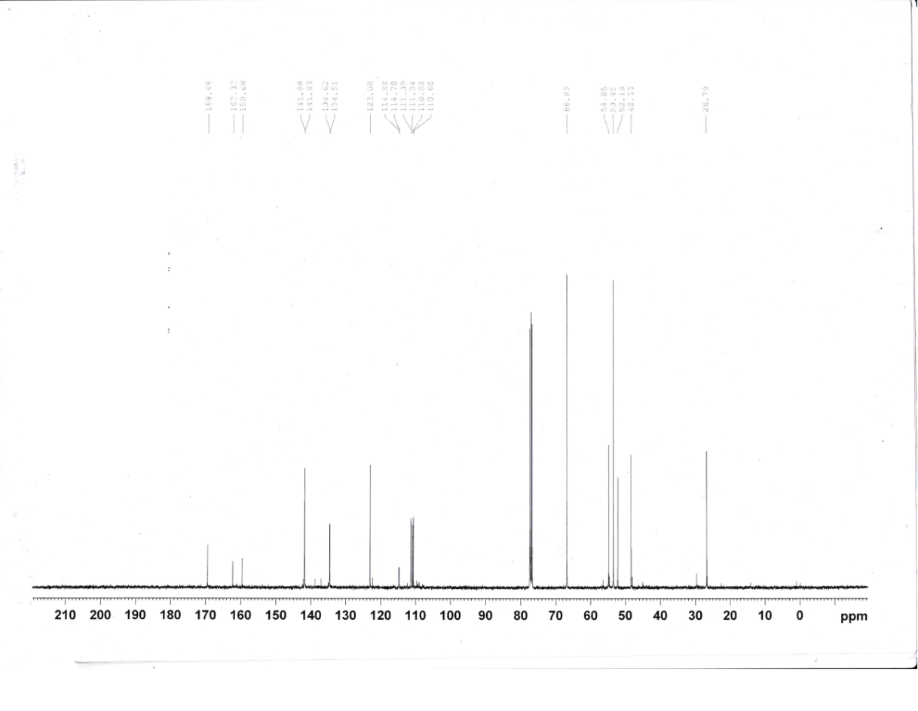
Figure S64: ¹³C- NMR spectrum of compound 10d

