Supplementary Material
Figure Captions
Fig.S1. Schematic diagram of anaerobic reactor (Note: 1 is anaerobic reactor, 2 is gas collecting bottle, 3 is water collecting bottle, 4 is drain pipe, and 5 is exhaust pipe)
Fig.S2. XRD image of magnetic carbon (left) and FeS (right)
Fig.S3. Change of TOC during sludge anaerobic digestion with the addition of different materials
Fig.S4. Changes of pH during sludge anaerobic digestion with the addition of different materials
Fig.S5. Changes of acetic acid (a), propionic acid (b), and butyric acid (c) during sludge anaerobic digestion with the addition different materials
Fig.S6. Changes of NH₄⁺-N during sludge anaerobic digestion with the addition of different materials

Fig. S1
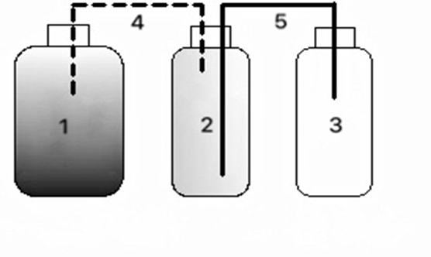

Fig. S2

Fig. S3

Fig. S4

Fig. S5

Fig. S6

List of Tables
Tab. S1. Microbial diversity index of digestion liquid sample in sludge anaerobic digestion systems with the addition of different materials（1, 2, and 3 are the before, middle, and after anaerobic digestion of sludge, respectively）

Tab. S1.

Sample | OTU | Shannon | Simpson | Ace | Chao1 | Coverage
C1 | 40186 | 3.940107 | 0.107794 | 1269.430139 | 1273 | 0.993928
C2 | 57383 | 4.399296 | 0.032411 | 1302.886203 | 1285.982249 | 0.995382
C3 | 33560 | 4.256719 | 0.045921 | 1322.579 | 1306.181176 | 0.991256
F1 | 55189 | 2.981031 | 0.172313 | 1202.506816 | 1180.040816 | 0.994727
F2 | 32021 | 4.539756 | 0.032599 | 1295.132849 | 1258.494565 | 0.991068
F3 | 38000 | 4.415854 | 0.041154 | 1341.27118 | 1375.784314 | 0.992342
M1 | 50738 | 4.669017 | 0.031865 | 1467.168915 | 1449.951351 | 0.995567
M2 | 56850 | 3.056017 | 0.201329 | 1167.200784 | 1147.007042 | 0.994422
M3 | 32136 | 4.3283 | 0.043854 | 1276.943678 | 1249.257143 | 0.991131

