Supplementary Material
Cadmium and chromium determination in herbal tinctures employing direct analysis by graphite furnace atomic absorption spectrometry (GF AAS)
Agatha Merilin de Oliveira Lopesª, Paula Rocha Chellini^{b} and Rafael Arromba de Sousa ª*
ªDepartment of Chemistry, Universidade Federal de Juiz de Fora, Juiz de Fora, Brazil; ^{b}Pharmacy Faculty, Universidade Federal de Juiz de Fora, Juiz de Fora, Brazil
Department of Chemistry, Universidade Federal de Juiz de Fora, 36036-900, Juiz de Fora, MG, Brazil. E-mail: rafael.arromba@ufjf.edu.br

Table S1. Instrumental parameters recommended by the manufacturer for the determination of cadmium and chromium by GF AAS
Parameters | Cadmium | Chromium
Pyrolysis Temperature (°C) | 300ª, 600^{b} | 1200
Atomization Temperature (°C) | 900ª, 1000^{b} | 2500
Chemical modifier | Pd or Mg(NO₃)₂ | Mg(NO₃)₂
ª without the chemical modifier ^{b} with the chemical modifier

Table S2. Analysis of linear regression of the external calibration model for the determination of cadmium and chromium by direct analysis by GF AAS
Statistical test | Cadmium | Chromium
Shapiro-Wilk Test (W_{tab} = 0.859) | W_{calc} = 1.024 | W_{calc} = 0.965
Cochran Test (C_{tab} = 0.7808) | C_{calc} = 0.6504 | C_{calc} = 0.4874
Lack of adjust (F_{faj-tab} = 4.53) | F_{faj-calc} = 3.21 | F_{faj-calc} = 0.51
Regression (F_{reg-tab} = 1.04) | F_{reg-calc} = 1347 | F_{reg-calc} = 497
R² | 0.9940 | 0.9909

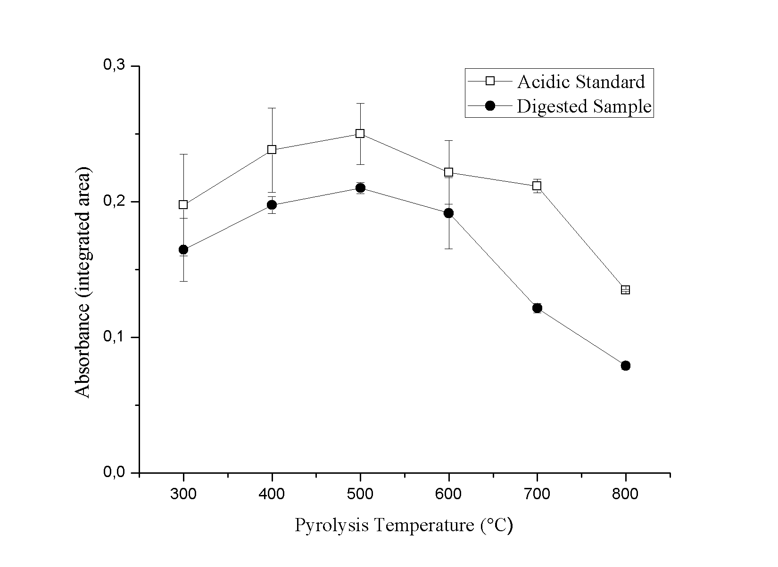
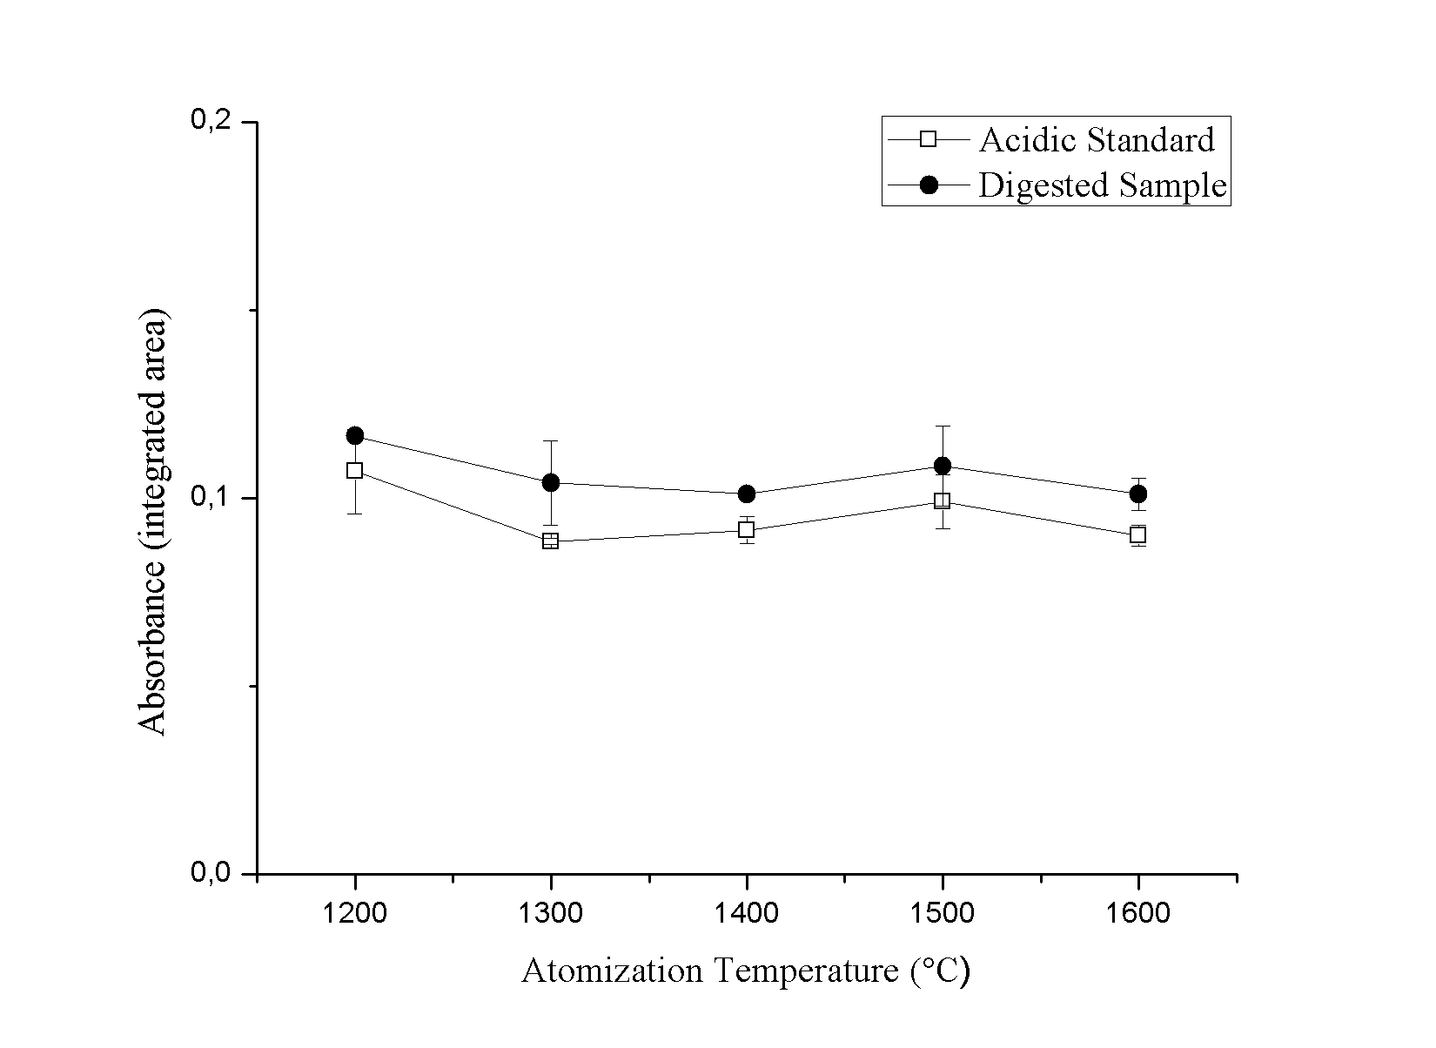
Figure S1. Pyrolysis and atomization temperature curves for Cd. Acidic standard and digested sample. Fixed values to the optimization, atomization temperature: 900°C and pyrolysis temperature: 500°C.
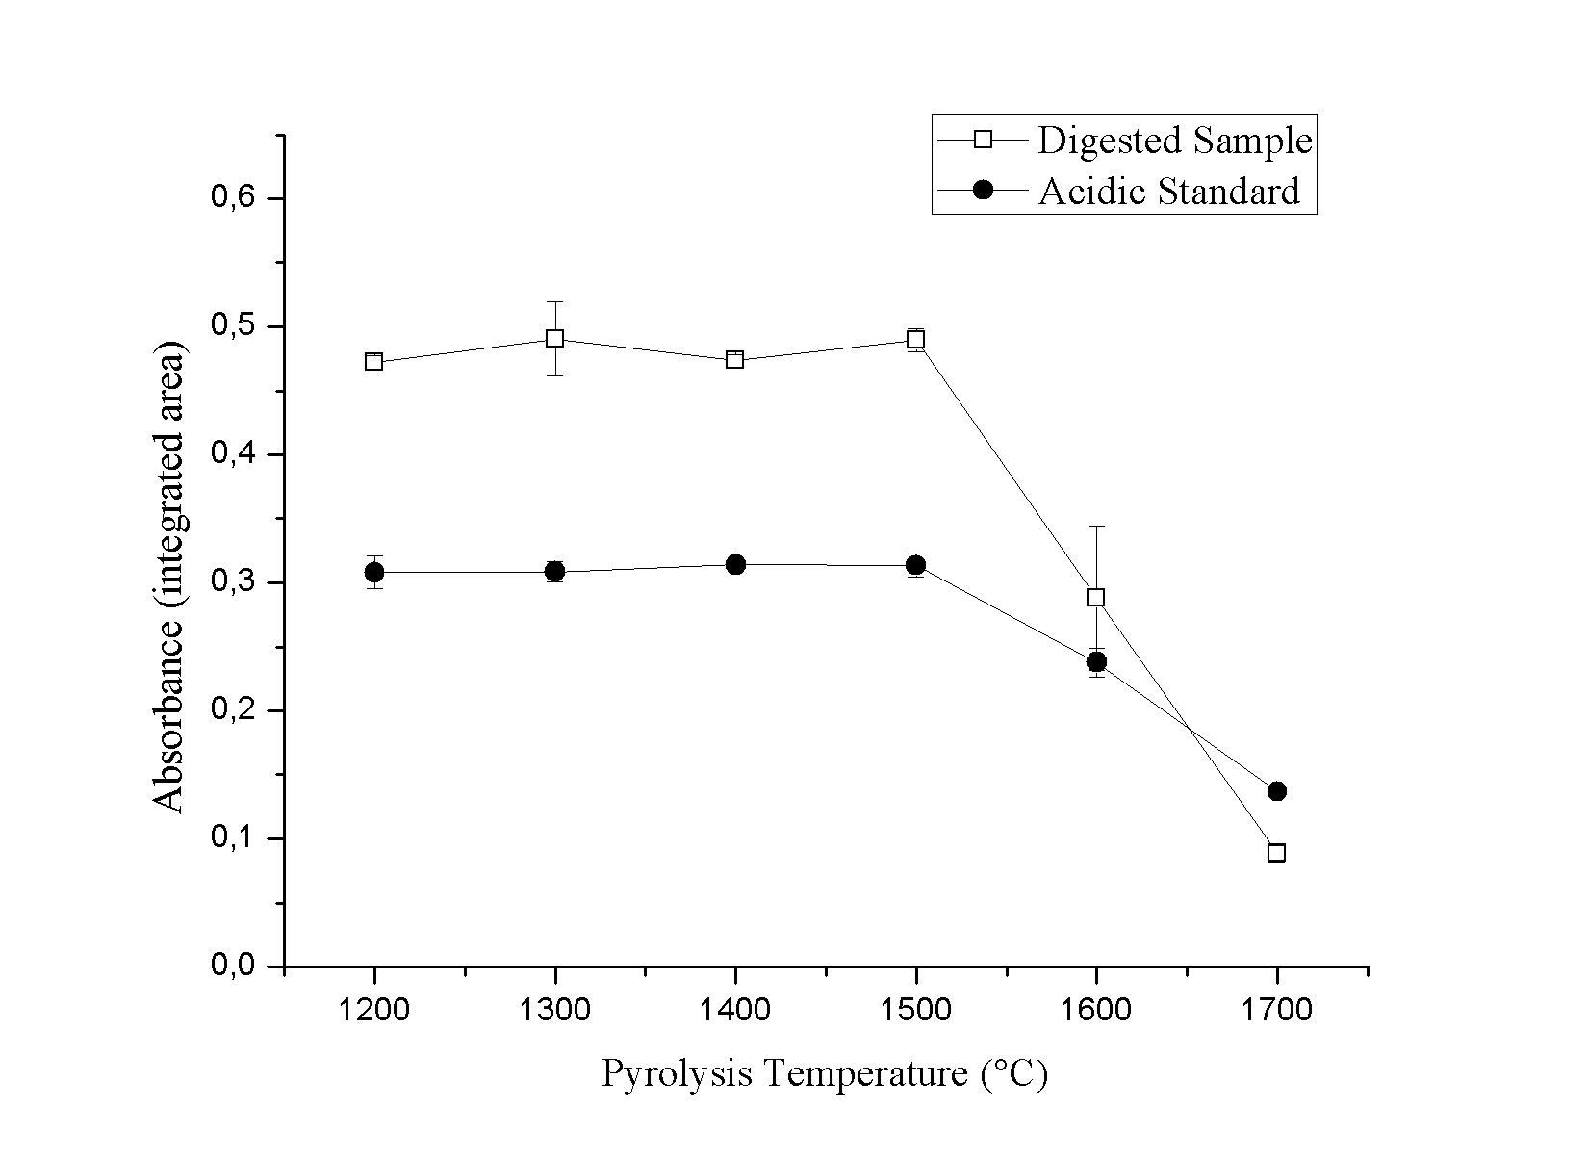
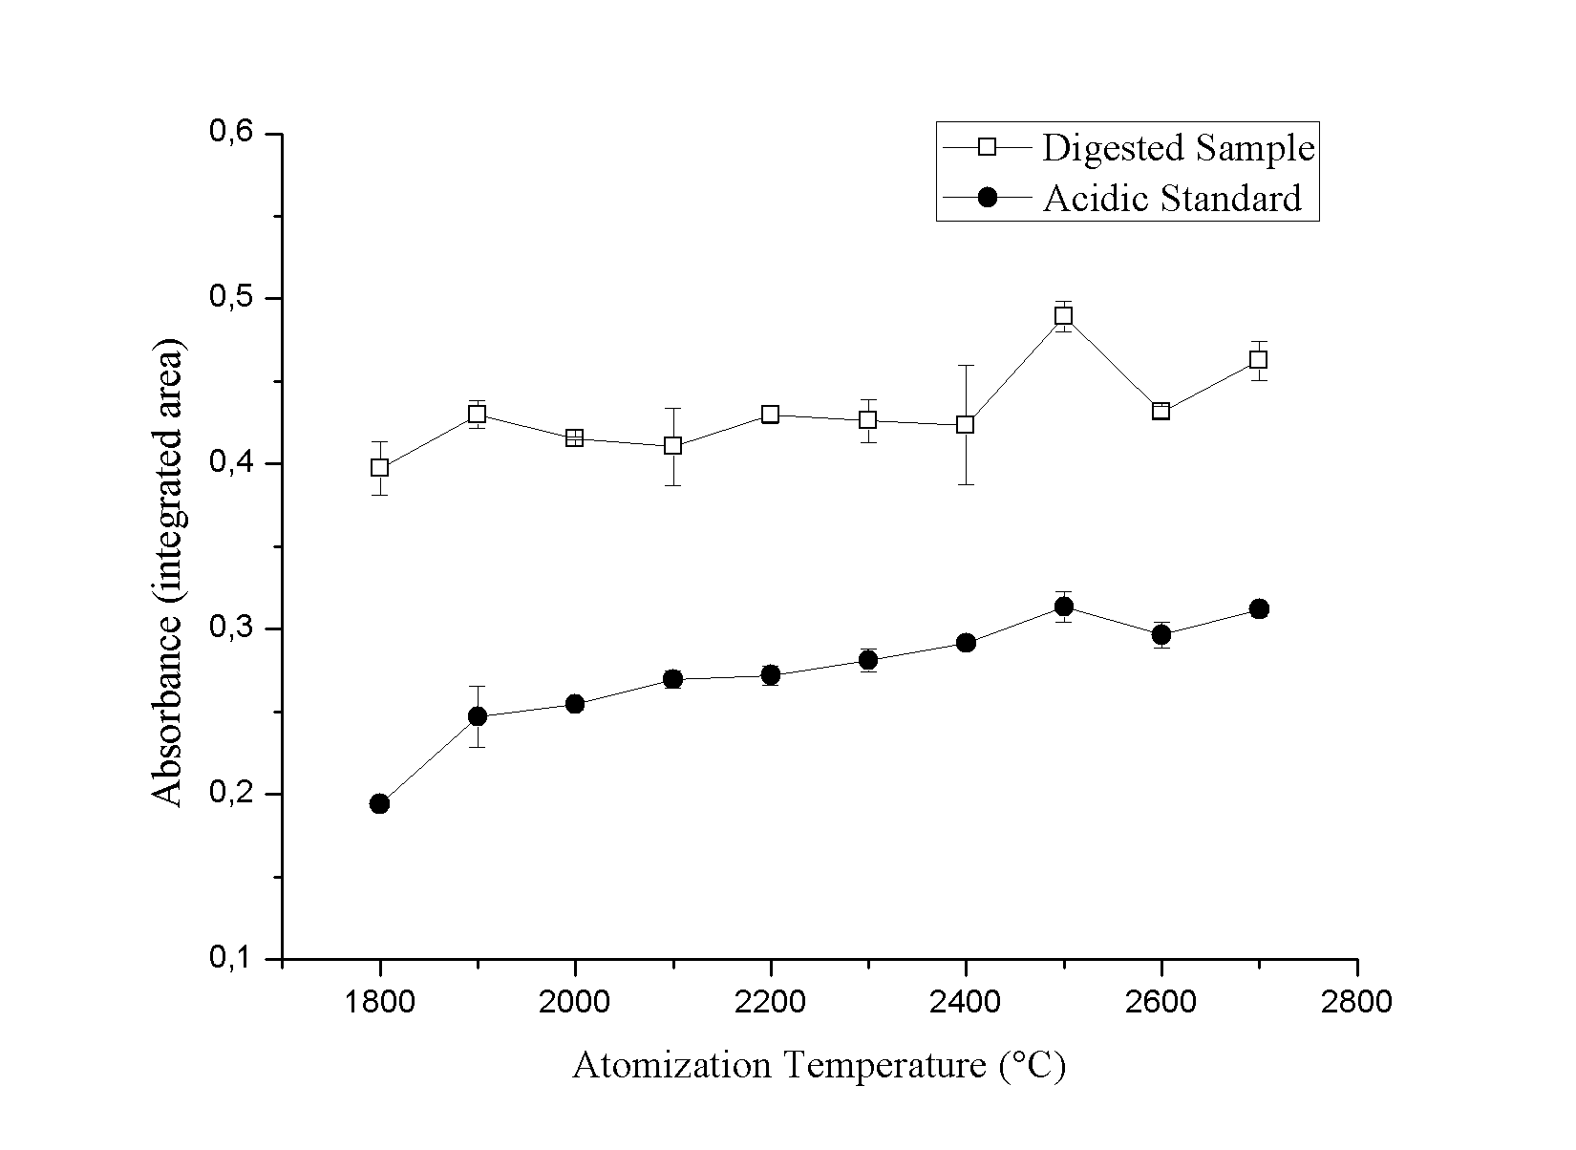
Figure S2. Pyrolysis and atomization temperature curves for Cr. Acidic standard and digested sample. Fixed values to the optimization, atomization temperature: 2500°C and pyrolysis temperature: 1500 °C.

