Supporting Information:

Bicomponent polymeric micelles as pH-responsive carrier
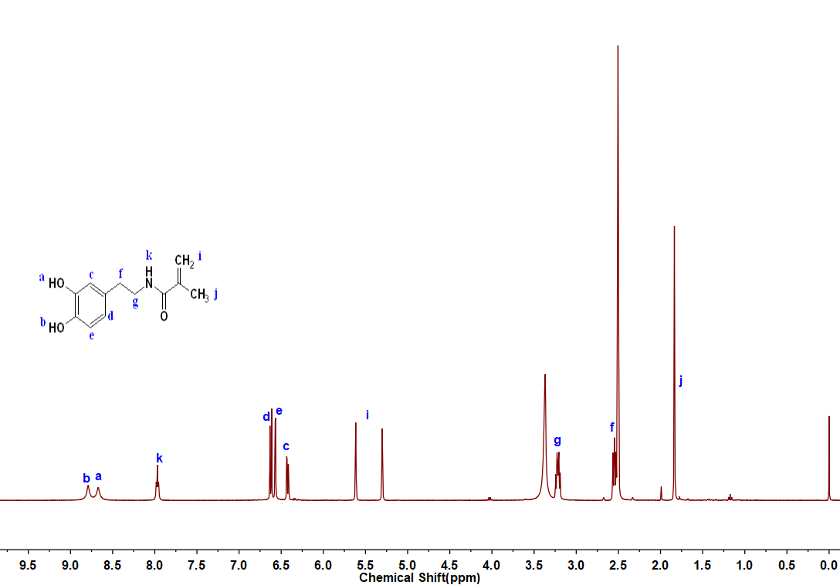
Figure S1. ¹H-NMR spectra of Monomer DMA.

Figure S2 FT-IR spectera of the polymers( mPEG-PCL-PVBA and mPEG-PCL-PVBA) and bicomponent micelles.

Figure S3. XRD analysis results of DOX formulation: DOX powder, the physical mixture of mPEG-PCL-PDMA/mPEG-PCL-PVBA+DOX, blank micelle mPEG-PCL-PDMA/mPEG-PCL-PVBA, drug-loaded micelles mPEG-PCL-PDMA/mPEG-PCL-PVBA-DOX.
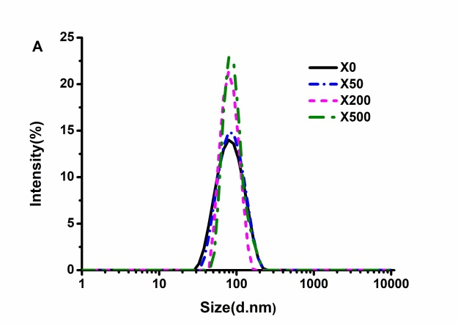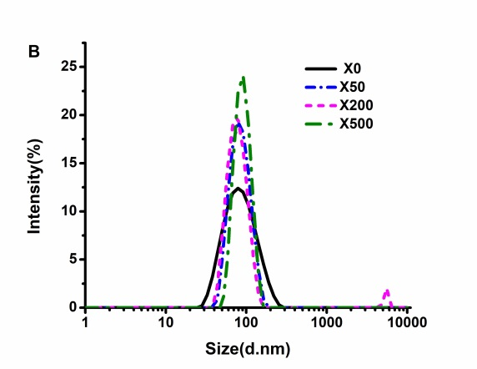
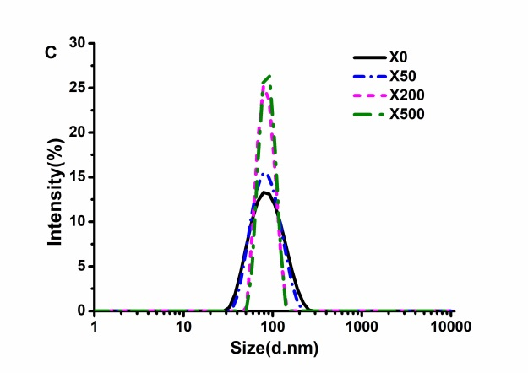
Figure S4. Determination of stability of drug loaded micelles under different dilution times by DLS: (A) mPEG-PCL-PDMA-DOX, (B) mPEG-PCL-PVBA-DOX, (C) mPEG-PCL-PDMA/mPEG-PCL-PVBA-DOX.

Figure S5. Plasma stability of drug loaded micelles at 37 ℃.

Figure S6. Storage stability of drug loaded micelles at 4 ℃.

Figure S7. Cytotoxicity of blank micelle (Culture with 48 h, n=3).
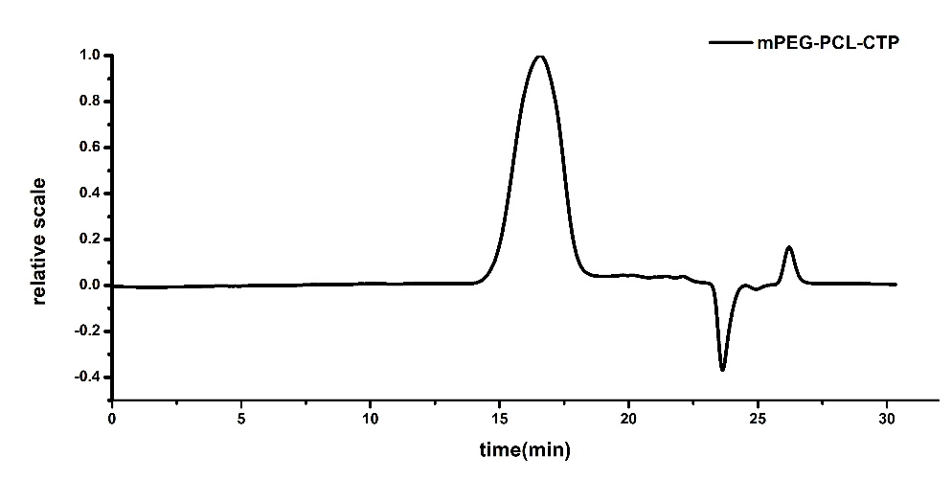
(a)
(b)
Figure S8 Elution time of polymers on GPC: (a) mPEG-PCL-CTP, (b) mPEG-PCL-PVBA.

