Supporting Information
Main Title: Computational investigation on the effect of Oleuropein aglycone on the α-Synuclein aggregation
Priyanka Borah§#, Airy Sanjeev§#, and Venkata Satish Kumar Mattaparthi §*
§Molecular Modelling and Simulation Laboratory, Department of Molecular Biology and Biotechnology, Tezpur University, Tezpur-784 028, Assam, India
#contributed equally
*Corresponding Author: Venkata Satish Kumar Mattaparthi, M. Tech., Ph.D.,
Full Postal Address: Dr. Mattaparthi Venkata Satish Kumar
Assistant Professor,
Molecular Modelling and Simulation Laboratory,
Department of Molecular Biology & Biotechnology,
Tezpur University, Tezpur – 784028, Napaam,
District: Sonitpur, Assam, India
E-mail: mvenkatasatishkumar@gmail.com, venkata@tezu.ernet.in
Telephone: +91-3712-275443 (O), +91-8811806866 (M)
Fax: +91-3712-267005/267006

Contents | Page No.

Supplementary Figures

Figure S1. Top 10 representative docked models for (α-synuclein + OleA) complex generated by Patchdock along with their rankings based on their Atomic Contact Energies (ACE), score and area.  Figure S2. (A) Temperature, (B) Pressure, and (C) Energy plots of (α-synuclein + OleA) complex system as a function of simulation time.  Figure S3. A) Average RMSD at each block versus block size in picoseconds B) Standard deviation for the RMSD at each block size versus block size in picoseconds for the α-synuclein (apo) Molecular dynamics trajectory.  Figure S4. A) Average RMSD at each block versus block size in picoseconds B) Standard deviation for the RMSD at each block size versus block size in picoseconds for the (α-synuclein + OleA) complex Molecular dynamics trajectory.  Figure S5. Ligplot analysis showing the interaction of hydrophobic residues of α-synuclein with OleA.  Figure S6. Snapshots of the conformers (from simulation-II) of α-synuclein taken at different interval of simulation time (A) α-synuclein (apo), (B) (α-synuclein + OleA) complex. Centre of mass distance in angstroms between the ligand OleA and the binding pocket in α-synuclein as a function of simulation time in pico seconds.  Figure S7. Snapshots of the conformers (from simulation-III) of α-synuclein taken at different interval of simulation time (3rd MD simulation) (A) α-synuclein (apo), (B) (α-synuclein + OleA) complex.  Figure S8. Intra-molecular distance analysis (from simulation-II) between NAC and C-terminal domains as a function of simulation time for the α-synuclein (apo) and (α-synuclein + OleA) complex. | S5  S6  S7  S8  S9  S10  S11  S12
Figure S9. Intra-molecular distance analysis(from simulation-III) between NAC and C-terminal domains as a function of simulation time for the α-synuclein (apo) and (α-synuclein + OleA) complex.  Figure S10. ∆∆G_{bind} of various energy components in A) MM-PBSA and B) MM-GBSA method of Binding free energy calculation of (α-synuclein + OleA) complex.  Figure S11. Per-residue energy decomposition (PRED) plots for the interface residues of ligand (OleA) and receptor α-synuclein calculated by MM-GBSA/PBSA method. | S13  S14  S15

Supplementary Tables

Table S1. Physico-chemical properties of Oleuropein aglycone (OleA). | S16
Table S2. Interactions of residues of α-synuclein (Receptor) with OleA (ligand) obtained from Ligplot+ software.  Table S3. Intra-molecular Hydrogen bond occupancy between NAC and C-terminal domain of α-synuclein (apo).  Table S4. Intra-molecular Hydrogen bond occupancy between NAC and C-terminal domain of (α-synuclein + OleA) complex.  Table S5. The various components of the Binding Free Energy (kcal mol⁻¹) calculated by Molecular Mechanics/Generalized Borne Surface Area (MM-GBSA) and Molecular Mechanics/Poisson−Boltzmann Surface Area (MM-PBSA) method between (α-synuclein+OleA) complex (for Simulation II).  Table S6. The various components of the Binding Free Energy (kcal mol⁻¹) calculated by Molecular Mechanics/Generalized Borne Surface Area (MM-GBSA) and Molecular Mechanics/Poisson−Boltzmann Surface Area (MM-PBSA) method between (α-synuclein+OleA) complex (for Simulation III). | S17-S18  S19-S20  S21-S22  S23-S24  S25-S26

Supplemtentary figures
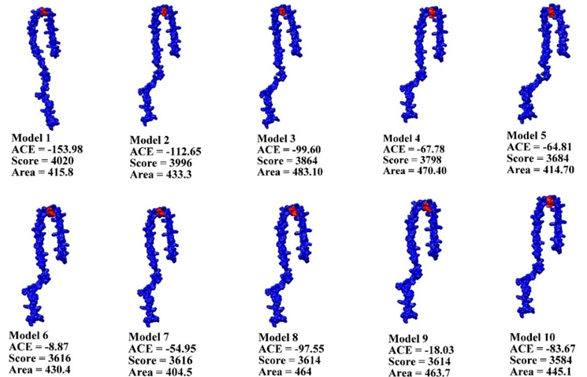
Figure S1. Top 10 representative docked models for (α-synuclein + OleA) complex generated by Patchdock along with their rankings based on their Atomic Contact Energies (ACE), score and area.

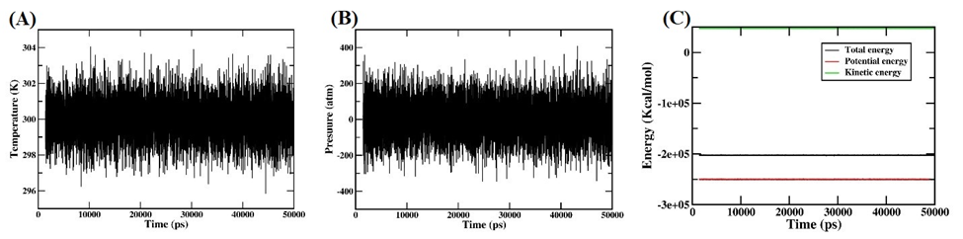
Figure S2. (A) Temperature, (B) Pressure, and (C) Energy plots of (α-synuclein + OleA) complex system as a function of simulation time.

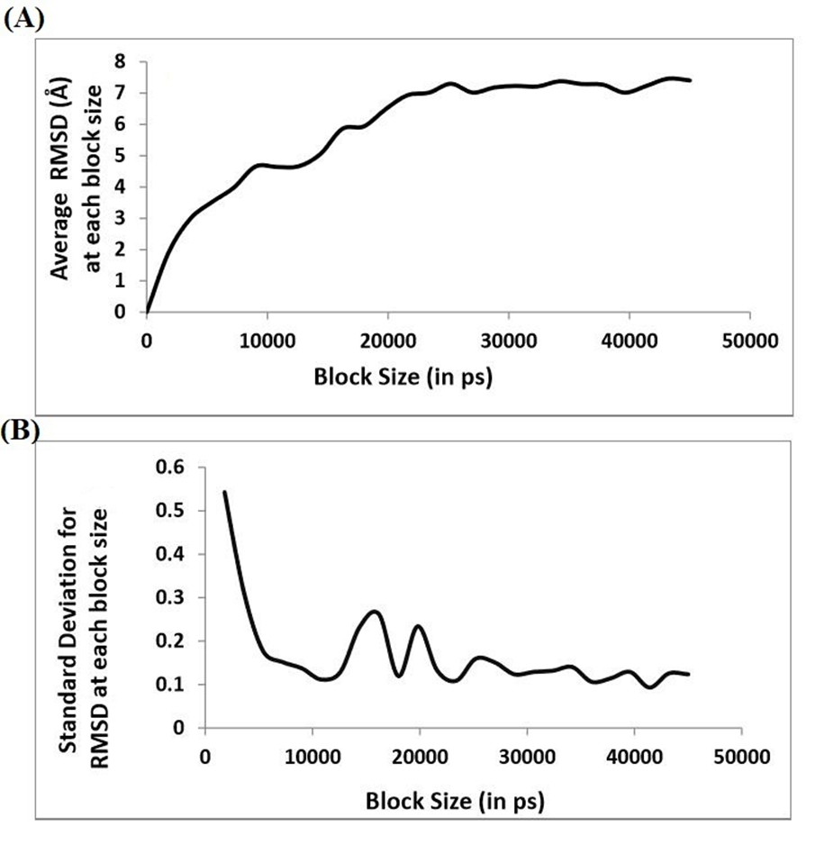
Figure S3. A) Average RMSD at each block versus block size in picoseconds B) Standard deviation for the RMSD at each block size versus block size in picoseconds for the α-synuclein (apo) Molecular dynamics trajectory.

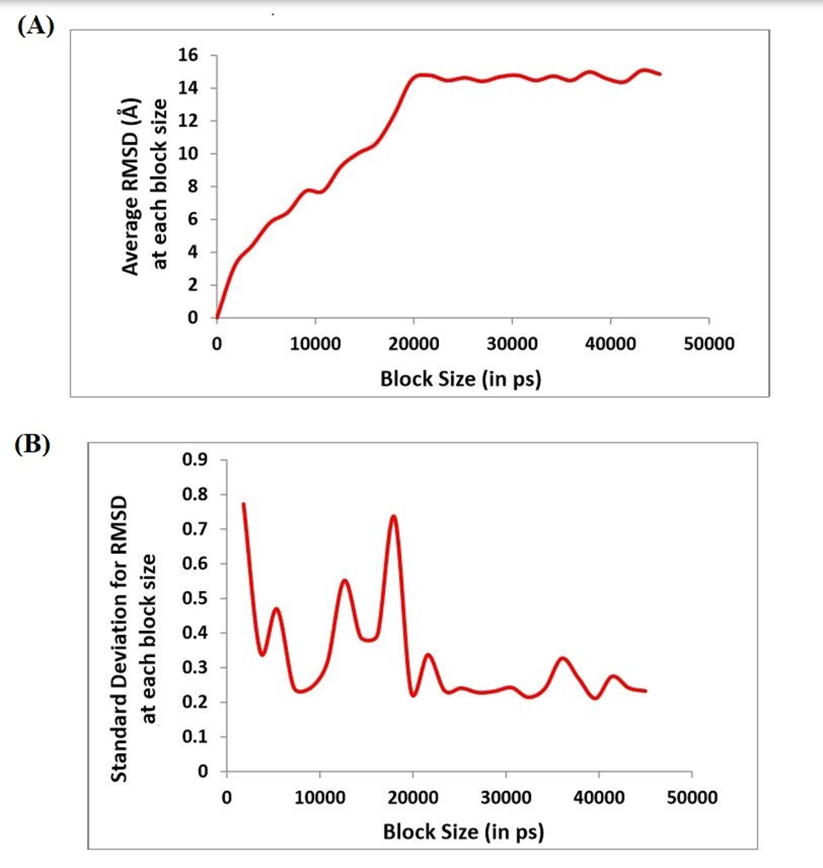
Figure S4. A) Average RMSD at each block versus block size in picoseconds B) Standard deviation for the RMSD at each block size versus block size in picoseconds for the (α-synuclein + OleA) complex Molecular dynamics trajectory.

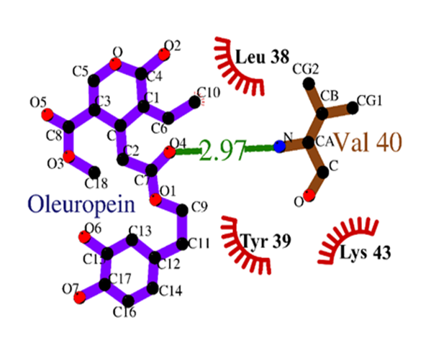
Figure S5. Ligplot analysis showing the interaction of hydrophobic residues of α-synuclein with OleA.

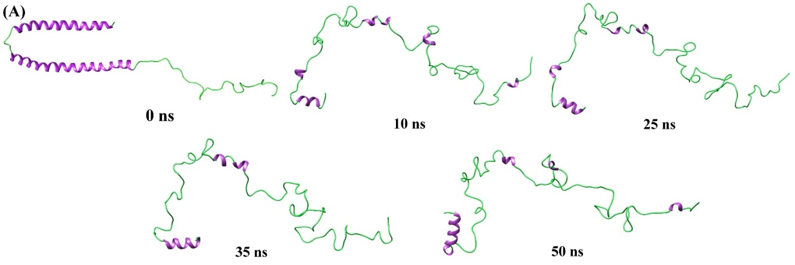
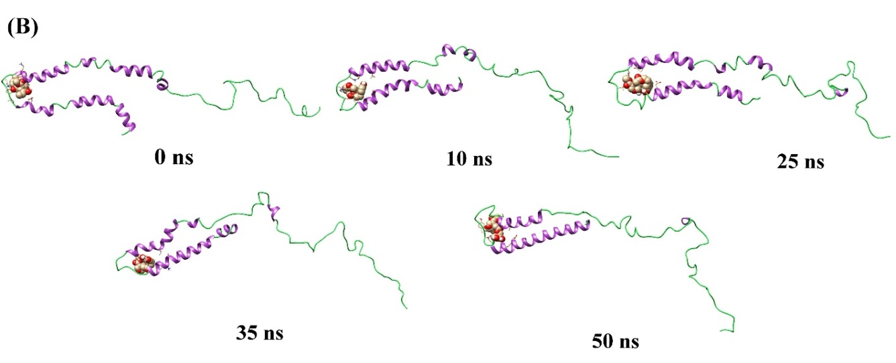
Figure S6. Snapshots of the conformers (from simulation-II) of α-synuclein taken at different interval of simulation time (A) α-synuclein (apo), (B) (α-synuclein + OleA) complex.

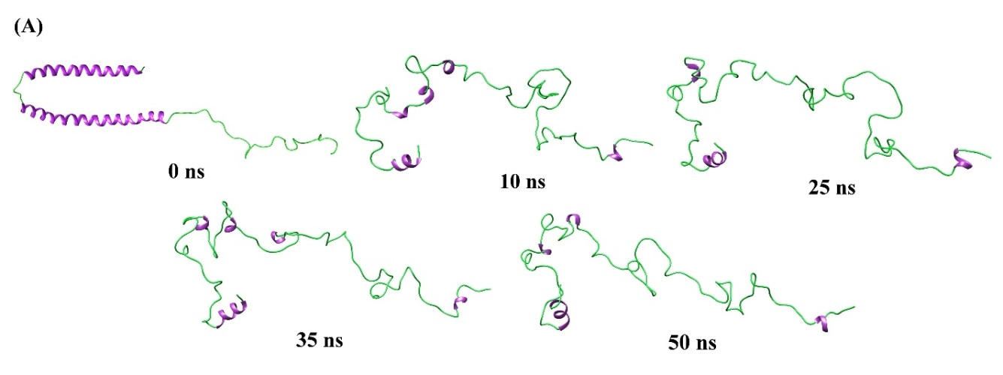
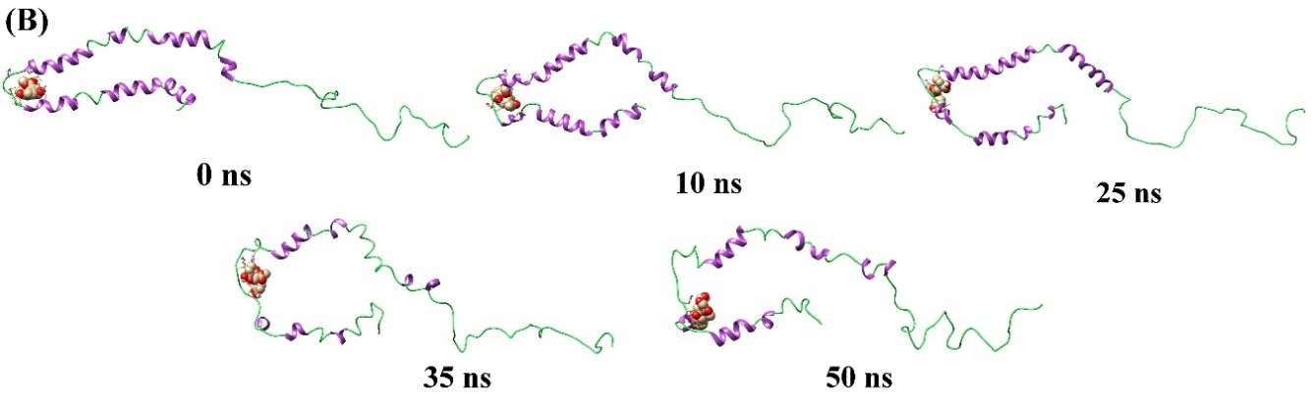
Figure S7. Snapshots of the conformers (from simulation-III) of α-synuclein taken at different interval of simulation time (A) α-synuclein (apo), (B) (α-synuclein + OleA) complex.

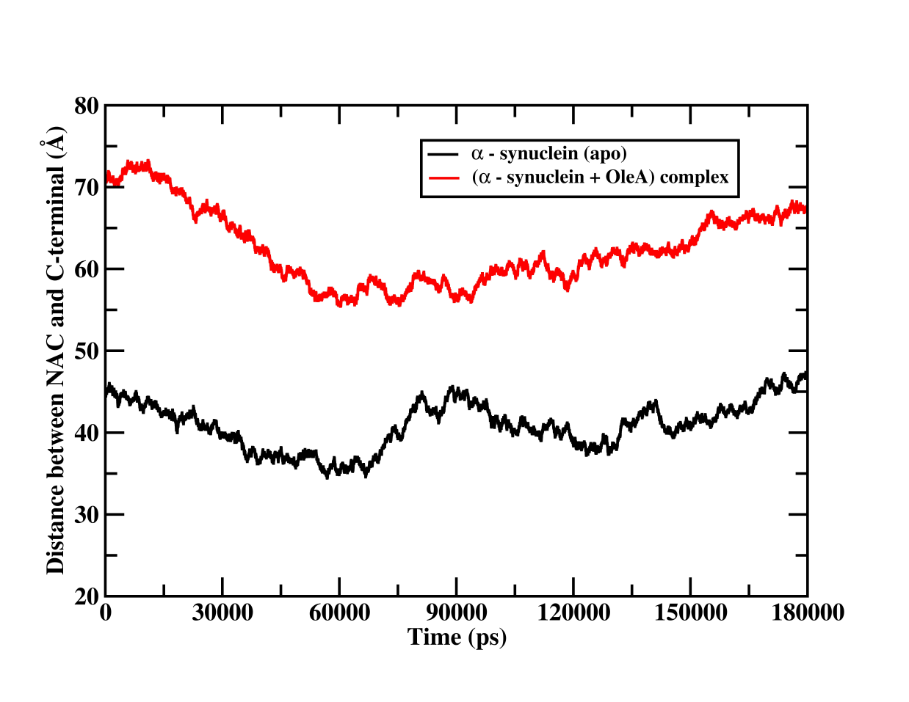
Figure S8. Intra-molecular distance analysis (from simulation-II) between NAC and C-terminal domains as a function of simulation time for the α-synuclein (apo) and (α-synuclein + OleA) complex.

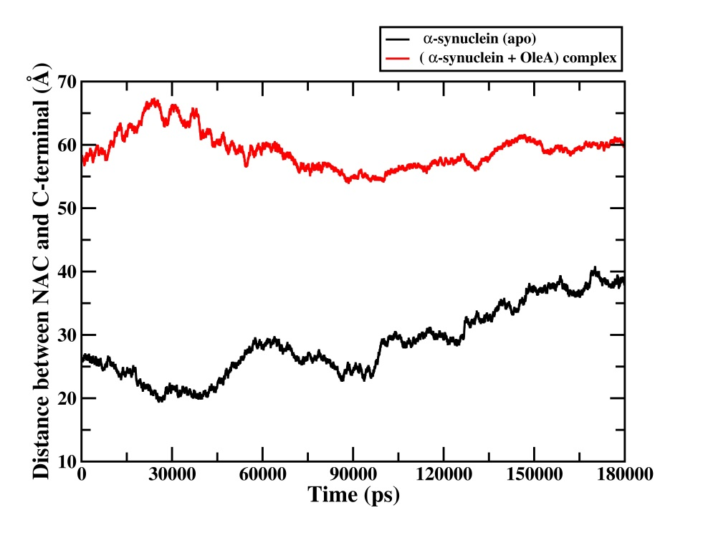

Figure S9. Intra-molecular distance analysis (from simulation-III) between NAC and C-terminal domains as a function of simulation time for the α-synuclein (apo) and (α-synuclein + OleA) complex.

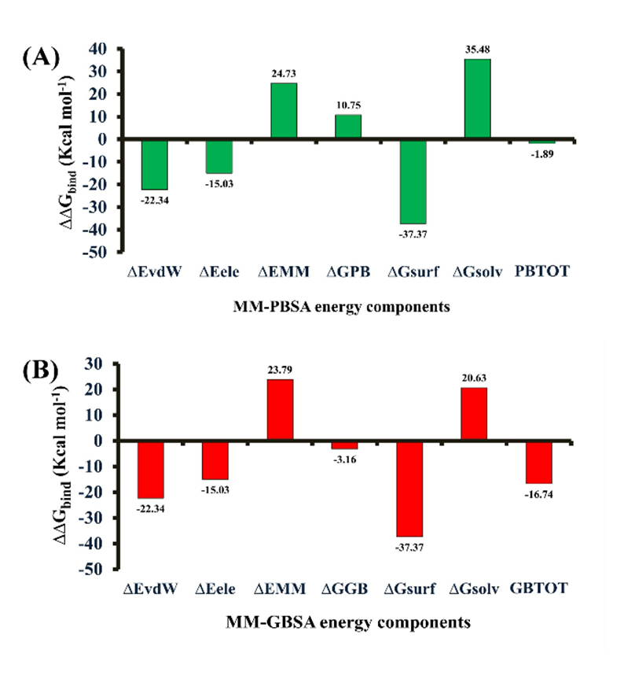
Figure S10. ∆∆G_{bind} of various energy components in A) MM-PBSA and B) MM-GBSA method of Binding free energy calculation of (α-synuclein + OleA) complex.

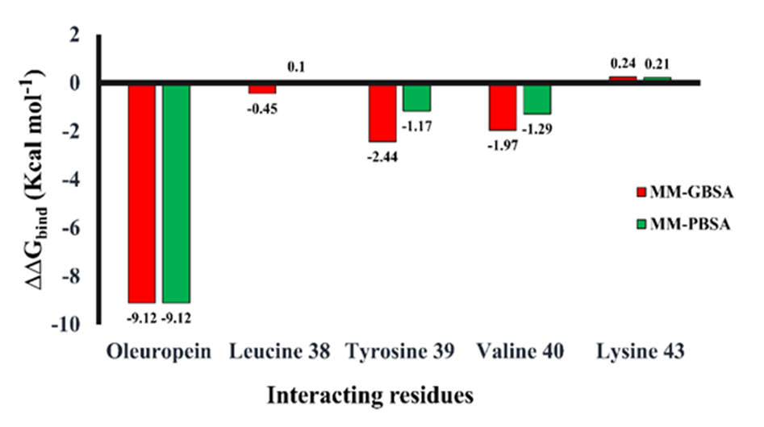
Figure S11. Per-residue energy decomposition (PRED) plots for the interface residues of ligand (OleA) and receptor α-synuclein calculated by MM-GBSA/PBSA method.

Supplementary tables
Table S1. Physico-chemical properties of Oleuropein aglycone (OleA)
Chemical structure | 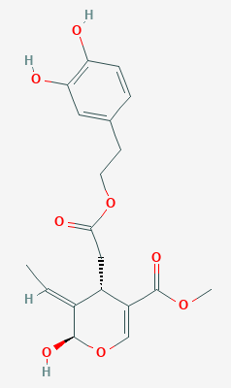
Chemical name)  (IUPAC | methyl (2R,3E,4S)-4-{2-[2-(3,4-dihydroxyphenyl)ethoxy]-2-oxoethyl}-3-ethylidene-2-hydroxy-3,4-dihydro-2H-pyran-5-carboxylate
SMILES | COC(=O)C1=COC(C(=CC)C1CC(=O)OCCc1ccc(c(c1)O)O)O
Molecular formula | C₁₉H₂₂O₈
Molecular weight | 378.377 g/mol
H-Bond donor | 8
H-Bond acceptor | 3
Log P^{c} | 1.34
Rotatable bonds | 8
TPSA (A²) | 122.53
TPSA = Topological polar surface area; logP = octanol-water partition coefficients

Table 2. Interactions of residues of α-synuclein (Receptor) with OleA(ligand) obtained from Ligplot⁺ software.
α-synuclein(Receptor) |  |  |  | OleA(ligand)
Atom name | Residue name | Residue number | < ---> | Atom name | Residue name | Residue number | Bond distance
CD2 | TYR | 40 | < ---> | O1 | LIG | 1 | 3.65
CE1 | TYR | 40 | < ---> | O1 | LIG | 1 | 3.80
CE2 | TYR | 40 | < ---> | O1 | LIG | 1 | 3.16
CZ | TYR | 40 | < ---> | O1 | LIG | 1 | 3.32
OH | TYR | 40 | < ---> | O1 | LIG | 1 | 3.76
CA | TYR | 40 | < ---> | O4 | LIG | 1 | 3.37
C | TYR | 40 | < --- > | O4 | LIG | 1 | 3.63
CG | TYR | 40 | < --- > | O4 | LIG | 1 | 3.54
CD2 | TYR | 40 | < --- > | O4 | LIG | 1 | 3.58
N | VAL | 41 | < --- > | O4 | LIG | 1 | 2.97
CA | TYR | 41 | < --- > | O4 | LIG | 1 | 3.83
C | TYR | 40 | < ---> | O1 | LIG | 1 | 3.83
O | TYR | 40 | < ---> | O1 | LIG | 1 | 3.67
CG2 | TYR | 40 | < ---> | O1 | LIG | 1 | 3.79
O | TYR | 40 | < ---> | C2 | LIG | 1 | 3.66
CG | TYR | 40 | < ---> | C2 | LIG | 1 | 3.89
CD1 | TYR | 40 | < ---> | C2 | LIG | 1 | 3.42
CE1 | TYR | 40 | < --- > | C2 | LIG | 1 | 3.39
CZ | TYR | 40 | < --- > | C2 | LIG | 1 | 3.82
CG | TYR | 40 | < --- > | C7 | LIG | 1 | 3.52
CD1 | TYR | 40 | < --- > | C7 | LIG | 1 | 3.59
CE1 | TYR | 40 | < --- > | C7 | LIG | 1 | 3.68
CE2 | TYR | 40 | < --- > | C7 | LIG | 1 | 3.51
CZ | TYR | 40 | < --- > | C7 | LIG | 1 | 3.65
CE2 | TYR | 40 | < --- > | C9 | LIG | 1 | 3.52
O | TYR | 40 | < --- > | C10 | LIG | 1 | 2.96
CE2 | TYR | 40 | < --- > | C11 | LIG | 1 | 3.85
C | LYS | 44 | < --- > | C18 | LIG | 1 | 3.80
O | LYS | 44 | < --- > | C18 | LIG | 1 | 3.09

Table S3. Intra- molecular Hydrogen bond occupancy between NAC and C-terminal domain of α-synuclein (apo).
 | Acceptor | Donor | Frac | AvgDist | AvgAng
 | LYS_98@HG2 | VAL_96@CB | 0.0018 | 2.9256 | 139.8006
 | LYS_98@H | VAL_96@CB | 0.0014 | 2.894 | 146.0744
 | LYS_97@HE3 | PHE_95@CE2 | 0.0009 | 2.9101 | 146.5537
 | LYS_98@H | VAL_96@CG2 | 0.0009 | 2.9193 | 148.7936
 | GLN_100@HE21 | VAL_96@CG2 | 0.0005 | 2.8565 | 143.1733
 | LYS_97@HG3 | PHE_95@CE2 | 0.0004 | 2.9465 | 142.9428
 | LYS_98@H | VAL_96@CG2 | 0.0004 | 2.8978 | 142.1204
 | GLN_100@HE22 | VAL_96@CG2 | 0.0004 | 2.8627 | 147.7553
 | LYS_97@HG3 | PHE_95@CE1 | 0.0003 | 2.9669 | 140.9906
 | LYS_98@HE2 | VAL_96@CG2 | 0.0003 | 2.9483 | 144.263
 | LYS_98@HE2 | VAL_96@CG1 | 0.0003 | 2.8777 | 139.3384
 | ASP_99@HB2 | VAL_96@CB | 0.0003 | 2.9706 | 140.7942
 | GLN_100@HG3 | PHE_95@CE2 | 0.0003 | 2.9164 | 139.2789
 | LYS_97@HG2 | PHE_95@CE2 | 0.0002 | 2.9469 | 137.6289
 | LYS_97@HE2 | PHE_95@CE1 | 0.0002 | 2.9581 | 150.7708
 | LYS_98@HE2 | VAL_96@CG1 | 0.0002 | 2.8796 | 143.8116
 | GLN_100@HE22 | VAL_96@CG1 | 0.0002 | 2.9376 | 143.6786
 | LYS_97@HB2 | PHE_95@CE1 | 0.0001 | 2.9183 | 141.9421
 | LYS_97@HB2 | PHE_95@CE2 | 0.0001 | 2.9904 | 141.6481
 | LYS_97@HG3 | PHE_95@CD1 | 0.0001 | 2.9718 | 144.6032
 | LYS_97@HE2 | PHE_95@CZ | 0.0001 | 2.9362 | 140.0901
 | LYS_97@HE3 | PHE_95@CE1 | 0.0001 | 2.9397 | 135.6953

Table S4. Intra-molecular Hydrogen bond occupancy between NAC and C-terminal domain of (α-synuclein + OleA) complex.
Acceptor | Donor | Frac | AvgDist | AvgAng
GLU_105@OE2 | SER_87@OG | 0.179 | 2.6941 | 164.734
GLU_105@OE1 | SER_87@N | 0.1048 | 2.8667 | 158.75
GLU_104@OE2 | SER_87@OG | 0.0952 | 2.7018 | 164.754
GLU_104@OE1 | SER_87@OG | 0.0558 | 2.6918 | 163.688
GLU_105@OE1 | SER_87@OG | 0.044 | 2.7219 | 163.493
GLU_104@OE2 | SER_87@N | 0.015 | 2.8303 | 152.884
LYS_96@HE3 | ALA_89@CB | 0.0092 | 2.9177 | 151.355
LYS_96@HE3 | ALA_89@CB | 0.0034 | 2.9099 | 145.029
GLN_99@HE22 | ALA_89@CB | 0.0014 | 2.8935 | 142.496
LYS_96@HE3 | ALA_89@CB | 0.0012 | 2.8848 | 148.269
GLU_105@OE2 | SER_87@N | 0.0012 | 2.9551 | 142.979
LYS_96@HD3 | ALA_89@CB | 0.001 | 2.8931 | 139.063
LYS_96@HD3 | ALA_89@CA | 0.001 | 2.9396 | 141.174
LYS_96@HZ3 | THR_75@CG2 | 0.001 | 2.8856 | 143.181
LYS_96@HE2 | THR_92@CG2 | 0.0008 | 2.8692 | 154.939
LYS_96@HE2 | THR_92@CG2 | 0.0008 | 2.9365 | 148.028
LYS_96@HZ3 | THR_75@CG2 | 0.0006 | 2.924 | 139.655
GLN_99@HE21 | ALA_89@CB | 0.0006 | 2.8379 | 138.273
GLN_99@HE22 | ALA_90@CA | 0.0006 | 2.9409 | 149.404
LYS_96@HB2 | ALA_89@CB | 0.0004 | 2.9503 | 135.449
LYS_96@HB3 | ALA_89@CB | 0.0004 | 2.9771 | 141.74
LYS_96@HD2 | ALA_89@CB | 0.0004 | 2.9654 | 147.532
LYS_96@HD2 | ALA_89@CB | 0.0004 | 2.9523 | 150.409
GLU_104@HG3 | ALA_89@CB | 0.0004 | 2.936 | 135.334
GLU_105@CD | SER_87@OG | 0.0004 | 2.9799 | 159.428

Table S5: The various components of the Binding Free Energy (kcal mol⁻¹) calculated by Molecular Mechanics/Generalized Borne Surface Area (MM-GBSA) and Molecular Mechanics/Poisson−Boltzmann Surface Area (MM-PBSA) method between (α-synuclein+OleA) complex (for Simulation II)..
- MM-GBSA calculation

Energy components | COMPLEX | LIGAND | RECEPTOR | DELTA
 | Energy (kcal mol⁻¹) | Energy (kcal mol⁻¹) | Energy (kcal mol⁻¹) | Energy (kcal mol⁻¹)
E_{vdW} | 664.61 | -4.23 | -635.98 | -24.40
E_{ele} | -8984.29 | 1.36 | -8950.26 | -35.39
E_{GB} | -4160.73 | -34.63 | -4170.14 | 44.04
E_{SURF} | 95.96 | 3.85 | 95.95 | -3.83
G_{gas} | -9648.90 | -2.87 | -9586.24 | -59.79
G_{solv} | -4064.76 | -30.78 | -4074.19 | 40.20
GB_{TOTAL} | -13713.67 | -33.65 | -13660.43 | -19.59
TS_{TRA} | 16.27 | 16.25 | 13.02 | -12.99
TS_{ROT} | 17.87 | 17.62 | 10.77 | -10.53
TS_{VIB} | 1647.97 | 1593.56 | 31.47 | 22.94
TS_{TOT} | 1682.11 | 1627.43 | 55.26 | -0.58
∆G_{bind}(kcal mol⁻¹) |  |  |  | -19.01

Electrostatic energy (E_{ele}); van der Waals contribution (E_{vdw}); total gas phase energy (G_{gas}); nonpolar contribution to the solvation free energy (E_{SURF}); the electrostatic contribution to the solvation free energy (E_{GB}); sum of nonpolar and polar contributions to solvation (G_{solv}); final estimated binding free energy (GB_{TOTAL}); translational energy (TS_{TRA}); rotational energy (TS_{ROT}); vibrational energy (TS_{VIB}), total entropic contribution (TS_{TOT}); binding free energy (ΔG_{bind}).
- MM-PBSA calculation

Energy components | COMPLEX | LIGAND |  | RECEPTOR |  | DELTA
 | Energy (kcal mol⁻¹) |  | Energy (kcal mol⁻¹) |  | Energy (kcal mol⁻¹) |  | Energy (kcal mol⁻¹)
E_{vdW} | -664.61 |  | -4.23 |  | -635.98 |  | -24.40
E_{ele} | -8984.29 |  | 1.36 |  | -8950.26 |  | -35.39
E_{PB} | -4213.35 |  | -37.70 |  | -4220.05 |  | 44.39
E_{SURF} | 232.96 |  | 1.58 |  | 219.74 |  | 11.91
G_{gas} | -9648.90 |  | -2.87 |  | -9586.24 |  | -59.79
G_{solv} | -3980.40 |  | -36.13 |  | -4000.58 |  | 56.30
PB_{TOTAL} | -13629.31 |  | -38.99 |  | -13586.82 |  | -3.49
TS_{TRA} | 16.27 |  | 16.25 |  | 13.02 |  | -12.99
TS_{ROT} | 17.87 |  | 17.62 |  | 10.77 |  | -10.53
TS_{VIB} | 1647.97 |  | 1593.56 |  | 31.47 |  | 22.94
TS_{TOT} | 1682.11 |  | 1627.43 |  | 55.26 |  | -0.58
∆G_{bind}(kcal mol⁻¹) |  |  |  |  |  |  | -2.91

Electrostatic energy (E_{ele}); van der Waals contribution (E_{vdw}); total gas phase energy (G_{gas}); nonpolar contribution to the solvation free energy (E_{SURF}); the electrostatic contribution to the solvation free energy (E_{PB}); sum of nonpolar and polar contributions to solvation (G_{solv}); final estimated binding free energy (PB_{TOTAL}); translational energy (TS_{TRA}); rotational energy (TS_{ROT}); vibrational energy (TS_{VIB}), total entropic contribution (TS_{TOT}); binding free energy (ΔG_{bind}).

Table S6: The various components of the Binding Free Energy (kcal mol⁻¹) calculated by Molecular Mechanics/Generalized Borne Surface Area (MM-GBSA) and Molecular Mechanics/Poisson−Boltzmann Surface Area (MM-PBSA) method between (α-synuclein+OleA) complex (for Simulation III).
- MM-GBSA calculation

Energy components | COMPLEX | LIGAND | RECEPTOR | DELTA
 | Energy (kcal mol⁻¹) | Energy (kcal mol⁻¹) | Energy (kcal mol⁻¹) ± SD | Energy (kcal mol⁻¹) ± SD
E_{vdW} | -675.67 | -4.83 | -643.08 | -27.76
E_{ele} | -8887.38 | 1.39 | -8867.49 | -21.29
E_{GB} | -4267.36 | -34.38 | -4264.44 | 31.46
E_{SURF} | 95.53 | 3.84 | 95.90 | -4.22
G_{gas} | -9563.05 | -3.43 | -9510.57 | -49.05
G_{solv} | -4171.83 | -30.54 | -4168.54 | 27.25
GB_{TOTAL} | -13734.88 | -33.97 | -13679.11 | -21.79
TS_{TRA} | 16.27 | 13.02 | 16.25 | -12.99
TS_{ROT} | 17.88 | 10.77 | 17.67 | -10.56
TS_{VIB} | 1668.37 | 31.43 | 1603.22 | 33.72
TS_{TOT} | 1702.53 | 55.22 | 1637.14 | 10.17
∆G_{bind}(kcal mol⁻¹) |  |  |  | -31.96

Electrostatic energy (E_{ele}); van der Waals contribution (E_{vdw}); total gas phase energy (G_{gas}); nonpolar contribution to the solvation free energy (E_{SURF}); the electrostatic contribution to the solvation free energy (E_{GB}); sum of nonpolar and polar contributions to solvation (G_{solv}); final estimated binding free energy (GB_{TOTAL}); translational energy (TS_{TRA}); rotational energy (TS_{ROT}); vibrational energy (TS_{VIB}), total entropic contribution (TS_{TOT}); binding free energy (ΔG_{bind}).

- MM-PBSA calculation

Energy components | COMPLEX | LIGAND |  | RECEPTOR |  | DELTA
 | Energy (kcal mol⁻¹) |  | Energy (kcal mol⁻¹) |  | Energy (kcal mol⁻¹) |  | Energy (kcal mol⁻¹)
EvdW | -675.67 |  | -4.83 |  | -643.08 |  | -27.76
E_{ele} | -8887.38 |  | 1.39 |  | -8867.49 |  | -21.29
E_{PB} | -4328.55 |  | -36.73 |  | -4326.53 |  | 34.71
E_{SURF} | 237.88 |  | 1.51 |  | 222.76 |  | 13.46
G_{gas} | -9563.05 |  | -3.43 |  | -9510.57 |  | -49.05
G_{solv} | -4090.67 |  | -35.23 |  | -4103.77 |  | 48.32
PB_{TOTAL} | 13653.73 |  | -38.66 |  | -13614.34 |  | -0.73
TS_{TRA} | 16.27 |  | 13.02 |  | 16.25 |  | -12.99
TS_{ROT} | 17.88 |  | 10.77 |  | 17.67 |  | -10.56
TS_{VIB} | 1668.37 |  | 31.43 |  | 1603.22 |  | 33.72
TS_{TOT} | 1702.53 |  | 55.22 |  | 1637.14 |  | 10.17
∆G_{bind}(kcal mol⁻¹) |  |  |  |  |  |  | -10.90
Electrostatic energy (E_{ele}); van der Waals contribution (E_{vdw}); total gas phase energy (G_{gas}); nonpolar contribution to the solvation free energy (E_{SURF}); the electrostatic contribution to the solvation free energy (E_{PB}); sum of nonpolar and polar contributions to solvation (G_{solv}); final estimated binding free energy (PB_{TOTAL}); translational energy (TS_{TRA}); rotational energy (TS_{ROT}); vibrational energy (TS_{VIB}), total entropic contribution (TS_{TOT}); binding free energy (ΔG_{bind}).

