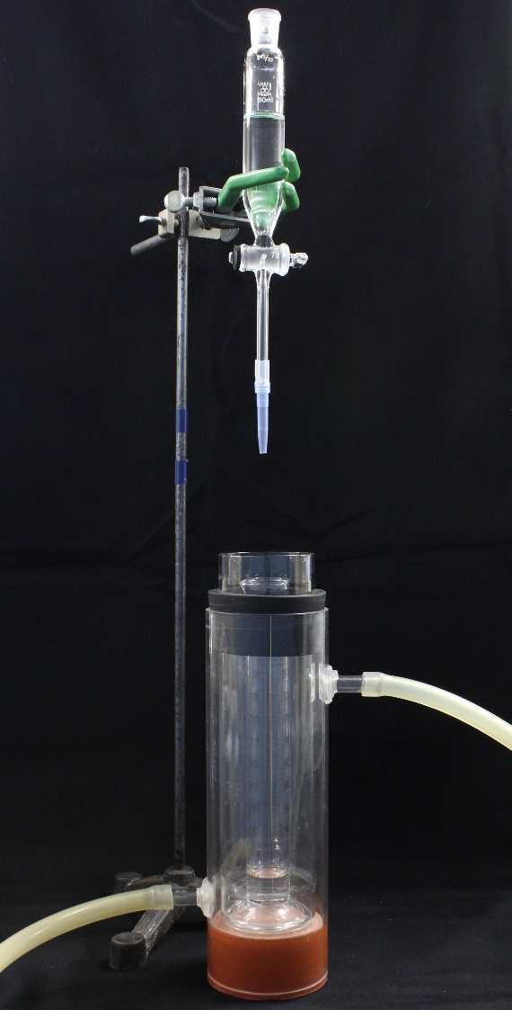

Figure S1. Photograph of the modified Ross-Miles method instrument.

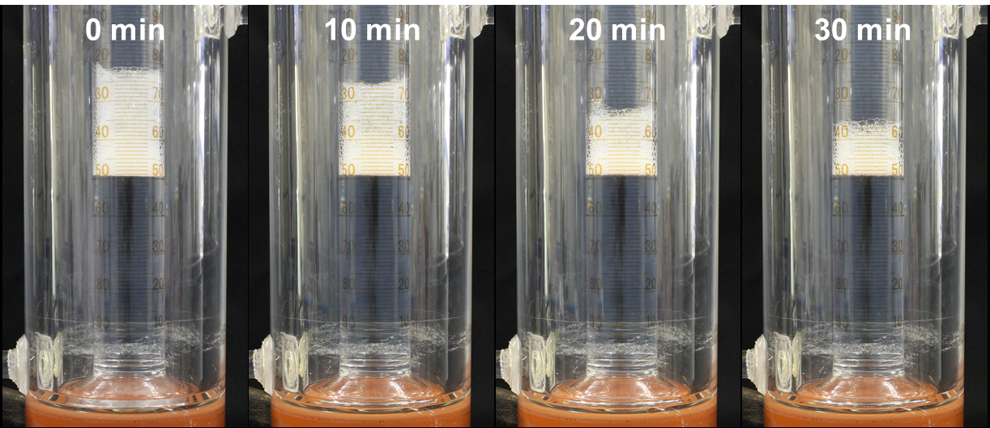

Figure S2. Photographs of foam volume change of 10 mM C12AS aqueous solution against time course at 25 °C.