SUPPLEMENTARY MATERIAL

A new labdane diterpene from the rhizomes of Alpinia officinarum
Qiong-Yu Zou ª, Hai-Feng Wu ^{b}, Yu-Lian Tang ª and Di-Zhao Chen ª*

ª Key Laboratory of Hunan Province for Study and Utilization of Ethnic Medicinal Plant Resources, Department of Chemistry & Chemical Engineering, Huaihua University, Huaihua, Hunan 418008, P.R. China;
^{b} Key Laboratory of Bioactive substances and Resources Utilization of Chinese Herbal Medicine, Peking Union Medical College, Ministry of Education, Institute of Medicinal Plant Development, Chinese Academy of Medical Sciences, Beijing 100193, P.R. China

ABSTRACT
A new labdane diterpene, (Z)-12,14-labdadien-15(16)-olide-17-oic acid (1) was isolated from the ethanolic extract of the rhizomes of Alpinia officinarum, together with four known compounds, 4-isopropyl-6-methyl-1-naphthalenemethanol (2) previously synthesized and obtained from a natural source for the first time, galangin (3), kaempferol (4), and quercetin (5). Their structures were elucidated by extensive spectroscopic methods. Compounds 1 and 2 showed no remarkable cytotoxic activity against Hela and HepG2 cancer cell lines with IC₅₀ > 50 μg mL^{–1}.
Keywords: Alpinia officinarum; labdane diterpene; cadinane sesquiterpene

List of Contents

Figure S1. The Key HMBC ( ), NOESY ( ) and ¹H-¹H COSY ( ) correlations of 1.
Figure S2. The ¹H NMR (600 MHz, CDCL₃) spectrum of the new compound 1
Figure S3. The ¹³C NMR (150 MHz, CDCL₃) spectrum of the new compound 1
Figure S4. The ¹H-¹H COSY spectrum spectrum of the new compound 1.
Figure S5. The HSQC spectrum of the new compound 1
Figure S6 The HMBC spectrum of the new compound 1
Figure S7. The NOESY spectrum of the new compound 1
Table S1. ¹H and ¹³C NMR spectroscopic data of 1 (600 and 150 MHz, CD₃OD).

Figure S1 Key HMBC ( ), NOESY ( ) and ¹H-¹H COSY ( ) correlations of 1

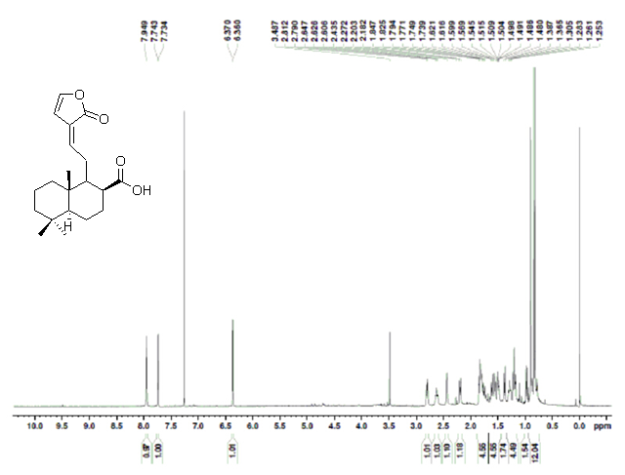
Figure S2. The ¹H NMR (600 MHz, CDCL₃) spectrum of the new compound 1

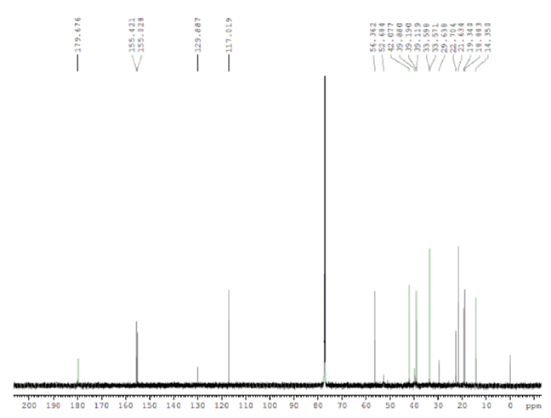
Figure S3. The ¹³C NMR (150 MHz, CDCL₃) spectrum of the new compound 1

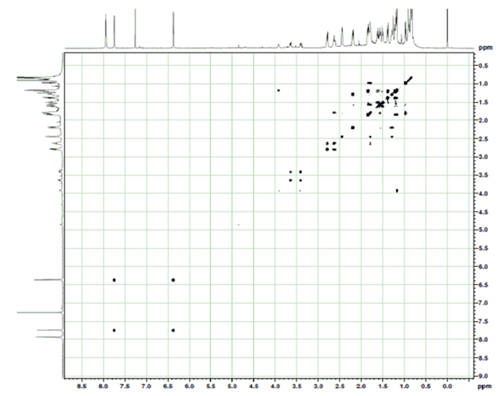
Figure S4. The ¹H-¹H COSY spectrum spectrum of the new compound 1.

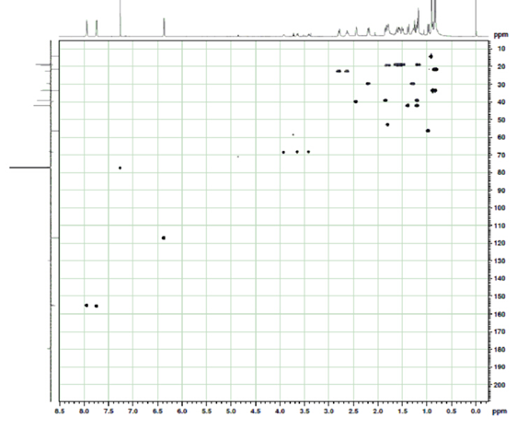
Figure S5. The HSQC spectrum of the new compound 1

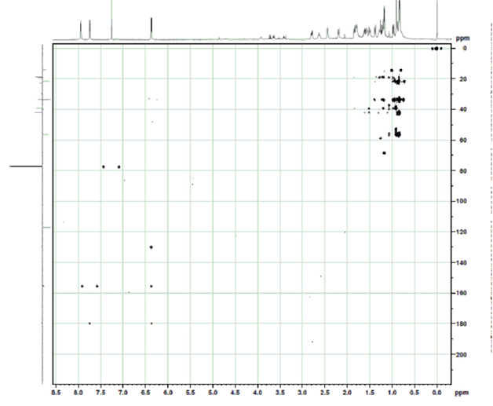
Figure S6. The HMBC spectrum of the new compound 1

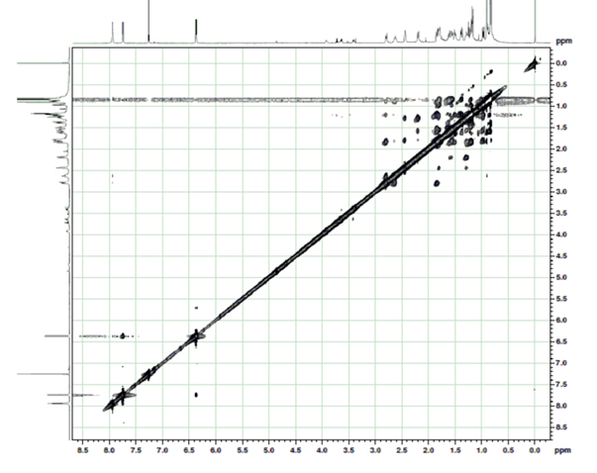
Figure S7. The NOESY spectrum of the new compound 1

Table S1 ¹H and ¹³C NMR spectroscopic data of 1 (600 and 150 MHz, CDCL₃).

No. | δ_{C} δ_{H} (J in Hz) |  | No. | δ_{C} δ_{H} (J in Hz)
1 | 39.2 | 1.20 m | 9 | 52.7 | 1.79 ddd (12.0, 4.0, 2.0)
 |  | 1.83 m | 10 | 39.1
2 | 18.9 | 1.37 m | 11 | 22.7 | 2.80 ddd (15.0,12.0, 1.0)
 |  | 1.55 m |  |  | 2.62 ddd (15.0, 2.0, 1.0)
3 | 42.1 | 1.15 m | 12 | 155.4 | 7.74 dd (1.0, 1.0)
 |  | 1.38 m | 13 | 129.9
4 | 33.6 |  | 14 | 117.0 | 6.37 d (6.0)
5 | 56.4 | 0.97 dd (13.0, 3.0) | 15 | 155.0 | 7.95 d (6.0)
6 | 19.3 | 1.81 dddd (13.0, 5.0, 3.1, 3.0) | 16 | 179.7
 |  | 1.61 dddd (13.0, 13.0, 12.0, 3.1) | 17 | 179.7
7 | 29.6 | 1.28 m | 18 | 33.6 | 0.84 (3H, s)
 |  | 2.19 m | 19 | 21.6 | 0.82 (3H, s)
8 | 39.9 | 2.43 m | 20 | 14.4 | 0.90 (3H, s)

