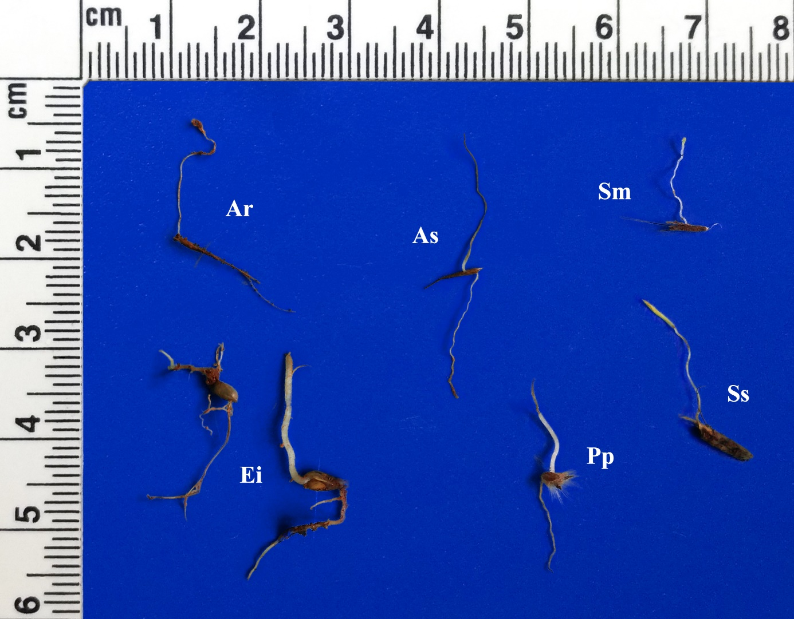
Figure S1. Non-emerged seedlings of six common and widely distributed Cerrado grasses sown at different depths (mm). Ar, Aristida recurvata; As, Aristida setifolia; Ei, Echinolaena inflexa; Pp, Paspalum polyphyllum; Sm, Schizachyrium microstachyum; Ss, Schizachyrium sanguineum.

