Supplementary Materials for

Metal/metalloid levels and variation in lifetime cancer risks among tissues

Xiang Wang^{a†}, Zhuozhi Liang^{a†}, Jiayu Guoª, Meixia Wang^{b}, Ruimei Zhu^{c}, Yuelin Liª, Jiayi Zhangª, Yixin Zhangª, Luying Tang^{d*}and Zefang Ren^{a*}

- School of Public Health, Sun Yat-sen University, Guangzhou, China
- Xiamen Branch, Zhongshan Hospital, Fudan University, Xiamen, China
- The First Affiliated Hospital, Sun Yat-sen University, Guangzhou, China
- The Third Affiliated Hospital, Sun Yat-sen University, Guangzhou, China

*Correspondence to:
Ze-Fang Ren
Email: renzef@mail.sysu.edu.cn (Zefang Ren)

Lu-Ying Tang
Email: tangly@mail.sysu.edu.cn (Luying Tang)

Table S1. Analytical techniques for the 23 metals/metalloids in all tissues.*
Metal/metalloid | Technique | Metal/metalloid | Technique
U | ICP-MS | Cu | ICP-MS
Th | ICP-MS | Fe | ICP-AES
Rb | ICP-MS | Mo | ICP-AES
Ba | ICP-AES | Se | ICP-MS
Ce | ICP-MS | Zn | ICP-AES
Co | ICP-MS | Al | ICP-MS
Cs | ICP-MS | As | ICP-MS
I | ICP-MS | Cd | ICP-MS
La | ICP-MS | Hg | ICP-MS
Sr | ICP-MS | Pb | ICP-MS
Zr | ICP-MS | Sn | ICP-MS
Cr | GF-AAS
ICP-MS inductively coupled plasma mass spectrometry; ICP-AES inductively coupled plasma atomic emission spectrometry; GF-AAS graphite furnace atomic absorption spectrometry
*Source from (IRMCAMS, 2014)

Table S2. The references of metal/metalloid concentrations among tissues for Chinese (mg/kg). †*
Metal | Thyroid | Liver | Colon | Rectum | Lung | Kidney | Stomach | Testis | Pancreas | Blood | Ovary | Brain | Bone | Skin | Small intestine |  | Adrenal gland
U | 1.06 | 0.44 | 6.00 | 6.00 | 1.54 | 1.10 | 1.33 | 0.66 | 1.62 | 0.10 | NA | NA | 1.58 | 1.00 | 2.01 | 1.58
Th | 1.32 | 0.30 | 0.32 | 0.32 | 8.44 | 0.27 | 0.65 | 0.24 | 0.33 | 0.15 | NA | NA | 1.82 | 0.62 | 0.98 | 0.73
Rb | 4.19 | 7.31 | 0.64 | 0.64 | 4.51 | 4.58 | 3.67 | 3.86 | 4.72 | 2.62 | NA | NA | 3.20 | 1.04 | 3.14 | 1.76
Ba | 0.10 | 0.09 | 0.19 | 0.19 | 0.73 | 0.05 | 0.19 | 0.10 | 0.09 | 0.07 | NA | NA | 3.20 | 0.13 | 0.56 | 0.18
Ce | 55.00 | 91.40 | 2.47 | 2.47 | 113.00 | 2.16 | 3.20 | 1.99 | 6.12 | 0.57 | NA | NA | 36.60 | 9.28 | 3.24 | 4.27
Co | 35.00 | 40.40 | 3.96 | 3.96 | 24.20 | 13.20 | 6.21 | 3.25 | 6.88 | 0.66 | 15.00 | 27.00 | 33.60 | 2.52 | 28.50 | 8.32
Cs | 11.60 | 12.20 | 2.52 | 2.52 | 16.40 | 14.70 | 10.30 | 9.07 | 10.00 | 3.06 | NA | NA | 8.86 | 3.82 | 9.82 | 3.46
I | 662.00 | 0.27 | 0.15 | 0.15 | 0.15 | 0.25 | 0.18 | 0.14 | 0.28 | 0.06 | 0.14 | NA | 0.23 | 0.14 | 0.21 | 0.17
La | 13.00 | 34.50 | 4.81 | 4.81 | 62.30 | 2.58 | 15.10 | 1.14 | 1.95 | 1.22 | NA | NA | 27.00 | 4.36 | 14.30 | 4.13
Sr | 0.38 | 0.10 | 0.84 | 0.84 | 0.19 | 0.13 | 0.34 | 0.12 | 0.15 | 0.04 | 0.17 | 0.09 | 42.30 | 0.15 | 0.43 | 0.16
Zr | 47.00 | 71.00 | 8.04 | 8.04 | 28.00 | 9.80 | 8.00 | 7.57 | 16.20 | 5.11 | NA | NA | 56.70 | 19.20 | 25.50 | 16.10
Cr | 0.09 | 0.11 | 0.04 | 0.04 | 0.13 | 0.06 | 0.08 | 0.01 | 0.06 | 0.01 | 1.16 | 0.16 | 0.13 | 0.04 | 0.14 | 0.08
Cu | 2.05 | 8.90 | 0.91 | 0.91 | 1.32 | 2.80 | 1.94 | 0.64 | 1.08 | 0.74 | 0.89 | 4.40 | 0.70 | 0.52 | 2.74 | 1.38
Fe | 52.30 | 282.00 | 18.50 | 18.50 | 169.00 | 90.20 | 36.50 | 16.80 | 42.20 | 506.00 | 44.60 | 61.70 | 81.20 | 11.20 | 31.90 | 67.30
Mo | 0.18 | 0.81 | 0.02 | 0.02 | 0.01 | 0.25 | 0.11 | 0.03 | 0.06 | 0.00 | 0.29 | 0.04 | 0.02 | 0.02 | 0.03 | 0.09
Se | 0.70 | 0.37 | 0.14 | 0.14 | 0.18 | 0.86 | 0.19 | 0.43 | 0.29 | 0.11 | NA | 1.56 | 0.12 | 0.11 | 0.18 | 0.31
Zn | 28.80 | 53.90 | 12.80 | 12.80 | 12.10 | 34.30 | 16.40 | 11.40 | 31.70 | 7.22 | 10.80 | 13.90 | 50.00 | 5.66 | 16.00 | 13.10
Al | 12.80 | 1.58 | 2.62 | 2.62 | 20.00 | 0.78 | 0.97 | 0.90 | 0.86 | 0.41 | NA | NA | 7.69 | 0.70 | 11.20 | 1.72
As | 53.10 | 40.60 | 29.40 | 29.40 | 26.30 | 29.00 | 30.80 | 35.50 | 34.20 | 25.40 | NA | NA | 102.00 | 38.20 | 19.00 | 27.80
Cd | 0.59 | 0.97 | 0.09 | 0.09 | 0.42 | 5.88 | 0.26 | 0.09 | 0.58 | 0.00 | 0.16 | 0.11 | 0.08 | 0.02 | 0.07 | 0.16
Hg | 6.02 | 16.50 | 2.02 | 2.02 | 6.60 | 31.00 | 5.44 | 5.73 | 9.46 | 6.30 | NA | NA | 10.00 | 3.49 | 1.40 | 3.18
Pb | 0.07 | 0.38 | 0.05 | 0.05 | 0.17 | 0.16 | 0.06 | 0.03 | 0.11 | 0.10 | 0.07 | 0.15 | 1.12 | 0.05 | 0.07 | 0.15
Sn | 5.88 | 22.00 | 5.13 | 5.13 | 31.10 | 12.10 | 6.90 | 7.57 | 5.68 | 6.87 | NA | NA | 12.80 | 7.36 | 9.16 | 7.85
†The concentration of metal/metalloid was described in median.
*Source from (IRMCAMS, 2014)

Table S3. Lifetime cumulative cancer risks of the tissues for Chinese (%).*
Tissue | Lifetime cumulative risk  (male) | Lifetime cumulative risk  (female) | Lifetime cumulative risk  (both sexes)
Thyroid | 0.43 | 1.31 | 0.86
Liver | 3.15 | 1.05 | 2.10
Colon | 1.13 | 0.83 | 0.98
Rectum | 1.27 | 0.80 | 1.04
Lung | 6.20 | 2.80 | 4.48
Kidney | 0.39 | 0.21 | 0.30
Stomach | 3.58 | 1.34 | 2.45
Testis | 0.03 | NA | 0.03
Pancreas | 0.59 | 0.41 | 0.50
Blood | 0.52 | 0.39 | 0.46
Ovary | NA | 0.57 | 0.57
Brain | 0.54 | 0.61 | 0.58
Bone | 0.16 | 0.12 | 0.14
Skin | 0.04 | 0.03 | 0.04
Small intestine | 0.10 | 0.07 | 0.09
Adrenal gland | 0.02 | 0.02 | 0.02
*Source from (He and Chen 2017)

Table S4. Pearson correlations between each two log10-transformed concentrations of metals/metalloids.
Metal | U | Th | Rb | Ba | Ce | Co | Cs | I | La | Sr | Zr | Cr | Cu | Fe | Mo | Se | Zn | Al | As | Cd | Hg | Pb | Sn
U | 1 | 0.27 | -0.53 | 0.36 | 0.06 | 0.25 | -0.17 | 0.02 | 0.22 | 0.52 | 0.01 | 0.36 | -0.10 | -0.66 | 0.15 | -0.12 | 0.07 | 0.43 | -0.03 | 0.27 | -0.47 | -0.18 | -0.23
Th | 0.27 | 1 | 0.19 | 0.71 | 0.70 | 0.61 | 0.43 | 0.26 | 0.77 | 0.39 | 0.57 | 0.69 | 0.02 | 0.07 | -0.05 | -0.13 | 0.08 | 0.82 | 0.21 | 0.18 | -0.09 | 0.33 | 0.54
Rb | -0.53 | 0.19 | 1 | -0.05 | 0.42 | 0.52 | 0.89 | 0.24 | 0.28 | -0.21 | 0.44 | 0.30 | 0.56 | 0.56 | 0.41 | 0.55 | 0.58 | 0.09 | 0.16 | 0.50 | 0.70 | 0.42 | 0.57
Ba | 0.36 | 0.71 | -0.05 | 1 | 0.40 | 0.45 | 0.12 | -0.14 | 0.63 | 0.80 | 0.44 | 0.52 | -0.19 | -0.02 | -0.28 | -0.51 | 0.15 | 0.68 | 0.38 | -0.17 | -0.25 | 0.49 | 0.36
Ce | 0.06 | 0.70 | 0.42 | 0.40 | 1 | 0.77 | 0.54 | 0.44 | 0.81 | 0.27 | 0.89 | 0.68 | 0.37 | 0.24 | 0.39 | 0.15 | 0.49 | 0.63 | 0.51 | 0.42 | 0.30 | 0.54 | 0.65
Co | 0.25 | 0.61 | 0.52 | 0.45 | 0.77 | 1 | 0.70 | 0.44 | 0.77 | 0.32 | 0.85 | 0.72 | 0.64 | 0.17 | 0.59 | 0.46 | 0.67 | 0.73 | 0.35 | 0.62 | 0.27 | 0.53 | 0.57
Cs | -0.17 | 0.43 | 0.89 | 0.12 | 0.54 | 0.70 | 1 | 0.31 | 0.46 | -0.02 | 0.50 | 0.51 | 0.54 | 0.28 | 0.48 | 0.56 | 0.60 | 0.34 | 0.18 | 0.68 | 0.61 | 0.33 | 0.61
I | 0.02 | 0.26 | 0.24 | -0.14 | 0.44 | 0.44 | 0.31 | 1 | 0.21 | 0.10 | 0.45 | 0.14 | 0.26 | -0.02 | 0.35 | 0.54 | 0.35 | 0.44 | 0.36 | 0.34 | 0.09 | -0.05 | -0.16
La | 0.22 | 0.77 | 0.28 | 0.63 | 0.81 | 0.77 | 0.46 | 0.21 | 1 | 0.41 | 0.74 | 0.82 | 0.47 | 0.24 | 0.28 | -0.12 | 0.40 | 0.74 | 0.27 | 0.30 | 0.04 | 0.50 | 0.66
Sr | 0.52 | 0.39 | -0.21 | 0.80 | 0.27 | 0.32 | -0.02 | 0.10 | 0.41 | 1 | 0.36 | 0.18 | -0.26 | -0.23 | -0.07 | -0.37 | 0.41 | 0.50 | 0.67 | -0.02 | -0.13 | 0.42 | -0.01
Zr | 0.01 | 0.57 | 0.44 | 0.44 | 0.89 | 0.85 | 0.50 | 0.45 | 0.74 | 0.36 | 1 | 0.74 | 0.46 | 0.24 | 0.45 | 0.16 | 0.62 | 0.61 | 0.55 | 0.34 | 0.24 | 0.64 | 0.55
Cr | 0.36 | 0.69 | 0.30 | 0.52 | 0.68 | 0.72 | 0.51 | 0.14 | 0.82 | 0.18 | 0.74 | 1 | 0.34 | 0.07 | 0.53 | 0.25 | 0.25 | 0.65 | 0.21 | 0.36 | 0.11 | 0.34 | 0.48
Cu | -0.10 | 0.02 | 0.56 | -0.19 | 0.37 | 0.64 | 0.54 | 0.26 | 0.47 | -0.26 | 0.46 | 0.34 | 1 | 0.40 | 0.60 | 0.62 | 0.54 | 0.18 | -0.16 | 0.56 | 0.36 | 0.31 | 0.45
Fe | -0.66 | 0.07 | 0.56 | -0.02 | 0.24 | 0.17 | 0.28 | -0.02 | 0.24 | -0.23 | 0.24 | 0.07 | 0.40 | 1 | -0.04 | 0.10 | 0.30 | 0.01 | 0.01 | 0.06 | 0.55 | 0.62 | 0.57
Mo | 0.15 | -0.05 | 0.41 | -0.28 | 0.39 | 0.59 | 0.48 | 0.35 | 0.28 | -0.07 | 0.45 | 0.53 | 0.60 | -0.04 | 1 | 0.58 | 0.58 | 0.02 | 0.20 | 0.78 | 0.43 | 0.15 | 0.18
Se | -0.12 | -0.13 | 0.55 | -0.51 | 0.15 | 0.46 | 0.56 | 0.54 | -0.12 | -0.37 | 0.16 | 0.25 | 0.62 | 0.10 | 0.58 | 1 | 0.34 | -0.02 | 0.03 | 0.58 | 0.54 | 0.04 | 0.10
Zn | 0.07 | 0.08 | 0.58 | 0.15 | 0.49 | 0.67 | 0.60 | 0.35 | 0.40 | 0.41 | 0.62 | 0.25 | 0.54 | 0.30 | 0.58 | 0.34 | 1 | 0.25 | 0.53 | 0.68 | 0.61 | 0.65 | 0.33
Al | 0.43 | 0.82 | 0.09 | 0.68 | 0.63 | 0.73 | 0.34 | 0.44 | 0.74 | 0.50 | 0.61 | 0.65 | 0.18 | 0.01 | 0.02 | -0.02 | 0.25 | 1 | 0.18 | 0.19 | -0.26 | 0.23 | 0.37
As | -0.03 | 0.21 | 0.16 | 0.38 | 0.51 | 0.35 | 0.18 | 0.36 | 0.27 | 0.67 | 0.55 | 0.21 | -0.16 | 0.01 | 0.20 | 0.03 | 0.53 | 0.18 | 1 | 0.08 | 0.38 | 0.57 | 0.09
Cd | 0.27 | 0.18 | 0.50 | -0.17 | 0.42 | 0.62 | 0.68 | 0.34 | 0.30 | -0.02 | 0.34 | 0.36 | 0.56 | 0.06 | 0.78 | 0.58 | 0.68 | 0.19 | 0.08 | 1 | 0.57 | 0.23 | 0.36
Hg | -0.47 | -0.09 | 0.70 | -0.25 | 0.30 | 0.27 | 0.61 | 0.09 | 0.04 | -0.13 | 0.24 | 0.11 | 0.36 | 0.55 | 0.43 | 0.54 | 0.61 | -0.26 | 0.38 | 0.57 | 1 | 0.56 | 0.48
Pb | -0.18 | 0.33 | 0.42 | 0.49 | 0.54 | 0.53 | 0.33 | -0.05 | 0.50 | 0.42 | 0.64 | 0.34 | 0.31 | 0.62 | 0.15 | 0.04 | 0.65 | 0.23 | 0.57 | 0.23 | 0.56 | 1 | 0.62
Sn | -0.23 | 0.54 | 0.57 | 0.36 | 0.65 | 0.57 | 0.61 | -0.16 | 0.66 | -0.01 | 0.55 | 0.48 | 0.45 | 0.57 | 0.18 | 0.10 | 0.33 | 0.37 | 0.09 | 0.36 | 0.48 | 0.62 | 1
The bold indicated that this metal/metalloid was highly correlated with Cd/Rb/Cs/Sn, with a Pearson coefficient larger than 0.6.

- b.
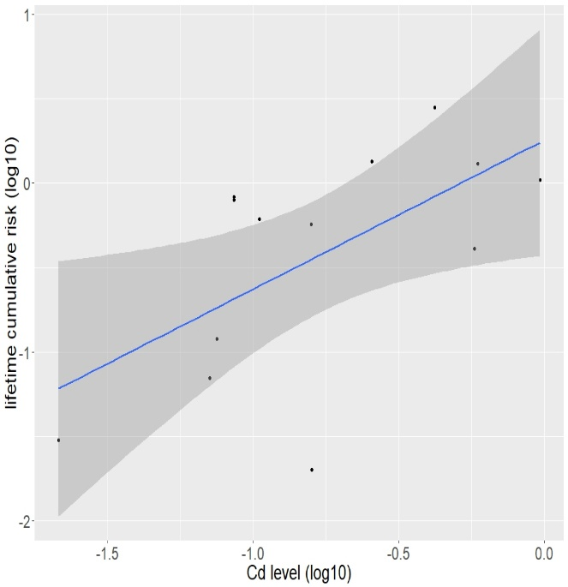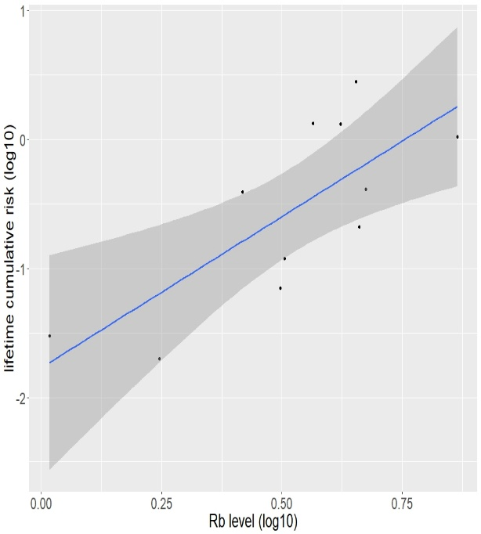
c. d.
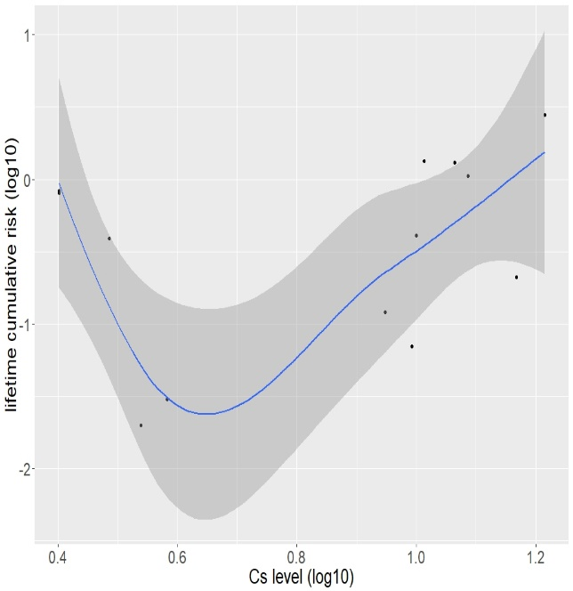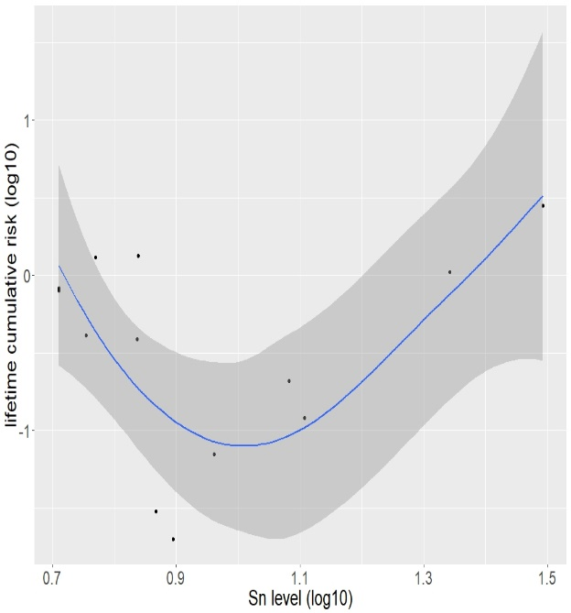
Figure S1. Linear/nonlinear correlation curves and 95% confidence bands for each element with the lifetime cancer risks of the tissues among females. (a) linear correlation curve for Cd; (b) linear correlation curve for Rb; (c) nonlinear correlation curve for Cs; (d) nonlinear correlation curve for Sn.

- b.
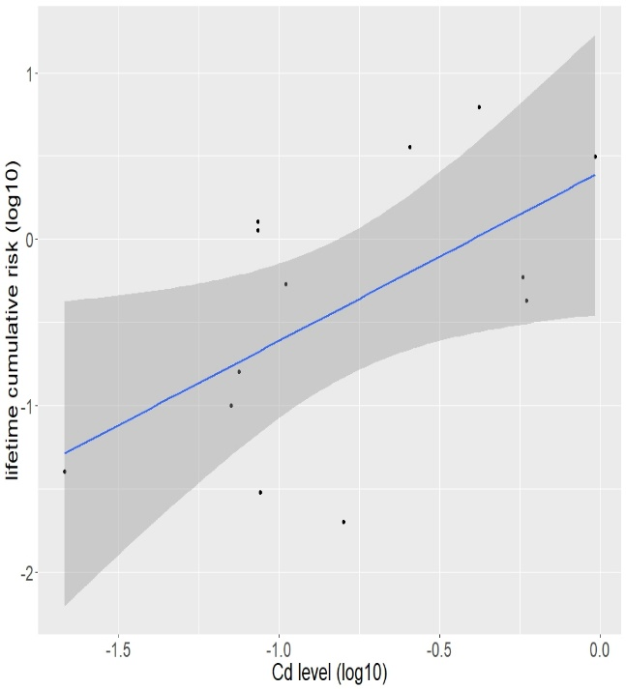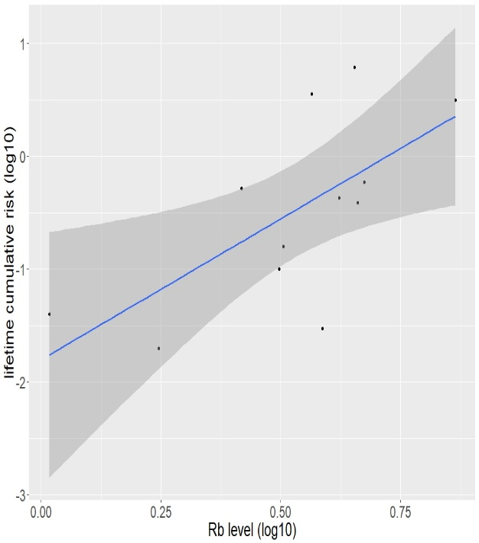
c. d.
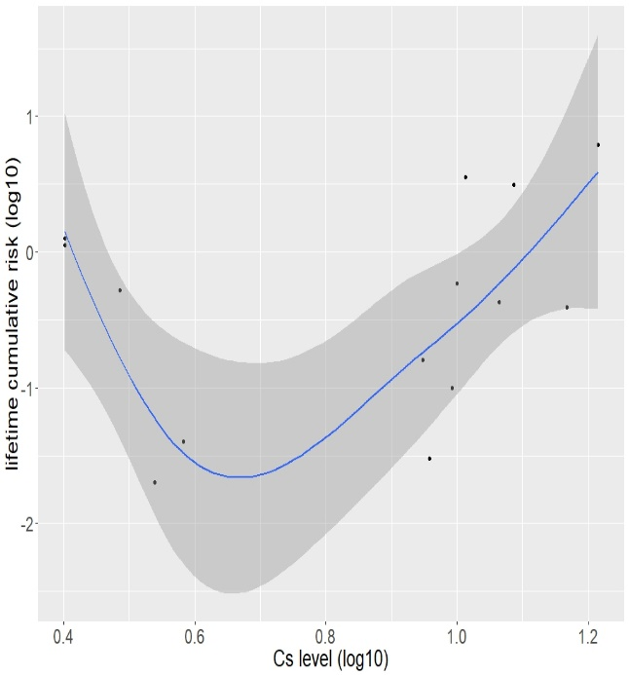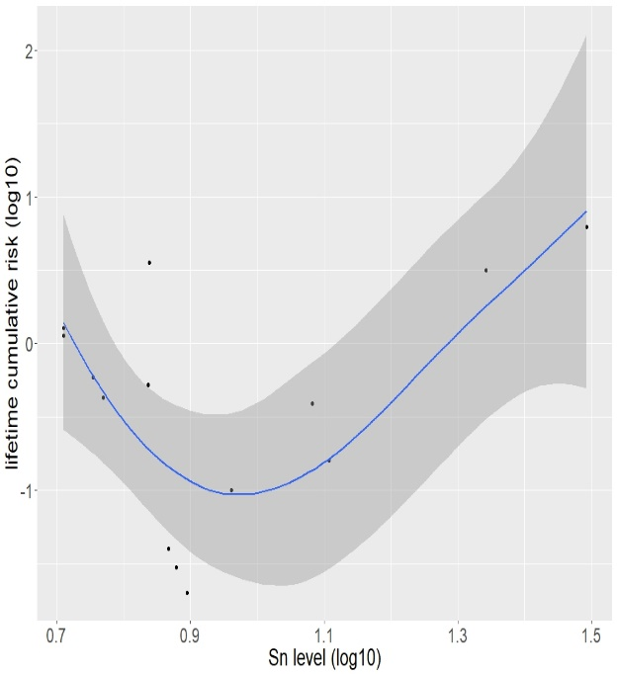
Figure S2. Linear/nonlinear correlation curves and 95% confidence bands for each element with the lifetime cancer risks of the tissues among males. (a) linear correlation curve for Cd; (b) linear correlation curve for Rb; (c) nonlinear correlation curve for Cs; (d) nonlinear correlation curve for Sn.

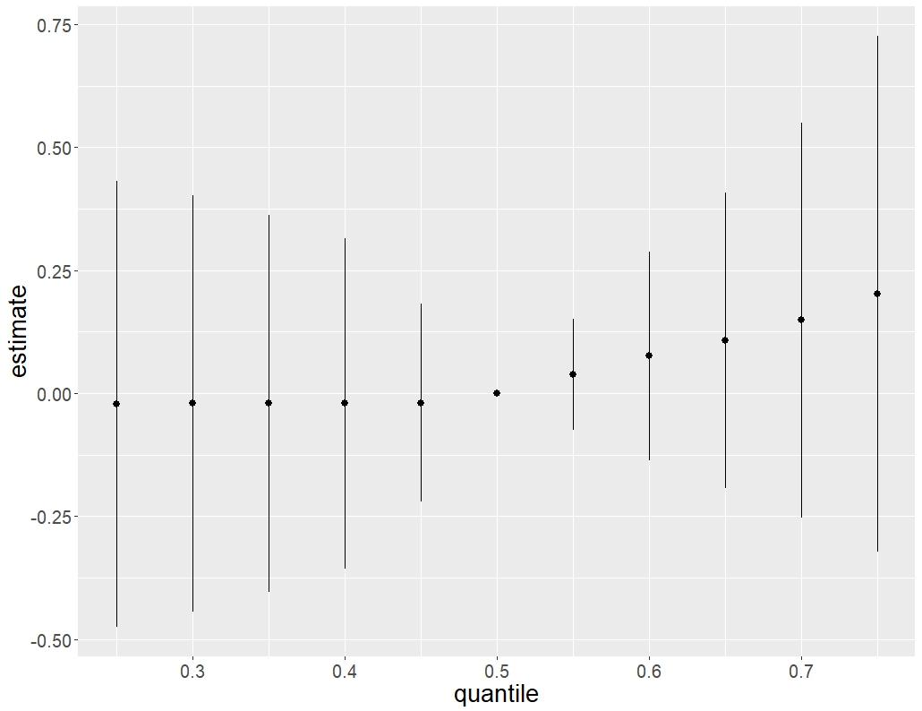
Figure S3. Overall correlation of the mixture (estimates and 95% credible intervals) with the lifetime cancer risks of the tissues among females. The plot compared the lifetime cumulative risk when all the exposures are at a particular percentile to when all are at 50th percentile. X-axis (quantile) referred to the percentile of the metal and metalloid mixture, which was between the 25th and 75th in 5% increments; Y-axis (estimate) referred to estimated overall correlation of the mixture with the lifetime cumulative cancer risk.

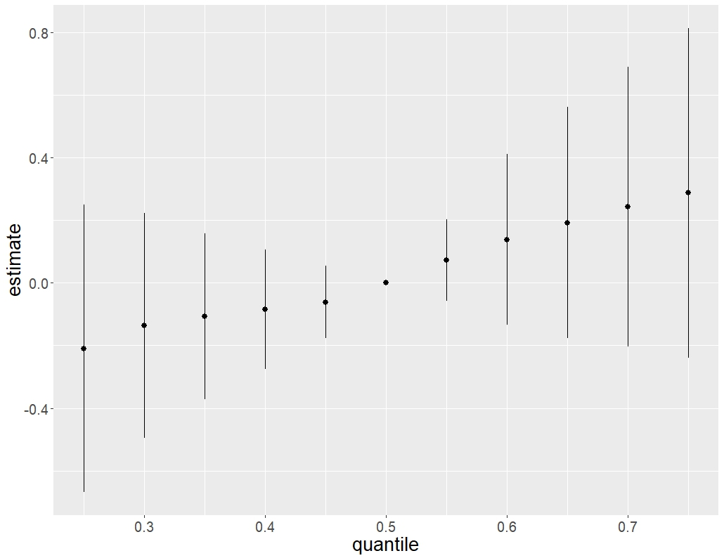Figure S4. Overall correlation of the mixture (estimates and 95% credible intervals) with the lifetime cancer risks of the tissues among males. The plot compared the lifetime cumulative risk when all the exposures are at a particular percentile to when all are at 50th percentile. X-axis (quantile) referred to the percentile of the metal and metalloid mixture, which was between the 25th and 75th in 5% increments; Y-axis (estimate) referred to estimated overall correlation of the mixture with the lifetime cumulative cancer risk.

- b.
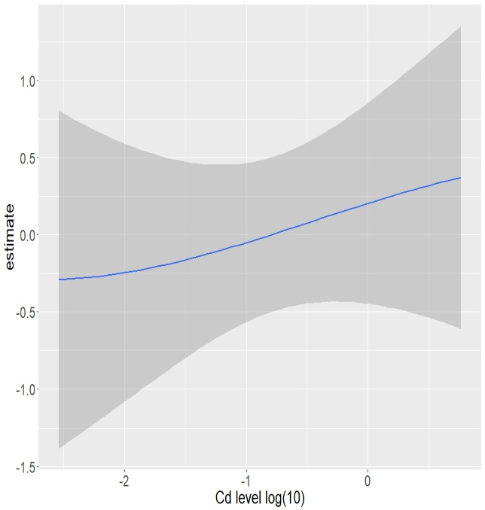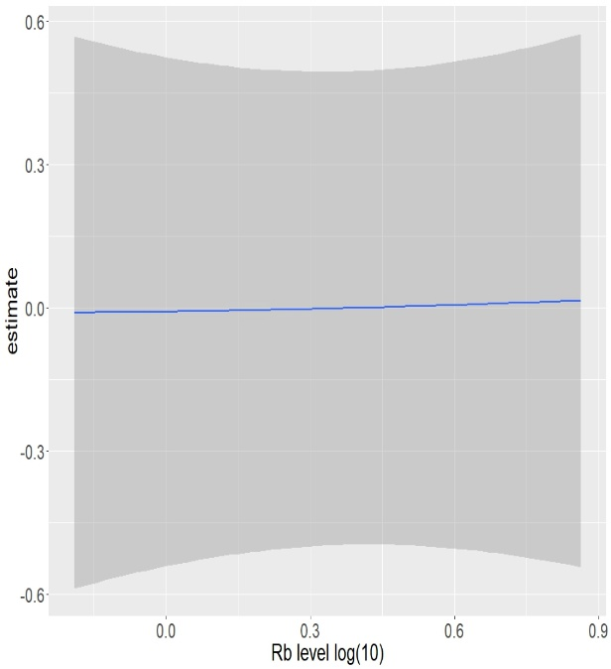
c. d.
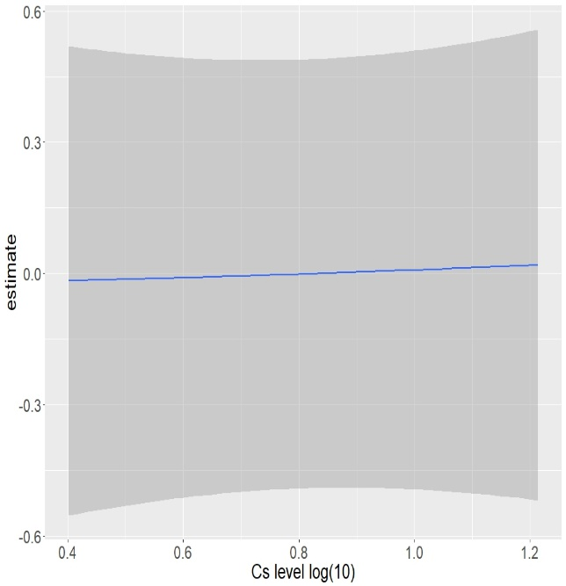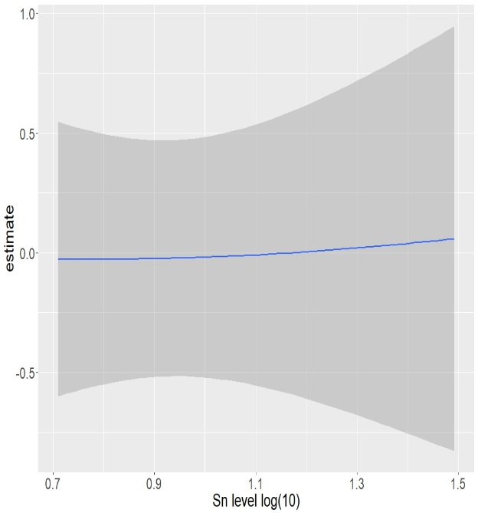
Figure S5. Univariate exposure-response curves and 95% confidence bands for each element with the other elements fixed at the median among females. X-axis referred to the log10-transformed concentration of a certain element. Y-axis (estimate) referred to estimated univarite correlation of a certain element with the lifetime cumulative cancer risk. (a) univariate exposure-response curve for Cd; (b) univariate exposure-response curve for Rb; (c) univariate exposure-response curve for Cs; (d) univariate exposure-response curve for Sn.

- b.
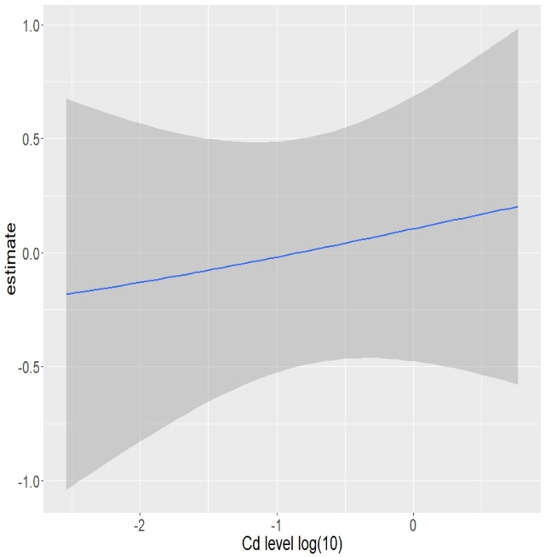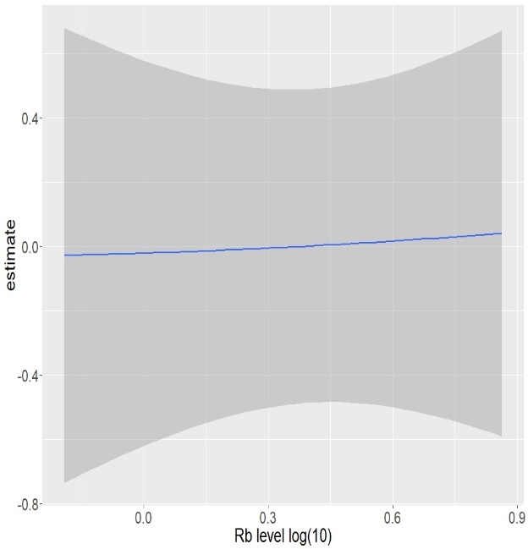
c. d.
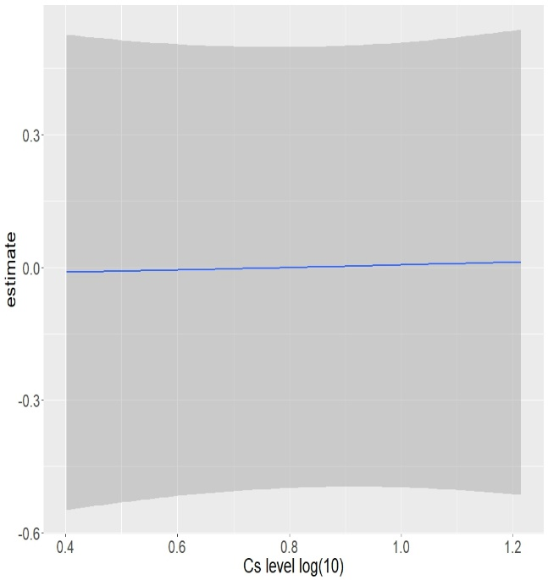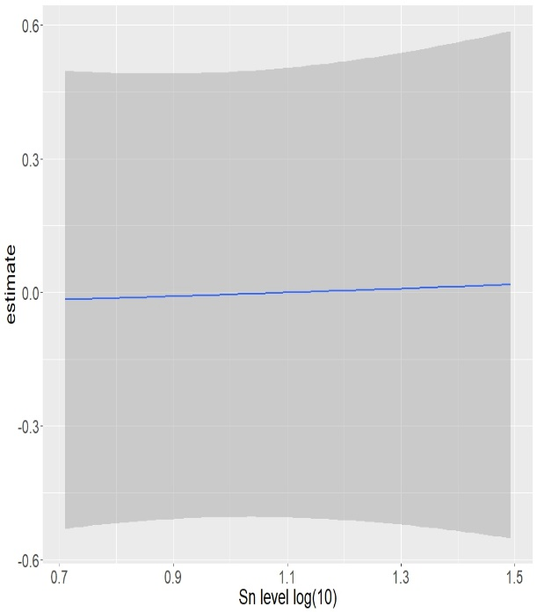
Figure S6. Univariate exposure-response curves and 95% confidence bands for each element with the other elements fixed at the median among males. X-axis referred to the log10-transformed concentration of a certain element. Y-axis (estimate) referred to estimated univarite correlation of a certain element with the lifetime cumulative cancer risk. (a) univariate exposure-response curve for Cd; (b) univariate exposure-response curve for Rb; (c) univariate exposure-response curve for Cs; (d) univariate exposure-response curve for Sn.

