**Combining water supply and flood control purposes in the Coghinas Basin (Sardinia, Italy)**

**A. Sulis b,*, S. Frongia a, S. Liberatore a, R. Zucca a and G.M. Sechi a, b**

**a** *Dept. of Civil and Environmental Engineering (DICAAR), University of Cagliari, 09123 Cagliari, Italy*

**a** *Center of Environmental Sciences (CINSA), University of Cagliari, 09123 Cagliari, Italy*

**\*** *Corresponding author : phone: +39 0706756318; e-mail:* [*asulis@unica.it*](mailto:andrea.sulis@unica.it)

**Keywords**:WARGI-SIM, flood mitigation, reservoir operating rules, flood damage function.

**Abstract:** The increased level of impact on life and infrastructure and the environment caused by flooding in Sardinia (Italy) has resulted in the need for the Flood Risk Management Plans (FRMP). The FRMP has been developed by Sardinian Region Administration that selected the Coghinas Basin (North Sardinia) as a pilot basin in according with the EU and National legislation. Recently the European Flood Directive 2007/60/CE has stated that the flood-risk evaluation should be include a cost-benefit analysis and an integrated decision-making tool should help optimize operating rules for multipurpose reservoirs, primarily with regard to the mitigation of flood risks and high priority demand supplies, and selected flood control works. The main purpose of this study was develop an integrated flood management model to predict flood inundation in the flood-prone areas for various probabilities of occurrence, identify the flood operating rules in a multi-purpose reservoir which accomplish a reduction in flood risk, and assess the total damage due to flooding. The FRMP is currently assessing the impacts of new reservoir operating rules reservoir and new works for flood damage mitigation. Based on a calibrated benefit-cost analysis, the proposed model suggested the best scenario of reservoir operating rules and flood control works with a significant saving of money compared to the actual scenario in the FRMP.

# Introduction

Disasters caused by river floods affect more people worldwide than any other hazard (UNISDR, 2011) and have recently led the European Commission (EC) to develop a comprehensive planning approach for decision support in evaluating damage mitigation alternatives (European Commission, 2007). Mediterranean regions have experienced severe flood damage caused by flash floods, which are characterised by a short duration and concentrated rainfall intensity in small river basins and steep slope areas (Pistrika, 2014). Because flash floods are accompanied by rapid flow velocity and landslides, there is not sufficiently available time to control them. The urbanization of large rural areas makes an emergency or disaster management plan even more necessary in terms of preparation, support and reconstruction when natural or man-made disasters occur (Price and Vojinovic, 2008). The EC Flood Directive draws the attention to the assessment and management of flood risks. Flood damage and loss estimation forms an integral part of flood risk assessment and is useful for developing flood mitigation structural works and upstream reservoir management policies for flood loss prevention and reduction since many of the ﬂood risk reduction decisions are made based on cost–beneﬁt analysis. Specifically, the Article 7 of Chapter IV states that the “Flood Risk Management Plans shall take into account relevant aspects such as costs and benefits”, and the Chapter III requires the preparation of flood hazard and risk maps. According to the EU Directive, the Italian Legislation (DL 49/2010) states that the flood risk R has to be evaluated as the product of the flood hazard P and expected damages D. Consequently, flood flows expected for a pre-defined return periods Tr set of values and consequent damages should be previously determined evaluating flood risk. Maps of water depth and current velocity (flood inundation characteristics) in potential floodplain areas are an essential information to flood damage estimation through the use of damage functions that expresses a relationship between flood inundation characteristics and potential losses for different flood scenarios (Dutta et al., 2003). Other advocated factors as sediment load, wind and duration can also be incorporated into the damage assessment analysis (Green et al., 2011). In addition, damage can be specified into two categories: tangible and intangible damages, the former divided into direct and indirect damages (Jongman et al., 2012). The estimation of flood losses is difficult (Ramirez et al., 1988; Gissing and Blong, 2004) and the reliability of loss modelling is fairly unknown, since flood-loss models are scarcely validated, mainly due to a lack of data from extreme flood events (Downton & Pielke, 2005).

For single-purpose reservoirs in series serving solely for flood control downstream, the aim of the reservoir-operating rules is to regulate flood by filling the higher reservoirs first and emptying the lower reservoir first (Lund and Guzman, 1999). The operation of reservoirs in series for flood control is complementary with water supply operations. The operation of parallel reservoirs requires to maintain balance between reservoirs in terms of occupied capacities and flood runoff (balancing rule) while maximizing undamaging releases in single (USACE, 1976) or multiple downstream flood damage location In multiple-reservoir systems there are conflicting and complementary purposes served by the water stored in and releases from reservoirs (Loucks and Sigvaldason, 1981). The purpose of flood control is to define ideal storage level during periods when flood are possible and maximum downstream releases during periods of high runoff to reduce the likelihood of flood damage. Specifically, reservoir operating policies include the definition of a flood control zone for storing large inflows and temporarily downstream flows then volumes are within this zone. Flood control analyses typically involve multiple reservoir releases to multiple downstream control points, with maximum allowable streamflow targets often being a function of reservoir storage. Traditionally, simulation-based operation models were adopted for flood control: fuzzy theory by Cheng and Chau (2004) and system dynamics modelling by Ahmad and Simonovic (2000).

This study aims to analyse the impacts of the operation of Coghinas Reservoirs to large flooding in the downstream Coghinas Basin. The Coghinas Basin is the pilot basin where the Sardinian Region Administration has to develop the Flood Risk Management Plans, as required by EU and National legislation. Two main objectives are specifically addressed: 1) to develop and apply a comprehensive model which can simulate both reservoir operation, its impacts to flood inundation within a river basin and the flood damage, and 2) to demonstrate the effectiveness of using the proposed model in assessing alternative reservoir operation rules which can potentially mitigate floods. More specifically, the following sub-objectives will be addressed in this paper: (1) combining a water system simulation model (WARGI-SIM), (Sechi et al. 2000; 2009) and a hydrodynamic model (HEC-RAS 2D) (U.S. Army Corps of Engineers; 2016), (2) development of a site-specific flood depth-damage curve, (3) evaluation of the impacts of alternative reservoir operation rules and structural work in the basin on flood inundation, (4) a costs-benefits analysis to allow the definition of the economic efficiency of structural and non-structural flood risk reduction options..

# Muzzone Dam: historical overview of flood control

Muzzone Dam is the main dam on the Coghinas River with a capacity of 240 million of cubic meters. It is a hydropower multipurpose reservoir designed and operated to provide services beyond electricity generation, such as water supply and flood and drought management. Recently, the definition of new operational rules for flood control has been a critical issue for the Coghinas Water Authority. Defining effective operating rules to minimize competition among these multipurpose water uses of the Muzzone hydropower reservoir is a challenging task that should assure shared rights and risks, shared costs and benefits (Branche, 2017). While flood control, water supply operations and hydroelectric generation could be complementary at times, they are often competitive at Muzzone Dam. ENEL is the Italian multinational manufacturer and distributor of electricity that holds all the water rights for Muzzone Dam in exchange for perpetual contracts to release certain amount of water for urban and agricultural uses in North-West of Sardinia. Hydropower generation requires reservoir water level to be kept at maximum level to store as much energy as possible for daily hydropower generation. In Muzzone reservoir, since the volume of water stored is often utilized fully and effectively for hydropower generation and water supply, the secondary function of reservoir as flood control is generally under utilized and the flood control zone minimized. Under the current reservoir operating policy, even the occurrence of small annual floods determines high maximum flood discharge values with large flood inundation areas in the Coghinas lowland flood-prone valley. The valley has a long history of floods causing significant damage to property, destruction of crops, loss of livestock, and deterioration of the environment and local habitats. To partially reduce the cost of flood damage, Sardinian Region Administration defined a safe flood-plain zoning in the valley, which placed strong restrictions on all uses of land on a large extents of flood plains. Such very restrictive regulations were adverse by local communities, particularly those people owing flood-prone properties. Structural options, including reservoirs, levees and channel improvement, have been largely realized by the administration.

# As opposed to simply ‘fighting the water’ with the adoption of restrictive land use regulations and structural options, new modes of flood protection should be developed in flood risk approach. This require a gradual shift from flood defence to flood management. Non-structural options, including definition of new rules for reservoir management and operation, can be used as measurements for flood damage reduction. In this paper, the proposed selection of management options was performed based on experience from previous flood events that highlights crucial conflicts between hydroelectric production, flood control and water supply. Specifically, an optimal combination of structural and management options should assure adequate storage for flood prevention while meeting the ENEL’s energy and water requirements. The methodology

The proposed modelling methodology has four components: (1) WARGI-SIM, a generic model for simulating reservoir operation in multi-reservoir and multi-use water resource system, (2) an unsteady flow routing model for the downstream river basin (HEC-RAS 2D), (3) a flood damage assessment model, (4) a decision making tool to evaluate the economic efficiency of structural and non-structural flood risk reduction options. Figure 1 shows the overall model structure and the interconnection of model components. WARGI-SIM involves the operation of a reservoir system by making decisions about reservoirs operation rules, assuring demands satisfactions together with storage limitations in order to determine flood reduction downstream the reservoirs. Releases are evaluated on the basis of hydrological flood scenarios with different return periods. Discharges from reservoirs to downstream areas are propagated and inundation in the prone area are simulated by HEC-RAS. In order to calculate flood damages, the proposed damage assessment model requires the inundation map in terms of water depth and flow velocities, and a consistent land use map of flood prone areas. Flood mitigation measures to be analysed can consider structural works, as riverbanks to protect urbanized areas and improvements in drainage works of lower level areas, as well as non structural options, mainly related to modified reservoir management rules.

# WARGI-SIM

WARGI-SIM is the simulation-only module developed by the Water Research Group (WRG) at the Department of Civil and Environmental Engineering (formerly Department of land Engineering) at the University of Cagliari (Italy), within the WARGI user-friendly tool. WARGI-SIM (Sulis and Sechi, 2013) does not require the input of specific operating rules, but more intuitive preferences and priorities. Specifically, the operator can define preferences for each combination of possible transfer between the resource and the demand nodes. Each demand has a hierarchical list of resources, and each reservoir has a reserved zone and a target storage volume. Specifically, storage volume in each month is expected to be as close as possible to the target storage volume while attempting to satisfy demands. Multiple zoning in WARGI-SIM defines five allocation zones including the monthly flood control zone. In addition, the conditional rules, including the SQ type linear decision rule (Loucks, 1970) can be implemented using the linear programming module WARGI-OPT (Sechi and Sulis, 2009).

# HEC-RAS 2D

An unsteady flow simulation model is one of the approaches for releases routing from downstream reservoirs. HEC-RAS has been developed by the U.S. Army Corps of Engineers Hydrologic Engineering Center - River Analysis System, and is based upon solving the Saint-Venant equations. For a given set of operation policies, an unsteady flow simulation model can be used to simulate the flow rates, water surface elevations, and velocities at various locations throughout a river-reservoir system for specified time steps. The basic equations that describe the two dimensional unsteady flow are the Saint-Venant equations represented by the continuity and the momentum equations, respectively (Chow et al. 1988).

|  |  |  |
| --- | --- | --- |
|  | $$\frac{∂U}{∂t}+\frac{∂F}{∂x}+\frac{∂G}{∂y}=S$$ | ( 1 ) |

where **U** is a vector of conservative variables

|  |  |  |
| --- | --- | --- |
|  | $$U=\left[\begin{matrix}h \\ uh \\ vh\end{matrix}\right]$$ | ( 2 ) |

**F** e **G** are the flux vectors

|  |  |  |
| --- | --- | --- |
|  | $$F\left(U\right)=\left[\begin{matrix}hu \\ hu^{2}+{gh^{2}}/2 \\ huv\end{matrix}\right]$$ | ( 3 ) |
|  | $$G\left(U\right)=\left[\begin{matrix}hv \\ huv \\ hv^{2}+{gh^{2}}/2\end{matrix}\right]$$ | ( 4 ) |

and **S** is the source vector

|  |  |  |
| --- | --- | --- |
|  | $$S=\left[\begin{matrix}q \\ gh\left(S_{0x}-S_{fx}\right) \\ gh\left(S_{0y}-S_{yf}\right)\end{matrix}\right]$$ | ( 5 ) |

where *h* is the water depth, *q* is the lateral inflow per unit length, *S0* is the bed slope and *Sf* is the friction slope approximated using Manning equation:

|  |  |  |
| --- | --- | --- |
|  |  | ( 6 ) |

in which *η* is the Manning resistance coefficient and *R* is the hydraulic radius.

Because of the relative magnitude of the terms in the momentum equation, HEC-RAS allows to neglect the local and the convective acceleration terms and implements diffusion wave model as a simplified approximation of the (1).

# Flood-damage assessment module

From recent flood events, researchers have analysed hydrological data collected during on-site inspections immediately after the flood event, but also synthetic data from “what-if” simulation analysis of potential flood are still used (Jongman et al.,, 2012). This study mainly applies the JRC Model (Huizinga, 2007) for flood-damage assessment. Both National and European scale are used in the JRC model. In JRC model, flood damage assessment considers both type of data: empirical and synthetic; and flood depth is treated as the determining factor for expected damage. More research is needed on the validation and transferability of multi-parameter models both conceptual (Nicholas et al., 2001) and site-specific (Kreibich et al., 2010)

The depth–damage function in Figure 2 gives the percentage loss (y-axis) to the maximum damage value as a function of water depth (x-axis). Several inputs are needed to calculate flood damages for both case study areas. The inundation maps are the main results from HEC-RAS. From land cover data JRC model selects five macro categories of land use: 1) Residential buildings; 2) Commerce; 3) Industry; 4) Agriculture; 5) Roads.

This study presents potential improvements in land use attribution and depth-damage function. Specifically, the CORINE (CORINE European Project, 2007) land cover data has been detailed to take into account particular characteristics of Sardinia territory using high-resolution orthorectified aerial and satellite imagery coverage of Sardinian areas and maps of land uses. We added seven classes to the above selected classes from the original CORINE data. In Table 1 land uses classes are listed and the corresponding maximum damage values are given. Land uses from 9 to 12 are considered associated only to direct intangible damages. For the JRC flood damage assessment methodology at the meso-scale, a validation procedure was applied based on empirical data from a flood in October 2008 in the South-East of Sardinia. In Frongia et al. (2015) residential buildings damage function was obtained adding an optimized percentage of standard deviation to the mean depth value (Figure 3). Compared to the residential damage function of JRC model, the damage function of Frongia et al. (2015) gives higher gradient in damages values at low and high depth values. The validation procedure presented in Frongia et al. (2015) shows good results with no bias and low mean absolute errors and the application to Sardinia areas reveals that the damage functions are especially suitable at low and high water depths. Additionally, in Frongia et al. (2015) these curves can be specifically obtained for this region only for residential use; therefore, for other land uses the JRC damage-curves have been applied.

# 2.4 Cost-Benefit analysis to evaluate options

As previously asserted, we need a rational decision-making tool combining flood mitigation measures in terms of new works and reservoir management rules adaptation changes. A costs-benefits analysis allows definition of the economic efficiency of considered structural and non-structural flood risk reduction options. Scenarios of structural works for flood mitigation have to be previously designed considering specific options, as well as reservoir rule options. Raisings of existing levees on the riverbanks and improvements in drainage works of lower level areas are the main works that will be hereafter considered. Moreover, the comparison between the present scenario in reservoir management and the introduction of new storage regulation limits in order to increase the flood lamination volume will be considered as non-structural options. The alternatives in mitigation measures need a costs-benefits analysis as a decision-making tool. Obviously, the adoption of mitigation measures should give back an amount adequate to justify their cost. Economic analysis must show the achievement of a balance between benefits and costs in the time horizon assumed as reference time to justify considered options.

# Application to Coghinas Basin

The Coghinas River is a river of northern Sardinia. With a length of 115 kilometres from its source in the Mountains of Alà to its delta discharging in the Asinara Gulf, the Coghinas River is the third longest river of the island. It has a drainage basin of 2’551 square kilometres. Following ARDIS (2014), in this study, we predicted three flood peaks associated to 50, 100 and 200 years return periods (Tr) as being significant for the definition of a flood operational and planning strategy at the Coghinas lowland flood-prone valley. In the hydraulic simulation, the sea level was estimated equal to +1.8 m referred to mean sea level (asl). in order to include the relevant forcing factors (astronomical tide, and wind and wave setup). Using a GIS-based process, the expected water depth for each Tr predicted flood has been associated to the land use class in a grid cell of 3 x 3 meters. In a first step, the flood-damage evaluation was carried out in the current structural and management configuration of the basin. Figure 4 gives the expected flood-area for Tr = 200 years. Using depth-damage function of JRC, integrated with results from Frongia et al. (2015) for residential use, the flood damages have been calculated in each cell and the total potential flood damage in the flooded area was given as the sum of each cell damage value (Table 2). As previously asserted, uses from 9 to 12 are considered associated only to direct intangible damages.

# Reservoir operating rules for flood mitigation

The Muzzone Dam is a rock-fill dam on the Coghinas River, completed in 1926. The dam rises 58 m above ground level and impounds Lake Coghinas; this huge reservoir has a capacity of 240 million of cubic meters and at the beginning since its construction operates mainly for hydroelectric power production. Today times, a crucial purpose for the reservoir is the water supply to an extended water system of urban and agricultural uses in North-West of Sardinia (Figure 5) that frequently has experienced severe drought conditions. The operation of Muzzone Dam for flood control could be consequently competitive with water supply operations and hydroelectric generation. Above all, the maintenance of water supply storage to minimize demand deficits, particularly at high priority level, has conflicted with the flood control capability of the system, and vice versa. The definition of new operational rules for flood control has been a critical issue for the Coghinas Water Authority. Simulation results of North-West water supply system has been carried out using WARGI-SIM in the framework of the proposed methodology. As in southern Mediterranean climate extreme flood events occurred substantially from late autumn to winter, WARGY-SIM simulation results shows that decreasing the conservation capacity by leaving the spillway gates of Muzzone Dam open in the late autumn and early winter, does not significantly affect the water supply system in terms of performance indexes (Hashimoto et al., 1982). Specifically, the time and volumetric reliabilities of urban supply remain at 100%.

It is worthy to note that conflicts between hydropower generation and competing water uses have significantly increased during recent periods of water scarcity. The main goal of the hydropower plant owner is to make optimal use of the water potential and minimize operation costs. If the water stored in the Muzzone Dam is used up to the buffer zone, releases are decreased temporarily to satisfy essential needs only and a significant power deficit occurs. Vice versa, maintaining a large stored volume *V* in the reservoir maximizes energy generation in the reservoir (due to variations of the water head *h*) making difficult to adequately define a flood control strategy that should reserve the flood control zone only for storing large inflows during flood periods. Simulation results shows that the total water discharge *Q* for hydropower generation is not significantly affected by urban and agricultural supply and flood control requirements. However, the hydropower is a variable depending on *Q* and *h* with *h* varying non-linearly with *V*. In addition, hydropower from Muzzone generation plant is especially suited to managing fluctuations in electricity demand frequently varying even at hourly time-steps that cannot be considered in the simulation model given by WARGY-SIM. All of these issues make simulation of reservoir operation for hydropower generation very complex and with a high level of uncertainty due to energy requirements behaviour. We can state that even if in terms of turbine water volume for hydropower generation slight differences occurred, the economic impacts of reservoir operating policies to hydropower generation requires additional data, not available at the moment.

Because hydrological processes are highly nonlinear and complex, the storage limits in multipurpose reservoir operating rule have been selected considering different threshold values of the flood-control storage zone. Table 3 shows the main results in terms of maximum flood discharge from the reservoir in different scenarios of storage limits at Muzzone Dam. At each scenario, the evaluated floods with return periods Tr of 50-year, 100-year and 200-year has been considered inflowing in the reservoir and consequently maximum values in discharges have been evaluated.

Scenario results in Table 3 refer to:

* AEFV (Actually Expected Flood Value): the expected flood discharge with the current reservoir operating policy;
* A1 and A2: un-gated dam with the top of regulation zone at 155.6 m a.s.l. and 159.7 m a.s.l., respectively;
* B1 and B2: gated dam with the top of regulation zone at 155.6 m a.s.l. and 159.7 m a.s.l., respectively;

A comparison is carried out between the present reservoir operating at Muzzone Dam and the above four proposed alternative rules, namely A1, A2, B1 and B2. The simulation results of AEFV may be used as a benchmark to evaluate the alterative operating rules. As expected, the simulation results show that both A1, A2, B1 and B2 rules can reduce peak outflow under all return periods. It was noted that the flood control zones in A1 and B1 are larger than those in A2 and B2 assuring a greater reduction in maximum flood discharge values for all return periods without significantly affecting the water supply to high priority demands during the dry periods. In average, the four selected operating rules give a flood reduction between 23% and 26% compared to the present reservoir operation. When the flood control zone top is at 159.7 m a.s.l. the reduction decrease up to 16% and 23%.

Compared with AEFV, results in scenario B1 show the more substantial reductions in downstream flood discharge. This B1 scenario allows the increase of lamination by the reservoir and ensures the safe flow of flood events in the lowland valley in the present situation up to 50 years’ return time. In the following Section, Scenario B1 will be considered in the evaluation of combined structural and reservoir management mitigation actions.

# Combining operational and structural scenarios

A more permanent option to reduce the flood risk in the Coghinas basin is desirable and should be included in a long-term investment framework. Various types of flood control works have been proposed by the Coghinas Basin Authority (CBA). It is worthy to note that these flood control works have been previously selected by CBA in the present reservoir operation. A more comprehensive analysis should include the evaluation of new works using as design parameter the maximum flood discharge for different reservoir operating rules at Muzzone Dam. This require the use of a rational decision-making tool for the evaluation of alternative operating-design scenarios as combination of new works and the above reservoir operating rules. As required by the EU legislation, a costs-benefits analysis should help defining which of the considered scenario could be the best one in economic terms. A summary of the simulation results is presented in this paper. The reader is referred to the technical report of ARDIS (2015) for an extended presentation of these results.

Flood control works include:

* C: construction of a 2'029-meter-length levee on the right bank of the Coghinas river to protect urbanized area downstream Muzzone Dam;
* D: demolition of the two old bridges to improve water hydraulic conveyance and yield reduction of potential flooding to an acceptable level;
* M1: management activities of existing 8495-meter-length levee on the left bank of the Coghinas river;
* M2: improvements in drainage system in the potential flood plain area of lower level areas.

Estimated direct costs of flood control works in a C+D+M1+M2 design configuration include preliminary construction cost of approximately 21.7 million of Euros, and the annual operation and maintenance costs of 274’000 Euros per year. Indirect (e.g.: resettlement costs and possible accident costs) and environmental costs were not included. In the present reservoir operation at Muzzone Dam, the AEFV maximum discharges for 50-year, 100-year and 200-year flood were simulated in the Coghinas Basin using HEC-RAS to assess the damage mitigation works’ effectiveness. The simulated flood inundation extents in terms water depths and flow velocities were processed through the flood damage assessment module in order to calculate the flood damage. Specifically, the land uses classes and the corresponding maximum damage values of Table 1 were used. The direct economic damages and areas of simulated floods is documented in Table 4. The estimated total damage reaches approximately 37.5 million of Euros in the 200-year flood. The flood return period in a cost-benefit analysis allow to determine if the future expected flooding risks is acceptable. In this analysis of the costs and benefits of flood control works in a C+D+M1+M2 design configuration, only the tangible monetary benefits were considered mainly from the reduction of damage costs. It has to be noted that areas outside the flooded area may also benefit from the flood mitigation. In such a “limited” cost-benefit analysis, the total estimated direct costs of flood control works were compared with the decrease in expected flood damage. The upper-left side of Figure 6 shows the relation between increasing flood damage reduction and flood return period, basically meaning that flood mitigation measures are more attractive in the case of high flood return period. The lower-left side of Figure 6 shows that the present-value benefits through reduction of projected flood damage and the present-value costs of C+D+M1+M2 flood control works will accumulate over time. It can be seen, that the benefits will exceed the costs after about 40 years, and net benefits will further increase over the lifetime of the investment.

Considering the alternative operating rules (A1, A2, B1 and B2) at Muzzone Dam, the maximum discharges for 50-year, 100-year and 200-year flood were simulated in the Coghinas Basin to assess the damage mitigation effectiveness of C+D+M1+M2 flood control works. Results of the application of the proposed model showed that the cost-benefit analysis cannot pass the test for the assumed flooding probabilities. The reduced maximum flood discharge for either A1, A2, B1 and B2 proposed alternative rules will make the benefits in terms of flood damage reduction significantly lower than the total estimated direct costs of C+D+M1+M2 flood control works. In a trial-and-error procedure, the proposed approach was iteratively applied under different scenarios of reservoir operating rules and flood control works. This paper summarises the key results in the best scenario that includes the B1 reservoir management, allowing in substantial reductions in downstream flood discharge, and D+M1+M2 design configuration with estimated preliminary construction cost of approximately 13.6 million of Euros, and the annual operation and maintenance costs of 137’000 Euros per year. In Figure 7, the inundation map in terms of water depth shows a significantly reduced total flooded area for the selected operating-design scenario that also reduces the paypack period up to 25 years after which the benefits will exceed the total costs.

# Conclusions

The aim of this paper is to present a comprehensive flood model and to investigate its application to the Coghinas Basin in the Northern Sardinia (Italy). The proposed model consists of the generic water system simulation model WARGI-SIM, the hydraulic model HEC-RAS 2D and a flood damage assessment model. Alternative reservoir operating rules have been tested at the Muzzone Dam using WARGI-SIM and the propagation of the maximum flood discharge has been simulated to identify the best scenario of reservoir operating rules and flood control works. Specifically, flood damage assessment model has been developed and applied to Coghinas Basin after calibration. In the case of a flood operating rule at Muzzone Dam, the benefit-cost analysis suggests that only three of four flood control works proposed by the Coghinas Basin Authority are attractive. The scenario would allow a reduction of the estimated preliminary construction cost of approximately 8 million of Euros, and the annual operation and maintenance costs of 137’000 Euros per year.

# Acknowledgments

This research was developed with the financial support of the Agenzia di Distretto Idrografico of the Regional Board of Sardinia (Italy).

# References

Ahmad, S., and Simonovic, S.P., 2000. System dynamics modeling of reservoir operations for flood management. J. Comput. Civil Eng., 14, (3), 190–198.

ARDIS (2014). Progetto di Piano di Gestione del rischio alluvioni, Hydrographic District - Regional Board of Sardinia, Cagliari, <http://www.regione.sardegna.it/autoritadibacino/pianificazione>

Branche, E., 2017. The multipurpose water uses of hydropower reservoir: The SHARE concept. Comptes Rendus Physique, 18 (7-8), 469-478.

Chen, S., and Hou, Z., (2004). Multicriterion decision making for flood control operations: theory and applications. J. Am. Water Resour. Assoc. 40, (1), 67–76.

Chow, V. T., Maidment, D. R., and Mays, L. W., (1988). Applied Hydrology. Singapore: McGraw-Hill Science.

CORINE European Project (Coordination of information on the environment) - EEA Technical report. European Environment Agency. Copenhagen (2007). ISSN 1725–2237, http://www.eea.europa.eu/publications/technical_report_2007_17.

Downton, M. W. and Pielke, R. A. Jr. 2005. How accurate are disaster loss data? The case of the US flood damage. Nat. Hazards, 35: 211–228.

Dutta, D., Herath, S., and Musiake, K. (2003) A mathematical model for flood loss estimation. J. Hydrol., 277, 24-49.

European Commission. (2007). EU Directive 2007/60 on the Assessment and management of flood risks. Official Journal of the European Union.

Frongia, S., Liberatore, S., and Sechi, G.M. (2015). Flood Damage Risk Assessment Optimizing a Flood Mitigation System, Proceedings of 9th EWRA Conference, Istanbul.

Gissing, A. and Blong, R. 2004. Accounting for variability in commercial flood damage estimation. Aust. Geogr, 35(2): 209–222.

Green, C. H., Viavattene, C., and Thompson, P. (2011). Guidance for assessing flood losses: CONHAZ report, Flood Hazard Research Centre – Middlesex University, Middlesex, WP6 Report.

Hashimoto, T., Loucks, D. P., and Stedinger, J. (1982). Reliability, resilience and vulnerability for water resources system performance evaluation. Water Resources Research, 18(1), 14–20.

Huizinga, H. C. (2007). Flood damage functions for EU member states - JRC-Institute for Environment and Sustainability - HKV Consultans Report.

Jongman, B., Kreibich, H., Apel, H., Barredo, J. I., Bates, P.D., Feyen, L., Gericke, A., Neal, J., Aerts, J.C.J.H,. and Ward, P.J., (2012). Comparative flood damage model assessment: towards a European approach. Natural Hazards and Earth System Sciences, 12, 3733-3752.

Kreibich, H., Seifert, I., Merz, B., and Thieken, A. H., (2010). Development of FLEMOcs – A new model for the estimation of flood losses in companies. Hydrological Sciences Journal, J. Sci. Hydrol., 55, 1302–1314.

Loucks, D.P., 1970. Some comments on linear decision rules and change constraints. Water Resources Research, 6(2), 668-671.

Loucks, D.P., Sigvaldason, O.T., 1982. The operation of multiple reservoir systems, In Multiple-reservoir operation in North America. Z. Kaczmarekand J. Kindler (Eds.), International Institute for Applied Systems Analysis, Laxemburg, Austria.

Lund, J. R., and Guzman, J., (1999). Derived operating rules for reservoirs in series or in parallel, J. Water Resour. Plng. Mgmt., 125(3), 143–153.

Nicholas, J., Holt, G. D., and Proverbs, D., (2001). Towards standardizing the assessment of flood damaged properties in the UK, Struct. Survey, 19, 163–172.

Pistrika A., Tsakiris, G., and Nalbantis, I. (2014). Flood Depth-Damage Functions for Built Environment. Environmental Processes, 1(4), 553-572.

Price, R. K., and Vojinovic, Z. (2008). Urban flood disaster management. Urban water Journal, 5(3), 259-276.

Ramirez, J., Adamowicz, W. L., Easter, K. W. and Graham-Tomasi, T. 1988. Ex post analysis of flood control: benefit–cost analysis and the value of information. Water Resour. Res, 24(8): 1397–1405.

Sechi, G. M., and Zuddas, P. (2000). WARGI: Water resources system optimization aided by graphical in- terface, in Hydraulic engineering software, W. R. Blain and C. A. Brebbia, eds., WIT-Press, Southampton, U.K., 109–120.

Sechi, G.M., and Sulis, A., (2009). Water system management through a mixed optimization-simulation approach, Journal of Water Resources Planning and Management, 135(3), 160-170.

Sulis, A., and Sechi, G. M., (2013). Comparison of generic simulation models for water resource systems, Environmental Modelling & Software 40, 214-225.

UNISDR (2011). Global Assessment Report on Disaster Risk Reduction – Revealing risk, redefining development, United Nations, Geneva.

U.S. Army Corps of Engineers, (1976), Flood Control by Reservoirs, Hydrologic Engineering Methods for Water Resources Development, Volume 7, Hydrologic Engineering Center, Davis, CA.

# List of Figures

1. **Figure 1.** Architecture of the proposed model.
2. **Figure 2.** JRC water depth - damage values curves for different land use classes.
3. **Figure 3.** Comparison of JRC and Sardinian site-specific flood depth – damages curves.
4. **Figure 4.** Expected flood-area and water depth in the Coghinas Basin (Tr = 200 years) in the present reservoir operating rules.
5. **Figure 5.** Draft of the North -West Sardinia water supply system.
6. **Figure 6.** Flood damages reduction curves (blu line) and cumulative present value of costs (red line) and benefits (green line) considering flood control works configuration (upper side) and the best combination of reservoir operating rule – flood control works scenario B1+D+M1+M2 (lower side) .
7. **Figure 7.** Expected flood-area and water depth in the Coghinas Basin (Tr = 200 years) in the best reservoir operating rules – flood control works scenario.



**Figure 1.** Architecture of the proposed model.

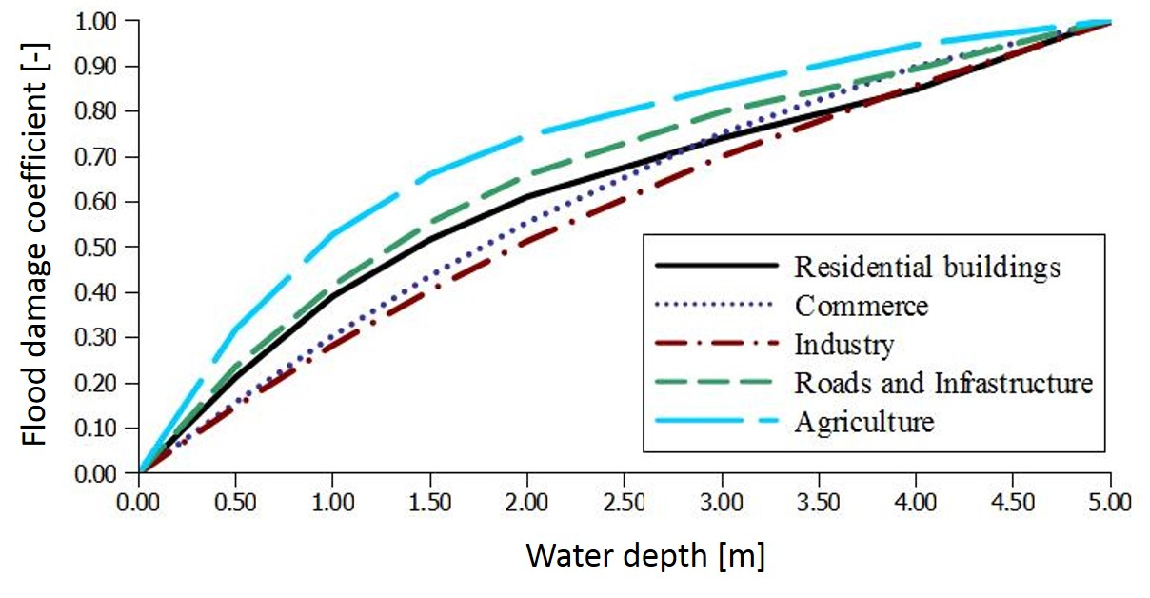

**Figure 2.** JRC water depth - damage values curves for different land use classes.

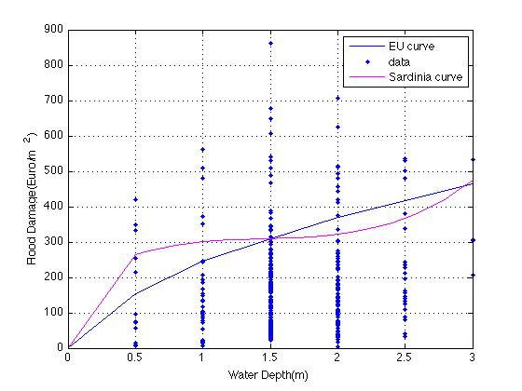

**Figure 3.** Comparison of JRC and Sardinian site-specific flood depth – damages curves.

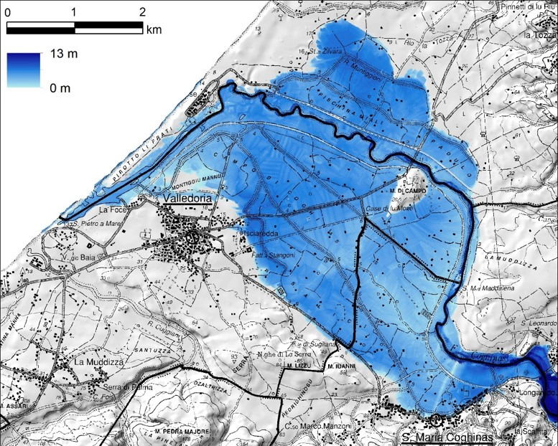

**Figure 4.** Expected flood-area and water depth in the Coghinas Basin (Tr = 200 years) in the present reservoir operating rules.

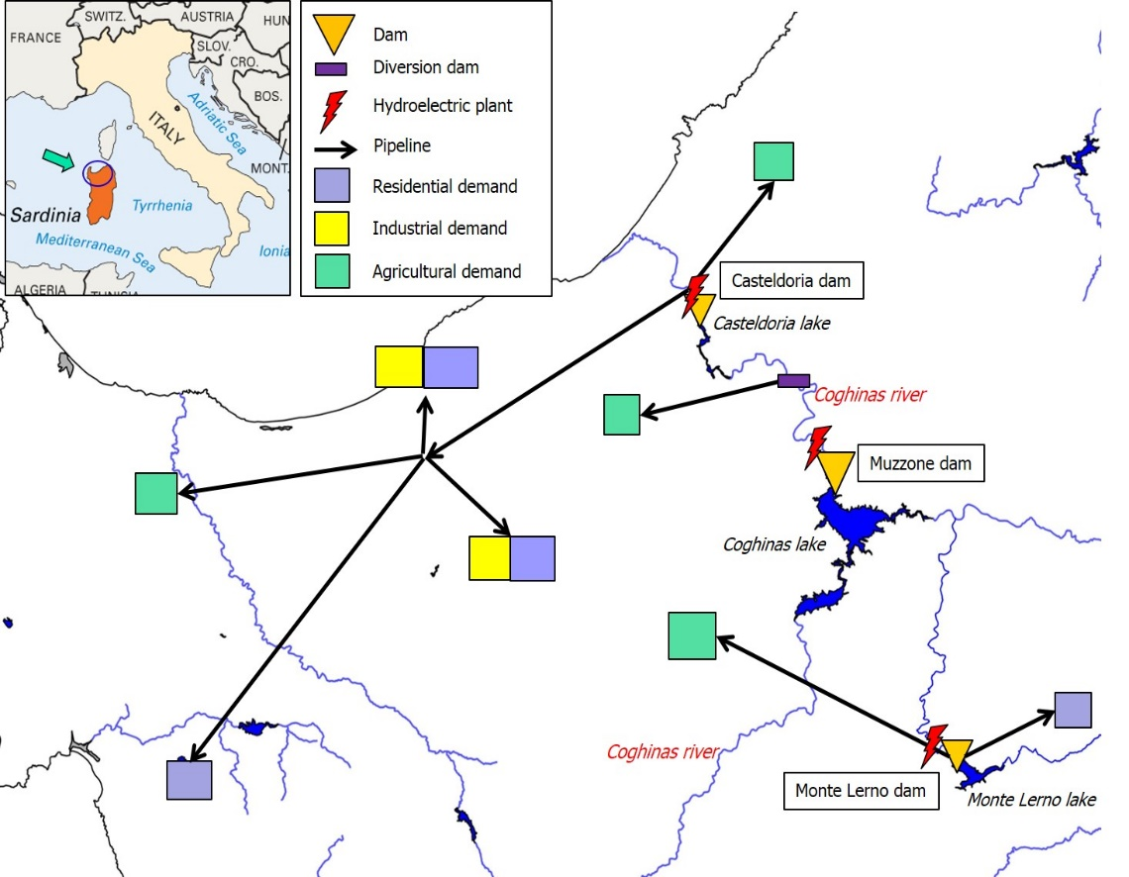

**Figure 5.** Draft of the North -West Sardinia water supply system.

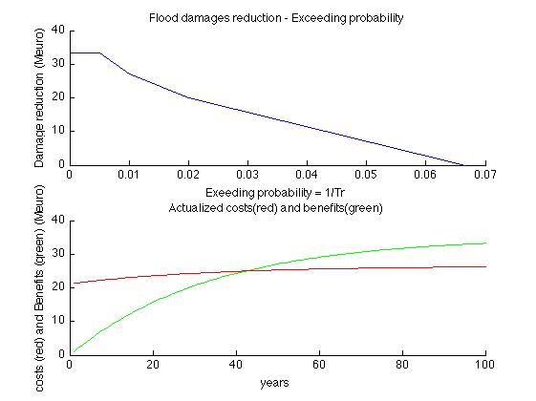

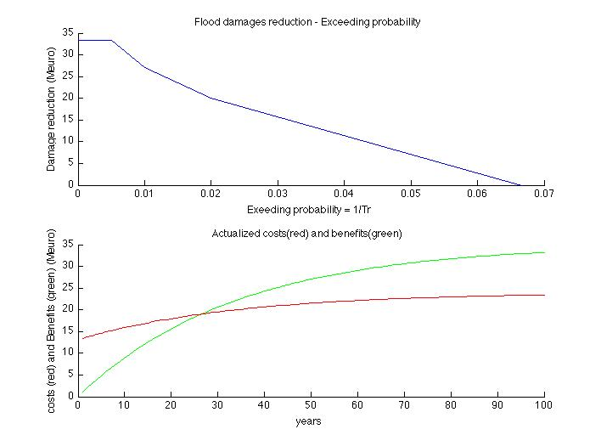

**Figure 6.** Flood damages reduction curves (blu line) and cumulative present value of costs (red line) and benefits (green line) considering flood control works configuration (upper side) and the best combination of reservoir operating rule – flood control works scenario B1+D+M1+M2 (lower side).

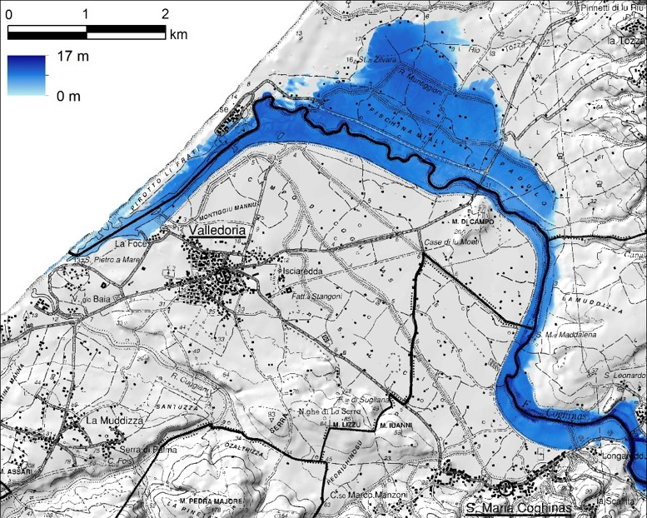

**Figure 7.** Expected flood-area and water depth in the Coghinas Basin (Tr = 200 years) in the best reservoir operating rules – flood control works scenario.

# List of Tables

1. **Table 1**. Land use classes and maximum damage values.
2. **Table 2.** Evaluated potential area and damages in Coghinas Basin (Present reservoir operating rules - flood control works).
3. **Table 3.** Maximum flood discharge values in different scenario.
4. **Table 4.** Evaluated potential flooded area and damages in Coghinas Basin (best reservoir operating rules - flood control works scenario).

|  |  |  |
| --- | --- | --- |
| **Land use class** | **Label** | **Maximum Damage Value (€/m2)** |
| 1. Residential Buildings | R | 618 |
| 1. Commercial | C | 511 |
| 1. Industry | I | 440 |
| 1. Agriculture | A | 0.63 |
| 1. Council Roads | N | 10 |
| 1. Provincial Roads | P | 20 |
| 1. Other Roads | S | 40 |
| 1. Infrastructural (Areas with water supply network, electricity grid and similar systems) | T | 40 |
| 1. Dams, rivers and similar areas | H | - |
| 1. Environmental heritage areas | J | - |
| 1. Historical and archaeological heritage areas | K | - |
| 1. Area subjected of other intangible damages | X | - |

**Table 1**. Land use classes and maximum damage values.

| **Label Land-Use Category** | **Tr 50** | | **Tr 100** | | **Tr 200** | |
| --- | --- | --- | --- | --- | --- | --- |
| **Area (m2)** | **Damage (€)** | **Area (m2)** | **Damage (€)** | **Area (m2)** | **Damage (€)** |
| A | 13'055'381 | 5'221'925 | 13'219'059 | 5'688'986 | 13'319'222 | 6'019'251 |
| C | 41'021 | 7'581'223 | 41'969 | 9'107'924 | 42'396 | 10'304'961 |
| I | 53'292 | 7'193'880 | 70'330 | 9'150'344 | 73'184 | 10'950'897 |
| J | 2'075'232 | - | 2'099'058 | - | 2'119'113 | - |
| K | 22'310 | - | 26'687 | - | 40'014 | - |
| N | 42'576 | 168'716 | 45'321 | 204'835 | 45'786 | 232'406 |
| P | 99'089 | 802'391 | 104'138 | 979'904 | 111'261 | 1'137'800 |
| R | 114'945 | 23'916'273 | 135'434 | 31'182'354 | 148'135 | 37'856'384 |
| T | 213'333 | 3'497'885 | 217'036 | 4'054'690 | 220'499 | 4'504'593 |
| X | 634'887 | - | 656'570 | - | 673'836 | - |
| **Total** | 16'352'066 | 48'382'292 | 16'615'603 | 60'369'036 | 16'793'446 | 71'006'292 |

**Table 2.** Evaluated potential area and damages in Coghinas Basin (Present reservoir operating rules - flood control works).

|  |  |  |  |
| --- | --- | --- | --- |
| **Scenario** | **Tr 50** | **Tr 100** | **Tr 200** |
| **AEFV** | 2’952 | 3’745 | 4’460 |
| **A1** | 2'119 | 2'636 | 3'154 |
| **A2** | 2'478 | 3'033 | 3'589 |
| **B1** | 2'039 | 2'581 | 3'097 |
| **B2** | 2'424 | 2'950 | 3'419 |

**Table 3.** Maximum flood discharge values [m3/s] in different scenario.

| **Label Land-Use Category** | **Tr 50** | | **Tr 100** | | **Tr 200** | |
| --- | --- | --- | --- | --- | --- | --- |
| **Area (m2)** | **Damage (€)** | **Area (m2)** | **Damage (€)** | **Area (m2)** | **Damage (€)** |
| A | 4'319'298 | 2'427'457 | 4'357'614 | 2'542'281 | 4'396'981 | 2'634'604 |
| C | 18'890 | 6'669'257 | 19'136 | 7'430'968 | 19'359 | 7'956'705 |
| I | 11'947 | 3'333'775 | 11'974 | 3'402'500 | 11'983 | 3'843'127 |
| J | 2'437'801 | - | 2'542'692 | - | 2'616'783 | - |
| K | 32'083 | - | 33'679 | - | 34'736 | - |
| N | 27'529 | 218'202 | 27'667 | 235'546 | 28'629 | 252'514 |
| P | 14'940 | 158'655 | 21'288 | 225'245 | 23'967 | 291'544 |
| R | 47'618 | 23'306'680 | 53'437 | 16'892'655 | 58'371 | 19'842'025 |
| T | 75'514 | 2'312'239 | 78'287 | 2'528'998 | 80'929 | 2'742'693 |
| X | 618'436 | - | 635'210 | - | 648'948 | - |
| **Total** | 7'604'057 | 28'426'264 | 7'780'984 | 33'258'193 | 7'920'688 | 37'563'213 |

**Table 4.** Evaluated potential flooded area and damages in Coghinas Basin (best combination of reservoir operating rule - flood control works scenario B1+D+M1+M2).