Supplementary Data
Analysis of Biosurfactants Produced by Bacteria Growing on Textile Sludge and Their Toxicity Evaluation for Environmental Application

Tables

Table S1 Biochemical characterization and various carbon source utilization by biosurfactant producing isolates (Stenotrophomonas sp. BAB-6435 and Brevisbacillus brevis BAB-6437).
Test | Result |  | Test | Result
 | BAB-6435 | BAB-6435 |  | BAB-6435 | BAB-6435
Gram character | -ve | +ve | citrate utilization | +ve | +ve
Shape | rod shape | rod shape | urea hydrolysis | -ve | -ve
Motility | Non-motile | Motile | gelatine hydrolysis | +ve | +ve
Catalase activity | +ve | +ve | Carbon source utilization
Growth temp. (ºC) | 25-40 | 30-55 | β-Lactose | +ve | +ve
Optimum temp. (ºC) | 32 | 37 | Sucrose | +ve | +ve
Indole | -ve | +ve | L-fructose | +ve | +ve
MR | -ve | +ve | L-rhamnose | +ve | +ve
VP | +ve | -ve | D-galactose | -ve | +ve
Starch hydrolysis | -ve | -ve | L-glucose | +ve | +ve
Nitrate reduction | +ve | +ve | D-Trehalose | +ve | -ve
Amylase | +ve | -ve | L-mannose | -ve e | +ve
Hydrogen sulphide production | +ve | -ve | D-mannitol | +ve | -ve

Table S2 Experimental design matrix of three levels of environmental factors with coded values by using Box-Behnken Design with observed responses
Run | X1 | X2 | X3 | Stenotrophomonas sp. BAB-6435 |  |  | Brevisbacillus brevis BAB-6437
 |  |  |  | DB (gL⁻¹) | BP (gL⁻¹) | Stability (E₂₄%) | DB(gL⁻¹) | BP(gL⁻¹) | Stability (E₂₄%)
1 | 0 | 1 | 1 | 0.157 | 0.137 | 48.56 | 1.014 | 0.114 | 54.18
2 | -1 | 0 | -1 | 0.777 | 0.364 | 45.3 | 0.9147 | 0.541 | 63.41
3 | 0 | 0 | 0 | 1.37 | 0.936 | 80.78 | 3.217 | 2.115 | 88.88
4 | 0 | 0 | 0 | 1.97 | 0.918 | 81.25 | 3.364 | 2.084 | 89.27
5 | 0 | 0 | 0 | 1.788 | 0.924 | 81.08 | 3.088 | 2.154 | 89.79
6 | -1 | -1 | 0 | 0.677 | 0.372 | 80.76 | 2.1947 | 1.341 | 89.43
7 | 0 | 0 | 0 | 1.967 | 0.984 | 80.92 | 3.179 | 2.184 | 89.66
8 | -1 | 0 | 1 | 0.857 | 0.314 | 79.31 | 0.447 | 0.0431 | 88.24
9 | 0 | 1 | -1 | 0.177 | 0.0524 | 20.55 | 0.884 | 0.224 | 29.35
10 | 0 | 0 | 0 | 1.483 | 0.984 | 81.13 | 3.302 | 2.106 | 89.68
11 | 1 | 0 | -1 | 0.171 | 0.0184 | 48.96 | 0.589 | 0.0804 | 62.87
12 | 0 | -1 | -1 | 0.527 | 0.134 | 50.93 | 1.304 | 0.464 | 64.34
13 | 1 | -1 | 0 | 1.071 | 0.268 | 81.42 | 1.869 | 0.714 | 88.89
14 | -1 | 1 | 0 | 0.227 | 0.0604 | 47.38 | 0.77 | 0.101 | 54.44
15 | 0 | -1 | 1 | 0.607 | 0.484 | 81.94 | 1.434 | 0.114 | 65.17
16 | 1 | 1 | 0 | 0.621 | 0.2658 | 48.04 | 1.449 | 0.474 | 53.9
17 | 1 | 0 | 1 | 1.341 | 0.5684 | 79.97 | 1.719 | 0.804 | 87.7

X1-temperature; -1(4ºC), 0(42ºC), 1(80ºC)
X2 –Salinity; -1(0mg/100ml), 0(5g/100ml), 1(10g/100ml
X3-pH; -1(3.5), 0(8.5), 1(13.5)
DB-dry biomass of microbial cell; BP-biosurfactant production

Table S3 Level of significance for the response surface quadric model generated from Box behnken design (BBD)
Source | P-value
 | Stenotrophomonas sp. BAB-6435 |  |  | Brevisbacillus brevis BAB-6437
 | DB | BP | Stability (E₂₄%) | DB | BP | Stability (E₂₄%)
Model | 0.003ª | <0.0001ª | < 0.0001ª | < 0.0001ª | <0.0001ª | < 0.0001ª
A | 0.279^{NS} | 0.895^{NS} | 0.0818^{NS} | 0.0271^{c} | 0.938^{NS} | 0.8337^{NS}
B | 0.021^{c} | <0.0001ª | < 0.0001ª | 0.0007^{b} | 0.0202^{c} | < 0.0001ª
C | 0.054^{NS} | <0.0001ª | < 0.0001ª | 0.0885^{NS} | 0.6959^{NS} | < 0.0001ª
AB | 1.00^{NS} | 0.0017^{c} | 1.0000^{NS} | 0.0187^{c} | 0.0435^{c} | 0.8107^{NS}
AC | 0.03^{c} | <0.0001ª | 0.1705^{NS} | 0.0019^{c} | 0.0198^{c} | 0.4818^{NS}
BC | 0.811^{NS} | 0.0038^{c} | 0.1705^{NS} | 1.000^{NS} | 0.5736^{NS} | 0.0124^{c}
A2 | 0.003^{c} | <0.0001ª | 0.0051^{c} | <0.0001ª | <0.0001ª | 0.0231^{c}
B2 | <0.0001ª | <0.0001ª | < 0.0001ª | <0.0001ª | <0.0001ª | < 0.0001ª
C2 | 0.0001ª | <0.0001ª | < 0.0001ª | <0.0001ª | <0.0001ª | < 0.0001ª

a-significant at ≤0.0001; b- significant at ≤0.001; c-significant at ≤0.05; NS-non significant
DB-dry biomass; BP-biosurfactant production
A-temperature; B-NaCl; C-pH

Table S4 Micro-elemental analysis by Scanning electron microscopy-energy dispersive X-ray spectroscopy (SEM-EDS) of purified biosurfactants from Stenotrophomonas sp. BAB-6435 and Brevisbacillus brevis BAB-6437. Data are represented by weight and atomic % with their standard formula.

Element | Standard | Glycolipid  (Stenotrophomonas sp. BAB-6435) |  | Lipopeptide  (Brevisbacillus brevis BAB-6437)
 |  | Weight % | Atomic % | Weight % | Atomic %
C | CaCO3 | 55.17 | 66.55 | 59.05 | 69.76
O | SiO2 | 32.19 | 29.15 | 29.94 | 26.55
Na | Albite | 1.78 | 1.12 | - | -
P | GaP | 1.88 | 0.88 | - | -
S | FeS2 | 3.19 | 1.44 | 5.75 | 2.55
K | MAD-10 Feldspar | 1.42 | 0.53 | - | -
Zn | Zn | - | - | 5.26 | 1.14

Figures

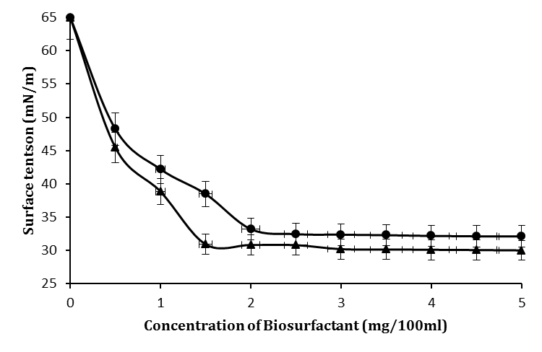
Figure S1 Surface tension activity and CMC estimation of the Glycolipid () and Lipopeptide () produced by Stenotrophomonas sp. BAB-6435 and Brevisbacillus brevis BAB-6437 respectively. Cultures were grown in MSM media supplemented with 2.0% (w/v) glucose.

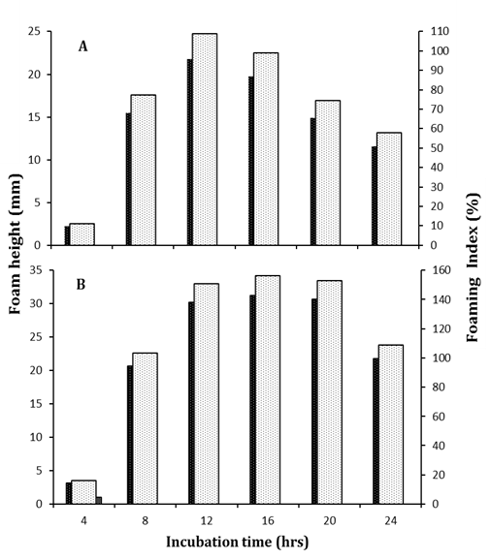
Figure S2 Foam formation profile of Stenotrophomonas sp. BAB-6435 (A) and Brevisbacillus brevis BAB-6437 (B) represented through foam height () and foaming index () at different time interval (0-24 hours) of culture incubation.

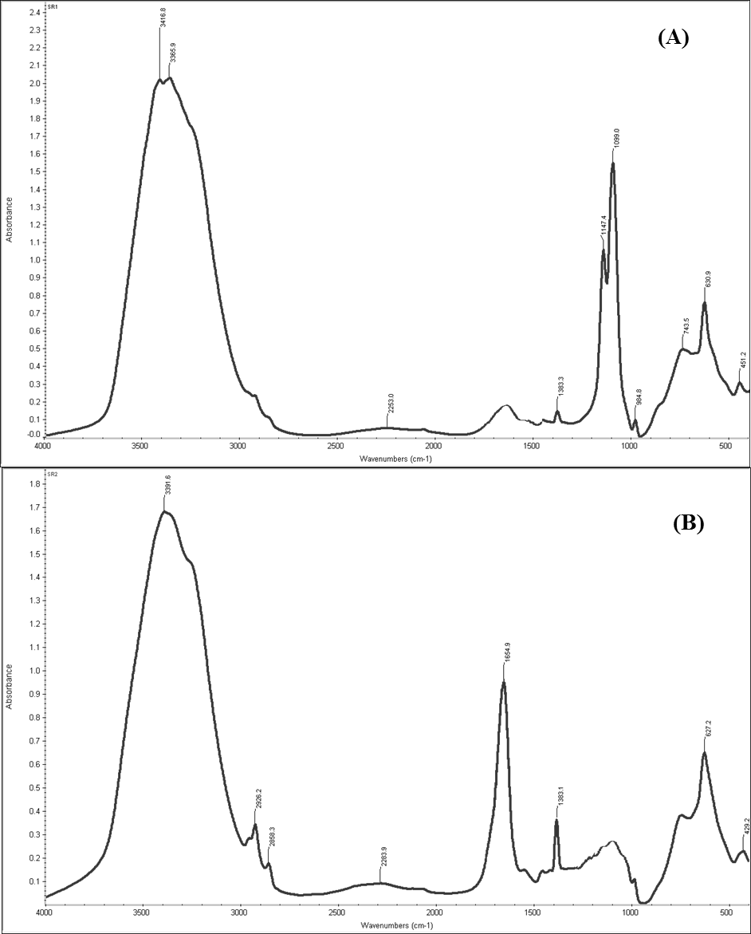

Figure S3 FT-IR spectrum of the purified biosurfactants; Glycolipid (A) and Lipopeptide (B) produced from Stenotrophomonas sp. BAB-6435 and Brevisbacillus brevis BAB-6437 respectively. Cultures were grown in MSM media supplemented with 2.0% (w/v) glucose.

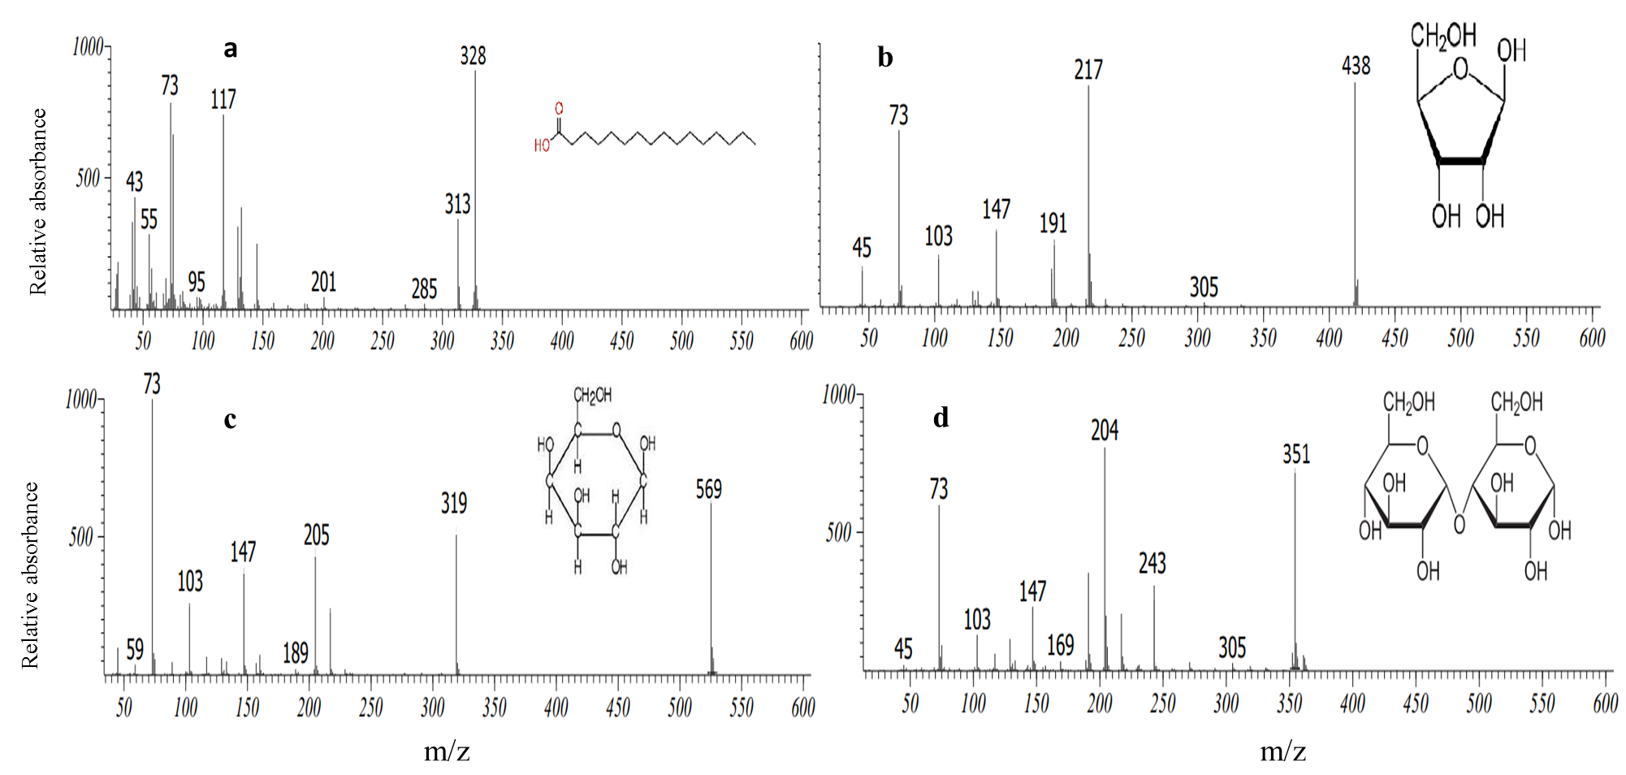

Figure S4 Mass spectrum analysis of the GC profiling peaks of purified, derivatized Glycolipid biosurfactants. Spectrum identified as Palmitic acid methyl esters (a); Ribose (b); Galactose (c); and Maltose (d) using NIST mass spectrum database library.
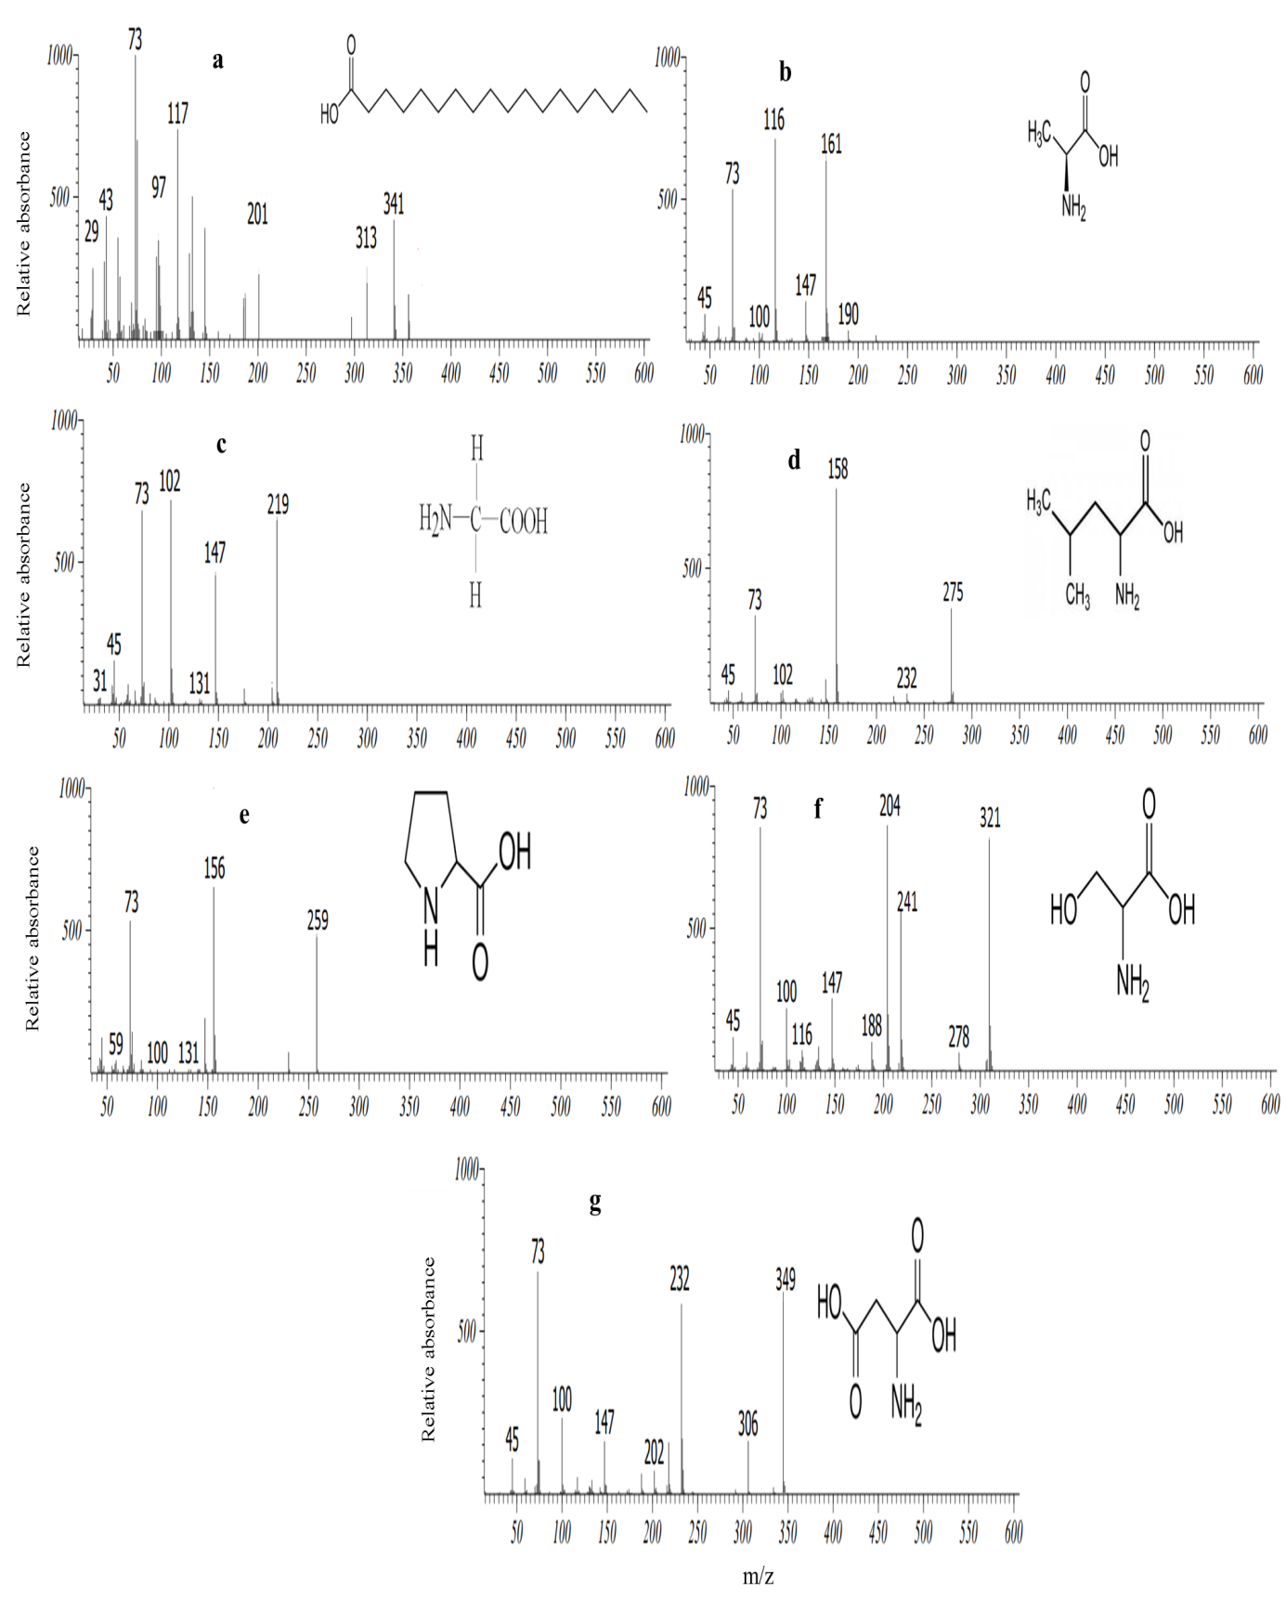
Figure S5 Mass spectrum analysis of the GC profiling peaks of purified, derivatized Lipopeptide biosurfactants. Spectrum identified as Stearic acid methyl esters (a); Alanine (b); Glycine (c); Leucine (d); Proline (e); Serine (f); Aspartic acid (g) using NIST mass spectrum database library.

