Appendix

Simulation Study for comparing Type I error levels and Power analysis for FANOVA and Distance based Tests:

In the FANOVA based approach, our goal is to model the difference between pre- and post-treatment pedaling torques (functional response) in terms of different factors (functions) and therefore the influence of these factors on the functional response can be suitably simulated using the idea from Cuesta-Albertos and Febrero-Bande, 2010. However, the non-parametric approach is based on the computation of the distance between pre- and post-treatment torques, which we don’t really have a model for due to the exploratory nature of the original study. Therefore, in our simulation setup, we have simulated pre-treatment torques randomly, with a covariance structure similar to the original data and simulated the difference following Cuesta-Albertos and Febrero-Bande, 2010. We have used the following model for the simulation study:
$$\begin{matrix}X_{i}^{r,s}(t)= & m(t)+f^{r}(t)+g^{s}(t)+ \\ & h^{r,s}(t)+γ(t)Y_{i}^{r,s}+ϵ_{i}^{r,s}(t), t∈[a,b],\end{matrix}$$
where $n_{r,s}=100$ and
- $m(t):=30(1-t)t.$
- $f^{r}(t):=α(-1)^{r}|sin(4πt)|,r∈\{1,2\},α∈\{0,.025,.05,.075,.10,.15,.25,.35,.50\}.$
- $g^{s}(t):=β(-1)^{s}I_{lt>0.51},s∈\{1,2\},β∈\{0,.025,.05,.075,.10,.15,.25,.35,.50\}.$
- $h^{r,s}(t):=-f^{r}(t)g^{s}(t)I_{\{α≥0.25\}}.$
- $ϵ_{i}^{r,s}(t)$ is Gaussian Process with mean zero and covariance function:
$$Cov\left(ϵ_{i}^{r,s}\left(t_{1}\right),ϵ_{i}^{r,s}\left(t_{2}\right)\right)= σ_{r,s}^{2}exp\left(-\left|t_{1}-t_{2}\right|/.3\right), σ_{r,s}^{2}=.2+r×s×.1$$
- $t∈[0,1]$ discretized in N = 180 points (following real data).
- Numbers of projections used in this study are: 1, 5, 15, 30 and 100.
The parameters $α$ and $β$ control the influence of functional factors $f^{r}(t)$ and $g^{s}(t)$ respectively. We have created K=10 replications for every possible pairs of $α$ and $β$.
The following figure depicts a dataset generated using the above-mentioned scheme with $α=.5$ and $β= .5$.
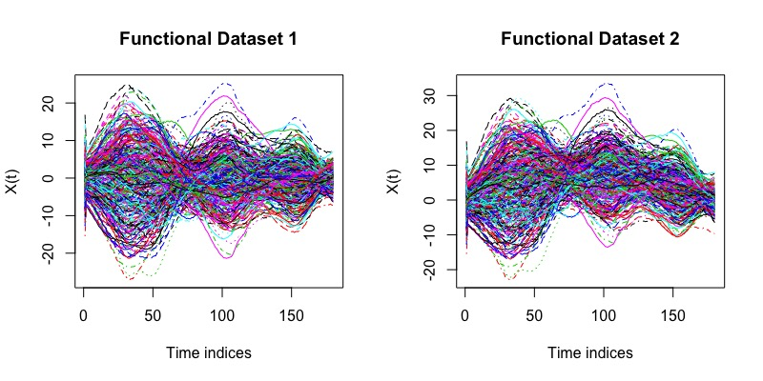
In the above figure, Functional Dataset 1 represents pre-treatment torques and Functional Dataset 2 represent post-treatment torques. We have performed FANOVA on the difference between these two. The goal is to test:
- $H_{0}^{A}:f^{1}=⋯=f^{R}=0$
- $H_{0}^{B}:g^{1}=⋯=g^{S}=0$
We have used an Ornstein-Uhlenbeck process to generate random projection vectors of similar dimensions as that of the simulated functional data. Under the above simulation setup, any one-dimensional projection will be Gaussian and therefore we have opted for standard ANOVA for the testing of unidimensional projections.
For the nonparametric approach, we chose DTW as the distance measure and performed Wald-type permutation test. Since there are 9 possible values for both $α$and $β$ and 10 replications for every pair of $α$and $β$ values, the corresponding test results were obtained based on 90 replications which have been reported in the following tables:

Table 1 Proportion of rejections for $H_{0}^{A}$ at the level p = .05
RP | α = .00 | α = .025 | α = .05 | α = .075 | α = .10 | α = .15 | α = .25 | α = .35 | α = .50
1 | 0.02 | 0.16 | 0.19 | 0.31 | 0.48 | 0.58 | 0.71 | 0.81 | 0.78
5 | 0.02 | 0.10 | 0.29 | 0.66 | 0.86 | 0.97 | 0.99 | 1 | 1
15 | 0.01 | 0.13 | 0.52 | 0.88 | 0.99 | 1 | 1 | 1 | 1
30 | 0.04 | 0.16 | 0.63 | 0.98 | 1 | 1 | 1 | 1 | 1
100 | 0.02 | 0.23 | 0.87 | 1 | 1 | 1 | 1 | 1 | 1
DTW | 0.04 | 0.03 | 0.17 | 0.23 | 0.40 | 0.54 | 0.96 | 1 | 1

Table 2 Proportion of rejection for $H_{0}^{B}$ at the level p = .05
RP | β = .00 | β = .025 | β = .05 | β = .075 | β = .10 | β = .15 | β = .25 | β = .35 | β = .50
1 | 0.6 | 0.6 | 0.14 | 0.26 | 0.39 | 0.58 | 0.79 | 0.76 | 0.91
5 | 0.02 | 0.11 | 0.33 | 0.56 | 0.80 | 0.94 | 0.99 | 0.99 | 1
15 | 0.07 | 0.10 | 0.56 | 0.92 | 1 | 1 | 1 | 1 | 1
30 | 0.06 | 0.13 | 0.68 | 0.96 | 1 | 1 | 1 | 1 | 1
100 | 0.04 | 0.16 | 0.86 | 1 | 1 | 1 | 1 | 1 | 1
DTW | 0.04 | 0.07 | 0.08 | 0.13 | 0.19 | 0.43 | 0.87 | 0.98 | 1

From the above tables 1 and 2, we observe that in both the testing procedures (FANOVA and nonparametric), the behavior is as expected. One noteworthy point however is that, the distance-based tests are more likely to reject the null hypotheses at higher influence of the corresponding factor than the FANOVA based tests.

References:
Cuesta-Albertos J.A. and Febrero-Bande M. (2010). A simple multiway ANOVA for functional data. Test 19, 537–557.

