Supplemental Information

Phenylbutyrate induces LL-37-dependent autophagy and intracellular killing of Mycobacterium tuberculosis in human macrophages

Rokeya Sultana Rekha,^{1,2} SSV Jagadeeswara Rao Muvva,³ Min Wan,⁴ Rubhana Raqib,² Peter Bergman,¹ Susanna Brighenti,³ Gudmundur H. Gudmundsson,^{5#} Birgitta Agerberth^{1#*}

¹Department of Laboratory Medicine, Clinical Microbiology, Karolinska Institutet, Huddinge, Stockholm, Sweden
²International Centre for Diarrheal Disease Research, Bangladesh (icddr,b), Mohakhali, Dhaka, Bangladesh
³Center for Infectious Medicine, Department of Medicine Huddinge, Karolinska Institutet, Stockholm, Sweden
⁴Department of Medical Biochemistry and Biophysics, Karolinska Institutet, Stockholm, Sweden
⁵Biomedical Center, University of Iceland, Reykjavik, Iceland.

# These authors contributed equally
*Correspondence to: Birgitta Agerberth,
Professor of Medical Microbial Pathogenesis
Department of Laboratory Medicine,
Clinical Microbiology, Karolinska Institutet
Karolinska University Hospital, F68
SE-141 86 Stockholm, Sweden
Cell phone: +46 707 494952
Fax: +46 8 585 87933
Email: Birgitta.Agerberth@ki.se

Running title: LL-37-dependent autophagy by phenylbutyrate
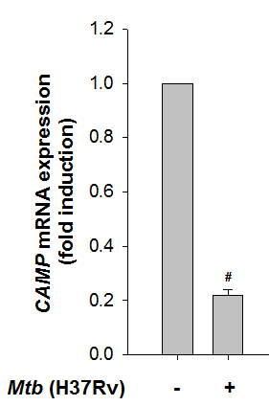
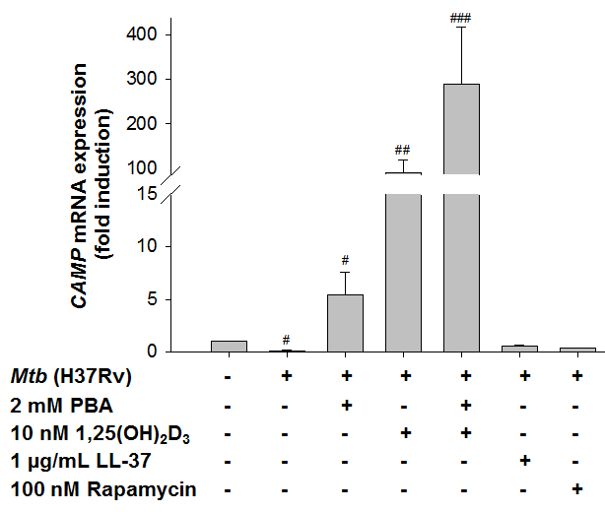
A B

Figure S1. Phenylbutyrate (PBA) and the active form of vitamin D₃ (1,25(OH)₂D₃) induced CAMP mRNA expression in human monocytic cell line THP-1. (A) THP-1 cells were differentiated with PMA (10 ng/mL, for 36 to 48 h) and infected with the virulent strain of Mycobacterium tuberculosis H37Rv at a multiplicity of infection of 1:5 for 4 h, and quantitative real-time PCR for the expression of the CAMP transcript was determined (normalized to RNA18S/18S rRNA expression). (B) After Mtb infection cells were treated with PBA (2 mM), 1,25(OH)₂D₃ (10 nM), LL-37 (1 µg/mL) and rapamycin (100 nM) for 24 h; real-time qPCR was performed for transcript of CAMP (normalized to RNA18S/18S rRNA expression) in 3 independent experiments (mean ± SD). The P values in A and B were ≤0.001, ≤0.01, ≤0.05 as indicated by ###, ## and #, respectively.

Figure S2. Phenylbutyrate (PBA), vitamin D₃ and LL-37 control intracellular survival of Mtb in human monocyte derived macrophages (MDMs). Human MDMs were infected with the virulent strain of Mycobacterium tuberculosis H37Rv at a multiplicity of infection of 1:5 for 4 h, after that cells were treated with PBA (2 mM) and/or 1,25(OH)₂D₃ (10 nM) or LL-37 (1 µg/mL) or rapamycin (100 nM) for 3 days. Intracellular bacterial viability was determined based on the number of colony forming units (CFUs). For the infected control at day 0, intracellular bacteria were harvested after 4 h infection and for the other conditions that were mentioned bacteria were harvested after 3 day and cells were lysed with 0.036% SDS. The lysates were then cultured on Middle Brook 7H11 agar media (Becton, Dickinson and company) and after 21 to 28 days of culture at 37ºC bacterial viability was calculated by the CFU count. Results are shown from 5 independent experiments (mean ± SD). Infection at day 3 was used as a control when comparing with treated cells. The P values were ≤0.001, ≤0.01 as indicated by *** and **, respectively.
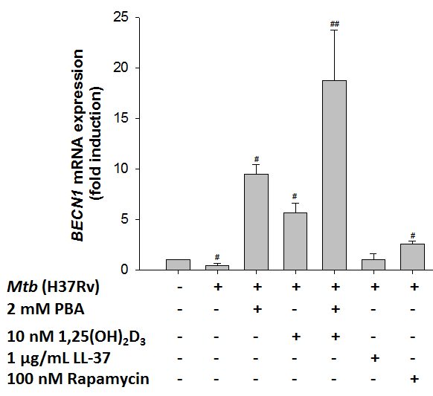
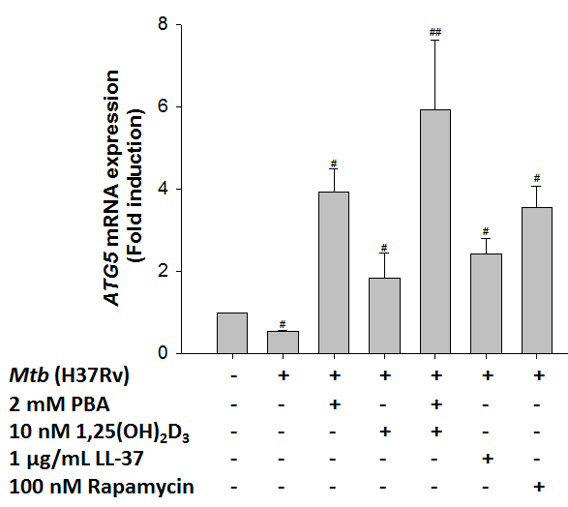
A B

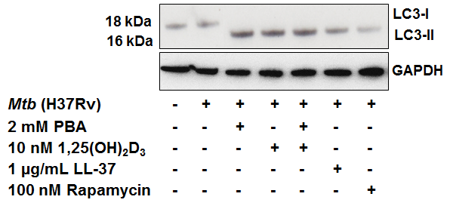
C

Figure S3. Phenylbutyrate (PBA) induced autophagy in THP-1 cells by upregulation of expression of the autophagy related genes BECN1 and ATG5, and conversion of LC3-I to the autophagosome-bound form LC3-II. THP-1 cells were infected with the virulent strain of Mycobacterium tuberculosis H37Rv for 4 h and treated with PBA (2 mM), 1,25(OH)₂D₃ (10 nM), LL-37 (1 µg/mL) and rapamycin (100 nM) for 24 h. (A and B) The expression of the autophagy-related genes (A) BECN1 and (B) ATG5 mRNA (normalized to RNA18S/18S rRNA expression) was measured by real time PCR. Results are shown from 3 independent experiments (mean ± SD). (C) A representative western blot shows the conversion of LC3-I to LC3-II and the housekeeping protein GAPDH (glyceraldehyde 3-phosphate dehydrogenase) from 3 independent experiments. The P values were ≤0.01 and ≤0.05 as indicated by ##and #, respectively.
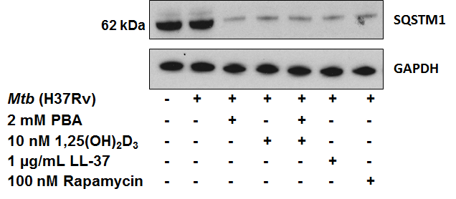
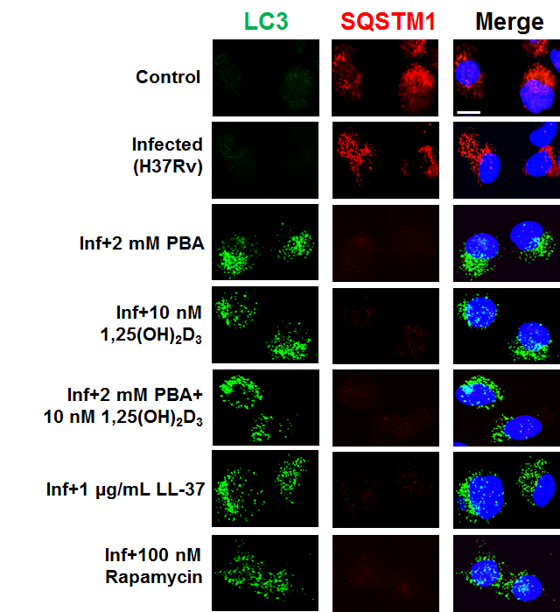
A B

Figure S4. Phenylbutyrate (PBA) induced the expression of the autophagy protein LC3 and degradation of the SQSTM1 protein. (A) Human MDMs were infected with the virulent strain of Mycobacterium tuberculosis H37Rv for 4 h and treated with PBA (2 mM), 1,25(OH)₂D₃ (10 nM), LL-37 (1 µg/mL) and rapamycin (100 nM) for 24 h. The expression of LC3 and SQSTM1 protein was investigated by confocal microscopy. Cells were stained with anti-LC3 and anti-SQSTM1, followed by the addition of Alexa Fluor 488/594-conjugated goat anti-mouse/rabbit IgG (green and red color, respectively). Cells were also stained with DAPI to visualize the nuclei (blue). One representative image out of 6 independent experiments is shown; scale bars: 10 μm; (B) A representative western blot from 6 independent experiments shows the presence the SQSTM1 protein and GAPDH in cell lysate

