Supporting information for

Impact of the 2018 European heatwave on lake surface water temperature

R. Iestyn Woolway^{1*}, Eleanor Jennings¹, Laura Carrea²

- Dundalk Institute of Technology, Dundalk, Co. Louth, Ireland
- Department of Meteorology, University of Reading, Reading, UK

*Corresponding author: riwoolway@gmail.com

Contents of this file
Figures S1-S5
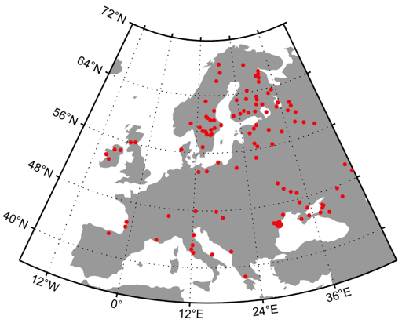

Figure S1. Location of the 115 lakes with satellite-derived surface water temperature observations investigated in this study.
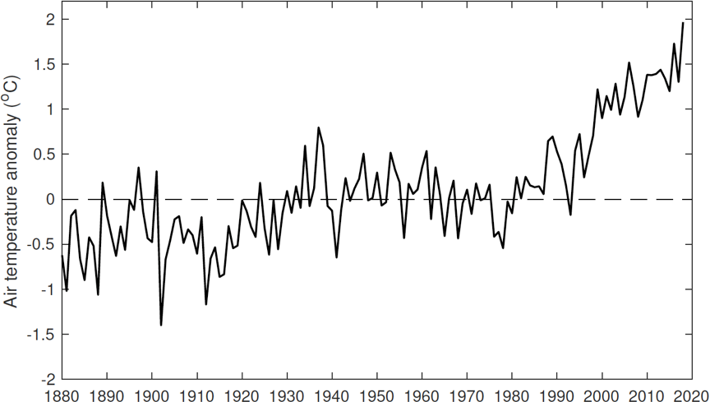

Figure S2. Long-term change in May-Oct average air temperature anomalies in Europe relative to 1951-1980; data from the Goddard Institute for Space Studies surface temperature analysis (GISTEMP) (GISTEMP Team 2016; Hansen et al. 2010) database (http://data.giss.nasa.gov/gistemp/).
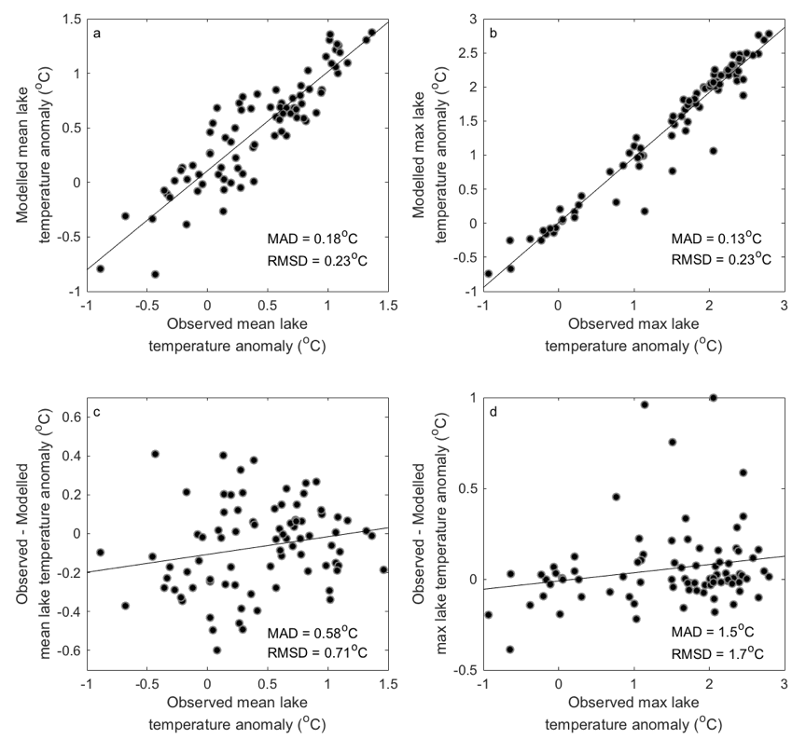

Figure S3. Comparison of 2018 May-Oct average satellite-derived and modelled lake surface water temperature anomalies. Shown are the relationships between the (a) mean and (b) maximum lake surface temperatures. Also shown are comparisons of the observed (c) mean and (d) maximum temperatures with the difference between the observed and modelled data. The trend line is shown in black. The mean absolute difference and the root mean square difference is shown in each panel. The lake model was driven by climate data from ERA-Interim.
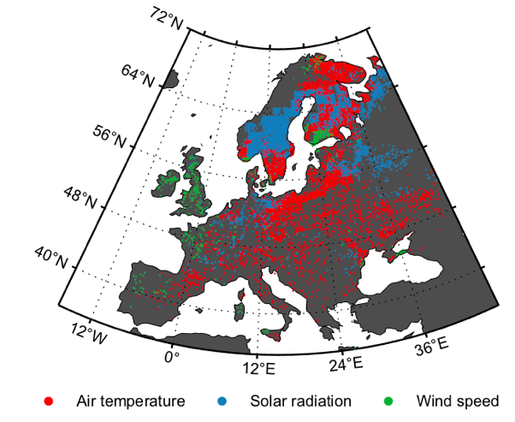

Figure S4. Attribution of lake surface temperature responses to the 2018 European heatwave. Colors represent the meteorological variable which had the greatest influence on mean lake surface water temperature anomalies during May-Oct 2018. Only shown are lakes with mean surface temperature anomalies that were within the 90th percentile in 2018, relative to all May-Oct average temperatures during the study period (1980-2018).
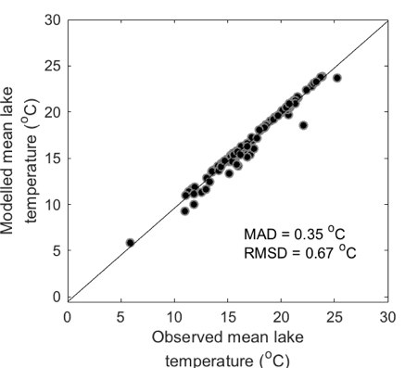

Figure S5. Comparison of 1995-2005 May-Oct average satellite-derived and modelled lake surface temperature anomalies. The trend line is shown in black. The mean absolute difference and the root mean square difference is shown. The lake model was driven by climate data from HadGEM2-ES.

